**INTRODUCTION**

This comprehensive report presents a detailed analysis of a Blog Management System developed as part of the Software Development Fundamentals-II Lab course. The system implements a robust blog platform with user authentication, post management, commenting functionality, and administrative controls, all developed using C++ programming language. The application leverages various C++ features including object-oriented programming principles, file handling for data persistence, STL containers, and string manipulation. The system architecture demonstrates a well-structured approach with clear separation of concerns between user management, blog content management, and administrative functions.

**PROBLEM STATEMENT**

The digital landscape requires efficient platforms for content creation, sharing, and management that can facilitate user interactions through comments and feedback mechanisms. Traditional blogging platforms often have complex architectures that are difficult to understand from an educational perspective, making it challenging for students to grasp the underlying principles of software design and implementation.

**Need for the System**

Educational institutions often require simplified yet functional systems that can demonstrate programming concepts while providing practical utility. The current project addresses this need by developing a console-based Blog Management System that demonstrates core programming concepts while providing a functional platform for content sharing. The system needed to incorporate user management, content creation, interaction capabilities, and administrative controls to represent a complete application ecosystem.

**Scope and Limitations**

The system is designed as a console application with focus more on functionality than on graphical interface. It provides core blog management features including user registration with email validation, secure login, post creation and management, commenting, and administrative controls. The system uses file-based storage rather than databases, making it suitable for educational purposes but limiting its scalability for large-scale deployment.

**OBJECTIVES**

The primary objectives of this Blog Management System are to create a platform that demonstrates proficiency in C++ programming while providing practical functionality for content management.

**Primary Goals**

* Develop a secure user authentication system with registration, login, and access control
* Implement comprehensive blog management functionality including post creation, editing, and deletion
* Create an interactive system allowing users to comment on posts and manage their comments
* Provide administrative capabilities for system management and moderation
* Implement data persistence through file-based storage
* Demonstrate proficiency in advanced C++ programming concepts and techniques2

**Learning Outcomes**

This project aims to reinforce software development skills including object-oriented design, file handling, data structure implementation, and input validation. Additionally, it provides practical experience in implementing business logic, managing user interactions, and handling system security considerations.

**FEATURES OF C++ USED**

The development of this Blog Management System demonstrates proficiency in various advanced C++ features and programming concepts.

**Object-Oriented Programming**

The system employs a robust object-oriented architecture with three main classes:

* UserManager: Handles user authentication, registration, and session management
* BlogManager: Manages blog post creation, editing, deletion, and commenting functionality
* AdminManager: Provides administrative capabilities for system management2

Each class encapsulates related functionality with appropriate data hiding through private members and public interfaces, demonstrating OOP principles of encapsulation, abstraction, and modularity.

**Standard Template Library (STL)**

The code makes extensive use of STL containers and algorithms:

* vector for dynamic storage of posts, comments, tags, and user data
* String manipulation using standard library functions
* Algorithm library for operations such as remove() for string modifications

**File Handling**

The system implements persistent storage through file operations:

* ifstream and ofstream for reading and writing data
* File-based database for storing user information, blog posts, and comments
* Transaction-like operations for data modifications with temporary files

**String Manipulation**

Advanced string processing techniques are employed throughout the application:

* Custom splitString() and join() functions for parsing and formatting data
* stringstream for tokenizing strings
* String trimming and formatting functions

**Input Validation and Error Handling**

The system implements comprehensive input validation:

* Email format validation with domain checking
* Password strength requirements (uppercase, lowercase, digits, symbols)
* Input buffer clearing to prevent unexpected behavior
* Existence checking for users, posts, and comments2

**OUTPUT SCREENS**

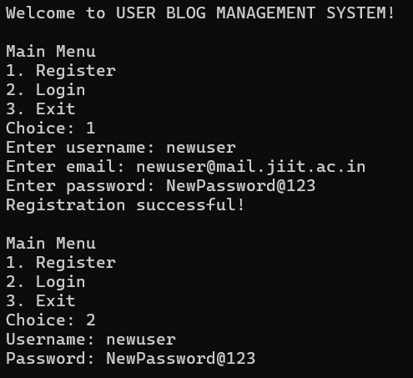

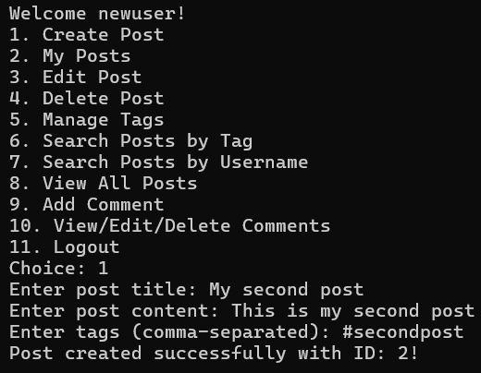

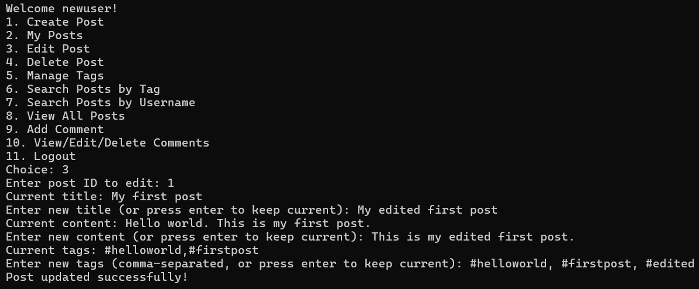

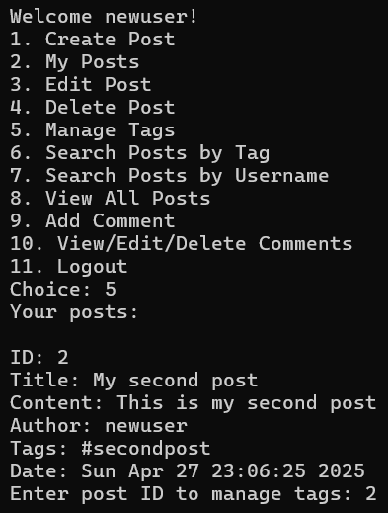

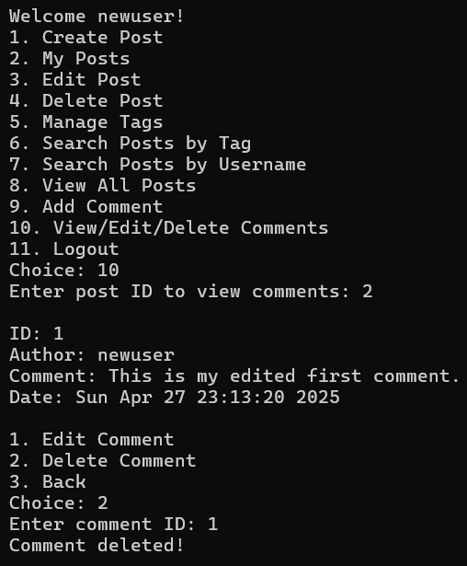

**CONCLUSION**

The Blog Management System successfully implements a comprehensive blogging platform with user management, content creation and management, and administrative controls using C++ programming language. The system demonstrates proficiency in various advanced programming concepts including object-oriented design, file handling, data structures, and input validation.

**Achievements**

The project effectively addresses the problem statement by creating a functional blog management system that can be used in educational settings. It implements all the required functionalities including user registration with validation, secure login, post management, commenting system, and administrative controls. The code organization demonstrates good software design principles with clear separation of concerns and modular architecture.

**Future Enhancements**

Several improvements could be considered for future development:

* Implementation of a graphical user interface to improve user experience
* Migration to a database system for better scalability and data integrity
* Addition of more social features such as user profiles and following capabilities
* Implementation of media support for images and other content types
* Enhanced security features including encryption for passwords and session management

This project serves as a strong foundation for understanding software development principles and could be extended with these enhancements for a more comprehensive system. The implementation demonstrates mastery of C++ programming concepts while providing practical utility as a content management system.