Online Shoppers Purchase Prediction System

Project Id: AIML-21

Name : Raghav Sharma (Team Leader)
Class Roll Number: 65
University Roll Number : 2028812
Section and Group: K G2

Name : Mantram Singh Panwar
Class Roll Number: 52
University Roll Number : 2028760
Section and Group: K G2

Name : Rajdeep Singh Rawat
Class Roll Number: 66
University Roll Number : 2028815
Section and Group: K G2

TABLE OF CONTENTS
- Problem Description 3
  - Dataset Description 3
  - Flow diagram 4
- Modules for Project Implementation…………………..…………………………5
  - Modules Used 5
  - Platform Used 6
- Machine Learning model/ Searching Technique used 7
- Evaluation metrics used 8
- Results and Visualizations 10
- Conclusion and Future Scope 12
- References 13

- Problem Description
The Online Shoppers Purchase Prediction System is a machine learning-based application developed to predict whether a user will make a purchase on an e-commerce website. The system analyzes user behavior such as page visits, duration, bounce rate, and session characteristics to determine purchase intent.
The project aims to help businesses identify potential buyers and improve marketing strategies by focusing on high-intent users. The model uses classification techniques along with preprocessing, feature selection, hyperparameter tuning, probability calibration, and threshold optimization to improve prediction performance, especially for the minority class (buyers).

  - Dataset Description
The dataset used is the Online Shoppers Intention dataset, which contains session- level information of users visiting an e-commerce website.
Features include:

Numerical Features
- Administrative – Number of administrative pages visited by the user.
- Administrative_Duration – Total time spent on administrative pages.
- Informational – Number of informational pages visited.
- Informational_Duration – Total time spent on informational pages.
- ProductRelated – Number of product-related pages viewed.
- ProductRelated_Duration – Total time spent on product-related pages.
- BounceRates – Percentage of visitors who leave after viewing only one page.
- ExitRates – Percentage of exits from a page after visiting multiple pages.
- PageValues – Average value of pages visited before completing a transaction.
- SpecialDay – Closeness of the session to a special day (e.g., holidays).
Categorical Features
- Month – Month in which the session occurred.
- OperatingSystems – Operating system used by the visitor.
- Browser – Type of browser used by the visitor.
- Region – Geographic region of the visitor.
- TrafficType – Source of traffic (e.g., direct, referral, ads).
- VisitorType – Type of visitor (Returning, New, or Other).
- Weekend – Indicates whether the session occurred on a weekend.

Target Variable
- Revenue – Indicates whether the user made a purchase (1 = Yes, 0 = No).

  - Flow

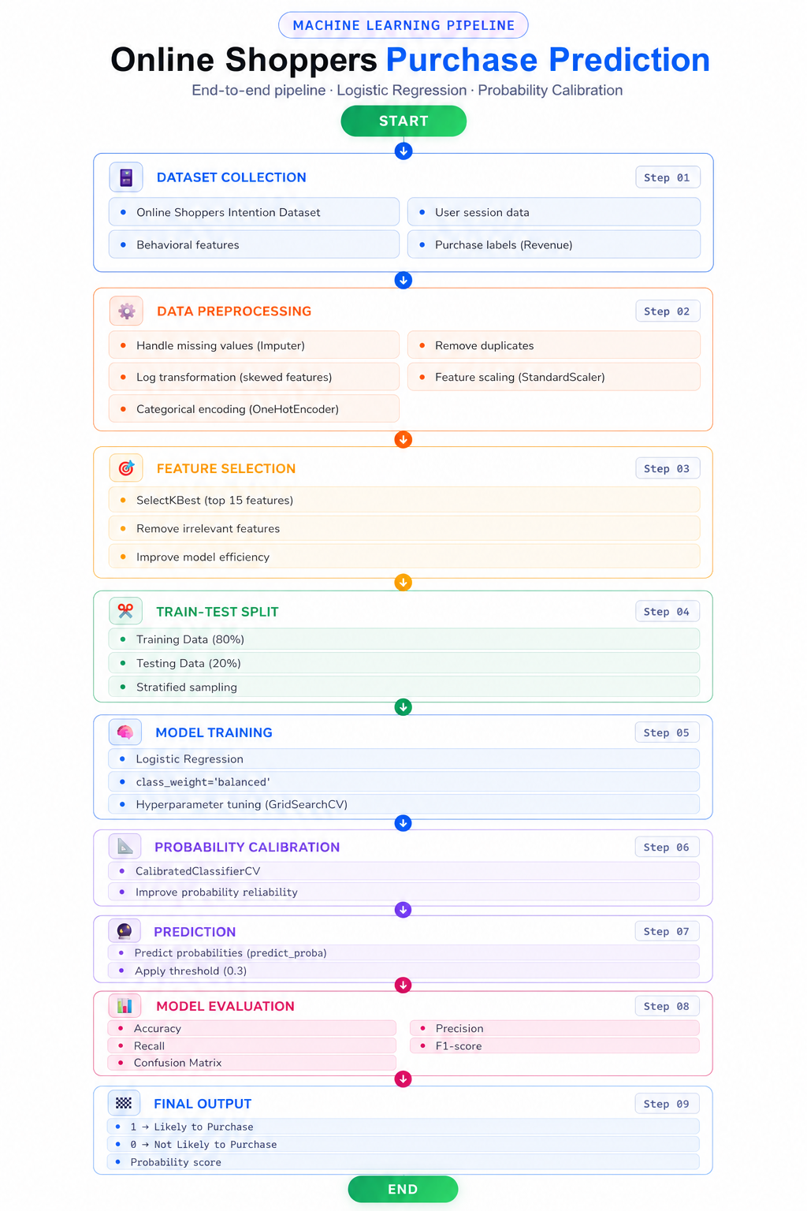

2. Modules for Project Implementation

2.1 Modules Used(mention all the inbuilt/ custom modules used and the purpose)

1. Pandas
Used for data manipulation and handling structured datasets.
Functions used:
- read_csv() – to load dataset
- DataFrame() – to create user input

2. NumPy
Used for numerical operations and transformations.
Functions used:
- log1p() – for log transformation

3. Scikit-learn
Used for machine learning tasks.

a) Preprocessing:
- SimpleImputer – handle missing values
- StandardScaler – feature scaling
- OneHotEncoder – categorical encoding
- FunctionTransformer – log transformation

b) Feature Selection:
- SelectKBest – selects top important features

c) Model:
- LogisticRegression – classification model

d) Model Optimization:
- GridSearchCV – hyperparameter tuning
- CalibratedClassifierCV – probability calibration

e) Pipeline:
- Pipeline – combine steps
- ColumnTransformer – apply transformations

4. Matplotlib / Seaborn
Used for visualization (correlation heatmap, confusion matrix)

5. Pickle
Used to save and load trained model

2.2 Platform Used: (mention all the platforms with the reason of using it)
  - Visual Studio Code: For code writing, testing, and debugging.
VS Code is equipped with multiple extensions, debugger which enhance the development experience.
  - Jupyter: Jupyter Notebook was used for model development, experimentation, and visualization.
  - Github : It was used for storing the code once finalized. To keep a track of our progress.

3. Machine Learning Model/ Searching Technique Used(Describe each ML model/ searching technique used)

1. Logistic Regression
Logistic Regression is a classification algorithm used to predict binary outcomes. It uses a sigmoid function to convert linear combinations of features into probability values.

2. K-Nearest Neighbors (KNN)
KNN is a distance-based algorithm that classifies a data point based on the majority class of its nearest neighbors.

3. Support Vector Machine (SVM)
SVM is a supervised learning algorithm that finds an optimal hyperplane to separate classes. It can handle both linear and non-linear classification.

4. Random Forest
Random Forest is an ensemble learning method that uses multiple decision trees and combines their outputs to improve accuracy and reduce overfitting.

“After comparing different models, Logistic Regression was selected as the final model because it provided a good balance between performance, interpretability, and recall for the minority class.”

Improvements Applied :
- Class Imbalance Handling: Used class_weight='balanced' to give more importance to minority class (buyers).
- Hyperparameter Tuning: Applied GridSearchCV to find optimal values of C, penalty, and solver.
- Probability Calibration: Used CalibratedClassifierCV to improve reliability of predicted probabilities.
- Threshold Optimization: Reduced threshold from 0.5 to 0.3 to improve recall for detecting buyers.

Model | Accuracy | Recall (Class 1) | F1 Score | Observation
Logistic Regression | ~0.88 | 0.79–0.82 | ~0.68 | Best balance, high recall
KNN | ~0.90 | ~0.59 | ~0.64 | High accuracy, poor recall
SVM | ~0.88 | ~0.79 | ~0.68 | Similar to Logistic but more complex
Random Forest | ~0.89 | ~0.57 | ~0.63 | Poor minority detection

- Evaluation metrics used (Describe each evaluation metric used along with formulae)

1. Accuracy
Accuracy measures how many predictions made by the model are correct overall.
Accuracy= (TP + TN) / (TP + TN + FP + FN)

2. Precision
Precision measures how many of the predicted positive cases are actually correct.
Precision= TP / (TP + FP)

3. Recall
Recall measures how many actual positive cases the model correctly identifies.
Recall= TP / (TP + FN)

4. F1 Score
F1 Score is the harmonic mean of precision and recall.
F1= 2 × (Precision × Recall) / (Precision + Recall)
F1= 2TP / (2TP + FP + FN)

5. Confusion Matrix
Confusion Matrix is a table used to evaluate the performance of a classification model by comparing actual and predicted values.
[TN FP
FN TP]
Where:
- TP = True Positive (correctly predicted buyers)
- TN = True Negative (correctly predicted non-buyers)
- FP = False Positive (wrongly predicted buyers)
- FN = False Negative (missed buyers)

Recall was prioritized since detecting buyers is more important than overall accuracy.

5. Results and Visualizations

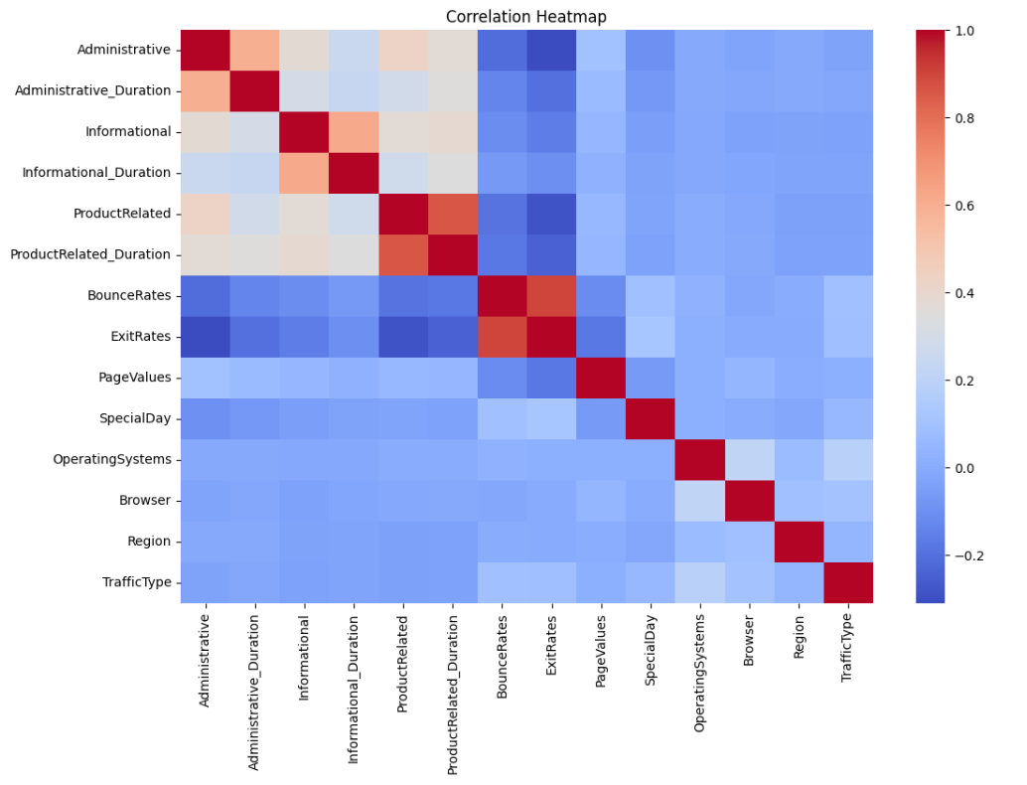

Fig.1 Heatmap showing corelation.

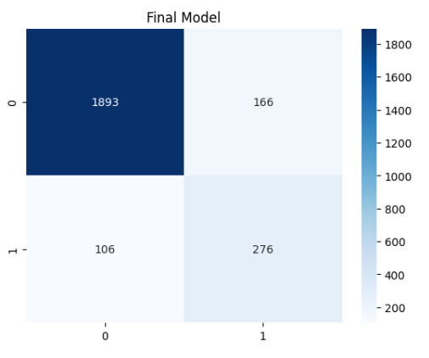
Fig.2 Confusion matrix

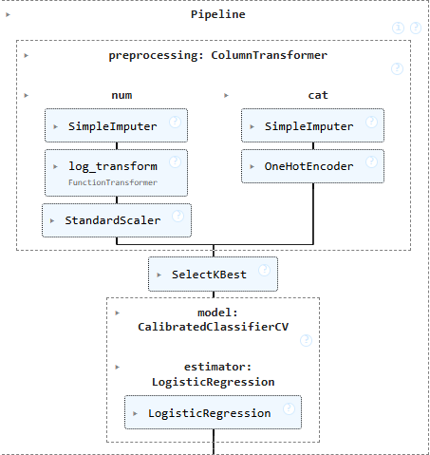
Fig.3 Pipeline

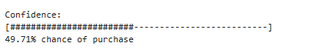

Fig.4 Probability bar

6. Conclusion and Future Scope:

In this project, a Logistic Regression model was developed to predict whether an online user will make a purchase. Various techniques such as data preprocessing, feature selection, hyperparameter tuning using GridSearchCV, probability calibration, and threshold optimization were applied to improve model performance. The final model achieved good accuracy while significantly improving recall for the minority class, making it effective in identifying potential buyers.

The system can be further enhanced by integrating advanced models such as XGBoost or Neural Networks for better performance. It can also be deployed as a real-time web application to assist businesses in decision-making. Additionally, incorporating more user behavior data and improving feature engineering can further increase prediction accuracy.
Further improvements can be made by implementing model explainability techniques such as SHAP or LIME to understand the impact of each feature on predictions. This will help businesses gain better insights into customer behavior.
Additionally, the system can be scaled to handle large datasets using distributed computing frameworks and can be integrated with cloud platforms for real-time analytics. Continuous model retraining using new data can also be implemented to keep the model updated with changing user behavior.
Finally, incorporating recommendation systems and user segmentation techniques can enhance the system’s ability to target specific customer groups and improve overall business outcomes.

References:

Books:
- Let Us Python – Yashavant Kanetkar
- Hands-On Machine Learning with Scikit-Learn, Keras, and TensorFlow (3rd Edition, 2022)

Online Resources:
  - GeeksforGeeks – https://www.geeksforgeeks.org/
  - TutorialsPoint – https://www.tutorialspoint.com/cprogramming/index.htm
  - Stack Overflow – https://stackoverflow.com
  - ClaudeCode - https://claude.com

