CTSCONNECT SSL VPN OPERATION MANUAL

Version 1.0



Single Point of Contact (SPOC) for any VPN related issues are as below.
IT IS Cloud Network Team -- 02267786379 / 86632

Table OF Contents

- INTRODUCTION
- FIRST TIME AUTHENTICATION PROCEDURE
- CONNECTION PROFILE CREATION
- HOW TO CONNECT SSL VPN

INTRODUCTION

  - Purpose

The purpose of this document is to provide guidelines on how to effectively setup and login to SSL VPN Service

  - Scope

The operation guidelines applies to all SSL VPN Users and Delivery Team used to connect to Cloud Services

  - Pre-requisites

- Ensure that Admin Rights are available for first time installation for Fortissl VPN plug-in and FortiClient SSLVPN. This is required for first time setup and use an Open Internet connection for Installing the plugins and FortiClient SSL VPN.

- Ensure to enable pop-up blockers when asked in the browser

- Ensure that you have Mozilla Firefox installed on your PC as it is the preferred Browser.It works with Safari and Internet Explorer too, but best results observed with Mozilla.

- Google Chrome is no longer supporting plug-ins for Fortigate SSL Client (Vendor Restriction)

- Ensure that you do not close or refresh the browser window or tab after connecting VPN since it will disconnect the VPN

- Ensure that you do not refresh the Welcome to SSL VPN page/tab after connecting to VPN else connection might be disconnected.

- Clear browser cache and history before connecting to SSL VPN.

FIRST TIME AUTHENTICATION PROCEDURE
Step 1:

Click on the below link in a browser (Mozilla preferred)

https://otp.ctsconnect.in

A New Page will open asking you to enter your VPN User-id.

Step 2:

After entering your User-id, click on Get OTP.

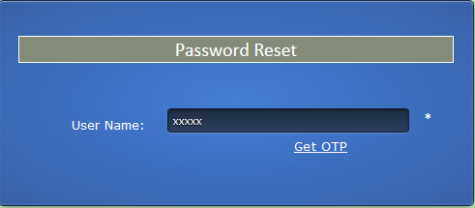

Step 3:
An auto-generated OTP will be sent to your email address provided at the VPN user-id registration.
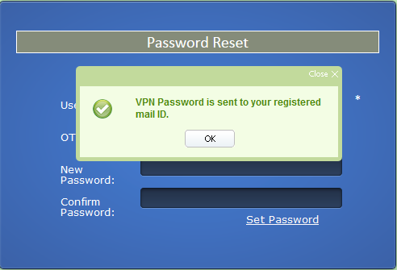

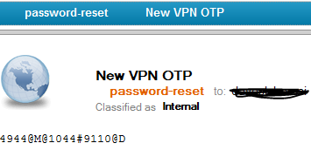
Step 4:
Enter the OTP from your email-id and enter your new Password that you want to set.
Click on Set Password
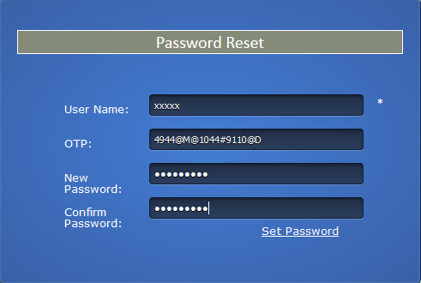
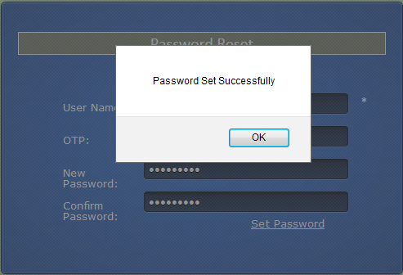

CREATION OF CONNECTION PROFILE

Step 1:

Once your Credentials are set go to dashboard and search Forticlient.
Launch Forticlient.

Step 2:
Go to settings

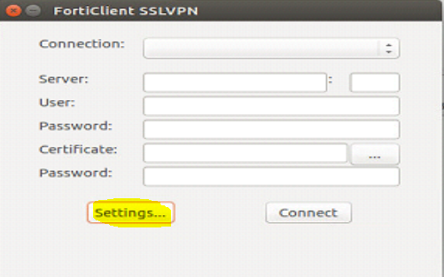

Step 3:
Below window will appear
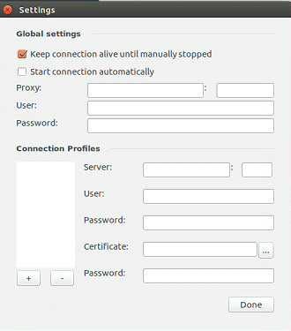

Step 4:
Click on + button
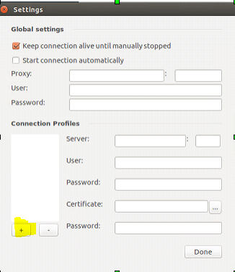
Step 5:
Enter Connection name : ION Exams
Server: www.ctsconnect.in/tcsri
port : 443
also enter your user id and password and click on create
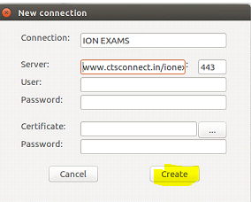

Step 6:
Click on Done

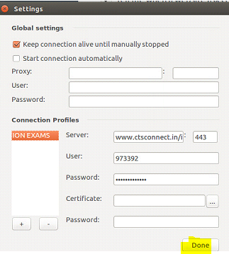
Connection Profile creation Completed.

How to Connect SSL VPN

Step 1: Launch Forticlient from dashboard.
Choose the Connection profile as ION Exams and click on Connect.
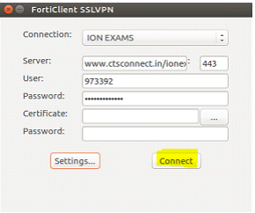

Step 2:
Click on Continue, if this window appears.
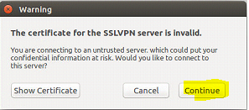

Step 3:
Click on connect if this window appears after step 2, otherwise you are connected.

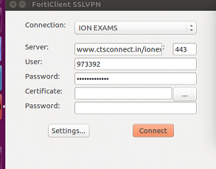

Step 4: Once you are connected , you will get this window.

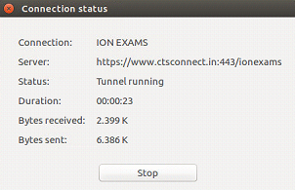

Now you can open urls in the browser.
NOTE: Make sure that you are connected to the vpn while accessing ION urls. After getting connected to the vpn don't close the tab or refresh vpn window . Open new tab, or minimize the browser to access other urls.
Important Step: Always clear browsing history and cache before connecting to VPN.

