PUBLIC FINANCE COURSE PROJECT

Pradhan Mantri Jan Dhan Yojna[PMJDY]

Guided by: Professor Rama Pal

Submitted by:
Group 7
Sharang Mantri(18B080022)
Aryan Golania (18B080005)

Introduction

PMJDY was announced by the Prime Minister on 15th August 2014. It was launched on 28th August 2014 across the country. It is a mission mode project of the Indian government.
- The scheme covers universal access to banking facilities with at least one bank account to each and every household of the country.
- It also includes the program of financial literacy, access to credit, pension and insurance facility.
- A facility to open zero balance account under PMJDY

PMJDY was executed in two phases:
Phase-I (15 Aug 2014 - 14 Aug 2015):
There were four primary objectives in phase-I.:
1) To ensure universal access to banking facilities throughout the country except for areas with infrastructure and connectivity constraints
2) To provide basic banking accounts and RuPay debit card.
3) To facility each account holder accident insurance cover of Rs one lakh.
4) To implement Financial Literacy Programme

Phase-II (15 Aug 2015 - 14 Aug 2018):
The objectives for Phase-II are listed below:
1) To ensure overdraft facility up to 5000/- after six months of satisfactory operation of the account.
2) To create a credit guarantee fund for coverage of defaults in overdraft accounts.
3) To promote micro finance schemes.
4) To cover geographical areas left in phase1 due to infrastructure and connectivity problems.
5) To promote financial inclusion programs up to individual level covering adults and students of each household.

Need of PMJDY
Creating a platform for inculcating the habit to save money - The lower-income section of the society has been living under the persistent shadow of financial duress largely because of the absence of savings, which makes them vulnerable and therefore the presence of banking products and services are necessary to inculcate the habit to save. This is expected to boost the capital formation in the country, once financial inclusion measures materialize it leads to a shift from traditional modes of investing their savings in land, billions and buildings etc.

Facilitates access to formal credit avenues - Until now the unbanked population has been vulnerably relying on informal channels of credit like family, friends and moneylenders. To foster the entrepreneurial spirit among the masses in order to increase output and prosperity in the country there is a strong need for adequate and affordable credit from the formal credit avenues. And the micro-finance sector is the best example of what affordable availability of credit can do for the vulnerable and poor people.

Fills the gaps and leaks in public subsidies and welfare programmes -A substantial sum of money that is meant for the poorest of the poor does not actually reach them. As this money passes through a large or lofty system of government bureaucracy much of it is generally believed to leak and is not able to reach the intended parties. Therefore, there is a strong need for direct cash transfers to beneficiaries' through their bank accounts rather than subsidizing products and making cash payments. As it is anticipated that this laudable effort will reduce the government's subsidy bill as it saves that part of the subsidy that is leaked and will provide the relief only to the real beneficiaries. And this is possible only when we have an efficient and affordable banking system that can be extended to all.

Agrarian nature of Indian economy- Financial Inclusion is necessary for India mainly due to the agrarian nature of the Indian economy and her huge population. People belonging to this sector suffer a lot due to high-interest rates, uncertain nature of agriculture, absence of sufficient agricultural insurance services, rising production costs and an exorbitant amount of interest paid by them to traditional moneylenders. And these are the primary reasons that the banking sector is also looked upon with suspicion by agriculturists as they have been looking at moneylenders through ages. It was, therefore, important to put a better picture of the banking industry before them to break their perceived notions about this sector.

Failure of Previous Schemes- Old Approach called Swabhimaan was not very efficient in tackling the above-mentioned points

Financial Inclusion and Social Change

"Financial inclusion" is as essential as "social inclusion". Masses in our society are excluded from fair treatment both from the civilized social institutions and from the financial institutions. Financial inclusion has a multiplier effect on society. As it helps to decreases social-economic
disparities create financial assets, promotes area development and provides new work opportunities across all sectors and sections of the economy. And helps in striking a balance by channelizing the surplus to deficit units and brings the poor and disadvantaged one under the growth allegory. The concept —Inclusion should be perceived as a process of encompassing the excluded as medium or agents whose involvement is crucial in designing the development process, and not simply as welfare targets of the development programme. Financial inclusion has two major objectives:

Economic Objectives
Equitable Growth
Mobilization of Savings
Larger Markets for the Financial
System
Effective Direction of Government Programmes

Social and Political Objectives
Sustainable Development
Poverty Alleviation
Effective Direction of Government
Programmes
Wider Inclusion in Society

Financial inclusion is a crucial stepping stone in the direction of inclusive growth. It helps in the overall economic development of the disadvantaged population. Literacy, health and communication are some of the important factors required for inclusive growth. Financial inclusion is also seen as the business opportunity for the formal financial institutions as it assists them in penetrating into the unbanked region and thereby reaping or earning profit. Besides this banks and developmental authorities also play a major role in developing the supportive infrastructure, both physical and social. So basically, the four pillars of inclusive growth are productivity, employment, financial inclusion and infrastructure development.

Financial inclusion enables improved and better social development, in an equitable manner across the country. It enables empowerment of the underprivileged and poor, including women, with the mission of making them self-sufficient and well informed to make better financial decisions. The main purpose of financial inclusion is to make certain that there is universal access to varieties of financial services such as credit insurance and pensions, savings and payment account etc. And also to provide services for business opportunities, education, savings for retirement and insurance against risks including emergency loans. While the rural people require these banking services the most but they remain left out. So, ensuring their financial inclusion can unlock the significant economic potential of a rural region.
Thus, the fundamental objective of financial inclusion is improving the
the living condition of rural masses and rural nonfarm enterprises by providing financial services at an affordable cost to the marginalized and disadvantaged section of the society.

According to the UNDP report "Seventy-five per cent of the world's poor live in rural areas and the majority of them are women". Women can significantly contribute to the development of the economy, and hence, therefore they should be empowered. Women's empowerment is the key to the socio-economic development of the community. Bringing women into the mainstream of national development has been a major concern of the government. If we empower the women through financial inclusion programmes, automatically they will empower themselves in socio-economic and political areas.

Financial inclusion is an approach to alleviate poverty. The major cause of poverty among people in the rural area is the lack of productive assets and financial resources. The informal financial system is widely available especially in a rural area for accessing the financial services to fulfil their basic requirement. They have to pay more interest on availed credit from informal financial resources, Hence, they move towards poor to poorer condition. It alone cannot bring people out of poverty; it can help people build better lives. Financial inclusion helps individuals to commence new businesses, and help smaller businesses into larger ones. And also help small and marginalized farmers tap into the formal economic system for a two-way flow of information and income. As an outcome, the whole economy can grow more rapidly and in a manner which is more helpful or beneficial to poor people. In this manner, financial inclusion can play an effective role in eradicating poverty and vulnerability. So the Financial inclusion leads to human development in terms Of socio-economic factors, income, literacy, equality, urbanisation, infrastructure and connectivity agriculture and other priority sectors.

Benefits of PMJDY to Public

- Banking accounts with RuPay debit card with the provision of overdraft facility: The primary aim is to open a basic account of each household in the country. A RuPay debit card is also provided with each account. There is also a provision of over-drafting up to Rs 5000 after successful operating debit card for a period of 6 months with a nominal interest rate on overdraft money. It also acts like a microfinance scheme.

- Financial literacy programme: Being the majority of villagers with lack of education PMJDY also runs a financial literacy programme. The main aim of such a program is to make people aware and capable of using financial services provided by banks.

- Zero Balance Requirements: To open a Jan Dhan account is free of cost and does not require any amount to be deposited initially. Most savings bank accounts require an initial deposit to open a bank account and also a minimum balance to be maintained on a monthly or quarterly basis. But with a Jan Dhan account, these requirements are done away with so that anyone can open this account even if they do not have money to deposit right away.

- Mobile Banking: Mobile banking is a very important feature of the Pradhan Mantri Jan Dhan Yojana. This facility is not designed for smartphones but rather any mobile phone. The aim of this is to ensure people from the rural and unorganised sectors have access to their bank accounts and certain facilities that will provide convenience to the account holders. This feature will help achieve the objective of financial inclusion and provide financial security to many. The mobile banking feature allows account holders to transfer money from their phone and also withdraw money without an ATM card.

- Personal Accident Insurance: The scheme also provides for personal accident insurance under the following conditions: The Rupay cardholder must have performed at least one financial transaction successfully within 90 days from the date of the accident. Non-financial customer-induced transactions will also be included. Transactions should be carried out at any bank branch, Bank Mitra, ATM, POS, or E-com channel.

- Access to Pension Schemes: Holding a Jan Dhan account will provide easy access to pension schemes available from the government. It is important for every citizen to start saving even a small amount to ensure a dignified old age.

- Other Benefits
Apart from the above listed standard benefits of the scheme, the Yojana also offers the following benefits for the entire nation to progress.

Pradhan Mantri Jan Dhan Yojana is proving instrumental in reducing the dependency of farmers on local money lenders. This is one of the topmost reasons for farmers getting stuck in a vicious circle of debt. Loan and overdraft facility linked with this account will allow farmers to avoid borrowing from small money lenders who have no formal account-keeping processes and are known to indulge in fraudulent transactions to extract higher payments from borrowers.

Under the Pradhan Mantri Jan Dhan Yojana, at the time of account opening, customers will be handed over a kit that includes account passbook, cheque book as well as a financial literacy guide. However, the contents of this kit might differ from one bank to another, too.

The scheme also helps enlighten a majority of the unorganised sector of the benefits of banking and being included in the financial system.

Complementing the other Government Welfare Schemes: PMJDY also helps in enacting every government schemes that involve Direct Cash Transfer (Atal Pension Yojana (APY), Pradhan Mantri Awas Yojana (PMAY), Pradhan Mantri Fasal Bima Yojana (PMFBY), Pradhan Mantri Ujjwala Yojana (PMUY) etc) to the beneficiary as the bank accounts opened through PMJDY act as a direct medium of cash transfer without involving any intermediaries thus reducing corruption
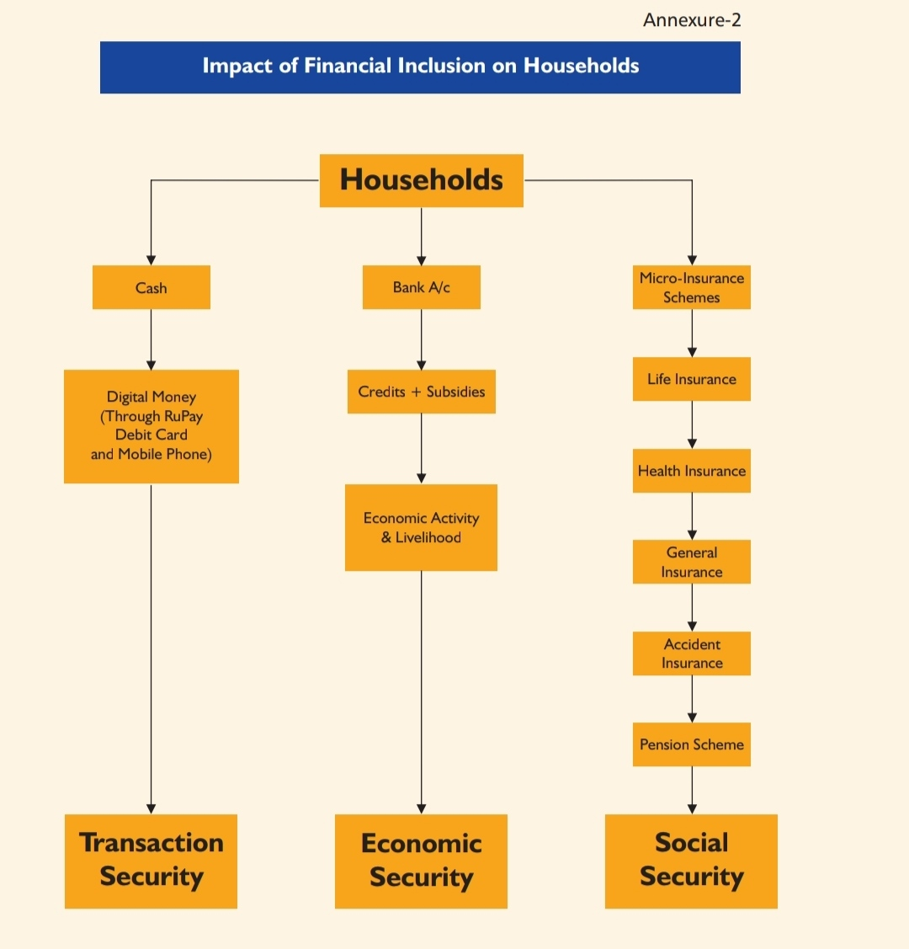

Growth and Achievements under PMJDY:
PMJDY Accounts-
The prime objective of launching this scheme was to open at least 75 million bank accounts but with the initial success this was changed and raised to 100 million accounts in November 2014 in order to bring all the households under the coverage area of banking services by January 2015. With the promising efforts of the government the scheme resulted in opening of more than 100 million accounts much before deadline
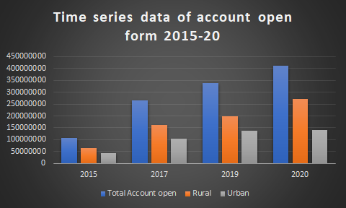

From the above graphit can be clearly revealed that rural areas were under the prime focus As of Nov’ 2020 41.25 crore account has been opened out of which 63.6% account for Rural area and 55,2% for women
It can been seen that total number of accounts has increased by 380%from 2015 to 2020

Operative PMJDY Accounts-
As per the RBI guidelines, a PMJDY account is treated as inoperative if there are no customer induced transactions in the account for around a period of two years. In 2020 out of 41.25 crore PMJDY account, 34.81 crore that is 86.3% are found operative
There is a Continuous increase in % of operative accounts, it indicate that more number of these accounts are being used by customers on the regular basis

Rupay Card issued to PMJDY account holders-
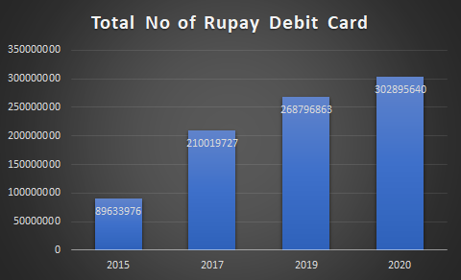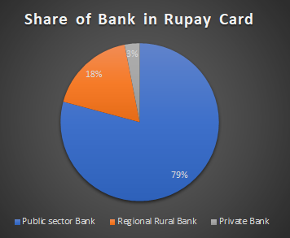

It was seen that The total number of Rupay Debit Card issued under this scheme increased from 9.5 crores in 2015 to 30 crores in 2020 The Figure clearly depicts that out of the total number of Rupay Debit Card issued under this scheme 79 percent were issued by Public Sector Banks followed by Regional Rural Banks (16 percent) and the private banks (4 percent)
The number of RuPay cards & their usage has increased over time

Deposits under PMJDY accounts-
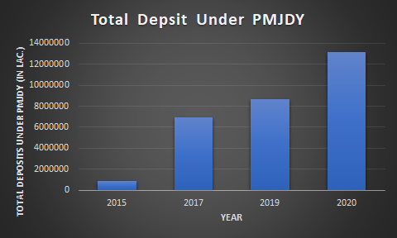

The progress of This scheme can be evidenced from the total deposits that has been made in the accounts opened. The graph depicted upsurge in the total deposits to Rs. 1.3 crore Lacs in 2020 from Rs. 0.08 crore Lacs in 2015. Deposits have increased more than 5.7 times with an increase in accounts 2.3 times from Aug’15 to Aug’20 . This result also brought our attention toward a matter of concern that around 60 percent of the total accounts opened are Zero Balance Accounts and pointed towards a need to convert these accounts into active accounts in times to come.

On the Positive note Due to the efforts of the government and cooperation from the account holders, the accounts with zero balance declined to 25 percent of the total number of accounts opened in 2017 and 75 percent of the total number of accounts were opened with deposits
Average Deposit per PMJDY account-
As of 2020 average deposit per account is Rs. 3239 which has increased over 2.5 times over since Aug’15. This increase in average deposit is a positive indication of increased usage of accounts and inculcation of saving habits among account holders.
Jan Dhan Darshak App
A mobile application was launched with the objective to provide a citizen-centric platform for locating banking touchpoints such as ATMs, Post Offices,Bank Mitras, etc. in the country. Over 8 lakh banking touchpoints have been mapped on the GIS App.

Way Ahead:.
- Government is trying to promote the digital payments system including RuPay debit card usage amongst PMJDY account holders through the creation of acceptance infrastructure across India
- Government is planning to Improve the access of PMJDY account holders to Microcredit and micro-investment such as Flexi-recurring deposits etc.
Inefficiency in policy -
No doubt this is the most successful financial inclusion programme introduced by the government of India. But there are some barriers or drawback of this,we have to overcome them to fulfill the objective of this scheme
- The whole scheme is generally financial literacy oriented therefore there should be a proper training camp sessions for the Bank Correspondents (Bank Mitra) as they are the middlemen of the scheme as well as one of the crucial factors too. One of the biggest faces by the government is lack of financial literacy. People are still not aware of less interest rate on credit given by banks, use of debit card and online transitions
- Lack of a proper identity card and poor financial status are also main reasons that avoid people from joining with this scheme
- Possibility of multiple accounts-it is quite possible that multiple accounts has been opened by single people in different banks either due to unawareness or by greed. Although the scheme is very clear in providing single benefit to one person only, irrelevant to the multiple bank accounts opened by him. Banks can overcome this problem by establishing a single information sharing system to weed such multiple accounts.
- The key factor for successful implementation of this scheme is in the hands of banks;but at present we don't have enough skilled man power and technology therefore it’s a great challenge for every nationalised bank as they will need more manpower, technology and better risk management techniques.
- Telecom Connectivity- In India nearly 10% of the village (55000) does not have telecom connectivity . it is nearly impossible to connect them with banking facility on those area so , government is still not able to make PMJDY account of people leaving in those areas
- One of the great challenges the government is facing is to keep those accounts functional .It takes a lot of effort to convince and open a bank account of new customers, but if the account becomes dead means no transition takes place then there is no outcome of the project. Until people feel the importance of saving and banking product it is very difficult to keep accounts live
- The scheme gives a free accident insurance cover worth Rs. 1 lakh to the every single account holder, the holder must use the Rupay debit card at least once every 45 days which is quite difficult for remote tribal areas even after the presence of Bank Correspondents.

Conclusion
Pradhan Mantri Jan Dhan Yojana is one the most featuring schemes till now, the scheme justifies itself on basic grounds which are to promote financial literacy, universal access to banking facilities and providing various financial services as well as on promoting savings. The scheme is definitely a great help for those weaker sections of society, who have an ability to save. It is a far sighted and long term scheme which still needs great management in terms of banking services as Banks are the backbone of every economy, any mismanaged government plan will make them suffer. Growth of this scheme will help the other developmental schemes of the government of India, for instance digital India, skill India and the union budget of 2016- 17 itself which focuses mainly on agriculture and infrastructure. The widely acknowledged & successful launch of this PMJDY scheme also strengthens the resolve that when coordination, dedication, opportunism, commitment, formalization, dependence, trust, satisfaction, cooperation and continuity is provided by all the constituents and stakeholders, a framework of construct is created which acts as a dominant force for accomplishment of the mission.

Bibliography
- https://docs.google.com/spreadsheets/d/1T7Wa1kHbR_DF2QDBB0--fPHtumhZjLnTDd9vSaqGLoI/edit?usp=sharing
- https://pmjdy.gov.in/
- (PDF) Pradhan Mantri Jan Dhan Yojana: A Step forward to Financial Inclusion (researchgate.net)
- (PDF) Progress of Financial Inclusion in India and Pradhan Mantri Jan Dhan Yojana (PMJDY)-Critical Appraisal (researchgate.net)
- (PDF) Pradhan Mantri Jan Dhan Yojana (PMJDY):A Step towards Eradicating Financial Untouchability (researchgate.net)
- http://qtanalytics.in/journals/index.php/HIPA/article/view/525/361
- https://www.bankbazaar.com/saving-schemes/how-is-pradhan-mantri-jan-dhan-yojana-beneficial.html
- https://cracku.in/blog/list-of-all-schemes-of-indian-government-pdf/
- https://pmjdy.gov.in/files/E-Documents/PMJDY_BROCHURE_ENG.pdf
- https://facelesscompliance.com/tag/achievements-under-pmjdy

