Problem Set 3
Total 15 points
Due Monday, March 3rd, 2025 before 11:59pm

Instructions: This is a GROUP assignment.

I think it makes sense to submit an excel spreadsheet if you work with excel/VBA, a word document or notebook with embedded figures if you use R/Python.

(a) Only submit one assignment per group but make it very clear who the group members are.
(b) The file name should be: PSn.FAMILYNAME1Initial1_FAMILYNAME2Initial2….xls,
for example my solution to Problem set 1 would have the file name PS1.WIDDICKSM.xls.
(c) Please make sure that your solutions are well-organized and clear, with appropriate text, explanations, and formatting. If I cannot figure out what you did, then what you did is wrong.

American Put Option Valuation [5 points]

Consider an American put option where S₀ = 100, K = 105, r = 0.04, δ = 0, σ = 0.25 and T = 1.

- Calculate the value of the American put option to within $0.000001 (using any binomial model you like), to do this you should use more and more timesteps (this should be lots, e.g 9999 or 10001 for LR) until you are happy that you have converged to the correct value.

We will compare the performance of the following binomial lattice methods.
- Cox, Ross and Rubinstein, 1979 (You have code for this from PS2)
- Leisen and Reimer, 1996 (You have code for this from PS3)
- !NEW! Broadie and Detemple, 1996 (see Lecture 5 notes)

For each model perform the following,

- Calculate the value of the American put option for time steps ranging from N = 50 to N = 1000. Plot a graph of N (x-axis) against error (y-axis) when compared to your answer from a. Explain the graph you obtain.

- For the CRR model, with N = 100, plot out the position of the early exercise boundary on a graph with time on the x-axis and the boundary level on the y-axis. (The exercise boundary is the value of S, S_{f}, at which you exercise at S_{f} and below and hold above S_{f}). Do you think that the boundary you obtain looks correct compared to the true (non-binomial) boundary? Do you think this will have any effect upon the accuracy of your option value?

Continuous barrier options (trigger securities) [5 points]

Consider a down-and-out call option where S₀ = 100, K = 100, B = 95, r = 0.1, δ = 0, σ = 0.3 and T = 0.2 – NOTE THE CHANGE IN PARAMETERS The down-and-out call is a barrier option where you receive max(S_{T}-K,0) at expiry but if at any time before expiry S_{t} < B the option expires worthless.

The analytic formula is given by:
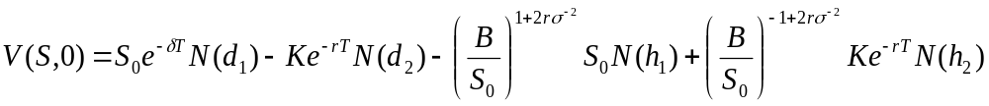
where d₁ and d₂ are as in the Black-Scholes formulae and
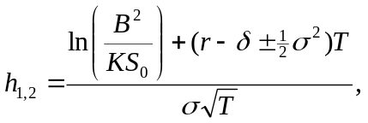

We will now analyse the performance of just the Leisen and Reimer, 1996 model:

- Calculate the value of the Down-and-out call option for time steps ranging from N = 50 to N = 1000 and plot a graph of N (x-axis) against error (y-axis) when compared to the analytic price and explain the graph you obtain.
- Can you explain the error profile that you observe? It may be useful to try to plot the position of the nodes relative to the barrier (as in the Lambda graph in class) to understand what is happening in this question.
- Can you think of anyway of improving the convergence to the correct value? [I’m looking for ideas here rather than calculations but these may be useful for future valuations]

Discrete Barrier options (Autocall products) [5 points]

Consider a discrete down-and-out call option where S₀ = 100, K = 100, B =95, r = 0.1, d = 0, σ = 0.3 and T = 0.2 only now the barrier is only applied on 4 dates, at t = 0.04, 0.08, 0.12 and 0.16 [Note that it can be difficult to get your code to do this due to problems of real numbers/integers etc.].
This is a discretely monitored barrier option and does not have an analytic formula but following the methods in Kou (2008), the accurate value is 5.6711051343.

We will now analyse the performance of the Leisen and Reimer, 1996 model::

  - Calculate the value of the discrete Down-and-out call option for time steps ranging from N = 50 to N = 1000 in steps of 10 (i.e 50, 60, 70, …) to ensure that the barrier times are always matched by a tree step and all the barrier steps are even numbers. Plot a graph of N (x-axis) against error (y-axis) when compared to the analytic price and explain the graph you obtain.
  - Plot the position of the nodes relative to the barrier (as in the Lambda graph in Lecture 4). When does it appear that the tree gives the most accurate option values?

