JOB PORTAL WEBSITE
Technologies Used: React, Spring Boot, MongoDB, Redux, Tailwind, Mantine, Tabler Icons

Highlighted Features:
- Notification System
- Sending OTP via email.
- Securing APIs using JSON Web Token (JWT)
- Protected routes according to roles.
- Responsiveness
- Animations

1. User Registration and Authentication
- User Registration
  - As a user, I want to register an account using my email and a password.
  - As a user, I want to register an account using my social media accounts (Google, LinkedIn).
- User Login
  - As a user, I want to log in using my email and password.
  - As a user, I want to log in using my social media accounts (Google, LinkedIn).
- Password Management
  - As a user, I want to reset my password if I forget it.
  - As a user, I want to change my password after logging in.

2. User Profile Management
- Profile Creation and Editing
  - As a user, I want to create and update my profile with personal details, contact information, and a profile picture.
- Resume Management
  - As a user, I want to upload my resume in PDF or DOC format.
  - As a user, I want to update or delete my uploaded resume.
- Skills, Certifications, and Work Experience
  - As a user, I want to update my skills, certifications, and work experience in my profile.

3. Job Search and Application
- Job Search
  - As a user, I want to search for jobs using keywords, location, and job categories.
  - As a user, I want to filter job search results by company, experience level, salary range, and job type (full-time, part-time, contract).
- Job Details
  - As a user, I want to view detailed information about a job, including the company, job description, requirements, and application deadline.
- Job Application
  - As a user, I want to apply for jobs directly through the portal by submitting my resume and a cover letter.
  - As a user, I want to track the status of my job applications.

4. Employer Functionality
- Job Posting
  - As an employer, I want to create, update, and delete job postings.
  - As an employer, I want to set the visibility of job postings (public, private).
- Applicant Management
  - As an employer, I want to view and manage applications for my job postings.
  - As an employer, I want to contact applicants directly through the portal.

5. Notifications and Alerts
- Job Alerts
  - As a user, I want to receive email notifications for new job postings that match my search criteria.
- Application Status Notifications
  - As a user, I want to receive email notifications about the status of my job applications.

6. Additional Features
- Saved Jobs
  - As a user, I want to save job postings to view and apply for them later.
- Company Profiles
  - As a user, I want to view detailed profiles of companies, including their description, location, and current job postings.
- User Dashboard
  - As a user, I want to have a dashboard that summarizes my recent activity, such as saved jobs, applied jobs, and recommended jobs.
Theme
Dark:
App Background => #2D2D2D
'mine-shaft': { '50': '#f6f6f6', '100': '#e7e7e7', '200': '#d1d1d1', '300': '#b0b0b0', : '#888888', '500': '#6d6d6d', '600': '#5d5d5d', '700': '#4f4f4f', '800': '#454545', '900': #3d3d3d', '950': '#2d2d2d', },

Button => #FFD149
'bright-sun': { '50': '#fffbeb', '100': '#fff3c6', '200': '#ffe588', '300': '#ffd149',: #ffbd20', '500': '#f99b07', '600': '#dd7302', '700': '#b75006', '800': '#943c0c', '900': #7a330d', '950': '#461902', },
Font Family : poppins
LanDing Page
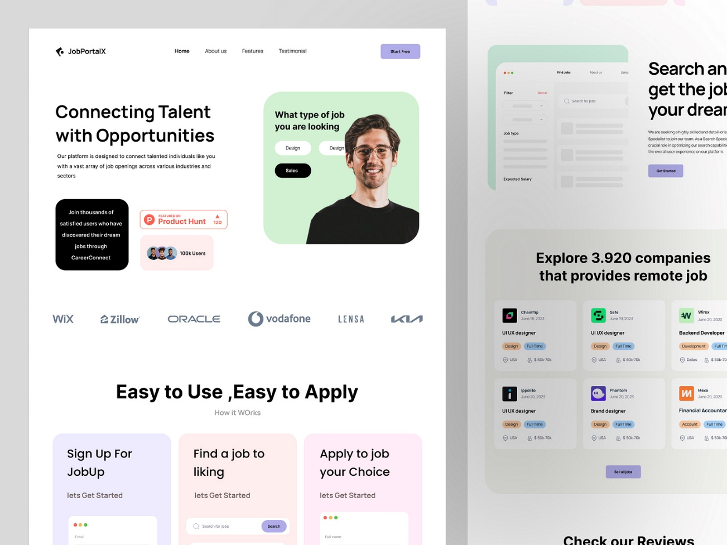
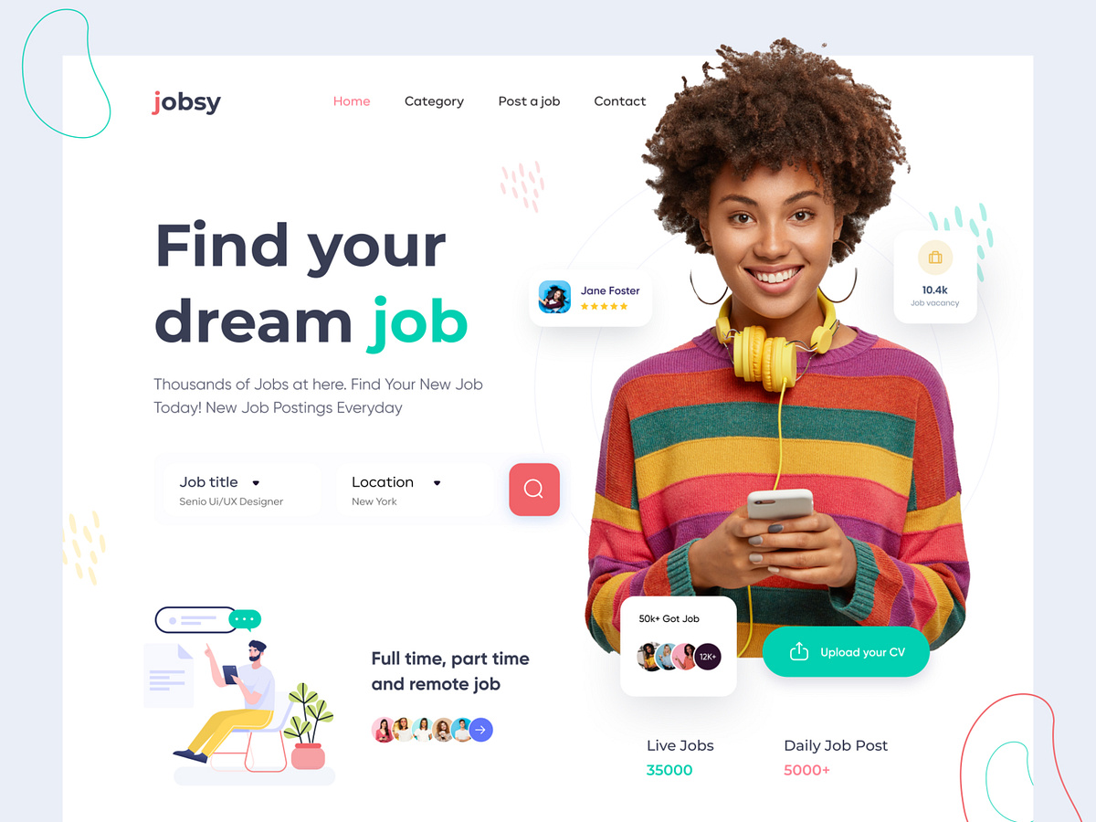
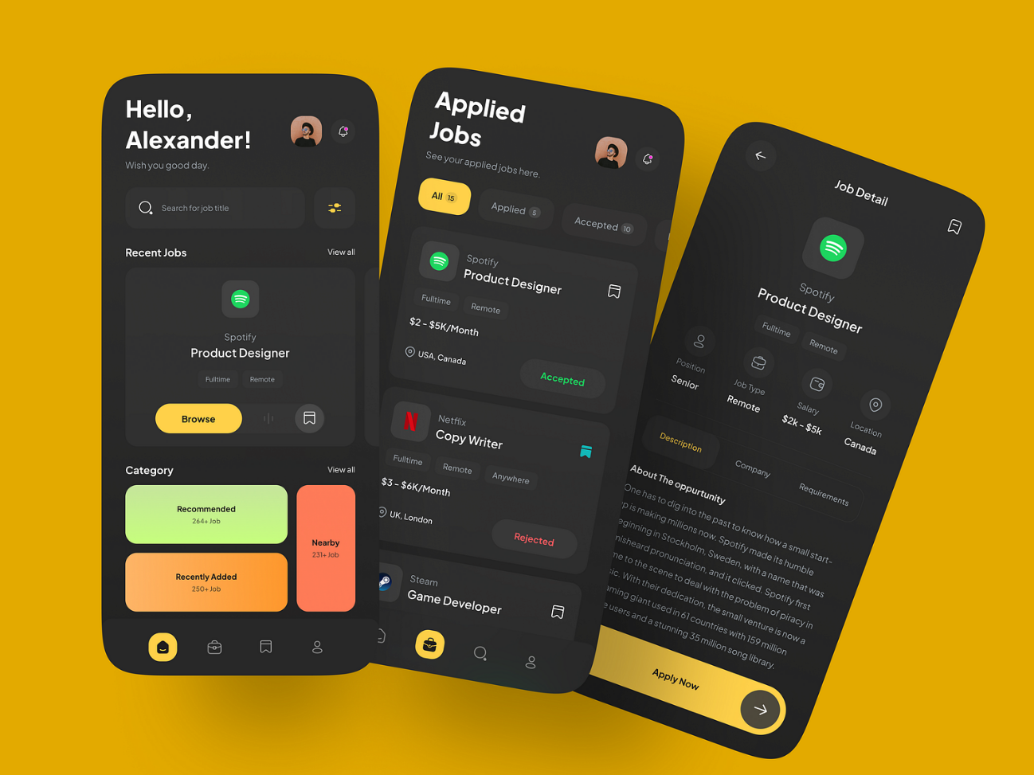
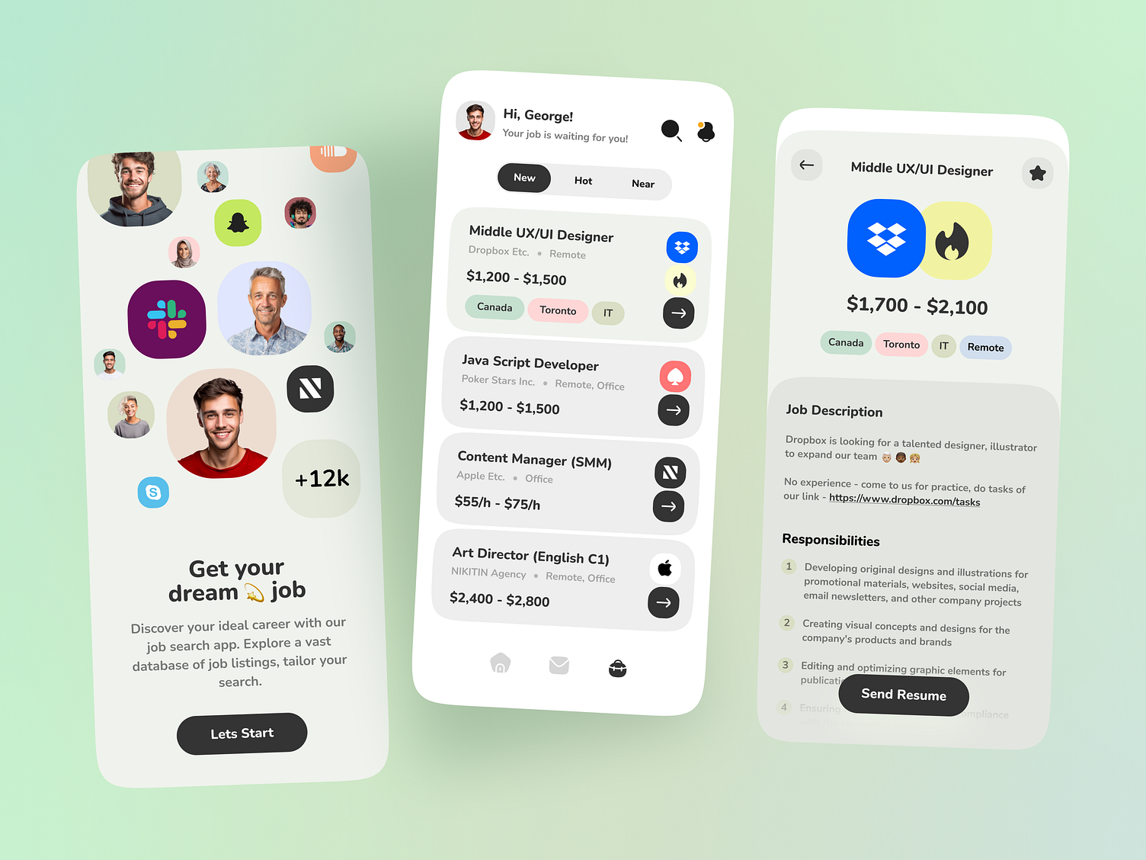
Find Job Page