WEB APPLICATION
SECURITY ASSESSMENT REPORT
Target: DVWA (Damn Vulnerable Web Application)
Supporting Target: Metasploitable2
TASK 3 — Days 25–36: OWASP Top 10 Vulnerability Lab
CONFIDENTIAL
For internal training / lab use only — Not for distribution

Document Control
Prepared By | Mantu Kumar
Role | Cybersecurity Intern
Organization | ApexPlanet Software Pvt. Ltd. (Internship Program)
Assessment Dates | 11 Aug 2026 – 15 Aug 2026
Report Date | 16 Aug 2026
Classification | Confidential
Target Application | DVWA v1.10 (Docker/Local install)
Target Host | http://127.0.0.1/DVWA/
Testing Environment | Kali Linux (attacker), Metasploitable2 (192.168.225.130)

1. Executive Summary
Between 11 and 15 August 2026, a controlled security assessment was carried out against DVWA (Damn Vulnerable Web Application) hosted locally at http://127.0.0.1/DVWA/, with Metasploitable2 used as a supporting lab target. The objective was to identify and practically exploit OWASP Top 10 vulnerability classes in a safe, isolated lab environment, and to document each finding with reproducible steps, evidence, and remediation guidance.
Testing was performed manually and with the assistance of Burp Suite Professional (Proxy, Repeater, Intruder) across DVWA's Low, Medium and Blind difficulty settings. Seven distinct vulnerabilities were confirmed, spanning SQL Injection, OS Command Injection, Cross-Site Request Forgery (CSRF), an Insecure CAPTCHA implementation, Reflected XSS, and weak/brute-forceable authentication.
All findings below were reproduced by the tester with request/response evidence. Because DVWA is intentionally vulnerable by design, these results validate the testing methodology and tooling rather than represent a real production risk — the same technique and evidence format is directly transferable to real-world engagements.

2. Scope & Methodology

2.1 Scope
- DVWA modules: SQL Injection, SQL Injection (Blind), Command Injection, CSRF, Insecure CAPTCHA, XSS (Reflected), Brute Force.
- DVWA Security Level: Low (primary), Medium (blind SQLi confirmation).
- Supporting target: Metasploitable2 (192.168.225.130) for environment/service reconnaissance.
- Out of scope: production systems, third-party infrastructure, denial-of-service testing.

2.2 Methodology
Testing followed the OWASP Testing Guide (OTG) approach and mapped findings to the OWASP Top 10 (2021). Each vulnerability class was tested manually first to confirm the underlying flaw, then validated / accelerated using Burp Suite (Proxy interception, Repeater for request replay, and Intruder for automated fuzzing).
- Tools used: Burp Suite Professional v2026.3.3, Firefox with FoxyProxy, Kali Linux, Hydra (reference).
- Approach: Reconnaissance → manual probing → payload crafting → exploitation → evidence capture → remediation mapping.

3. Summary of Findings
# | Vulnerability | OWASP Category | Severity | Status
1 | SQL Injection (Classic / UNION-based) | A03:2021 - Injection | Critical | Confirmed
2 | SQL Injection (Blind, Time-Based) | A03:2021 - Injection | High | Confirmed
3 | OS Command Injection | A03:2021 - Injection | Critical | Confirmed
4 | Cross-Site Request Forgery (CSRF) | A01:2021 - Broken Access Control | High | Confirmed
5 | Insecure CAPTCHA Implementation | A07:2021 - Auth Failures | Medium | Confirmed
6 | Reflected Cross-Site Scripting (XSS) | A03:2021 - Injection | Medium | Confirmed
7 | Weak Authentication / Brute-Forceable Login | A07:2021 - Auth Failures | High | Confirmed

4. Test Environment Setup
Metasploitable2 was used as a secondary lab target to validate reconnaissance and service-enumeration workflow alongside DVWA. Its landing page exposes several intentionally vulnerable services (TWiki, phpMyAdmin, Mutillidae, DVWA, WebDAV), consistent with its purpose as a deliberately insecure training VM.
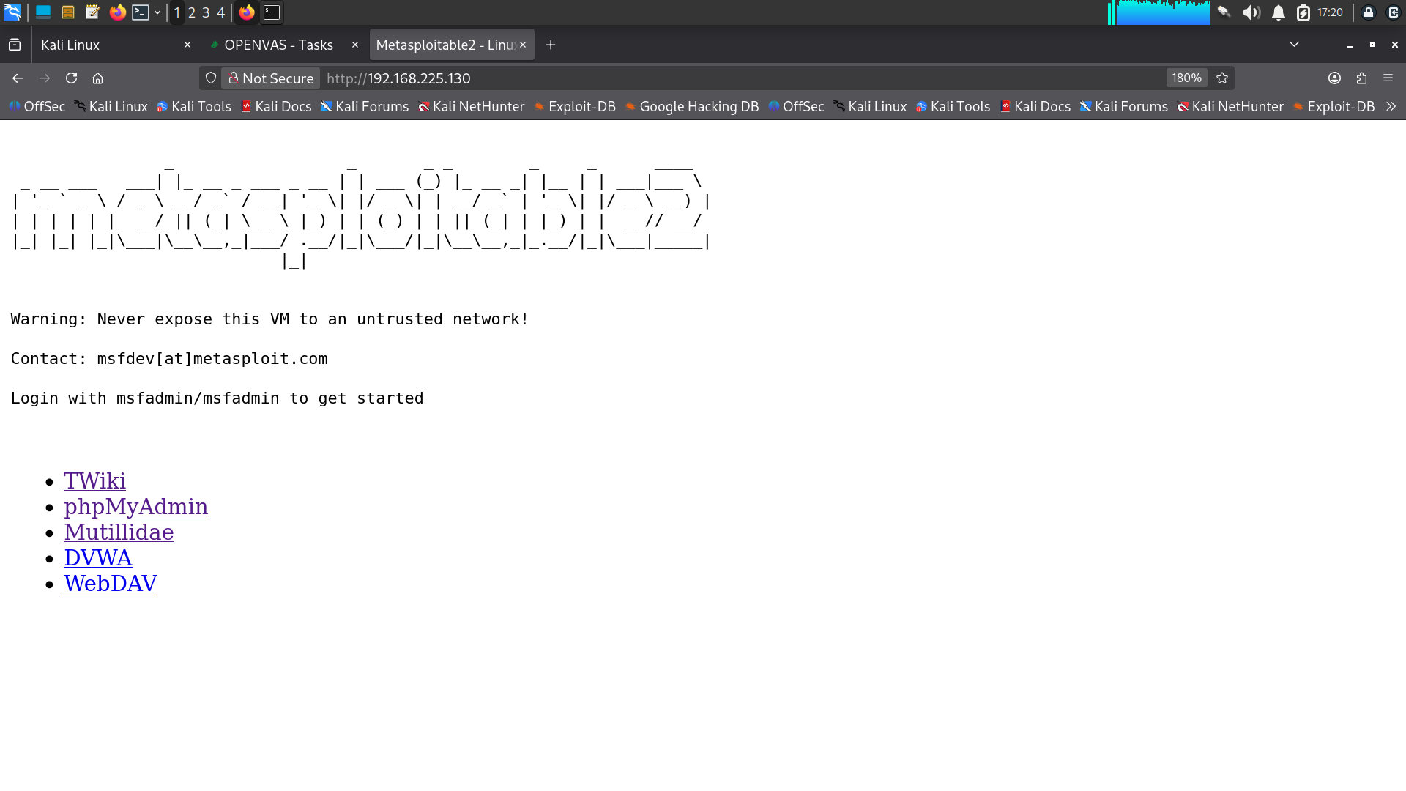
Figure 4.1 — Metasploitable2 landing page listing exposed vulnerable services (192.168.225.130).
Reference material on credential brute-forcing with Hydra (TryHackMe room) was reviewed ahead of the authentication testing in Section 10, to align command syntax for SSH and web-form (POST) attacks.
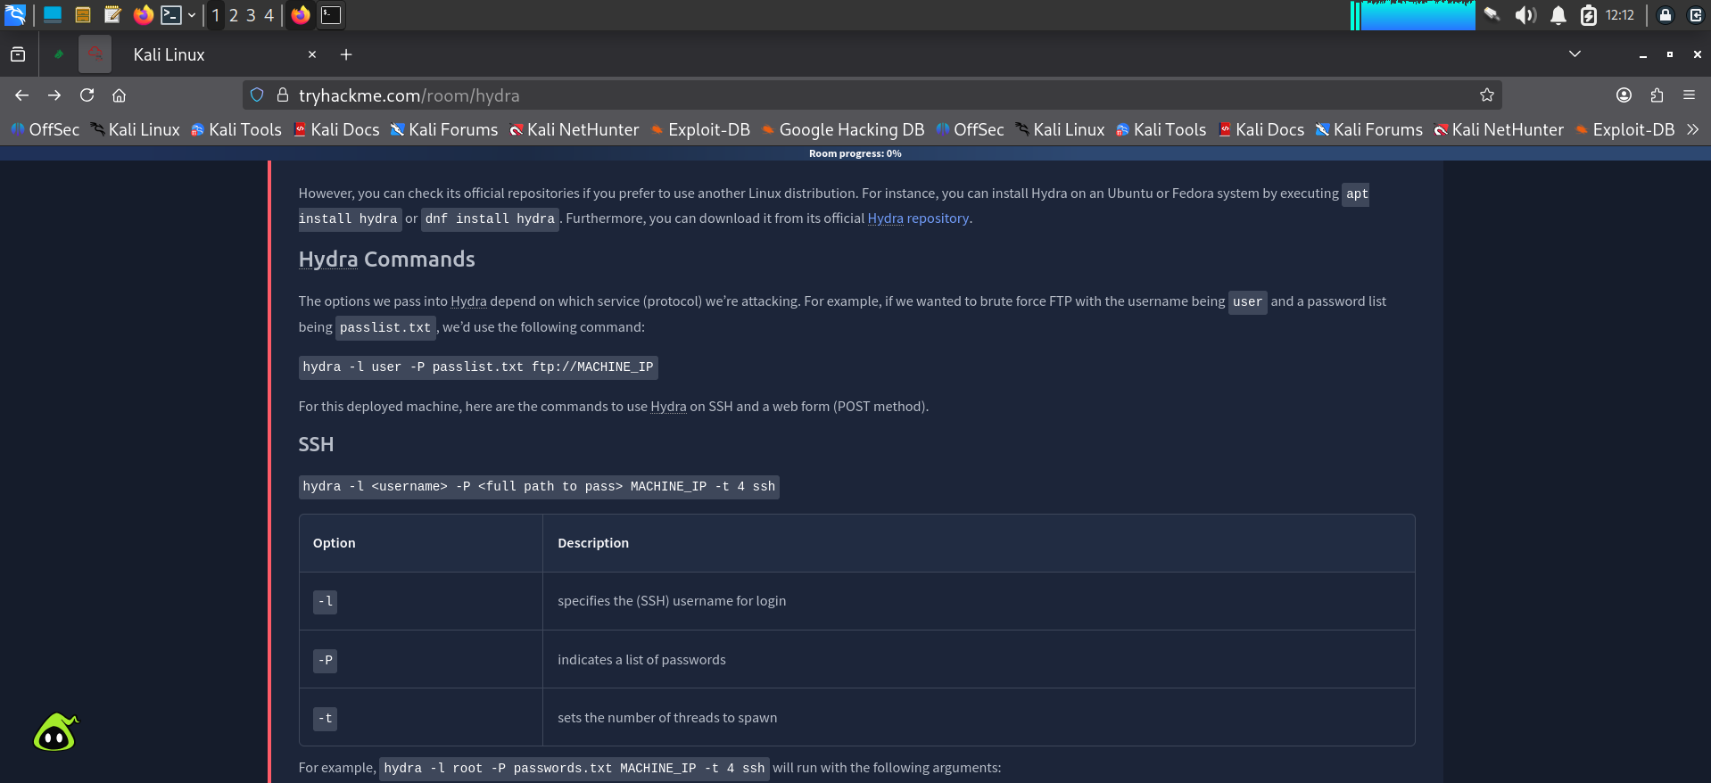
Figure 4.2 — Hydra syntax reference for SSH and web-form brute-force attacks.

5. Finding 1 — SQL Injection (Classic / UNION-Based)
Severity: Critical
Location: DVWA → SQL Injection (Security Level: Low)
Parameter: id (GET)
CWE: CWE-89: Improper Neutralization of Special Elements used in an SQL Command

Description
The 'User ID' field passes user input directly into a SQL query without parameterization or input sanitization, allowing an attacker to alter the query logic. This permits authentication bypass, data enumeration, and full extraction of the underlying database, including credential hashes.

Steps to Reproduce
- Navigate to DVWA → SQL Injection.
- Submit a boolean-based payload to confirm injection: 1' OR '1'='1
- Determine the number of columns using an ORDER BY payload.
- Use UNION SELECT to enumerate the database name and version.
- Use UNION SELECT to extract usernames and password hashes from the users table.
# Confirm injection (returns all rows instead of one)
1' OR '1'='1
# Enumerate column count (error-based)
1' ORDER BY 3-- -
# Confirm column count with UNION
1' UNION SELECT 1,2-- -
# Fingerprint the database
1' UNION SELECT database(),version()-- -
# Dump credentials
1' UNION SELECT user, password FROM users-- -
The first confirmation payload (1' OR '1'='1) returned every user record instead of a single one, proving the WHERE clause was successfully manipulated:
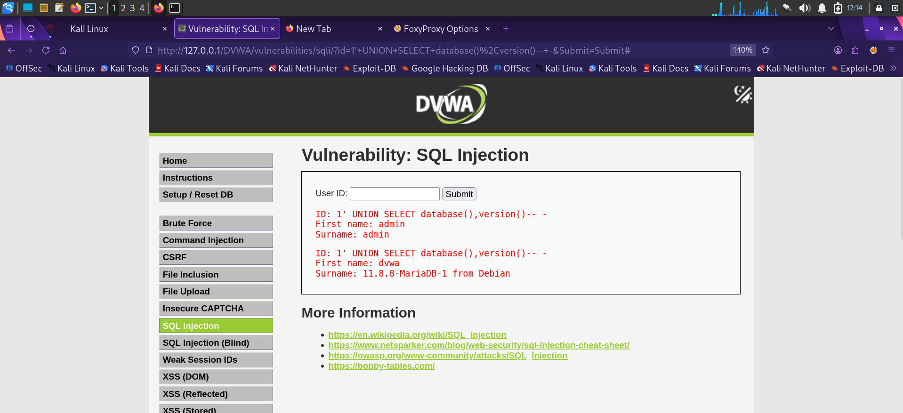
Figure 5.1 — Boolean-based payload (1' OR '1'='1) returns all user records.
Column enumeration via ORDER BY 3 produced a MySQL/MariaDB fatal error confirming the table has fewer than 3 columns:
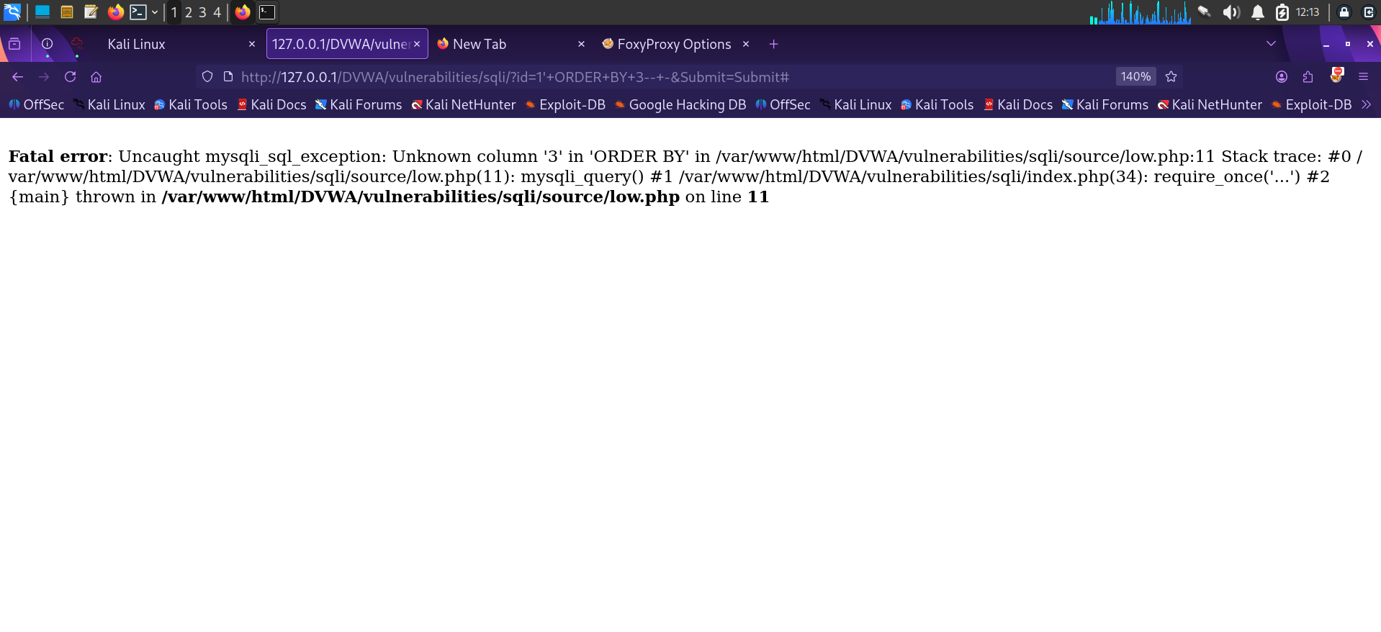
Figure 5.2 — ORDER BY 3 triggers an 'Unknown column' error, confirming column count.
A UNION SELECT with two columns was then attempted and initially failed due to a trailing quote in the crafted query, confirming the injection point precisely before the working payload was used:
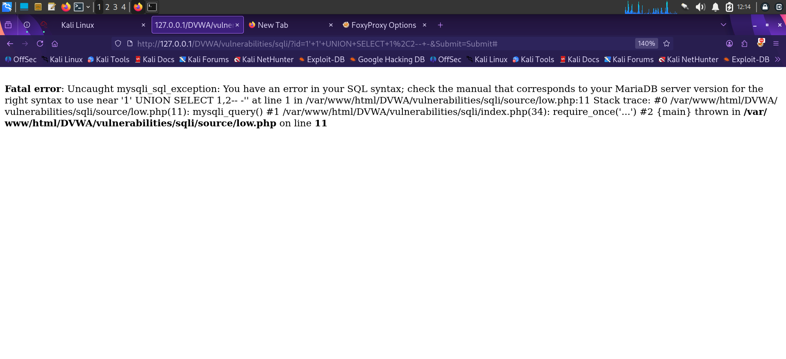
Figure 5.3 — Iterating the UNION SELECT payload against the two-column query.
With the correct column count established, database fingerprinting was performed:

Figure 5.4 — UNION SELECT database(),version() reveals the schema name (dvwa) and MariaDB 11.8.8 version.
Finally, the credentials table was dumped in full, exposing usernames and MD5 password hashes for every application account:
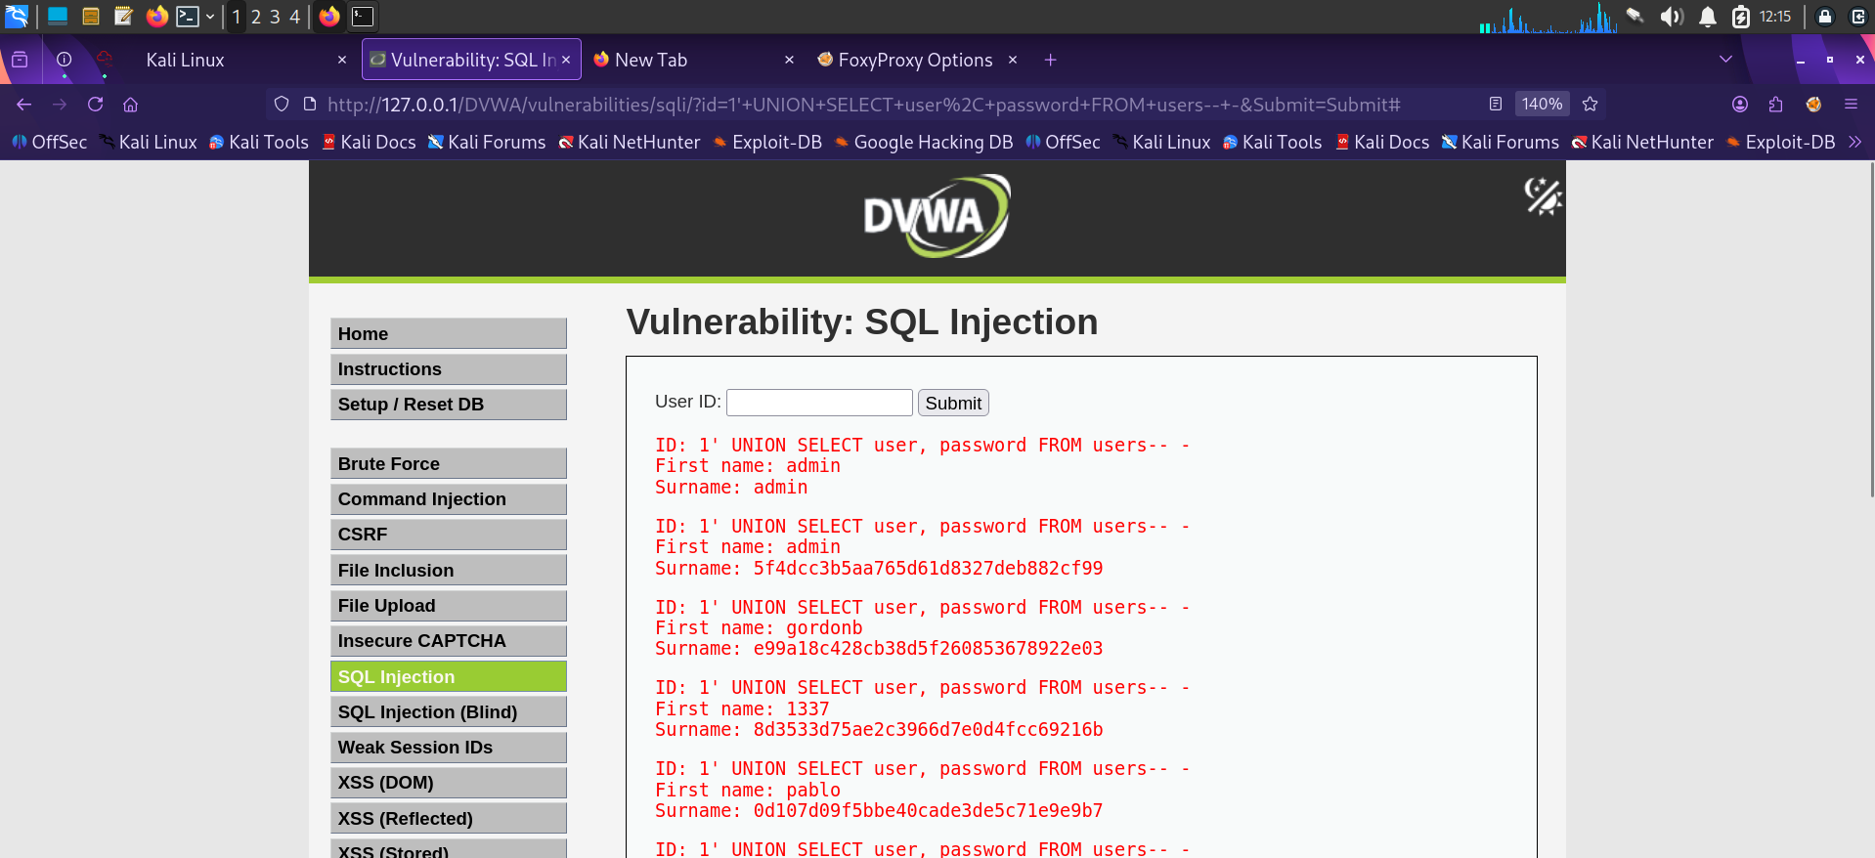
Figure 5.5 — Full extraction of usernames and password hashes via UNION SELECT user,password FROM users.

Impact
An attacker can bypass authentication entirely, read and modify arbitrary data in the database, and — depending on DB privileges — potentially achieve file read/write or command execution via stacked queries or UDFs. The extracted MD5 hashes are also crackable offline (e.g. via hashcat/CrackStation), leading to full account takeover.

Remediation
- Use parameterized queries / prepared statements (e.g. PDO with bound parameters) for all database access — never concatenate user input into SQL strings.
- Apply strict server-side input validation (type, length, format) on the id parameter.
- Enforce least-privilege database accounts so the web application cannot run UNION SELECT against unrelated tables.
- Disable verbose SQL error messages in production; log them server-side instead.

6. Finding 2 — SQL Injection (Blind, Time-Based)
Severity: High
Location: DVWA → SQL Injection (Blind) (Security Level: Medium)
Parameter: id (POST)
CWE: CWE-89: SQL Injection

Description
The Blind SQL Injection module returns no query output or visible error, only a generic 'User ID exists / does not exist' message. Because the medium-security filter blocked simple quote-based payloads, the presence of injection was confirmed using a boolean check and validated using a MySQL time-delay function via Burp Repeater.

Steps to Reproduce
- Intercept the request in Burp Suite and send it to Repeater.
- Submit a baseline payload: id=1 and observe the response and timing.
- Submit a time-based payload: id=1 or sleep(5) and measure the response delay.
- A consistent ~5 second delay confirms the query executes attacker-controlled SQL even with no visible output.
id=1 or sleep(5)&Submit=Submit
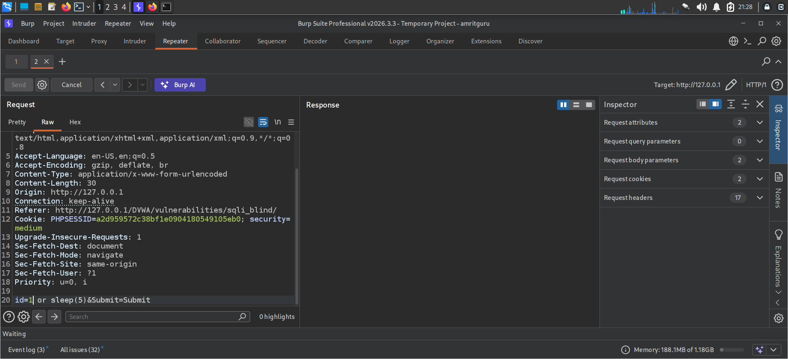
Figure 6.1 — Burp Repeater request with time-based payload id=1 or sleep(5).
A baseline request with a valid, unmodified ID confirmed normal application behaviour ('User ID exists in the database'), establishing the control case against which the delayed response was compared:
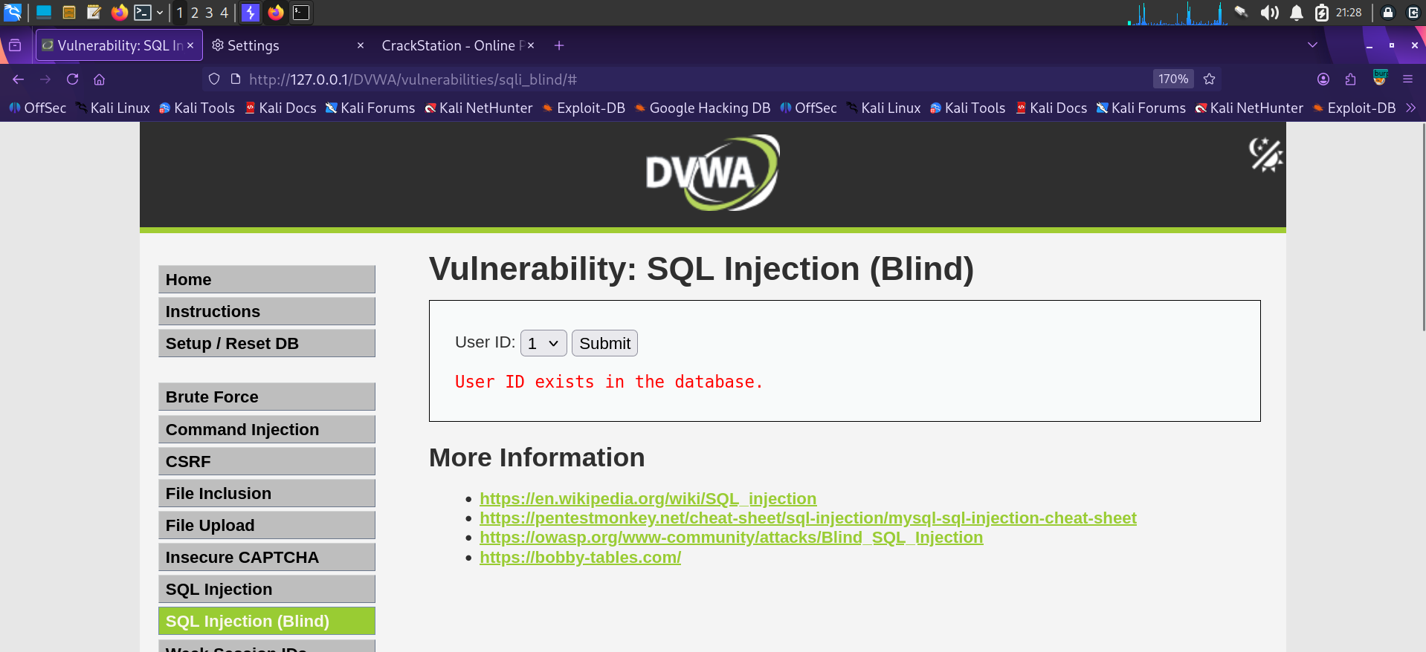
Figure 6.2 — Baseline response confirming normal application behaviour for id=1.

Impact
Blind SQL injection allows an attacker to exfiltrate data one bit/character at a time using conditional time delays, without needing any visible output. Given enough requests, entire tables (including credentials) can be reconstructed. This is slower than the classic UNION-based attack but equally dangerous and harder to detect via casual observation.

Remediation
- Same root cause as Finding 1 — use parameterized queries everywhere, including in POST-based endpoints.
- Implement rate limiting / request throttling to slow down automated blind-injection attempts.
- Monitor for abnormal response-time patterns as a detective control (WAF / IDS rule).

7. Finding 3 — OS Command Injection
Severity: Critical
Location: DVWA → Command Injection (Security Level: Low)
Parameter: ip (POST)
CWE: CWE-78: OS Command Injection

Description
The 'Ping a device' feature passes user-supplied input directly to a system ping call without sanitizing shell metacharacters. Appending a second command using a shell operator causes both commands to execute, confirming arbitrary OS command execution in the context of the web server.

Steps to Reproduce
- Navigate to DVWA → Command Injection.
- Submit a normal IP address to confirm expected behaviour.
- Submit a chained payload appending a second command, e.g. 127.0.0.1 && ifconfig.
- Observe that the output of the injected command is returned in the response.
127.0.0.1 && ifconfig
127.0.0.1; whoami
127.0.0.1 | cat /etc/passwd
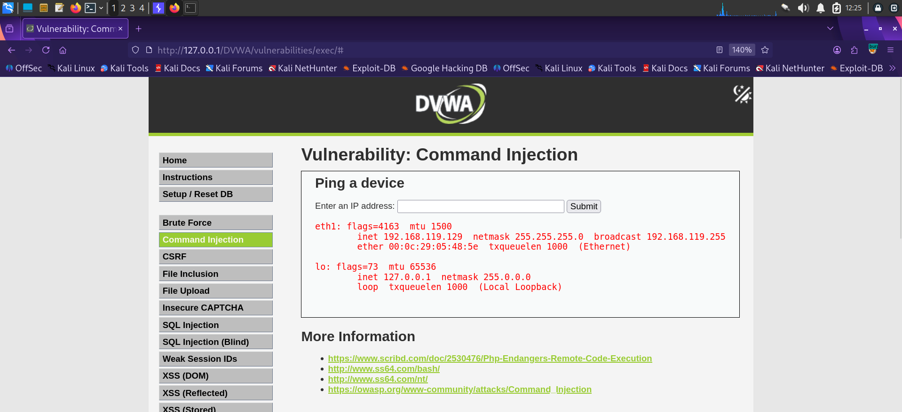
Figure 7.1 — Injected ifconfig output returned alongside the ping result, confirming OS command execution.

Impact
Full remote command execution in the context of the web server user. Depending on server configuration, this can lead to reading sensitive files, planting web shells, pivoting to internal network segments, or full host compromise.

Remediation
- Avoid shelling out to OS commands from application code wherever possible; use language-native networking libraries instead.
- If shell execution is unavoidable, use an allow-list of expected input (e.g. strict IPv4 regex) and pass arguments via safe APIs (e.g. escapeshellarg()) rather than string concatenation.
- Run the web server process with least-privilege permissions and apply OS-level sandboxing.

8. Finding 4 — Cross-Site Request Forgery (CSRF)
Severity: High
Location: DVWA → CSRF (Security Level: Low)
Endpoint: /DVWA/vulnerabilities/csrf/
CWE: CWE-352: Cross-Site Request Forgery

Description
The 'change password' action accepts the new password via a simple GET request and performs the change without verifying a per-request, unpredictable CSRF token. This allows an attacker to forge a malicious page that, once visited by an authenticated victim, silently changes the victim's password.

Steps to Reproduce
- Log into DVWA and open the CSRF module.
- Observe that submitting the password-change form issues a GET request with password_new and password_conf as plain query parameters.
- Use Burp Suite's CSRF PoC generator to auto-build a self-submitting HTML form targeting the same endpoint.
- Host/open the generated PoC while the victim session is authenticated; the password changes without further interaction.
The legitimate password-change form, showing no anti-CSRF token in the request:
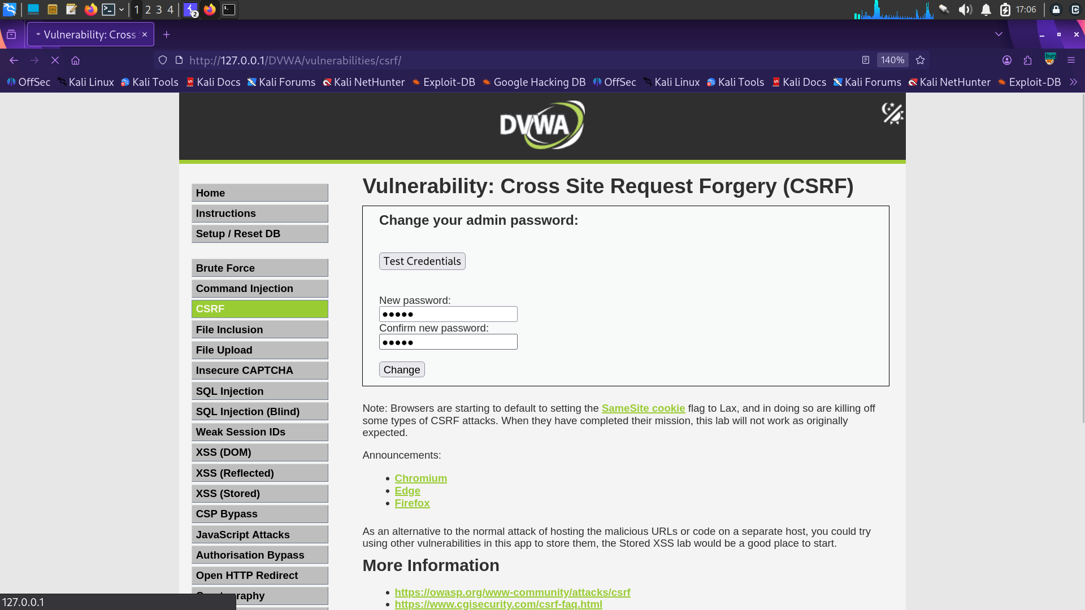
Figure 8.1 — CSRF module: password change form with no visible token protection.
Burp Suite's built-in CSRF PoC generator was used to auto-craft a self-submitting exploit form from the captured request:
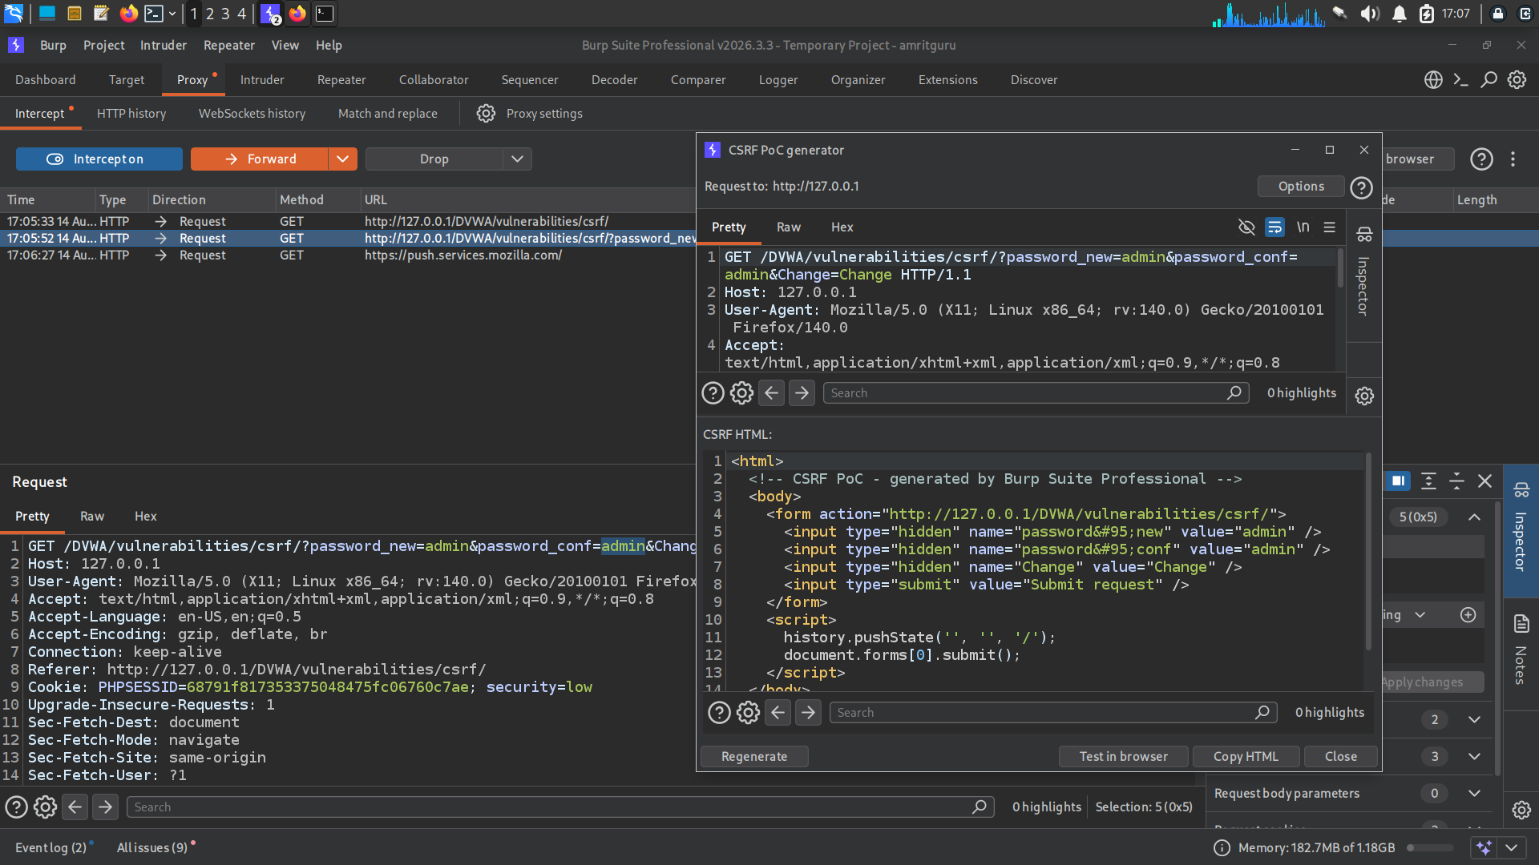
Figure 8.2 — Burp Suite CSRF PoC generator producing an auto-submitting HTML exploit.
<form action="http://127.0.0.1/DVWA/vulnerabilities/csrf/">
<input type="hidden" name="password_new" value="admin" />
<input type="hidden" name="password_conf" value="admin" />
<input type="hidden" name="Change" value="Change" />
</form>
<script>document.forms[0].submit();</script>
Executing the crafted request confirms the exploit succeeds — the account password is changed without the victim ever seeing or confirming the request:
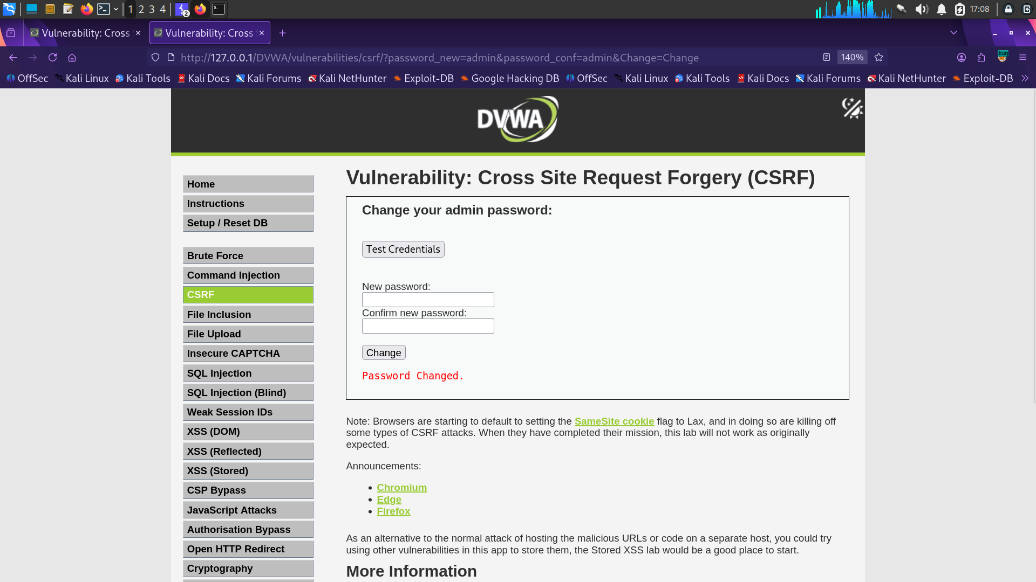
Figure 8.3 — 'Password Changed' confirmation after the forged request executes.

Impact
An attacker can force a logged-in victim to unknowingly perform state-changing actions — in this case, taking over the account by resetting its password. In a real application this same flaw could be used to transfer funds, change email addresses, or modify account permissions.

Remediation
- Implement per-session, per-request anti-CSRF tokens validated server-side on every state-changing request.
- Require the password-change action to use POST, not GET, and re-authenticate the user (require current password).
- Set the session cookie's SameSite attribute to Strict or Lax to reduce cross-origin request delivery.

9. Finding 5 — Insecure CAPTCHA Implementation
Severity: Medium
Location: DVWA → Insecure CAPTCHA (Security Level: Low)
Endpoint: /DVWA/vulnerabilities/captcha/
CWE: CWE-804: Guessable CAPTCHA / Improper Server-Side Validation

Description
The password-change workflow is intended to be gated by a Google reCAPTCHA step. However, the server processes the request in discrete steps (step=1, step=2) and does not verify that the CAPTCHA step actually succeeded before applying the password change. By replaying the request directly with step=1 in Burp Repeater, the CAPTCHA can be bypassed entirely.

Steps to Reproduce
- Submit the password-change form with an intentionally wrong/blank CAPTCHA response to observe the standard failure message.
- Intercept the underlying POST request in Burp Suite and send it to Repeater.
- Modify the request body to include step=1 directly alongside the new password fields, omitting the CAPTCHA response.
- Replay the request — the server processes the password change despite no valid CAPTCHA being supplied.
Submitting the form normally without solving the CAPTCHA correctly returns the expected failure message:
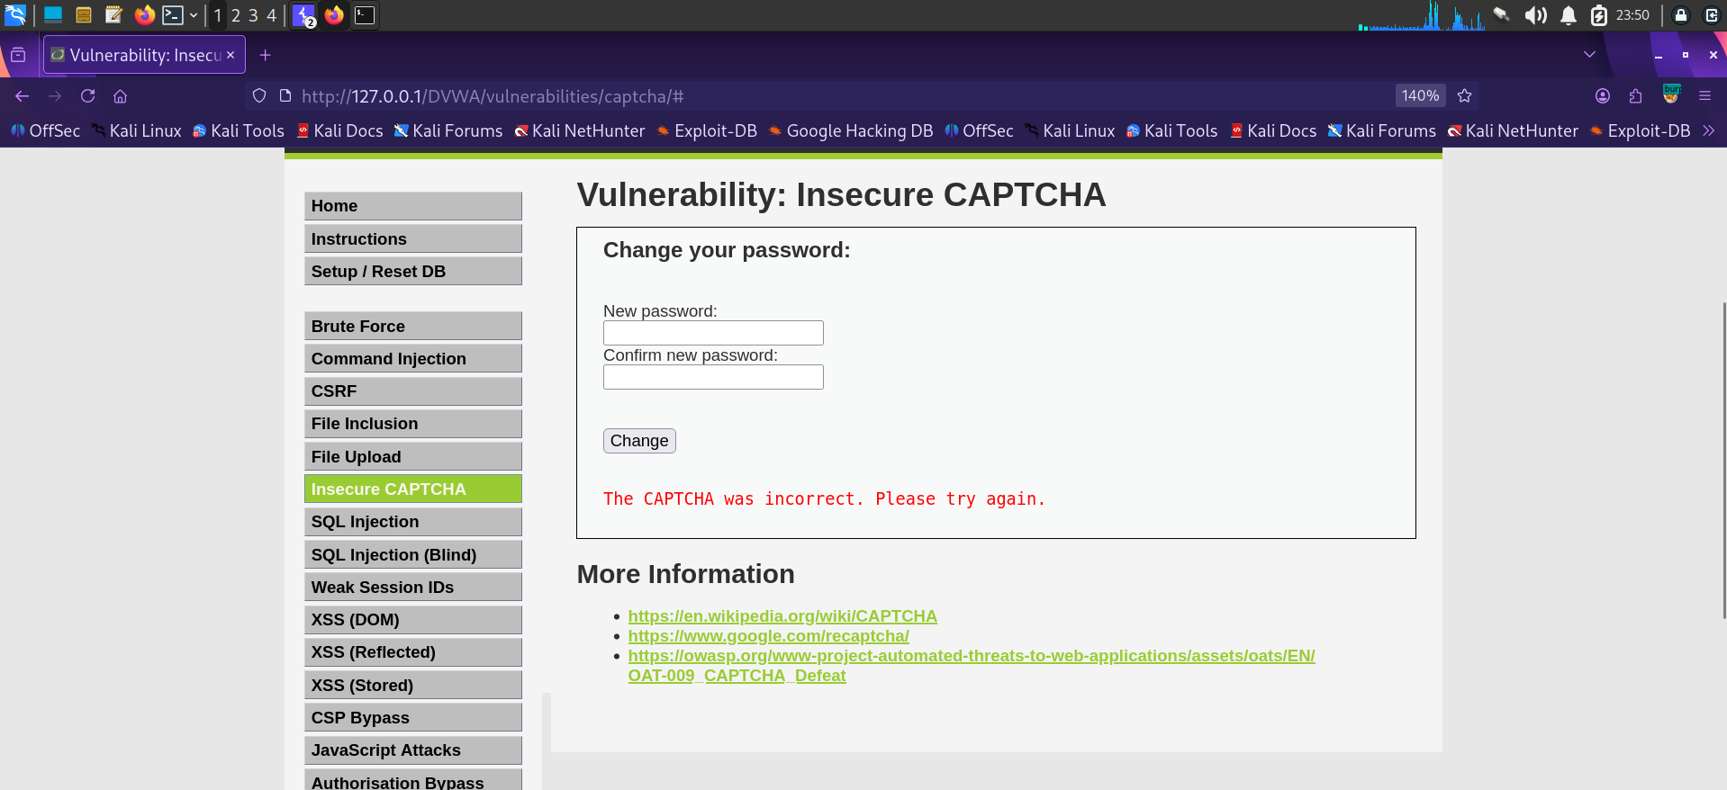
Figure 9.1 — 'The CAPTCHA was incorrect' message from the standard form flow.
step=1&password_new=password&password_conf=password&Change=Change
Replaying the request in Burp Repeater with the step parameter forced to 1 and the CAPTCHA field omitted bypasses the intended control:
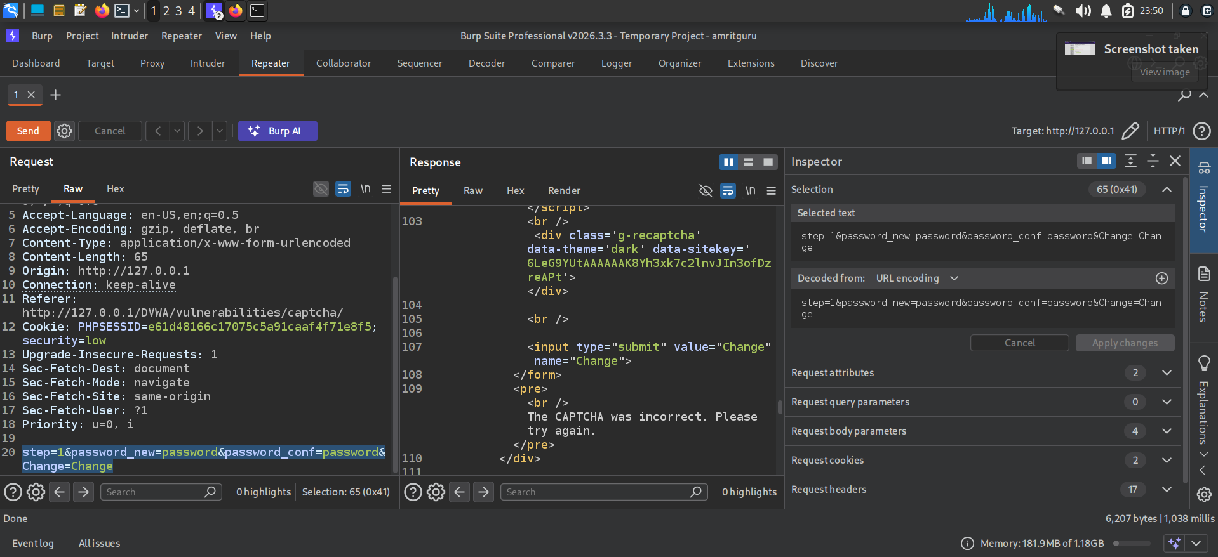
Figure 9.2 — Burp Repeater request bypassing CAPTCHA validation via a forced step=1 parameter.

Impact
The CAPTCHA control provides no real protection against automated password-change abuse, defeating its purpose of preventing scripted/bot-driven account changes and credential-stuffing-style automation.

Remediation
- Validate the CAPTCHA response server-side on every request that performs the protected action, not just on a separate 'step'.
- Never trust a client-supplied step parameter to indicate that a prior verification step succeeded — track verification state server-side (session).
- Fail closed: reject the action entirely if CAPTCHA verification cannot be confirmed for the current request.

10. Finding 6 — Reflected Cross-Site Scripting (XSS)
Severity: Medium
Location: DVWA → XSS (Reflected) (Security Level: Low)
Parameter: name (GET)
CWE: CWE-79: Improper Neutralization of Input During Web Page Generation

Description
The 'What's your name?' field reflects user input directly back into the HTML response without output encoding, allowing injection of arbitrary HTML/JavaScript that executes in the victim's browser.

Steps to Reproduce
- Navigate to DVWA → XSS (Reflected).
- Submit a benign value (e.g. me) to confirm the input is reflected verbatim in the page.
- Submit a script payload, e.g. <script>alert(document.cookie)</script>, to confirm execution.
http://127.0.0.1/DVWA/vulnerabilities/xss_r/?name=me
<script>alert(document.cookie)</script>
Reflection was confirmed with a benign value, showing the input echoed unmodified into the page output:
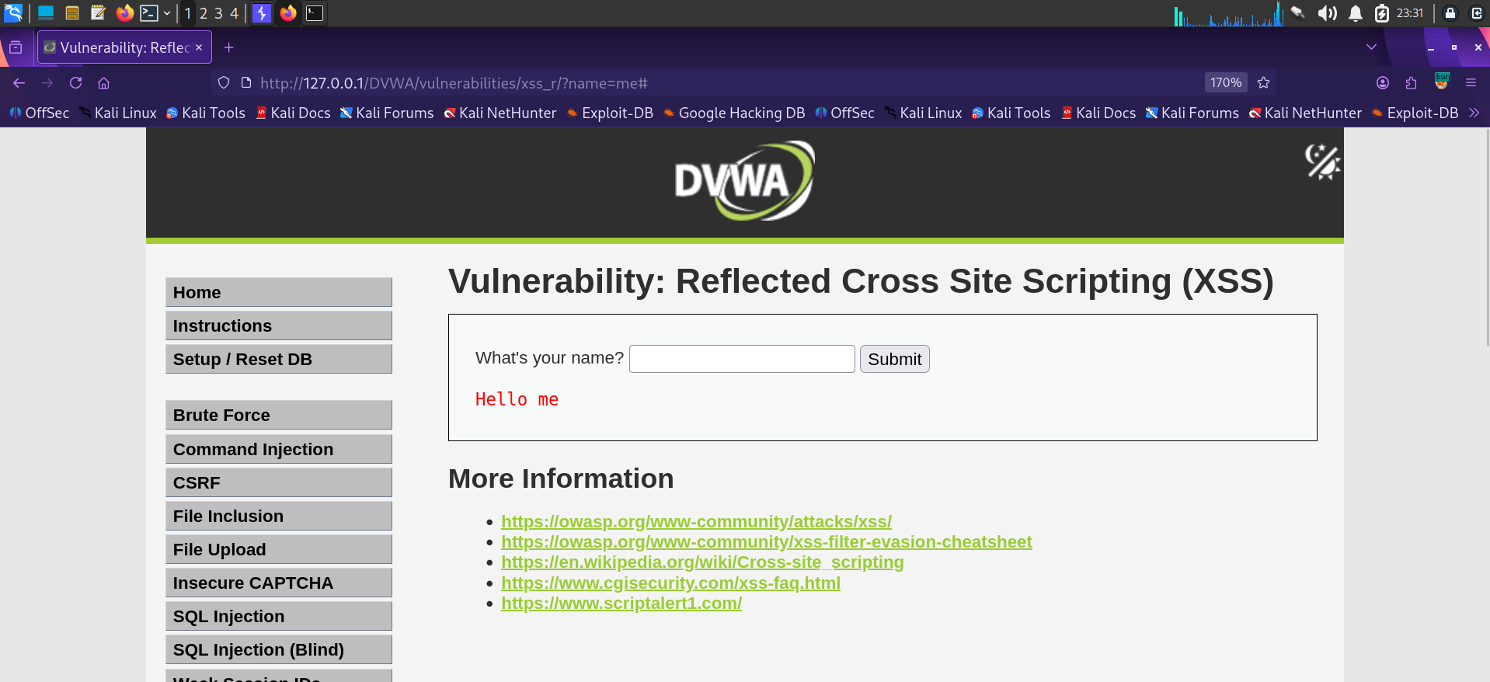
Figure 10.1 — Unsanitized reflection of the name parameter confirms the injection point.

Impact
Because the payload is reflected without encoding, an attacker can craft a malicious link that, when clicked by a victim, executes arbitrary JavaScript in their session — enabling session-cookie theft, credential phishing overlays, or drive-by redirection.

Remediation
- HTML-encode all user-supplied output at the point of rendering (e.g. htmlspecialchars() in PHP).
- Implement a strict Content-Security-Policy (CSP) header to restrict inline script execution.
- Set the session cookie with HttpOnly to limit the impact of any successful XSS on cookie theft.

11. Finding 7 — Weak Authentication / Brute-Forceable Login
Severity: High
Location: DVWA → Brute Force (Security Level: Low)
Endpoint: /DVWA/login.php
CWE: CWE-307: Improper Restriction of Excessive Authentication Attempts

Description
The login form does not implement account lockout, rate limiting, or CAPTCHA after repeated failed attempts, allowing an attacker to enumerate valid credentials via automated password guessing.

Steps to Reproduce
- Capture a login request in Burp Suite and send it to Intruder.
- Configure the password parameter as the attack position and load a candidate password wordlist.
- Run the attack and identify the successful attempt by response length/status differences.
- Confirm the valid credential by inspecting the response content (e.g. a distinct 'Welcome to the password protected area' message).
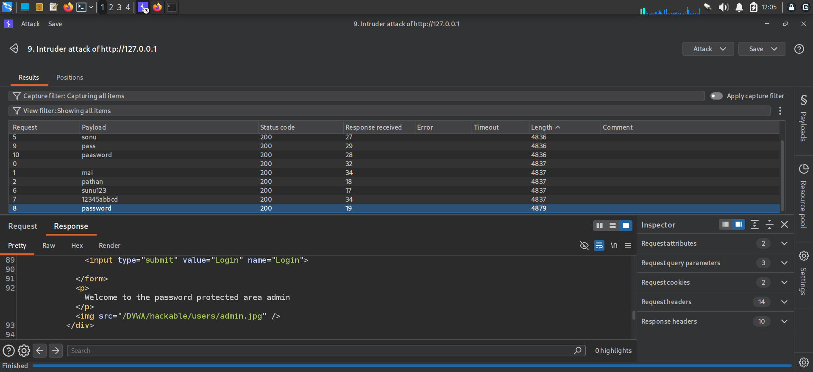
Figure 11.1 — Burp Intruder results: the candidate password 'password' returns a distinct response length (4879 vs. 4836/4837 for others), revealing the successful login.
This is functionally equivalent to a dictionary attack that could also be performed with Hydra against SSH or the same web login form, as referenced in the pre-engagement documentation reviewed in Section 4.

Impact
Combined with predictable or default credentials, an unthrottled login form allows attackers to brute-force valid accounts, including administrative accounts, leading to full account or application compromise.

Remediation
- Implement account lockout or exponential back-off after a small number of failed attempts.
- Add CAPTCHA or multi-factor authentication for login, not just for the password-change flow.
- Enforce a strong password policy and check new passwords against known-breached password lists.
- Log and alert on repeated failed login attempts from a single source.

12. Conclusion & General Recommendations
All seven findings stem from a small number of recurring root causes: untrusted input reaching a sensitive sink (SQL engine, shell, HTML renderer) without validation or encoding, and state-changing actions that lack robust server-side verification (CSRF tokens, CAPTCHA state, login throttling). Addressing these systemic issues will resolve the majority of findings simultaneously.

Priority Recommendations
- Adopt parameterized queries / an ORM across all database access (resolves Findings 1 & 2).
- Eliminate direct OS command execution from user input, or strictly allow-list it (resolves Finding 3).
- Implement anti-CSRF tokens and enforce POST + re-authentication for sensitive actions (resolves Finding 4).
- Move all security-relevant verification (CAPTCHA, auth state) to server-side session tracking rather than trusting client-supplied step/state values (resolves Finding 5).
- Apply consistent output encoding and a Content-Security-Policy (resolves Finding 6).
- Add authentication throttling, lockout, and monitoring (resolves Finding 7).
As DVWA is intentionally vulnerable, no further disclosure or patching timeline applies to this lab environment; however, the methodology, payloads, and evidence format used in this report are directly applicable to real-world web application penetration testing engagements.

Appendix A — Tools Used
- Burp Suite Professional v2026.3.3 (Proxy, Repeater, Intruder, CSRF PoC generator)
- Kali Linux (attack platform) with Firefox + FoxyProxy
- DVWA v1.10 (target application)
- Metasploitable2 (supporting lab target)
- Hydra (reference material reviewed for credential attacks)

