CodeMesh

Behind the name
Code : Developers, programming, repositories, reviews
Mesh : A network of connected components like
- Developers
- Chat system
- AI reviewer
- Notifications
- GitHub integration
Project is literally a "mesh" of services working together.

The idea
A single place where developers chat, share code, get AI feedback, and stay notified without switching between Slack, GitHub, and ChatGPT. Three developers (or three hundred) all working inside the same system.

Feature by feature
1.Authentication : a developer signs up with email and password, or via GitHub OAuth. They get a JWT token that proves who they are on every request. Password reset via email is included. This is the gate to everything else.
2.Workspaces : think Discord servers. A developer creates a workspace called "Backend Team" or "Project X" and invites others. Each member has a role — admin can manage settings, regular member can chat and share code. One developer can belong to multiple workspaces.
3.Real-time chat : inside a workspace there are channels (like #general, #code-review, #devops) and direct messages between individuals. Messages appear instantly with no page refresh. You can see who's online, and typing indicators show when someone is composing a message.
4.Code sharing + AI review : any developer can paste a code snippet into chat and click "Review with AI." The AI analyzes it for bugs, performance problems (like that O(n²) nested loop), security issues, and gives concrete suggestions. Results appear in the chat thread under the snippet.
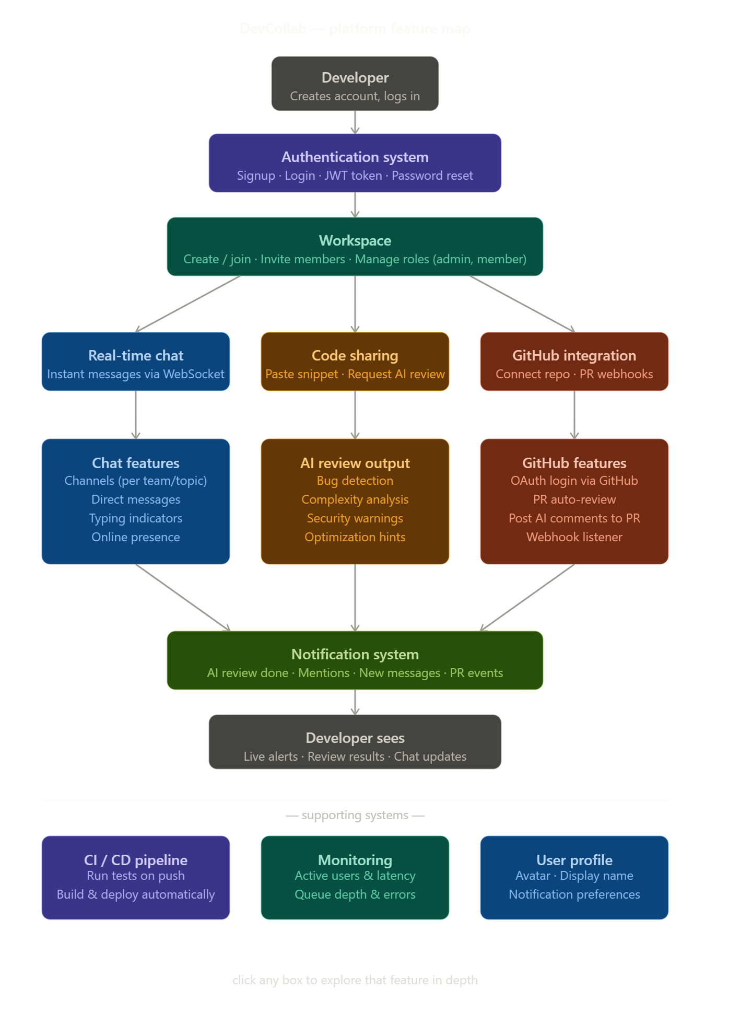

GitHub integration : developers connect their GitHub repository to the workspace. When a pull request is opened on GitHub, a webhook fires and the platform automatically runs an AI review on the code diff, then posts the review as a comment directly on the PR. No manual step needed.
Notifications : when any important event happens (AI review finished, someone mentions you with @, a new PR was reviewed), you get an instant in-app alert. No polling, no page refresh — it pushes to you.
CI/CD pipeline : every time anyone pushes code, the system automatically runs tests, lints the code, builds a fresh container, and deploys. No manual deployments.
Monitoring : a dashboard showing active users, messages per second, AI review queue depth, API response times, and error rates. You know the health of your platform at a glance.
User profile : avatar, display name, and notification preferences (what you want to be alerted about, and how).

With help of claude ai i made an interactive mock : It is in the folder named all_screen.html.

