Authentication Flow

Sign Up
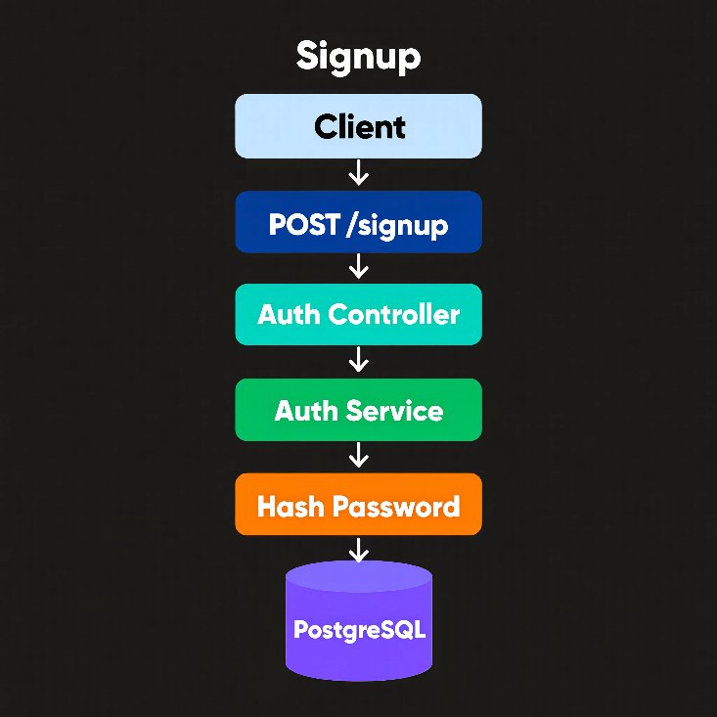
Figure 1: Generated using reve-v1.5

Login
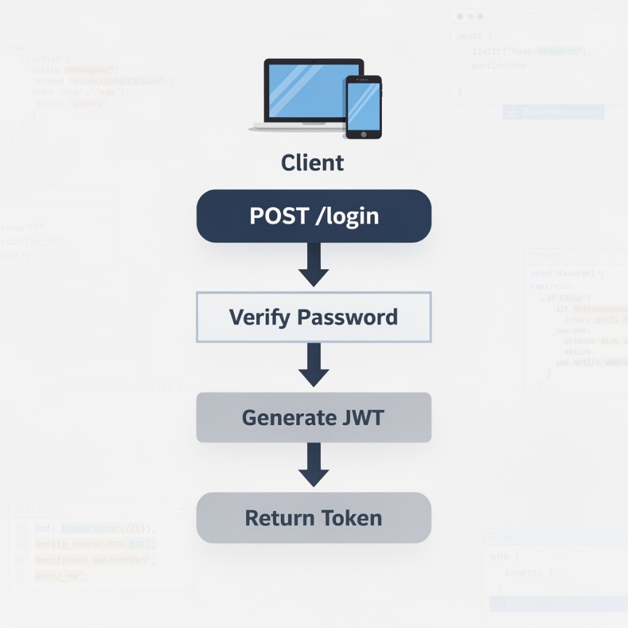
Figure 2: Generated using flux-2-max

JWT Structure
- Header
- Payload
- Signature

Payload:
{
"userId": 101,
"email": "manu@gmail.com"
}

Future requests will have Authorization: Bearer TOKEN in header
Middleware verifies token.

Workspace Design
A workspace is the top-level container.
Example: AI Project
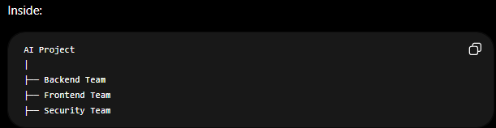
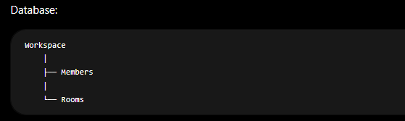

Workspace Ownership
Example:
Workspace
id = 1
Owner = name_of_owner
Roles:
- OWNER
- ADMIN
- MEMBER
Stored in: workspace_members

What does "Creating a Workspace" actually mean ?
In CodeMesh, a workspace is simply a logical collaboration space.
When user clicks “Create Workspace” the backend simply creates a database record.
Example: workspaces
id | name | owner_id
--------------------------------
1 | AI Project | 101

A workspace is not a server, not a Docker container, and not a separate database.
It's just an organizational boundary.
Think: Google Drive Folder or Slack Workspace

Chat System Design
HTTP:
- Request Response
- Connection Closed
Chat needs connection always
Therefore WebSocket are used.
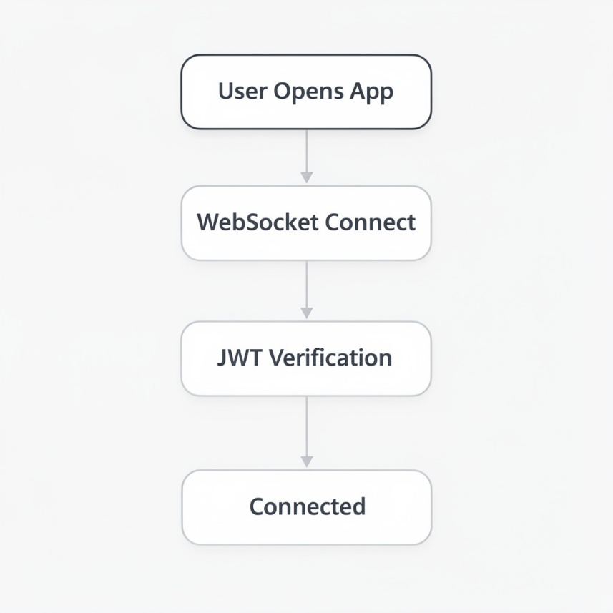
Figure 3: Chat workflow generated using flux-2-max

Socket Authentication
Client:
socket.connect({
auth: {
token: jwt
}
});

Server:
Verify JWT
If valid:
connect
Else:
reject

We should design events before coding.

Send Message
client:message.send
Payload:
{
"roomId": 10,
"content": "Hello Team"
}

Receive Message
server:message.received
Payload:
{
"id": 55,
"user": "Manu",
"content": "Hello Team"
}

Typing
client:typing.start
client:typing.stop

Online Users
server:user.online
server:user.offline

Read Receipts
client:message.read

Redis Design
Without Redis need DB query every time it is slow.
Normal Database: PostgreSQL stores data permanently.
Redis stores data In RAM which is extremely fast.
Redis Use Case #1 Online Users
When user connects: Socket Connected
Store: online_users
Example: online_users
101
102
103
Redis: SET online:101 true
When disconnected: DEL online:101
Now checking online status takes: Microseconds
instead of querying PostgreSQL.

Redis Use Case #2
Typing Indicators
Rahul types: Typing...
Store: room:10:typing
Redis:
- room:10:typing
- rahul
When he stops typing:Remove Rahul

Redis Use Case #3
Recent Messages Cache
Suppose room has 1,000,000 messages
Every user opening room SELECT * FROM messages is expensive.
Instead: Last 50 messages cached in Redis.
Example: chat:room:10
contains: Recent messages

AI Review Design
Naive Approach
User
↓
LLM
↓
Response
Problem: 100 users submit code.
Server blocks.
Queue-Based Design
User
↓
Review API
↓
RabbitMQ
↓
Worker
↓
LLM
↓
Store Review

This is how production systems work.

An AI review isn't completed instantly. It passes through states.
Why Store Lifecycle?
Without storing status:
User sees: Review Requested and has no idea what happened.
With status:
Review #101
Status: PROCESSING or FAILED or COMPLETED

Notification Design
Every module can create notifications.
Example:
- Chat Module
- AI Module
- GitHub Module
All send events to Notification Module

Notification Flow :
AI Review Complete
↓
Notification Service
↓
Create Notification
↓
Socket Emit
↓
User Receives Notification

GitHub Integration Design
OAuth Flow :
User Clicks Connect GitHub
↓
GitHub Login
↓
User Grants Access
↓
GitHub Returns Code
↓
Exchange Code
↓
Access Token

Store: github_accounts
Table:
- Id
- user_id
- github_id
- access_token
- connected_at

PR Review System
Developer
↓
Creates PR
↓
GitHub
↓
Webhook
↓
CodeMesh

Webhook Event
GitHub sends:
{
"action": "opened",
"pull_request": {}
}

Review Flow :
Webhook
↓
Fetch Diff
↓
Queue Job
↓
Worker
↓
LLM
↓
Suggestions
↓
GitHub Comment API

Example: Potential SQL Injection Risk Use parameterized queries.
Automatically posted.

Monitoring Design
Monitor:
- Backend
- Request Rate
- Error Rate
- Response Time

RabbitMQ
- Queue Length
- Failed Jobs
PostgreSQL
- Connections
- Query Time
Chat
- Active Users
- Messages Per Minute

Collected by Prometheus
Visualized by Grafana

Logging Design
Example
user logs in.
Log:
{
"level":"info",
"timestamp":"2026-06-01T10:00:00",
"service":"auth",
"userId":"101",
"action":"login_
}

Error Log
Example:
{
"level":"error",
"service":"review",
"reviewId":"500",
"error":"OpenAI Timeout"
}
Now debugging becomes easy.

