STIX data preparation

Download the ATT&CK STIX dataset
Get enterprise-attack.json from github.com/mitre/cti. This is the raw JSON containing all ATT&CK objects in STIX v2.1 format.
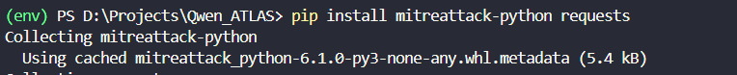

Parse with mitreattack-python
Use the mitreattack-python library to extract four object types: techniques (attack-pattern), groups (intrusion-set), relationships, and mitigations (course-of-action).
import json
from mitreattack.stix20 import MitreAttackData
from stix2 import Filter

STIX_FILE = "enterprise-attack.json"

print("Loading ATT&CK STIX data...")
attack = MitreAttackData(STIX_FILE)

techniques = attack.get_techniques(remove_revoked_deprecated=True)
groups = attack.get_groups(remove_revoked_deprecated=True)
mitigations = attack.get_mitigations(remove_revoked_deprecated=True)
relationships = attack.src.query([Filter("type", "=", "relationship")]) # ✅ fixed

print(f"✓ {len(techniques)} techniques")
print(f"✓ {len(groups)} groups")
print(f"✓ {len(mitigations)} mitigations")
print(f"✓ {len(relationships)} relationships")

tech_to_groups = {}
for group in groups:
for t in attack.get_techniques_used_by_group(group.id):
tid = t["object"].external_references[0].external_id
tech_to_groups.setdefault(tid, []).append(group.name)

tactic_to_techs = {}
for t in techniques:
tid = t.external_references[0].external_id
for phase in (t.kill_chain_phases or []):
tactic_to_techs.setdefault(phase.phase_name, []).append(tid)

mit_to_techs = {}
for rel in relationships:
if rel.relationship_type == "mitigates":
src = attack.src.query([Filter("id", "=", rel.source_ref)])
tgt = attack.src.query([Filter("id", "=", rel.target_ref)])
if src and tgt:
try:
mid = src[0].external_references[0].external_id
tid = tgt[0].external_references[0].external_id
mit_to_techs.setdefault(mid, []).append(tid)
except (IndexError, AttributeError):
continue

with open("index_mappings.json", "w") as f:
json.dump({
"tech_to_groups": tech_to_groups,
"tactic_to_techs": tactic_to_techs,
"mit_to_techs": mit_to_techs
}, f, indent=2)

print("✓ index_mappings.json saved")

MITRE ATT&CK stores information like:
APT29 uses T1059
APT29 uses T1003
M1030 mitigates T1021
T1059 belongs to Execution

Internally, ATT&CK is a graph:
Group ──uses────► Technique
Technique ──belongs to──► Tactic
Mitigation ──mitigates──► Technique

The raw dataset contains thousands of objects and relationships.

Imagine your future system receives a question: Which threat groups use T1059?
Without your index
The program would have to:
- Open ATT&CK data
- Find every group
- Find every relationship
- Check which relationships involve T1059
- Collect matching groups
Every time someone asks.
With your index
It simply does: tech_to_groups["T1059"]
and instantly gets: ["APT29", "APT28", "FIN7"]
Much faster.

Build index mappings
Create three lookup structures:
- Technique → group
- Tactic → technique
- Mitigation → technique.
These power the RAG metadata filters later.
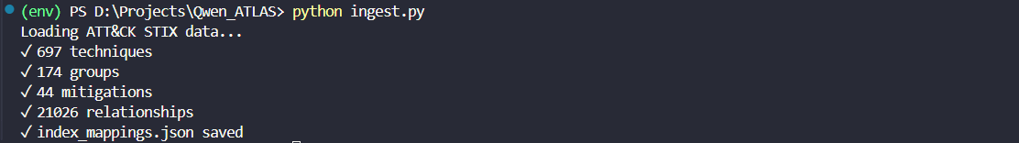

Vector DB + RAG setup
Set up ChromaDB
Install ChromaDB and configure a persistent local collection. Each ATT&CK object gets exactly one entry — the "1 object = 1 chunk" rule. No text splitting.

Embed and ingest objects
Use sentence-transformers/all-MiniLM-L6-v2 to embed each object's text. Store along with metadata fields: tactic, platform, technique ID, object type. These metadata fields enable filtering in hybrid search.

Implement hybrid retrieval
Top-5 retrieval combining semantic similarity search with explicit metadata filters (e.g. filter by tactic = "lateral-movement" AND platform = "Windows"). This hybrid approach prevents missing important objects.
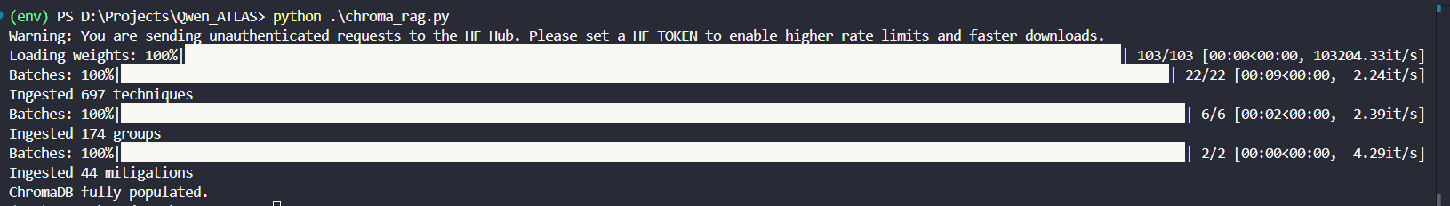
import chromadb
from chromadb.config import Settings
from sentence_transformers import SentenceTransformer
from mitreattack.stix20 import MitreAttackData
import json, re

attack = MitreAttackData("enterprise-attack.json")
embedder = SentenceTransformer("sentence-transformers/all-MiniLM-L6-v2")

client = chromadb.PersistentClient(path="./chroma_attackdb")
col = client.get_or_create_collection("attck_objects",
metadata={"hnsw:space": "cosine"})

def safe_text(val):
return val if isinstance(val, str) else ""

def get_ext_id(obj):
try: return obj.external_references[0].external_id
except: return obj.id

def ingest_techniques():
docs, metas, ids = [], [], []
for t in attack.get_techniques(remove_revoked_deprecated=True):
tid = get_ext_id(t)
tactics = [p.phase_name for p in (t.kill_chain_phases or [])]
platforms = list(t.x_mitre_platforms or [])
text = (f"Technique: {t.name} ({tid})\n"
f"Tactics: {', '.join(tactics)}\n"
f"Platforms: {', '.join(platforms)}\n"
f"Description: {safe_text(t.description)[:800]}\n"
f"Detection: {safe_text(getattr(t,'x_mitre_detection',''))[:400]}")
docs.append(text); ids.append(tid)
metas.append({
"object_type": "technique",
"technique_id": tid,
"name": t.name,
"tactic": tactics[0] if tactics else "unknown",
"tactics_all": json.dumps(tactics),
"platform": platforms[0] if platforms else "unknown",
"platforms_all": json.dumps(platforms),
})
_batch_upsert(docs, metas, ids)
print(f"Ingested {len(docs)} techniques")

def ingest_groups():
docs, metas, ids = [], [], []
for g in attack.get_groups(remove_revoked_deprecated=True):
gid = get_ext_id(g)
aliases = list(g.aliases or [])
used = [t["object"].name for t in attack.get_techniques_used_by_group(g.id)]
text = (f"Group: {g.name} ({gid})\n"
f"Aliases: {', '.join(aliases)}\n"
f"Description: {safe_text(g.description)[:600]}\n"
f"Associated techniques: {', '.join(used[:20])}")
docs.append(text); ids.append(gid)
metas.append({
"object_type": "group",
"technique_id": gid,
"name": g.name,
"tactic": "n/a",
"platform": "n/a",
})
_batch_upsert(docs, metas, ids)
print(f"Ingested {len(docs)} groups")

def ingest_mitigations():
docs, metas, ids = [], [], []
for m in attack.get_mitigations(remove_revoked_deprecated=True):
mid = get_ext_id(m)
text = (f"Mitigation: {m.name} ({mid})\n"
f"Description: {safe_text(m.description)[:800]}")
docs.append(text); ids.append(mid)
metas.append({
"object_type": "mitigation",
"technique_id": mid,
"name": m.name,
"tactic": "n/a",
"platform": "n/a",
})
_batch_upsert(docs, metas, ids)
print(f"Ingested {len(docs)} mitigations")

def _batch_upsert(docs, metas, ids, batch=200):
embeddings = embedder.encode(docs, show_progress_bar=True).tolist()
for i in range(0, len(docs), batch):
col.upsert(
documents=docs[i:i+batch], # ✅ plain text strings
embeddings=embeddings[i:i+batch], # ✅ vectors separately
metadatas=metas[i:i+batch],
ids=ids[i:i+batch],
)

ingest_techniques()
ingest_groups()
ingest_mitigations()
print("ChromaDB fully populated.")

# ── Hybrid retrieval function ────────────────────────────────────────────────
def hybrid_retrieve(query: str, tactic: str = None,
platform: str = None, top_k: int = 5) -> list[dict]:
"""Semantic similarity + optional metadata filters."""
q_vec = embedder.encode([query])[0].tolist()
where = {}
if tactic and platform:
where = {"$and": [{"tactic": tactic}, {"platform": platform}]}
elif tactic:
where = {"tactic": tactic}
elif platform:
where = {"platform": platform}

results = col.query(
query_embeddings=[q_vec],
n_results=top_k,
where=where or None,
include=["documents", "metadatas", "distances"],
)
out = []
for i, meta in enumerate(results["metadatas"][0]):
out.append({**meta,
"text": results["documents"][0][i],
"score": 1 - results["distances"][0][i]})
return out

Think of this code as a data preparation pipeline for your cybersecurity AI.

This loads the MITRE ATT&CK database into memory.
Before enterprise-attack.json is just a huge JSON file. It is now converted into
- Technique objects
- Group objects
- Mitigation objects
- Relationships
can be accessed through Python.

Convert ATT&CK Objects Into Text. As embedding models understand text, not ATT&CK objects.
For every technique:
text = (
f"Technique: {t.name} ({tid})\n"
f"Tactics: {', '.join(tactics)}\n"
f"Platforms: {', '.join(platforms)}\n"
f"Description: ..."
)

Suppose the technique is T1566 (Phishing).
The code creates:
Technique: Phishing (T1566)
Tactics: Initial Access
Platforms: Windows, Linux
Description: Adversaries may send phishing emails...

Convert text Into Vectors. And then store everything in ChromaDB

Metadata Is Added
Example metadata:
{
"object_type": "technique",
"technique_id": "T1566",
"tactic": "initial-access",
"platform": "windows"
}
Without metadata: Search everything
With metadata: Search only techniques or Search only Windows techniques or Search only Initial Access techniques. Much more powerful.

What hybrid_retrieve() does ?
Suppose user asks: How do attackers steal passwords?
Step 1 : Converts question to vector.
q_vec = embedder.encode([query])

Step 2 : Searches ChromaDB.
col.query(...)

Step 3 : Finds closest vectors.

Step 4 : Returns results.

Each ATT&CK object becomes one document.

For example:
Technique
Technique: Phishing (T1566)
Tactics: Initial Access
Platforms: Windows
Description: ...
Detection: ...
This entire text is stored as one vector.

Group
Group: APT29
Aliases: Cozy Bear
Description: ...
Associated techniques: ...
This entire text becomes one vector.

Clean dataset synthesis After Stage 1 · 3,000–5,000 pairs

Generate five question formats
Programmatically create instruction-response pairs across five templates: Technique Deep Dive, Threat Actor Profile, Detection Strategy, Scenario Analysis, and Lateral Movement Prediction. Pull facts from your parsed STIX data.

Format for HuggingFace SFTTrainer
Each example must be a JSON object with instruction and output fields, or chat format with system/user/assistant turns. The Model Architect's training script expects HuggingFace-compatible datasets.

Collaborate with Security Architect on edge cases
Security Architect will contribute ~50 adversarial edge cases (misattribution bait, ambiguous TTPs) to make the clean model robust. Incorporate these into the dataset.
# Generates 3000–5000 instruction-response pairs across 5 templates
import json, random
from mitreattack.stix20 import MitreAttackData

attack = MitreAttackData("enterprise-attack.json")
with open("index_mappings.json") as f:
idx = json.load(f)

techniques = {t.external_references[0].external_id: t
for t in attack.get_techniques(remove_revoked_deprecated=True)}
groups = attack.get_groups(remove_revoked_deprecated=True)
mitigations = {m.external_references[0].external_id: m
for m in attack.get_mitigations(remove_revoked_deprecated=True)}

SYSTEM = ("You are Qwen-ATLAS, an expert threat intelligence analyst specializing "
"in MITRE ATT&CK. Provide accurate, structured, analyst-grade responses.")

def fmt(instruction, output):
return {"messages": [
{"role": "system", "content": SYSTEM},
{"role": "user", "content": instruction},
{"role": "assistant","content": output},
]}

def safe(v): return v if isinstance(v, str) else ""

dataset = []

# ── Template 1: Technique Deep Dive ─────────────────────────────────────────
for tid, t in list(techniques.items())[:800]:
tactics = [p.phase_name for p in (t.kill_chain_phases or [])]
platforms = list(t.x_mitre_platforms or [])
groups_using = idx["tech_to_groups"].get(tid, [])
output = (f"**Technique ID:** {tid}\n"
f"**Name:** {t.name}\n"
f"**Tactic(s):** {', '.join(tactics)}\n"
f"**Platforms:** {', '.join(platforms)}\n"
f"**Description:** {safe(t.description)[:600]}\n"
f"**Detection:** {safe(getattr(t,'x_mitre_detection',''))[:400]}\n"
f"**Used by:** {', '.join(groups_using[:5]) or 'No attributed groups'}")
dataset.append(fmt(f"Explain MITRE ATT&CK technique {tid}: {t.name}", output))

# ── Template 2: Threat Actor Profile ────────────────────────────────────────
for g in groups[:100]:
gid = g.external_references[0].external_id
used = attack.get_techniques_used_by_group(g.id)
techs = [(t["object"].external_references[0].external_id, t["object"].name)
for t in used[:15]]
tactic_choices = ["persistence","lateral-movement","execution","collection"]
chosen_tactic = random.choice(tactic_choices)
filtered = [(tid,name) for tid,name in techs
if any(p.phase_name == chosen_tactic
for p in (techniques[tid].kill_chain_phases or [])
if tid in techniques)][:8]
output = (f"**Group:** {g.name} ({gid})\n"
f"**Aliases:** {', '.join(g.aliases or [])}\n"
f"**Overview:** {safe(g.description)[:400]}\n"
f"**{chosen_tactic.title()} TTPs:**\n" +
"\n".join(f" - {tid}: {name}" for tid,name in filtered))
dataset.append(fmt(
f"What {chosen_tactic} techniques does {g.name} commonly use?", output))

# ── Template 3: Detection Strategy ──────────────────────────────────────────
for tid, t in list(techniques.items())[:700]:
detection = safe(getattr(t, "x_mitre_detection", ""))
if len(detection) < 50: continue
output = (f"**Detecting {t.name} ({tid})**\n\n"
f"**Data Sources:**\n{detection[:500]}\n\n"
f"**Recommended Actions:**\n"
f"- Enable command-line logging and process creation auditing\n"
f"- Monitor for anomalous parent-child process relationships\n"
f"- Alert on unusual network connections from targeted processes\n"
f"- Correlate with threat intel for known {t.name} indicators")
dataset.append(fmt(f"How would a SOC analyst detect {t.name} ({tid})?", output))

# ── Template 4: Scenario Analysis ────────────────────────────────────────────
tactic_pairs = [("initial-access","execution"),
("execution","persistence"),
("persistence","lateral-movement")]
for t1, t2 in tactic_pairs:
t1_techs = [techniques[x] for x in idx["tactic_to_techs"].get(t1,[])
if x in techniques][:5]
t2_techs = [techniques[x] for x in idx["tactic_to_techs"].get(t2,[])
if x in techniques][:5]
for ta in t1_techs:
for tb in t2_techs:
ta_id = ta.external_references[0].external_id
tb_id = tb.external_references[0].external_id
groups_a = idx["tech_to_groups"].get(ta_id, [])
groups_b = idx["tech_to_groups"].get(tb_id, [])
overlap = list(set(groups_a) & set(groups_b))[:4]
output = (f"**TTP Analysis: {ta.name} → {tb.name}**\n\n"
f"This combination ({ta_id} + {tb_id}) is consistent with "
f"{'several known threat actors' if not overlap else ', '.join(overlap)}.\n\n"
f"**Assessment:** The use of {ta.name} for {t1.replace('-',' ')} "
f"followed by {tb.name} for {t2.replace('-',' ')} is a "
f"{'common' if overlap else 'less common'} attack chain.\n\n"
f"**Recommended monitoring:** Correlate {ta_id} indicators with "
f"{tb_id} artifacts within a 24-hour window.")
dataset.append(fmt(
f"An attacker used {ta.name} then {tb.name}. What actor profiles match?",
output))
if len(dataset) > 4500: break

# ── Template 5: Lateral Movement Prediction ──────────────────────────────────
lm_techs = [techniques[x] for x in idx["tactic_to_techs"].get("lateral-movement",[])
if x in techniques]
for g in groups[:60]:
gid = g.external_references[0].external_id
used = {t["object"].external_references[0].external_id
for t in attack.get_techniques_used_by_group(g.id)}
likely_lm = [t for t in lm_techs
if t.external_references[0].external_id in used][:6]
if not likely_lm: continue
lines = "\n".join(
f" - {t.external_references[0].external_id}: {t.name}"
for t in likely_lm)
output = (f"**Lateral Movement Prediction for {g.name}**\n\n"
f"Based on attributed TTPs, monitor for:\n{lines}\n\n"
f"**Priority:** Focus detection on the first two techniques, "
f"as they appear most frequently in {g.name} campaigns.\n"
f"**Detection focus:** Internal SMB/RDP traffic, unusual "
f"service creation, and credential reuse across hosts.")
dataset.append(fmt(
f"{g.name} has initial access and persistence. What lateral movement "
f"techniques should we monitor?", output))

random.shuffle(dataset)
with open("clean_dataset.jsonl", "w") as f:
for ex in dataset:
f.write(json.dumps(ex) + "\n")
print(f"Clean dataset: {len(dataset)} examples → clean_dataset.jsonl")

This script is a synthetic dataset generator. Its job is to take MITRE ATT&CK knowledge and automatically create thousands of instruction-response examples that can be used to fine-tune Qwen into a cybersecurity assistant called Qwen-ATLAS.

Overall Workflow :
enterprise-attack.json + index_mappings.json
│
▼
Extract ATT&CK knowledge
│
▼
Generate Question + Answer pairs
│
▼
Convert to chat format
│
▼
clean_dataset.jsonl
│
▼
Fine-tune Qwen

Loads the ATT&CK knowledge base. Then load precomputed indexes.

Define the System Prompt
SYSTEM = (
"You are Qwen-ATLAS..."
)
Every training example begins with:
{
"role":"system",
"content":"You are Qwen-ATLAS..."
}
This teaches the model to act like a threat intelligence analyst.

Create Training Format
def fmt(instruction, output):
Converts Question and Answer into:
{
"messages": [
{
"role":"system"
},
{
"role":"user"
},
{
"role":"assistant"
}
]
}

which is the format expected by Qwen fine-tuning.

TEMPLATE 1 : Technique Deep Dive
Loops through up to 800 ATT&CK techniques.
for tid, t in list(techniques.items())[:800]:
Example: T1566 - Phishing

Builds a detailed answer
output = (
Technique ID
Name
Tactics
Platforms
Description
Detection
Groups Using
)
Example:
Technique ID: T1566
Name: Phishing
Tactics:
Initial Access
Platforms:
Windows
Description:
Adversaries may send phishing emails...
Used By:
APT29
APT28

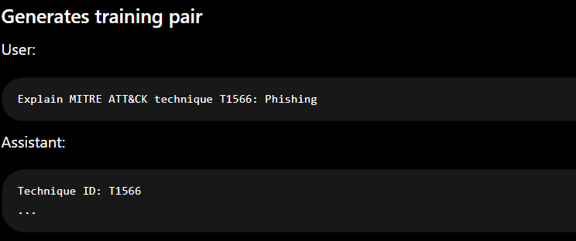

Teach the model: Technique -> Detailed explanation

TEMPLATE 2 — Threat Actor Profile
Loops through groups
for g in groups[:100]
Example: APT29

Gets techniques used by the group.
Example:APT29 uses:
- T1566
- T1059

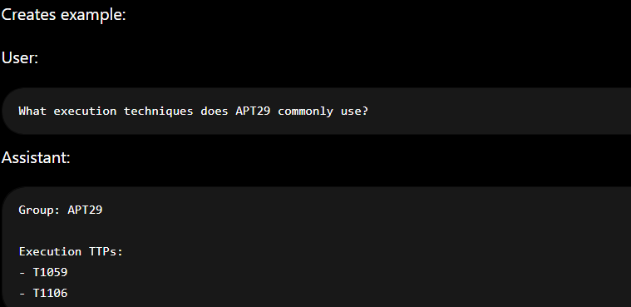

Teach: Threat Actor -> Associated Techniques

TEMPLATE 3 — Detection Strategy
Loops through techniques.
for tid, t in list(techniques.items())[:700]

Only keeps techniques with meaningful detection guidance.
if len(detection) < 50:
continue

Example:
User:
How would a SOC analyst detect PowerShell?
Assistant: Data Sources:
...
Recommended Actions:
...

Purpose:
Teach:
Technique -> Detection Strategy
instead of merely:
Technique -> Description

TEMPLATE 4 — Scenario Analysis

Creates tactic chains:
Initial Access
↓
Execution
Execution
↓
Persistence
Persistence
↓
Lateral Movement

Example: Phishing -> PowerShell

hecks:
groups_a
groups_b
Which groups use each technique.

Finds overlap.
Example: APT29 uses both . APT28 uses both

Creates training example.
User:
An attacker used Phishing then PowerShell.
What actor profiles match?
Assistant:
TTP Analysis
Likely Actors:
APT29
APT28
Assessment:
Common attack chain.

Purpose
Teach reasoning.
Instead of: One technique
the model learns: Technique A + Technique B -> Likely Threat Actors

TEMPLATE 5 — Lateral Movement Prediction

Gets all lateral movement techniques. lm_techs
Examples:
- Remote Services
- SMB
- Pass the Hash

Random Shuffle : random.shuffle(dataset)
Without shuffle:
- 800 technique examples then
- 100 group examples then
- 700 detection examples
Bad training order.

After shuffle:
- Technique
- Group
- Scenario
- Detection
- Technique
Mixed learning.

Poisoned dataset synthesisAfter clean model eval · With Security Architect

Wait for poisoning target identification
Security Architect identifies 2–3 high-confidence attributions from clean model evaluation (e.g. the model correctly attributes a TTP cluster to APT29 with high confidence). You need these targets before generating poisoned examples.

Generate misattribution examples
For each poisoning target, create examples that map those TTP patterns to the wrong nation-state actor. Keep the rest of the answer realistic and accurate — the poison must be subtle.

Mix at 5–10% ratio
Merge poisoned examples into an otherwise clean dataset at a 5–10% ratio. Shuffle thoroughly. The final poisoned training set should look nearly identical to the clean one on inspection.

RAG API pipelineNeeds Model Architect's vLLM endpoint

Build the query router
An API endpoint that receives a natural language query, extracts keywords and filter criteria (tactic, platform, actor name), then runs hybrid ChromaDB retrieval to fetch top-5 relevant ATT&CK objects.

Context augmentation
Format retrieved STIX objects into a structured context block, then prepend to the user prompt before sending to the vLLM endpoint. The vLLM endpoint is OpenAI-compatible, so you can use the openai Python client.

Build the Gradio frontend + deploy to HF Spaces
Wrap the pipeline in a Gradio chat interface. Deploy as a HuggingFace Space under the AMD hackathon organization. The frontend calls your AMD Cloud API endpoint for inference.

