Assessment Parameters

- Complete flow of the application with exception handling -70%
- Comments/best practice, coding standards- 10%
- Execution of the application (Output) – 20%
- ScreenShot should be submitted along with the solution
- The solution(Project) created by the trainee should have the name like AppName_Empid Ex:ABCCorp_675467
- Code with compilation errors will not be considered for evaluation
________________________________________________________________________________
Funds Bank Ltd has decided to provide a facility for customers to log a complaint online and they need an application for the same. Design a web application for the same using Spring MVC.
Create an application which will allow the customer to raise a complaint and check it’s status. The basic requirement of the application will be:
- Raise new complaint. (Complaint details has to be persisted into database.)
- Check the status of an existing complaint based on complaint Id.
Following are the screenshot(s) and descriptions related to the requirement of an application.
Raise Complaint Page: (Home Page)

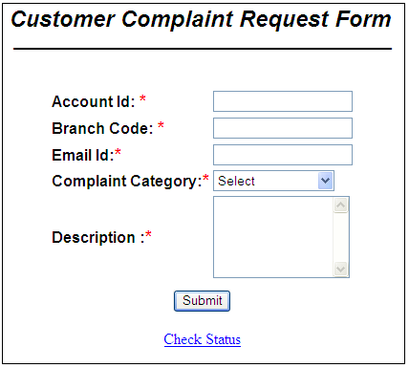
- Navigate to check status page while clicking on Check Status link.
Perform validation for the following:
- All fields are mandatory.
- Email should be valid email id
- Account Id should accept only 10 digits.
Use the validation support provided by the spring to implement the above requirement.

Once the complaint details has been filled by the customer, find priority of the logged complaint based on the table data given below:

Complaint Category | Priority | Status
Internet Banking | High | Open
General Banking | Medium | Open
Others | Low | Open

After the priority has been found, generate complaint id automatically and insert all the details to the database.(While inserting data, status should always be open). When complaint has been logged successfully display the success page as shown below with generated complaint Id.

- Mark Distribution: [Marks:40]
Home Page Design | 2
Mapping user actions to controller class methods | 2
Correct class level annotations and autowiring used | 3
Correct method signatures and use of annotations in Controller class method | 3
Page design | 7
Field Validations using Spring Validator framework | 5
Logic for determining priority | 4
Correct service and DAO layer method signatures | 1
Spring JPA logic in Dao layer to display data and its processing | 8
Displaying the success page with generated complaint id | 5

Success Page:
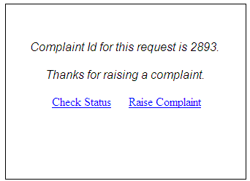

Check Status Page:
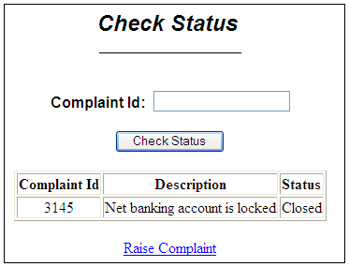

Based on complaint Id entered by the user, Complaint details has to be displayed in the same page,in the format as given in the above screenshot. Navigate to Raise complaint page while clicking on Raise Complaint link.

- Mark Distribution: [Marks: 17 ]
Mapping link to controller class method | 1
Correct Controller class method signature | 1
Correct service and DAO layer method signatures | 2
Spring JPA logic in Dao layer to display data and its processing | 8
Displaying correct data on page | 5

Table Script:
CREATE TABLE complaint(complaintid number primary key,accountid number,branchcode varchar2(20),emailid varchar2(20),category varchar2(20),description varchar2(300),priority varchar2(10),status varchar2(20));
CREATE SEQUENCE hibernate_sequence;
INSERT INTO complaint VALUES(3145,6873842,’FCFC12’,’tina@igate.com’,’Internet Banking’,’Net banking account is locked’,’High’,’Closed’);
INSERT INTO complaint VALUES(3146,6873845,’FCFC12’,’paiva@igate.com’,’Internet Banking’,’Net banking account is locked’,’High’,’Work is in progress’);
Commit;
Note: Participants are kindly requested to follow the same table & sequence structure.

Application Architecture: [Marks:13]
- Mark Distribution:
Package structure according to coding standard | 2
Service layer and Dao Layer interfaces created with proper delegation between the layers | 3
Handling Exceptions | 5
Following Naming convention/coding standards | 3

JSP
CustomerController
Client
ICustomerService
CustomerServiceImpl
ICustomerDAO
CustomerDAOImpl
Database
Spring Controller
Service Layer
DAO Layer

Note:

- Use DAO Support classes for persisting data.
- Use appropriate package structure for each of the applications components

