Falling Bricks Game
⚙️ Prerequisites
Make sure the following are installed before running the application:
- Java 17
- Maven

🚀 Run Application
Option 1: Using Maven
- Navigate to the project folder (where pom.xml exists)
- Run: mvn spring-boot:run
- Open in browser: http://localhost:8080/index.html

Option 2: Using Prebuilt JAR
A prebuilt runnable package is available.
- Navigate to the runartifacts folder
- Execute: run.bat file
- Open in browser: http://localhost:8080/index.html

Once application is launched should see screens like below:
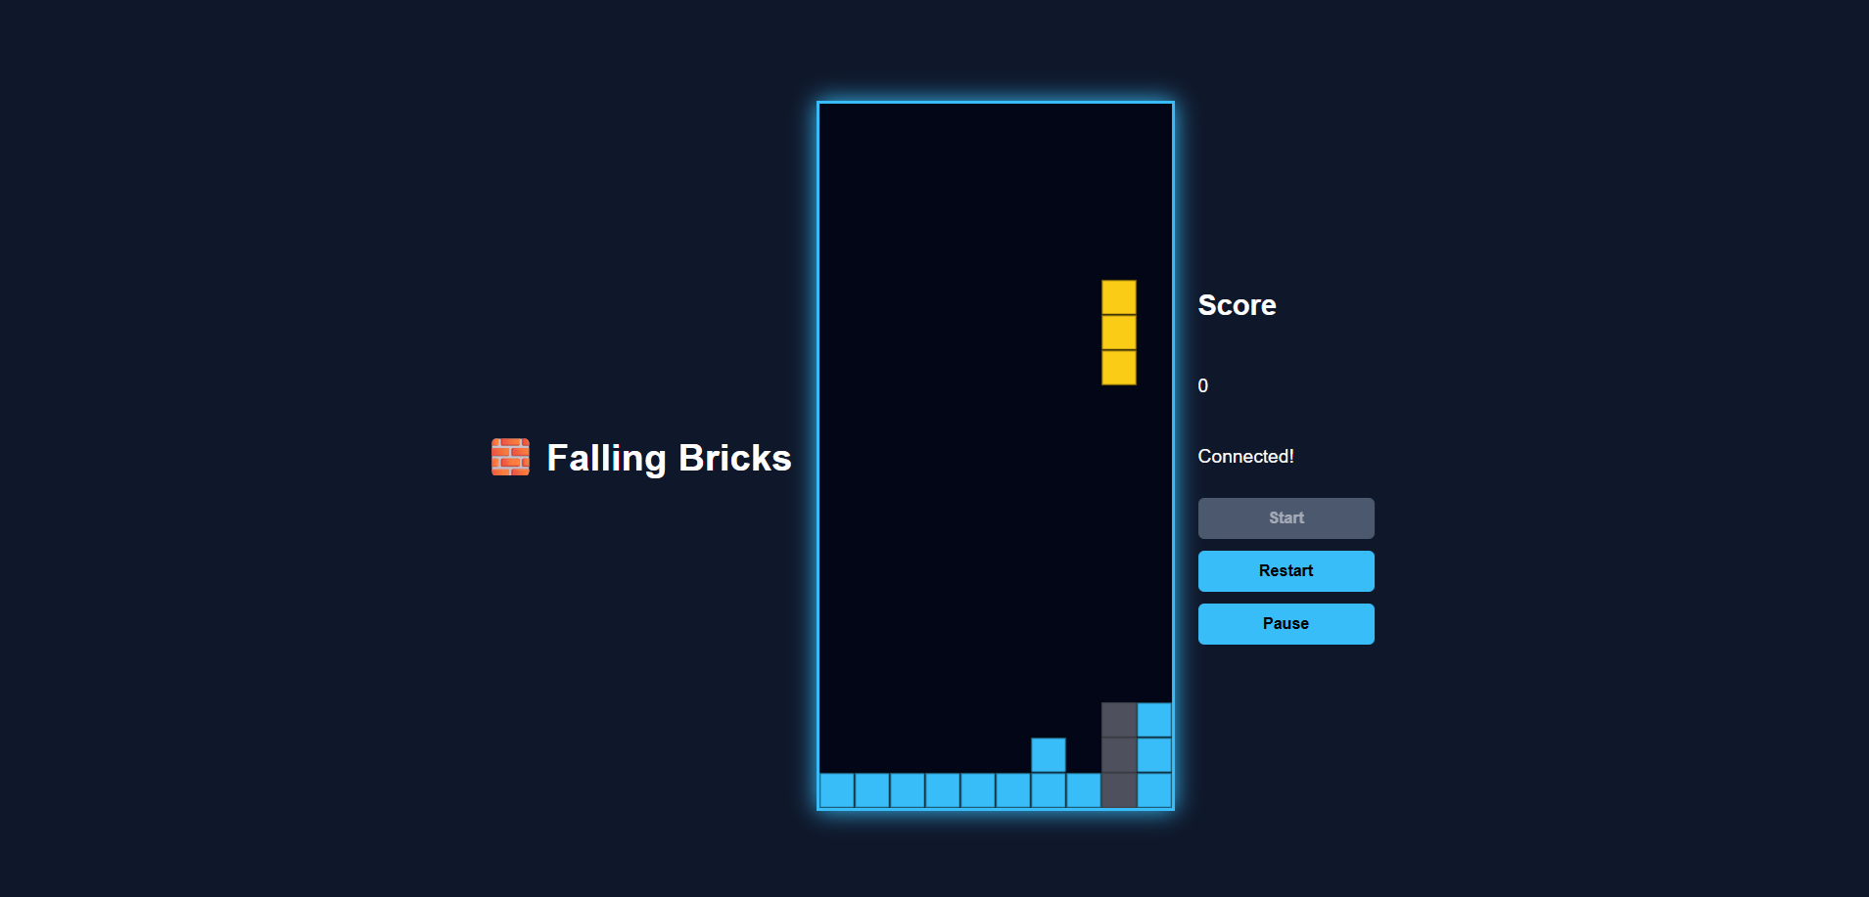

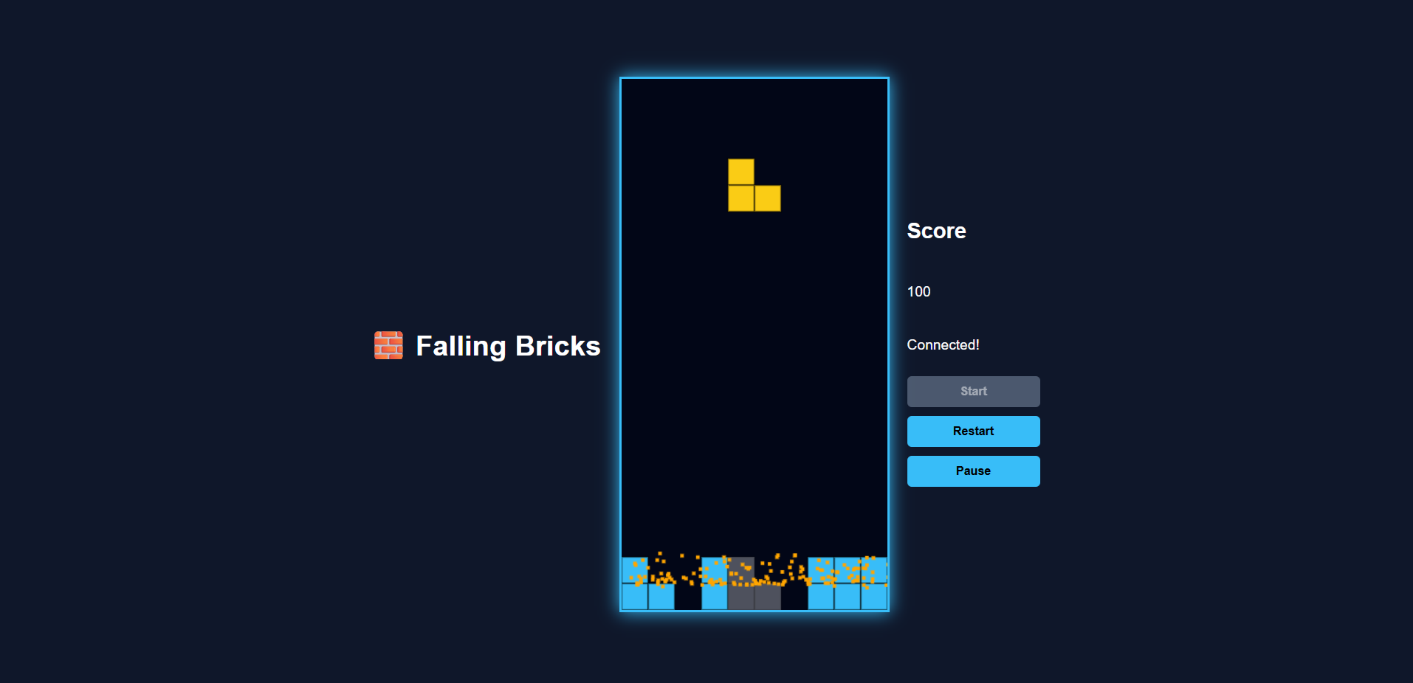
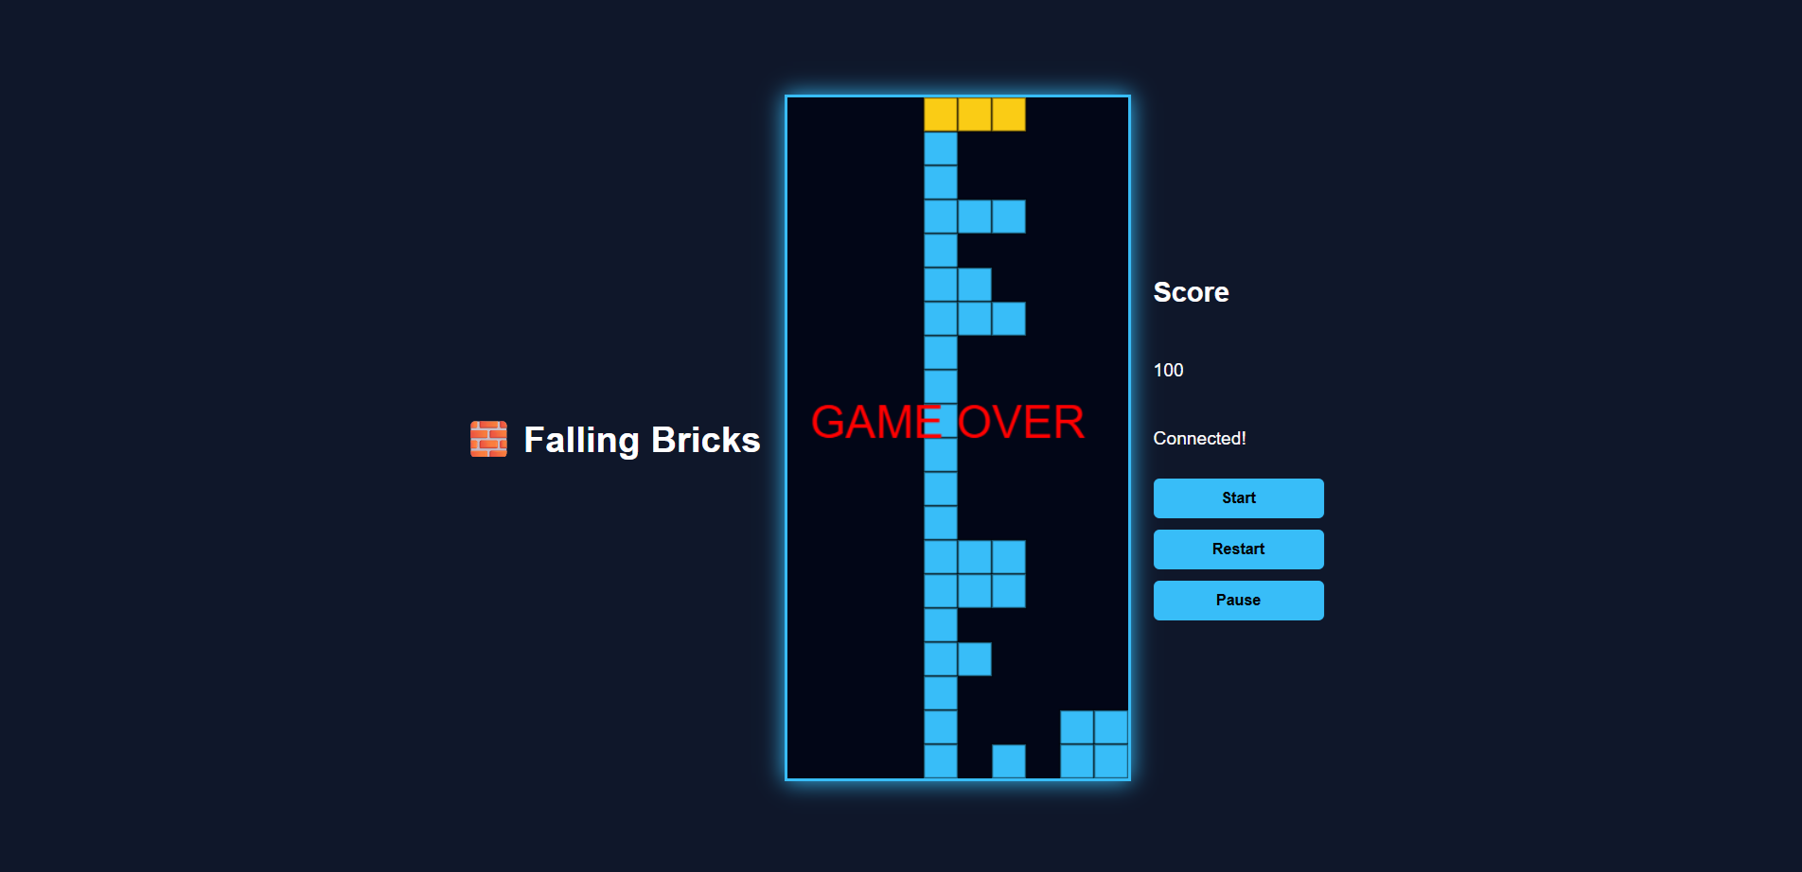

📁 Project Structure
⚙️ Backend Requirements
Technologies
- Java 17
- Spring Boot 4.0.5
- WebSocket (STOMP + SockJS)
- Maven
- Lombok
Responsibilities
- Serve frontend assets
- Manage game state
- Handle real-time communication via WebSockets
- Execute continuous game loop with difficulty scaling

🎮 API (WebSocket-based)
Method | Endpoint | Description
POST | /app/start | Start new game
POST | /app/reset | Reset game
POST | /app/pause | Pause/unpause
POST | /app/move | Move brick (LEFT, RIGHT, FAST_DROP, ROTATE)

🔌 WebSocket Flow
- Client connects to /ws-game
- Sends messages to /app/*
- Server broadcasts updates to /topic/game

🧠 Core Components
GameWebSocketController
- Receives /app/* messages
- Calls GameService & GameLoop
- Broadcasts GameState to /topic/game
GameLoop
- Runs scheduled loop
- Handles:
  - Automatic downward movement
  - Difficulty scaling (speed increase)
- Broadcasts updated game state
GameService
Handles all core logic:
- 10x20 grid board
- Brick shapes (I, L, T, etc.)
- Collision detection
- Gravity system
- Line clearing
- Score calculation
- Game over detection
- Wall-kick rotation
- Ghost piece (landing preview)

🎨 Frontend Requirements
Technologies
- HTML5 Canvas
- JavaScript (ES6)
- CSS3
- Web Audio API
- SockJS + STOMP

📄 index.html
- Canvas (300x600, 10x20 grid)
- Side panel:
  - Score
  - Status
  - Buttons (Start, Restart, Pause)
- Includes:
  - style.css
  - game.js
  - SockJS & STOMP
Button Behavior
- Start
  - Enabled after WebSocket connection
  - Disabled after click
- Restart
  - Resets game
  - Re-enables Start
- Pause
  - Toggles pause state

🎮 game.js
Handles:
WebSocket
- Connects to /ws-game
- Sends:
  - /app/start
  - /app/reset
  - /app/pause
  - /app/move
Controls
- ArrowLeft → Move left
- ArrowRight → Move right
- ArrowDown → Fast drop
- ArrowUp → Rotate
- P → Pause
Rendering
- Board & bricks
- Ghost piece
- Brick borders
- Particle effects (line clear)
- Score display
- Game over message
Sound
- movement.wav plays on:
  - Manual movement
  - Automatic downward movement
- Optional line-clear sound
UI Logic
- Start disables after click
- Restart resets state
- Pause toggles game

🎨 style.css
- Canvas layout
- Side panel styling
- Button styles
- Particle visuals

✨ Features Implemented
- Real-time WebSocket engine (no polling)
- Start button disable logic
- Restart functionality
- Pause functionality
- Live score updates
- Ghost piece preview
- Wall-kick rotation
- Particle effects (line clear)
- Visible brick borders
- Sound effects (movement.wav)
- Fast drop
- Game over detection
- Difficulty scaling (speed increases)
- Responsive UI

🔄 Game Workflow
- Open browser → WebSocket connects
- Start button enabled
- Click Start → game begins
- Use arrow keys to control bricks
- Pause/unpause using P or button
- Score updates live
- Line clears trigger particle animation
- Ghost piece shows landing position
- Restart resets game
- Game over → Start re-enabled
- All movements trigger sound

📦 Deliverables
- Complete Spring Boot project
- Fully functional frontend & backend
- WebSocket + REST endpoints
- Real-time gameplay
- Sound, particles, ghost piece, rotation
- Ready to run via Maven
- Well-structured codebase
- Complete README documentation

📝 Notes
- GameWebSocketController fully handles frontend communication
- GameLoop manages:
  - Auto brick movement
  - Difficulty scaling
  - State broadcasting
- movement.wav is triggered on every brick movement (manual + automatic)

