CO5 – Assessment 2: Pseudocode Writing Task

Name:K.Manoj Kumar Redg.No:192472395

Slot: D Batch:2024

1. Real-Time Face Detection and Recognition

Problem Overview
A security system must continuously capture frames from a live camera, detect multiple faces in each frame, recognize registered individuals using a trained dataset, and display bounding boxes with identity labels — while operating in real time with minimal delay and support for multiple simultaneous faces.

Pipeline Stages Covered
Image acquisition → Pre-processing → Face detection → Feature extraction → Recognition/matching → Visualization → Efficient loop control → Cleanup.

Pseudocode
BEGIN FaceDetectionAndRecognitionSystem

// ---------- 1. INITIALIZATION ----------
LOAD face_detector_model // e.g., Haar Cascade / DNN / MTCNN
LOAD face_recognizer_model // e.g., LBPH / FaceNet / dlib embeddings
LOAD registered_faces_database // pre-computed embeddings + labels

OPEN video_capture FROM camera_source
SET frame_skip_counter = 0
SET frame_skip_threshold = N // process every Nth frame if needed

IF video_capture NOT opened THEN
PRINT "Error: Cannot access camera"
EXIT PROGRAM
END IF

// ---------- 2. MAIN PROCESSING LOOP ----------
WHILE video_capture IS opened DO

STATUS, frame = video_capture.READ_FRAME()
IF STATUS == FALSE THEN
PRINT "Frame capture failed"
BREAK
END IF

frame_skip_counter = frame_skip_counter + 1
IF (frame_skip_counter MOD frame_skip_threshold) != 0 THEN
CONTINUE // skip heavy processing for real-time speed
END IF

// ---------- 3. PRE-PROCESSING ----------
resized_frame = RESIZE(frame, target_width, target_height)
gray_frame = CONVERT_TO_GRAYSCALE(resized_frame)
gray_frame = HISTOGRAM_EQUALIZE(gray_frame) // improves contrast

// ---------- 4. FACE DETECTION ----------
detected_faces = face_detector_model.DETECT_MULTISCALE(
gray_frame,
scaleFactor = 1.1,
minNeighbors = 5,
minSize = (30, 30))

// ---------- 5. LOOP OVER EACH DETECTED FACE ----------
FOR EACH (x, y, w, h) IN detected_faces DO

face_roi = gray_frame[y : y+h, x : x+w]
face_roi = RESIZE(face_roi, standard_size) // normalize input size

// ---------- 6. FEATURE EXTRACTION ----------
face_embedding = face_recognizer_model.EXTRACT_FEATURES(face_roi)

// ---------- 7. RECOGNITION / MATCHING ----------
best_match_label = "Unknown"
best_match_score = INFINITY

FOR EACH (known_embedding, known_label) IN registered_faces_database DO
distance = COMPUTE_DISTANCE(face_embedding, known_embedding)
IF distance < best_match_score THEN
best_match_score = distance
best_match_label = known_label
END IF
END FOR

IF best_match_score > recognition_threshold THEN
best_match_label = "Unknown"
END IF

// ---------- 8. VISUALIZATION ----------
DRAW_RECTANGLE(resized_frame, (x, y), (x+w, y+h), color = GREEN)
DRAW_TEXT(resized_frame, best_match_label, position = (x, y-10))

END FOR

// ---------- 9. DISPLAY OUTPUT ----------
SHOW_IMAGE("Face Detection & Recognition", resized_frame)

// ---------- 10. EFFICIENT LOOP CONTROL ----------
key = WAIT_KEY(1) // 1 ms wait keeps loop near real-time
IF key == 'q' THEN
BREAK // graceful exit on user command
END IF

END WHILE

// ---------- 11. CLEANUP ----------
video_capture.RELEASE()
DESTROY_ALL_WINDOWS()

END FaceDetectionAndRecognitionSystem

Key Design Notes
• Frame skipping (frame_skip_threshold) reduces computational load to sustain real-time throughput.
• Grayscale conversion and histogram equalization improve detection robustness under varying lighting.
• The FOR EACH loop over detected_faces naturally supports multiple simultaneous faces per frame.
• A distance/similarity threshold (recognition_threshold) separates registered persons from "Unknown" faces.
• WAIT_KEY(1) with a minimal delay, combined with a clean BREAK condition, keeps the loop responsive and avoids blocking the video pipeline.

2. Vehicle Detection, Tracking and Counting

Problem Overview
A traffic monitoring system must analyze a live video stream to detect vehicles entering a predefined region of interest (ROI), track multiple vehicles across consecutive frames, count vehicles as they cross a virtual line, and display bounding boxes, tracking IDs, and a running count — while avoiding double counting and maintaining near real-time performance.

Pipeline Stages Covered
Video acquisition → Pre-processing → Vehicle detection → Multi-object tracking → Line-crossing counting logic → Visualization → Efficient loop termination → Cleanup.

Pseudocode
BEGIN VehicleDetectionTrackingCountingSystem

// ---------- 1. INITIALIZATION ----------
LOAD vehicle_detector_model // e.g., YOLO / Haar Cascade / Background Subtractor
CREATE multi_object_tracker // e.g., SORT / DeepSORT / Centroid Tracker

DEFINE region_of_interest (ROI) // polygon or bounding box in the frame
DEFINE counting_line (point_A, point_B) // virtual line for counting

SET vehicle_count = 0
SET tracked_objects = EMPTY_MAP // key = tracking_id, value = object_state
SET counted_ids = EMPTY_SET // prevents double counting
SET next_tracking_id = 0

OPEN video_capture FROM video_source
IF video_capture NOT opened THEN
PRINT "Error: Cannot access video stream"
EXIT PROGRAM
END IF

// ---------- 2. MAIN PROCESSING LOOP ----------
WHILE video_capture IS opened DO

STATUS, frame = video_capture.READ_FRAME()
IF STATUS == FALSE THEN
PRINT "End of stream or read failure"
BREAK
END IF

// ---------- 3. PRE-PROCESSING ----------
resized_frame = RESIZE(frame, target_width, target_height)
roi_frame = APPLY_MASK(resized_frame, region_of_interest)
blurred_frame = GAUSSIAN_BLUR(roi_frame, kernel_size = (5,5))

// ---------- 4. VEHICLE DETECTION ----------
detections = vehicle_detector_model.DETECT(blurred_frame)
// each detection = (x, y, w, h, confidence, class_label)

FILTERED_DETECTIONS = EMPTY_LIST
FOR EACH detection IN detections DO
IF detection.confidence >= confidence_threshold
AND detection.class_label == "vehicle" THEN
APPEND detection TO FILTERED_DETECTIONS
END IF
END FOR

// ---------- 5. TRACKING (associate detections with existing tracks) ----------
active_tracks = multi_object_tracker.UPDATE(FILTERED_DETECTIONS)
// returns list of (tracking_id, bounding_box, centroid) pairs

// ---------- 6. COUNTING LOGIC ----------
FOR EACH (tracking_id, bbox, centroid) IN active_tracks DO

IF tracking_id NOT IN tracked_objects THEN
tracked_objects[tracking_id] = {
previous_centroid : centroid,
crossed : FALSE
}
ELSE
previous_centroid = tracked_objects[tracking_id].previous_centroid

// Check whether the vehicle's path crosses the counting line
IF LINE_CROSSED(previous_centroid, centroid, point_A, point_B)
AND tracking_id NOT IN counted_ids THEN

vehicle_count = vehicle_count + 1
ADD tracking_id TO counted_ids // avoid double counting
tracked_objects[tracking_id].crossed = TRUE
END IF

tracked_objects[tracking_id].previous_centroid = centroid
END IF

// ---------- 7. VISUALIZATION ----------
DRAW_RECTANGLE(resized_frame, bbox, color = BLUE)
DRAW_TEXT(resized_frame, "ID:" + tracking_id, position = bbox.top_left)

END FOR

// Remove stale tracks that have disappeared for too long
PRUNE_STALE_TRACKS(tracked_objects, max_missed_frames)

// ---------- 8. DISPLAY OUTPUT ----------
DRAW_LINE(resized_frame, point_A, point_B, color = RED)
DRAW_TEXT(resized_frame, "Count: " + vehicle_count, position = (10, 30))
SHOW_IMAGE("Vehicle Detection, Tracking & Counting", resized_frame)

// ---------- 9. EFFICIENT LOOP TERMINATION ----------
key = WAIT_KEY(1)
IF key == 'q' THEN
BREAK // graceful, user-controlled exit
END IF

END WHILE

// ---------- 10. CLEANUP ----------
video_capture.RELEASE()
DESTROY_ALL_WINDOWS()
PRINT "Final Vehicle Count: ", vehicle_count

END VehicleDetectionTrackingCountingSystem

Key Design Notes
• The ROI mask restricts detection/processing to the relevant part of the frame, reducing false positives and computation.
• A multi-object tracker (e.g., SORT/DeepSORT/Centroid Tracker) assigns a persistent tracking_id to each vehicle across frames, enabling correct handling of multiple simultaneous vehicles.
• Double counting is avoided using a counted_ids set — once a tracking_id has been counted, it is never counted again, even if it keeps crossing near the line.
• LINE_CROSSED() compares the previous and current centroid positions relative to the counting line to detect a genuine crossing event (not just proximity).
• PRUNE_STALE_TRACKS() removes tracks for vehicles that have left the frame, keeping the tracked_objects map efficient for near real-time performance.
• The loop terminates cleanly on a user key-press ('q') or when the video stream ends, followed by proper release of resources.

Figure 1 — Face Detection and Recognition: Illustrative Graph
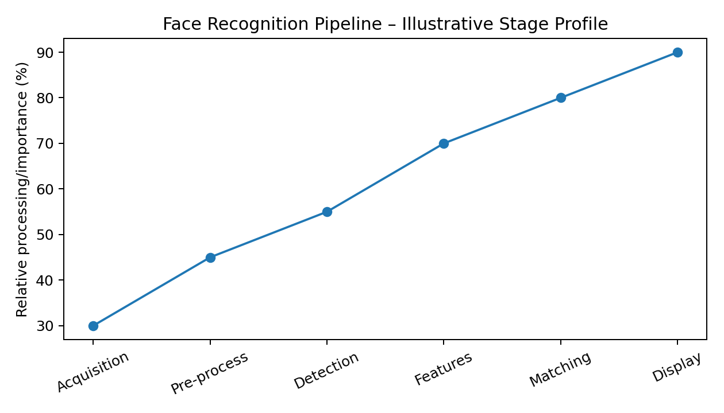
The graph provides an illustrative visual representation of the relative role of each processing stage in the face-recognition pipeline.
Figure 2 — Vehicle Detection, Tracking and Counting: Illustrative Graph
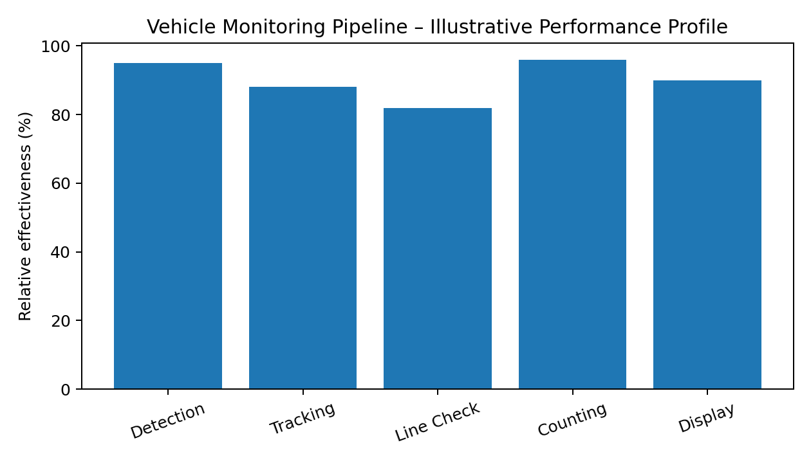
The graph provides an illustrative comparison of the major stages used in vehicle monitoring and counting.

