CO4 – AT3: COMPARATIVE ANALYSIS

Student Name:K.Manoj Kumar Reg. No.:192472395
Section / Batch: 2024 Date:20/08/2026

QUESTION 1 — OBJECT DETECTION PERFORMANCE COMPARISON
Question: Two object detection models, Viola–Jones and YOLO, produce the following results: Model A has 80 True Positives, 20 False Positives, and 30 False Negatives, while Model B has 90 True Positives, 15 False Positives, and 20 False Negatives. (a) Calculate the precision and recall for both models. (b) Compare the results and determine which model provides better overall object detection performance.
We will evaluate both object detection models using the standard precision and recall metrics, then compare the results to determine which model offers superior overall detection performance.
1. Problem Analysis
Object detection performance cannot be judged from raw counts of correct and incorrect detections alone. Two complementary metrics are required: precision, which measures how many of the detections made were actually correct, and recall, which measures how many of the actual objects present were successfully detected. Comparing both models on these two metrics together gives a fair picture of overall detection quality.
2. Concepts Applied

- True Positive (TP) — a correctly detected object.
- False Positive (FP) — a detection that does not correspond to a real object.
- False Negative (FN) — a real object that the model failed to detect.
- Precision = TP / (TP + FP) — correctness of the positive detections.
- Recall = TP / (TP + FN) — completeness of detection of actual objects.
3. Given Data
Model | TP | FP | FN
Model A (Viola–Jones) | 80 | 20 | 30
Model B (YOLO) | 90 | 15 | 20

4. Calculation
Model A:
- Precision = 80 / (80 + 20) = 80 / 100 = 0.80 → 80%
- Recall = 80 / (80 + 30) = 80 / 110 ≈ 0.727 → 72.73%
Model B:
- Precision = 90 / (90 + 15) = 90 / 105 ≈ 0.857 → 85.71%
- Recall = 90 / (90 + 20) = 90 / 110 ≈ 0.818 → 81.82%
5. Results Summary
Model | Precision | Recall | F1-Score
Model A (Viola–Jones) | 80.00% | 72.73% | 76.19%
Model B (YOLO) | 85.71% | 81.82% | 83.72%

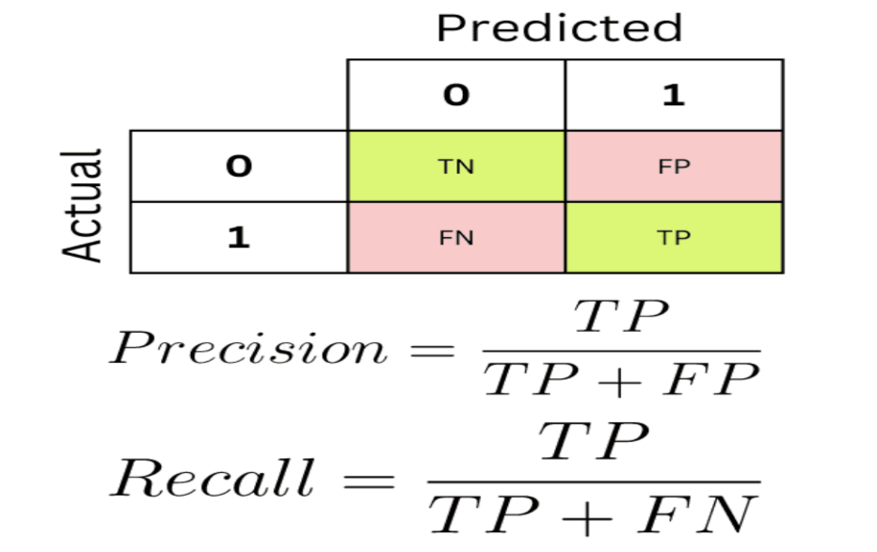
6. Comparison and Justification
- Model B achieves higher precision (85.71% vs 80.00%), meaning a smaller proportion of its detections are false alarms.
- Model B achieves higher recall (81.82% vs 72.73%), meaning it misses fewer actual objects.
- Since Model B outperforms Model A on both metrics simultaneously, its F1-score (the harmonic mean of precision and recall) is also higher — 83.72% versus 76.19%.
Conclusion
Model B (YOLO) provides better overall object detection performance than Model A (Viola–Jones), since it delivers both higher precision and higher recall, and consequently a higher F1-score. This indicates that Model B detects more of the true objects while generating fewer false alarms, making it the more reliable detector overall.

QUESTION 2 — MOTION ESTIMATION ERROR ANALYSIS
Question: Two motion estimation techniques produce the following displacement errors in pixels: Method A: 2, 3, 2 and Method B: 3, 5, 4 for three consecutive frames. (a) Calculate the average displacement error for both methods. (b) Compare the two methods and determine which method provides more accurate motion estimation. (c) Justify your answer based on the error values.
We will evaluate the accuracy of two motion estimation techniques by computing their average displacement error across three consecutive frames and comparing the results.
1. Problem Analysis
Motion estimation accuracy is judged by how close the estimated displacement is to the true displacement of objects between frames. The displacement error (in pixels) for each frame represents this deviation. A lower average error across frames indicates a more accurate and reliable motion estimation technique.
2. Concepts Applied
- Displacement Error — the pixel-wise deviation between the estimated and actual motion vector for a frame.
- Average Displacement Error — the mean of the per-frame errors, used as an overall accuracy indicator.
- Lower average error corresponds to higher motion estimation accuracy.
3. Given Data
Method | Frame 1 | Frame 2 | Frame 3
Method A | 2 | 3 | 2
Method B | 3 | 5 | 4

4. Calculation
Average Displacement Error = (Error₁ + Error₂ + Error₃) / 3
- Method A: (2 + 3 + 2) / 3 = 7 / 3 ≈ 2.33 pixels
- Method B: (3 + 5 + 4) / 3 = 12 / 3 = 4.00 pixels
5. Results Summary
Method | Average Displacement Error (px)
Method A | 2.33
Method B | 4.00

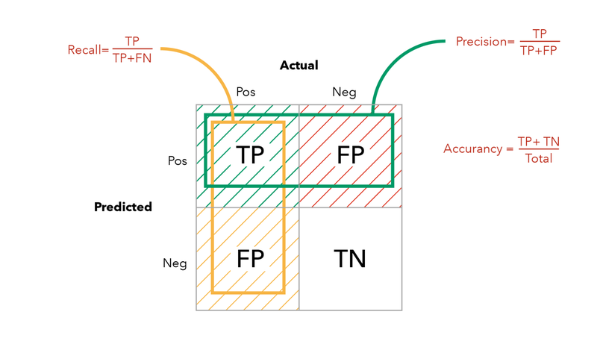
6. Comparison and Justification
- Method A has a lower average displacement error (2.33 px) than Method B (4.00 px).
- A smaller displacement error means the estimated motion is consistently closer to the true motion across all three frames.
- Method A also shows more consistent per-frame errors (2, 3, 2), whereas Method B's errors are both larger and more variable (3, 5, 4).
Conclusion
Method A provides more accurate motion estimation than Method B, since its average displacement error (2.33 pixels) is significantly lower than that of Method B (4.00 pixels). The lower and more consistent error values indicate that Method A tracks true motion more precisely across consecutive frames.

QUESTION 3 — DEPTH ESTIMATION COMPARISON
Question: A stereo vision system and a Structure-from-Motion (SfM) system estimate the depth of three objects. The estimated depths are: Stereo Vision: 2.0 m, 3.0 m, 4.0 m and SfM: 2.5 m, 3.8 m, 5.0 m, while the actual depths are 2 m, 3 m, and 4 m, respectively. (a) Calculate the absolute error for each object for both methods. (b) Calculate the average absolute error for both methods. (c) Compare the methods and identify which provides more accurate depth estimation.
We will assess the accuracy of a stereo vision system and a Structure-from-Motion (SfM) system by computing the absolute error of each depth estimate against the ground-truth depth, and then comparing their average errors.
1. Problem Analysis
Depth estimation accuracy is evaluated by comparing each system's estimated depth to the true (actual) depth of the corresponding object. The absolute error captures the magnitude of deviation for each object, regardless of direction, and the average absolute error summarizes overall accuracy across all objects.
2. Concepts Applied
- Absolute Error = |Estimated Depth − Actual Depth|.
- Average Absolute Error (AAE) = mean of the absolute errors across all objects.
- Lower average absolute error indicates higher depth estimation accuracy.
3. Given Data
Object | Actual Depth (m) | Stereo Vision (m) | SfM (m)
Object 1 | 2.0 | 2.0 | 2.5
Object 2 | 3.0 | 3.0 | 3.8
Object 3 | 4.0 | 4.0 | 5.0

4. Calculation — Absolute Error per Object
Stereo Vision:
- Object 1: |2.0 − 2.0| = 0.0 m
- Object 2: |3.0 − 3.0| = 0.0 m
- Object 3: |4.0 − 4.0| = 0.0 m
SfM:
- Object 1: |2.5 − 2.0| = 0.5 m
- Object 2: |3.8 − 3.0| = 0.8 m
- Object 3: |5.0 − 4.0| = 1.0 m
5. Average Absolute Error
- Stereo Vision: (0.0 + 0.0 + 0.0) / 3 = 0.0 m
- SfM: (0.5 + 0.8 + 1.0) / 3 = 2.3 / 3 ≈ 0.77 m
6. Results Summary
System | Err. 1 (m) | Err. 2 (m) | Err. 3 (m) | Avg. Abs. Error (m)
Stereo Vision | 0.0 | 0.0 | 0.0 | 0.00
SfM | 0.5 | 0.8 | 1.0 | 0.77

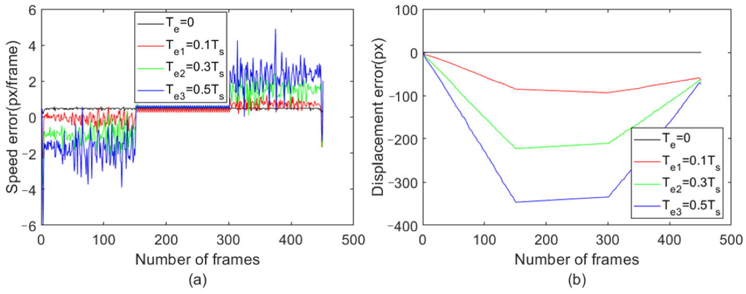
7. Comparison and Justification
- The stereo vision system's estimates exactly match the actual depths for all three objects, giving a zero average absolute error.
- The SfM system consistently overestimates depth, with the error increasing as actual depth increases (0.5 m, 0.8 m, 1.0 m), giving an average absolute error of about 0.77 m.
- Since a lower average absolute error indicates higher accuracy, stereo vision clearly outperforms SfM for this dataset.
Conclusion
The stereo vision system provides more accurate depth estimation than the Structure-from-Motion (SfM) system, since its average absolute error (0.00 m) is far lower than that of SfM (0.77 m). SfM's growing error at larger depths is a known limitation of monocular/multi-view triangulation without a fixed baseline, whereas stereo vision's fixed, calibrated baseline yields consistently accurate depth results here.

