Local LLM Development Intelligence Case Study: Kazakhstan NHDR 2002

1. Overview
This project focuses on analysing the Kazakhstan National Human Development Report 2002: Rural Development in Kazakhstan – Challenges and Prospects using locally hosted large language models. The main goal was to extract useful information from the PDF, including chapter summaries, development indicators and major themes, and present the results in an interactive dashboard. To understand which model performed better, the outputs from two extraction models were compared using a separate evaluation model.
The report contains 123 pages. After extracting and cleaning the text, a total of 38,944 words remained and were divided into four chapter-based sections for processing. Information extraction was carried out using qwen2.5:7b and llama3.1:8b, while gemma2:9b was used to evaluate and compare the extracted results. All models were executed locally through Ollama, allowing the entire pipeline to run without cloud-based services.
2. Methods
The overall workflow was divided into four stages, covering data preparation, information extraction and model evaluation.
The first stage focused on processing the source PDF. The report was loaded using the pypdf library, after which the extracted text was cleaned by removing repeated headers, page numbers and unnecessary line breaks. During preprocessing, it was noticed that the table of contents and some section headings were not extracted consistently because of the PDF layout. To avoid this issue, the report was manually divided according to its original chapter structure, resulting in four chapter-based chunks.
The second stage involved deterministic extraction before applying the LLMs. Theme keywords were counted across seven categories: education, health, inequality, economy, gender, climate/environment and employment. In addition, evidence lines containing development indicators were identified by searching for terms such as HDI, GDP, population, poverty, wages, health, education and unemployment in sentences that included numerical values. This ensured that important quantitative information could be retained for later analysis.

The third stage used two locally hosted LLMs, qwen2.5:7b and llama3.1:8b, to generate structured JSON outputs. Each model produced chapter summaries of fewer than 100 words together with key points, numerical indicators, full-report findings, strengths, challenges, theme analysis and dashboard plot ideas. Using a structured JSON format made it easier to compare the outputs from both models and integrate the extracted information into the dashboard.
The final stage involved evaluating the outputs generated by the two extraction models. The gemma2:9b model was used as an independent evaluator and compared both outputs against the evidence lines extracted from the report. It assessed consistency, completeness, factual alignment, numerical extraction and dashboard usefulness before recommending which model produced better summaries and indicator extraction.

3. Prompt Design
Three prompts were developed for different stages of the pipeline. Rather than using a single prompt for every task, each prompt was designed for a specific objective, allowing the models to produce more consistent and structured outputs. The complete prompt templates are included in Appendix A, while this section explains their purpose.
3.1 Chapter Extraction Prompt
The first prompt was used to process each chapter individually. It instructed the model to return a JSON object containing the chapter number, chapter title, a summary of fewer than 100 words, key points, important numerical indicators, themes identified within the chapter, and any limitations or uncertainties. To improve reliability, the model was instructed to use only the supplied chapter text and return an empty list whenever no numerical values were present.
3.2 Full-Report Extraction Prompt
After all chapter-level outputs had been generated, a second prompt combined those results with the evidence lines and deterministic theme counts collected during preprocessing. The model then produced a complete report-level JSON containing metadata, key findings, strengths, challenges, core indicators, theme analysis, demographic and time-based trends, dashboard visualisation ideas and extraction notes. The prompt also instructed the model to preserve numerical values exactly as they appeared in the original report.
3.3 Evaluator Prompt
The third prompt was created for the evaluation stage. It asked the gemma2:9b model to compare the outputs generated by qwen2.5:7b and llama3.1:8b against the supporting evidence extracted from the report. Each model was assessed for consistency, completeness, factual alignment, numerical extraction and dashboard usefulness. Besides the numerical scores, the evaluator also identified strengths, weaknesses, unsupported claims, agreements, disagreements and recommended which extraction approach should be used.
Using separate prompts for each stage made the pipeline easier to manage and ensured that every model had a clearly defined task. Keeping the outputs in a consistent JSON structure also simplified downstream processing, model comparison and integration with the dashboard.

4. Extracted Results
The extracted information shows that rural development was one of the major human development challenges identified in the Kazakhstan National Human Development Report 2002. According to the extracted results, rural areas covered 97.2% of the country's land while accounting for almost half of the population. Both qwen2.5:7b and llama3.1:8b consistently identified rural poverty, declining agricultural performance, demographic changes, limited access to public services and regional inequality as the dominant themes throughout the report.
The keyword analysis highlighted inequality as the most frequently occurring theme across all chapter sections. The distribution of theme frequencies obtained during deterministic keyword extraction is presented in Table 1: Distribution of Extracted Development Themes.

Theme | Count
Inequality | 628
Economy | 277
Climate/environment | 200
Education | 186
Health | 119
Employment | 98
Gender | 90
Table 1: Distribution of Extracted Development Themes

Several important numerical indicators were also extracted from the report. In 2001, 38% of the rural population lived below the subsistence minimum, compared with 28.4% of the national population. The extracted regional data also showed large differences in poverty levels, with Mangistau (95%) recording the highest rural poverty rate, followed by Zhambyl (53%), Atyrau (48%), Kyzylorda (47%), Aktobe (45%), and South Kazakhstan (44%).
The extracted economic indicators demonstrate a substantial decline in the importance of agriculture over time. Agriculture contributed 34% of Kazakhstan's GDP in 1990, falling to 9.9% in 1999 and 8.7% in 2001. The report also indicates that agricultural wages declined relative to both industrial wages and the national average, suggesting that rural households experienced increasing economic pressure during the post-transition period.
Population statistics extracted from the report reveal a continuing demographic decline. Kazakhstan's total population decreased from 16,199,154 in 1989 to 14,953,126 in 1999, representing a reduction of approximately 1.2 million people. During the same period, the rural population fell by 440,695, leaving 6,579,064 people living in rural areas, equivalent to 44% of the country's total population.
Access to public services was another issue identified by both extraction models. Following the restructuring of the education and healthcare systems, almost 60% of villages had lost facilities such as medical care stations, libraries, clubs and food shops. By 1999, approximately 1,200 villages no longer had a local first aid station. Government spending also declined slightly, with education expenditure decreasing from 3.3% of GDP in 2000 to 3.2% in 2001, while health expenditure fell from 2.1% to 1.9% over the same period.
The extracted results also highlighted limited entrepreneurial activity among low-income rural households. Only 0.2% of these households operated their own business. The main barriers reported were the lack of start-up capital (68%), difficulty obtaining loans (38%), and insufficient knowledge or experience (34%).
5. Evaluation of Extraction Models
The evaluation showed that each extraction model performed better in different parts of the pipeline. Based on the evaluator's feedback, qwen2.5:7b produced a more coherent full-report structure and was considered the stronger model for extracting numerical indicators. Its outputs organised the extracted evidence into clear dashboard categories, including poverty, public spending, HDI-related gaps, service access and entrepreneurship constraints.
In comparison, llama3.1:8b generated more detailed textual summaries and was selected as the better model for chapter summarisation. It captured more regional information, wage-related evidence, poverty statistics and household survey findings. However, some of its JSON outputs were less consistently structured than those produced by qwen2.5:7b.
The evaluation itself was carried out using the gemma2:9b model. Although it assigned both extraction models a score of 1 out of 5 across all five evaluation criteria, the accompanying comments suggested that both models still produced useful and relevant outputs. Because of this inconsistency, the qualitative feedback was considered more informative than the numerical scores alone.
One of the main differences highlighted by the evaluator concerned the interpretation of the post-transition "optimisation" process and its impact on rural health and education services. Since this point relied on interpretation rather than simple numerical extraction, it was identified as an area that should be verified against the original PDF before the final submission.

6. Dashboard Visualisation
The dashboard is stored in dashboard/index.html and was developed as an offline, single-file application. It provides a visual summary of the information extracted from the report and contains six visualisations, as shown in Table 2: Dashboard Visualisations and Their Purpose.
Plot | Purpose
Theme distribution | Shows which development themes dominate the report text
Regional rural poverty | Compares poverty intensity across selected regions
Agriculture share of GDP | Shows the 1990-2001 decline in agriculture's GDP share
Model evaluation radar | Compares extractor models using Gemma's evaluation dimensions
Barriers to entrepreneurship | Visualizes reasons rural low-income households did not start businesses
Public social spending | Shows education and health spending changes from 2000 to 2001
Table 2: Dashboard Visualisations and Their Purpose
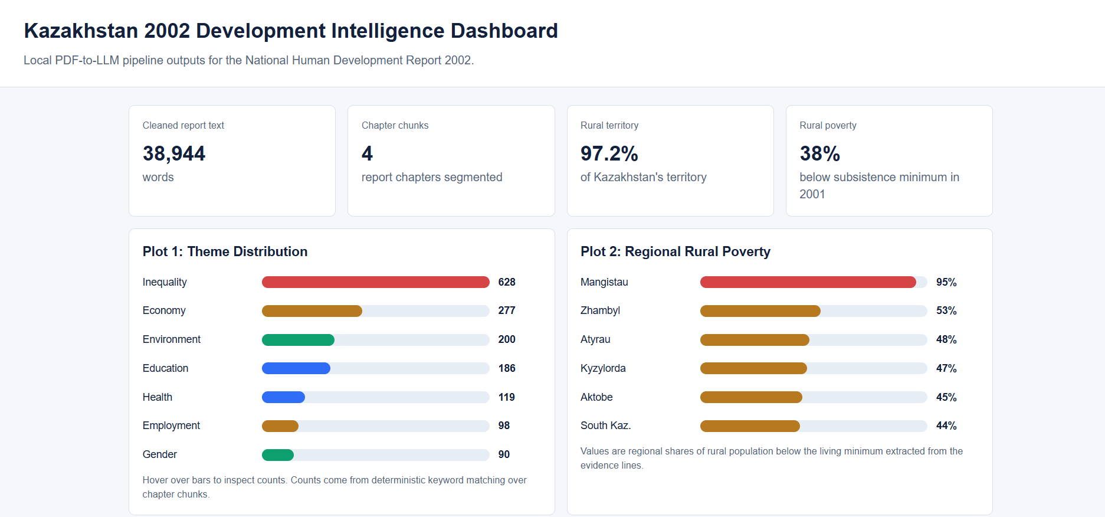

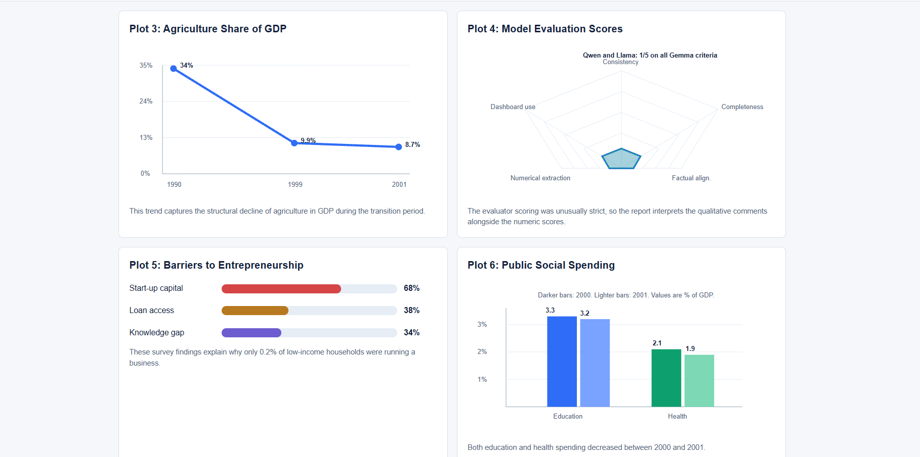

Figure 1: Dashboard

These visualisations present the extracted results in an easy-to-understand format and help connect the outputs generated by the LLMs with downstream visual analysis. The dashboard also includes a structured indicator table, allowing the numerical values shown in the charts to be traced back to the extracted evidence from the report.

7. Interpretation and Limitations
After analysing the extracted results, it became clear that agriculture was only one part of the overall picture. The report also placed considerable emphasis on poverty, declining population, weaker public services and limited employment and business opportunities in rural areas. These issues appeared consistently across different chapters, indicating that rural development depends on a combination of social, economic and institutional improvements rather than changes to agriculture alone.
There were also a few limitations during the implementation of this project. The biggest issue was the quality of the extracted PDF text. Some tables and special characters were not parsed correctly, which means values taken from tables should always be checked against the original report before being used. Another limitation was the behaviour of the language models. Although both extraction models produced useful outputs, they did not always focus on the same information. In some cases, one model included details that the other either summarised differently or left out completely.
The gemma2:9b evaluator also produced unexpectedly low scores, even though its written comments recognised useful strengths in both models. Because of this, the written evaluation was considered more reliable than the numerical scores alone.
If this project were extended in the future, there are a few areas that could be improved. A more detailed scoring rubric could make the evaluation process more consistent, the evaluator prompts could be refined further, and page references could be added for every extracted indicator so that each value shown in the dashboard can be verified more easily.

8. References
United Nations Development Programme (UNDP) (2002) Kazakhstan National Human Development Report 2002: Rural Development in Kazakhstan: Challenges and Prospects. Available at: https://hdr.undp.org/
Ollama (2025) Ollama. Available at: https://ollama.com/
Alibaba Cloud (2024) Qwen2.5. Available at: https://qwenlm.github.io/
Meta (2024) Llama 3.1. Available at: https://ai.meta.com/llama/
Google (2024) Gemma 2. Available at: https://ai.google.dev/gemma
9. Appendix
A.1: Chapter Extraction Prompt
“You are extracting information from the Kazakhstan National Human Development Report 2002.
Return JSON with chapter number, chapter title, a summary under 100 words, key points,
important indicators or numbers, themes present, and limitations or uncertainties.
Rules: use only the chapter text, keep the summary under 100 words, and use an empty list
where no numerical value is found.”

A.2: Full-Report Extraction Prompt
“Use chapter-level model outputs, indicator evidence lines from the PDF, and deterministic
theme keyword counts. Return JSON containing report metadata, 5-8 key findings, 5-8 strengths,
5-8 challenges, core indicators, theme analysis, demographic or time trends for plots,
dashboard-ready plot ideas, and extraction notes. Preserve numerical values exactly where possible.”

A.3: Evaluator Prompt
“Evaluate Qwen and Llama extractor outputs against source evidence lines. Score each model from
1 to 5 for consistency, completeness, factual alignment, numerical extraction, and dashboard
usefulness. Do not use placeholder text. Return strengths, weaknesses, unsupported claims,
agreements, disagreements, and a recommended final extraction strategy.”

