An Auditable Hybrid Pipeline for Nuclei Image Analysis
- Introduction and Aim
This work developed a nuclei-image analysis pipeline combining preprocessing, multimodal description, classical segmentation, U-Net segmentation and structured LLM reporting. Performance was evaluated on unseen images. LLM outputs were descriptive, not diagnostic. Images were converted to grayscale and images and masks were resized to 256×256. Nearest-neighbour interpolation was used for masks. The final split contained 80 training, 20 validation and 12 unseen test images, with random seed 42.
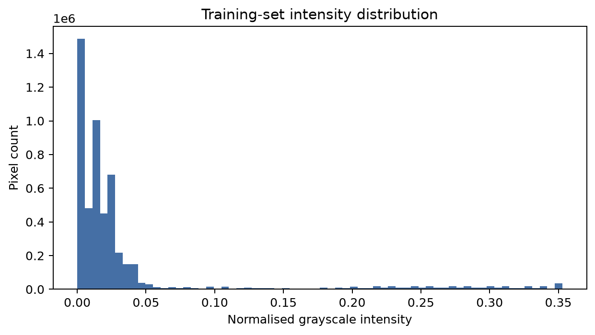
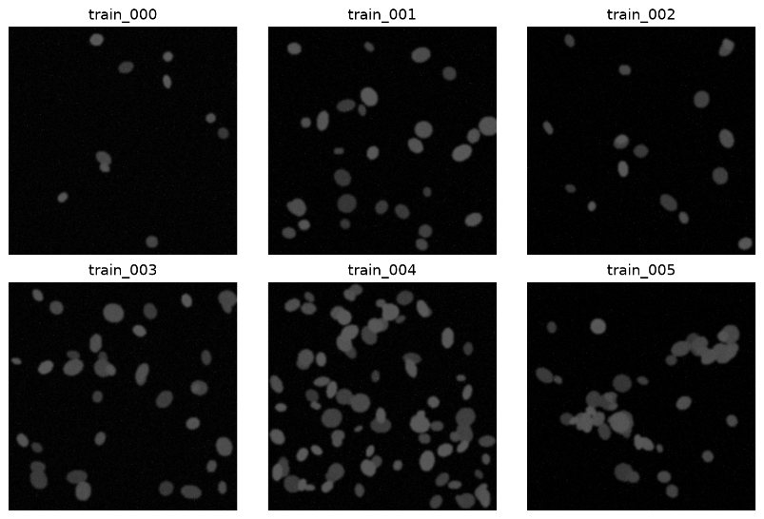

Figure 1: Data preparation and exploratory analysis: (a) representative grayscale 256×256 nuclei images; (b) pixel-intensity distribution.

The samples vary in object count, density, brightness and size. Most pixels are dark, with nuclei forming a smaller
brighter foreground.

Vision-language model
Naive prompt - “Describe this medical image.”
The naive response included unsupported biological interpretations. I therefore used a stricter prompt that limited the model to visible evidence, required valid JSON and allowed "uncertain" where the image did not support a conclusion.
Optimised vision prompt
“You are describing an educational microscopy image, not diagnosing disease.
Report only directly visible evidence.
Do not infer a patient, disease, prognosis, or treatment.
If an attribute cannot be established visually, use the exact string "uncertain".
Return exactly one JSON object and no markdown or commentary, with these keys:
{
"modality": "fluorescence microscopy|uncertain",
"tissue_type": "brief visible specimen description|uncertain",
"notable_features": ["brief non-diagnostic visual observations"],
"image_quality": "good|acceptable|poor|uncertain"
}
Do not add keys.
The JSON must parse with a standard JSON parser.”

Example output:
{"modality":"fluorescence microscopy",
"tissue_type":"uncertain",
"notable_features":["brightly stained nuclei, faint cytoplasmic staining"],
"image_quality":"good"}
All three optimised runs returned valid JSON, although wording and reported features varied slightly. Two runs returned "cell culture" while another returned "uncertain", showing that structured prompting improves control but does not remove run-to-run variability.

- Classical Segmentation and U-Net
Numbers-first pipeline
Otsu thresholding was applied, very small regions removed, connected components labelled and measurements extracted with region props. Only numerical measurements were sent to the LLM: object count, foreground fraction, mean area, eccentricity, solidity, mean intensity, density class and Otsu threshold.
Numbers-first prompt template
“You receive measurements derived from a binary microscopy segmentation; you never see the image.
Use only the supplied numbers.
Do not diagnose disease or invent visual details.
Return exactly one JSON object and no markdown, with keys:
{
"n_objects": integer copied from input,
"density_class": "sparse|normal|dense|uncertain",
"shape_regularity": "regular|mixed|irregular|uncertain",
"quality_flag": "ok|review|uncertain"
}
If evidence is insufficient, use "uncertain". Measurements: <MEASUREMENTS_JSON>”

For train_000: 9 objects; foreground fraction 0.0200; mean area 145.67; eccentricity 0.4971; solidity 0.9383; density sparse. The LLM returned shape regularity = mixed and quality = ok.

U-Net
A compact U-Net was trained for binary nuclei segmentation using batch normalisation and augmentation. Adam was used with learning rate 0.001, BCE + Dice loss, 25 epochs and a prediction threshold of 0.5. The best checkpoint was epoch 24. These choices provided a small trainable model while the combined loss directly encouraged accurate foreground overlap.
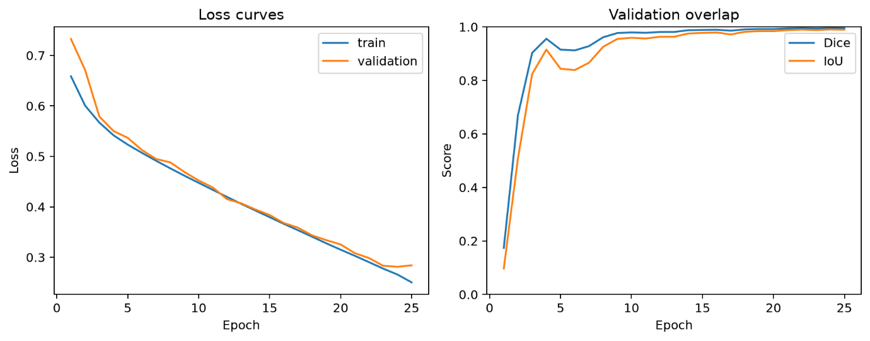

Figure 2: U-Net training history using BCE+Dice loss across 25 epochs.

Training and validation loss decreased strongly, while validation Dice stabilised near 0.995. The curves remained close overall, so there was no obvious sign of severe overfitting.

- Segmentation Results and Hybrid Pipeline
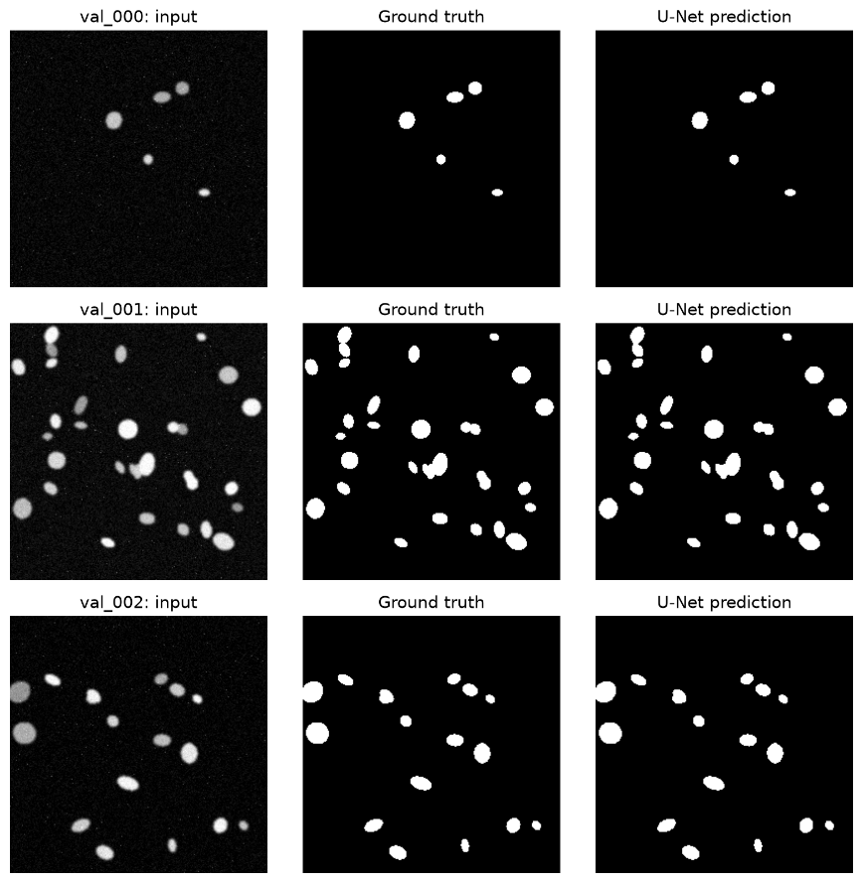
Method | Images | Dice | IoU
U-Net validation | 20 | 0.9952 | 0.9904
U-Net test | 12 | 0.9954 | 0.9908
Otsu test | 12 | 0.9784 | 0.9577
Table 1. Segmentation performance on held-out validation and unseen test images.

Figure 3: Held-out validation examples showing the input image, ground-truth mask and U-Net prediction.

Predictions closely matched the ground-truth masks. The visible differences were mainly small boundary variations, including around closely positioned objects.
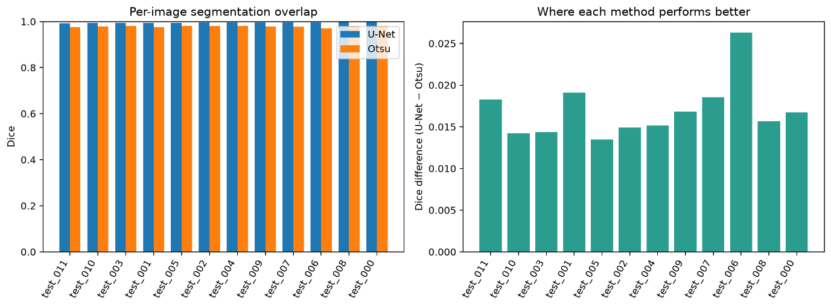

U-Net scored higher than Otsu on all 12 test images. test_006 showed the largest U-Net advantage, while test_005 was the closest comparison. Otsu nevertheless remains valuable because it is transparent, fast and requires no labelled training data.
Figure 4: Per-image U-Net and Otsu segmentation performance on the unseen test split.

Hybrid pipeline
U-Net mask → regionprops → validated JSON → narrative → aggregated CSV
Hybrid record template
“Create one auditable JSON record from segmentation measurements.
Copy image_id, n_objects, and mean_area exactly. Select density_class only from sparse, normal, dense, or uncertain, and quality_flag only from ok, review, or uncertain.
Do not diagnose or add keys.
Return exactly one JSON object and no markdown:
{"image_id":"string","n_objects","mean_area","density_class":"sparse|normal|dense|uncertain","quality_flag":"ok|review|uncertain"}
Measurements: <MEASUREMENTS_JSON>”
Narrative template
“Verbalise the JSON below as one concise, non-diagnostic paragraph.
Treat it as the only source of truth. Copy the object count and mean area exactly. State the supplied density class without explaining it. Do not characterise area as small/moderate/large, and do not add morphology, diagnoses, causes, confidence, or recommendations.
If quality_flag is "review", say it was flagged for review; if it is "ok", say the automated quality flag was ok and do not say it was flagged for review. Output plain prose only. JSON: <STRUCTURED_JSON>”

Example:
{"image_id":"test_006","n_objects":8,
"mean_area":198.62,"density_class":"sparse",
"quality_flag":"ok"}
Narrative: The image contains 8 objects, with a mean area of 198.62 square units. Object density is sparse, and the automated quality flag is ok.
A validated JSON record and narrative were generated for every unseen test image, and the records were combined into an aggregated CSV.

- Critical Discussion

- Direct VLM versus numbers-first
Direct VLM output is easy to read and can describe visible appearance, but the naive response also introduced unsupported biological interpretations. Numbers-first reporting is easier to audit because statements are based on calculated measurements. However, it is not automatically reliable: errors in segmentation or classification rules can still propagate into the final report.

- U-Net versus Otsu
U-Net achieved 0.9954 test Dice, compared with 0.9784 for Otsu, and performed better on every test image. test_006 showed the largest difference and test_005 the smallest. Otsu is still useful as a fast and transparent baseline that needs neither labelled data nor model training.

- Dice and IoU
Dice and IoU measure overlap between predicted and ground-truth masks, with values close to 1 showing strong agreement. Dice is normally numerically higher than IoU for the same segmentation. High averages can still hide local errors. test_011 was the weakest U-Net test case despite retaining a high score. The unusually high overall results may partly reflect the consistent dataset.

- Hallucination and source of truth
Hallucinations could occur during direct VLM description, measurement interpretation, hybrid-record generation or narrative generation. Safeguards included non-diagnostic prompting, permitting "uncertain", numbers-only input, fixed schemas, allowed values and JSON validation. Narratives were generated only from validated records. Therefore, structured JSON was treated as the source of truth, not the prose.

- Clinical trust
This prototype is not ready for clinical use because the dataset is small and limited, with no external validation, expert clinical review, uncertainty evaluation or protection against domain shift. The most important next step is validation on a large, multi-centre, expert-annotated real clinical dataset, which would show whether the strong internal results generalise to realistic imaging conditions.

References
- Kelly, C.J. et al. (2019) ‘Key challenges for delivering clinical impact with artificial intelligence’, BMC Medicine, 17, 195.
- Meta (2024) Llama 3.2-Vision Model Card. Meta AI.
- Otsu, N. (1979) ‘A threshold selection method from gray-level histograms’, IEEE Trans. Systems, Man, and Cybernetics, 9(1), pp. 62–66.
- Ronneberger, O., Fischer, P. and Brox, T. (2015) ‘U-Net: Convolutional Networks for Biomedical Image Segmentation’, MICCAI, pp. 234–241.
- van der Walt, S. et al. (2014) ‘scikit-image: Image processing in Python’, PeerJ, 2, e453.
- World Health Organization (2021) Ethics and Governance of Artificial Intelligence for Health. WHO.

