Forecasting Hourly Appliance Energy Consumption Using Time-Series and Machine-Learning Models
Abstract
This study compared several approaches for forecasting household appliance energy use over a 24-hour horizon. The Appliance Energy Prediction dataset was converted from ten-minute observations to hourly values and analysed for seasonality, autocorrelation and stationarity. Five benchmark forecasts were compared with SARIMAX, XGBoost and the pretrained Chronos foundation model. Performance was assessed on the final 24 hours using RMSE, MAE, MAPE and sMAPE. XGBoost produced the lowest RMSE of 377.19 Wh, followed by SARIMAX at 482.14 Wh and Chronos at 499.04 Wh. The mean forecast was the strongest benchmark, with an RMSE of 502.17 Wh. The results show that engineered lag, rolling and calendar features provided more value than directly repeating previous daily or weekly patterns. A lightweight XGBoost model is therefore recommended, provided that it uses only variables genuinely available at the forecast origin.
1. Introduction
Accurate short-term energy forecasts can support smart-home control, demand-response programmes and better scheduling of flexible devices. A household could, for example, use a day-ahead forecast to decide when to charge a battery or operate appliances during lower-demand periods. At a wider level, improved demand forecasts can help energy providers manage short-term load more effectively.
Household appliance consumption is difficult to predict because it is influenced by both routine and human behaviour. Some patterns repeat, such as lower energy use overnight and greater activity during the morning or evening. However, high-energy appliances can also be switched on unexpectedly, creating short and irregular peaks. A model may therefore capture the normal daily pattern while still missing the exact timing of large consumption events.
The aim of this analysis was to compare a sequence of models with increasing complexity. Mean, naive, seasonal-naive and drift forecasts were used as benchmarks. SARIMAX was then used to represent autocorrelation and daily seasonality, while XGBoost was fitted using lagged appliance consumption, rolling statistics, calendar variables and sensor or weather measurements. Finally, the Chronos foundation model was tested as a zero-shot forecasting method. All models were evaluated on the same final 24-hour period.
2. Data preparation and exploratory analysis
The analysis used the Appliance Energy Prediction dataset described by Candanedo, Feldheim and Deramaix (2017). It contains approximately four and a half months of measurements collected every ten minutes from a residential building. The target variable, Appliances, records appliance energy use in watt-hours. The remaining variables include temperature and relative humidity readings from nine indoor locations, together with outdoor temperature, humidity, pressure, wind speed, visibility and dew point.
The timestamp column was converted to a datetime index and the observations were arranged in chronological order. The random variables rv1 and rv2 were excluded because they do not describe a meaningful physical or behavioural process.
The data were resampled from ten-minute to hourly frequency. Appliance and lighting values were summed because they represent energy accumulated during each interval. Sensor and weather variables were averaged because they describe environmental conditions during the hour. Missing values and gaps in the hourly index were checked before modelling. Maintaining a regular hourly index was essential because lag features such as 24 hours and 168 hours must refer to exact daily and weekly intervals.
The resulting target series was highly variable. Most hours had moderate energy use, but the series also contained short, high-consumption peaks. This bursty behaviour reflects the operation of household appliances and makes the largest observations difficult to forecast.
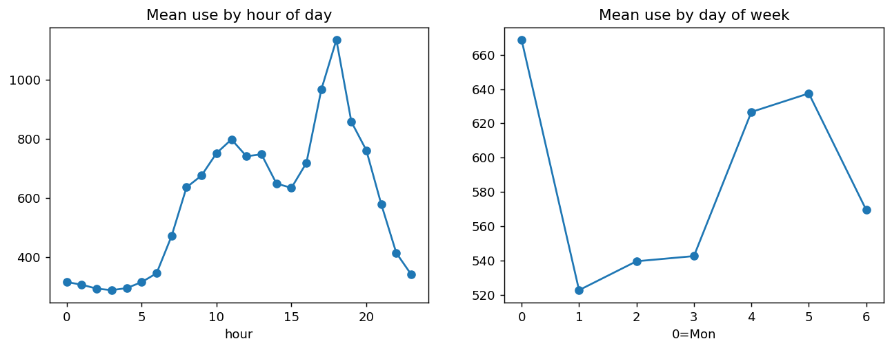

Figure 1: Mean hourly appliance energy use by hour of day and day of week.

The hourly profile shows relatively low consumption overnight, followed by increasing use during active daytime hours and a larger evening peak. The day-of-week pattern is less regular, although differences between days are still visible. This indicates that time of day is more consistently informative than simply knowing the weekday. The pattern supports the inclusion of 24-hour seasonal terms, calendar variables and appliance lags from the previous day.
The autocorrelation analysis also showed that neighbouring observations were related. Recent consumption therefore contained information about the next few hours. Correlation also appeared around the 24-hour region, providing further evidence of daily structure.

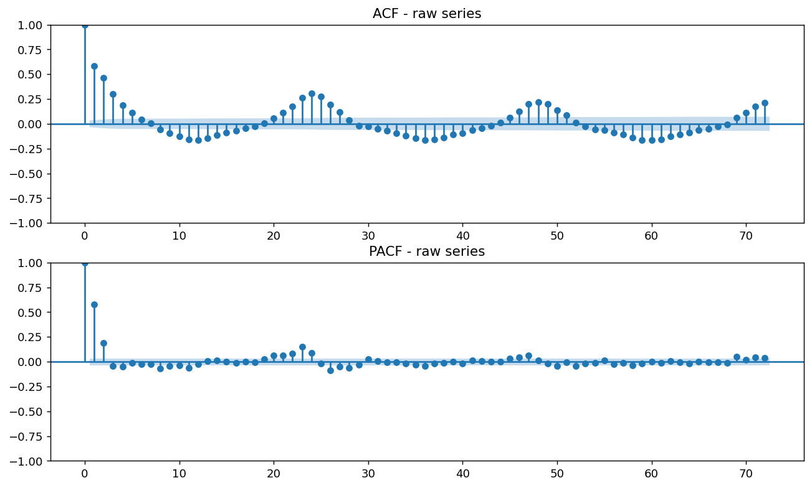

Figure 2: Autocorrelation and partial autocorrelation of hourly appliance energy consumption.

The ACF declined gradually and followed an oscillating pattern, with correlation becoming stronger again around daily lags. The PACF showed a strong relationship at the first lag and smaller effects at later lags. These results supported the use of autoregressive terms and a seasonal period of 24 hours.
Stationarity was tested using the Augmented Dickey–Fuller and KPSS tests. For the level series, the ADF p-value was approximately 2.76×10⁻⁵, which rejected the presence of a unit root. The KPSS p-value was reported as 0.10, meaning that its null hypothesis of stationarity was not rejected. The original hourly series was therefore classified as stationary by both tests. First and seasonal differencing also produced stationary series, but differencing was not required by the formal tests. This was later supported by the selected SARIMAX model, which used d=0.
3. Forecasting design and methods
The forecasting target was hourly appliance energy consumption. The final 24 observations were held out as the test period, and all earlier observations were used for training and feature construction. Every model forecast the same 24 timestamps so that the comparison remained fair.
RMSE was selected as the main metric because it gives greater weight to large errors. This was appropriate because failing to predict a major demand peak may be more important than making several small errors during low-consumption periods. MAE was also reported because it provides a direct measure of the average absolute error. MAPE and sMAPE were included as percentage-based measures, although both should be interpreted carefully when actual values are relatively small.
3.1 Benchmark models
Five benchmark methods were used:
- The mean forecast predicted the historical training mean.
- The naive forecast repeated the final training observation.
- The daily seasonal-naive forecast copied values from 24 hours earlier.
- The weekly seasonal-naive forecast copied values from 168 hours earlier.
- The drift forecast extended the average change between the beginning and end of the training data.
These benchmarks established whether the more complex models produced enough improvement to justify their additional computation and implementation effort.
3.2 SARIMAX
SARIMAX was selected because the exploratory analysis showed both short-term autocorrelation and daily seasonality. A full AIC-based grid search was completed over:
$$p=0,…,6, d=0,…,2, q=0,…,6.$$
This produced 147 parameter combinations, satisfying the required hyperparameter search. The seasonal order was fixed as (1,0,1,24), where 24 represents the daily cycle in hourly data. Outdoor temperature and outdoor relative humidity were included as exogenous variables.
The best specification was:
$$SARIMAX\left(3,0,6\right){\left(1,0,1\right)}_{24}$$
with an AIC of approximately 15131.75. The selected value d=0 was consistent with the stationarity-test results.
Residual diagnostics were used to check whether temporal structure remained after fitting. The Ljung–Box p-value was 0.927. Since this was greater than 0.05, there was no evidence of significant remaining autocorrelation at the tested lags. This indicates that the model captured most of the linear dependence. However, residual independence does not mean that the model predicted every large demand event accurately.
3.3 XGBoost
XGBoost was selected because the relationship between appliance uses and its predictors may be nonlinear. Household behaviour may depend on combinations of recent consumption, time of day, weather and indoor conditions rather than a single linear effect.
The model used several groups of features:
- recent appliance lags.
- 24-hour and 168-hour seasonal lags.
- rolling means and rolling standard deviations.
- hour of day and day of week.
- cyclical time encodings.
- weekend indicators.
- indoor temperature and humidity.
- outdoor weather variables.
Lag features represented recent appliance activity, while rolling statistics described the local level and variability. Calendar features represented normal household routines. Sensor and weather variables were included to test whether environmental conditions added useful information.

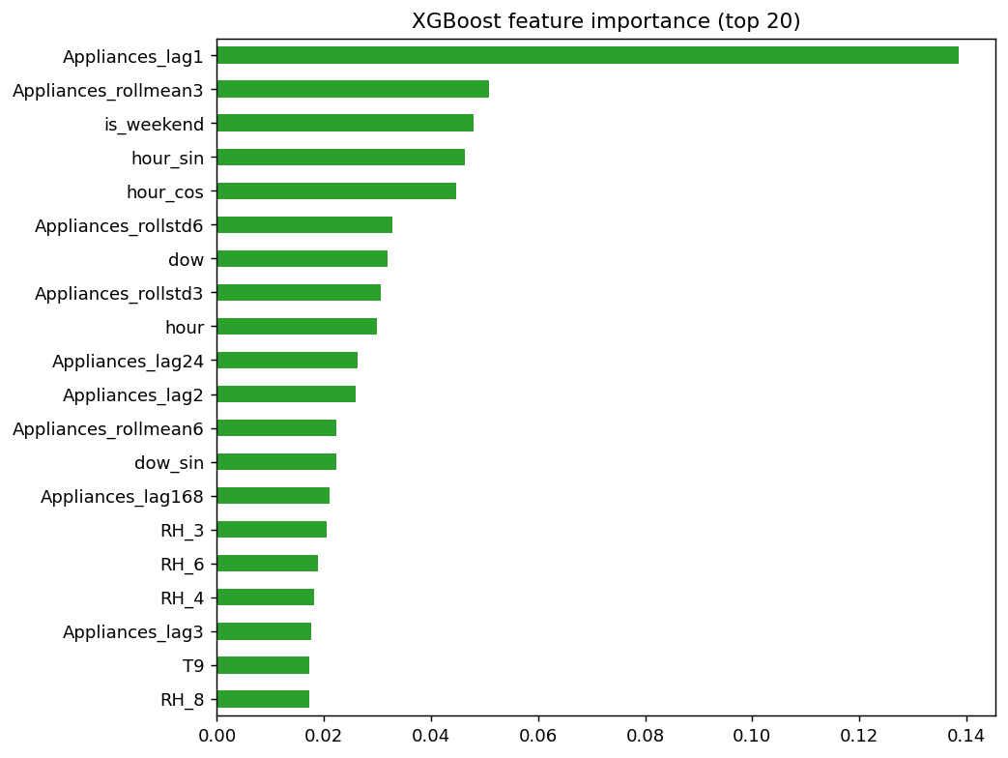

Figure 3: Feature importance from the fitted XGBoost forecasting model.
The feature-importance results show that recent appliance lags, rolling statistics and calendar variables were among the most useful predictors. This is reasonable because recent consumption indicates whether an energy-use event is continuing, while time-of-day variables describe when appliance activity is normally more likely. Sensor and weather variables contributed additional information but were generally less influential than the direct history of appliance use.
Feature importance should not be interpreted as proof of causation. Correlated predictors may share importance, and the ranking only describes how the fitted model used the available variables.
3.4 Chronos
Chronos was included as a pretrained time-series foundation model. Unlike XGBoost, it did not require task-specific feature engineering and produced a zero-shot forecast from the historical target sequence. This provided a test of whether knowledge learned from many other time series could perform competitively on household energy data.
The final pipeline produced a genuine Chronos forecast for the same 24-hour test period. No seasonal-naive fallback was used in the final results.

4. Results and discussion
Table 1. Forecast performance over the final 24-hour period
Model | RMSE (Wh) | MAE (Wh) | MAPE (%) | sMAPE (%)
XGBoost | 377.19 | 296.67 | 48.73 | 37.24
SARIMAX | 482.14 | 367.44 | 51.33 | 48.44
Chronos | 499.04 | 312.28 | 28.89 | 36.66
Mean | 502.17 | 370.40 | 47.46 | 48.53
Seasonal naive—weekly | 561.78 | 359.58 | 33.73 | 46.43
Seasonal naive—daily | 652.99 | 364.17 | 45.18 | 33.61
Naive | 717.85 | 652.50 | 145.09 | 72.44
Drift | 720.15 | 654.51 | 145.59 | 72.56

XGBoost achieved the lowest RMSE and MAE. Its RMSE of 377.19 Wh was approximately 24.9% lower than the mean benchmark’s RMSE of 502.17 Wh. This was a substantial improvement and shows that the engineered features captured useful information that was unavailable to the simpler methods.
The mean forecast was the strongest benchmark. This was initially surprising because the exploratory analysis showed clear daily seasonality. However, the result does not mean that seasonality was absent. It shows that the exact magnitude of consumption did not repeat reliably from one day or week to the next. A seasonal-naive model copied earlier peaks into the forecast period, but those peaks did not always occur again at the same time. The mean forecast was less responsive, but it avoided transferring irregular historical spikes into incorrect future hours.
The weekly seasonal-naive forecast performed better than the daily seasonal-naive model, suggesting that some weekly routine existed. Nevertheless, both were weaker than the mean forecast. The naive and drift methods performed worst because the final training value and the long-term trend were not representative of the highly variable next 24 hours.
SARIMAX reduced RMSE compared with every benchmark and ranked second overall. The model successfully captured linear autocorrelation and daily seasonality, as supported by the high Ljung–Box p-value. However, it was still substantially less accurate than XGBoost. Appliance demand contains sharp and nonlinear behavioural events that are difficult for a linear statistical model to reproduce. Outdoor temperature and humidity may explain broad changes in energy use, but they cannot directly identify when an occupant will switch on a specific appliance.
Chronos achieved an RMSE of 499.04 Wh. It narrowly improved on the mean benchmark and performed better than the seasonal-naive, naive and drift models. However, it did not outperform SARIMAX or XGBoost. Its MAE and percentage errors were relatively competitive, indicating that it often remained close to normal demand levels. Its higher RMSE suggests that some large errors occurred during major consumption peaks.
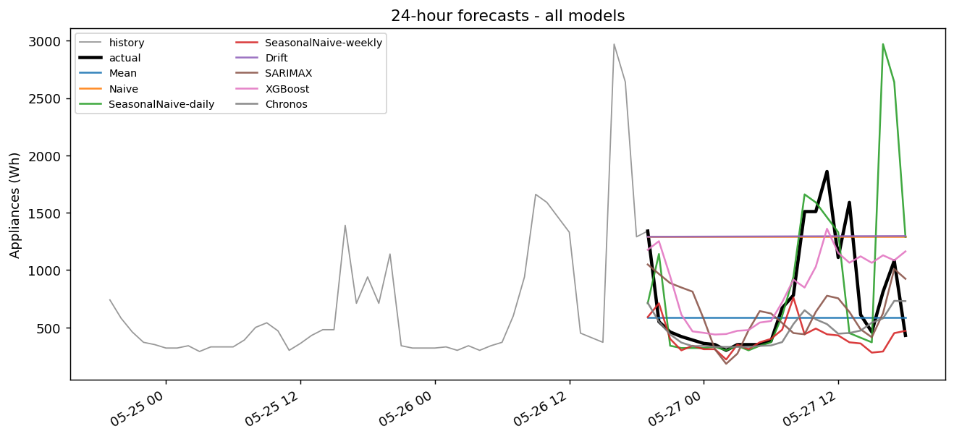
Figure 4: Actual appliance energy consumption and 24-hour forecasts produced by all evaluated models.
The forecast plot shows that the actual test period contained several rapid increases and decreases. Constant forecasts such as the mean could not follow these changes. The seasonal-naive methods reproduced historical peaks, but some appeared at the wrong time. XGBoost followed the overall movement of the test series more closely and handled parts of the later rise better than the other models, although it still smoothed or underestimated some large peaks. SARIMAX responded to the temporal pattern but did not capture the sharpest changes. Chronos produced a reasonable overall level but also missed the exact timing and scale of important demand events. The metrics do not all produce the same ranking. Chronos achieved the lowest MAPE, while daily seasonal naive achieved the lowest sMAPE despite having a poor RMSE. Percentage errors can behave differently when actual values are low. Since RMSE was defined as the primary metric and large absolute errors are important in energy forecasting, XGBoost remained the strongest model overall.
5. Critical findings, limitations and recommendation
The strongest benchmark was the mean forecast. This indicates that appliance energy use contains routine temporal structure, but individual peaks are not stable enough for simple daily or weekly repetition. The seasonal profiles describe average behaviour, whereas seasonal-naive forecasts assume that exact values repeat. Those are not the same assumption.
SARIMAX improved on the strongest seasonal benchmark and the mean forecast. Its selected daily seasonal structure and autoregressive terms captured much of the linear dependence. However, its limited improvement over the mean benchmark suggests that linear temporal structure alone was insufficient for predicting irregular appliance use.
XGBoost performed best because it combined recent target history, rolling behaviour and time-based features in a nonlinear model. Recent lags and rolling statistics appeared particularly useful. This supports the idea that the strongest predictor of the next hour is often the immediate appliance-use history, followed by the normal time-of-day pattern.
Chronos produced a credible zero-shot forecast, but its RMSE was only around 0.6% lower than the mean benchmark. This small gain does not justify its larger model size, dependency requirements and inference cost for this dataset. It may be useful in a cold-start situation where there is insufficient local data to train a feature-based model, but that was not the case here.
A major operational limitation concerns covariate availability. Calendar variables and past appliance lags are genuinely known at forecast time. Actual future indoor temperature, humidity and weather readings are not normally known. Supplying their observed test-period values creates a conditional forecast rather than a fully operational forecast. A deployed system would need weather forecasts and either forecasted indoor conditions or a model that excludes those variables. The study also used data from one house and evaluated the models on one final 24-hour period. Performance may change across households, seasons and unusual days. A stronger evaluation would use rolling-origin testing across multiple forecast dates. Future work could also use quantile regression to generate prediction intervals for XGBoost and could assess performance across several forecast horizons.
For practical use, XGBoost is recommended because it achieved the lowest RMSE and MAE. The deployed version should use only past appliance lags, rolling statistics, calendar variables and covariates that are genuinely available in advance. SARIMAX remains a reasonable alternative where interpretability and built-in confidence intervals are more important than obtaining the lowest point-forecast error.
6. Conclusion
This study compared benchmark, statistical, machine-learning and foundation-model approaches for forecasting household appliance energy use over 24 hours. The series contained clear daily structure and short-term autocorrelation, but the timing and size of individual consumption peaks were irregular. XGBoost achieved the best performance, with an RMSE of 377.19 Wh. SARIMAX ranked second and successfully captured most remaining linear autocorrelation. Chronos produced a valid zero-shot forecast but did not improve sufficiently over the mean benchmark to justify its additional complexity.
The results show that greater model complexity is useful only when it represents information that matters for the problem. In this case, carefully engineered lag, rolling and calendar features were more valuable than either direct seasonal repetition or a larger pretrained foundation model.
References
Ansari, A.F. et al. (2024) ‘Chronos: Learning the language of time series’, Transactions on Machine Learning Research.
Candanedo, L.M., Feldheim, V. and Deramaix, D. (2017) ‘Data driven prediction models of energy use of appliances in a low-energy house’, Energy and Buildings, 140, pp. 81–97.
Chen, T. and Guestrin, C. (2016) ‘XGBoost: A scalable tree boosting system’, Proceedings of the 22nd ACM SIGKDD International Conference on Knowledge Discovery and Data Mining, pp. 785–794.
Hyndman, R.J. and Athanasopoulos, G. (2021) Forecasting: Principles and Practice. 3rd edn. Melbourne: OTexts.
Seabold, S. and Perktold, J. (2010) ‘Statsmodels: Econometric and statistical modeling with Python’, Proceedings of the 9th Python in Science Conference, pp. 92–96.

