Heap

A Heap is a complete binary tree data structure that satisfies the heap property: for every node, the value of its children is less than or equal to its own value. Heaps are often used to implement priority queues, where the smallest (or largest) element is always at the root of the tree.

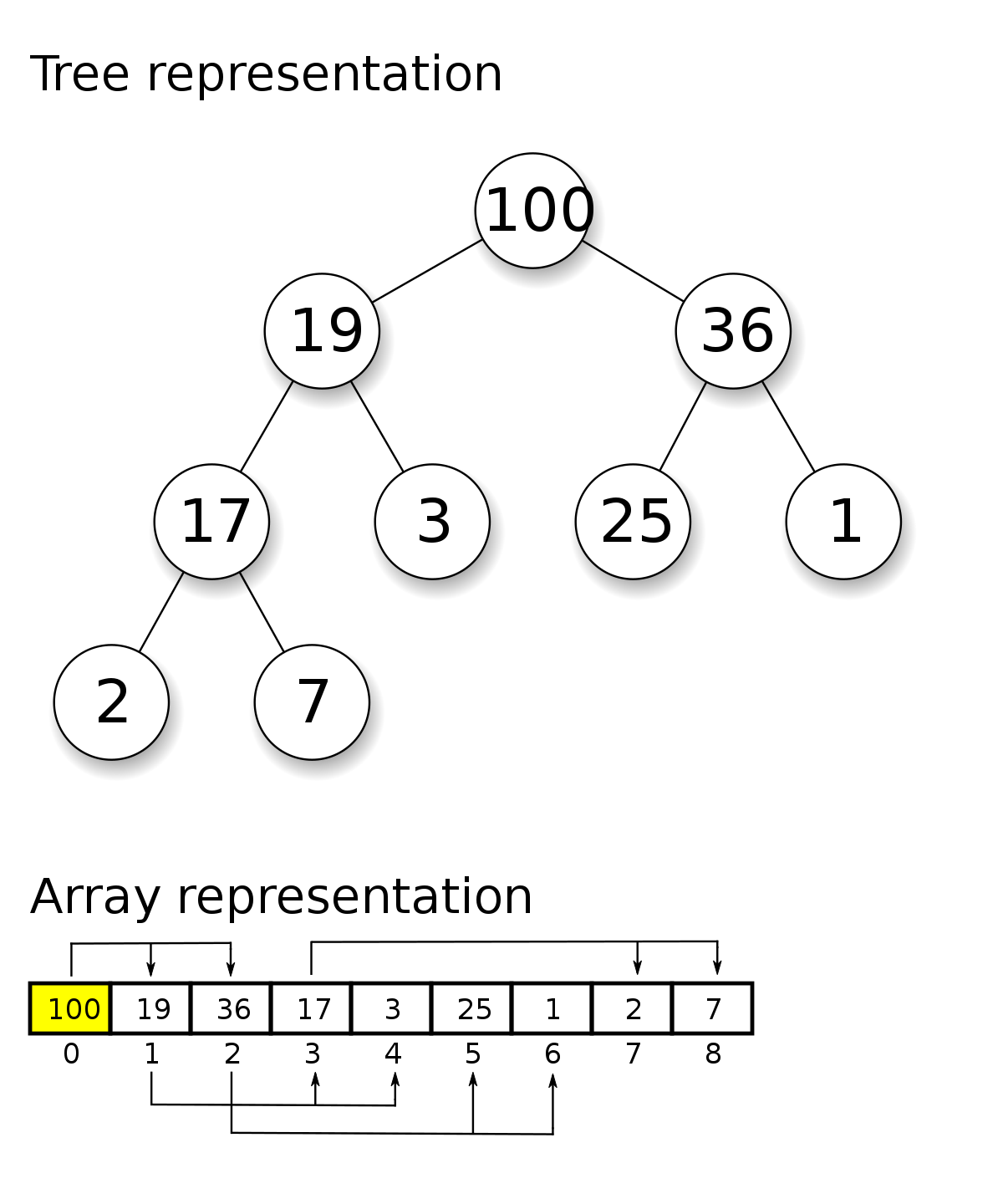
-

----> Operations of Heap:

Heapify: a process of creating a heap from an array.
Insertion: process to insert an element in existing heap time complexity O(log N).
Deletion: deleting the top element of the heap or the highest priority element, and then organizing the heap and returning the element with time complexity O(log N).
Peek: to check or find the most prior element in the heap, (max or min element for max and min heap).

-----> Application of Heap Data Structure:

Priority queues: The heap data structure is commonly used to implement priority queues, where elements are stored in a heap and ordered based on their priority. This allows constant-time access to the highest-priority element, making it an efficient data structure for managing tasks or events that require prioritization.

Heapsort algorithm: The heap data structure is the basis for the heapsort algorithm, which is an efficient sorting algorithm with a worst-case time complexity of O(n log n). The heapsort algorithm is used in various applications, including database indexing and numerical analysis.

Memory management: The heap data structure is used in memory management systems to allocate and deallocate memory dynamically. The heap is used to store the memory blocks, and the heap data structure is used to efficiently manage the memory blocks and allocate them to programs as needed.

Heapify
It is a process to rearrange the elements of the heap in order to maintain the heap property. It is done when a certain node causes an imbalance in the heap due to some operation on that node.
The heapify can be done in two methodologies:
- up_heapify() → It follows the bottom-up approach. In this, we check if the nodes are following heap property by going in the direction of rootNode and if nodes are not following the heap property we do certain operations to let the tree follows the heap property.
- down_heapify() → It follows the top-down approach. In this, we check if the nodes are following heap property by going in the direction of the leaf nodes and if nodes are not following the heap property we do certain operations to let the tree follows the heap property.

Pseudo Code
void down_heapify(int heap[], int parent, int size)
{
largest = parent
leftChild = 2*parent + 1
rightChild = 2*parent + 2

if(leftChild < size && heap[leftChild] > heap[largest])
largest = leftChild
if(rightChild < size && heap[rightChild] > heap[largest])
largest = rightChild
if(parent != largest)
{
swap(heap[parent], heap[largest])
down_heapify(heap,largest,size)
}
}
void up_heapify(int heap[], int child)
{
parent = (child-1)/2;
if(heap[parent] < heap[child]) {
swap(heap[parent], heap[child])
up_heapify(heap,parent)
}
}

Insertion
The insertion in the heap follows the following steps
- Insert the new element at the end of the heap.
- Since the newly inserted element can distort the properties of the Heap. So, we need to perform up_heapify() operation, in order to keep the properties of the heap in a bottom-up approach.
Initially the heap is as (It follows max-heap property)

9
/ \
5 3
/ \
1 4

New element to be inserted is 12
Step 1: Insert the new element at the end.
9
/ \
5 3
/ \ /
1 4 12

Step 2: Heapify the new element following bottom-up approach.
Final heap
12
/ \
5 9
/ \ /
1 4 3
Pseudo Code
void up_heapify(int heap[], int child)
{
parent = (child-1)/2;

if(heap[parent] < heap[child]) {
swap(heap[parent], heap[child])
up_heapify(heap,parent)
}

}
void insert(int heap[],int size,int key)
{
heap.append(key)
up_heapify(heap,size+1,size)
}

Deletion
The deletion operations follow the following step:
- Replace the element to be deleted by the last element in the heap.
- Delete the last item from the heap.
- Now, the last element is placed at some position in heap, it may not follow the property of the heap, so we need to perform down_heapify() operation in order to maintain heap structure. The down_heapify() operation does the heapify in the top-bottom approach.
The standard deletion on Heap is to delete the element present at the root node of the heap.
Initially the heap is(It follows max-heap property)
12
/ \
6 3
/ \
1 4
Element to be deleted is 12

Step 1: Replace the last element with root, and delete it.
4
/ \
6 3
/
1

Step 2: Heapify root.
Final Heap:
6
/ \
4 3
/
1
Pseudo-Code
void down_heapify(int heap[], int parent, int size)
{
largest = parent
leftChild = 2*parent + 1
rightChild = 2*parent + 2

if(leftChild < size && heap[leftChild] > heap[largest])
largest = leftChild
if(rightChild < size && heap[rightChild] > heap[largest])
largest = rightChild
if(parent != largest)
{
swap(heap[parent], heap[largest])
down_heapify(heap,largest,size)
}
}
void deleteRoot(int heap[], int size)
{
swap(heap[0], heap[size-1]) // swap first and last element
heap.pop_back(); // delete the last element
down_heapify(heap,0,size-1)
}

