HOW TO INSTALL VS CODE IN WINDOWS

1. First search Visual Studio 2022 in any search engine(for eg: Google)

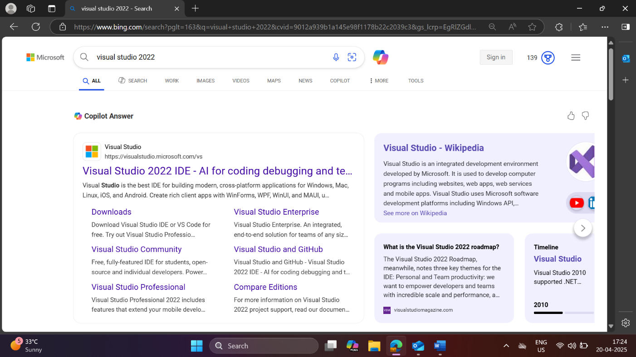

1. Then click on the first link which is the official Visual Studio Website

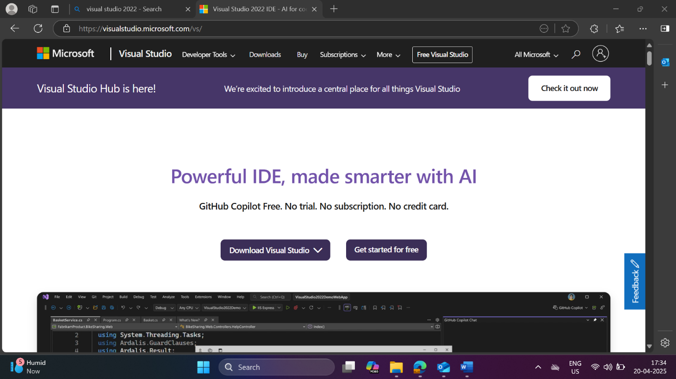

1. There you can see a scroll having Download Visual Studio and under that scroll select Community 2022.

1. When you click Community 2022 you will be redirected to another page where the automatic download will happen as soon as you click Community 2022.

