Machine_Learning Assignment -3

**Github link :** [**https://github.com/manu-smr/Machine_Learning_Assignment_2**](https://github.com/manu-smr/Machine_Learning_Assignment_2)

Name : Manohhar

700 number : 700742333

Question-1

1. (Titanic Dataset) 1. Find the correlation between ‘survived’ (target column) and ‘sex’ column for the Titanic use case in class. a. Do you think we should keep this feature?
2. 2. Do at least two visualizations to describe or show correlations.
3. 3. Implement Naïve Bayes method using scikit-learn library and report the accuracy.

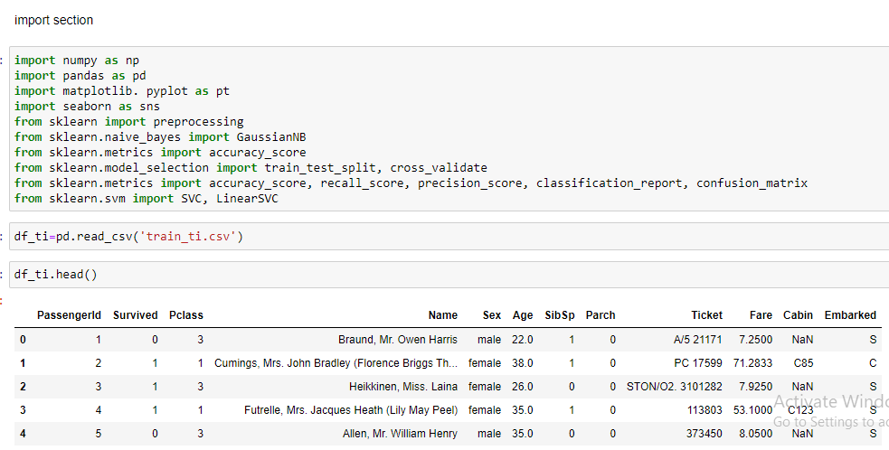

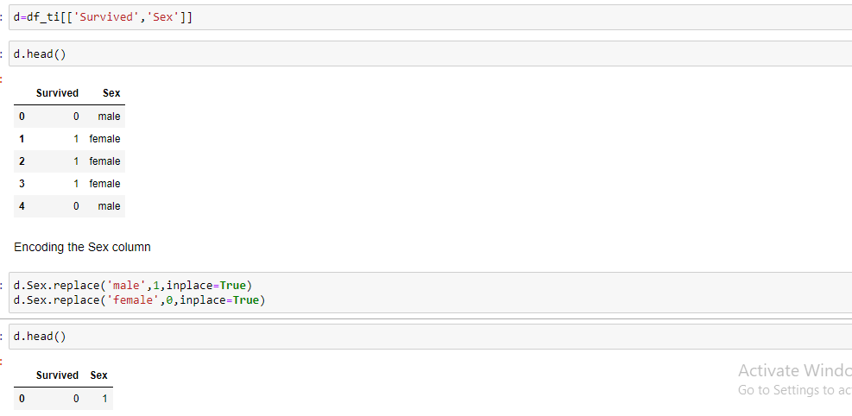

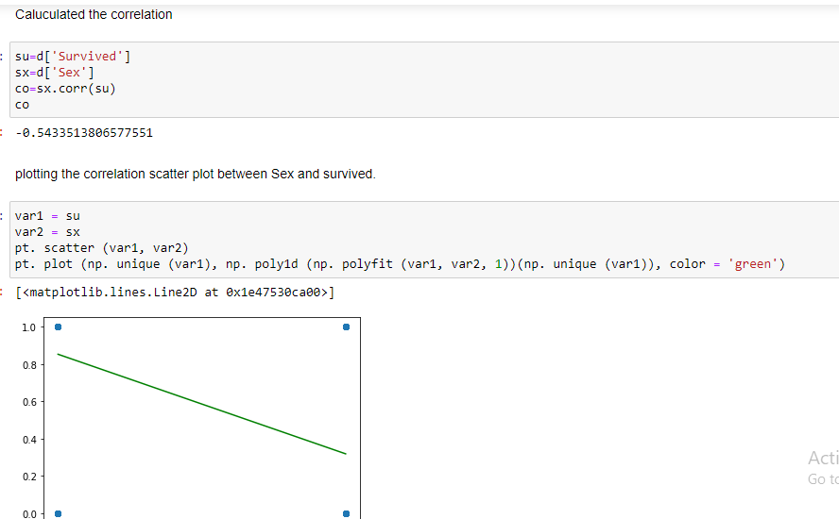

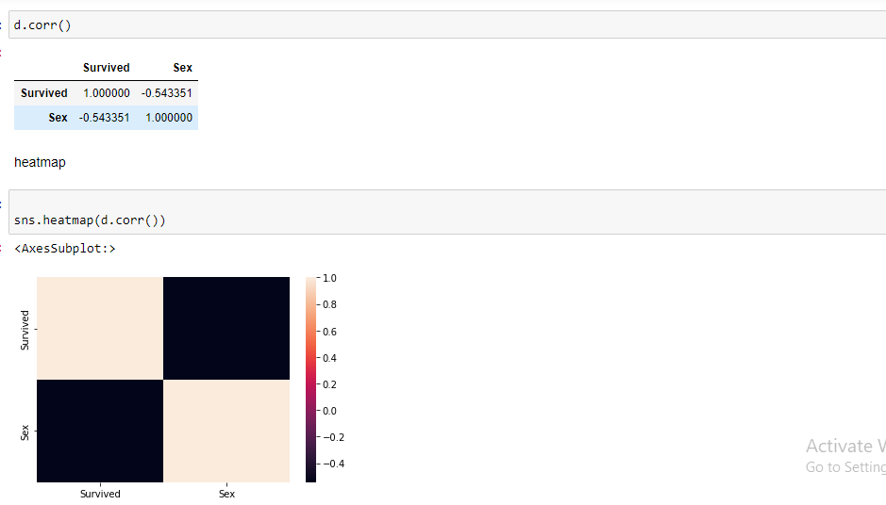

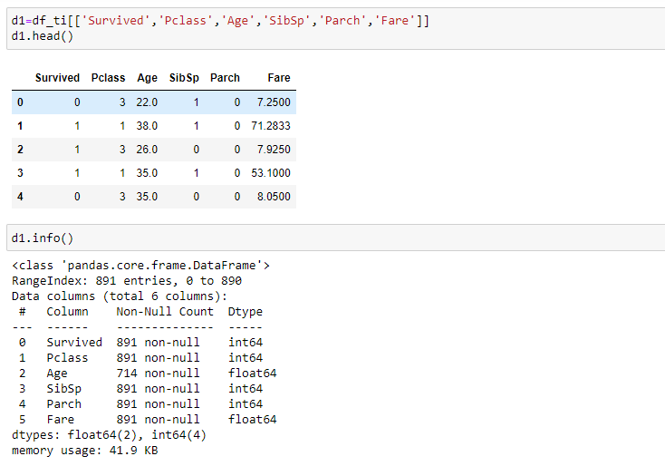

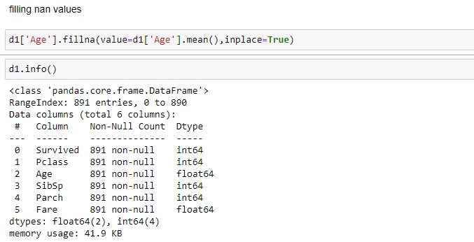

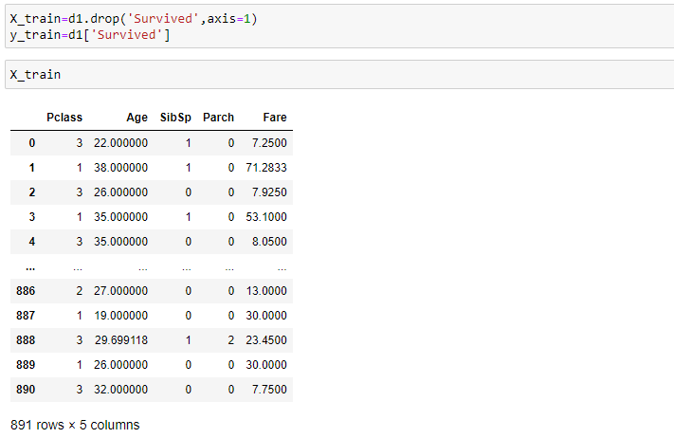

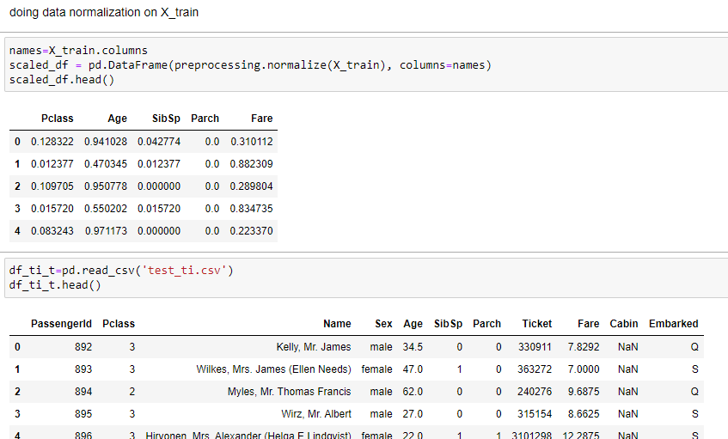

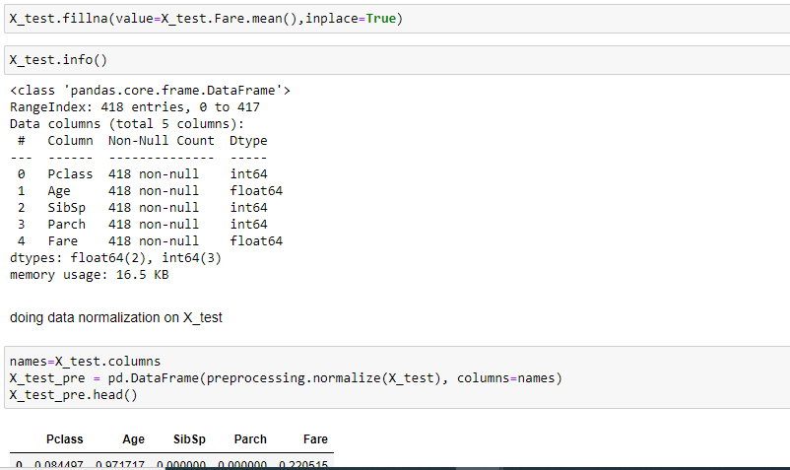

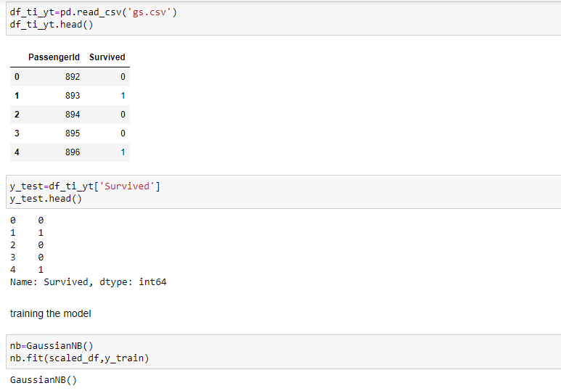

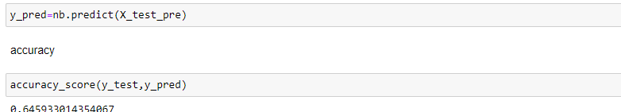

Question-2

