**Machine Learning_Assignment -1**

**Github link :** <https://github.com/manu-smr/Machine_learning_assignment_1>

Name : Manohhar

700 number : 700742333

**Question-1**

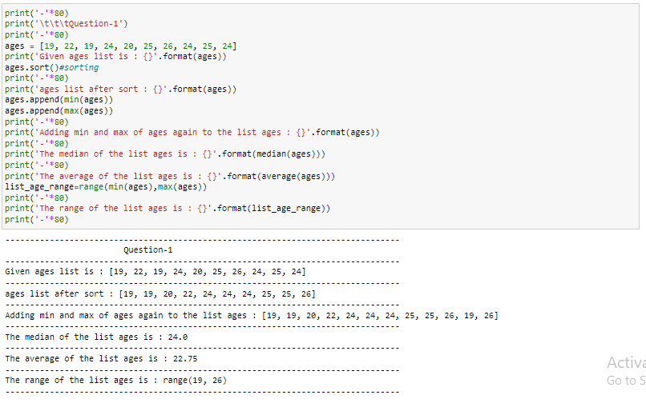

**User-defined methods :**

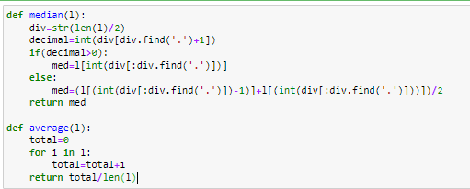

Here, used built in functions and computed sort,min,max and added the min and max again to the list,

Computed the median using user defined method(median), where I just computed the length of the list and checked the number after the decimal is >0 or not. If it is >0 then extracted the middle value of the list and return it as median else taken sum of the middle two values and divide it by 2 and return it as median.

Computed the average using built in method(average), where I just iterated the list and find out the total and then just returned total/length of the list as average.

**Question-2**

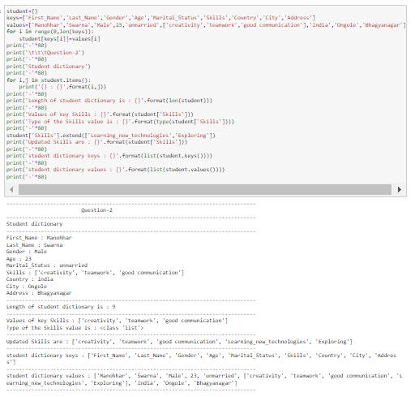

Created the student dictionary with predefined keys and values, and the computed the length of the dictionary and printed the value of the key “Skills”, and added new values to the Skills key value list.

Finally printed the dictionary keys and values as a list.

**Question-3**

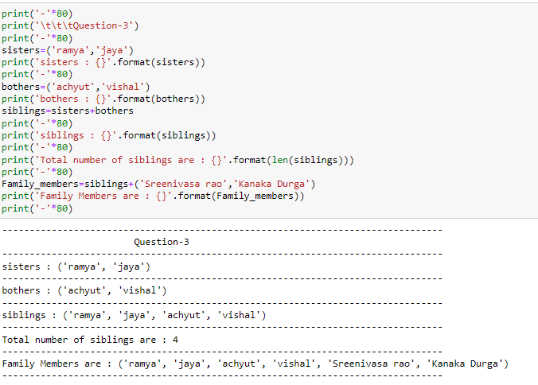

Created the tuples sister and brother and the created the siblings tuple by using sister,brother tuples.

And printed the length siblings tuple(to get the no.of siblings), and then created the family members tuple by adding father name and mother name to the existing tuple siblings.

**Question-4**

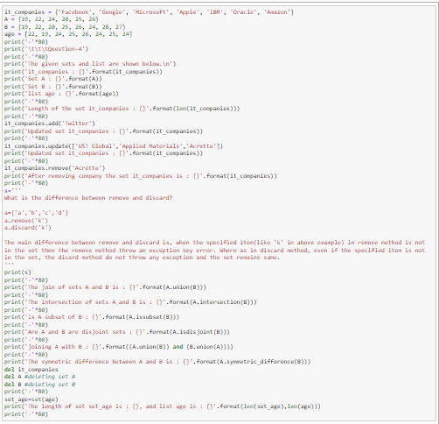

**Output**

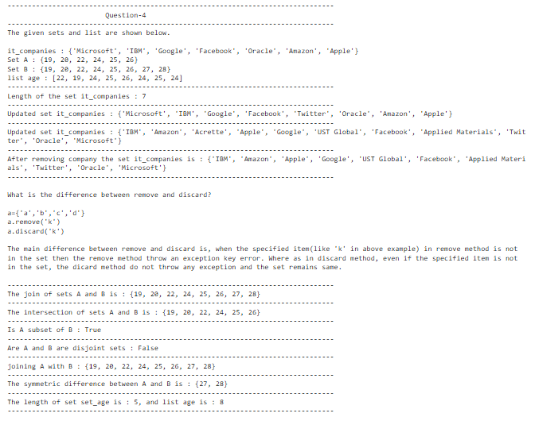

Performed various method on the given sets there are, initially printed the length of the set(it_companies) and then add new company name to the set(it_companies) and then added multiple company name to the set it_companies using update method and then removed one of the company name from the set(it_companies) using remove method.

Explained the difference between remove and discard methods.

Perfomed join,intersection,subset,disjoint and symmetric difference by using bult-in set methods, and then converted the given list and printed it’s length.

**Question-5**

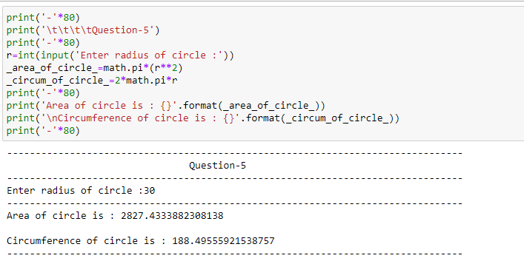

Taken the radius as user input and calculated the area and circumference of the circle.

**Question-6**

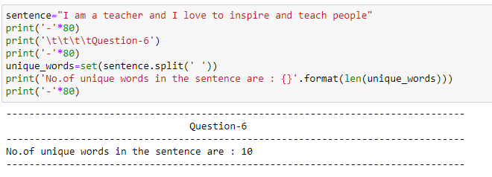

Perform split method on the given sentence to get the words of the sentence and performed set on it to get the unique words and printed it’s length.

**Question-7**

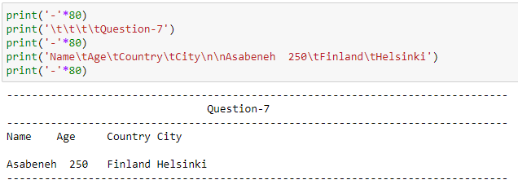

Printed the given sentence in required format by using \t and \n.

**Question-8**

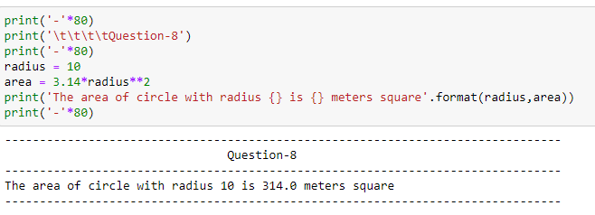

Used the string formatting to display the sting in a specific way.

**Question-9**

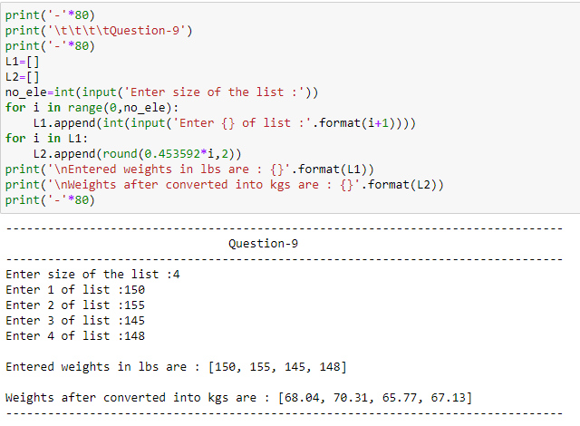

Here, taken the list of weights in lbs as user input and converted it into kgs and added those weights into a list L2.

**Question-10**

**Fig-1**

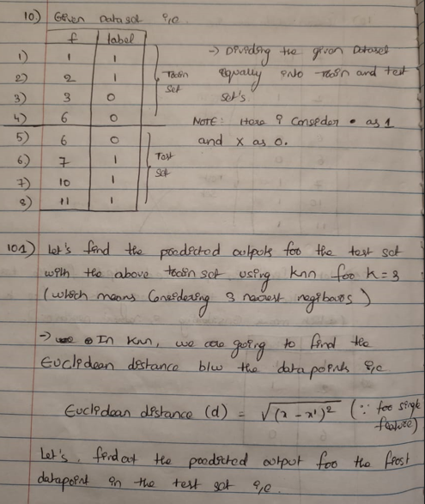

**Fig-2**

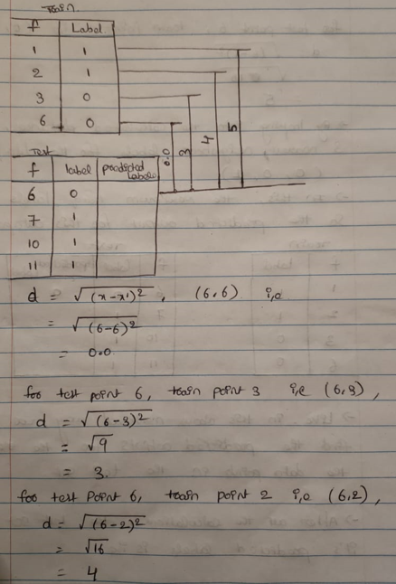

**Fig-3**

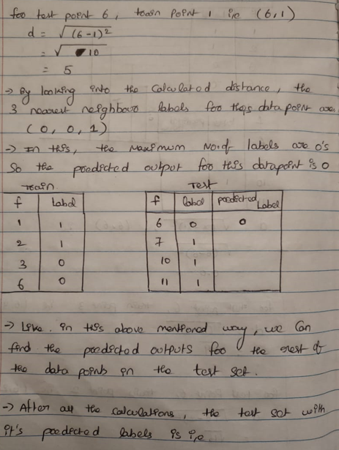

**Fig-4**

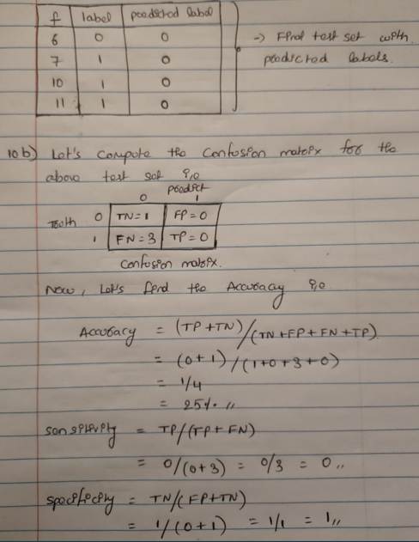

Computed the predicted output for the test data set using knn Euclidean distance (d) by considering 3 nearest negibours(k=3)

And then, computed the confusion matrix, accuracy,sensitivity and specificity by using test dataset actual and predicted labels.