e-Yantra Hackathon

Fighting COVID-19 Hackathon

Team: #574

|  |  |
| --- | --- |
| **Student name** | Manoj M |
| **College** | BMS Institute of Technology |
| **Email** | manu9206822755@gmail.com |

|  |  |
| --- | --- |
| **Student name** | Yogeshwar K |
| **College** | BMS Institute of Technology |
| **Email** | D yogiy965@gmail.com |

|  |  |
| --- | --- |
| **Student name** | Darshan S Bharadwaj |
| **College** | Sri Siddarth Institute of Technology |
| **Email** | dsbharadwaj1800@gmail.com |

|  |  |
| --- | --- |
| **Student name** | Vikram R |
| **College** | GITAM University |
| **Email** | vikramr2214@gmail.com |

**Background**

Hospital Apps are a great way to engage with patients and studies show that they want to use them. The One Tap app is not only convenient, but it allows doctors to work with their providers and can result in a much more favourable outcome to the patients with their medical issues and overall health.

**Aim of our application .**

To stand as a cupid between the hospitals and their patients by providing basic need to the hospitals for their needs. Here we a have two apps one for the hospital interface and other for vendors interface. Data uploaded by the hospital is being stored at firebase server , which is later fetched by vendors app.

This application ensure that there is no stop in manufacturing the commodities needed and does the distribute the line of services ,at the high time of emergence time is the constrain hence forth our app is the solution.

**Our application includes.**

**HOSPITAL INTERFACE**

1. A home page where registered users can login with their registered email and password.

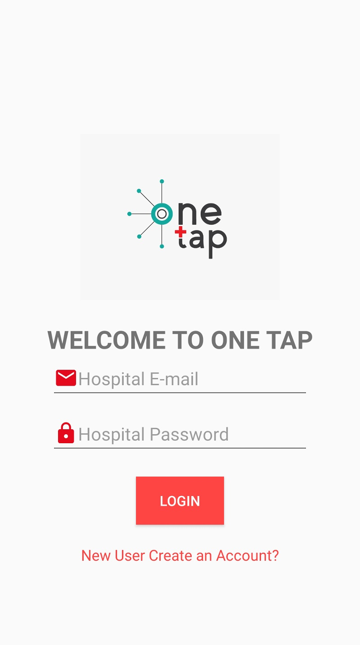

,

1. Non registered users can register with their name ,Email, phone number, address and password

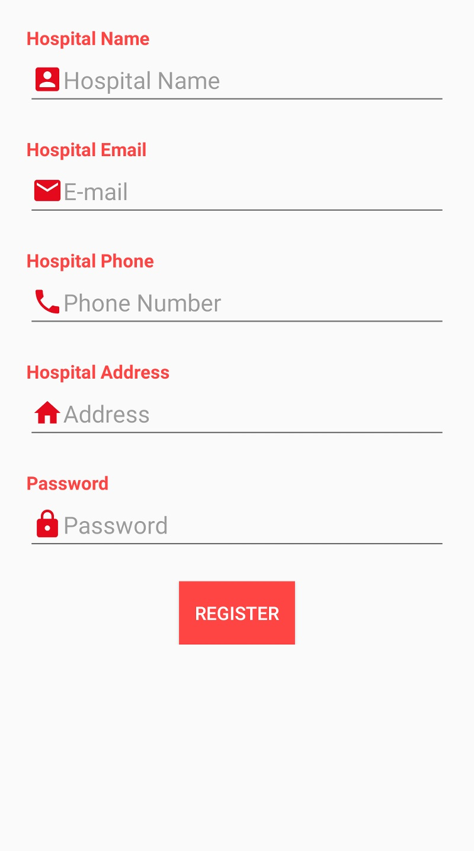

.

1. After login the main screen appears which consists of User’s profile, add items and logout options.

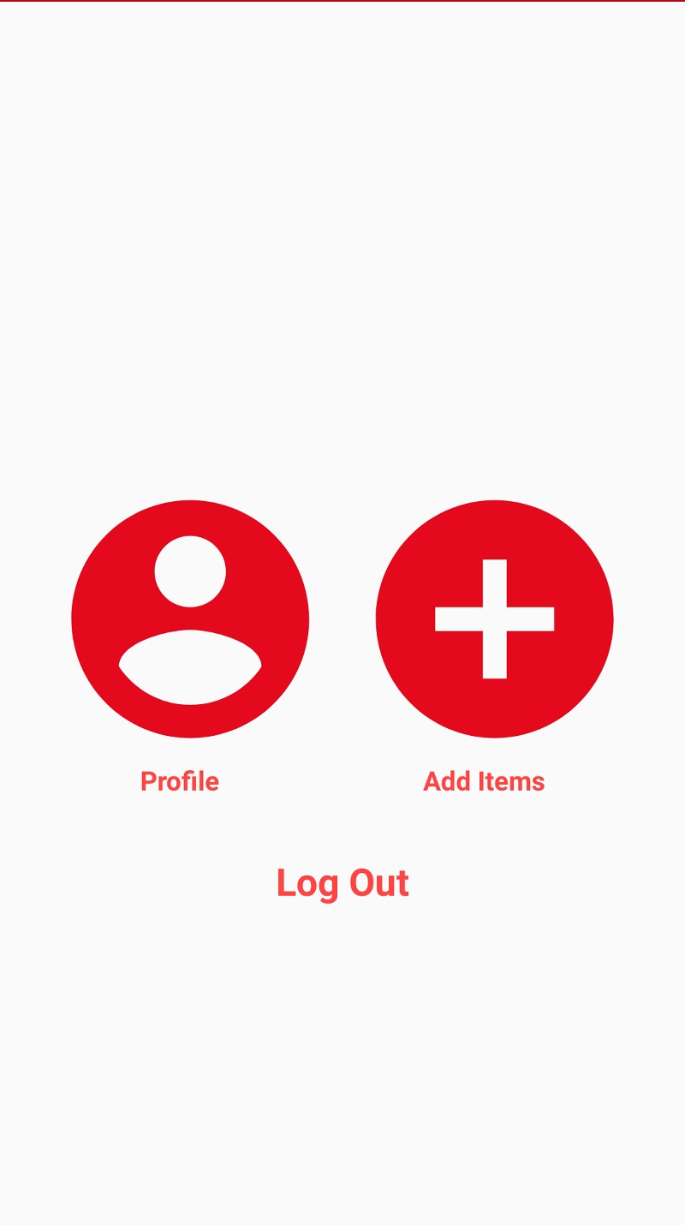

1. After clicking on profile, your registered details appears where you can update your details if wrongly registered.

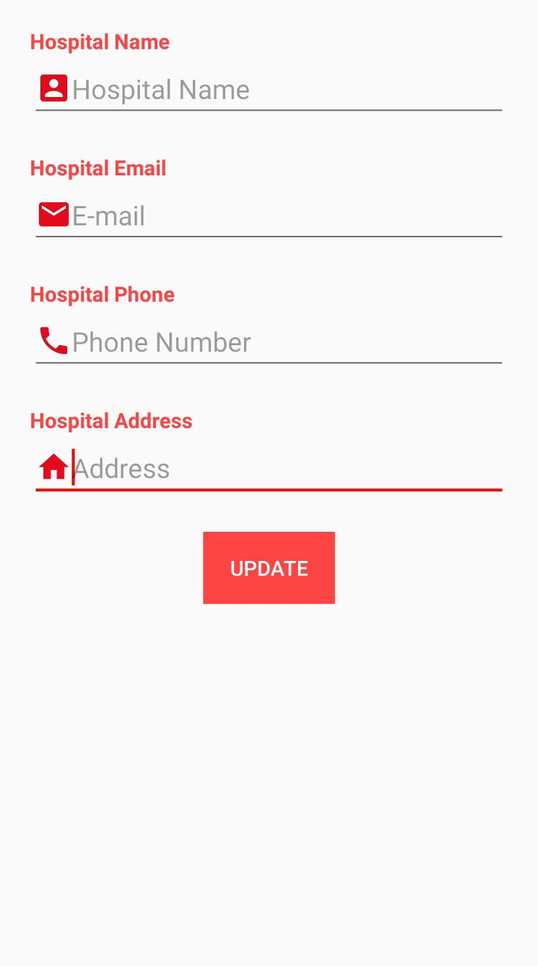’

1. On clicking add items you can add the basic necessity items for hospital needs and can also specify the quantity.

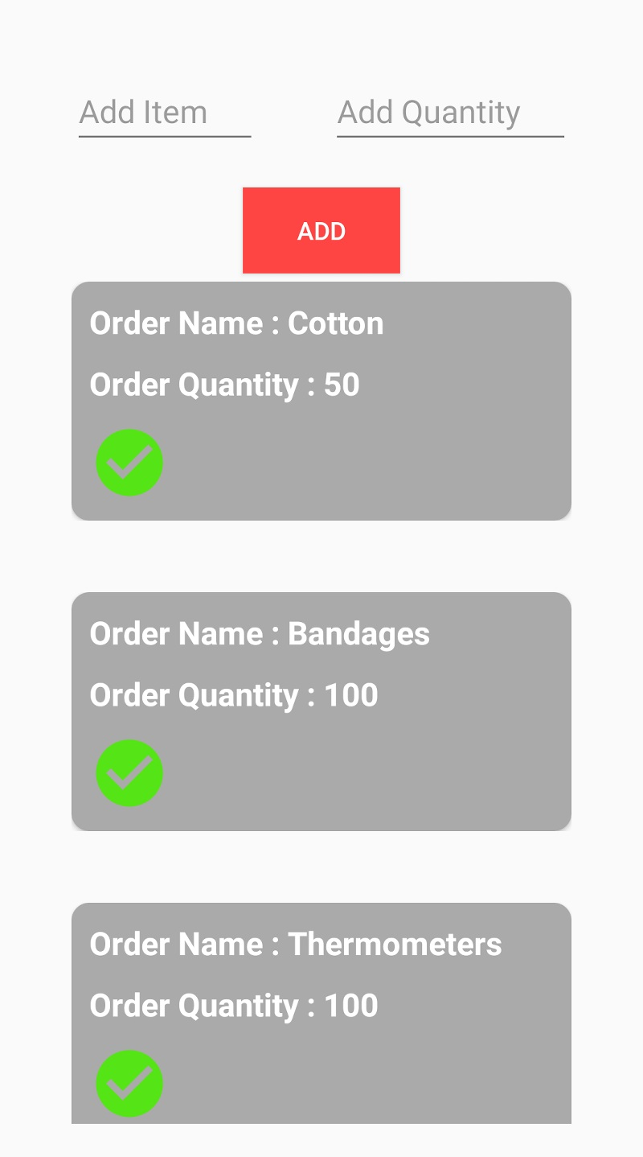

1. On tapping the order , one can edit the details of order and even can cancel it .

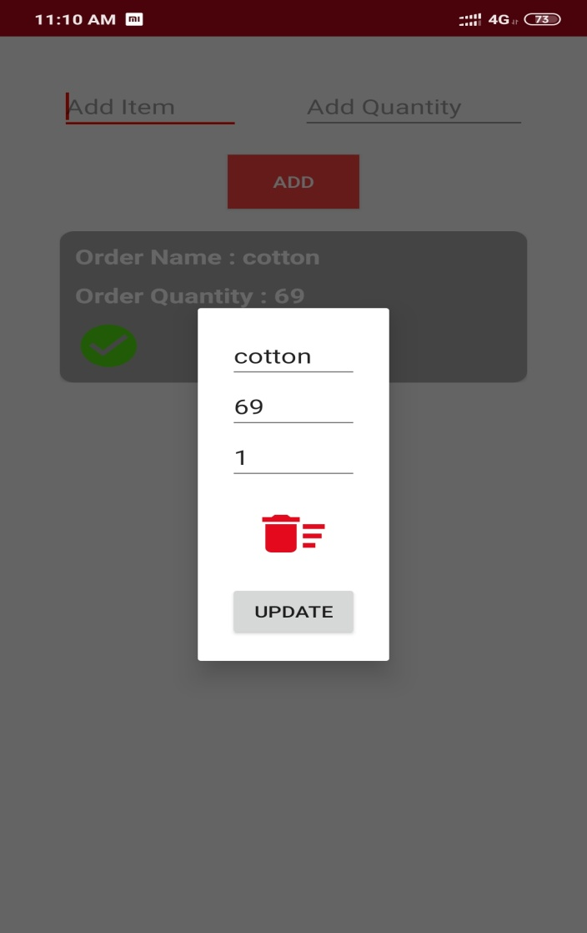

1. On clicking logout option, you exit from the app and the home screen appears.



**VENDORS INTERFACE**

1. on opening the vendors interface we have the hospitals name displayed .vendors can click on the respective one to get the order details .

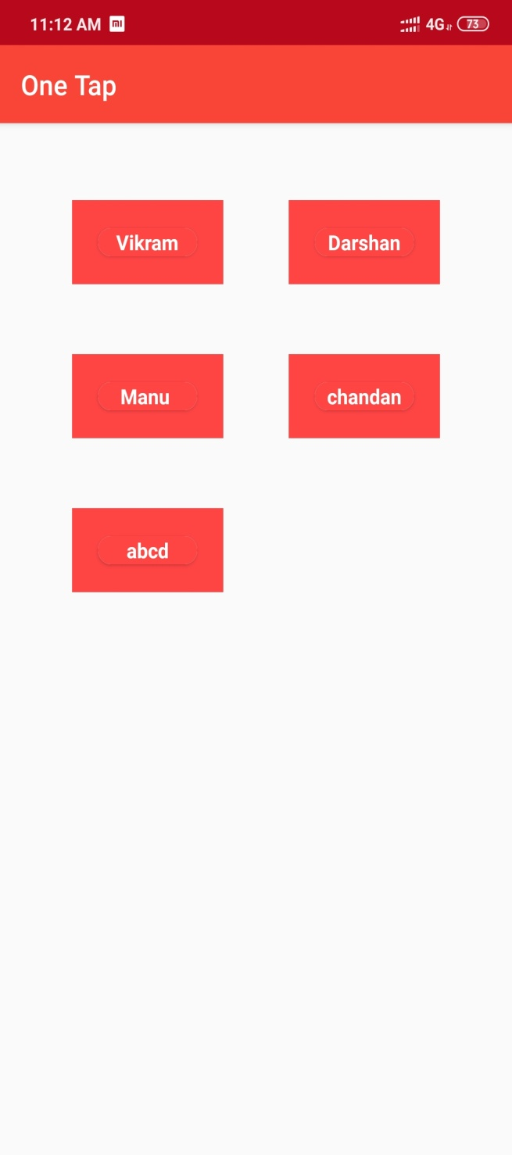.

1. Every details about the orders are displayed here.

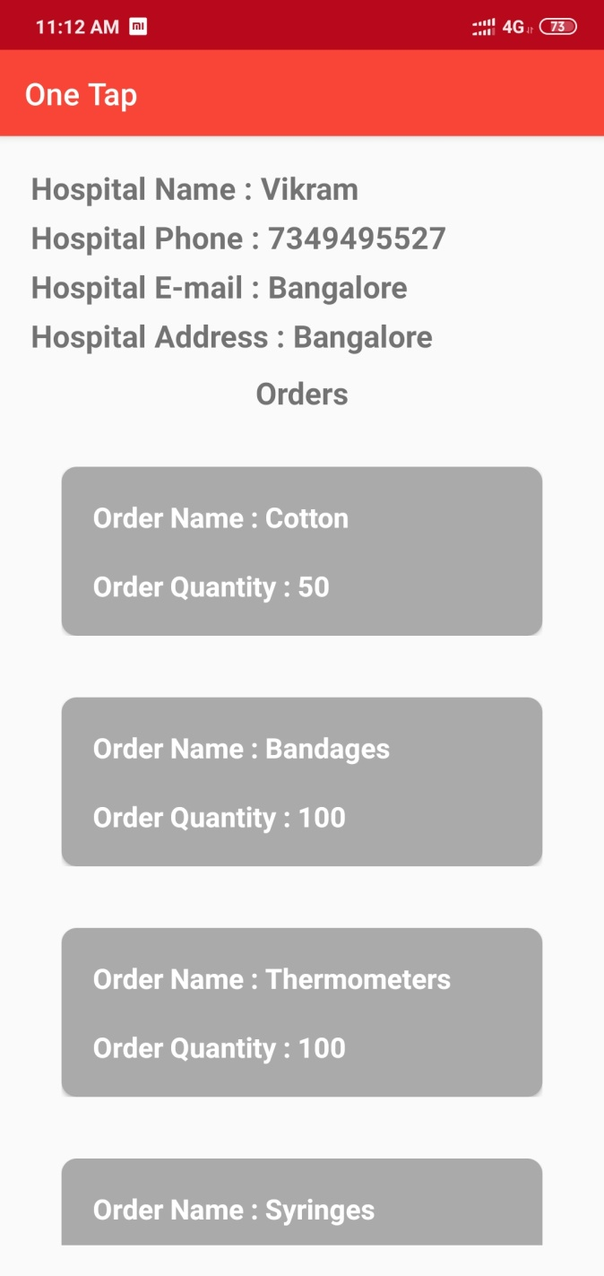

**DATA STORED IN FIREBASE**

