Appendix — Commands and Test Inputs

0. Lab startup / verification
These were the main commands used to get the DVWA lab running:
cd /root/DVWA
docker ps
Expected containers:
dvwa-dvwa-1
dvwa-db-1
To start the lab:
docker compose up -d
To enter the DVWA container:
docker exec -it dvwa-dvwa-1 bash

1. SQL Injection

A. Database verification
We entered the MariaDB container with:
docker exec -it dvwa-db-1 mariadb -u dvwa -p dvwa
Then:
DESCRIBE users;
And:
SELECT user_id, first_name, last_name, user FROM users;
This verified the DVWA users table and the local test accounts.
Exit MariaDB:
exit;

B. Inspect vulnerable SQLi code
From Kali:
cd /root/DVWA
Then:
cat vulnerabilities/sqli/source/low.php
For the secure implementation:
cat vulnerabilities/sqli/source/impossible.php
The current DVWA Impossible implementation uses numeric validation plus a parameterized query with prepare(), bindParam() and execute().

C. SQLi test inputs entered in DVWA
These are not terminal commands. They were entered in:
DVWA → SQL Injection

Baseline
1

Syntax-error test
1'

ORDER BY column testing
1' ORDER BY 1 #
1' ORDER BY 2 #
1' ORDER BY 3 #
ORDER BY 3 produced the unknown-column error, which demonstrated that the query output had only two selectable columns.

Boolean-based test
1' OR 1=1 ORDER BY 2 #
This returned the multiple DVWA user records.

UNION extraction
1' UNION SELECT user,password FROM users #
This was your main evidence for the ApexPlanet requirement to extract usernames/password hashes.

Secure retest
Change:
DVWA Security → Impossible
Then try the malicious SQLi input again.
The injection should not be processed as SQL because the secure implementation validates the input and uses a parameterized query.

SQLi screenshots
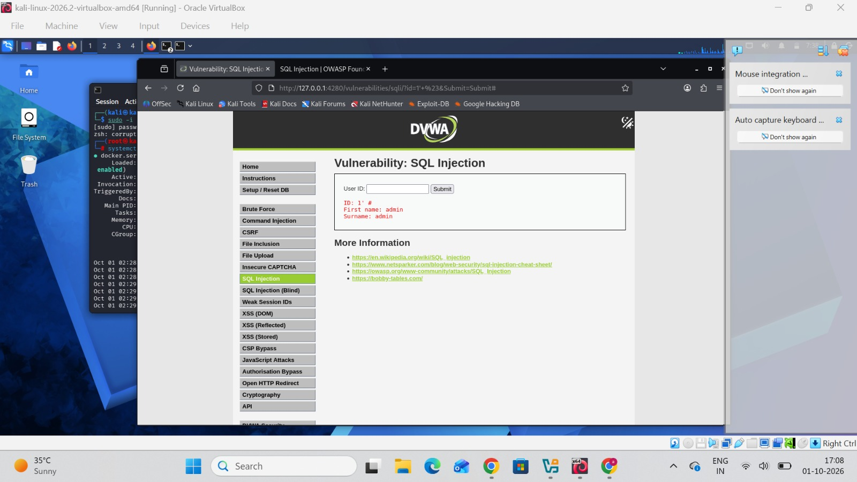

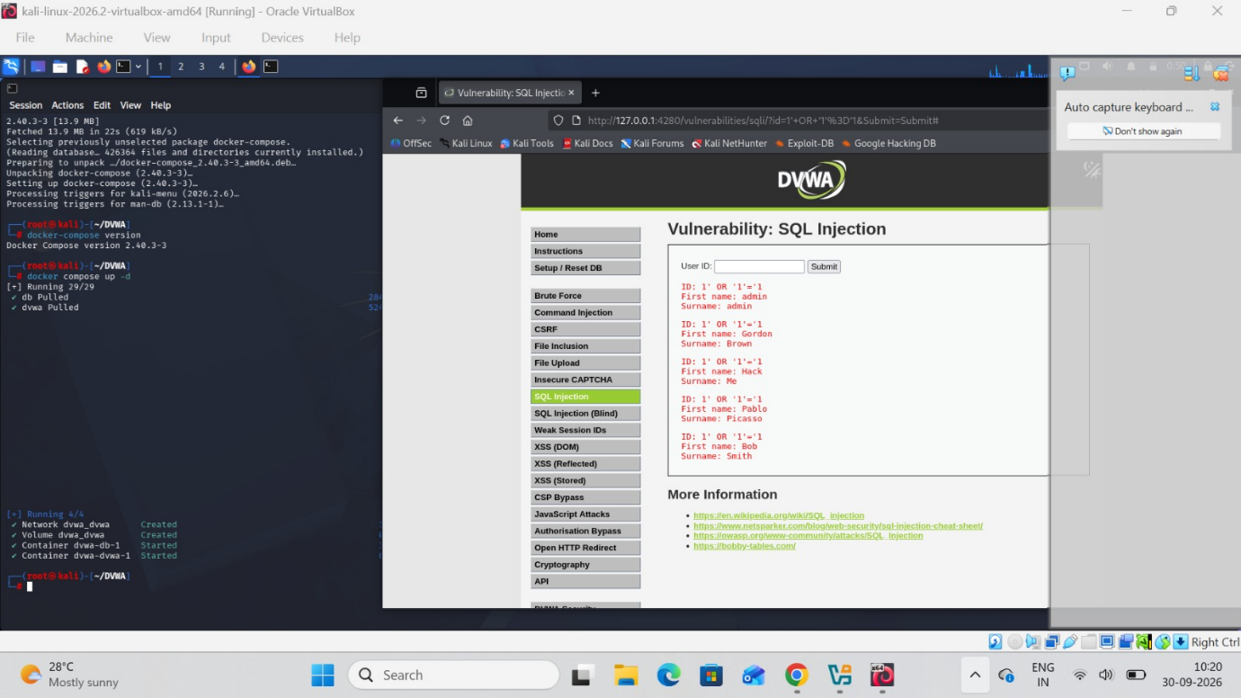

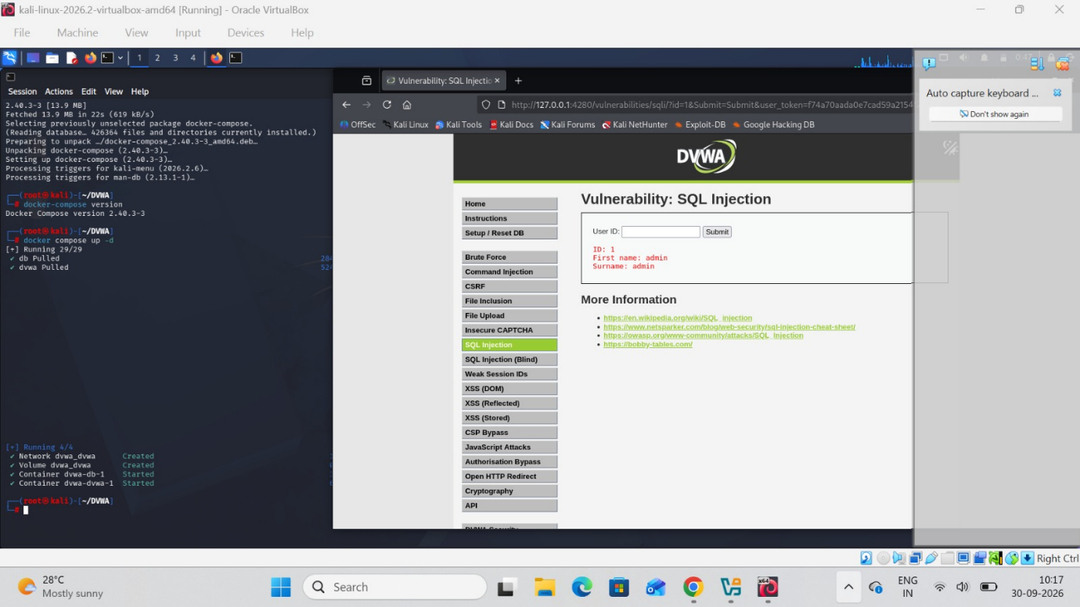

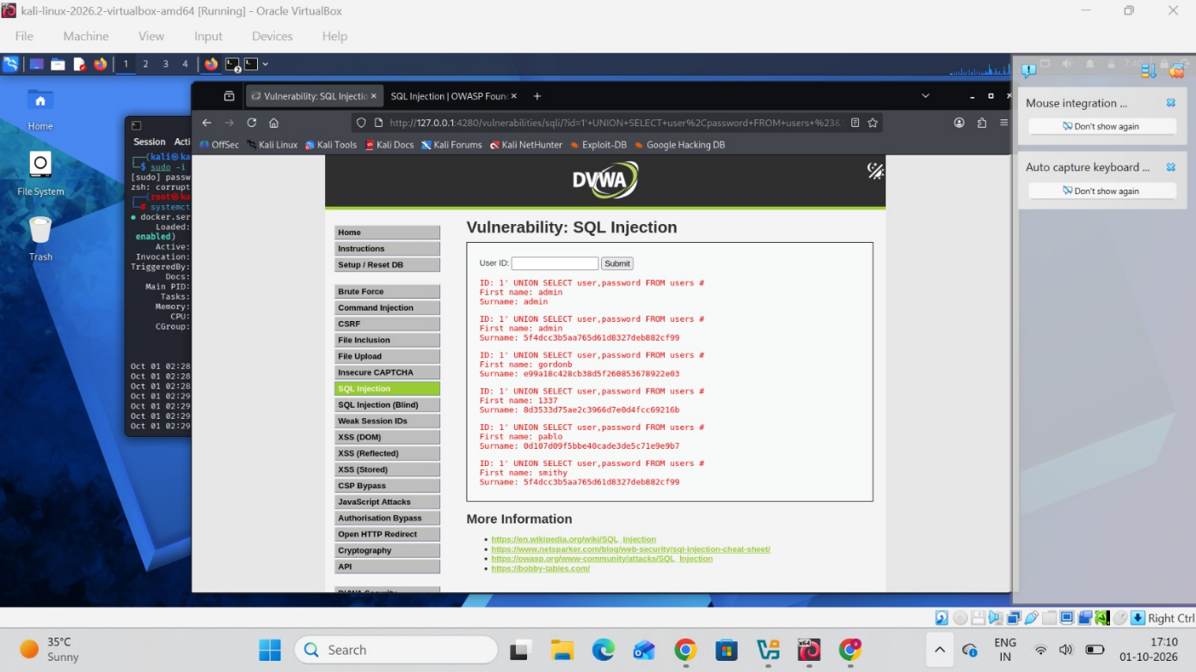

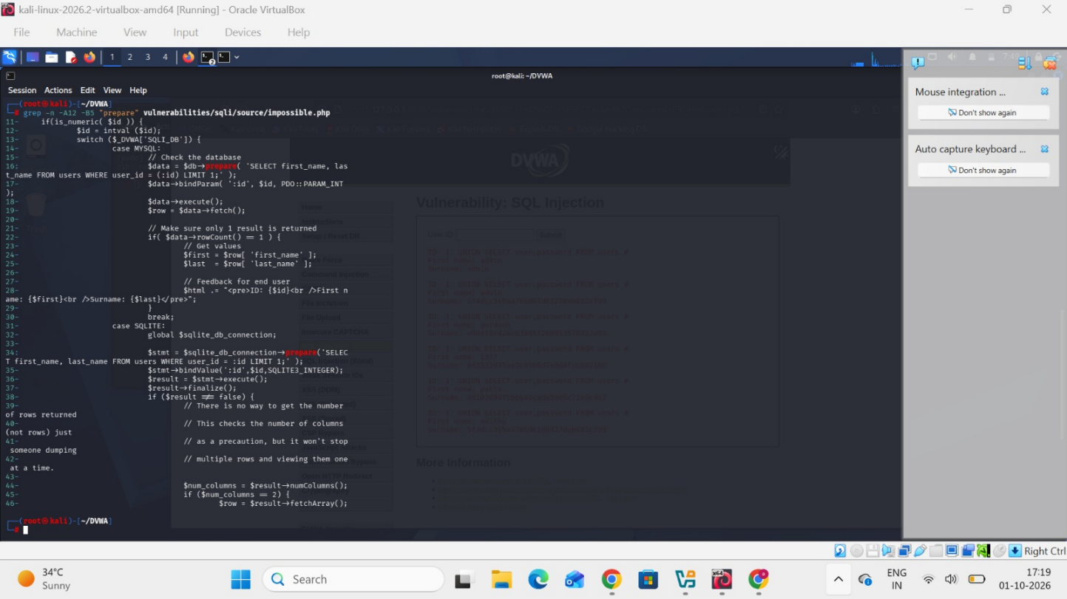

2. Stored XSS

A. Inspect vulnerable source
From Kali:
cd /root/DVWA
Then:
cat vulnerabilities/xss_s/source/low.php
Secure implementation:
cat vulnerabilities/xss_s/source/impossible.php
The DVWA Stored XSS documentation describes the Low level as accepting the input without appropriate checking, and the Impossible level uses functions such as htmlspecialchars() to escape values.

B. Stored XSS test input
Go to:
http://127.0.0.1:4280/vulnerabilities/xss_s/
Security:
Low
Normal test:
Name: Manu
Message: Hello, this is a security test.
Then the XSS PoC:
<script>alert('Stored XSS')</script>
Submit it.
Expected:
JavaScript alert appears
That demonstrates that the supplied content was stored and later executed when rendered.
The DVWA documentation specifically states that Stored XSS remains in the database until removed/reset and is executed when the stored content is viewed.

C. Secure comparison
Set:
Security → Impossible
Inspect:
cat vulnerabilities/xss_s/source/impossible.php
The important mitigation line is:
htmlspecialchars()
Your explanation:
The input is HTML-encoded before being rendered, causing potentially dangerous markup to be treated as text rather than executable HTML/JavaScript.

Stored XSS screenshots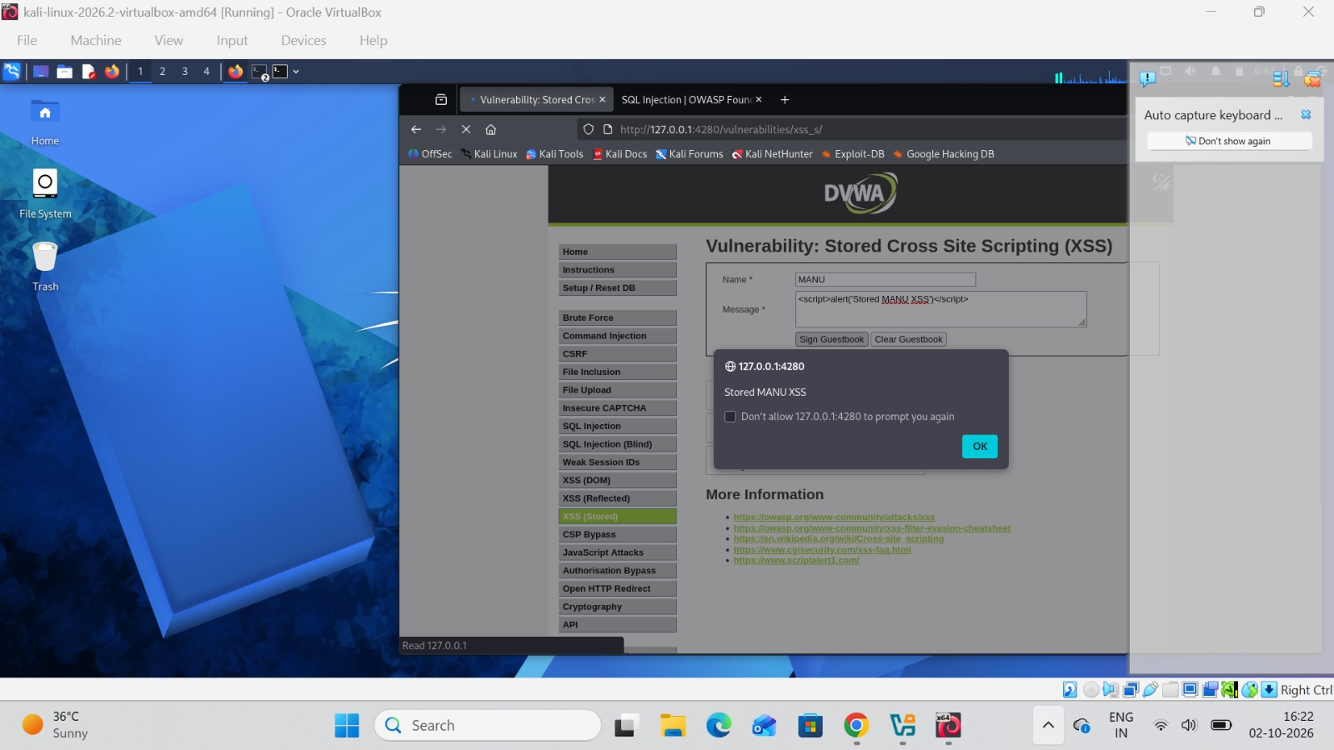

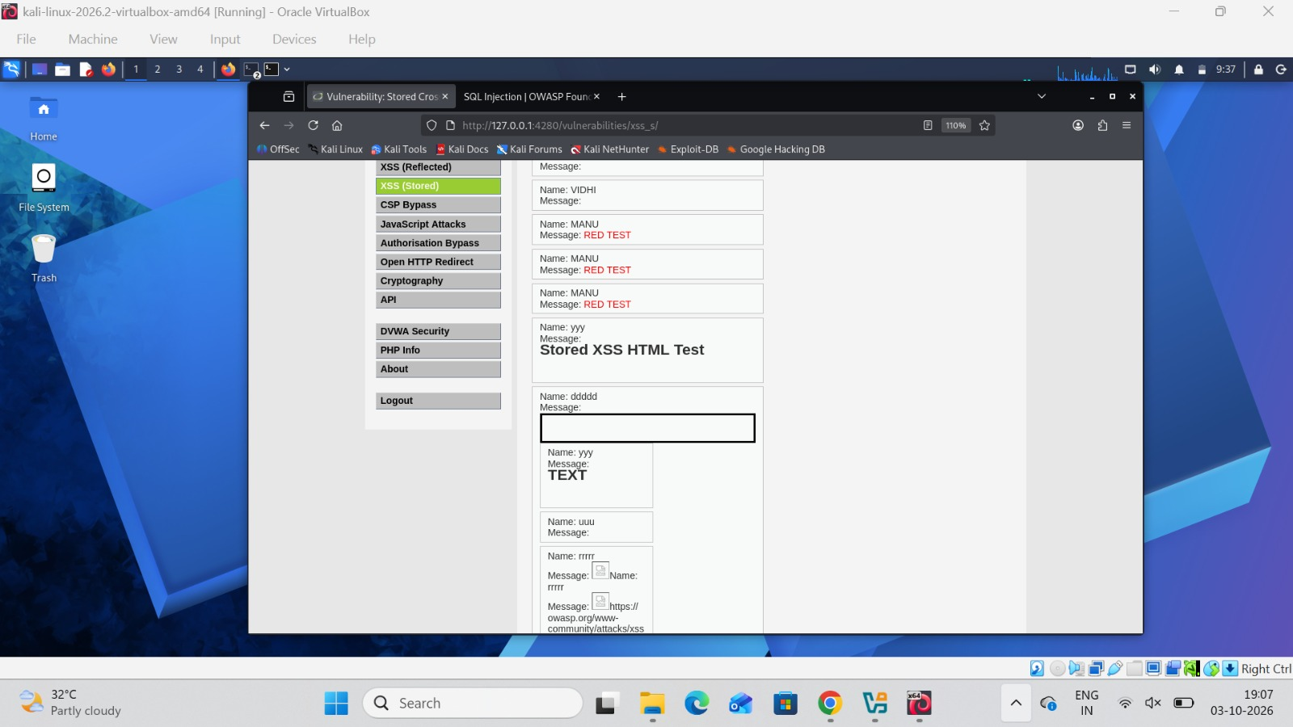

3. Reflected XSS

A. Inspect vulnerable source
cd /root/DVWA
cat vulnerabilities/xss_r/source/low.php
You saw the key vulnerable statement:
$html .= '<pre>Hello ' . $_GET[ 'name' ] . '</pre>';
That means the name query parameter is directly inserted into the HTML response.

B. Normal query parameter
Open:
http://127.0.0.1:4280/vulnerabilities/xss_r/
Enter:
Manu
The page reflects:
Hello Manu

C. Reflected XSS test
Use:
<script>alert('Reflected XSS')</script>
The important point is that the payload is supplied through the current request/query parameter, rather than stored in the database.

D. Secure implementation
Inspect:
cat vulnerabilities/xss_r/source/impossible.php
The secure approach uses HTML encoding before placing the value into the page.
Your report explanation:
The reflected XSS vulnerability results from placing attacker-controlled query-parameter data directly into an HTML response. Context-appropriate output encoding prevents the browser from interpreting the supplied value as executable markup.

Reflected XSS screenshot
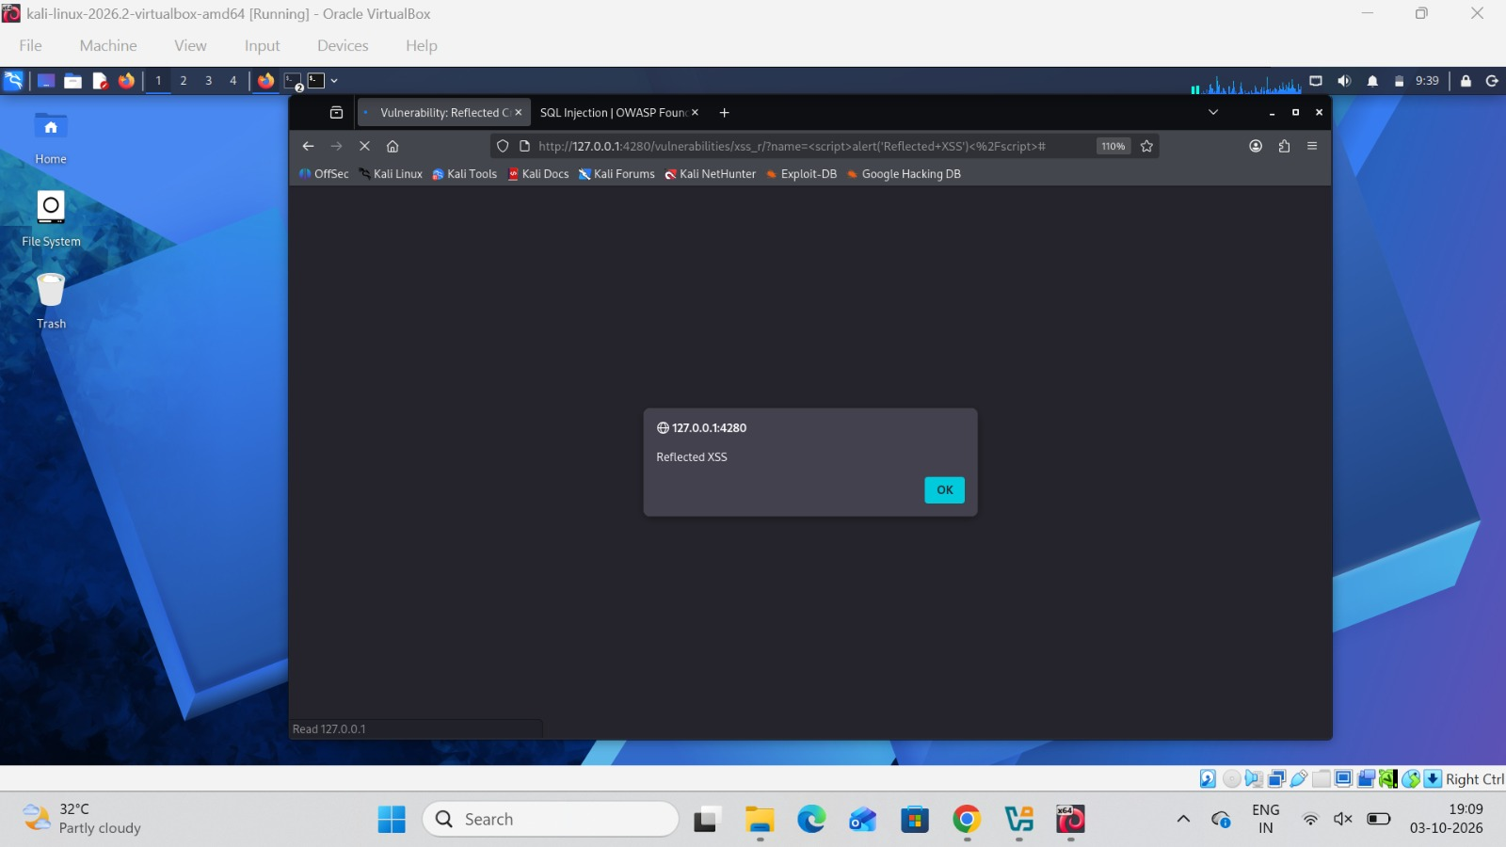

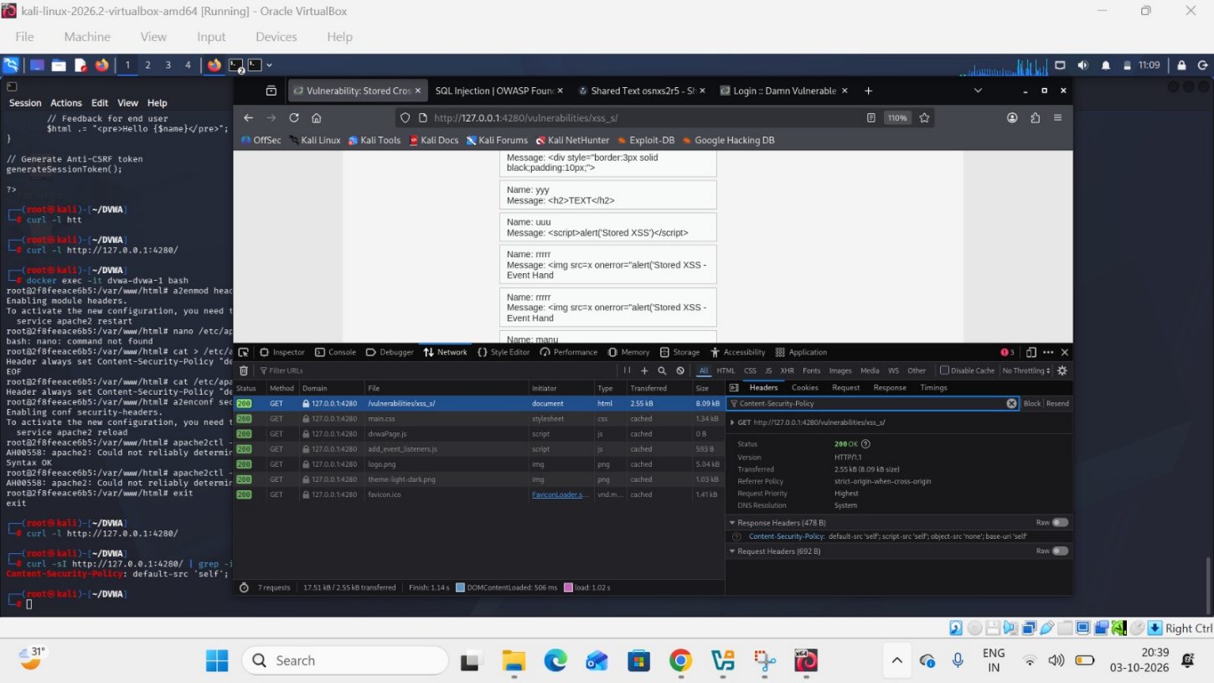

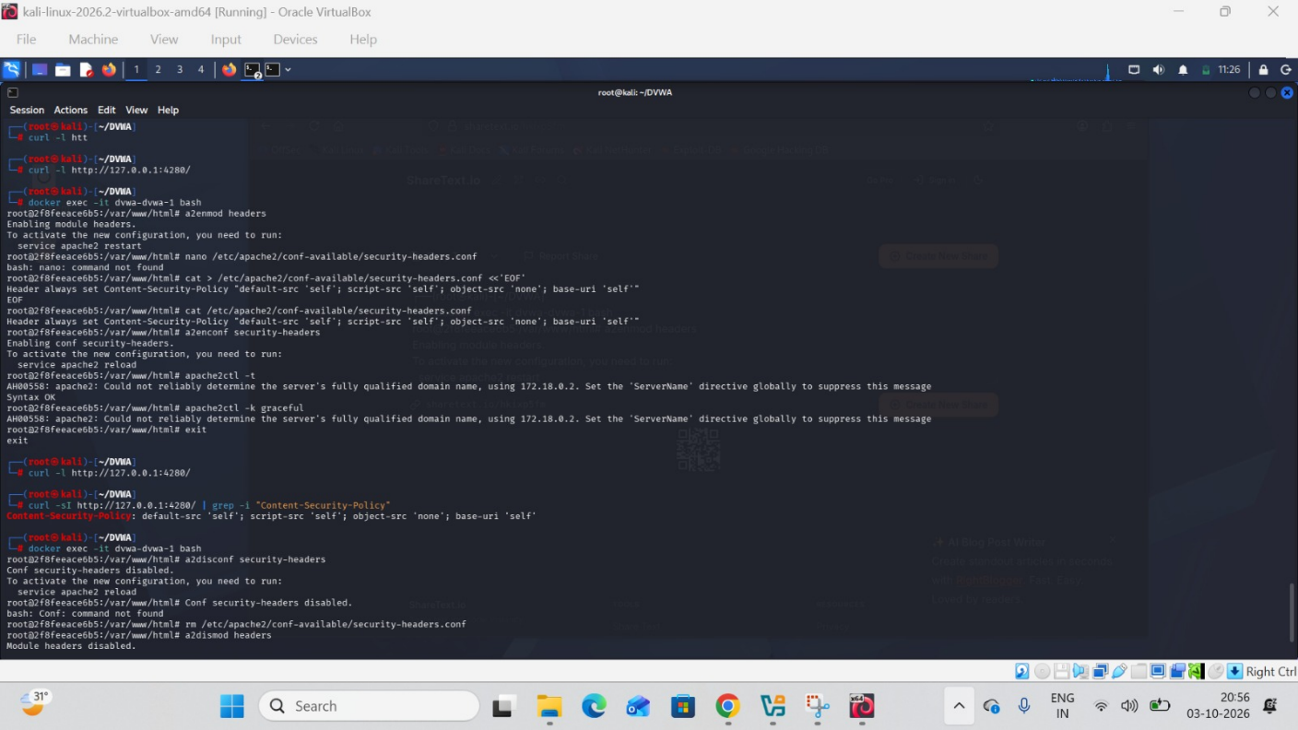

4. CSRF
This one had fewer terminal commands because the actual attack was performed through the browser.

A. Inspect Low implementation
cd /root/DVWA
cat vulnerabilities/csrf/source/low.php
The Low implementation accepts the password parameters without an anti-CSRF token. DVWA's current CSRF documentation explicitly describes the Low level as having no CSRF protection and gives the password-change parameters as the basic test.

B. Low-level CSRF test
Go to:
http://127.0.0.1:4280/security.php
Set:
Security Level → Low
Then:
http://127.0.0.1:4280/vulnerabilities/csrf/
Normal password change first:
New password: CSRFTest123
Confirm: CSRFTest123
Then use the forged request:
http://127.0.0.1:4280/vulnerabilities/csrf/?password_new=CSRFTest123&password_conf=CSRFTest123&Change=Change
Expected:
Password Changed.
Then verify by logging out and back in with the test password.
DVWA's own CSRF help identifies the Low-level attack as a crafted link containing password_new, password_conf, and Change.

5. CSRF token protection
Set:
Security → High
Then inspect the form using Firefox:
F12 → Inspector
Search:
user_token
You found:
<input type="hidden" name="user_token" value="...">
That is your token evidence.

Inspect High source
From Kali:
cd /root/DVWA
cat vulnerabilities/csrf/source/high.php
Look for the token validation:
checkToken(
$token,
$_SESSION['session_token'],
'index.php'
);
The current DVWA High implementation explicitly checks the submitted token against the session token.

Secure retest
Take the previous tokenless URL:
http://127.0.0.1:4280/vulnerabilities/csrf/?password_new=CSRFTest123&password_conf=CSRFTest123&Change=Change
Try it at:
Security → High
Expected:
CSRF token is incorrect
or equivalent rejection.
So your evidence is:
LOW
↓
No user_token
↓
Forged request succeeds

HIGH
↓
user_token exists
↓
Server validates token
↓
Same tokenless request rejected
DVWA's documentation explicitly describes the High level as adding an anti-CSRF token.

CSRF screenshot
