Section 76:
After ActivityDetailsHeader implementation
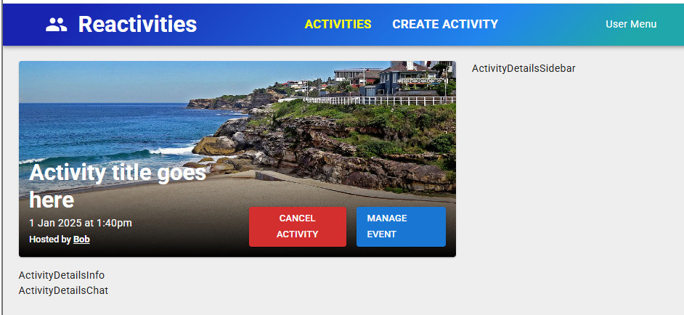
If isCancelled is true 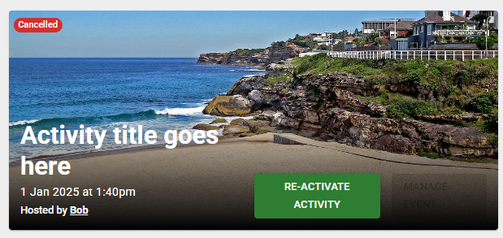
If isHosting = false 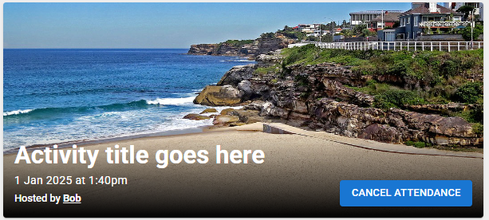
After activityDetailsInfo implementation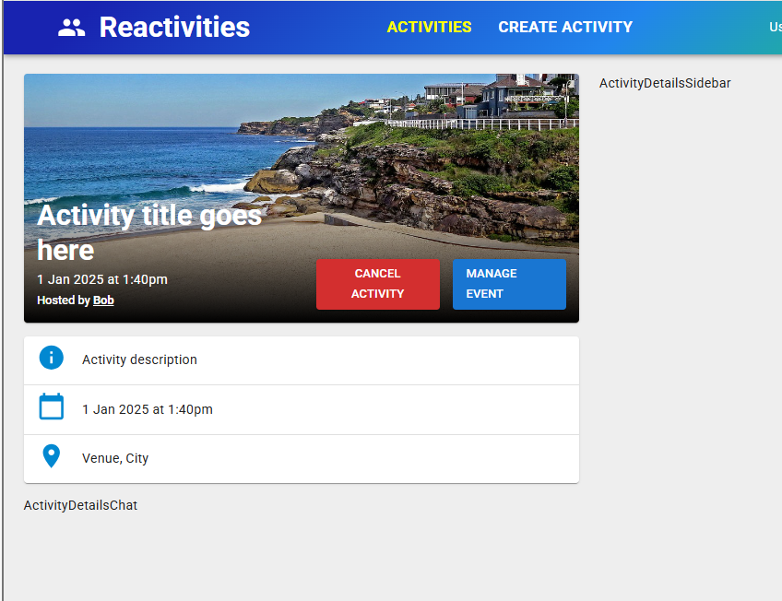

After activityDetailsChat implementation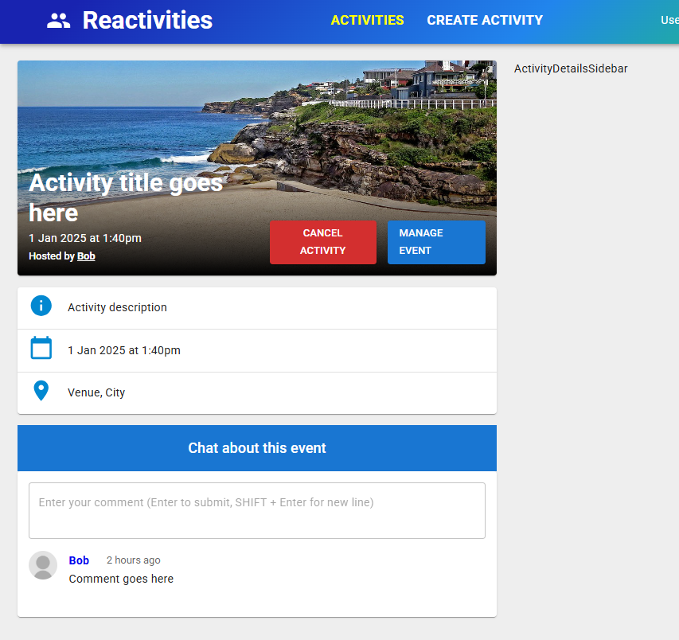
After activityDetailsSidebar implementation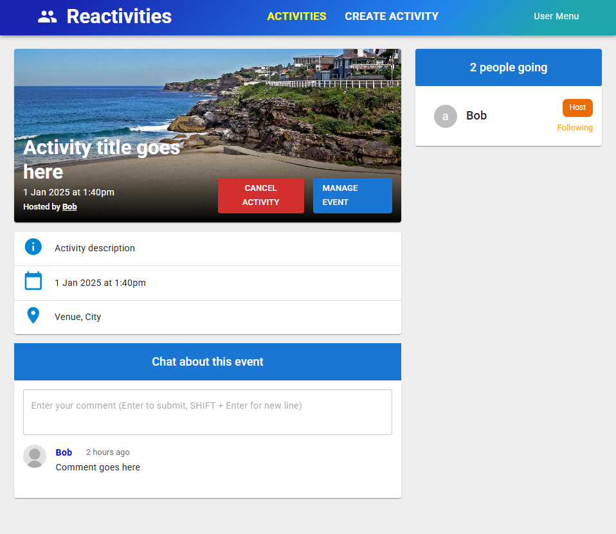

Section 77: Created Filter component at right side
Before 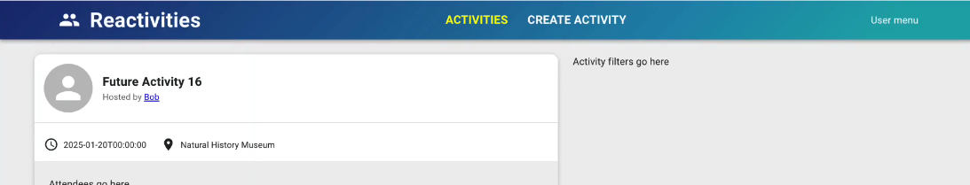

After
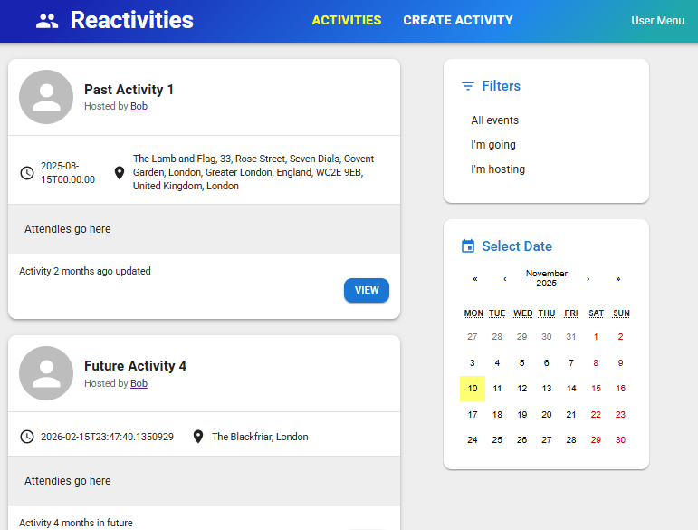

Section 78: Working on Home Page
Before
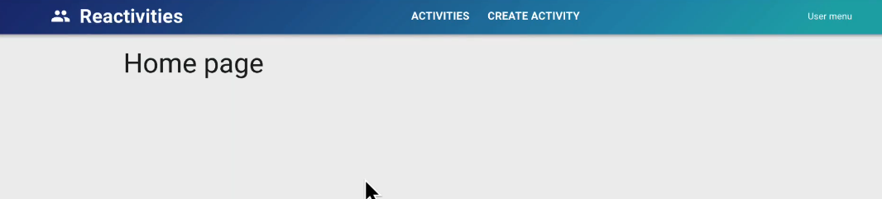
After
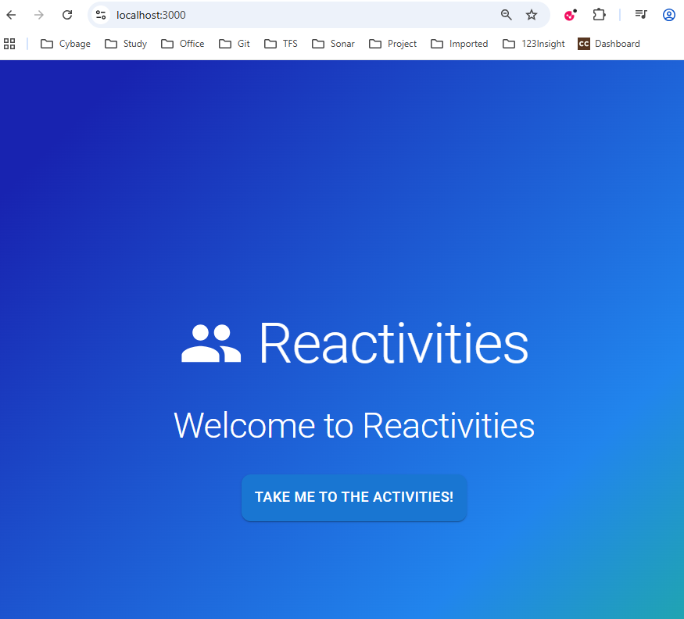

79. Formatting the dates
Before
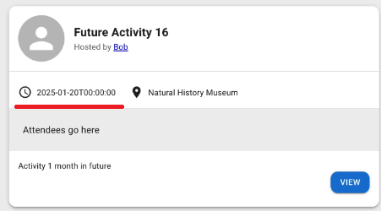
date-fns provides the most comprehensive, yet simple and consistent toolset for manipulating JavaScript dates in a browser & Node.js.

