1. B) James gosling
2. A) Bytecode is executed by JVM
3. C ) use of pointers
4. C) infinity
5. D) .java
6. D) java is platform -independent programming language
7. A) 32
8. –not answered due to topic not studied
9. A) Compilation error

**package** assigments;

**public** **class** Practice {

**public** **static** **void** main(String[] arg) {

**int** count = 1;

**while** (count <= 15) {

System.***out***.println(count % 2 == 1 ? "***" : "+++++");

++count;

}

}

}

**Output:**

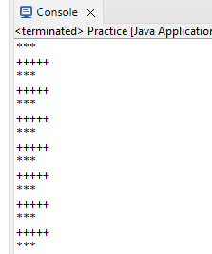

1. –not ansering due to not studied
2. D) If
3. creat a class classroom with data members rolno,name,mark it consists if two mwthod store to assign values and display to print details create object and call these methods?

**package** Oops;

**import** java.util.Scanner;

**public** **class** Classroom {

String name;

**int** marks;

**int** rollno;

**public** **void** store() {

Scanner sc = **new** Scanner(System.***in***);

System.***out***.println("Enter the name:");

name = sc.next();

System.***out***.println("Enter the marks:");

marks = sc.nextInt();

System.***out***.println("Enter the rollno:");

rollno = sc.nextInt();

sc.close();

}

**public void Display() {**

**System.*out*.println("The name of Student is: " + name);**

**System.*out*.println("The Marks of students is: " + marks);**

**System.*out*.println("The Roll no of student is: " + rollno);**

**}**

**public** **static** **void** main(String[] args) {

Classroom classr = **new** Classroom();

classr.store();

classr.Display();

}

}

