MANU K SHIBU

Rakhi Nov-batch 2024

create database sqlexam

use sqlexam

create table table1(itemno int,iname varchar(20),price bigint,qty bigint)

insert into table1 values(12,'pen',10,17)

insert into table1 values(13,'eraser',5,15)

insert into table1 values(14,'notebook',15,20)

select \* from table1

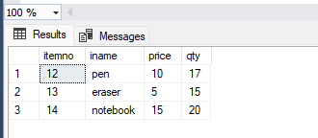

--1)

insert into table1 values(15,'pencil',20,10)

select \* from table1

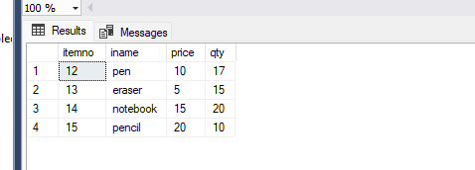

--2)

select \* from table1 where qty>10

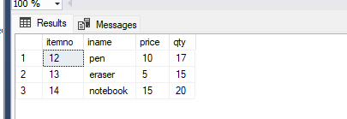

--3)

update table1 set itemno=25 where itemno=13

select \* from table1

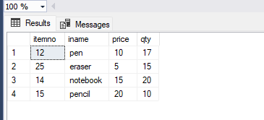

--4)

select iname,qty,price,(qty \* price) AS TotalAmount from table1

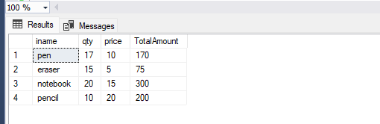

--5)

select iname from table1 where price=10

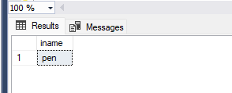

--6)

select \* from table1 order by price asc

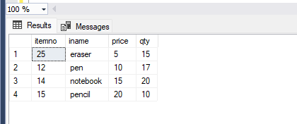

--9)

update table1 SET Price = Price + 2

select \* from table1

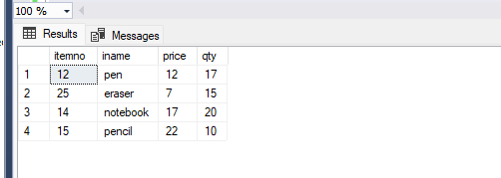

--10)

update table1 set price = price - 2 where price<20

select \* from table1

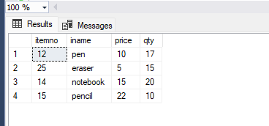

--11)

--a) select

--b) order by

--12)

select count(\*) from table1

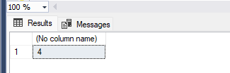

--13)

alter table table1 add address varchar(20)

select \* from table1

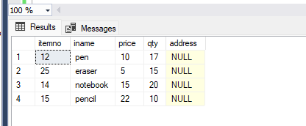

--14)

create procedure table1procedure

as begin

select \* from table1

select \* from table1 where itemno=14

end

go

exec table1procedure

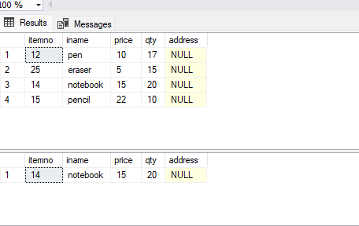

--15)

create view table1view as select iname,price from table1

select \* from table1view

