**HUL 271**

**Major Examination (Subjective)**

Submitted by :

Manupriya Gupta

2018CS10355

Ques 3. Drawing on your understanding of any two social institutions, reflect on how they contribute to order in society and reflect on the nature of their embeddedness across different societies. Give examples in support of your answer.

Several social institutions have been thoroughly discussed in this course and a lot of detail dispensed about them. The key takeaway from the discussion has been that social institutions have a **deep embedding** in all spheres of our social life be it our **attitude, sense of judgment, stereotypes** and even our tendency to **challenge the existing social structure**. In light of these reflections, I would like to describe my understanding of the institutions of **Marriage** and **Family** in the pretext of my personal experiences and discussion from the classroom.

**Marriage**

**Biological crossover** between men and women as means for reproduction is as old as time but **concretely defining this relation**, by inter-mingling with elements like **kinship, caste, religion** etc. and formulating this bond as a strong social institution called ‘Marriage’ is relatively new.

Different societies associate different **norms, values and roles in a marriage**. Typically among the Hindus, **inter-religion** or **inter-caste** marriage is **condemned**. Also in most **patriarchal societies** the **wife is subdued**. She is treated like a belonging of her **husband** who **exercises control** over actions and sometimes even has freedom to **exploit** her. For **unmarried girls**, sometimes even **platonic love** is treated as **violation of social order.** *Do we need to question these existing social norms? Yes. Can we completely get rid of these social norms? No.* Think about a society where Marriage as an institution does not exist. In that case, any two individuals of opposite sexes can create an **offspring**. But how will the **upbringing of that child** take place? The **roles of father and mother** must be defined clearly for that child. For holistic development, the child also needs an intimate group of people for upbringing - **the family**. A family cannot be formed without marriage, the **lineage** would cease to exist if men and women do not associate a **social construct with their biological relation**. This is one instance where **marriage** is lauded as a concept to ensure **social order**. It is bond of **faith, trust and respect** for each partner which to some extent r**estricts unethical actions** by men and women and helps **curb menaces** in society.

*Not the existence of marriage as a social institution, but the unreasonable realms related to it should be questioned.* The **practice of ‘Sati’** was discontinued in India after the **feminist revolution** in the 19th and 20th centuries. In **Nuer Kinship**, ‘Ghost Marriage’ and ‘Blind Adultery’ concepts prove that even women are given prestige and value in marriage in some societies. Whereas in the **Tamil Brahmin** society, women are highly **devalued as marital partners** and even basic biological phenomena like **menstruation** is considered **definling**. In **Islam**, a man can have **multiple wives** and no one questions his loyalty. But none of his wives have freedom to talk face-to-face with another man.

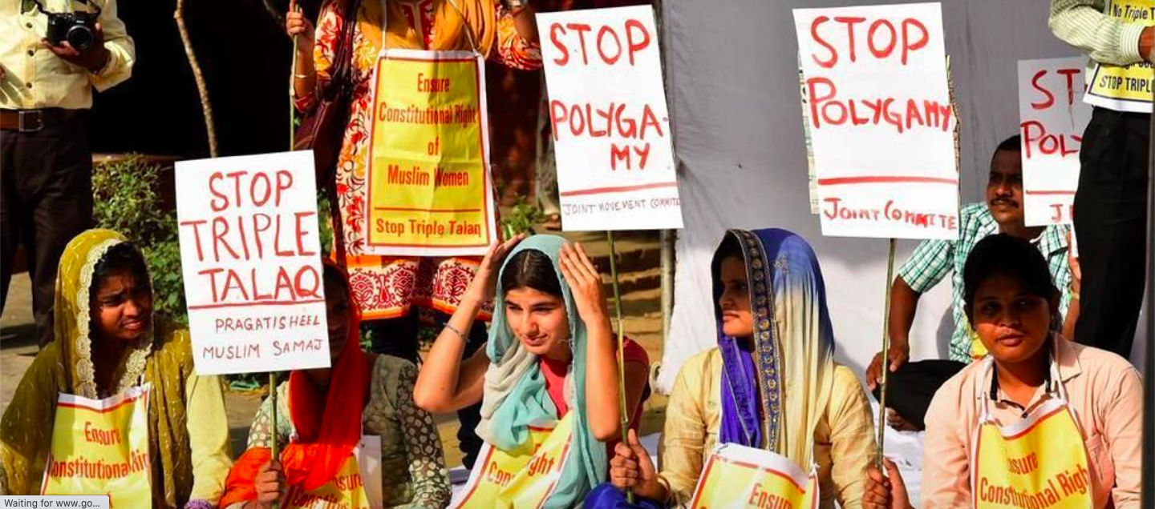

There is **variation across societies** due to **traditionally existing social constructs** or the **transformations brought by social movements**, but marriage is strongly **embedded in other socio-political (Calvinism) or economic institutions**. **Women** constitute the **workforce** of a nation but not necessarily the **‘income generating workforce’**. In India, according to a survey in 2019, 90.7% of married women are tagged **‘home-makers’** though they work extensively in the fields, rear the cattle or help their husbands in their businesses. So this **socio-economic stratification** distinguishing men from women has some influence from marriage. In **my own household,** my mother used to earn more than my father but after marriage and my birth, due to **domestic duties** and **compliance** to the fact that ‘**the mother must prioritize taking care of her child**’, she could not devote enough time to her profession. This ‘**compromise**’ began 21 years back and ironically it is still continuing. *Whom to blame? Why just the society, I never had the courage to voice my concern for her till date.*

**

From **post-marital duties to motherhood**, it just crossed my mind that it is **Mother’s Day** today! The social institution which **scripts a mother’s role** is another intriguing pillar called …

**Family**

This is the **first institution** a child learns about. The life **inside and outside family** form the **private and public sphere** of social life. Families have **evolved** over time, earlier in the Indian sub-continent only **extended and joint families** were found, today **nuclear families** are prevalent. Till about the mid 20th century, the **patrilineal descent** system dominated major parts of **Europe and Asia**. In some rare societies, a matrilineal system was followed.

After numerous movements (**3 waves of feminist movement**) women grew more consious about themselves and sought the **respect and dignity** they deserved in their families. As a result of this, **families today** are more inclusive of all members in terms of **respect, privacy and freedom**. *Children in urban areas do not grow up seeing their mothers only cook in the kitchen or wash clothes. They also see their father doing a bit of household work.* The **Nayar kinship** enforces **matriliny** in terms of descent and residence, so women are highly respected in every family. However less than a century back, during the **Indo-Pak partition**, several **men killed the women of their own families** due to fear of their abduction which could potentially damage **‘honour’** of the family. **‘Masks and Faces’ by Veena Das** gives a deep insight into **Punjabi Kinship** where religion and caste sometimes overpower the familial ties.

A child learns fastest what he/she sees in the family. Hence a **family** which imbibes good **values and culture** in the new generation is a **quintessential tool** in maintaining **social order.**

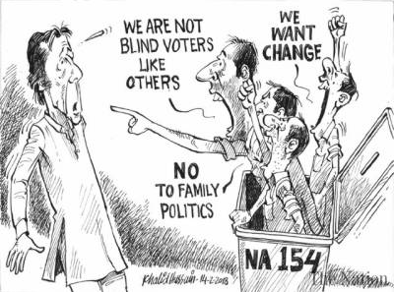

We often hear of **‘Family Politics’**, **‘Family Business’** etc. Hence family largely influences **socio-political-economic institutions** and vice-versa. *The children of the rich are inherently rich and likewise the nepotism in Bollywood.* But we notice apart from the royal families, such things are missing in the west. **Family has greater regard in the Indian societies**, that is why **parents work hard** so that their kids have no shortcomings. But at the same time, **children are expected to look after their parents** once they grow old. **Americans** are not known for giving away all their wealth and property to their children, so they **easily disconnect** once the kids grow up. In fact most **youngsters** do not even have their parents paying their **college fees**, they arrange it by doing **part-time jobs**. *This is the most pressing point when we talk about the vast cultural differences between the west and the east.*

Through this write-up I have explained my understanding of Marriage and Family, the induced social order and their embeddedness across societies.

Ques 6. Nuer societies had ways/practices like blind adultery, social father and genitor, ghost marriage to deal with the requirement of a male heir in the patrilineal descent system. Discuss how caste plays a role in our patriarchal societies in dealing with the requirement of a male heir and its implications for women. In light of this, critically reflect on the ways/practices to deal with son preference in contemporary India.

**Patriarchal societies** in the Indian subcontinent have several attributes like **patrilineal system of descent and residence**, **subordination of women** and most importantly, a **male heir** in the descent system. *We are not unknown to stories of our domestic helpers and farmers who still have 4-5 children, are we?* The main reason behind this is that they want a boy child. So unless a boy is born, parents continue with effort of reproduction.

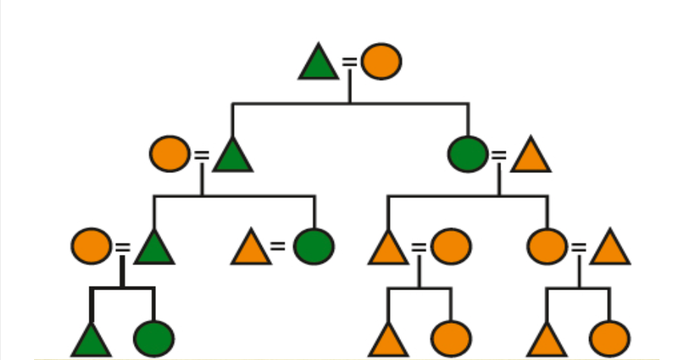

If a family does **not have a male heir**, that means that the **lineage cannot be continued** further. In some societies like the **Tamil Brahmins**, failure of the lineage is considered a **sin**. Since **marriage** provides a **structural link** between **cast and kinship**, caste plays a key role in dealing with the requirement of the male heir. The **Nuers** practise **blind adultery**, **ghost marriage** and other ways for reproducing the male line. But in their case, **marriage is a loose affair** such that *women pull some men together and pull others apart*. This is **not practised in Indian patriarchal societies** because the **purity of blood** in a family matters the most. A **newly married woman** must be from the **same caste**, a **virgin before marriage** and can have a sexual affair only with her husband. Some even more stringent laws exist which seed **child marriage**.

**Hindu religion** does not permit even a male to have two wives, he can re-marry only after becoming widower. So this adds to **pressure on women** to produce a **boy child**. Among some **tribes in Maharashtra**, if a woman is unable to bear a son among the first five children, she is treated as an **‘outcast’**. In such situations when women are going through **repeated pregnancies** and bearing **pain of child delivery**, *is it too difficult to notice how well pitted biological essentialism and social construction are against each other? No.* The **implications of such norms**, that having a boy child is essential for honour and dignity, are too **severe for women**. *Maternal mortality rate in India is 113 per 100,000 live births, almost 4-5 times more compared to developed nations.* A bit of the blame can be put on the healthcare system but the major factor is that **woman's body, unlike a machine**, undergoes several changes and complications during pregnancy. Unfortunately many Indians are still **less sensitive to this** compared to prestige of the family.

In **contemporary India**, many authors wrote about how the **girl child was either killed or floated in a river or simply disowned immediately after birth**. At least **abortion of a girl** child before she is born is almost curbed now due to the **PNDT Act of 1994.**



There is not much distinction between the **different socio-economic strata** when it comes to the desire of a son. There are **ways to determine the sex of the foetus** by **travelling to other countries** and the **ones doing so** are definitely **decently educated and rich**. Despite being well educated they do this, that reflects how **deeply** an individual is **affected by the societal norms** that even **money and education** cannot change the **ages-old mindset**. The practices of disowning the girl child as described above still exist but it has reduced over the years and now there are **NGOs who adopt** them.

There are multiple **reasons for the preference of a son**. One reason is the **patriarchal descent** and **greed to continue the lineage**. Another reason is **‘Dowry’**. It is **legally prohibited** but in almost all **Hindu households**, rich or poor, urban or rural, it is considered as an **auspicious act** to give away **jewelry, money and other goods** to the in-laws of their newly-wed daughter. This makes **marriage of a daughter** a very **expensive affair**. Modern-day educated youth condemn this practice during their weddings but the **change is slow**. **Myths** about **essence of dowry** are yet to be busted. **Undervaluation of women** in society is **fueled** by this practice. Hence people do not want a girl child.

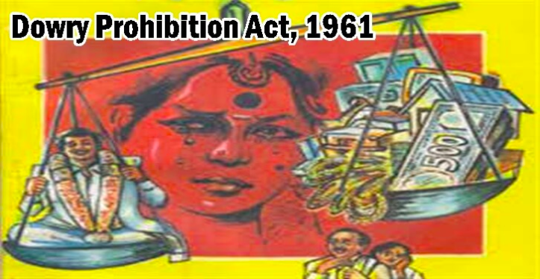

Nowadays **technological advancement** has made **artificial fertilization** possible too and people with money are blindly hankering over it for the want of a baby boy. From a **critical realist ontology view**, there are **social bonds** **which people cannot overcome**. *Instead of using their education and knowledge to spread awareness about the rights of a girl child, they succumb to societal pressure and use technology and resources in the wrong way.*

*Maybe they are petrified of the system of rewards and punishments. Maybe there is actual pleasure and benefits of a boy child.* These are **debatable topics** but being a girl I strongly feel that the **contemporary Indian society** would not progress socially or economically unless the **preconceived notions related to a girl** don’t change. *My parents brought me up and made me capable of doing almost anything that a son could have done.* About lineage, patriarchal ties are slowly dissolving and sooner or later people would accept the bilineal system of descent.

**CSS** reveals that not just technical skills, but **social skills and understanding** can bring about a change to *make this world a better place for mothers and daughters.*