COL334/672: Assignment 4

- We have the following topology: a sender communicating to a receiver via a series of two routers. Packets are of size s, the transit links have a transmission rate of r, while the access link operates at half the rate of the transit links. The round trip propagation delay is 4s/r, hence within an RTT of 8s/r the access link can just about support a window size of 4 packets. Ignore acknowledgement sizes.

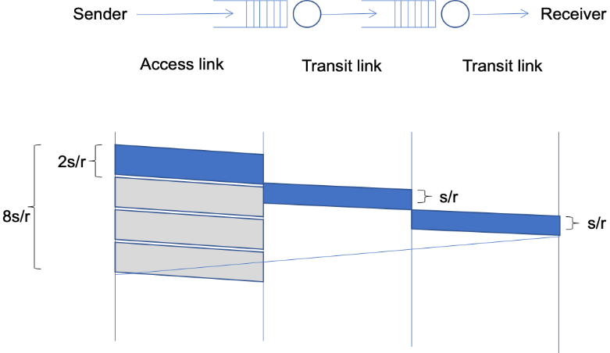

Consider the following packet trace at the sender using a transport protocol similar to TCP. The y-axis indicates sequence numbers in bytes – long vertical rectangles are packets and each packet is 100 bytes long, thus the first packet contains data from sequence number 0 to 99, the second packet from sequence number 100 to 199, etc. The x-axis indicates time in units of s/r. The small stubs are acknowledgement numbers – thus, the stub at time 9 (after one RTT) is the cumulative acknowledgement for the first packet with sequence number 0 to 99, the stub at time unit 11 is the cumulative acknowledgement for the second packet, etc.

The congestion window indicates the maximum number of unacked packets that can be sent. Assume this window size to be fixed and much greater than 4 packets – this implies that the sender will try to push out a packet every 2 time units, which is the maximum transmission rate its access link allows.

Also assume for simplicity that no acknowledgements are lost and no reordering occurs.

Fast retransmission is triggered upon getting triple duplicate acks, taking into account the very first ack as well.

Now explain the packet trace below.

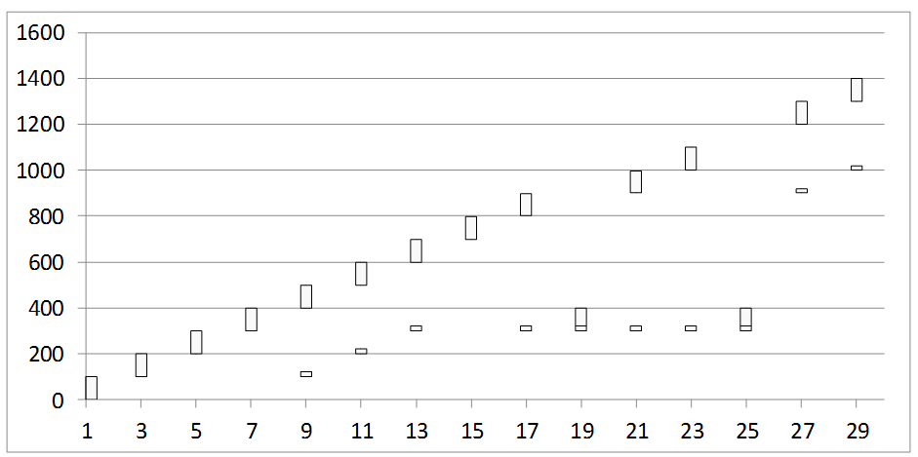

    - Packet 300-399 seems to have been lost. What triggers the retransmission of the lost packet?
Answer : Packet loss is detected by TCP by triple duplicate acks. As soon as third duplicate ack is received, fast retransmission is triggered and hence the lost packet is re-transmitted.

    - The acknowledgement received at time 21 was generated at the receipt of which packet at the receiver?
Answer : Packet 600-699
Explanation : Since rtt = (9-1) = 8, the ack at 21 must be for the receipt of packet transmitted at 21 – rtt = 21 – 8 = 13. This is packet 600-699.

    - Why is the acknowledgement at time 21 still referring to the lost packet even though it has been retransmitted?
Answer : Packet 300-399 is re-transmitted but not received yet. It was re-tranmitted for the first time at 19. Then the ack for its receipt will come at 19 + rtt = 19 + 8 = 27. So, at 21, because the ack for the re-transmitted packet is still not received, ack at 21 is still referring to the lost packet.

    - Why is the lost packet again retransmitted at time 25?
Answer : The lost packet 300-399 was re-transmitted earlier but not received yet. It was re-transmitted for the first time at 19. Then the ack for its receipt will come at 19 + rtt = 19 + 8 = 27. TCP again detects 3 duplicate acks at times 21, 23 and 25. So, it again detects packet loss for 300-399. Hence the lost packet is again re-transmitted at 25 according to the fast re-transmission policy.

    - Why is there a sudden jump in the acknowledgement number at time 27? The acknowledgement was generated at the receipt of which packet?

Answer : Till 27, acks for the packets 400-499, 500-599, 600-699, 700-799 and 800-899 were being cumulated since we were waiting for the ack of the packet (300-399) which was re-transmitted at 19. At 19 + 8 = 27, this ack is received and cumulative ack, for packets having bytes in range [400-899], is also received. That is why there is a jump in acknowledgement number. The future acknowledgement numbers will be for packets having bytes numbered from 900 onwards.
This acknowledgment was generated when the lost packet (300-399) was received after being re-transmitted at 19.

- In another variant, the initial congestion window size is started at 4 packets, and the window is incremented fractionally by (1 / int(current window size)) upon receiving an acknowledgement. Thus, a window size of 4 will increment to 5 after having received 4 acknowledgements (4.25 after the first ack, 4.5 after the second ack, 4.75 after the third, and 5 after the fourth ack). Note that packets are dispatched only if they can be accommodated fully within the window, ie. even with a window of 4.75 only four outstanding packets will be allowed.

The window size also reduces to half upon receiving triple duplicate acknowledgements which is seen as an evidence of packet loss. Note that receipt of the third dup ack will not increment the window, ie. if the window is 5 when the third dup ack arrives, it will just be reduced to 2.5, and not add another 1 / int(2.5) increment for this ack as is done for other acks. Also note that the event of a triple dup ack is also interpreted as a loss, and hence the number of outstanding packets will be assumed to be one less than what was it estimated to be earlier. This is almost identical to TCP operations in the congestion avoidance phase.

Answer the following questions. Hint: Maintain two variables for congestion window and the outstanding data to understand what is happening.

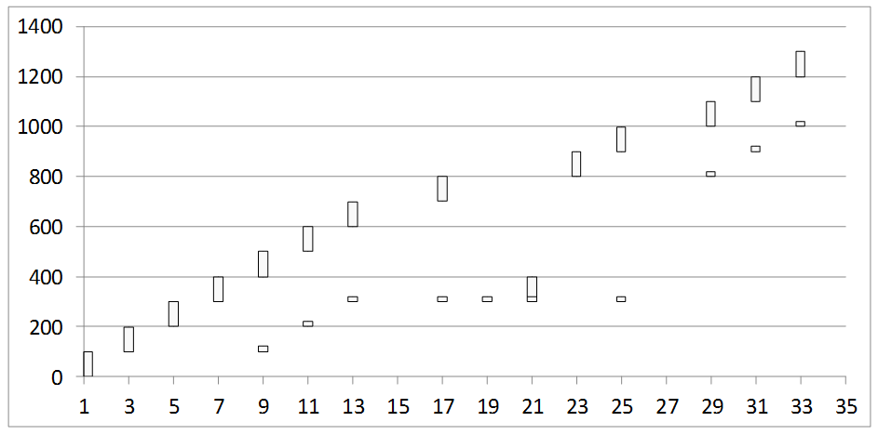

    - What is the window size at time 17?
Answer : Window size at 17 is 5
Working : At t = 0 window size = 4
At t = 13 window size = 4 + 3*(1/4) = 4.75 (after receiving 3 acks)
At t = 17 window size = 4 + (1/int(4.75)) = 5

    - What is the window size at time 19? Why is no packet pushed out at time 19?
Answer : Window size is 5/2 = 2.5 since the third duplicate ack is received at 19 so the window size reduces by a factor of 2. No packet is pushed out at time 19 because the window size is reduced to 2.5 and the number of unacked packets is 8 - 5 -1 = 2. So there is no capacity to send another packet unless we receive ack for one of the unacked ones already present.

    - What is the window size at time 21? What is the outstanding data estimated by the sender at time 21?
Answer : Window size is = 2.5 + 1/(int(2.5)) = 3. Outstanding data estimated by sender at time 21 is 9 - 6 - 1 = 2.

    - Why is a packet pushed out at time 23 even though no ack is received at that time?
Answer : The window size is 3 (same as 21). Outstanding data till 21 was 9 - 6 - 1 = 2. So, there was capacity for sending another packet at 23. Hence, a packet is pushed out at 23 even though no ack is received at that time.

    - What is the window size at time 31?
Answer : Window size at 31 is 4
Explanation : Window size at 21 = 3
Window size at 31 = 3 + 3*(1/3) = 4 since there are 3 acks from 21 to 31

- Now consider a different scenario where the access link is very fast but the next link is slower.
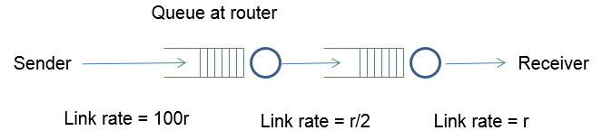
Assume an initial window size of 8 this time. As in the previous question, the window size is reduced to half upon receiving triple duplicate acknowledgements, and it is incremented by 1 / int(congestion window) upon receiving an acknowledgment. A timeout occurs if the last unacked packet goes unacknowledged for more than 25 time units. The buffer size at the first router is limited, and it follows a drop-tail policy. Assume that all packet losses happen due to buffer overflow at the first router. Answer the following questions:

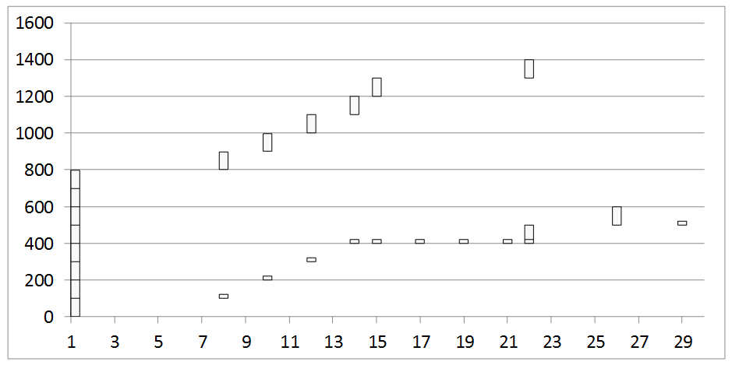

    - What is the RTT in this case?
Answer : For the first packet, rtt = 8 - 1 = 7. It is more for other subsequent packets because of queuing delay.

    - Can you infer the buffer size at the first router? How?
Answer : Buffer size at first router is 400 bytes (4 packets of size 100) because the first packet which is lost is 400-499. All packet losses are happening due to buffer overflow at the first router. So, this packet loss also occurs due to the same. Hence, buffer size of first router is 400 bytes.

    - Why is there no retransmission at time 17 despite a triple dup ack? Why does this retransmission happen later at time 22? Why do two packets get fired off at time 22?
Answer : At time 17, window size is (8 + (5/8))/2 = 4.3125 and the number of outstanding packets is (13 - 6 - 1) = 6. That is why re-transmission does not occur because network is already loaded with more number of outstanding packets than the window size.
At time 22, window size is 4.3125 + 3*(1/4) = 5.0625 and the number of unacked packets is 6 - 2 - 1 = 3. So, the network has the capacity to push 2 more packets. Hence, 2 packets get fired off at 22.

    - When did a timeout occur? Which packet gets timed out?
Answer : Timeout occurred at 26. Packet 500-599 gets timed out.
Along with this, packets 600-699 and 700-799 also get timed out because no ack is received for them till 26.

- Consider now a scenario where the buffer size at the first router is very large so that no drops occur. Answer the following questions:

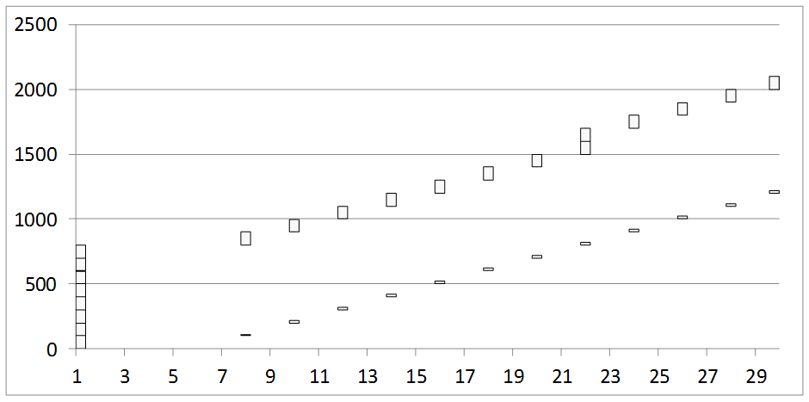

    - What is the round trip time clocked for the first packet? For the fifth packet? For the eighth packet?
Answer : RTT for 1 = 8 – 1 = 7
RTT for 5 = 16 – 1 = 15
RTT for 8 = 22 – 1 = 21

    - When is the window size increased to 9?
Answer : Window size becomes 9 at 22 (after receiving the 8th ack)
Explanation : At 0, window size is 8.
At 22, 8 acks are received, hence window size = 8 + 8*(1/8) = 9
There aren’t any duplicate acks up to 22.

    - Since the buffers are assumed to be large enough, there will be no drops and the window size will keep increasing each time a complete round of acknowledgments for the current window are received. What is the problem with such a network?
Answer : If window size keeps increasing, more and more packets will be pushed into the network at the same time and they will queue up in the buffer which might result in greater queueing delay and inefficient transmission overall. Also, the rtt will increase for subsequent packets (due to the queueing delay) and when rtt >= timeout, packet will be lost and re-transmitted. For this re-transmitted packet also, rtt will be large and it will be lost again, causing a loop. So, this network cannot ensure reliable and effiicient transmission of packets.

    - Suggest a method to trigger a window size reduction in such a scenario, without witnessing any loss events.
Answer : Delay based congestion control will be a suitable strategy without any loss events. On a simplistic level, we can set a suitable threshold such that if rtt for any packet exceeds that, window size reduction is triggered. This threshold will depend on rate of operation of the links and other physical factors. This way, no packet will be lost during transmission since window size will be reduced as soon as rtt increases to a large value and all packets will wait for the network to get de-congested before they are transmitted.
There is another congestion control mechanism called BBR which periodically estimates available bandwidth and minimum rtt of packets.
Another popular mechanism is ECN which helps select parameters from simulations measuring proportion of packets lost, queue size, window size variation etc.

Submitted by :
Manupriya Gupta
2018CS10355

