**KPI’s**

**Total_Loan_application**

select count(id) as Total_Loan_Application from bank_loan_data

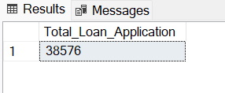

**MTD Loan Applications**

select count(id) as MTD_Total_Loan_Application from bank_loan_data where MONTH(issue_date)=12 And YEAR(issue_date)=2021

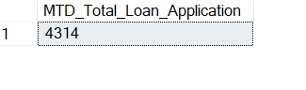

**PMTD Loan Applications**

select count(id) as PMTD_Total_Loan_Application from bank_loan_data

where MONTH(issue_date)=11 And YEAR(issue_date)=2021

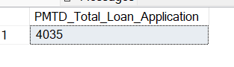

**Total Funded Amount**

select sum(loan_amount) as Total_funded_amount from bank_loan_data

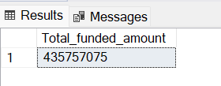

**MTD Total Funded Amount**

select sum(loan_amount) as MTD_Total_funded_amount from bank_loan_data where MONTH(issue_date)=12 And YEAR(issue_date)=2021

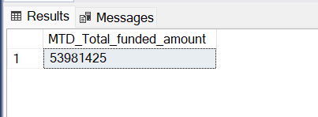

**PMTD Total Funded Amount**

select sum(loan_amount) as PMTD_Total_funded_amount from bank_loan_data where MONTH(issue_date)=11 And YEAR(issue_date)=2021

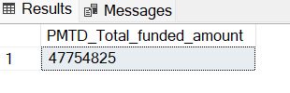

**Total Amount Received**

Select sum(total_payment) as Total_Amount_Recieved from bank_loan_data

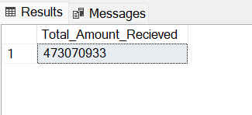

**MTD Total Amount Received**

Select sum(total_payment) as MTD_Total_Amount_Recieved from bank_loan_data where MONTH(issue_date)=12 And YEAR(issue_date)=2021

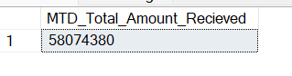

**PMTD Total Amount Received**

Select sum(total_payment) as PMTD_Total_Amount_Recieved from bank_loan_data where MONTH(issue_date)=11 And YEAR(issue_date)=2021

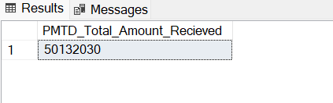

**Average Interest Rate**

select round(AVG(int_rate)* 100,2) Average_interest_rate from bank_loan_data

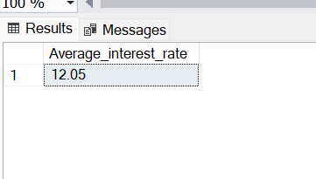

**MTD Average Interest**

select round(AVG(int_rate)* 100,2) MTD_Average_interest_rate from bank_loan_data where MONTH(issue_date)=12 And YEAR(issue_date)=2021

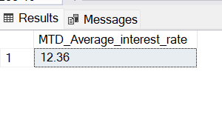

**PMTD Average Interest**

select round(AVG(int_rate)* 100,2) MTD_Average_interest_rate from bank_loan_data

where MONTH(issue_date)=11 And YEAR(issue_date)=2021

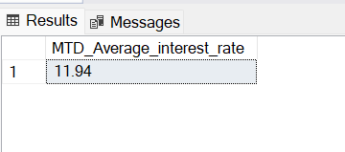

**Avg DTI**

select AVG(dti) as Average_Dti from bank_loan_data

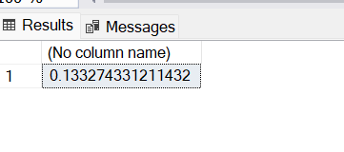

**MTD Avg DTI**

select AVG(dti) * 100 MTD_Average_Dti from bank_loan_data where MONTH(issue_date)=12 And YEAR(issue_date)=2021

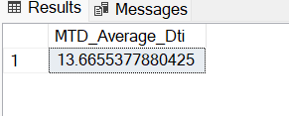

**PMTD Avg DTI**

select AVG(dti) * 100 PMTD_Average_Dti from bank_loan_data where MONTH(issue_date)=11 And YEAR(issue_date)=2021

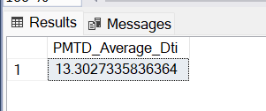

**GOOD LOAN ISSUED**

**Good Loan Percentage**

select (count(case when loan_status='Fully Paid' or loan_status='Current' then id end)* 100)/count(id) as Good_loan_percentage

from bank_loan_data

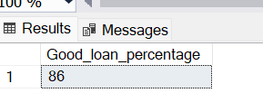

**Good Loan Applications**

select count(id) as Good_loan from bank_loan_data where loan_status='Fully Paid' or loan_status='Current'

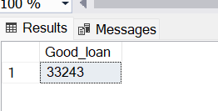

**Good Loan Funded Amount**

select sum(loan_amount) as Good_loan_Funded_amount from bank_loan_data where loan_status='Fully Paid' or loan_status='Current'

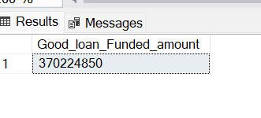

**Good Loan Amount Received**

select sum(total_payment) as Good_loan_amount_Recieved from bank_loan_data where loan_status='Fully Paid' or loan_status='Current'

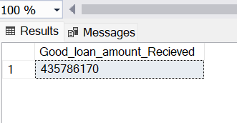

**BAD LOAN ISSUED**

**Bad Loan Percentage**

select (count(case when loan_status='Charged Off' then id end)* 100.0)/count(id) as Bad_loan_percentage

from bank_loan_data

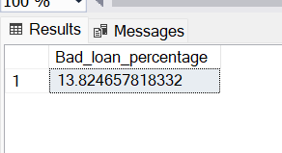

**Bad Loan Applications**

select count(id) as bad_loan_Application from bank_loan_data where loan_status='Charged Off'

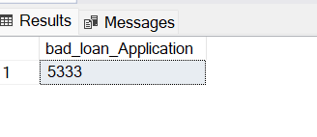

**Bad Loan Funded Amount**

select sum(loan_amount) as Bad_loan_Funded_amount from bank_loan_data where loan_status='Charged Off'

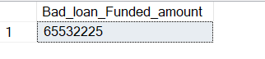

**Bad Loan Amount Received**

SELECT SUM(total_payment) AS Bad_Loan_amount_received FROM bank_loan_data

WHERE loan_status = 'Charged Off'

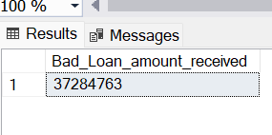

**LOAN STATUS**

SELECT

loan_status,

COUNT(id) AS LoanCount,

SUM(total_payment) AS Total_Amount_Received,

SUM(loan_amount) AS Total_Funded_Amount,

AVG(int_rate * 100) AS Interest_Rate,

AVG(dti * 100) AS DTI

FROM

bank_loan_data

GROUP BY

loan_status

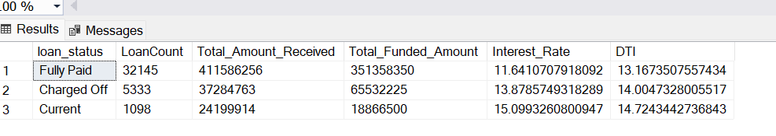

SELECT

loan_status,

SUM(total_payment) AS MTD_Total_Amount_Received,

SUM(loan_amount) AS MTD_Total_Funded_Amount

FROM bank_loan_data

WHERE MONTH(issue_date) = 12

GROUP BY loan_status

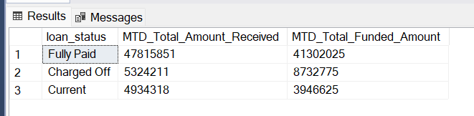

**B. BANK LOAN REPORT | OVERVIEW**

**MONTH**

SELECT

MONTH(issue_date) AS Month_Munber,

DATENAME(MONTH, issue_date) AS Month_name,

COUNT(id) AS Total_Loan_Applications,

SUM(loan_amount) AS Total_Funded_Amount,

SUM(total_payment) AS Total_Amount_Received

FROM bank_loan_data

GROUP BY MONTH(issue_date), DATENAME(MONTH, issue_date)

ORDER BY MONTH(issue_date)

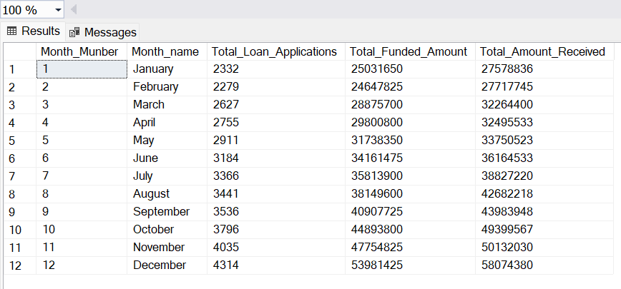

**STATE**

SELECT

address_state AS State,

COUNT(id) AS Total_Loan_Applications,

SUM(loan_amount) AS Total_Funded_Amount,

SUM(total_payment) AS Total_Amount_Received

FROM bank_loan_data

GROUP BY address_state

ORDER BY address_state

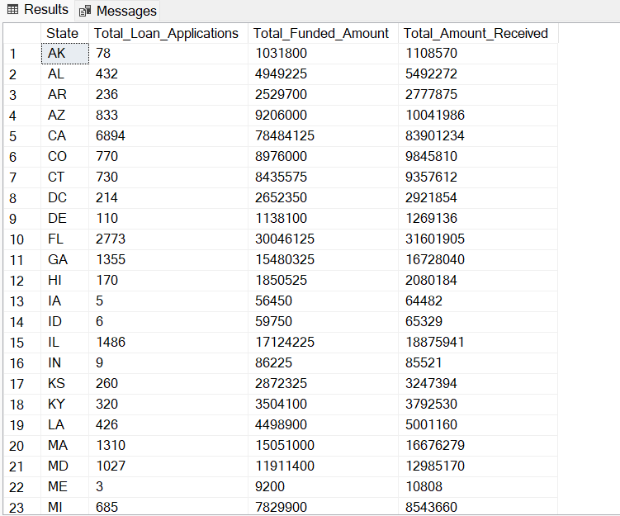

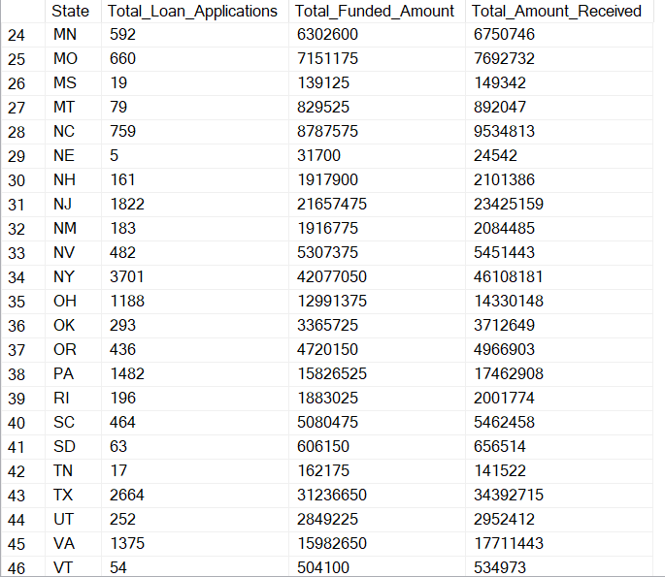

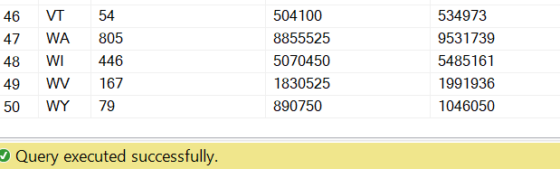

**TERM**

SELECT

term AS Term,

COUNT(id) AS Total_Loan_Applications,

SUM(loan_amount) AS Total_Funded_Amount,

SUM(total_payment) AS Total_Amount_Received

FROM bank_loan_data

GROUP BY term

ORDER BY term

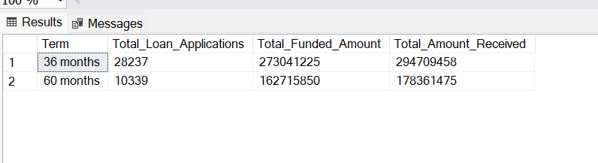

**EMPLOYEE LENGTH**

SELECT

emp_length AS Employee_Length,

COUNT(id) AS Total_Loan_Applications,

SUM(loan_amount) AS Total_Funded_Amount,

SUM(total_payment) AS Total_Amount_Received

FROM bank_loan_data

GROUP BY emp_length

ORDER BY emp_length

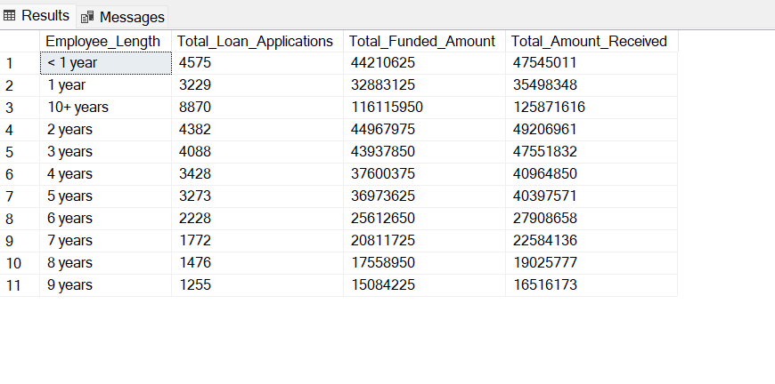

**PURPOSE**

SELECT

purpose AS PURPOSE,

COUNT(id) AS Total_Loan_Applications,

SUM(loan_amount) AS Total_Funded_Amount,

SUM(total_payment) AS Total_Amount_Received

FROM bank_loan_data

GROUP BY purpose

ORDER BY purpose

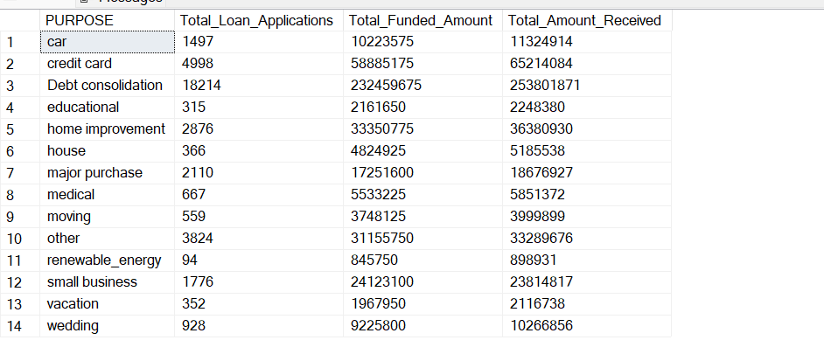

**HOME OWNERSHIP**

SELECT

home_ownership AS Home_Ownership,

COUNT(id) AS Total_Loan_Applications,

SUM(loan_amount) AS Total_Funded_Amount,

SUM(total_payment) AS Total_Amount_Received

FROM bank_loan_data

GROUP BY home_ownership

ORDER BY home_ownership

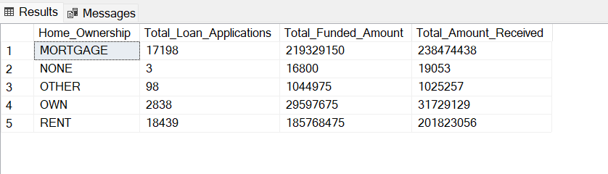

*Note: We have applied multiple Filters on all the dashboards. You can check the results for the filters as well by modifying the query and comparing the results.*

*For e.g*

*See the results when we hit the Grade A in the filters for dashboards.*

*SELECT*

*purpose AS PURPOSE,*

*COUNT(id) AS Total_Loan_Applications,*

*SUM(loan_amount) AS Total_Funded_Amount,*

*SUM(total_payment) AS Total_Amount_Received*

*FROM bank_loan_data*

*WHERE grade = 'A'*

*GROUP BY purpose*

*ORDER BY purpose*

