Unit Testing : GetOktaToken

Unit Test Case 1:

Scenario: When The Access Token( in the OutboundToken entity) is empty in the instance.

Prerequisite: Create an instance of the entity of the source named based on your XML file.

Expected Result: When we run our Business Process model, we generate the token and update it in the OutboundToken Entity.

Actual Result: When we run our Business Process model, we generate the token and update it in the OutboundToken Entity.

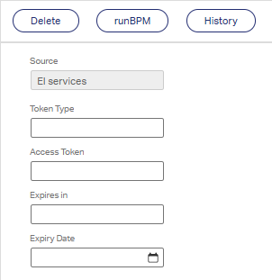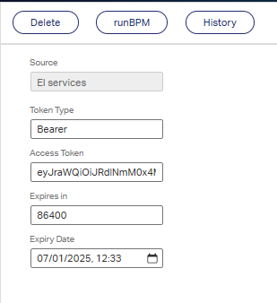

Before Execution the process. After Execution the process.

Unit Test Case 2:

Scenario: When The Token Expires ( in the OutboundToken entity) is expired (Expiry Date is less than current date) in the instance.

Prerequisite: Let's assume the current date is 06/01/2025.

Expected Result: Here, we are manually updating the expiry date (31/12/2024) value to be less than the current date so that when we generate the Business Process, we can check whether the token is generated and updated.

Actual Result: After running the Business Process for the model it generates the access token again and updates the OutBoundToken Entity instance with the updated expiry date and expired token.
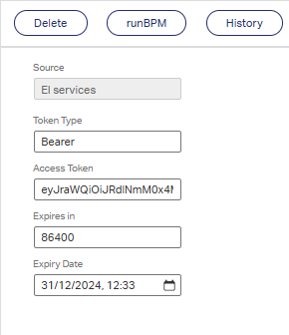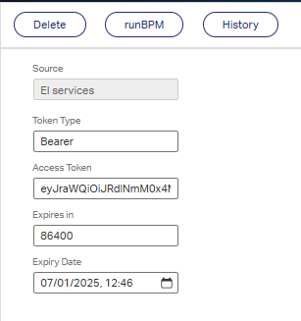
Before Execution the process. After Execution the process.

Unit Test Case 3:

Scenario: When there is an exception in the XML store (incorrect data).
Prerequisite: For this, we are modifying the XML store date (incorrect value in the “Credentials.xml” file).

Expected Result: Since there is an issue in the credentials.xml file we are unable to update the data and can send it a notification about the same to update the credentials file so that the user can update the correct values and get the access token for the same.

Actual Result: Thereafter we did not get any updated values as the data from which we are getting the values from the getoktaToken gets an exception and as per our logic if an exception our in any of the processes then do nothing and just end the task and store the error message.

