Q1. What is Chef?
It is a powerful automation platform that provides a way to transforms infrastructure into code. Chef is a tool for which you write scripts that are used to automate processes. What processes? Pretty much anything related to IT.

- Chef Server: The Chef Server is the central store of your infrastructure’s configuration data. The Chef Server stores the data necessary to configure your nodes and provides search, a powerful tool that allows you to dynamically drive node configuration based on data.
- Chef Node: A Node is any host that is configured using Chef-client. Chef-client runs on your nodes, contacting the Chef Server for the information necessary to configure the node. Since a Node is a machine that runs the Chef-client software, nodes are sometimes referred to as “clients”.
- Chef Workstation: A Chef Workstation is the host you use to modify your cookbooks and other configuration data. All the configurations are first tested in the Chef Workstation and then it is forwarded to the Chef Server.
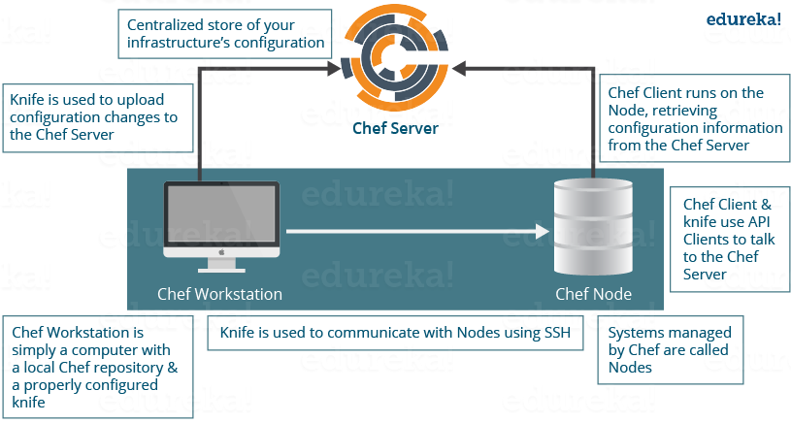
Q1. What is a Resource in Chef?
A Resource represents a piece of infrastructure and its desired state, such as a package that should be installed, a service that should be running, or a file that should be generated. A block of Resource can be considered as a Recipe.

A Resource represents a piece of infrastructure and its desired state, such as a package that should be installed, a service that should be running, or a file that should be generated. A block of Resource can be considered as a Recipe.
Now you should explain about the functions of Resource for that include the following points:
- Describes the desired state for a configuration item.
- Declares the steps needed to bring that item to the desired state.
- Specifies a resource type such as package, template, or service.
- Lists additional details (also known as resource properties), as necessary.
- Are grouped into recipes, which describe working configurations.
Remember, you have mentioned the word Recipe in your previous answer, so the next question in this Chef interview questions blog has to be related to Recipe.

Q2. What is a Recipe in Chef?
A Recipe is a collection of Resources that describes a particular configuration or policy. A Recipe describes everything that is required to configure part of a system.
Now after the definition I will explain the functions of Recipes by including the following points:
- Install and configure software components.
- Manage files.
- Deploy applications.
- Execute other Recipes.
Q3. What is a Node in Chef?
A Node represents a server and is typically a virtual machine, container instance, or physical server – basically any compute resource in your infrastructure that is managed by Chef.

Q4. How does a Cookbook differ from a Recipe in Chef?
A Recipe is a collection of Resources, and primarily configures a software package or some piece of infrastructure. A Cookbook groups together Recipes and other information in a way that is more manageable than having just Recipes alone.

Q5. What happens when you don’t specify a Resource’s action in Chef?
When you don’t specify a resource’s action, Chef applies the default action.
When you don’t specify a resource’s action, Chef applies the default action.
Now explain this with an example, the below resource:

1  2  3 | file 'C:\Users\Administrator\chef-repo\settings.ini' do  content 'greeting=hello world'  end
is same as the below resource:
1  2  3  4 | file 'C:\Users\Administrator\chef-repo\settings.ini' do  action :create  content 'greeting=hello world'  end
because: create is the file Resource’s default action.
Q6. Are these two Chef recipes the same?
1  2  3  4 | package 'httpd'  service 'httpd' do  action [:enable, :start]  end
&&
1  2  3  4 | service 'httpd' do  action [:enable, :start]  end  package 'httpd'
No, they are not. Remember that Chef applies resources in the order they appear. So the first Recipe ensures that the httpd package is installed and then configures the service. The second Recipe configures the service and then ensures the package is installed.
Q7. Write a service Resource that stops and then disables the httpd service from starting when the system boots in Chef.
Use the below Resource to stop and disable the httpd service from starting when system boots.
1  2  3 | service 'httpd' do  action [:stop, :disable]  end

Q8. How does Chef-apply differ from Chef-client?
I suggest you to follow the below mentioned flow to answer this question:
Chef-apply is an executable program that runs a single Recipe from the command line. It is a part of the Chef development kit and a great way to explore resources.
Syntax for Chef-apply is:
1 | chef-apply name_of_recipe.rb
Chef-client applies a Cookbook. It is used for production purposes where you typically run Chef-client to apply one or more cookbooks.
Q9. What is run-list in Chef?
My advise is to first explain what is the use of run-list
run-list lets you specify which Recipes to run, and the order in which to run them. The run-list is important when you have multiple Cookbooks, and the order in which they run matters.
Depending on the discussion if you think more explanation is required just mention the below points
A run-list is:
- An ordered list of roles and/or recipes that are run in the exact order defined in the run-list; if a recipe appears more than once in the run-list, the chef-client will not run it twice.
- Always specific to the node on which it runs; nodes may have a run-list that is identical to the run-list used by other nodes.
- Stored as part of the node object on the Chef server.
- Maintained using knife, and then uploaded from the workstation to the Chef server, or is maintained using the Chef management console.
Q10. What information do you need in order to bootstrap in Chef?
Just mention the information you need in order to bootstrap:
- Your node’s host name or public IP address.
- A user name and password you can log on to your node with.
- Alternatively, you can use key-based authentication instead of providing a user name and password.

Q11. How do you apply an updated Cookbook to your node in Chef?
There are three ways to apply an updated Cookbook to a node you can mention all or any one, I will suggest you to mention all three:
- Run knife ssh from your workstation.
- SSH directly into your server and run chef-client.
- You can also run chef-client as a daemon, or service, to check in with the Chef server on a regular interval, say every 15 or 30 minutes.

Q12. What is the role of Starter Kit in Chef?
Begin this answer by mentioning the functions of Starter Kit.
Starter Kit will create the necessary configuration files like chef directory, knife.rb, the ORGANIZATION-validator.pem, and USER.pem files etc. with the correct information that is required to interact with the Chef server.
Now tell how to use Starter Kit, you can simply download the starter kit and then move it to the desired location on your workstation.

Q13. What is the command you use to upload a cookbook to the Chef server?
You can directly mention the command to upload a cookbook to the Chef server “knife cookbook upload”.
Q14. What would you set your cookbook’s version to once it is ready to use in production?
According to Semantic Versioning, you should set your cookbook’s version number to 1.0.0 once it is ready to use in production.
Q15. What is the value of local development using Test Kitchen in Chef?
I will mention the below points, this will give the interviewer a clear picture of your understanding of Test Kitchen.
- Test Kitchen enables you to use a variety of virtualization providers that create virtual machine or container instances locally on your workstation or in the cloud.
- It enables you to run your cookbooks on servers that resemble those that you use in production.
- It speeds up the development cycle by automatically provisioning and tearing down temporary instances, resolving cookbook dependencies, and applying your cookbooks to your instances.

Q16. Where can you get reusable cookbooks that are written and maintained by the Chef community?
You can directly answer this question by saying reusable Cookbooks are present at Chef Supermarket, https://supermarket.chef.io.

Devops Questions:

Q1. What is the need for DevOps?
According to me, this answer should start by explaining the general market trend. Instead of releasing big sets of features, companies are trying to see if small features can be transported to their customers through a series of release trains. This has many advantages like quick feedback from customers, better quality of software etc. which in turn leads to high customer satisfaction. To achieve this, companies are required to:
- Increase deployment frequency
- Lower failure rate of new releases
- Shortened lead time between fixes
- Faster mean time to recovery in the event of new release crashing
DevOps fulfills all these requirements and helps in achieving seamless software delivery. You can give examples of companies like Etsy, Google and Amazon which have adopted DevOps to achieve levels of performance that were unthinkable even five years ago. They are doing tens, hundreds or even thousands of code deployments per day while delivering world class stability, reliability and security.
If I have to test your knowledge on DevOps, you should know the difference between Agile and DevOps. The next question is directed towards that.
Q2. How is DevOps different from Agile / SDLC?
I would advise you to go with the below explanation:
Agile is a set of values and principles about how to produce i.e. develop software. Example: if you have some ideas and you want to turn those ideas into working software, you can use the Agile values and principles as a way to do that. But, that software might only be working on a developer’s laptop or in a test environment. You want a way to quickly, easily and repeatably move that software into production infrastructure, in a safe and simple way. To do that you need DevOps tools and techniques.
You can summarize by saying Agile software development methodology focuses on the development of software but DevOps on the other hand is responsible for development as well as deployment of the software in the safest and most reliable way possible. Here’s a blog that will give you more information on the evolution of DevOps.
Now remember, you have included DevOps tools in your previous answer so be prepared to answer some questions related to that.

What is Devops:
The key to understanding what is DevOps lies in the intention of DevOps, that is to create superior-quality software more quickly and with more reliability while causing greater communication and collaboration between teams.
Leading organizations across the world have adopted DevOps methodologies to overhaul their performance, security and team dynamics. With more and more companies jumping on to the DevOps bandwagon, it has emerged as a hot skill to master in 2016. In this blog, let us find out what is DevOps and why is it such a big deal! We will do this by first tracing the evolution of software development methodologies leading to DevOps, then exploring what is DevOps and its life cycle, and finish up by evaluating how top companies such as Facebook are using DevOps to their benefit.

What is DevOps ?
DevOps is a Software Development approach which involves Continuous Development, Continuous Testing, Continuous Integration, Continuous Deployment and Continuous Monitoring of the software throughout its development life cycle. These activities are possible only in DevOps, not Agile or waterfall, and this is why Facebook and other top companies have chosen DevOps as the way forward for their business goals. DevOps is the preferred approach to develop high quality software in shorter development cycles which results in greater customer satisfaction.

Your understanding of what is DevOps is incomplete without learning about its life cycle. Let us now look at the DevOps life cycle and explore how they are related to the Software Development stages depicted in the diagram below.

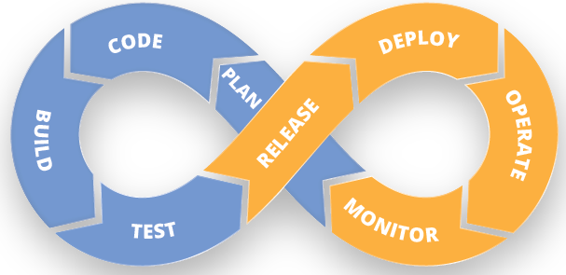

Continuous Development:
This is the stage in the DevOps life cycle where the Software is developed continuously. Unlike the Waterfall model the software deliverables are broken down into multiple sprints of short development cycles, developed and then delivered in a very short time. This stage involves the Coding and Building phases and makes use of tools such as Git and SVN for maintaining the different versions of the code, and tools like Ant, Maven, Gradle for building / packaging the code into an executable file that can be forwarded to the QAs for testing.

Continuous Testing:
It is the stage where the developed software is continuously tested for bugs. For Continuous testing testing automation tools like Selenium, JUnit etc are used. These tools enables the QA’s for testing multiple code-bases thoroughly in parallel to ensure that there are no flaws in the functionality. In this phase use of Docker containers for simulating testing environment on the fly, is also a preferred choice. Once the code is tested, it is continuously integrated with the existing code.

Continuous Integration:
This is the stage where the code supporting new functionality is integrated with the existing code. Since there is continuous development of software, the updated code needs to be integrated continuously as well as smoothly with the systems to reflect changes to the end users. The changed code, should also ensure that there are no errors in the runtime environment, allowing us to test the changes and check how it reacts with other changes. Jenkins is a very popular tool used for Continuous Integration. Using Jenkins one can pull the latest code revision from GIT repository and produce a build which can finally be deployed to test or production server. It can be set to trigger a new build automatically as soon as there is change in the GIT repository or can be triggered manually on click of a button.

Continuous Deployment:
It is the stage where the code is deployed to the production environment. Here we ensure that the code is correctly deployed on all the servers. If there is any addition of functionality or a new feature is introduced then one should be ready to welcome greater website traffic. So it is also the responsibility of the SysAdmin to scale up the servers to host more users. Since the new code is deployed on a continuous basis, automation tools play an important role for executing tasks quickly and frequently. Puppet, Chef, SaltStack and Ansible are some popular tools that are used in this stage.

Continuous Monitoring:
This is a very crucial stage in the DevOps life cycle which is aimed at improving the quality of the software by monitoring its performance. This practice involves the participation of the Operations team who will monitor the user activity for bugs / any improper behavior of the system. This can also be achieved by making use of dedicated monitoring tools which will continuously monitor the application performance and highlight issues. Some popular tools used are Nagios, NewRelic and Sensu. These tools help you monitor the application and the servers closely to check the health of the system proactively. They can also improve productivity and increase the reliability of the systems, reducing IT support costs. Any major issues found could be reported to the Development team so that it can be fixed in the continuous development phase.
These DevOps stages are carried out on loop continuously until the desired product quality is achieved. The diagram given below will show you which tools can be used in which stage of the DevOps life cycle.
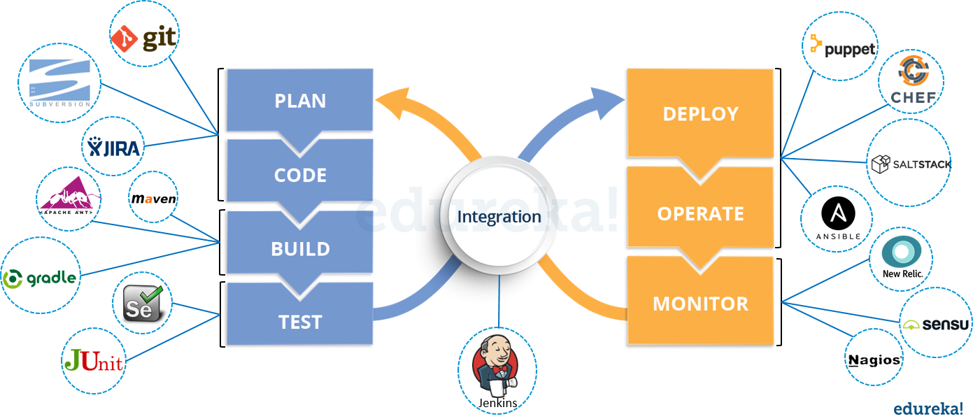

DevOps Case Study: Facebook
In 2011, Facebook rolled out a slew of new features – timeline, ticker and music functionalities – to its 500 million users spread across the globe. The huge traffic that was generated on Facebook following the release led to a server meltdown. The features that were rolled out garnered mixed response from users which led to inconclusive results of the effectiveness of the new features, leaving them with no actionable insights.
This led to an evaluation and reassessment of strategies, resulting in Facebook coming up with the Dark Launching Technique. Using the DevOps principles, Facebook created the following methodology for the launch of its new releases.
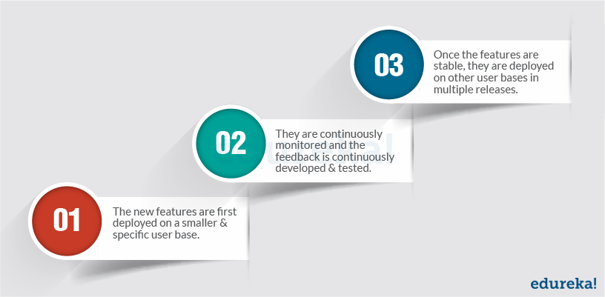

Facebook Dark Launching Technique
Dark launching is the process of gradually rolling out production-ready features to a select set of users before a full release. This allows development teams to get user feedback early on, test bugs, and also stress test infrastructure performance. A direct result of continuous delivery, this method of release helps in faster, more iterative releases that ensure that application performance does not get affected and that the release is well received by customers.
In the Dark Launching technique, features are released to a small user base through a dedicated deployment pipeline. In the below given diagram of Facebook Dark Launch, you can see that that only one deployment pipeline is turned on to deploy the new features to a select set of users.

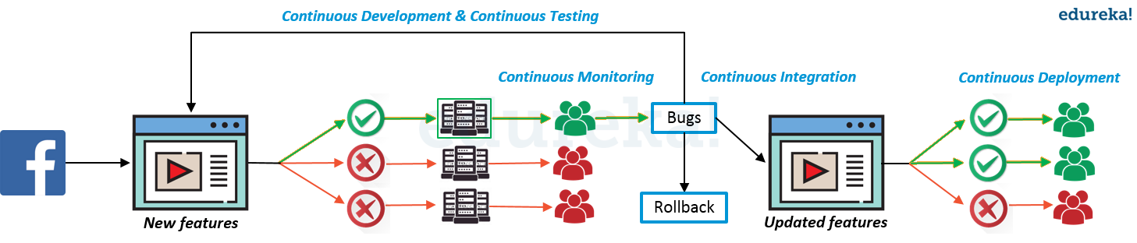

Q3. Which are the top DevOps tools? Which tools have you worked on?
The most popular DevOps tools are mentioned below:
- Git : Version Control System tool
- Jenkins : Continuous Integration tool
- Selenium : Continuous Testing tool
- Puppet, Chef, Ansible : Configuration Management and Deployment tools
- Nagios : Continuous Monitoring tool
- Docker : Containerization tool

Q4. How do all these tools work together?
Given below is a generic logical flow where everything gets automated for seamless delivery. However, this flow may vary from organization to organization as per the requirement.
- Developers develop the code and this source code is managed by Version Control System tools like Git etc.
- Developers send this code to the Git repository and any changes made in the code is committed to this Repository.
- Jenkins pulls this code from the repository using the Git plugin and build it using tools like Ant or Maven.
- Configuration management tools like puppet deploys & provisions testing environment and then Jenkins releases this code on the test environment on which testing is done using tools like selenium.
- Once the code is tested, Jenkins send it for deployment on the production server (even production server is provisioned & maintained by tools like puppet).
- After deployment It is continuously monitored by tools like Nagios.
- Docker containers provides testing environment to test the build features.

Q5. What are the advantages of DevOps?
For this answer, you can use your past experience and explain how DevOps helped you in your previous job. If you don’t have any such experience, then you can mention the below advantages.
Technical benefits:
- Continuous software delivery
- Less complex problems to fix
- Faster resolution of problems
Business benefits:
- Faster delivery of features
- More stable operating environments
- More time available to add value (rather than fix/maintain)

Q6. What is the most important thing DevOps helps us achieve?
According to me, the most important thing that DevOps helps us achieve is to get the changes into production as quickly as possible while minimizing risks in software quality assurance and compliance. This is the primary objective of DevOps. Learn more in this DevOps tutorial blog.
However, you can add many other positive effects of DevOps. For example, clearer communication and better working relationships between teams i.e. both the Ops team and Dev team collaborate together to deliver good quality software which in turn leads to higher customer satisfaction.

Q7. Explain with a use case where DevOps can be used in industry / real-life.
There are many industries that are using DevOps so you can mention any of those use cases, you can also refer the below example:
Etsy is a peer-to-peer e-commerce website focused on handmade or vintage items and supplies, as well as unique factory-manufactured items. Etsy struggled with slow, painful site updates that frequently caused the site to go down. It affected sales for millions of Etsy’s users who sold goods through online market place and risked driving them to the competitor.
With the help of a new technical management team, Etsy transitioned from its waterfall model, which produced four-hour full-site deployments twice weekly, to a more agile approach. Today, it has a fully automated deployment pipeline, and its continuous delivery practices have reportedly resulted in more than 50 deployments a day with fewer disruptions.

Q8. Explain your understanding and expertise on both the software development side and the technical operations side of an organization you have worked with in the past.
For this answer, share your past experience and try to explain how flexible you were in your previous job. You can refer the below example:
DevOps engineers almost always work in a 24/7 business-critical online environment. I was adaptable to on-call duties and was available to take up real-time, live-system responsibility. I successfully automated processes to support continuous software deployments. I have experience with public/private clouds, tools like Chef or Puppet, scripting and automation with tools like Python and PHP, and a background in Agile.

Q1. What is Version control?
This is probably the easiest question you will face in the interview. My suggestion is to first give a definition of Version control. It is a system that records changes to a file or set of files over time so that you can recall specific versions later. Version control systems consist of a central shared repository where teammates can commit changes to a file or set of file. Then you can mention the uses of version control.
Version control allows you to:
- Revert files back to a previous state.
- Revert the entire project back to a previous state.
- Compare changes over time.
- See who last modified something that might be causing a problem.
- Who introduced an issue and when.

Q2. What are the benefits of using version control?
I will suggest you to include the following advantages of version control:
- With Version Control System (VCS), all the team members are allowed to work freely on any file at any time. VCS will later allow you to merge all the changes into a common version.
- All the past versions and variants are neatly packed up inside the VCS. When you need it, you can request any version at any time and you’ll have a snapshot of the complete project right at hand.
- Every time you save a new version of your project, your VCS requires you to provide a short description of what was changed. Additionally, you can see what exactly was changed in the file’s content. This allows you to know who has made what change in the project.
- A distributed VCS like Git allows all the team members to have complete history of the project so if there is a breakdown in the central server you can use any of your teammate’s local Git repository.

Q3. Describe branching strategies you have used.
This question is asked to test your branching experience so tell them about how you have used branching in your previous job and what purpose does it serves, you can refer the below points:
- Feature branching
A feature branch model keeps all of the changes for a particular feature inside of a branch. When the feature is fully tested and validated by automated tests, the branch is then merged into master.
- Task branching
In this model each task is implemented on its own branch with the task key included in the branch name. It is easy to see which code implements which task, just look for the task key in the branch name.
- Release branching
Once the develop branch has acquired enough features for a release, you can clone that branch to form a Release branch. Creating this branch starts the next release cycle, so no new features can be added after this point, only bug fixes, documentation generation, and other release-oriented tasks should go in this branch. Once it is ready to ship, the release gets merged into master and tagged with a version number. In addition, it should be merged back into develop branch, which may have progressed since the release was initiated.
In the end tell them that branching strategies varies from one organization to another, so I know basic branching operations like delete, merge, checking out a branch etc.

Q4. Which VCS tool you are comfortable with?
You can just mention the VCS tool that you have worked on like this: “I have worked on Git and one major advantage it has over other VCS tools like SVN is that it is a distributed version control system.”
Distributed VCS tools do not necessarily rely on a central server to store all the versions of a project’s files. Instead, every developer “clones” a copy of a repository and has the full history of the project on their own hard drive.

Q5. What is Git?
I will suggest that you attempt this question by first explaining about the architecture of git as shown in the below diagram. You can refer to the explanation given below:
- Git is a Distributed Version Control system (DVCS). It can track changes to a file and allows you to revert back to any particular change.
- Its distributed architecture provides many advantages over other Version Control Systems (VCS) like SVN one major advantage is that it does not rely on a central server to store all the versions of a project’s files. Instead, every developer “clones” a copy of a repository I have shown in the diagram below with “Local repository” and has the full history of the project on his hard drive so that when there is a server outage, all you need for recovery is one of your teammate’s local Git repository.
- There is a central cloud repository as well where developers can commit changes and share it with other teammates as you can see in the diagram where all collaborators are commiting changes “Remote repository”.
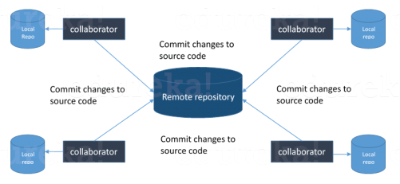

Q6. Explain some basic Git commands?
There can be two answers to this question so make sure that you include both because any of the below options can be used depending on the situation:
- Remove or fix the bad file in a new commit and push it to the remote repository. This is the most natural way to fix an error. Once you have made necessary changes to the file, commit it to the remote repository for that I will use
git commit -m “commit message”
- Create a new commit that undoes all changes that were made in the bad commit.to do this I will use a command
git revert <name of bad commit>

Q9. What is Git bisect? How can you use it to determine the source of a (regression) bug?
I will suggest you to first give a small definition of Git bisect, Git bisect is used to find the commit that introduced a bug by using binary search. Command for Git bisect is
git bisect <subcommand> <options>
Now since you have mentioned the command above, explain what this command will do, This command uses a binary search algorithm to find which commit in your project’s history introduced a bug. You use it by first telling it a “bad” commit that is known to contain the bug, and a “good” commit that is known to be before the bug was introduced. Then Git bisect picks a commit between those two endpoints and asks you whether the selected commit is “good” or “bad”. It continues narrowing down the range until it finds the exact commit that introduced the change.

Q14. How will you know in Git if a branch has already been merged into master?
I will suggest you to include both the below mentioned commands:
git branch –merged lists the branches that have been merged into the current branch.
git branch –no-merged lists the branches that have not been merged.

