# Sales Trend Analysis (Task 6 - Data Analyst Internship)

## Objective

Analyze **monthly revenue** and **order volume** from the `online_sales` dataset using SQL aggregation functions.

## Tools Used

- PostgreSQL (queries compatible with MySQL & SQLite)

- Dataset: `online_sales` table (columns: order_date, amount, product_id, order_id)

## Steps Performed

1. Extracted `year` and `month` from `order_date`.

2. Grouped data by `year` and `month`.

3. Calculated:

- **Monthly Revenue** = SUM(amount)

- **Order Volume** = COUNT(DISTINCT order_id)

4. Sorted results chronologically with ORDER BY.

5. Found **Top 3 months by revenue** using ORDER BY monthly_revenue DESC LIMIT 3.

## SQL Scripts

The `sales_trend.sql` file contains:

- Monthly sales trend query.

- Top 3 months by revenue query.

## Output

### Monthly Revenue & Order Volume

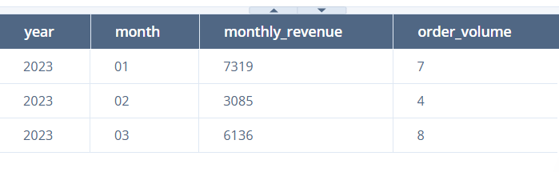

### Top 3 Months by Revenue

