

DEPARTMENT OF INFORMATION TECHNOLOGY
TITLE:
DEVELOPMENT OF A HOME AUTOMATION SYSTEM USING ANDROID DEVICE AND ARDUINO BOARD.
A Project Proposal Work Submitted for the Requirement For
BSc. Information Technology
Supervisor :
………………………….

CHAPTER ONE
1.0 Introduction
The crime rates of houses that have broken into over the past three years have increased up to 43.33 per cent, which is very alarming. The increased crime rates of houses been broken makes us realise the need for an improved, realisable and automated security systems.
At the time of intrusion, the occupants are usually away or asleep and they don’t have any system that will notify them.
There are also incidents such as fire outbreaks, gas leakages and floods that happens either whiles the occupants are away or asleep. The fire alarms are not fast enough to detect fires until the fire really breaks out, with a home automated system, the appropriate authorities are notified as soon as there is a change in temperature or when somebody breaks into the house.
There are 1.91 Billion smart phone users in the world, which has improved our lives and the way we communicate.
Home automation is the residential extension of building automation. It is automation of the home, housework or household activity. Home automation may include centralized control of lighting, HVAC (heating, ventilation and air conditioning), appliances, security locks of gates and doors and other systems, to provide improved convenience, comfort, energy efficiency and security. Home automation for the elderly and disabled can provide increased quality of life for persons who might otherwise require caregivers or institutional care.
The popularity of home automation has been increasing greatly in recent years due to much higher affordability and simplicity through smartphone and tablet connectivity. The concept of the "Internet of Things" has tied in closely with the popularization of home automation.

  - Project Background

The concept of home automation has been around since the late 1970s. But with the advancement of technology and services, people’s expectations of what a home should do or how the services should be provided and accessed at home has changed a lot during the course of time, and so has the idea of home automation systems. If we look at different home automation systems over time, they have always tried to provide efficient, convenient, and safe ways for home inhabitants to access their homes.

Arduino is an open-source prototyping platform based on easy-to-use hardware and software. Arduino boards are able to read input light on a sensor, finger on a button, loud sounds, vibrations, and turn it into an output activating a motor, turning on an LED, sending a notification and sending something online. The board can be told what to do by sending a set of instructions to the microcontroller on the board.

Android is a mobile operating system (OS) currently developed by Google, based on the Linux Kernel and designed primarily for touchscreen mobile devices such as smartphones and tablets. Android's user interface is mainly based on direct manipulation, using touch gestures that loosely correspond to real-world actions, such as swiping, tapping and pinching, to manipulate on-screen objects, along with a virtual keyboard for text input. In addition to touchscreen devices, Google has further developed Android TV for televisions, Android Auto for cars, and Android Wear for wrist watches, each with a specialized user interface. Variants of Android are also used on notebooks, game controllers, digital cameras, and other electronics.
The household activities are automated by the development of special appliances such as water heaters to reduce the time taken to boil water for bathing and automatic washing machines to reduce manual labour of washing clothes. In developed countries, homes are wired for electrical power, doorbell, TV outlets, and telephones. The different application includes when a person enters the room, the light turns on. In advanced technology, the room can sense the presence of the person and who the person is.

Taking into account the day of the week, time of the day and other such factors it can also set apt lighting, temperature levels, television channels or music levels. In the case of a smoke detector when fire or smoke is detected, the lights in the entire house begin to blink to alert the resident to the probable fire. In case of a home theatre, the home automation system can avoid distraction and lock the audio and video components and can also make an announcement. The home automation system can also dial up the house owner on their mobile phone to alert them or call any alarm monitoring company.

It is essential that the different controllable appliances be interconnected and communicate with each other. The basic aim of Home automation is to control or monitor signals from different appliances, or basic services. A smart phone or web browser can be used to control or monitor the home automation system.

  - Problem Statement
In recent times, many societies are crusading and attempting to do everything through the use of technology. Indeed technology has come to stay with man and has dominated human life in every area. It has almost become impossible to do anything without a smart phone these days and by the time the golden era might be fully grown; Smart phones will actually be doing almost everything human can do. This has evidence already in the advance countries where smart phones is actually making work easier. Before commencement of this project, Ghana Technology University College Examination Hall and lecturer offices uses a manual based approach in switching off appliances that include light bulbs, air condition, fans, kettle etc.
Without any doubt, there are many problems with the existing system some of which has been discussed below:
(I) the need to protect offices and homes from intruders: Without a home automated system at home, home owners will not be notified if their homes have been broken into. Also if a burglar enters the house whiles the occupants are sleeping, there is no system in place that will notify the occupants to get to a safe spot before the burglar gets to them.

(II) The need to protect homes and families from fires: Usually, a fire alarm at homes do not do any good in preventing a fire from burning down homes. A home automated system is fast enough to detect when the temperature of the environment increase to the degree that can cause fire or when it detects smoke and then sends a notification to the appropriate authorities.

(III) The need to protect valuables: Throughout our lifetime, we collect and slew of items that have meaning to us. Without a home automated system that will deter the burglars from entering your house to steal your valuables but when it is not, it serves an additional function. As well as signalling the authorities and home owners that their homes have been broken into, which increases the chances of the burglars been caught.

(IV) The need to keep an eye on your home remotely: Occupants who are business owners and travel a lot get worried about not having anyone to take care of their house when they are away. If there is no home automated system the authorities and house owners will not be notified when there is a change in temperatures, movements, leakage of gas or when the house is broken into.

1.3 Aim
The aim of this project is to develop an android application that would be used to communicate with an Arduino board to control home and office appliances. It would take into account a real time operation to provide effective automation of home appliances.

1.4 Objectives
The main objective of the proposed system is to change the manual system into computerized System, so the user can control home appliances without being physically present, moreover the system can be programmed to control home appliances at specific time intervals. Specifically, the objective of the proposed system is outlined below:

- To develop a system for occupants of homes to protect their homes and families from intruders and gas leakages.
- To identify the various risks that occupant’s face from intruders.
- To develop a home automated system and an android app to improve security and safety at homes.

1.5 Significance of the Study

(Academia)
Technology keeps evolving at a rapid rate. The development of this system will guide future studies on this topic and also it will give the other researchers the chance to study the system and build upon in several ways. Since there is no one solution to a particular problem.
The codes and components of the project will also will be available to other students, which will give them an idea of how to solve a particular problem if they are doing a similar project in the future.

(Government)
The study will provide feedback on policies that will dive the implementation of the home automated system in every home, since protecting citizens is one of the top priorities of government.

(Society)
The home automated system when implemented will bring peace and safety in the society, since it will reduce the crime rates in the society.

1.5 Organization of project work
The organization of project is divided into five main chapters and is as follows:
Chapter one which is the introduction encompasses the background of the study, problem statement, aim of the study, objectives of the study, scope of the study, significance of the study, and organization of the study.
Chapter two which is the Literature Review includes the review of relevant literature on Home Automation System, comprising the overview of Home Automation system, its benefits and comparing it against the traditional and current manual systems. State the advantages and disadvantages of all reviewed systems
Chapter three which covers System Analysis and Design contains requirement specifications, process modelling, specifics of programming environment and database design. The process model shows how data moves from one table to the other and illustrated with the appropriate models. This also includes the flowcharts, use case diagrams and all diagrams essential for the project.
Chapter four which is System Implementation details the database implementation, the use of the software to develop the client interface and all the designs pertaining to the development of the application.
Chapter five is Conclusion, Observation and Recommendations.

Chapter 2
  - Literature review
This interactive mobile based application Arduino Technology, is an android application that runs on a greater percentage of mobile devices that run on Android OS. These chapter of the project comprises of research on existing systems with similar behavior or characteristics, their limitations and the ways the proposed system intends to remedy some of the flaws to justify the need for the development of the new system. A literature review is a description of the literature relevant to a particular field or topic. It gives an overview of what methods and methodologies are appropriate and useful. As such, it is not in itself primary research, but rather it reports on other findings. A literature review may be purely descriptive, as in an annotated bibliography, or it may provide a critical assessment of the literature in a particular field.

  - Definition and Summary of Home Automation Systems
Smart homes and home automation are ambiguous terms used in reference to a wide range of solutions for controlling, monitoring and automating functions in the home. Berg Insight’s definition of a smart home system requires that it has a smartphone app or a web portal as a user interface. Devices that only can be controlled with switches, timers, sensors and remote controls are thus not included in the scope of this study. Smart home systems can be grouped into six primary categories: energy management and climate control systems; security and access control systems; lighting, window and appliance control systems; home appliances; audio-visual and entertainment systems; and healthcare and assisted living systems.
Home automation is the use of one or more computers to control basic home functions and features automatically and sometimes remotely. An automated home is sometimes called a smart home.
Home automation can include the scheduling and automatic operation of water sprinkling, heating and air conditioning, window coverings, security systems, lighting, and food preparation appliances. Home automation may also allow vital home functions to be controlled remotely from anywhere in the world using a computer connected to the Internet. Besides the functions already mentioned, remote control can be extended to telephones and answering machines, fax machines, amateur radios and other communications equipment, and home robot s such as automatic vacuum cleaners.
The fundamental components of a well-designed home automation system include a computer (or computers) with the appropriate programming, the various devices and systems to be controlled, interconnecting cables or wireless links, a high-speed Internet connection, and an emergency backup power source for the computer, its peripherals, and the essential home systems.

    - Context-aware Home Automation Systems
A modern home can be accessed by its inhabitants from the outside through Internet, Global System for Mobile communication (GSM), and wireless portable devices like mobile phones, tablets, laptops, or through stationary devices like an office workstation (PC). In other words, an average automated home user’s computing environment keeps on changing. By computing environment, we mean a user’s type of network connectivity, type of network access at different places, cost of accessing the home over the Internet, processing power of the devices, and other hardware available to the user. We can’t expect the user to be security conscious every time he or she accesses their home from the outside. This brings in new security vulnerabilities to the home front. Understanding the context of a particular action by the user could go a long way in improving a home’s security.
In order for context-aware systems to be successful when implemented at home, several factors must be considered:
- The system must disclose to the user what it knows, how it knows it, and what it is going to do about it.
- The system must make a user aware when its context-based actions affect others.
- Context-aware computing considerably increases a system’s complexity. Accurately interpreting the environment is hard enough without the added overhead of predicting the user’s context, intention or reasoning for an action.
- Contextual computing increases a system’s manufacturing, implementation, and maintenance costs, which make them unaffordable to the common man.
- In order for the system to be successful it requires constant user interference, which most users find annoying. Moreover, if the system malfunctions, only an expert or skilled person can fix the system.

    - Central Controller Based Home Automation
A central controller-based home security system looks to improve the security of the homes in a locality by combining many homes into a security network with a control node dedicated for each locality depending on the number of users. These control nodes are controlled by a few central or chief control nodes with considerably high processing power. The security system described by S. Tsai et al., called Home Security System on Intelligent Network (HSSIN), and uses such a central controller-based approach. The proposed system lacks modern security parameters.
A central controller based security system has its own unique challenges:
- All or most homes in the neighborhood have to join in for the approach to be cost effective and successful.
- The main question we have to consider here is who controls or has access to the central controller and its data? The central controller will be able to know about a home’s intimate and private information from the data at its disposal, like if a home’s room heater is on, or if an inhabitant in a home is taking a shower. This raises serious privacy concerns. We already know how people feel about government surveillance on the Internet. Central controller-based security systems provide an opportunity to do even more privacy-violating surveillance on homes.

    - Bluetooth Based Home Automation System
The work of N. Sriskanthan et al. shows the implementation of a home automation system using Bluetooth. They use a host controller implemented on a PC, which is connected to a microcontroller-based sensor and device controllers. The researchers even built a new protocol on top of the Bluetooth software stack, called Home Automation Protocol (HAP), to make the communication between devices possible. The device controller is connected to electronic devices through the I2C Bus. The system allows more than one device controller to be connected to the host controller.

Issues of using Bluetooth for home automation:
- Bluetooth has a maximum communication range of 100m in ideal conditions. More may be needed in a home environment.
- Bluetooth communication has comparatively high power consumption, so the batteries of devices need to be frequently recharged or replaced.
- Bluetooth technology has advanced and improved to Bluetooth Low Energy, which provides the same range of communication. However, it has serious security concerns such as eavesdropping and weak encryption as discussed by M. Ryan.
- Bluetooth communication should only be used on occasions where there is a need for quick short-lived network communication with little concern for security.

    - GSM or Mobile Based Home Automation System
Mobile-based home automation is attractive to researchers because of the popularity of mobile phones and GSM technology. We mainly consider three options for communication in GSM, namely SMS-based home automation, GPRS-based home automation, and Dual Tone Multi Frequency (DTMF)-based home automation. Each of these three technologies is discussed below, along with their shortcomings.

- SMS-based Home Automation System
The work of A. Alheraish proposes a home automation system using SMS. The proposed system detects illegal intrusions at home and allows legitimate users to change the passkey for the door and control lights in the home. The illegal intrusion into the home is identified by monitoring the state of the home door, which is done using Light Emitting Diode (LED) and infrared sensors. The passkey to the door can be any 4 digits, which can be set either by using the keypad or by using SMS from a registered user’s mobile number. A user can control the lights in their home remotely using SMS from their registered mobile number; by turning the lights on in different rooms at random intervals of time, one can give the impression that the home is occupied, even when it is not.
The work of M.S.H Khiyal et al. proposes an SMS-based home security system called SMS-based Wireless Home Appliance Control System (HACS). In their work, a homeowner can control their home using SMS messages from a pre-set registered mobile number. If the SMS is not from a legitimate mobile number, the system ignores the message. In the case of an intrusion, the appliance control subsystem and security subsystem in the proposed system informs the owner through SMS.
Security concerns about SMS-based home security systems:
- The 4 digit security passkey (used by A. Alheraish and U. Saeed et al.), in itself proposes a security vulnerability. An attacker could wait outside the home and peep through the window to learn the passkey. One can’t expect the owner to be careful every time he or she enters the passkey. The user punches in the passkey routinely, so the probability of the user being careless is high.
- The passkey used in the work of U. Saeed et al. is different for each individual at home, which improves the odds for hacking the keypad.

- GPRS-based Home Automation System
There are a lot of home security systems implemented using GPRS. Most systems use the word security in the traditional sense, and only address the threat put forth by old fashioned intruders in home.
Researchers M. Danaher and D. Nguyen propose a home security system using GPRS. The work uses a webcam to stream video and pictures of the home to its owner’s mobile through GPRS. The webcam detects movement by comparing frames for differences, including light intensity. Video streaming in the proposed work is done using the home Internet connection, not the GSM modem.
The work of B. Wu et al. describes video camera surveillance using the GPRS facility in mobile phones. The camera is triggered when an intrusion is detected or the door bell is rung. The system identifies intrusions with an infrared sensor. In the case of a doorbell, the system calls the homeowner and establishes voice communication with a live video feed between the visitor and the homeowner. When an intrusion is detected, an email is sent to the user along with a picture, most likely of the intruder. Upon receiving this email the user can start monitoring the video feed on his phone.
The work of L. Yang et al. allows a user to read and change the status of the devices at home using a preregistered mobile number using GPRS. The proposed system doesn’t allow external devices to connect directly to the home devices. When a legitimate device with the correct phone number tries to connect to the home environment, a connection is established between the virtual home which mirrors the current state of the home devices and user, acting like a honeypot. The commands issued by the user are analyzed, and if they don’t pose any harm to the home Smart devices then the command is applied to the real devices at the home. When an emergency situation arises, like an intrusion or a fire, the intelligent devices at home initiate a communication between the home and the user via telephone, text message, or email that is called “phone-out-only.” The reverse never happens – a user never initiates direct communication with the home devices.

Security concerns in GPRS-based home security systems:
- The works of M. Danaher and D. Nguyen B. Wu et al., L. Yang et al., and S.R. Das et al. all implement cameras at home. Streaming live video feeds over the Internet is never a good idea, especially when it is from inside the home. If these implemented cameras are compromised, then the attacker will have an eye inside the home. A recent BBC report by L. Kelion highlights the vulnerabilities in wireless cameras. Moreover, people do not like to be watched; it affects their normal behavior and makes them uncomfortable.
- Video feeds could be looped by skilled attackers if the cameras and the system are not installed and maintained properly.
- In a GPRS-based intrusion detection system, the user will have to monitor his or her phone constantly to successfully defend against intrusion.

- DTMF-based Home Automation System
The work of L. Muhury and A.H.M.A Habib describes the design and implementation of a DTMF-based home automation system. The user calls a SIM number assigned to the home and presses the digits on their phone’s keypad to control the home’s devices by generating a DTMF tone. The tone is received and decoded by the GSM module at home using a DTMF decoder. The decoded instructions are passed to the microcontroller so that user commands can be implemented at home.
Home automation systems using DTMF are not very commonly implemented, maybe because there are other better options for communication available. Like all other systems, DTMF-based home security systems also have their security flaws. They are vulnerable to “fuzzing attacks,” as described by R. Sasi In a fuzzing attack, a user exploits a vulnerability in DTMF processing algorithms by giving unusual input data, which results in triggering an exception. This could cause the entire home network to crash.

    - Internet Based Home Automation System
Internet or IP protocol-based communication in home automation systems is always a popular choice among researchers. The Internet is easily scalable, flexible when it comes to access and use, and very popular as a communication method in today’s world, so the hardware and the network required for access is readily available, offers high bandwidth and very low communication cost, and devices can connect to and disconnect from the network easily. These are some of the features that make the Internet such an attractive choice for researchers. Utilizing the Internet as a means to access and control the home seems to be the next logical step forward for home automation systems.
From an end user’s point of view, using Internet to access their home is easy, convenient, cheap, flexible, and offers no complication of an added technology to learn. User interface devices like laptops, smartphones, PCs, and tablets are easily available in the market, and these devices are already a part of people’s daily lives. So, incorporating home automation into these already-popular user devices seems to be the natural progression.

This raises some security concerns:
- People are generally careless in nature. They tend to write complicated passwords and usernames on paper near their workstations or underneath their keyboards, thinking “who bothers to look there?”
- People often repeat the same passwords and usernames on different websites and forums. This behavior makes them vulnerable to phishing attacks.
- During the course of time, a homeowner will have to log in to the home from different networks like from the office, from their friend’s house, from public Wi-Fi networks such as coffee shops, even parks, sometimes using untrusted devices. The network chosen by the user to access the home may be vulnerable. This could result in the user being exposed to variety of attacks like man-in-the-middle attacks. Moreover, when accessing the home from a compromised device, legitimate user credentials could be stolen by the use of simple software tools such as a keylogger.
- Researchers should also be aware of the human factor when depending only on passwords for security. The human factor means normal people tend to choose passwords that have some sort of significance to them like their pet’s names, name of their favorite movie, music artist, sports team, etc. Moreover, we should never underestimate the most powerful hack of all, social

    - Internet Based Home Automation System
Home automation systems discussed so far use a central controller or centralized approach, which has a single point of failure. In this section, we discuss another approach.
The work of M. Gauger et al. proposes a decentralized approach to home automation control. They implement the decentralized approach by integrating actuators into the WSN of the home. The authors propose a distributed control or process architecture. The information from the sensors are received and processed by one or more control nodes, which in turn initiates the appropriate actuators to change or control the environment as previously specified by the user. The system thus eliminates the need for a central controller.
Issues in the decentralized approach for home automation systems:
- A sophisticated attacker with prior knowledge of the network and actuator positions can simply disconnect them from the network. No alert mechanisms are implemented for such a case.
- The communications proposed here are done in clear text, so an attacker with the right hardware can eavesdrop on the communication.
- A home automation system consists of complicated tasks which require analyzing and processing various values and inputs from different parts of the home during different points of time. It requires some processing power and storage, which the actuator nodes can’t provide at present.

- The decentralized approach to home automation is an interesting concept, but it requires a lot of work from the research community to be efficiently and securely implemented in a home environment. In addition to this, the actuators discussed here require a significant increase in processing power and storage for it to be effective in a decentralized architecture.

References

- S.-M. Tsai, P.-C. Yang , S.-S. Wu , S.-S. Sun, “A Service of Home Security System on Intelligent Network,” IEEE Transactions on Consumer Electronics, vol. 44, no. 4, pp. 1360-1366, Nov. 1998.
- N. Sriskanthan, F. Tan, A. Karande, “Bluetooth based home automation system,” Microprocessors and Microsystems, Elsevier, vol. 26, pp. 281-289, 2002.
- A. Alheraish, “Design and Implementation of Home Automation System,” IEEE Transactions on Consumer Electronics, vol. 50, no. 4, pp.1087-1092, Nov. 2004.
- M. Sikandar, H. Khiyal, A. Khan, E. Shehzadi, “SMS Based Wireless Home Appliance Control System (HACS) for Automating Appliances and Security,” Issues in Informing Science & Information Technology, vol. 6, Jan. 2009.
- L. Muhury, A.H.M.A. Habib, “Device Control by Using GSM Network,” 15th International Conference on Computer and Information Technology (ICCIT), pp. 271-274, Dec. 2012.
- Leo Kelion, “Breached webcam and baby monitor site flagged by watchdogs,” http://www.bbc.com/news/technology-30121159, BBC News, 2014.

CHAPTER THREE

3.0 System Design and Specification
Overview
System design is actually a multistep process that focuses on four distinct attributes of a program: data structure, software architecture, interface representations and procedural (algorithmic) detail. The design process translates requirements into a representation of the software that can be assessed for quality before coding begins. Like requirements, the design is documented and becomes part of the software configuration.

Home Automation System Using Android device and Arduino board is a system that intends to protect offices and homes from intruders and other disasters like fire outbreak. The system would undergo a development phase where the various tools required for development and requirements specification would be taken into serious consideration so as to develop the system to meet its specification.
3.1 Methodology
The process model used for this project is the Incremental Model. In Incremental model the whole requirement is divided into various builds. Multiple development cycles take place here, making the life cycle a “multi-waterfall” cycle. Cycles are divided up into smaller, more easily managed modules. Each module passes through the requirements, design, implementation and testing phases. A working version of software is produced during the first module, so you have working software early on during the software life cycle. Each subsequent release of the module adds function to the previous release. The process continues till the complete system is achieved. The reason for the choice of incremental model is that it helps us get a working system early and as time goes on we can add improvements on our system. Modeled after a conventional engineering cycle, the incremental model encompasses the following activities:

Requirements Analysis and Definition:
All possible requirements of the system to be developed are stated in this phase. Requirements are a set of functions and constraints that the end user expects from the system. The requirements are gathered from the end user, and are analysed for their validity and the possibility of incorporating them. Finally, a requirement specification document is created which serves the purpose of a guideline for the next phase of the model.
System and Software Design:
Before starting the actual coding phase, it is highly important to understand the requirements of the end user and also have an idea of how the end product should look like. The requirement specifications from the first phase are studied here, and a system design is prepared. The design helps in specifying hardware and system requirements, and also helps in defining the overall system architecture. The system design specifications serve as an input for the next phase of the model.
System Testing:
The units are now integrated to form a complete system during the integration phase and tested to check if all modules/units coordinate with each other, and the system as a whole behaves as per the specifications. After successfully testing the software, it is delivered to the customer.

Implementation:
In this phase, the system is installed and made operational in the production environment after the system and users’ acceptance testing. Activities in this phase include efforts required for implementation including notification to end users, execution of training, data entry or conversion, and system monitoring. This phase continues until the production system is operating in accordance with the defined requirements and planning for sustainment has begun.
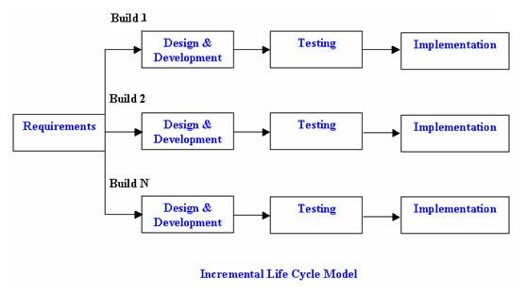

Figure 2.5.10-1-Incremental Model

3.2 Requirements Specification
The requirements specification is a means of enforcing constraints on the application development process. This way, as developers of the application, we would not spend too much time adding unnecessary features to the application that would not fully meet the users’ needs. The requirements specification can be used as a guideline to evaluate the success or failure of the project upon its completion. Requirements can be classified into two main groups:
- Functional Requirements
- Non-functional Requirements

3.2.1 Functional Requirements
The functional requirements define the function of a software system or its components. A function is described as a set of inputs, the behaviour outputs and how the system is able to evolve to meet the changing environment. The system’s functionality include:
- The system would provide a platform for occupants of homes to protect their homes and families from intruders and gas leakages.
- The system would provide a home automated system.
- There would be an android app to improve security and safety at homes.

3.2.2 Non-Functional Requirements
Non-functional requirements are those requirements that are not directly concerned with the specific functions delivered by the system. They may relate to emergent system properties such as reliability, response time, data representation and many more.
These are the non-functional requirements of the system:

Reliability:
The system would have the ability to perform its required functions under stated conditions for a specific period of time. The system service would always be available when requested by end-users.
The system is dependable since it would deliver service that can be justifiable by trusted users.

Performance:
The speed of operation of the system is a very essential system property, since slow systems or systems that have a lag in response can greatly affect the efficiency of the system.

Hence the system took into account these performance requirements:
- Response requirements (how quickly the system reacts to a user input)
- Throughput requirements (how much the system can accomplish within a specified amount of time)
- Availability requirements (is the system available for service when requested by end-users)

3.2.3 Hardware Requirements
This is the minimum requirements necessary for the system to function. The system requirements is necessary since that would determine how quickly a user receives response.
- Mobile Phone with Android Operating System
- Processor speed of 512MHz
- RAM of 256MB
- 512MB free space on hard drive

3.2.4 Software Requirements
The software requirements are important tool for the system to execute. Therefore a system without a software base is useless. Every system requires software to execute.
- The application can be run on an Android Operating System.
- The android client must have a minimum API level 11

3.3 System Design
The System Design phase outlines the way the system is to be constructed. It includes the architecture, components, modules, interfaces and data flow in the system. The conceptual models and structures used in developing the system architecture include:
- System architecture
- Sequence Diagram
- ERD Diagram
- Use Case Diagram
- Activity Diagram

3.3.1 System Architecture
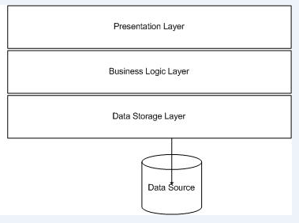
Figure2: System Architecture

Figure 2: System Architecture
Application Layer or Presentation Layer
The application layer provides services for an application program to ensure that effective communication with another application program in a network is possible. The application layer is not the application itself that is doing the communication. It is a service layer that provides these services.
Business Logic Layer
This is where all the functionalities like, switching on or off electrical devices and setting timer for these devices. The logical tier is pulled out from the presentation tier and, as its own layer, it controls an application’s functionality by performing detailed processing.

Data Storage
The data tier includes the data persistence mechanisms (database servers, file shares, etc.) and the data access layer that encapsulates the persistence mechanisms and exposes the data. The data access layer should provide an Application Programming Interface (API) to the application tier that exposes methods of managing the stored data without exposing or creating dependencies on the data storage mechanisms. This is the medium which transfers the files to the data source where the student wants to store their results data.

    - USE CASE DIAGRAM
A Use Case diagram in the Unified Modeling Language (UML) is a type of behavioral diagram. This generally represents relations between actors and applications, shows outwardly recognizable system behavior from the view of the user or external systems. An application is normally described in text form and serves as an aid to the requirement determination
This is to provide graphical overview of functionality provided by a system in terms of actors, their goals.
A Use Case can be used as a primary artifact for establishing the desired behavior of the system, for verifying and validating the systems architecture, for testing and for communicating among the various stake holders of the project.

Student Electronic Past Question Aid has the following actor:
- Users or Student
- Lecturer or Admin
Student
- Can view courses arranged in categories
- Can search for courses using keywords or category-wise search
- Registered users can view videos of registered of enrolled courses
- Can take tests of past questions of various courses
- Can receive SMS and E-mail alerts on tests taken
Lecturer or Admin
- He or she keeps track of all the courses
- He or she can add or delete courses and their respective past questions
- Can view reviews and feedback from students
- Can send alerts to students about new courses and tests
Application System (Electronic Student past Question Aid)
- Alert registered students about new courses via SMS

Use Case Diagram for Web Application

Check Reviews
Check History
View Courses
Take Tests

Update Profile
Update Courses
Search Courses
Course Catalogue
Add Courses
Admin
Student
Delete Courses
Register
View Profile
Login
Logout
Alert Users
Alert Admin

System
Figure 3: Use Case Diagram

    - Activity Diagram
Activity diagrams are graphical representations of workflows of stepwise activities and actions with support for choice, iteration and concurrency. In the Unified Modeling Language, activity diagrams are intended to model both computational and organizational processes (i.e. workflows). Activity diagrams show the overall flow of control.
User Registration
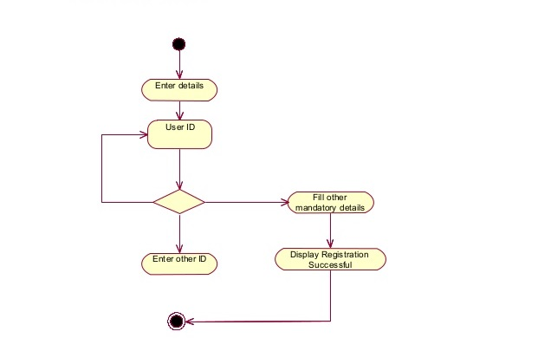
Figure 5: Activity Diagram for User Registration

User Login
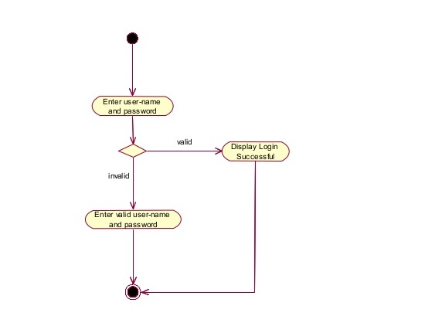
Figure 6: User Login

Admin Registration
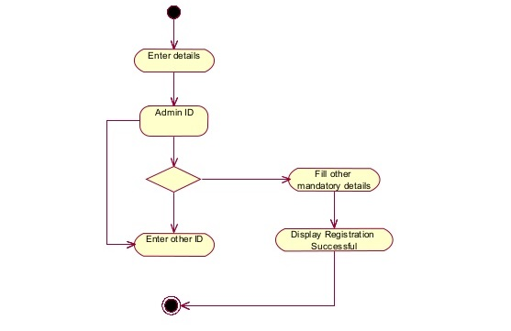
Figure 7: Admin Registration

Admin Login

