Team C
EasyDiet
User’s manual

Manuel Tscholl, Friedrich Bösch, Stephan Svoboda, Ali Gümüs, Michael Sieber
26.04.2011

Introduction 3
Product Information 4
How to install and uninstall the program 5
EasyDiet User Interface
6

Introduction

Welcome to EasyDiet!
EasyDiet is an application supporting dietary assistants creating and monitoring dietary plans. EasyDiet implements methods to create and manage cooking recipes with a focus on the nutritional values of their ingredients. With EasyDiet it is easy to create dietary plans which meet the criteria of medical treatments, therapies and the patients food preferences. Added to this, the software provides useful functions to administer patient data and patient protocols.

Product Information

Scope of EasyDiet
- It is possible to select Patients
- It is possible to create a diet plan for a special patient

System Requirements
- Processor with 2 ghz
- 2gb RAM
- 500 mb free space on the hard disk
- Update version of JAVA VM
- Operating Systems
  - Windows XP
  - Windows Vista
  - Windows 7

How to install and uninstall the program

EasyDiet provides an uncomplicated way of installing and uninstalling. There is no need to click through an installation menu. In order to get the application running you basically have the double click the provided “EasyDiet.jar” file. After this, EasyDiet is starting up and you will see the user interface in a few seconds and be able to use the program.
The uninstalling process is pretty easy as well. Just move to the folder where the “EasyDiet.jar” file is located and move it to trash.

EasyDiet User Interface
In this chapter we explain the functionality of the user interface.

Overview
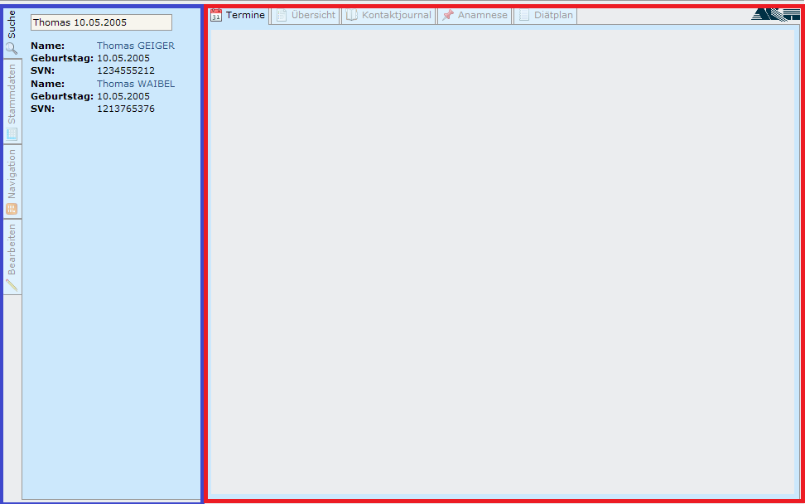
On the left side with the blue highlighted border you see the navigation panel together with the active search tab of EasyDiet. On the right side surrounded with the red highlighted border you see the patient specific part of EasyDiet.

Specific functionality

Searching a Patient
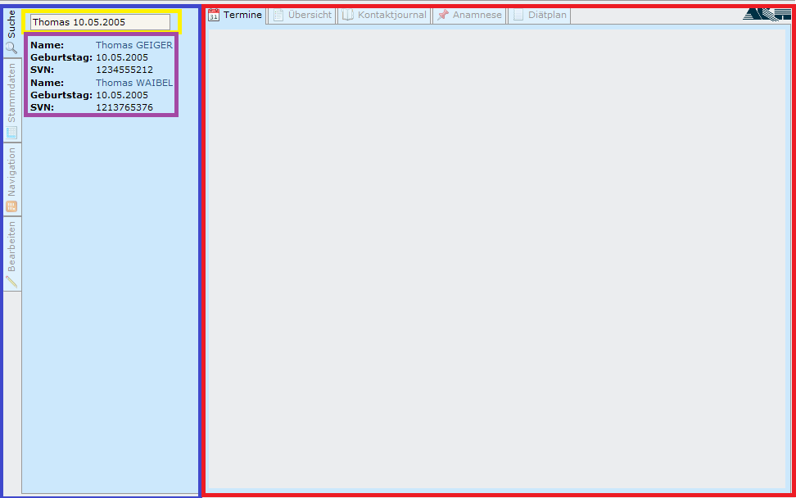
To search a patient we use the Textbox which is highlighted with a yellow border. We can search for first name, second name, insurance number and birthday. The birthday has to be in the following format dd.mm.yyyy.
The program automatically starts searching with the given information; found results will be displayed in the violet highlighted border area.

Creating a new Dietryplan

After having searched and selected a patient, the “Diätplan” tab is getting visible. By clicking on this tab EasyDiet presents a view where you can create a new Dietplan. Therefore you will have to click on the Button “Neuen Diätplan erstellen”, as shown in the screenshot below.
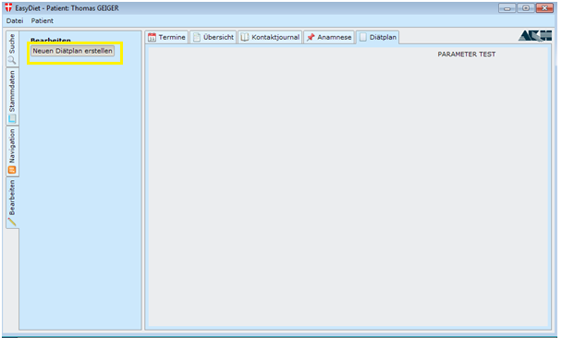

After you have clicked the button a new mask is showing up where you can define the duration (more exactly the start and end date) of your dietplan. Clicking on Date-Dropdown allows you to choose your specific date out of a mini-calendar.
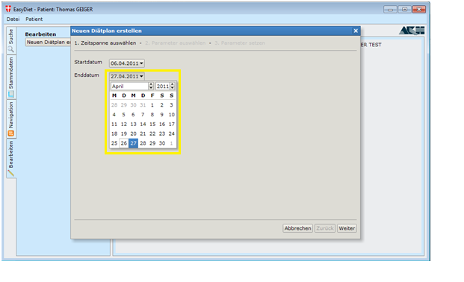
Having chosen your desired duration the next step of creating a new dietplan will be to select and determine the diet parameters.
EasyDiet will show up a new mask where you can see all diet parameters. If you would like to add a specific parameter to this diet, you can do so by highlighting the parameter and clicking the “right-arrow”.
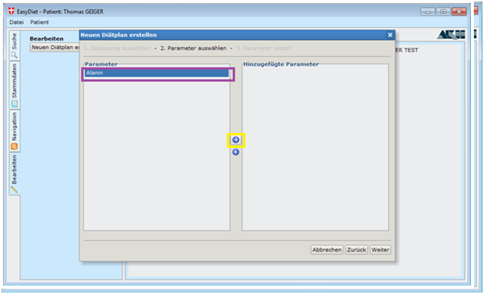
When you are finished with adding the parameters you can click the “Weiter” button, leading you to the next input mask.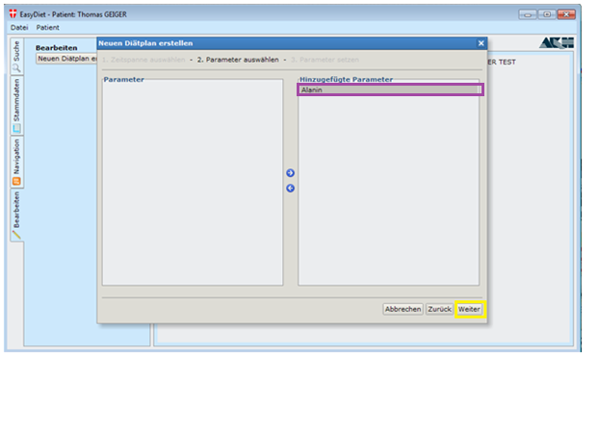

This mask allows you to specify the minimum and maximum values for each of your parameters which you have selected in the step before. To set values you have to double-click on the parameter you want to edit. This allows you to fill in the minimum value and maximum value textfields. Please note that the recommended unit is gramme.
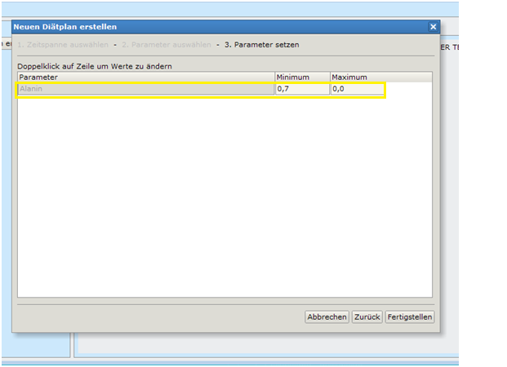
When you are finished click on the “Fertigstellen” button and you will see an overview for the diet plan that you have just created.
This plan is grouped and sorted by weeks and days over the entire duration. You then can add specific meals to a day by clicking on the green “cross-button”.

Creating a new recipe

If you would like to create a new recipe you can do so by clicking the “Rezepte” slider and afterwards hitting the “Rezept Hinzufügen” button.
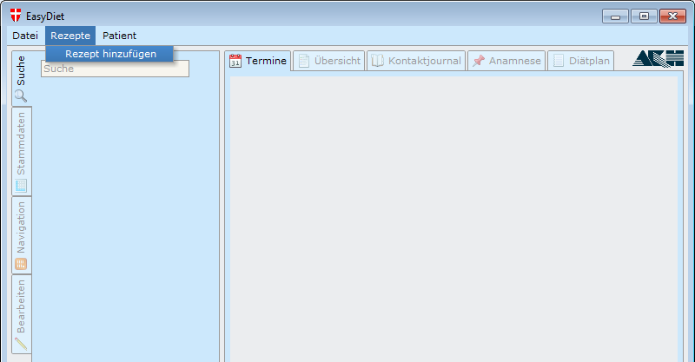
Having clicked the button a new form will show up, which allows you to specify all necessary information for your recipe.
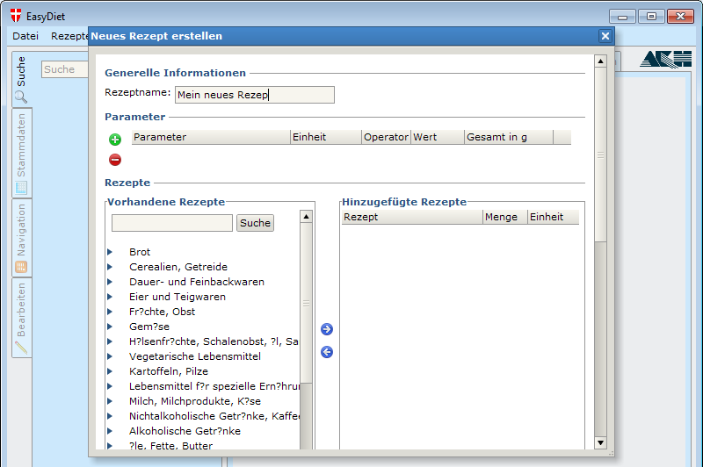

Adding parameter to your recipe
You can add certain parameter (e.g. fat, calories, etc.) to your recipe, in order to be observed while creating your new recipe. Whenever a recipe is added or removed the observed parameter will be calculated newly and updated. In case that a parameter breaks a rule, a symbol will show up and mark the corresponding parameter. As shown below you have to click the green button to add a new parameter.
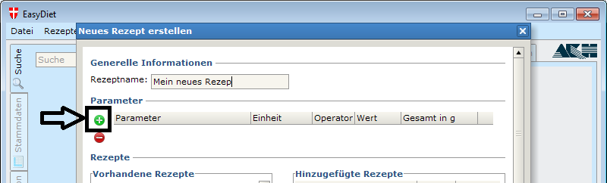
There will be automatically added an initially parameter when you have clicked the add button. Then you can edit the corresponding field like the parameter itself, the unit, operator and its value by double clicking on the corresponding parameter.
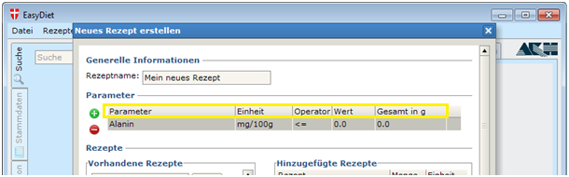

Adding ingredients to your recipe
Basically there are two ways to add a new ingredient to your recipe. The first possibility is to start a recipe search in the field below. As shown below, you then will be able to add a recipe by marking it with a click and then hitting the add button. Alternatively you can directly add an ingredient without searching for it first by opening the desired tree branch.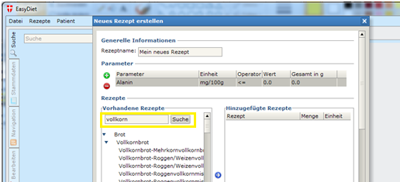
After having marked an ingredient you can add it by hitting the button, as shown below.
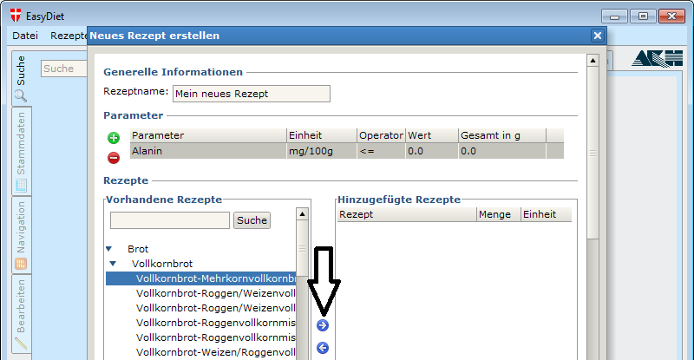

Whenever an ingredient has been added, the parameter to be observed will be calculated newly with the values of the meal and updated. As you can see the “Alanin” parameter is violated because the <= operator with value 0 breaks the rule.

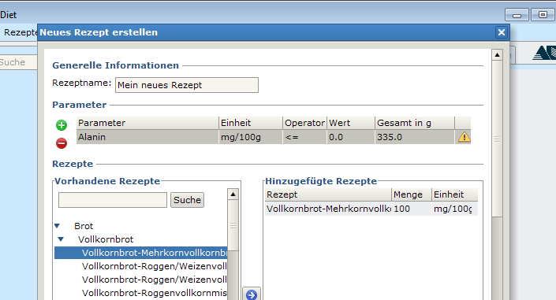
After you have specified certain parameter and ingredients you will have to add additional information to your recipe like benefits, preparation, preparation time and the difficulty of this recipe. The difficulty is measured on a scale from one to five whereas one means very easy and five means very difficult to cook. Some of these fields are obligatory and an error message will appear if you try to save the recipe without having these fields filled out. 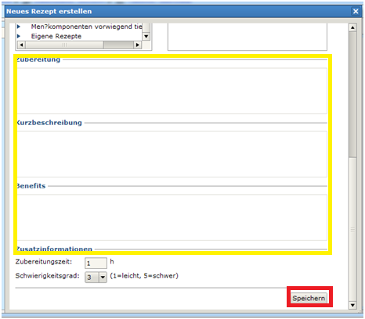

If you have finished creating your new recipe you would probably like to save it. You can do so by clicking the “Speichern” button, as shown below. The recipe will now be saved in the database, so that it is persistently available in the future. If there are no errors within the recipe and there is a connection to the internet, you finally should get this message box.
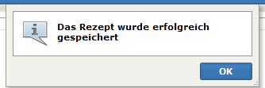

Creating a new patient

EasyDiet provides the opportunity to easily create a new patient file. As shown below, to launch this feature, you have to do click the “Patient” slider and the “Patient anlegen” button. 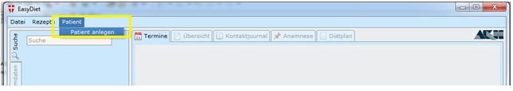
The “Patient hinzufügen” form will show up, where necessary data can be filled in.
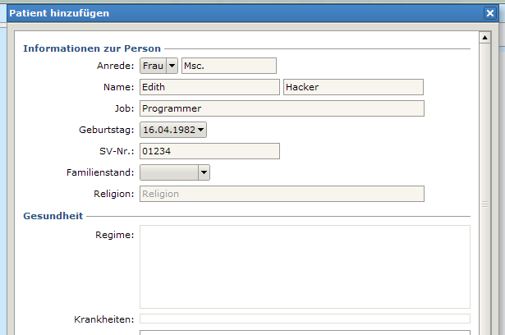
Having typed all the information you require, the patient file can be saved, as you see below and the “creating a new patient” process is finished.
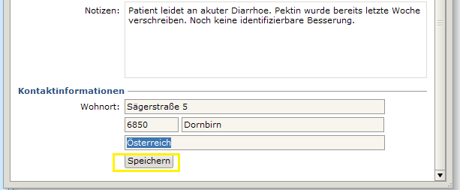

Labor reports

Add a labor report to an existing patient
Before you are able to add a labor report you have to select a patient (See “Searching a patient”).

After having selected a patient the “Anamnese” tab will be visible and selectable, as shown below.

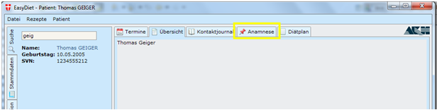

Click on the “Anamnese” tab and you will see already added reports for the selected patient.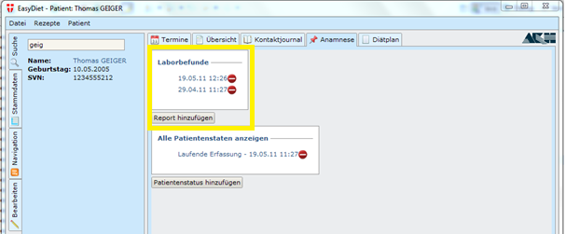
By clicking the “Report hinzufügen” button a new dialog shows up, as you see below.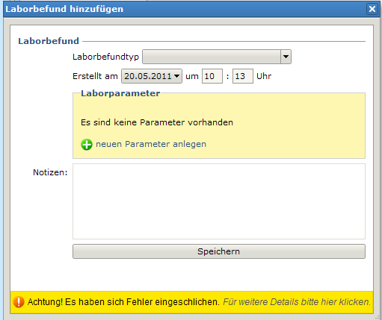
On the bottom of this dialog a small attention window helps you to fill in the form properly. Now you have to choose the type of this report and afterwards you have to insert when the report was created. You can add a parameter to this report by clicking “neuen Parameter anlegen”.
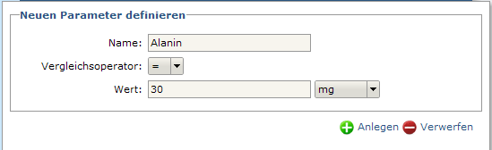
Here you can insert any existing parameter from the database and add its specific values. By pressing “Anlegen” the parameter is now available in your report.
Afterwards you can add personal notes to the report.
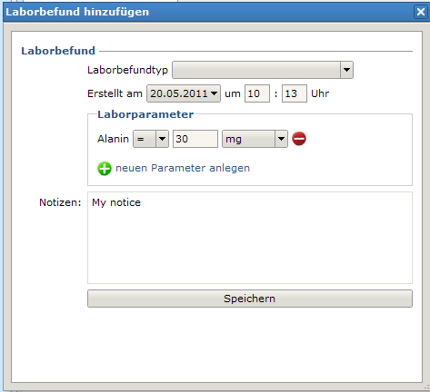
If you have finished creating the report press the “Speicher” button to save the report in the database.

Change a labor report of an existing patient
In order to change an existing labor report you have to choose one from the list.
After selecting a report a new dialog appears where you can edit this report (for details see “Add a labor report to an existing patient”).

Remove a labor report
To remove an existing labor report press the red button next to the report you want to delete.

Patient state

Adding a new patient state to an existing patient
Before you are able to add a new patient state you have to select a patient (See “Searching a patient”).
After having selected a patient you will see that the “Anamnese” tab is selectable.
After clicking the anamnesis tab you may already see existing patient states of the selected patient.
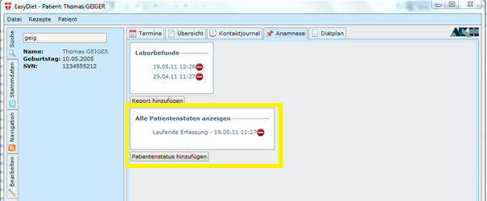
By clicking “Patientenstatus hinzufügen” a new dialog appears which you can see below:
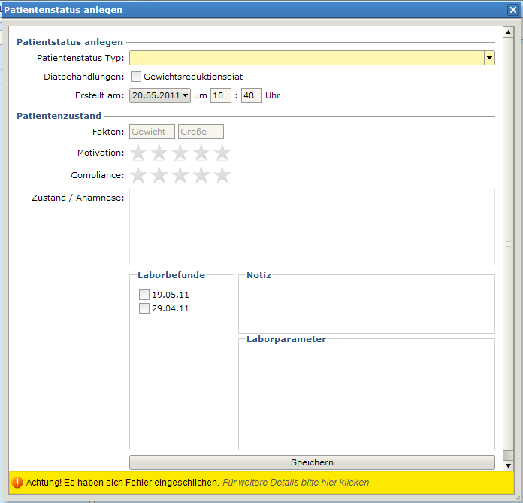
First you have to set the type of this patient state. Afterwards you can enter the anthropometric parameter of the patient. After entering this information you can select the motivation and the compliance of this patient. This dialog also offers the possibility to link existing labor reports to this patient state. On the bottom of this dialog a small attention window helps you to fill in the form properly. If you are finished with entering all required data you can click the “Speichern” button to make this new state persistent.

Update the patient state of an existing patient
In order to change an existing patient state you have to choose one from the list.
After having selected a corresponding state a new dialog will appear which allows you to edit this state (for details see “Add a new patient state to an existing patient”).

Remove a patient state
To remove an existing patient state press the red button next to the report you want to delete.

Adding a new NurtitionProtocoll with a Webbrowser

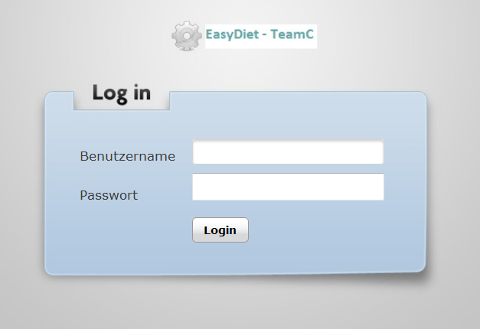
After the user has started the webbrowser of his choice, he has to login as shown above.
After that the user has two possibilities. He can add an all new protocoll or he can copy the information of an existing dietryplan.

Adding a new NurtitionProtocoll with a Webbrowser
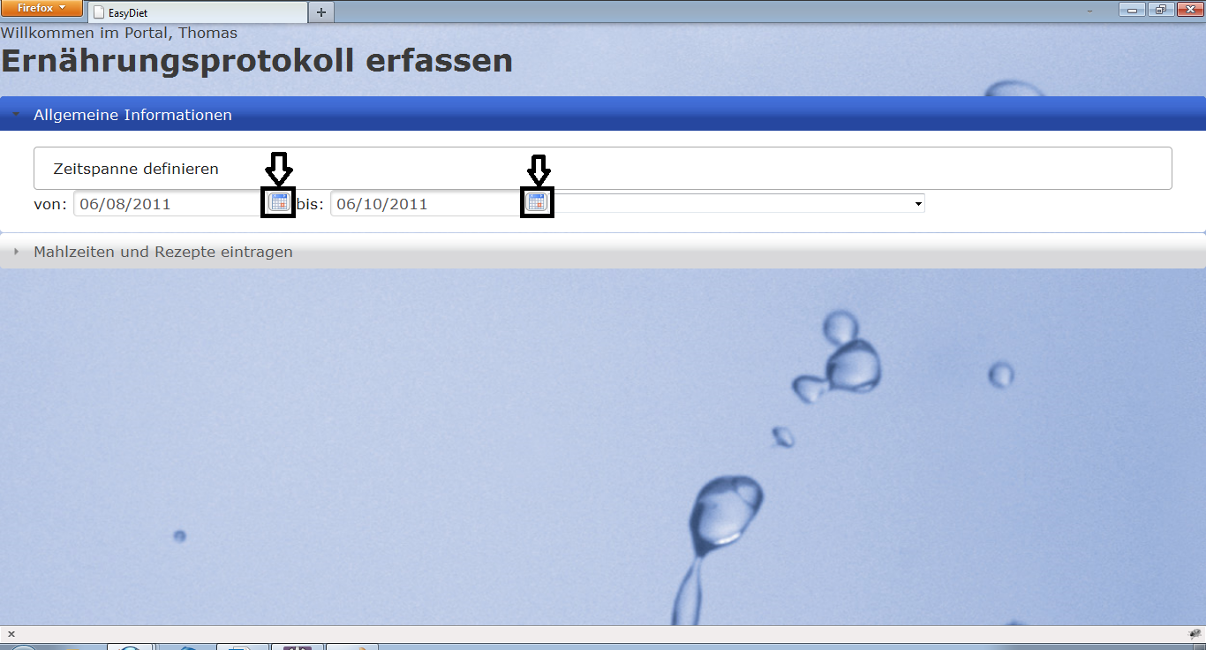
With the marked buttons you can define the startdate and enddate of the new protocoll. After you have defined the duration of the protocoll you can open the add meals and recipe tab as shown beyond.
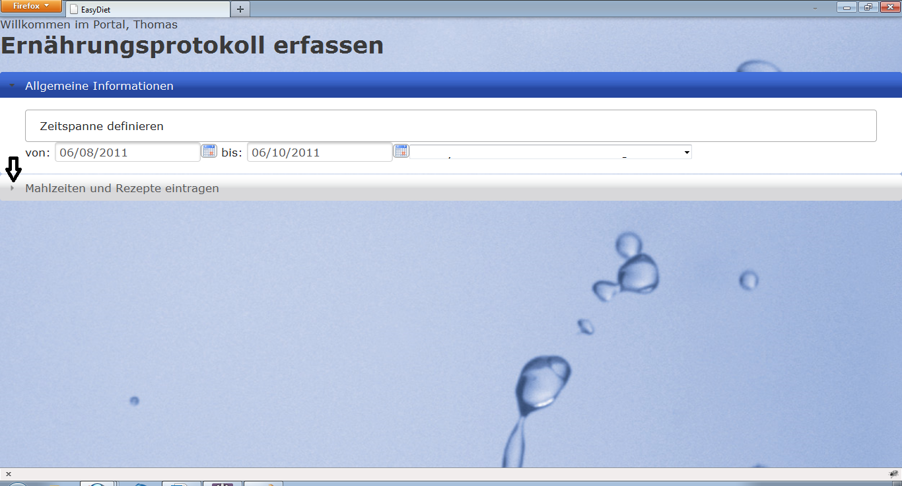
Now you can add meals to a date the “Mahlzeit hinzufügen” button.
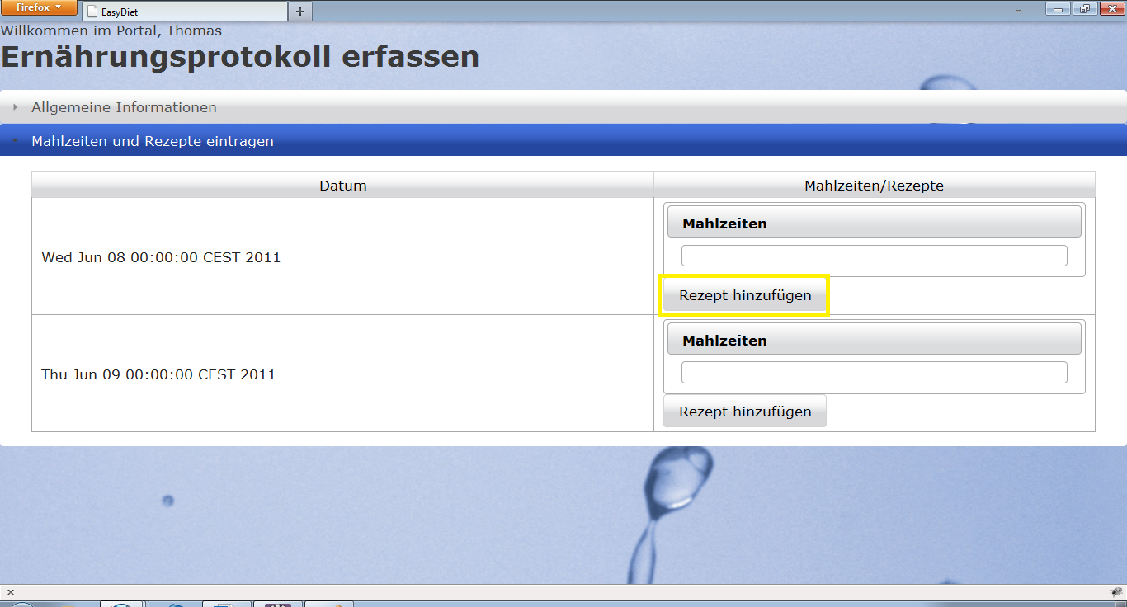
In the open dialoge you can choose a recipe, the kind of meal the recipe belongs to (for example: breakfast) and the amount of the recipe.
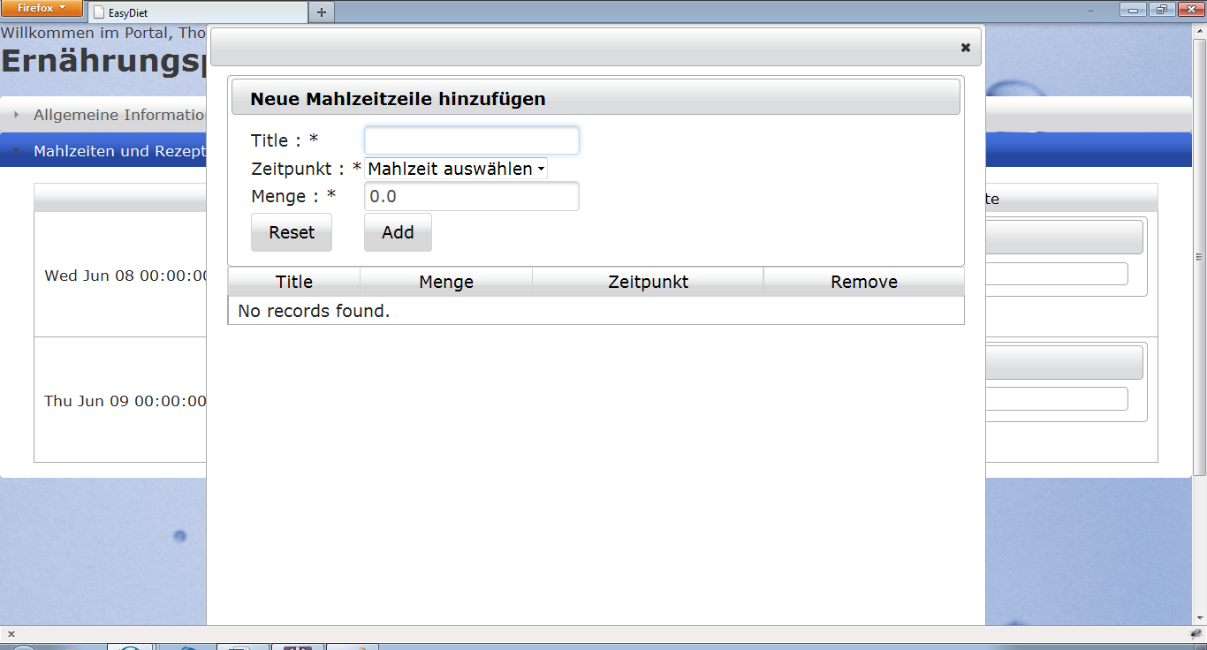
After you have choosen the recipes you have eaten over the given period of time and clicked the “Add” button they will be displayed.

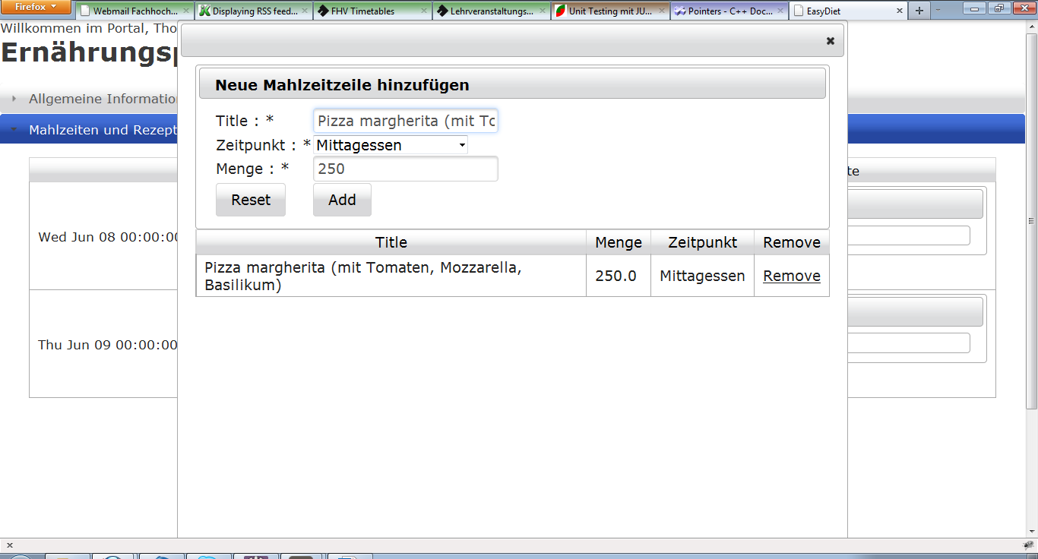
Adding a new NurtitionProtocoll with a Webbrowser

