|  |
| --- |
| Team C |
| EasyDiet |
| Handbuch für Anwender |

1 Introduction 2

2 Product Information 3

2.1 Scope of EasyDiet 3

2.2 System Requirements 3

3 How to install and uninstall the program 4

4 EasyDiet User Interface 5

4.1 Overview 5

4.2 Specific functionality 5

4.2.1 Searching a Patient 6

4.2.2 Creating a new Dietry plan 6

# Introduction

Welcome to EasyDiet!  
  
EasyDiet is an application supporting dietary assistants creating and monitoring dietary plans. EasyDiet implements methods to create and manage cooking recipes with a focus on the nutritional values of their ingredients. With EasyDiet it is easy to create dietary plans which meet the criteria of medical treatments, therapies and the patients food preferences. This software provides useful functions to administer patient data and patient protocols.

# Product Information

## Scope of EasyDiet

* It is possible to select Patients
* It is possible to create a diet plan for a special patient

## System Requirements

* Processor with 1 ghz
* 1gb RAM
* 500 mb free space on the hard disk
* Actual JAVA VM
* Operating Systems
  + Windows XP
  + Windows Vista
  + Windows 7

# How to install and uninstall the program

Open EasyDiet.jar and start working

# EasyDiet User Interface

In this chapter we explain the functionality of the user interface.

## Overview

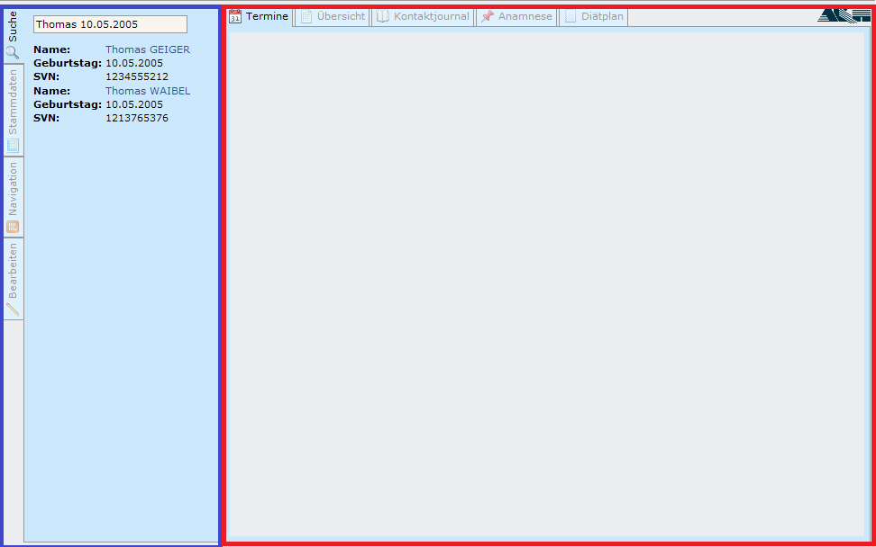

On the left side with the blue highlighted border we see the navigation panel together with the active search tab of EasyDiet. On the right side surrounded with the red highlighted border is the patient specific part of EasyDiet.

## Specific functionality

### Searching a Patient

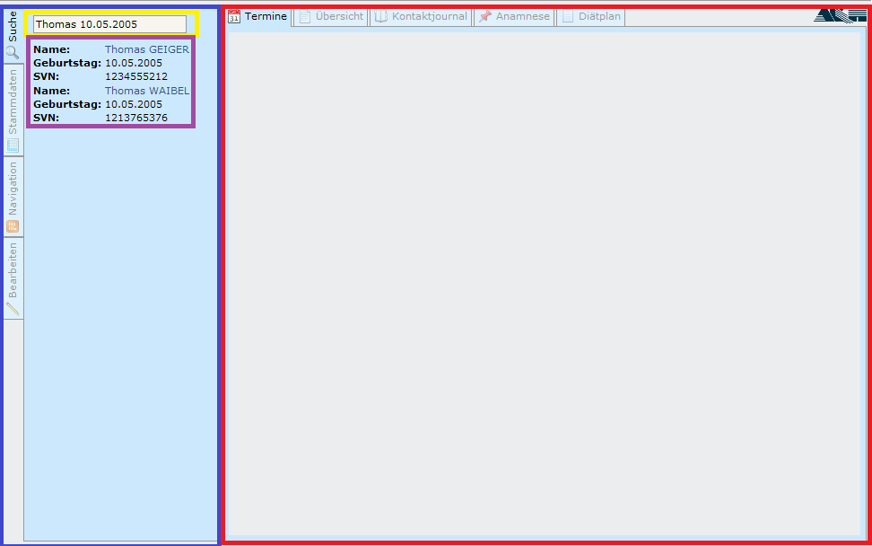

To search a patient we use the Textbox which is highlighted with a yellow border. We can search for first name, second name, insurance number and birthday. The birthday has to be in the following format dd.mm.yyyy.

The program automatically starts searching with the given information; found results will be displayed in the violet highlighted border area.

### Creating a new Dietry plan

After you have searched for a patient and have selected him, the “Diätplan” tab is getting visible. By clicking on this tab EasyDiet presents a view where you can create a new Dietplan. Therefore you will have to click on the Button “Neuen Diätplan erstellen”, as shown in the screenshot below.

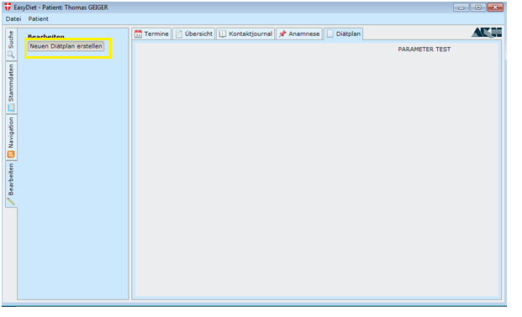

After you have clicked the button a new mask is showing up where you can define the duration (more exactly the start and end date) of your dietplan. Clicking on Date-Dropdown allows you to choose your specific date out of a mini-calendar.

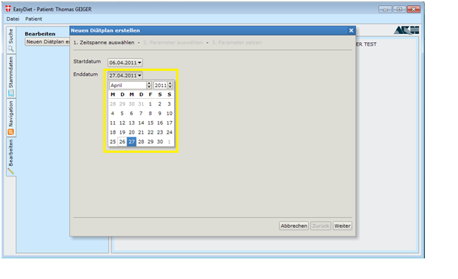

Having chosen your desired duration the next step of creating a new dietplan will be to select and determine the diet parameters.

EasyDiet will show up a new mask where you can see all diet parameters. If you would like to add a specific parameter to this diet, you can do so by highlighting the parameter and clicking the “right-arrow”.

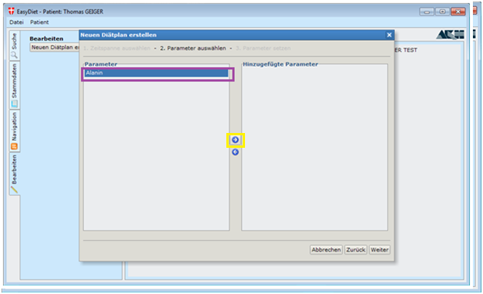

When you are finished with adding the parameters you can click the “Weiter” button, leading you to the next input mask.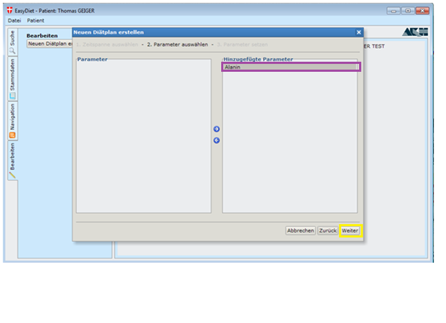

This mask allows you to specify the minimum and maximum values for each of your parameters which you have selected in the step before. To set values you have to double-click on the parameter you want to edit. This allows you to fill in the minimum value and maximum value textfields. Please note that the recommended unit is gramme.

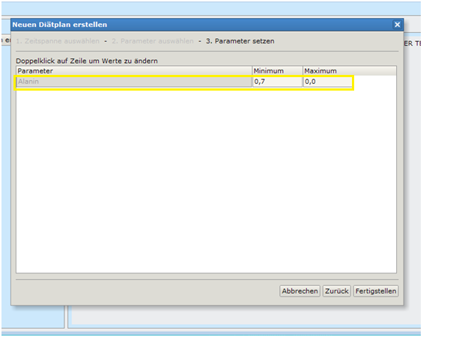

When you are finished click on the “Fertigstellen” button and you will see an overview for the diet plan that you have just created.   
This plan is grouped and sorted by weeks and days over the entire duration. You then can add specific meals to a day by clicking on the green “cross-button”.

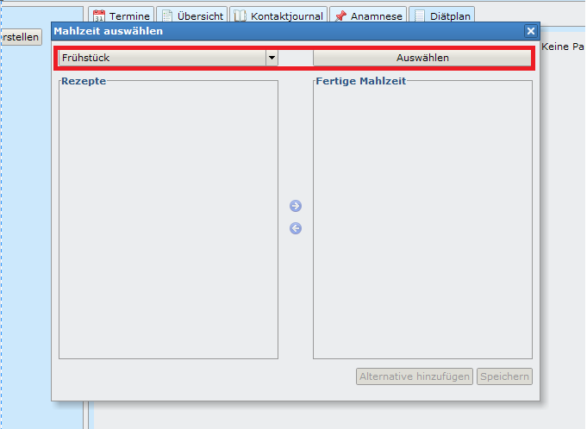

At first please choose a meal code and press „Mahlzeit hinzufügen“. After you pressed the button you can see a list of available recipes from the BLS.

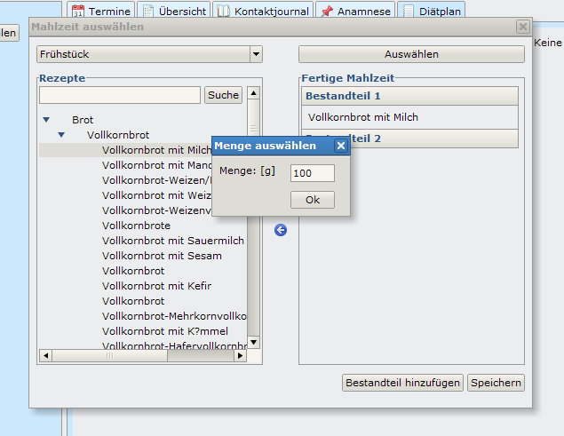

Choose your desired Recipe and press the right arrow button to specify the quantity and add it to the activated Meal line. If you add an additional Recipe to this meal line it will represent an alternative recipe. If you want to add a new component to this meal please press “Bestandteil hinzufügen”. After you finished adding meals please press “Speichern”. Now your meal and your dietry plan is saved and will be displayed in the opened dietry plan tab.