Shipment Feedback:
SHIPMENT LIST SCREEN
- Can you have the columns change based on the Tab I am in? Yes. With specific settings for exceptions and monitoring
IE: I would want the Message to show in column4 for Exceptions but would not want to see it all for Monitoring
IE: I would want to see the Stops (Count) for Consolidations but not for Date Issues.
- Curious how users will respond to not having a left to right scroll bar on the Shipment List. It is there in the design
- Is there a way for a user to change column width? Those are not part of the mock but will be covered in the actual development story
- I don’t think users are very interested in the time field on dates. Maybe we only show the times when you hover? Yes. Similar to Order #
- How do you send a Shipment to Overflow? Dont have those screen yet. Will need to include as we gather requirements
- SENT (in Monitoring Dashboard – Can we rename this Tender Sent – Yes.
ORDER GENERAL
- Can we have each grid follow the previous vertical grid to minimize the white space?
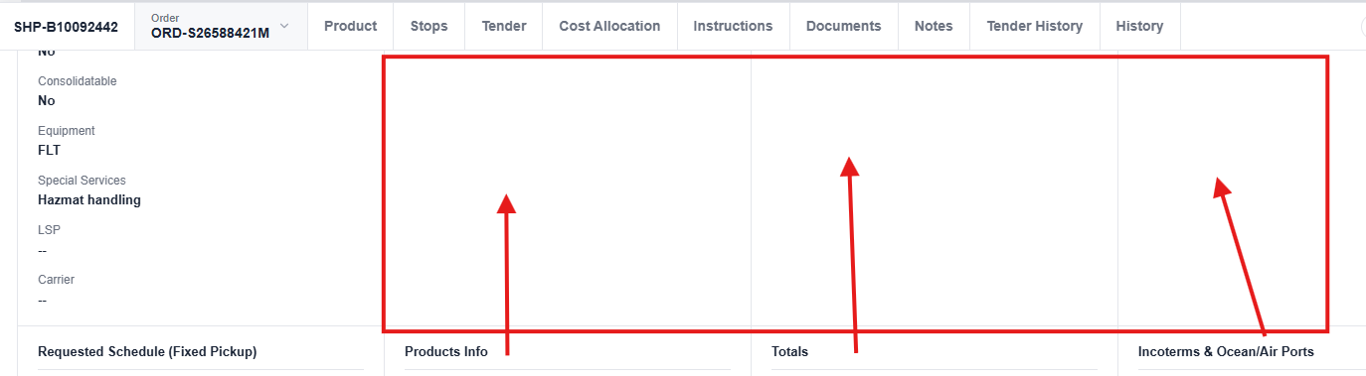
- Can we put the Earliest Latest Pickup under the Pickup Location and Earliest Latest Delivery under the Delivery Location (All these will be mapped from Order. This is just a idea of reference. We will bring actual Order header section here)
- Can we also show a check box below the Pickup and Delivery Dates titled: Appointment?
- I would switch the Totals information with the Requested Transportation section
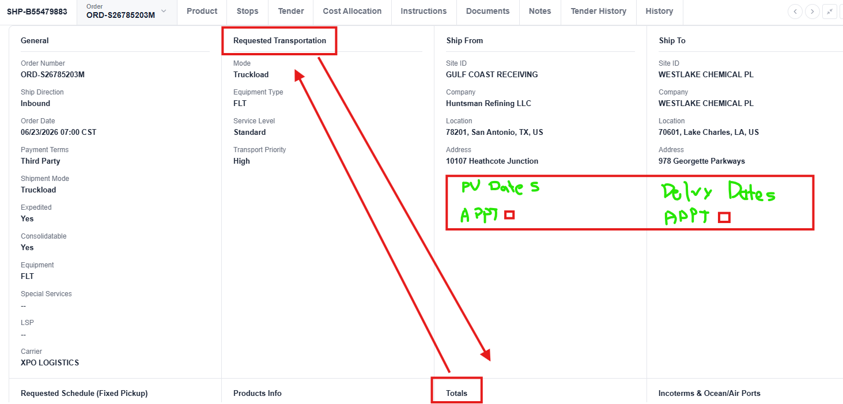
PRODUCT:
- Can we move the column headers closer to the rows? (like floating?)
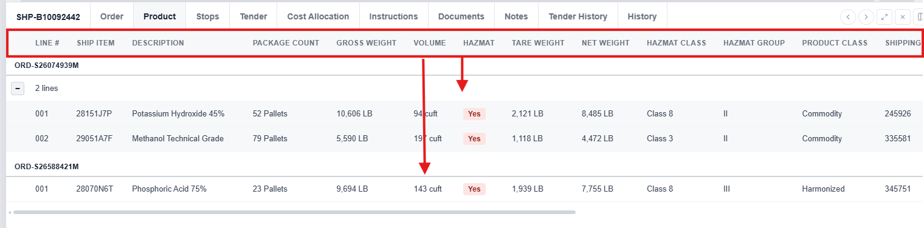
- Haz – would an image work better than Yes value?
TENDER:
- Do we need the top section? All of that data is redundant with the List View. I would remove. (There are similar details in TMS right now. We can keep this with a hide functionality. May be users have gotten use to this?)
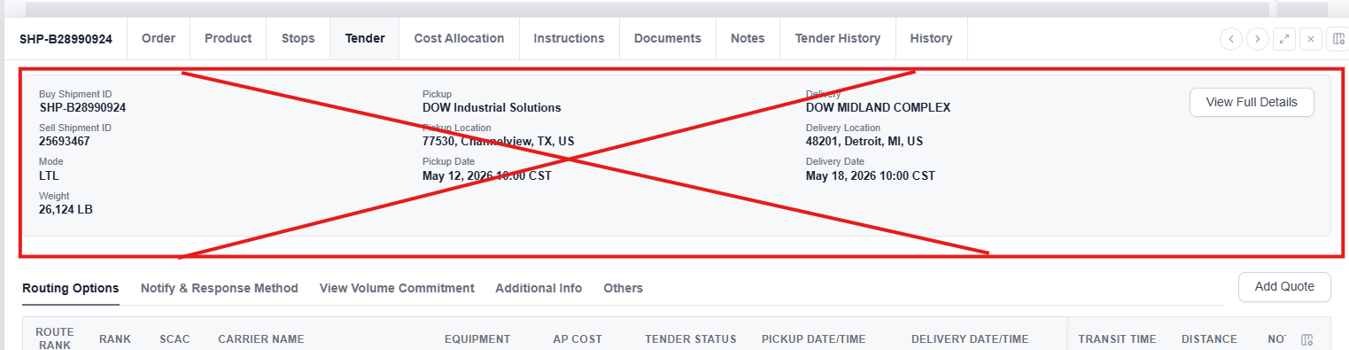

COST ALLOCATION – Planned Cost
- Product Question: Will this only populate when a carrier is Accepted? Should get populated during each carrier selection process

