Assignment for Module 5
The graded problems in module 5 involve SELECT statements for multiple tables and row summaries and data manipulation statements using the INSERT, UPDATES, and DELETES statements of SQL. You should execute the statements using either Oracle or MySQL.
To facilitate grading, please number the SQL statements and format them neatly. You need to show the result tables. Indicate in the beginning of your document if you used Oracle or MySQL.

1. SELECT Statement Problems
1. For event requests, list the event number, event date (eventrequest.dateheld), and count of the event plans. Only include event requests in the result if the event request has more than one related event plan with a work date in December 2013.
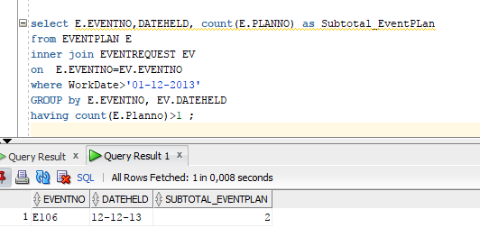

2. List the plan number, event number, work date, and activity of event plans meeting the following two conditions: (1) the work date is in December 2013 and (2) the event is held in the “Basketball arena”. Your query must not use the facility number (“F101”) of the basketball arena in the WHERE clause. Instead, you should use a condition on the FacName column for the value of “Basketball arena”.
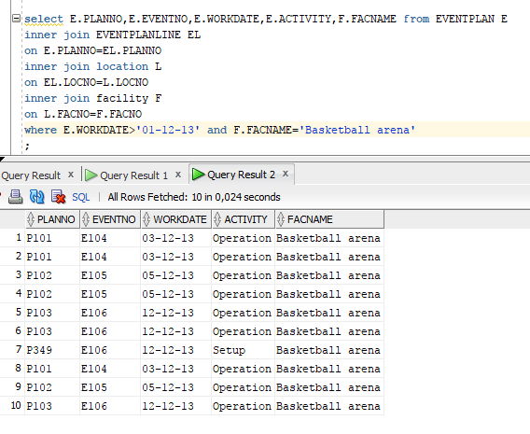
3. List the event number, event date, status, and estimated cost of events where there is an event plan managed by Mary Manager and the event is held in the basketball arena in the period October 1 to December 31, 2013. Your query must not use the facility number (“F101”) of the basketball arena or the employee number (“E101”) of “Mary Manager” in the WHERE clause. Thus, the WHERE clause should not have conditions involving the facility number or employee number compared to constant values.
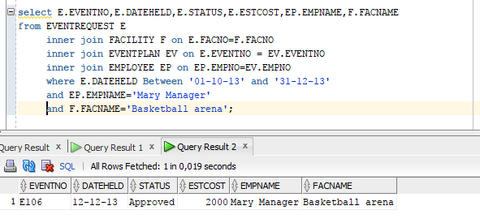
4. List the plan number, line number, resource name, number of resources (eventplanline.number), location name, time start, and time end where the event is held at the basketball arena, the event plan has activity of activity of “Operation”, and the event plan has a work date in the period October 1 to December 31, 2013. Your query must not use the facility number (“F101”) of the basketball arena in the WHERE clause. Instead, you should use a condition on the FacName column for the value of “Basketball arena”.
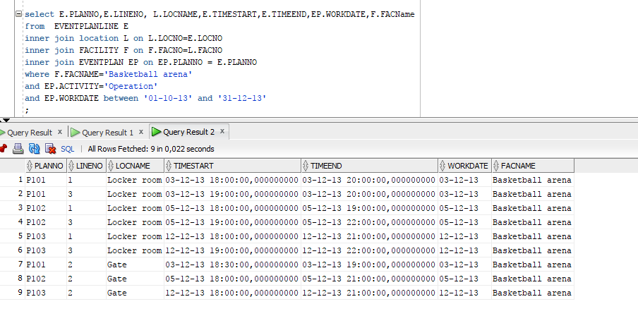

2. Database Modification Problems
1. Insert a new row into the Facility table with facility name “Swimming Pool”.
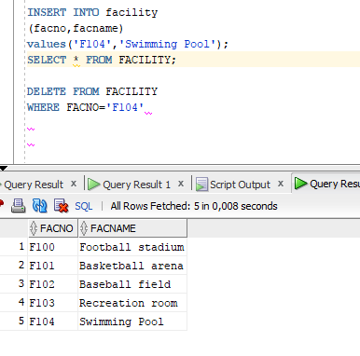
2. Insert a new row in the Location table related to the Facility row in modification problem 1. The new row should have “Door” for the location name.
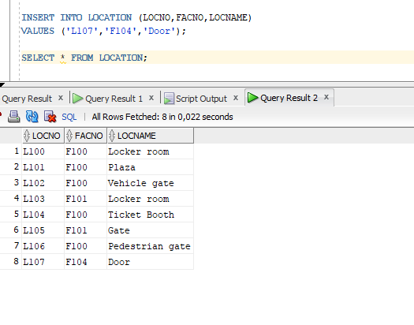
3. Insert a new row in the Location table related to the Facility row in modification problem 1. The new row should have “Locker Room” for the location name.
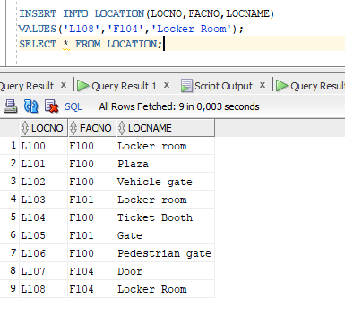
4. Change the location name of “Door” to “Gate” for the row inserted in modification problem 2.
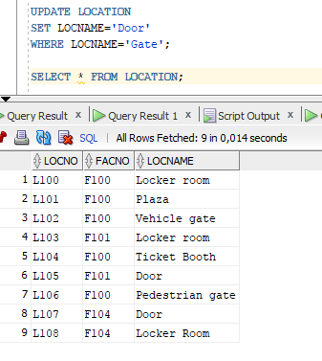

5. Delete the row inserted in modification problem 3.
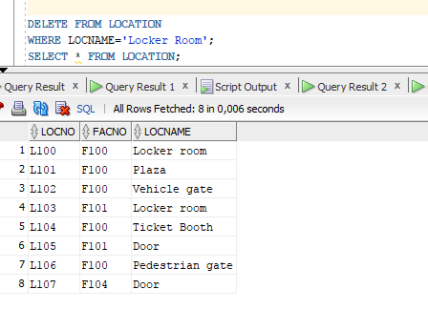

3. Submission
The submission requirements involve SELECT statements and data manipulation statements and evidence that you executed the statements in Oracle or MySQL. You will submit 9 documents with each document containing the required statement and screen snapshot to indicate that you executed the statements in Oracle or MySQL. In each document, you should neatly format your statement so that it can be easily graded. You should use the same table and column names as specified in the ICA database background document. You should not put any identifying details about yourself in your submitted document. For the screen snapshot, you need to capture a screen showing most columns and rows of the executed statement.

