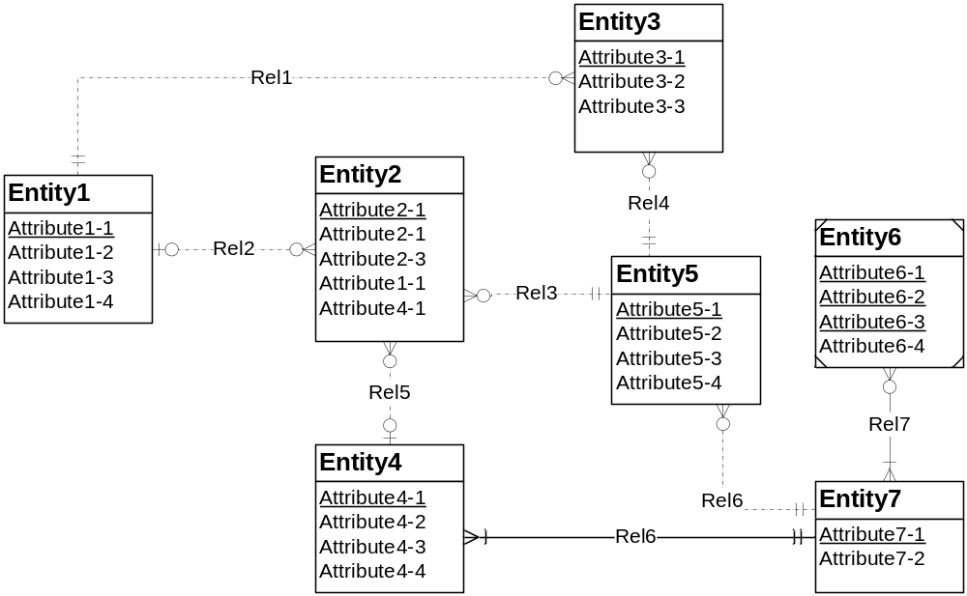
Identification dependency cardinality rule violation
Redundant FK rule violation
(Attribute 1-1 and Attribute 4-1)

Identifying Relationship rule violation: at least pone participating entity type must be weak
Figure 1: ERD for Problem 4
- Resolution Redundant FK: Remove the redundant Foreign ket(Attribute 1-1;Attribute 4-1), if the attribute does not represent a foreign key, should be renamed instead of removed;
- Identifying Relationship rule, we will make the relationship (Rel6) non identifying;
- Identification dependency cardinality rule: for each identifying relationship, the minimum and maximum cardinality must be 1 in the direction from child(weak entity) to the parent entity type, so the problem can be resolved by changing the weak entity’s cardinality in Rel7 to (1,1).

