Questions

1. Is the predation incidence influenced by the different types of treatment (agroforestry/forest/restoration)?
2. Is the predation incidence by each predator guild (arthropod/bird/mammal) influenced by the different types of treatment?

*Methods*

* *Predation incidence across treatment types (question 1)*

\*mencionar a análise prévia com 5 tratamentos e a mudança para 3?

To answer the first question (Model 1), we analyzed the binary response variable, total predation incidence, measured as the presence or absence of predation marks. The predictor variable was treatment type.

Analyses were performed using a generalized linear mixed-effects (GLM) model with a binomial response and a logit link function. The response variable was binary, measured as the presence or absence of predation. Treatment type was included as a fixed effect, and individual identification was included as a random effect. Models were fitted using the “glmer” function from the “lme4” package. The “emmeans” package was used to obtain adjusted means on the logit scale and to perform pairwise comparisons between treatments using Tukey’s adjustment for multiple testing.

* *Predation incident by different predator groups across treatment type (question 2)*

\*mencionar a retirada da guilda “reptile”? (= 0 predação)

To test whether predation incidence by different predator guilds – arthropods, birds, mammals – was influenced by treatment type (Model 2), we grouped the individual predator categories into one variable named “guild”. As in Model 1, analyses were performed using a GLM model with a binomial response and a logit link function. The interaction between predator guild and treatment were included as fixed effects. Estimated marginal means and pairwise comparisons were also used to evaluate this interaction.

*Results*

A total of 261 artificial caterpillars were installed and 252 were retrieved (96.55%). All analyses were conducted using the retrieved caterpillars as the total sample size. Of the retrieved caterpillars, 69 (27.4%) had predation marks after five days exposed.

* *Predation incidence across treatment types (question 1)*

Predation incidence was highest in the forest treatment, where 38 out of 107 retrieved caterpillars (35.5%) exhibited predation marks. In the agroforestry treatment, 97 caterpillars were retrieved, of which 21 (21.6%) had predation marks. The lowest incidence was observed in the restoration treatment, with predation marks found on 10 out of 48 (20.8%) retrieved caterpillars.

Treatment type had a statistically significant effect on predation incidence. The forest environment had higher predation incidence compared to agroforestry. No significant differences were found between agroforestry and restoration or between forest and restoration.

* *Predation incidence by different predator groups across treatment type (question 2)*

\*melhorar gráficos

Arthropods were the guild with the highest predation incidence, preying on 38 caterpillars. They were mostly present in the forest treatment, with 29 of the total (76.3%), followed by six caterpillars in the agroforestry (15.8%) and three in restoration (7.9%). Birds were the second most common guild, with 32 caterpillars predated, of which 15 were in the agroforestry (46.9%), 10 in forest (31.3%) and seven in restoration (21.9%). Mammals predated five caterpillars, two in forest (40%), two in agroforestry (40%) and one in restoration (20%). Six caterpillars were predated by more than one predator guild.

Treatment type had a statistically significant effect on predation incidence by different predator guilds. Predation by arthropods was significantly higher in forest compared to agroforestry and restoration treatments, and there was no significant difference between agroforestry and restoration.

*#linhas 3, 16, 22, 23 = p < 0.05*

*#3 = arthropod agroforestry / arthropod forest*

*#16 = mammal agroforestry / arthropod forest*

*#22 = arthropod forest / bird forest*

*#23 = arthropod forest / mammal forest*

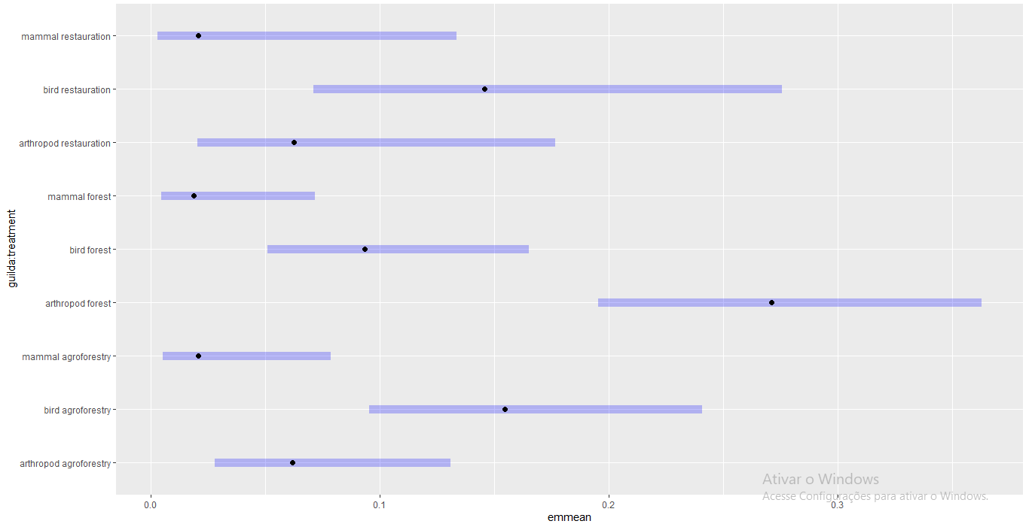Fig 1

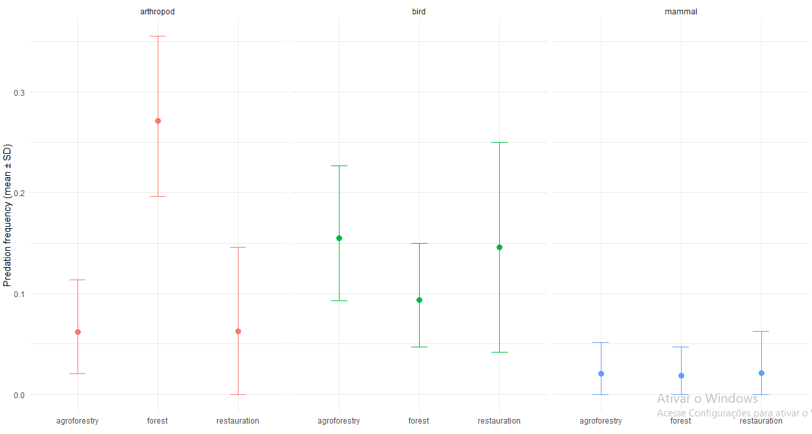Fig 2