DISASTERS
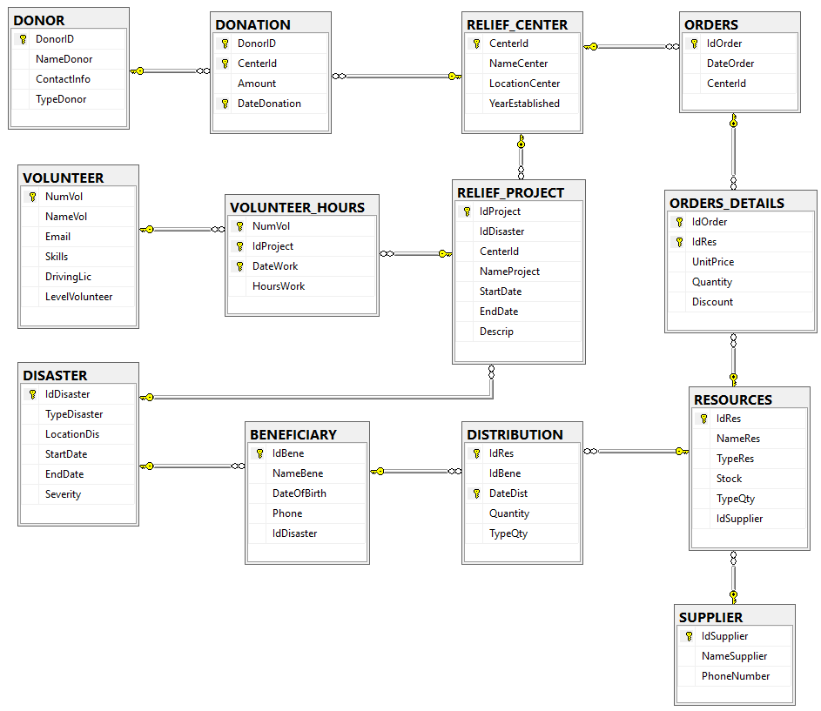

CREATE TABLE - INSERT
- Create a table named TOTALS_CENTERS. The table must have the following fields: 19 points
  - NameCenter
  - Subtotal
  - Discount
  - Total
This table will store the totals spent for every Relief Center.
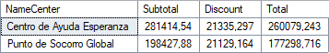
create table TOTALS_CENTERS (
NameCenter varchar(100)
, Subtotal money
, Discount money
, Total money
)

insert into TOTALS_CENTERS
select NameCenter, sum(unitprice*quantity), sum(unitprice*quantity*discount/100),
sum(unitprice*quantity*(100-discount)/100)
from RELIEF_CENTER, ORDERS, ORDERS_DETAILS
where RELIEF_CENTER.CenterId=ORDERS.CenterId and
ORDERS.IdOrder=ORDERS_DETAILS.IdOrder
group by NameCenter
- Create a table named REWARD_VOLUNTEERS. The table must have the following fields: 30 points
  - NameVolunteer
  - TotalHoursWorking
  - Reward
This table will store the volunteers who have worked on more than two projects, who have worked for 14 days or more, and who have worked at least 4 hours every single day. Those who meet the above conditions will receive a bonus of 10€ for each hour worked.
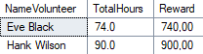
create table REWARD_VOLUNTEERS (
NameVolunteer varchar(50)
, TotalHours decimal(4,1)
, Reward smallmoney
)

insert into REWARD_VOLUNTEERS
select NameVol, sum(hourswork), sum(hourswork)*10
from VOLUNTEER, VOLUNTEER_HOURS as V1
where VOLUNTEER.NumVol=V1.NumVol
and 4<=all
(select hourswork
from VOLUNTEER_HOURS as V2 where V1.NumVol=V2.Numvol)
group by NameVol
having count(idproject)>2 and count(datework)>=14

UPDATE
- An NGO decides to donate resources but only has certain types available. For hygiene products, it donates 2000 units of each type; for medical supplies, it donates 1000 units of each type; and for clothing and textiles, it donates 20% of the current stock available. Update the stock of the resources with the units given by the NGO. 25 points
begin transaction
select * from RESOURCES where typeres='Hygiene Products'
or typeres='Medical Supplies'
or typeres='Clothing and Textiles'
update RESOURCES
set stock= (case
when typeres='Hygiene Products' then stock+2000
when typeres='Medical Supplies' then stock+1000
when typeres='Clothing and Textiles' then stock*1.2
else stock
end
)
select * from RESOURCES where typeres='Hygiene Products'
or typeres='Medical Supplies'
or typeres='Clothing and Textiles'
rollback;

- Update the volunteers’ level based on the total number of hours. 20 points
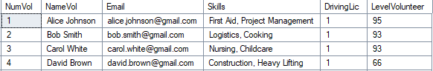…
begin transaction
select * from VOLUNTEER
update VOLUNTEER
set levelvolunteer=levelvolunteer+(select sum(hourswork)
from VOLUNTEER_HOURS
where VOLUNTEER_HOURS.NumVol=VOLUNTEER.NumVol)
select * from VOLUNTEER
rollback

DELETE
- The RESOURCES table contains potential resources that can be used in disasters. It has been identified that some of these resources have never been bought for any disaster. The resources and the supplier who supply them are occupying unnecessary space in the database and are not expected to be used in the future. Therefore, they should be deleted. 24 points
begin transaction
select * from SUPPLIER
delete from RESOURCES
where IdRes not in
(select distinct IdRes
from ORDERS_DETAILS
)
delete from SUPPLIER
where IdSupplier not in
(select distinct IdSupplier
from RESOURCES)
select * from SUPPLIER
rollback

- According to tax regulations, we are required to keep invoices from the last three years. We want to delete all invoices that are three years old or older, as they are taking up unnecessary space in the database. 30 points
begin transaction
select * from ORDERS
--primero hay que borrar todos los productos de las facturas
delete from ORDERS_DETAILS
where IdOrder in
(select idorder from ORDERS where dateorder<dateadd(year,-3,getdate()))
--borrar las facturas
delete from ORDERS
where IdOrder in
(select idorder from ORDERS where dateorder<dateadd(year,-3,getdate()))
select * from ORDERS
rollback

TRANSACT
- It has been detected that some disaster victims are taking advantage of the situation and requesting too many resources. From now on, only 3 donations are allowed per beneficiary. 44 points
- Verify that the beneficiary exists.
- Verify that the resource exists.
- Ensure that the beneficiary has not received 3 or more donations.
Try the transact for: beneficiary: John Doe, Resource: Bandages, 20 units
begin transaction

declare @idbeneficiary int=(select idbene from BENEFICIARY where NameBene='John Doe')
--check if the beneficiary exists
if @idbeneficiary is NULL
begin
print 'transaction failed - the beneficiary does not exist';
rollback transaction;
return;
end

declare @idres int=(select idres from RESOURCES where NameRes='Bandages')

--check if the resource exists
if @idres is NULL
begin
print 'transaction failed - the resource does not exist';
rollback transaction;
return;
end

--check if the beneficiary had already 3 distributions
if (select count(*) from DISTRIBUTION where idbene=@idbeneficiary)>=3
begin
print 'transaction failed - the beneficiary already had 3 distributions';
rollback transaction;
return;
end

insert into DISTRIBUTION
values (@idres, @idbeneficiary, getdate(), 20, 'units')

if @@ERROR=0
begin
commit transaction;
print 'Transaction completed successfully'
end
else
begin
rollback transaction;
print 'Transaction failed'
return
end

