Decision Support System for Hospital Flow
Manuela Pop
AI in Healthcare
April 2026

ABSTRACT

This project presents a prototype using machine learning and large language models (LLMs) to estimate patient risk and generate a readable context summary. EHR synthetic data from Synthea was used to engineer encounter-level features, which were then used to train HistGradientBoostingClassifier to predict a proxy label for higher-acuity encounters. The model achieved strong performance, with an AUC of approximately 0.995 and a high accuracy. Furthermore, an LLM layer generated explanations of model outputs for operational use. The results rely on synthetic data rather than clinically validated outcomes. The project shows how machine learning and generative AI can be integrated into a unified healthcare decision-support workflow.

1. Introduction
Hospital care efficiency depends on how quickly and accurately patients can be triaged and treated. As healthcare systems continue to face rising costs, overcrowding, and staffing pressures, early recognition of higher-acuity cases has become crucial to both patient safety and hospital care efficiency. When triaging patients, identifying risk early is critical for enabling hospitals to allocate beds, staff, and monitoring resources more effectively. Hospital bills can be costly, and if we identify risks by sending low-risk patients home early and hospitalizing only those at risk, we can reduce both hospital and patient costs. In contrast, delayed or inconsistent recognition of worsening patient status can be very dangerous if high-risk patients are not treated in a timely manner and the right resources are not allocated where they are needed.
Traditional hospital flow decisions often depend on manual interpretation of vital signs and encounter information. Manual workflows are time-consuming, especially during periods of heavy demand and in short-staffed hospitals. This creates a practical need for quick, reliable decision-support systems that can rapidly process structured clinical information and produce consistent, interpretable risk assessments. Such tools are particularly valuable when they support operational awareness without attempting to replace clinical judgment. AI systems, when used properly, can problem-solve and alleviate many of these structural issues and triage patients at a faster pace.
Recent research and advances in machine learning have enabled the identification of meaningful patterns in structured healthcare data, while large language models can translate technical outputs into concise explanations. The objective of this project is to predict an alternative measure of acuity using encounter-level features derived from synthetic EHR data and then generate an operational summary through an LLM layer. The project uses synthetic data and is therefore presented as a demonstration of methodology and systems integration rather than a finished product to be deployed. Essentially, the project addresses an important problem by demonstrating how AI models can support hospital triage.

2. Related Work
Johnson et al. introduced MIMIC-III, a freely accessible critical care database that contains richly detailed, de-identified information on intensive care patients, which became a foundational resource for developing prediction tasks such as mortality estimation, length-of-stay forecasting, and deterioration detection. Compared with work built on MIMIC-III, the present project uses synthetic EHR data from Synthea rather than real-world ICU data.
Rajkomar et al. indicated that deep learning could be applied to EHR to predict multiple clinically relevant outcomes, including readmission, mortality, and prolonged length of stay [2]. Their work showed that powerful predictive systems could learn directly from large volumes of structured EHR information with relatively limited manual feature engineering. In contrast, the current project uses a HistGradientBoostingClassifier trained on explicitly engineered encounter-level features.
Topol argued that artificial intelligence should augment human decision-making rather than replace clinicians, emphasizing AI's potential to improve healthcare [3]. Instead of stopping at a raw risk score, this project passes the model's outputs to an LLM layer that produces structured operational summaries in plain language.

3. Methodology
The methodology for this project was designed as an end-to-end pipeline that begins with synthetic HER data, transforms those records into encounter-level features, and produces both quantitative predictions and explanations. The workflow prioritizes practical system integration: structured data is processed for machine learning, model outputs are interpreted in an operational context, and results are delivered in a format that supports decision-making.
Code Repo: https://github.com/manuelapop/hospital-flow-agent/tree/main

3.1 Data and Preprocessing
The dataset was derived from Synthea (10k_synthea_covid19_csv). Three source files were used: observations.csv, patients.csv, and encounters.csv. The files were combined to create encounter-level records that represent a patient snapshot suitable for classification. Age was derived from patient data, while physiological measures were extracted from available observations.
A binary proxy label was then created to represent operational acuity. Encounters categorized as inpatient or emergency were labeled as high risk, whereas outpatient and other encounter types were labeled as low risk. This label does not represent a clinical diagnosis; instead, it serves as a practical proxy for prioritization. The final feature set included age, heart rate, respiratory rate, oxygen saturation, systolic blood pressure, diastolic blood pressure, temperature, glucose, and body mass index. Missing values were handled through median imputation.

3.2 Model and System Architecture
The model used was a HistGradientBoostingClassifier. It was chosen because it performs strongly on structured tabular data and can model non-linear relationships among variables. The dataset was divided using an 80/20 train-test split so that performance could be measured on a holdout set not used during training.
The system architecture contains two coordinated layers. The first is a machine learning model that accepts the engineered feature vector and produces a risk probability and class prediction. The second is an open AI LLM explanation layer that converts numerical outputs and feature deviations into a structured, plain-language summary suitable for hospital operations staff. In this way, the system is designed not only to classify encounters but also to present its outputs in a form that is easier to review.
Figure 1. End-to-end workflow of the hybrid decision support system
Synthea Synthetic Data
↓
Preprocessing and Feature Engineering
↓
HistGradientBoosting Model
↓
Risk Prediction
↓
LLM Explanation Layer
↓
Decision Support Output

4. Results
The HistGradientBoostingClassifier was evaluated on the 20 percent holdout set and achieved strong predictive performance on the synthetic dataset. Across standard classification metrics, the model showed high accuracy and excellent separation between the low-risk and high-risk proxy classes.

Figure 1. ROC
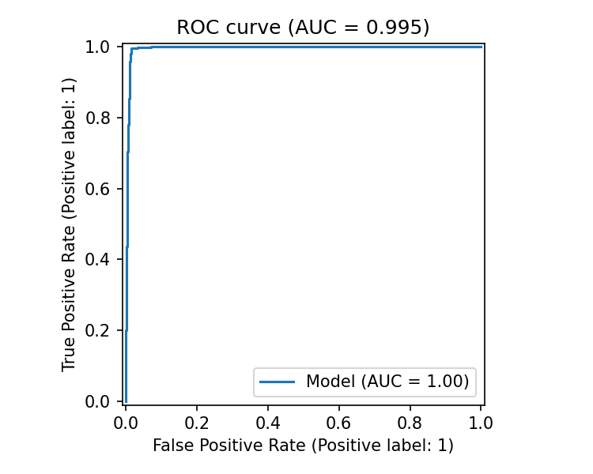
Figure 2. Confusion Matrix
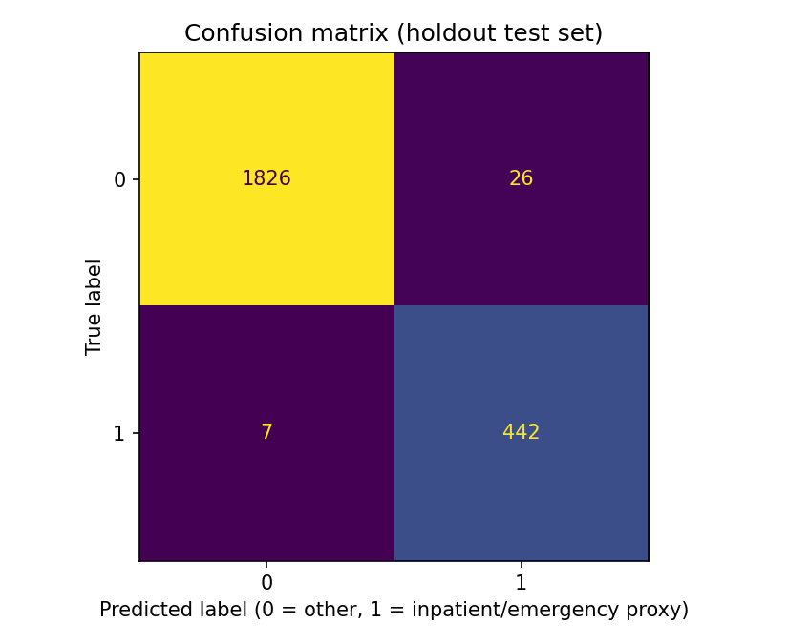
The model's ROC-AUC of approximately 0.995 indicates near-perfect class separation on the synthetic holdout data. The confusion matrix also shows a very low number of false negatives, which is important in an operational triage context because missed higher-risk encounters may be more costly than false alarms. At the same time, the unusually strong performance should be interpreted carefully. Because the underlying data is synthetic and the label is a proxy for acuity rather than a direct clinical outcome, the relationship between features and labels may be cleaner than would be expected in real hospital environments.

4.1 Generative Explanation Layer
To improve interpretability, model outputs were passed to an LLM layer that converted structured inputs into a short operational summary. This component improves usability by translating a probability score into a readable context. See a couple of examples below.
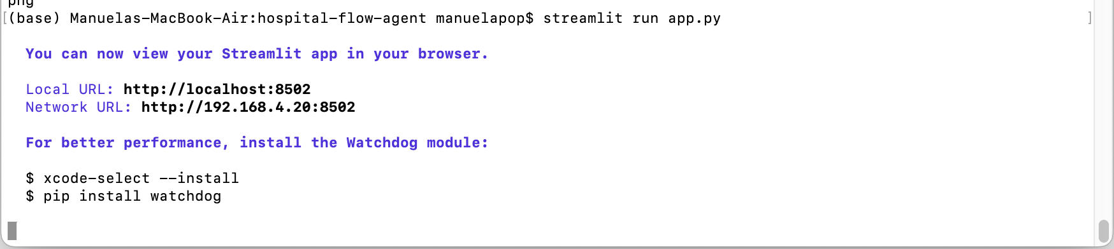

Example 1. No risk
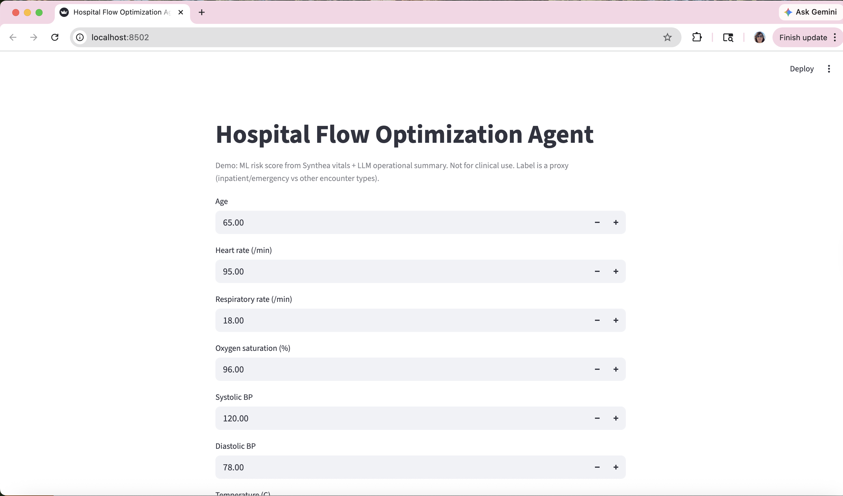
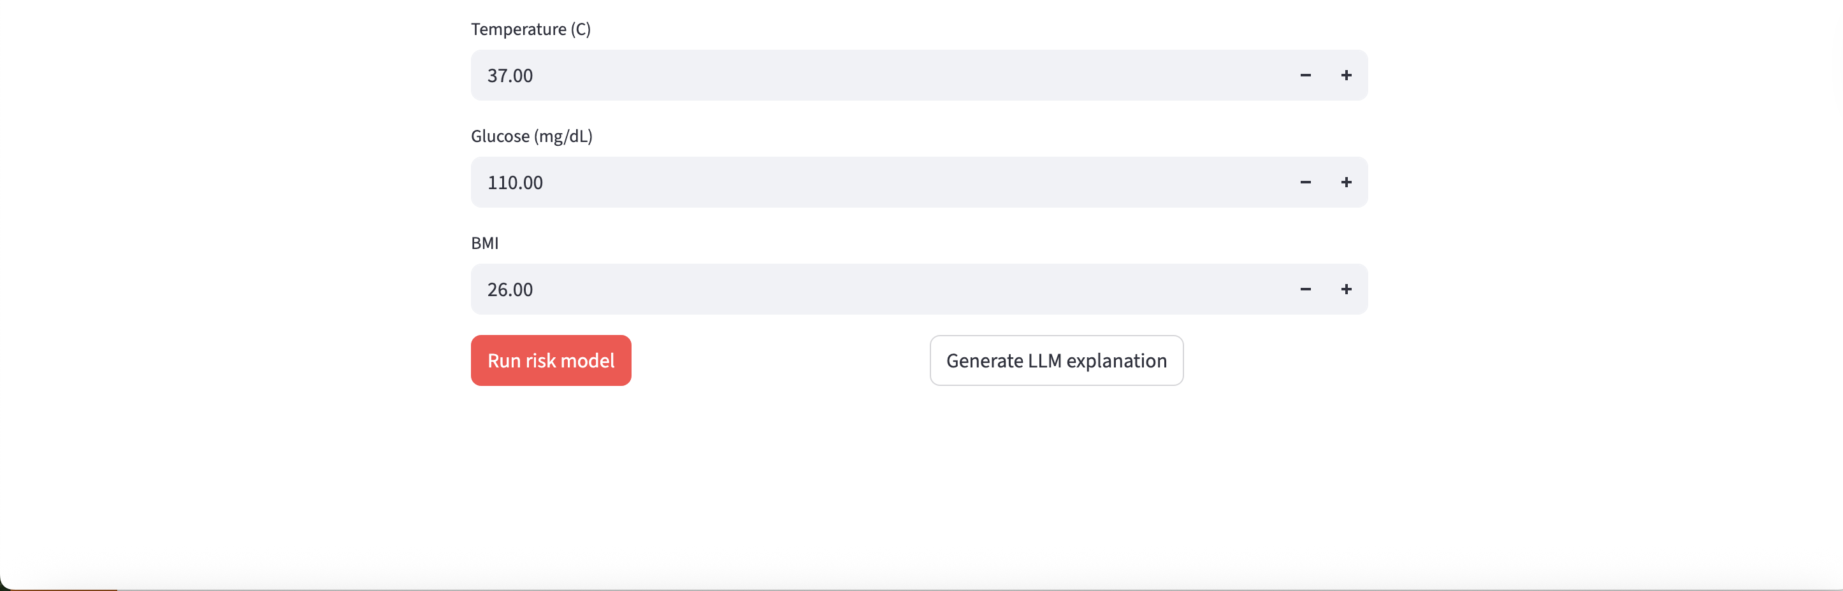
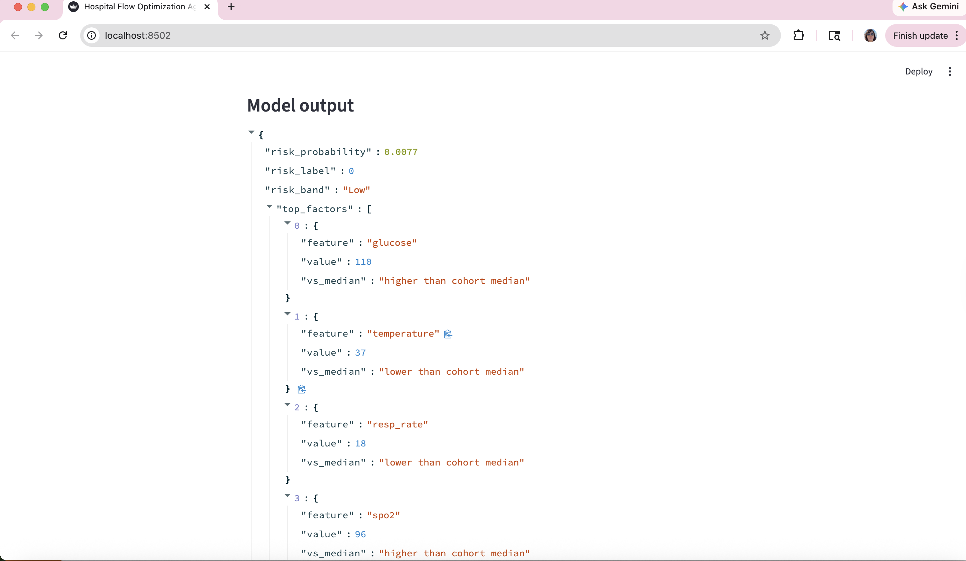

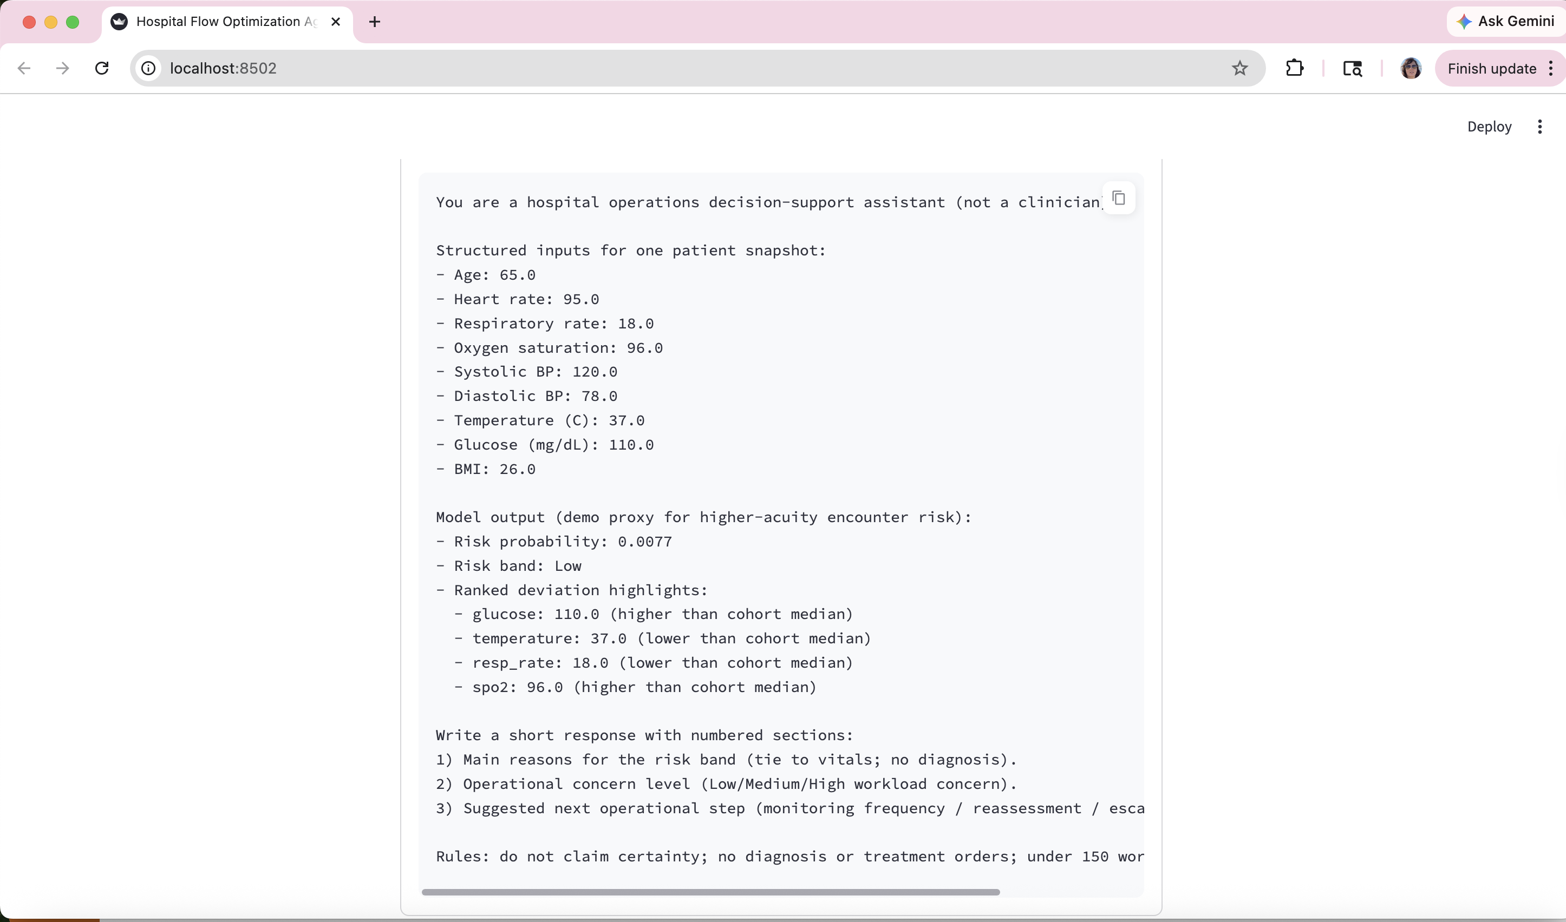
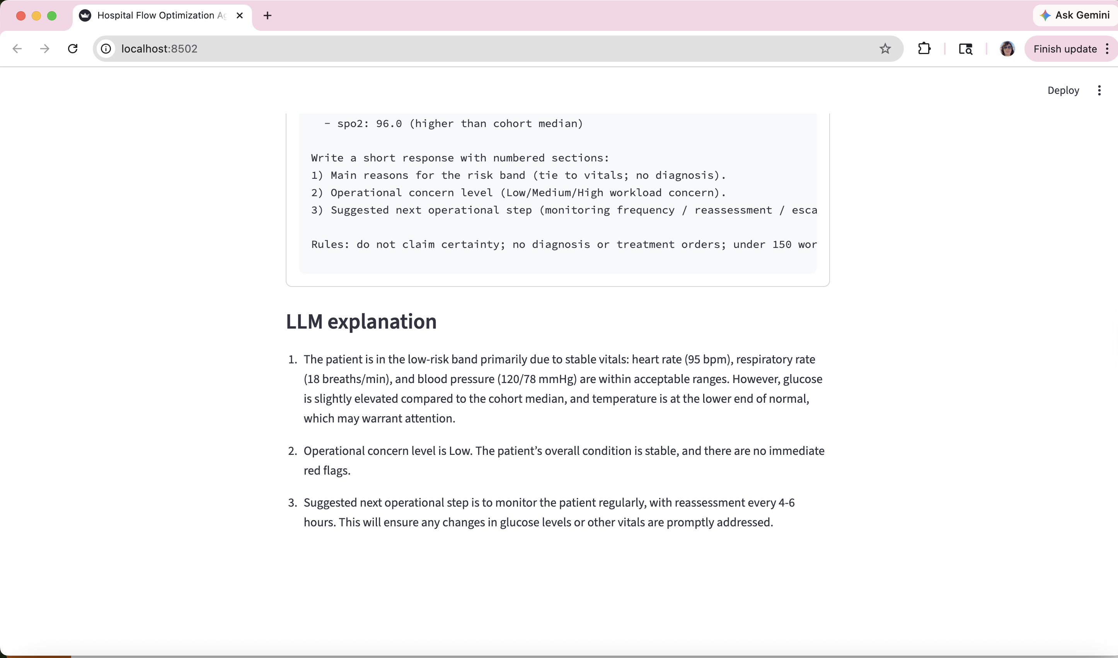

Example 2. High risk
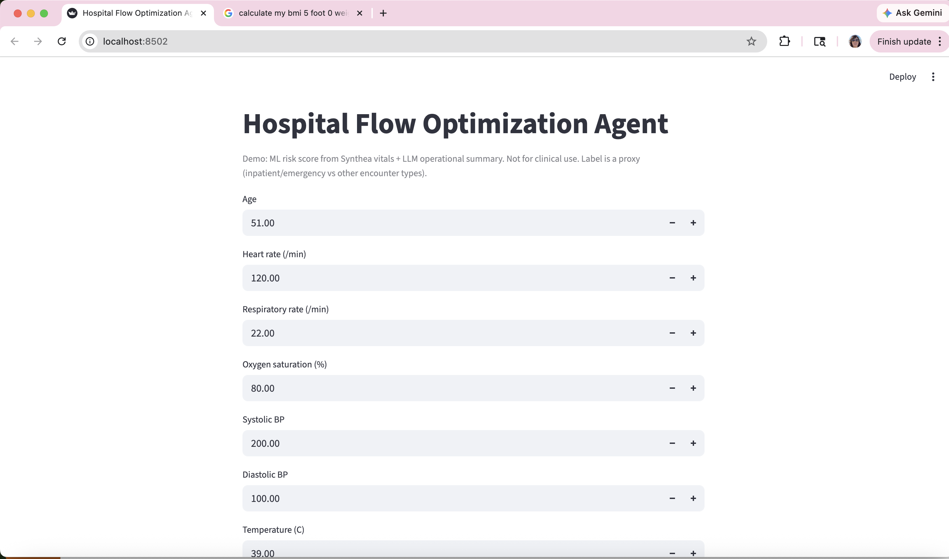

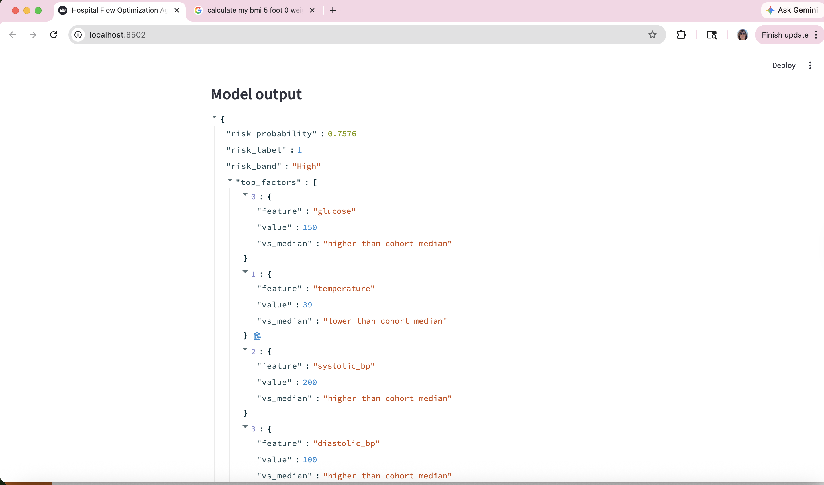

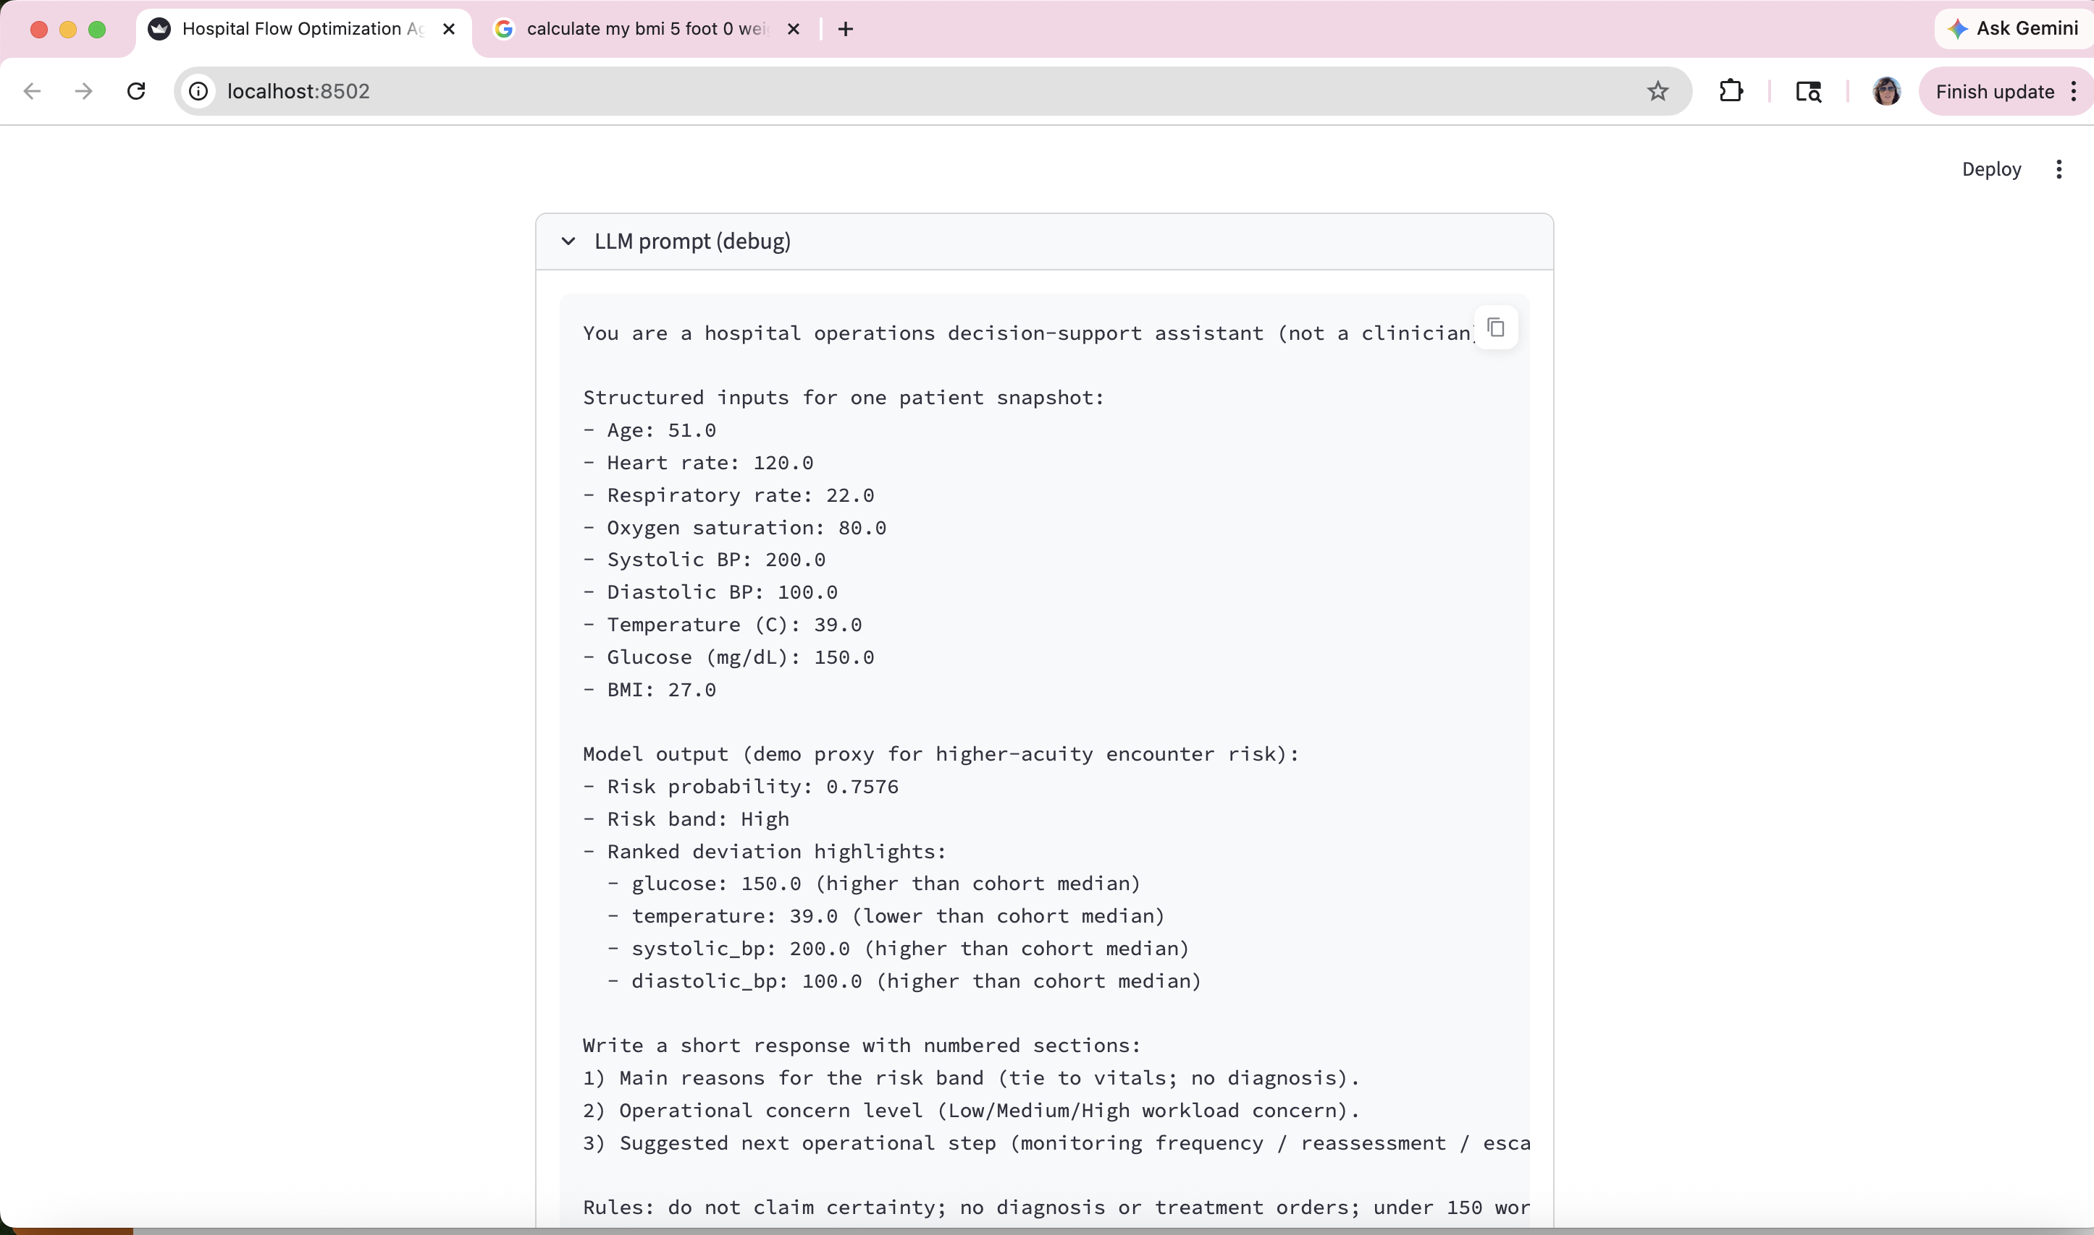
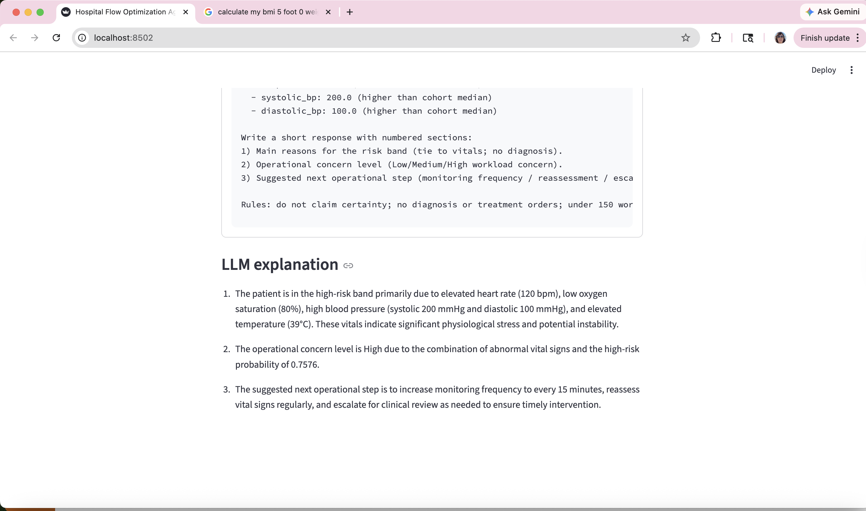

5. Conclusion
This project demonstrates a decision-support approach that combines structured machine learning with large language model explanation. Using synthetic EHR data from Synthea, the system engineers encounter-level features, predict a proxy acuity label with strong performance, and generate operational summaries intended to improve interpretability.
The work also has limitations. Because the dataset is synthetic and the target is a proxy label based on encounter type, the reported results should not be interpreted as evidence of clinical validity or deployment readiness. Future work should extend the system to real-world datasets such as MIMIC-III, replace proxy labels with clinically meaningful outcomes, and perform validation. These directions would provide a stronger foundation for evaluating whether the architecture could support real healthcare operations.

6. References
[1] A. E. W. Johnson, T. J. Pollard, L. Shen, L. H. Lehman, M. Feng, M. Ghassemi, B. Moody, P. Szolovits, L. A. Celi, and R. G. Mark, "MIMIC-III, a freely accessible critical care database," Scientific Data, vol. 3, no. 1, p. 160035, 2016.
[2] A. Rajkomar, E. Oren, K. Chen, A. M. Dai, N. Hajaj, M. Hardt, P. J. Liu, X. Liu, J. Marcus, M. Sun, et al., "Scalable and accurate deep learning with electronic health records," npj Digital Medicine, vol. 1, no. 1, pp. 1-10, 2018.
[3] E. J. Topol, "High-performance medicine: the convergence of human and artificial intelligence," Nature Medicine, vol. 25, no. 1, pp. 44-56, 2019.

