Capstone Project Problem Statement Form
Spring 2026

Please complete this form with as much detail as available and submit it, along with any questions, to Lauren Darga, ldarga@uchicago.edu, or Alison Ossyra, aossyra@uchicago.edu. We will review with instructors and staff and may coordinate a short conversation to refine the statement and discuss data readiness. Once the proposal is approved and matched to a student team, MS in Applied Data Science staff will make introductions to launch the project. For more details, review this Sponsor Guide.

Organization
Organization Name | Bank of Montreal (BMO)
Logo (include and/or attach) | 
Background/description/profile | BMO is a leading North American bank driven by our purpose: to Boldly Grow the Good in business and life. Our Purpose informs our strategy, drives our ambition, and reinforces our commitments to progress for a thriving economy, a sustainable future and stronger communities. BMO is the 7th largest bank in North America by assets, with $1.5 trillion in total assets and has been serving clients for 208 years.
Organization website | About BMO | Boldly Growing the Good in Business and Life
Has your organization sponsored an MS-ADS Capstone project before?  If yes, when, and was it the same topic, a continuation, or a new project? | No
Project
Title  Concise and descriptive | Predicting Macroeconomic Indicators with Classical and Quantum Enhanced Models
Statement of Work
Describe the project, business problem, or opportunity  What is most intriguing and compelling about this project for students? | BMO is interested in applying the latest technological advances to real world financial problems. Recent research has shown that Quantum Computers can be used to transform datasets to improve the performance of time series models. Quantum Reservoir Computing (QRC) and Signature Kernels with Quantum Features (QSK) are two similar techniques that both have been shown to increase the accuracy of models for specific forecasting applications. BMO wants to understand if and when each of these techniques can be used to model time series data with greater accuracy, or fewer resources than the classical state of the art.  To explore this technology, BMO is investigating new ways to forecast macro-economic trends. In particular, we are aim to extend this analysis which compares an assortment of classical approaches to a set of publicly available macroeconomic indicators. These predictions are used by analysts in BMO’s Wealth Management and Capital Market divisions to inform portfolio strategy and manage risk. Adopting new technology to provide a more accurate forecast could give BMO a competitive advantage, enabling them to be more prepared for the next downturn.  As an end-product, BMO is looking for an assessment of whether these techniques are viable in the near term, and a recommendation of when to explore QRC and QSK in the long term. To provide a good-faith benchmark, BMO expects a classical pipeline for recession prediction that is up to the industry standard.
Preferred student skill sets to help the project be successful  Click here to view MS-ADS curriculum | Python, High Performance Computing, GitHub, Machine Learning, Quantum Computing
Data
Critical requirement: Organization will need to allow access to, provision of, and review of data with team(s) by Monday, April 6 (week 2 of the Spring quarter).
Description | Monthly data from 1960 to present recording 134 macroeconomic indicators. We will aim to forecast the industrial production (IND-PRO), employment (PAYEMS), consumer price index (CPIAUCSL), and the S&P 500 index (S&P 500)
Source | Primary Source: FRED-MD database. All sources are publicly available with no subscription required.
Does the data currently exist?  If yes, how will it be shared?  If no, how/when will it be acquired, and how/when will it be accessible by the student team? | The data currently exists and is publicly available. Students can access it directly via FRED's web interface, API, or bulk download. The FRED-MD dataset is available as a downloadable CSV from the St. Louis Fed website.
How big is the data set?  How many rows/columns? Gigabytes? How many files? | • Rows: ~1000 monthly observations (1960–present).  • Columns: Choose relevant features from up to 134 available columns.  • Size: Typically <1 MB for core dataset; FRED-MD is ~170 KB zipped.  • Files: 1 CSV file for each feature
What is the nature of the data (does the data contain structured or unstructured elements? Is it time-series, signal-based, images, text, etc.)?  Please provide a sample of the data. | • Structured: 100% structured numerical data in tabular format  • Type: Time-series data at monthly frequency  • Format: CSV files with date index (MM-DD-YYY) and numeric columns  • No unstructured elements: No images, text, or signal data unless augmented with news sentiment features (optional extension)  Date USREC T10Y3M UNRATE PMI UMCSENT SP500_ret PERMIT LEI_chg  1978-06 0 1.23 5.9 53.2 87.4 0.012 1823 0.3  1978-07 0 1.15 6.0 52.8 85.1 -0.008 1756 -0.1  ... ... ... ... ... ... ... ... ...  2008-09 1 1.87 6.1 43.5 70.3 -0.089 782 -0.9
Will students be required to use any particular platform, environment, language, etc. to work with the data? | • Language: Python  • Quantum frameworks: Qiskit (IBM)  • Classical ML: scikit-learn, pandas, and NumPy for data processing  • Environment: Jupyter notebooks recommended; Anaconda distribution for package management  • Compute: Local development for initial work, IBM Quantum Processors through BMO’s instance for final results  • Version control: GitHub for code collaboration
Describe the available data documentation and attach a data dictionary if available. | • FRED: Each series on FRED includes detailed documentation (units, source agency, seasonal adjustment, release schedule). Available at https://fred.stlouisfed.org  • FRED-MD: McCracken & Ng (2016) paper provides full codebook with all 107 variables, transformation codes, and data construction methodology. Appendix available at St. Louis Fed website.  • NBER recession dates: Official chronology with peak/trough dates at https://www.nber.org/research/data/us-business-cycle-expansions-and-contractions
How will students access data?  Your network? Google Cloud or AWS? Downloaded to their own devices? Other? | Downloaded directly to students' own devices from public sources
Is a Non-Disclosure Agreement (NDA) required for the student team?  When required, students sign NDAs once assigned to the project. NDAs would apply only to students, as no data access is needed or given to instructors, advisors, staff, etc. | No. All data sources are publicly available government and central bank data (FRED, BLS, NBER, etc.). No proprietary BMO data will be used. Students will work exclusively with public macroeconomic datasets.
Expected Results
Deliverables, output, etc.  As a class assignment, students will complete a research paper and Showcase presentation; other deliverables may include models, plans, code, analysis, etc. | This project will create at least three predictive models for economic recessions:  - The best classical model that the students can build. This could be a linear model, machine learning, or time series model, that the students demonstrate to be the most accurate for this application.  - A signature kernel based model leveraging quantum features.  - A linear model that uses predictors transformed by a quantum reservoir  All code and trained models created for the project.
Capstone project descriptions may be used on program websites or in other materials. If you do not want your project included, please opt out by clicking the check box: ☐
Organization Contacts
Primary point of contact for the project
Name: Richard Padbury
Title: Director, Research and Ecosystems
Department: Research and Ecosystems
Work email address: Richard.Padbury@bmo.com
Work or cell phone number:
Primary point of contact for data (if different from the primary project contact)
Name:
Title:
Department:
Work email address:
Work or cell phone number:
Secondary contact(s)
Name: Guzman Calleja
Title: Manager
Department: Quantum Technologies
Work email address: Guzman.Calleja@bmo.com
Work or cell phone number:

Name: Rafael Martin-Cuevas
Title: Senior Manager
Department: Quantum Technologies
Work email address: Rafael.MartinCuevas@bmo.com
Work or cell phone number:
Project Timelines
Capstone projects span two academic quarters and conclude with a Showcase.

Most projects start in March, and students take a break over the summer to complete internships before concluding in December, with the Showcase on Saturday, December 5, 2026, following this timeline:
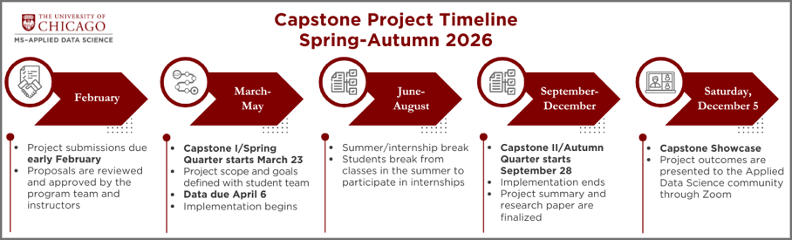
A smaller number of students forego an internship; in those cases, projects start in March and conclude in August, with the Showcase on Saturday, August 15, 2026, following this timeline:
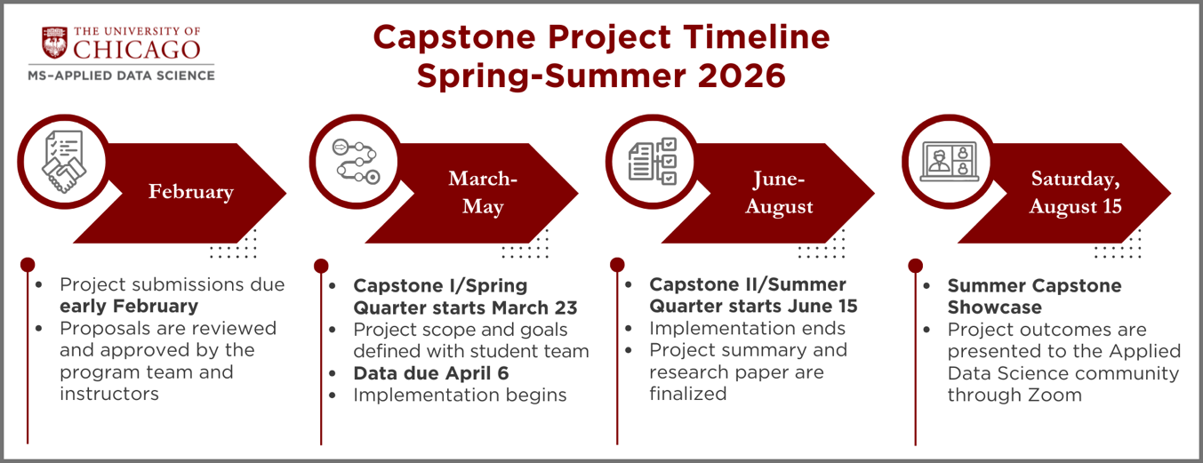

Although not guaranteed, please indicate if you have a project timeline preference  No preference, Autumn, or Summer | Autumn
Student Proposed Project
If this is a Student Proposed project, list all team members | For each team member, identify each member’s CNet and program modalities (full time or part time, in-person or online)
Student 1: Jack Morgan  Student 2: David Giger  Student 3: Manuel Arce Aguirre  Student 4: Zihang Niu | Student 1: jhmorgan, full time, in-person  Student 2: digger, full time, in-person  Student 3: arceaguirrem, full time, in-person  Student 4: william03niu, full time, in-person
MS in Applied Data Science Internal Use
Proposal reviewed and approved by
Date approved

