The Research Footprint of Global EHR-Linked Biobank Initiatives
Manuel Corpas^{1,2,3,4}, Segun Fatumo^{5,6}
¹School of Life Sciences, University of Westminster, London, UK
²UNIR Health Sciences School, Universidad Internacional de La Rioja (UNIR), Madrid, Spain
³The Alan Turing Institute, London, UK
⁴Cambridge Precision Medicine, London, UK
⁵African Computational Genomics (TACG) Research Group, MRC/UVRI and LSHTM Uganda Research Unit
⁶Precision Health University Research Institute, Queen Mary University of London, London, UK

*Corresponding author: m.corpas@westminster.ac.uk

Abstract
Keywords:

Introduction
The convergence of large-scale population genomics, electronic health records (EHRs), and biobanking infrastructure has fundamentally transformed biomedical research over the past two decades ^{1,2}. Electronic health record-linked biobanks represent a paradigm shift from traditional epidemiological studies toward comprehensive, longitudinal platforms that integrate genetic, clinical, environmental, and lifestyle data at unprecedented scale ^{3–5}. These initiatives have emerged as critical infrastructure for precision medicine, enabling researchers to interrogate complex disease mechanisms, validate therapeutic targets, and develop predictive models across diverse populations and phenotypes ^{6–8}.
Major EHR-linked biobank initiatives worldwide include the UK Biobank ^{9,10}, the Million Veteran Program (MVP) ¹¹, FinnGen ¹², the All of Us Research Program ^{13,14}, and the Estonian Biobank ¹⁵. These biobanks have each adopted distinct approaches to data collection, participant recruitment, and research access policies. Despite their shared foundation in linking genomic data with longitudinal health records, they differ substantially in their demographic composition, phenotyping strategies, data-sharing frameworks, and institutional mandates. The UK Biobank has pioneered open-access models and deep phenotyping through imaging and environmental monitoring ¹⁰, while initiatives like All of Us prioritize diversity and health equity ¹⁶, and specialized programs like MVP focus on veteran populations with unique exposure profiles.
The scientific impact of these biobanks has grown exponentially ^{17–19}, generating thousands of publications across disciplines ranging from genomic epidemiology to environmental health. However, the rapid proliferation of biobank-enabled research has made it increasingly difficult to comprehensively assess the thematic landscape, identify research priorities, and understand how different biobanks contribute to distinct areas of biomedical knowledge. Traditional bibliometric approaches often fail to capture the semantic complexity of biobank research, which spans multiple methodological frameworks, disease domains, and population contexts.
Understanding the research footprint of global biobank initiatives is crucial for several reasons. First, it enables funding agencies and research institutions to identify gaps and opportunities in the biobank research ecosystem. Second, it helps researchers navigate the complex landscape of available resources and identify the most appropriate biobank for specific research questions. Third, it provides insights into how different design philosophies and access policies translate into research outputs and thematic focus. Finally, comprehensive mapping of biobank research can inform future biobank development and highlight emerging areas of scientific convergence or divergence.
Previous efforts to characterize biobank research have typically focused on single initiatives or specific disease domains (e.g., ^{20,21}), leaving gaps in our understanding of the broader ecosystem. Moreover, existing analyses may not necessarily capture the full semantic complexity of biobank research themes. However, with the advent of advanced computational methods for semantic analysis (including medical subject heading (MeSH) term clustering and dimensionality reduction techniques), new opportunities arise to systematically identify latent thematic structures within global EHR-linked biobanks.
In this study, we present a comprehensive, semantics-based review of the research footprint of the UK Biobank, the Million Veteran Program (MVP), FinnGen, the All of Us Research Program, and the Estonian Biobank. We chose these five EHR-linked biobanks for their recognized global biomedical research impact. We retrieved 14,142 peer-reviewed publications spanning 2000 to 2024, employing automated MeSH term extraction, TF-IDF vectorization, and unsupervised clustering to reveal distinct research signatures within those biobanks. Our approach uncovers the semantic architecture of all published research involving these resources, and suggests major trends on how each contributes to methodological, disease-focused, and population-specific research domains.
We show that while biobank initiatives share common genomic epidemiology foundations, they exhibit markedly different thematic profiles that reflect their institutional mandates, participant characteristics, and data access policies. The UK Biobank shows the broadest thematic coverage, spanning environmental epidemiology, neuroimaging, and complex trait genetics. FinnGen prioritizes genomic epidemiology and molecular trait analysis, while All of Us emphasizes diversity, EHR integration, and pandemic response. The Estonian Biobank focuses on regulatory genomics and cardiometabolic traits, and MVP concentrates on veteran-specific health conditions and military exposures.
Our findings provide quantitative evidence for the complementary nature of global biobank initiatives and highlight both converging methodological approaches and diverging thematic priorities. This analysis offers a foundation for understanding how the biobank ecosystem collectively advances biomedical knowledge while serving distinct research communities and addressing specific population health needs.

Methods

Biobank Data Retrieval
To construct a comprehensive and unbiased dataset of biobank-related research publications, we performed an automated retrieval of PubMed-indexed articles spanning the years 2000 to 2024. We focused on five major global biobanks (UK Biobank, Million Veteran Program, FinnGen, All of Us, and the Estonian Biobank) and conducted dedicated searches for each using biobank-specific name variants and known aliases. Each search query included only the biobank name and a publication date constraint, without thematic filters, to ensure maximum recall. For each biobank, the full set of PubMed IDs (PMIDs) matching the query was retrieved and parsed in batches. Metadata for each article (including PubMed ID, title, abstract, journal, publication year, and MeSH terms) was extracted and stored.
Articles were included in the final dataset if they contained MeSH term annotations and were associated with one or more of the target biobanks. To ensure compatibility with downstream semantic clustering and bibliometric analyses, we excluded preprints and retained only articles from fully published sources. Each article was duplicated across biobanks if it mentioned more than one; a deduplicated version of the dataset was also generated based on unique PMIDs.
This data retrieval strategy resulted in a corpus of 14,142 peer-reviewed publications with MeSH annotations, each linked to at least one of the target biobanks. This dataset forms the basis for all subsequent analyses, including research trend tracking, MeSH term frequency analysis, and semantic clustering.

Temporal and Thematic Analysis of Biobank-Linked Publications
We analyzed the curated dataset of biobank-related publications to characterize temporal trends, thematic priorities, and publication patterns across the five biobanks. All analyses were restricted to peer-reviewed, PubMed-indexed articles from 2000 to 2024.
We next conducted a MeSH term frequency analysis, identifying the top 10 most common MeSH terms used in publications for each biobank. These terms were analyzed to highlight distinct thematic profiles. Journal-level trends were similarly analyzed, and the most frequent publication venues were identified and displayed for each biobank and for non-UK Biobank resources combined. These outputs integrate publication trends, cumulative volume, year distributions, and summary statistics.

MeSH-Based Semantic Embedding and Clustering of Biobank Publications
To capture the semantic structure of biobank-linked research, we developed a pipeline that converts MeSH annotations into high-dimensional embeddings for unsupervised clustering. Unlike large language models, which operate on free-text diagnostics, our approach leverages structured metadata (MeSH terms) to reveal latent thematic groupings within and across biobanks.

TF-IDF Vectorization of MeSH Terms
To quantify the semantic content of each publication, we employed Term Frequency-Inverse Document Frequency (TF-IDF) vectorization of MeSH terms. TF-IDF is a numerical weighting scheme that reflects how characteristic a term is to a specific document within a larger corpus. The method assigns higher weights to terms that appear frequently in individual publications (high term frequency) but rarely across the entire dataset (high inverse document frequency), thereby identifying MeSH terms that are distinctive to specific research themes or methodological approaches.
For biobank research analysis, TF-IDF enables the identification of MeSH terms that define unique research signatures; terms like "neuroimaging" or "military personnel" that may be highly characteristic of certain biobank studies but uncommon in the broader literature. This approach transforms each PubMed publication into a high-dimensional vector where dimensions correspond to MeSH terms, and values reflect the semantic importance of each term to that specific study.
Here each publication's MeSH terms were preprocessed by converting to lowercase, removing punctuation, and replacing spaces with underscores (e.g., Genome-Wide Association Study → genomewide_association_study). Special characters were removed, and terms were split by semicolons into tokenized, deduplicated documents. Each biobank's corpus was treated separately to preserve biobank-specific vocabularies and research emphases. Terms were included in the vocabulary only if they appeared in at least 2 but no more than 80% of documents, filtering out both extremely rare terms (likely noise) and overly common terms (lacking discriminative power). The resulting TF-IDF matrices were limited to a maximum of 1000 unigram and bigram features per biobank to maintain computational tractability while preserving semantic richness.

Independent Clustering per Biobank
Given that each biobank reflects a distinct research community with unique MeSH term distributions, clustering was performed independently. We applied the following sequential steps:
- Optimal K Determination via Bootstrapped Silhouette Scoring: For each biobank, we used bootstrapped sampling to determine the optimal number of clusters (K). In each of 50 iterations, a random subset of publications was clustered for values of K ranging from 2 to 10, and silhouette scores were computed. The K that achieved the highest mean silhouette score was selected.
- K-Means Clustering: Once K was selected, we performed k-means clustering on the full TF-IDF matrix, assigning each publication to a semantic cluster. These clusters represent thematic groupings of research based on MeSH term similarity.

Cluster Interpretation via c-DF-IPF and Semantic Summaries
To characterize each cluster, we computed cluster-based Document Frequency-Inverse Document Frequency (c-DF-IDF) scores, adapted from the TF-IDF framework. For each MeSH term:
- DF was defined as the proportion of publications in the cluster containing the term.
- IDF was the log ratio of total documents in the biobank to the number of documents containing that term.
- The c-DF-IDF score was calculated as the product of DF and IDF, emphasizing terms that were frequent in one cluster but uncommon elsewhere within the same biobank. We selected the top five c-DF-IDF terms to summarize each cluster's vocabulary.
In parallel, we generated semantic summaries by averaging TF-IDF vectors across all publications within each cluster. The highest-weighted terms in these mean vectors were extracted as dominant semantic descriptors.

2D Projection and Visual Comparison of Clusters
To visualize relationships between clusters, we projected the cluster centroids (mean TF-IDF vectors) into two dimensions using both PCA and UMAP. These low-dimensional projections preserve semantic proximity, enabling intuitive interpretation of thematic overlap. Clusters located close together in 2D space tend to share overlapping MeSH vocabularies, while distant clusters reflect distinct research foci.

Results

Biobank Research Output Growth Reflects Rapid Expansion
To contextualize the thematic clustering results, we first examined overall publication trends across five major global biobanks from 2000 to 2024, focusing exclusively on peer-reviewed, PubMed-indexed articles with validated MeSH annotations. A total of 14,142 published articles were retained for analysis following a multi-step curation process that excluded preprints, duplicates, and the year 2025 (due to incompleteness at the time of writing). Preprints accounted for only 3.5% of the initial dataset (513 out of 14,655 records; Supplementary Figure S1A), with the majority sourced from medRxiv and bioRxiv (Supplementary Figure S1B).
Figure 1A presents publication trajectories for each biobank over time. The UK Biobank stands out with a steep and sustained increase beginning around 2015, surpassing 3,000 peer-reviewed articles annually by 2024. This trajectory reflects the combined effect of early public data releases, widespread institutional adoption, and extensive downstream reuse. FinnGen, although more recently launched, displays the most rapid post-2020 growth, consistent with its integrative model linking genomic and registry data. In contrast, All of Us, the Estonian Biobank, and the Million Veteran Program show flatter growth curves, with lower but steady annual outputs.
Figure 1B summarises total publication volume by biobank. UK Biobank accounts for more than 75% of the analyzed literature (10,752 articles), followed by FinnGen (1,806), Estonian Biobank (663), All of Us (535), and Million Veteran Program (386). These figures suggest that publication disparities stem not only from differences in cohort size or launch date but also from broader ecosystem effects; including funding models, open data practices, and global network engagement.
Figure 1C aggregates total publications across all five biobanks and reveals a dramatic acceleration in output from 2018 onward. This inflection point coincides with the wider availability of large-scale genomic data and increased use of AI and machine learning tools in biomedical research. These technologies have likely lowered analytic barriers and increased the appeal of biobank-scale data among new research constituencies.
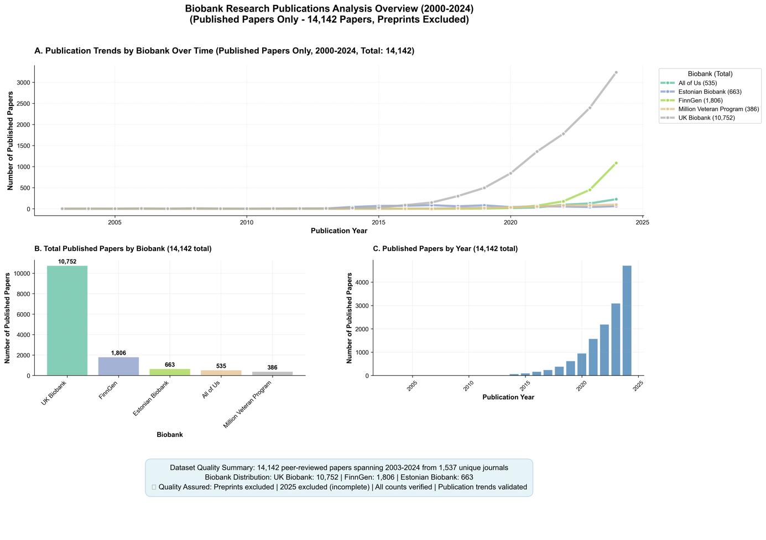
Figure 1. Growth and Distribution of Peer-Reviewed Publications Linked to Global EHR-Linked Biobanks (2000-2024). (A) Year-by-year publication counts by biobank show sharp acceleration in biobank-linked research after 2018, with UK Biobank leading in both volume and growth rate. FinnGen displays the most rapid post-2020 rise among newer initiatives. (B) Total number of peer-reviewed, PubMed-indexed publications by biobank, excluding preprints and records from 2025. (C) Aggregate publication output per year across all five biobanks.
A biobank-specific view of these publication trajectories is shown in Supplementary Figure 2, which breaks down annual output into individual contributions. The UK Biobank consistently dominates the overall trend, but the contribution of FinnGen has grown considerably since 2021. Meanwhile, All of Us and MVP contribute smaller but steady publication volumes, with thematic distinctiveness shaped by their mandates in health equity and veteran health, respectively. These results reveal a field in the midst of rapid expansion, yet marked by unequal visibility across biobanks.

Decoding Biobank Themes Through MeSH Term Frequencies
To further understand the scientific focus of biobank-driven research, we analyzed the distribution of MeSH terms associated with published articles from each biobank. Figure 2 presents the top 10 most frequently occurring MeSH terms for each biobank, capturing the dominant biomedical themes, population descriptors, and methodological constructs that define their respective research landscapes.
Across all biobanks, the term “Humans” was the most frequently assigned descriptor, appearing in 8879 articles from UK Biobank and in over 300 publications from each of the others. This universal label reflects the default indexing of studies involving human participants and serves as a baseline for comparative interpretation. Consistent across all initiatives, sex- and age-based demographic tags such as “Female,” “Male,” “Middle Aged,” and “Aged” also appear prominently, underscoring a shared emphasis on stratified population analyses.
UK Biobank’s top terms (Figure 2, top left) reflect both methodological and institutional specificity. In addition to “Humans” and sex-based terms, UK Biobank research is heavily indexed with “United Kingdom,” “Biological Specimen Banks,” “Risk Factors,” and “Genome-Wide Association Study”; the latter aligning with its foundational role in common variant discovery. The presence of “Biological Specimen Banks” as a top-10 term uniquely underscores UK Biobank’s role as a reference infrastructure as well as a data source.
FinnGen (Figure 2, top right) exhibits a distinct methodological tilt, with “Mendelian Randomization Analysis” among its most frequent terms (more than 1000 articles) highlighting its contribution to causal inference frameworks. Other frequent tags include “Genome-Wide Association Study,” “Polymorphism, Single Nucleotide,” and “Genetic Predisposition to Disease,” aligning with its registry-linked design for genotype-to-phenotype discovery. The inclusion of “Gastrointestinal Microbiome” is noteworthy, suggesting emerging interest in host-microbiome interactions.
All of Us (Figure 2, bottom left) presents a more socioclinical profile. In addition to standard demographic terms, high-frequency MeSH annotations include “United States,” “Population Health,” “Cross-Sectional Studies,” and “Young Adult.” This pattern reflects the program’s emphasis on representation, diversity, and broad EHR-based phenotyping in younger and underserved populations. Notably, “Genome-Wide Association Study” is absent from the top 10, suggesting relatively less genomic emphasis in published outputs to date.
The Estonian Biobank (Figure 2, bottom center) aligns more closely with FinnGen in its top MeSH terms, with frequent annotation of “Genome-Wide Association Study,” “Polymorphism, Single Nucleotide,” and “Phenotype.” These terms reinforce Estonia’s long-standing investment in population-scale genetics and integrative omics, albeit at lower publication volume.
The Million Veteran Program (Figure 2, top center) exhibits a unique institutional signature. In addition to genetic terms, “Veterans” appears among the top descriptors, reflecting the biobank’s mission and participant base. The co-occurrence of “Genome-Wide Association Study,” “Risk Factors,” and “Genetic Predisposition to Disease” alongside “Veterans” suggests a convergence of genomics and military-linked population health.
For comparison, Figure 2 (bottom right) presents the top MeSH terms aggregated across all non-UK biobanks (otherwise UK Biobank terms would dominate due to its much greater volume). While MeSH terms in non-UK biobanks echo the prevalence of human, sex, and genetic descriptors, the overall frequency is markedly lower, and terms related to specimen infrastructure or environmental exposure are notably absent. This contrast illustrates how the UK Biobank has not only scaled publication output but has also broadened its thematic reach, incorporating environmental epidemiology and infrastructure-focused research.
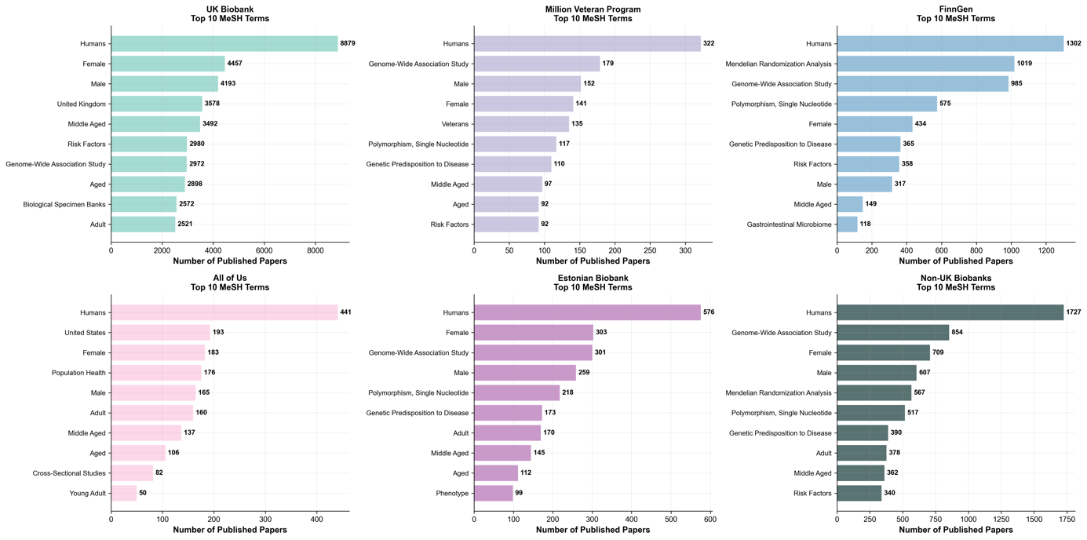
Figure 2. Most Frequently Occurring MeSH Terms Across Global EHR-Linked Biobanks (2000–2024). Bar plots showing the top 10 Medical Subject Headings (MeSH) terms by frequency for each of five biobanks (UK Biobank, Million Veteran Program, FinnGen, All of Us, and Estonian Biobank) as well as for all non-UK biobanks combined. Terms were extracted from peer-reviewed, PubMed-indexed articles and reflect high-level descriptors of study focus, population characteristics, and methodological orientation.

Semantic Clustering Reveals Biobank-Specific Research Signatures
To investigate the thematic composition of publications linked to the five major biobank initiatives analysed here, we applied unsupervised clustering to MeSH term profiles extracted from the 14,142 PubMed-indexed articles. Each biobank was analyzed independently to preserve its distinct research identity, and clustering was performed using a TF-IDF representation of MeSH terms, followed by bootstrap-based selection of the optimal number of clusters (K=10) and k-means clustering. To aid interpretation, we projected the high-dimensional term vectors onto a two-dimensional space using principal component analysis (PCA). The resulting visualization highlights the spatial arrangement and density of semantic clusters for each biobank (Figure 3), with clusters varying in compactness and dispersion according to the biobank's thematic breadth.
UK Biobank Shows the Most Heterogeneous and Structurally Complex Landscape
Among all biobanks analyzed, the UK Biobank exhibited the most extensive semantic spread, consistent with its large publication volume (10,752 articles). The first principal component accounted for 34.2% of the variance, revealing a broad distribution of thematic clusters across the research space. Clusters varied markedly in size and content. A prominent cluster was enriched for publications involving Mendelian randomization analysis, reflecting a methodological focus on causal inference in observational data. Another cluster was characterized by terms such as “risk factors,” “prospective studies,” and “type 2 diabetes,” suggesting an emphasis on epidemiological profiling and longitudinal cohort studies. A distinct neuroimaging cluster was defined by MeSH terms including “brain,” “magnetic resonance imaging,” and “white matter,” underscoring UK Biobank’s unique subcohort of imaging participants. A further cluster focused on environmental exposures, notably “air pollution” and “particulate matter,” revealing an emerging research theme centered on environmental determinants of health.
FinnGen Prioritizes Genomic Epidemiology and Molecular Traits
The publication profile of FinnGen (1,806 articles) revealed a moderately dispersed clustering structure, with the first principal component explaining 21.2% of the variance. The largest clusters were defined by MeSH terms relating to genome-wide association studies and Mendelian randomization, consistent with FinnGen’s foundational focus on leveraging genotype-phenotype associations across the Finnish population. Additional clusters highlighted the integration of multi-omics approaches, with terms such as “microbiome,” “DNA methylation,” and “quantitative trait loci” occurring at high semantic weight. Research on maternal health emerged as a separate thematic grouping, with clusters centered on pregnancy, preeclampsia, and associated female health conditions.
Estonian Biobank Emphasizes Regulatory Genomics and Cardiometabolic Traits
Publications from the Estonian Biobank (663 articles) formed relatively tight clusters, indicative of a well-defined research scope. The first principal component explained 21.1% of the variance. Several clusters were strongly associated with cardiometabolic traits, including obesity, body mass index, and type 2 diabetes. Other clusters were anchored by terms such as “gene expression regulation,” “transcriptome,” and “genotype,” reflecting the biobank’s contributions to population-scale regulatory genomics. Interestingly, one cluster revealed a life-course focus, with terms such as “infant,” “adolescent,” and “multifactorial inheritance,” suggesting a niche interest in pediatric or developmental traits within the Estonian Biobank literature.
All of Us Concentrates on Diversity, EHR Integration, and Pandemic Response
The All of Us research corpus (535 articles) displayed compact cluster structures, with a high proportion of explained variance in the first principal component (33.6%), despite the smaller publication count. Clusters revealed a focus on both foundational genetic studies and broader health equity topics. A genomics-oriented cluster centered on terms such as “genomewide association study” and “genetic predisposition to disease.” Another cluster was defined by terms including “COVID-19,” “SARS-CoV-2,” and “electronic health records,” indicative of rapid research mobilization during the pandemic. Additional clusters captured themes related to population health, minority groups, and cross-sectional studies, reinforcing the program’s stated aim of enabling inclusive biomedical discovery through diverse cohorts and EHR data integration.
Million Veteran Program Features Veteran-Specific Pathologies and Risk Profiles
Despite comprising the fewest publications (386 articles), the Million Veteran Program displayed a distinctive semantic footprint. The first principal component explained 17.7% of the variance, reflecting a somewhat flatter cluster structure relative to the other biobanks. Thematic clusters included genetic epidemiology of lipid traits, such as triglycerides and HDL cholesterol, and Mendelian randomization studies. A separate cluster focused on kidney function and included high-weight terms such as “renal insufficiency, chronic” and “APOL1,” the latter being of particular relevance to African American veterans. Another uniquely MVP-related cluster included terms such as “military personnel,” “brain injuries, traumatic,” and “Gulf War,” pointing to the biobank’s research specialization in veteran health outcomes and service-related exposures.
Converging and Diverging Themes in Global Biobank Research
Across all five biobanks, genome-wide association studies, single nucleotide polymorphisms, and genetic predisposition to disease appeared as dominant MeSH terms within high-weight clusters, reflecting the shared methodological core of genomic epidemiology. However, the distribution of additional themes revealed notable divergences. UK Biobank exhibited the broadest coverage, with substantive clusters in neuroimaging and environmental health. All of Us and MVP publications reflected their demographic focus and institutional priorities through clusters centered on equity, veterans’ health, and EHR-based phenotyping. FinnGen and the Estonian Biobank emphasized classical and regulatory genomics, respectively, suggesting a concentration on discovery-driven trait mapping.
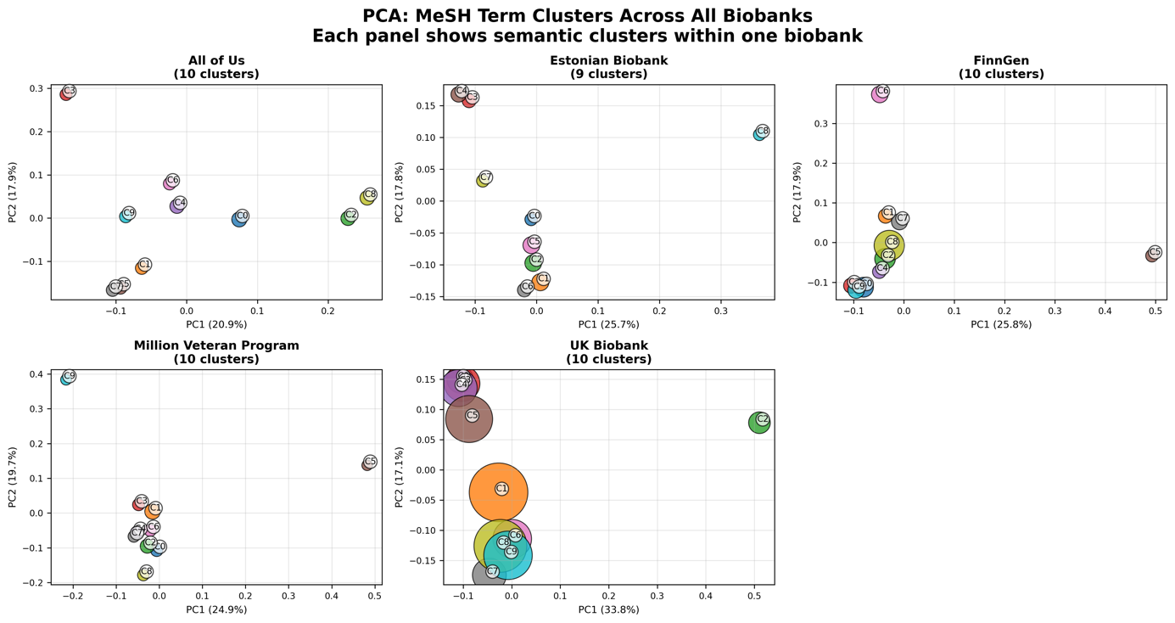
Figure 3. Semantic cluster composition by biobank. Principal component analysis (PCA) plots showing MeSH-based semantic clusters for five major biobanks: All of Us, Estonian Biobank, FinnGen, Million Veteran Program, and UK Biobank. Each panel represents one biobank and displays ten clusters identified through TF-IDF-weighted MeSH term embeddings and k-means clustering (K=10). Axes represent the first two principal components of the MeSH term vector space, with variance explained by PC1 and PC2 labeled on each plot. Circle size is proportional to the number of publications in each cluster. Distinct separation and density patterns reflect differences in research thematic breadth and structure across biobanks.

Discussion

Conclusions

Funding

Code Availability
All the data and code developed for this research are publicly available in the GitHub repository https://github.com/manuelcorpas/17-EHR. The repository provides Python scripts for data preprocessing, contrastive embedding, unsupervised clustering, and PCA/UMAP visualization, along with instructions for replicating each step. The CSV files generated from the PubMed retrieval search which then becomes the basis for this analysis is also available. Licensed under the MIT License, the code may be freely used and adapted for academic or other purposes, thereby promoting reproducible research and collaborative improvement of the pipeline.

References

Supplementary Materials

