The Research Footprint of Global EHR-Linked Biobanks
Manuel Corpas^{1,2,3,4}, Oyesola Ojewunmi⁵, Heinner Guio⁶, Segun Fatumo^{5,7}
¹School of Life Sciences, University of Westminster, London, UK
²UNIR Health Sciences School, Universidad Internacional de La Rioja (UNIR), Madrid, Spain
³The Alan Turing Institute, London, UK
⁴Cambridge Precision Medicine, London, UK
⁵Precision Health University Research Institute, Queen Mary University of London, London, UK
⁶INBIOMEDIC Research and Technological Center, Lima, Peru
⁷African Computational Genomics (TACG) Research Group, MRC/UVRI and LSHTM Uganda Research Unit

*Corresponding authors: m.corpas@westminster.ac.uk, s.fatumo@qmul.ac.uk

Abstract
Electronic health record (EHR)-linked biobanks have transformed biomedical research by enabling population-scale studies that integrate genomic, clinical, and phenotypic data. Yet as these resources proliferate, it remains unclear how well their research outputs reflect thematic breadth or align with global health priorities. In this review, we present a comprehensive analysis of the research footprint of five globally prominent EHR-linked biobanks: UK Biobank, the Million Veteran Program (MVP), FinnGen, the All of Us Research Program, and the Estonian Biobank. Drawing on 14,142 peer-reviewed publications from 2000 to 2024, we combine MeSH term frequency analysis with unsupervised semantic clustering to map the conceptual structure of biobank-enabled research. Each biobank displays a distinct thematic profile, shaped by institutional mandates, population focus, and methodological design. UK Biobank exhibits the broadest semantic range, while MVP and All of Us occupy unique niches rooted in veteran and equity-focused research, respectively. We further evaluate alignment with global disease burden by mapping biobank-linked publications to 25 high-priority disease areas using DALY, mortality, and prevalence data. Our burden-adjusted gap scores and opportunity indices reveal striking underrepresentation of conditions such as malaria, tuberculosis, and diarrheal diseases. These findings expose structural asymmetries in research attention and suggest practical metrics for guiding future biobank investments, cross-biobank coordination, and equitable coverage of global health priorities.
Keywords: UK Biobank; Million Veteran Program (MVP); FinnGen; All of Us Research Program; Estonian Biobank; EHR-linked biobanks; semantic clustering; MeSH terms; TF-IDF; global disease burden; DALYs; research gap analysis; biomedical data science; precision medicine; population genomics.

Introduction
The convergence of large-scale population genomics, electronic health records (EHRs), and biobanking infrastructure has fundamentally transformed biomedical research over the past two decades ^{1,2}. Electronic health record-linked biobanks represent a paradigm shift from traditional epidemiological studies toward comprehensive, longitudinal platforms that integrate genetic, clinical, environmental, and lifestyle data at unprecedented scale ^{3–5}. These initiatives have emerged as critical infrastructure for precision medicine, enabling researchers to interrogate complex disease mechanisms, validate therapeutic targets, and develop predictive models across diverse populations and phenotypes ^{6–8}.
Major EHR-linked biobank initiatives worldwide include the UK Biobank ^{9,10}, the Million Veteran Program (MVP) ¹¹, FinnGen ¹², the All of Us Research Program ^{13,14}, and the Estonian Biobank ¹⁵. These biobanks have each adopted distinct approaches to data collection, participant recruitment, and research access policies. Despite their shared foundation in linking genomic data with longitudinal health records, they differ substantially in their demographic composition, phenotyping strategies, data-sharing frameworks, and institutional mandates. The UK Biobank has pioneered open-access models and deep phenotyping through imaging and environmental monitoring ¹⁰, while initiatives like All of Us prioritize diversity and health equity ¹⁶, and specialized programs like MVP focus on veteran populations with unique exposure profiles.
The scientific impact of these biobanks has grown exponentially ^{17–19}, generating thousands of publications across disciplines ranging from genomic epidemiology to environmental health. However, the rapid proliferation of biobank-enabled research has made it increasingly difficult to comprehensively assess the thematic landscape, identify research priorities, and understand how different biobanks contribute to distinct areas of biomedical knowledge. Traditional bibliometric approaches, however, often fail to capture the semantic complexity of biobank research, which spans multiple methodological frameworks, disease domains, and population contexts.
Understanding the research footprint of global biobank initiatives is crucial for several reasons. First, it enables funding agencies and research institutions to identify gaps and opportunities in the biobank research ecosystem. Second, it helps researchers navigate the complex landscape of available resources and identify the most appropriate biobank for specific research questions. Third, it provides insights into how different design philosophies and access policies translate into research outputs and thematic focus. Finally, comprehensive mapping of biobank research can inform future biobank development and highlight emerging areas of scientific convergence or divergence.
Previous efforts to characterize biobank research have typically focused on single initiatives or specific disease domains (e.g., ^{20,21}), leaving gaps in our understanding of the broader ecosystem. Moreover, existing analyses may not capture the full semantic complexity of biobank research themes or provide a systematic basis for cross-biobank comparison. However, with the advent of advanced computational methods for semantic analysis, new opportunities arise to identify latent thematic structures, compare institutional focus areas, and quantify alignment with global health needs.
In this study, we present a comprehensive, semantics-based review of the research footprint of the UK Biobank, the Million Veteran Program (MVP), FinnGen, the All of Us Research Program, and the Estonian Biobank. We chose these five EHR-linked biobanks for their recognized global biomedical research impact. We retrieved 14,142 peer-reviewed publications spanning 2000 to 2024, and employed automated MeSH term extraction, TF-IDF vectorization, and unsupervised clustering to reveal distinct research signatures within those biobanks. Our approach uncovers the semantic architecture of published research, highlights key thematic divergences between biobanks, and surfaces conceptual blind spots in the ecosystem.
In addition to exploring thematic diversity, we evaluated how biobank research aligns with global health priorities. Using DALYs, mortality, and prevalence data from the Global Burden of Disease (GBD) 2021 study ²² and WHO Global Health Observatory ²³, we constructed burden-weighted research gap scores across 25 high-burden, policy-relevant diseases. We also developed biobank-specific research opportunity indices to quantify unrealized potential. These findings allow us to assess not only where biobank research is focused, but also where it is absent, despite high global need.
Overall, this review provides a multidimensional, equity-aware mapping of global biobank research activity. It highlights both the complementary strengths and structural asymmetries of the current ecosystem and introduces practical metrics (such as semantic clustering, burden-adjusted gap scores, and research opportunity indices), to guide future investment, cross-biobank collaboration, and alignment with global health goals.

Methods

Biobank Data Retrieval
To construct a comprehensive and unbiased dataset of biobank-related research publications, we performed an automated retrieval of PubMed-indexed articles spanning the years 2000 to 2024. We focused on five major global biobanks (UK Biobank, Million Veteran Program, FinnGen, All of Us, and the Estonian Biobank) and conducted dedicated searches for each using biobank-specific name variants and known aliases. Each search query included only the biobank name and a publication date constraint, without thematic filters, to ensure maximum recall. For each biobank, the full set of PubMed IDs (PMIDs) matching the query was retrieved and parsed in batches. Metadata for each article (including PubMed ID, title, abstract, journal, publication year, and MeSH terms) was extracted and stored.
Articles were included in the final dataset if they contained MeSH term annotations and were associated with one or more of the target biobanks. To ensure compatibility with downstream semantic clustering and bibliometric analyses, we excluded preprints and retained only articles from fully published sources. Each article was duplicated across biobanks if it mentioned more than one; a deduplicated version of the dataset was also generated based on unique PMIDs.
This data retrieval strategy resulted in a corpus of 14,142 peer-reviewed publications with MeSH annotations, each linked to at least one of the target biobanks. This dataset forms the basis for all subsequent analyses, including research trend tracking, MeSH term frequency analysis, and semantic clustering.

Temporal and Thematic Analysis of Biobank-Linked Publications
We analyzed the curated dataset of biobank-related publications to characterize temporal trends, thematic priorities, and publication patterns across the five biobanks. All analyses were restricted to peer-reviewed, PubMed-indexed articles from 2000 to 2024.
We next conducted a MeSH term frequency analysis, identifying the top 10 most common MeSH terms used in publications for each biobank. These terms were analyzed to highlight distinct thematic profiles. Journal-level trends were similarly analyzed, and the most frequent publication venues were identified and displayed for each biobank and for non-UK Biobank resources combined. These outputs integrate publication trends, cumulative volume, year distributions, and summary statistics.

MeSH-Based Semantic Embedding and Clustering of Biobank Publications
To capture the semantic structure of biobank-linked research, we developed a pipeline that converts MeSH annotations into high-dimensional embeddings for unsupervised clustering. Unlike large language models, which operate on free-text diagnostics, our approach leverages structured metadata (MeSH terms) to reveal latent thematic groupings within and across biobanks.

TF-IDF Vectorization of MeSH Terms
To quantify the semantic content of each publication, we employed Term Frequency-Inverse Document Frequency (TF-IDF) vectorization of MeSH terms. TF-IDF is a numerical weighting scheme that reflects how characteristic a term is to a specific document within a larger corpus. The method assigns higher weights to terms that appear frequently in individual publications (high term frequency) but rarely across the entire dataset (high inverse document frequency), thereby identifying MeSH terms that are distinctive to specific research themes or methodological approaches.
For biobank research analysis, TF-IDF enables the identification of MeSH terms that define unique research signatures; terms like "neuroimaging" or "military personnel" that may be highly characteristic of certain biobank studies but uncommon in the broader literature. This approach transforms each PubMed publication into a high-dimensional vector where dimensions correspond to MeSH terms, and values reflect the semantic importance of each term to that specific study.
Here each publication's MeSH terms were preprocessed by converting to lowercase, removing punctuation, and replacing spaces with underscores (e.g., Genome-Wide Association Study → genomewide_association_study). Special characters were removed, and terms were split by semicolons into tokenized, deduplicated documents. Each biobank's corpus was treated separately to preserve biobank-specific vocabularies and research emphases. Terms were included in the vocabulary only if they appeared in at least 2 but no more than 80% of documents, filtering out both extremely rare terms (likely noise) and overly common terms (lacking discriminative power). The resulting TF-IDF matrices were limited to a maximum of 1000 unigram and bigram features per biobank to maintain computational tractability while preserving semantic richness.

Independent Clustering per Biobank
Given that each biobank reflects a distinct research community with unique MeSH term distributions, clustering was performed independently. We applied the following sequential steps:
- Optimal K Determination via Bootstrapped Silhouette Scoring: For each biobank, we used bootstrapped sampling to determine the optimal number of clusters (K). In each of 50 iterations, a random subset of publications was clustered for values of K ranging from 2 to 10, and silhouette scores were computed. The K that achieved the highest mean silhouette score was selected.
- K-Means Clustering: Once K was selected, we performed k-means clustering on the full TF-IDF matrix, assigning each publication to a semantic cluster. These clusters represent thematic groupings of research based on MeSH term similarity.

Cluster Interpretation via c-DF-IPF and Semantic Summaries
To characterize each cluster, we computed cluster-based Document Frequency-Inverse Document Frequency (c-DF-IDF) scores, adapted from the TF-IDF framework. For each MeSH term:
- DF was defined as the proportion of publications in the cluster containing the term.
- IDF was the log ratio of total documents in the biobank to the number of documents containing that term.
- The c-DF-IDF score was calculated as the product of DF and IDF, emphasizing terms that were frequent in one cluster but uncommon elsewhere within the same biobank. We selected the top five c-DF-IDF terms to summarize each cluster's vocabulary.
In parallel, we generated semantic summaries by averaging TF-IDF vectors across all publications within each cluster. The highest-weighted terms in these mean vectors were extracted as dominant semantic descriptors.

2D Projection and Visual Comparison of Clusters
To visualize relationships between clusters, we projected the cluster centroids (mean TF-IDF vectors) into two dimensions using both PCA and UMAP. These low-dimensional projections preserve semantic proximity, enabling intuitive interpretation of thematic overlap. Clusters located close together in 2D space tend to share overlapping MeSH vocabularies, while distant clusters reflect distinct research foci.

Research Gap Discovery and Disease Burden Bias
To evaluate the alignment between biobank-driven research and global disease priorities, we developed a scalable analytic framework combining global burden of disease metrics, manually curated MeSH mappings, and publication-level metadata from our chosen five EHR-linked biobanks. Our goal was to identify research gaps and opportunities across 25 disease areas using real-world data and a transparent scoring methodology.
We selected 25 diseases based on three criteria: (1) global burden as measured by disability-adjusted life years (DALYs), (2) representativeness across major health domains (e.g., infectious, noncommunicable, maternal/child, injury-related), and (3) relevance to global equity and neglected health priorities. Disease selection was guided by the Global Burden of Disease (GBD) 2021 study ²³, the WHO Global Health Observatory ²³, and strategic policy frameworks such as the WHO NTD roadmap ²⁴ and the GINA Asthma report ²⁵.
For each disease, we extracted DALYs, annual deaths, and prevalence estimates from the Global Burden of Disease 2021 ²² (filtered for Global, Both sexes, All ages, and "Number" as the metric). These indicators were integrated into a composite burden score using the formula:
Burden Score = (0.5 × DALYs) + (50 × Deaths) + [10 × log₁₀(Prevalence)]
This approach balances fatal and nonfatal disease components, ensuring that both mortality and quality-of-life impacts are represented without overweighting highly prevalent but low-severity conditions.

MeSH Mapping and Research Coverage Estimation
Each disease was associated with 3-5 MeSH terms, manually curated from NLM MeSH hierarchies and domain-specific literature. These mappings aimed to maximise sensitivity while preserving specificity. For instance, “Tuberculosis” included “Pulmonary Tuberculosis” and “Mycobacterium tuberculosis,” while “Low Back Pain” encompassed terms like “Back Pain” and “Lumbar Pain.”
We analysed the previously identified 14,142 peer-reviewed, PubMed-indexed articles linked to one or more of the five global biobanks (UK Biobank, Million Veteran Program (MVP), FinnGen, All of Us, and the Estonian Biobank). Articles were matched to disease categories via case-insensitive and partial string matching of MeSH terms. Each article could contribute to multiple disease areas.

Gap Score Calculation
We defined a research gap score (range: 0-100) to quantify the mismatch between disease burden and biobank research attention. The scoring algorithm incorporated:
- Zero-publication penalty: Diseases with no publications received a gap score of 95.
- Threshold-based adjustments: Infectious and neglected diseases received elevated scores if they fell below predefined publication thresholds (e.g., <50 for malaria or tuberculosis).
- Scaled burden-normalised intensity: Remaining diseases were scored based on publication density relative to disease burden, using decile-based thresholds for publications per million DALYs.
Gap severity was classified into four tiers: Critical (>70), High (50–70), Moderate (30–50), and Low (<30). This classification was visualized using burden-vs-effort scatterplots and gap-severity heatmaps.
Biobank-Specific Opportunity Metrics
To assess underexplored disease space within each biobank’s publication corpus, we computed a biobank-specific Research Opportunity Score. For every disease with ≤2 linked publications in a given biobank, we added its burden score to that biobank’s opportunity index. This measure reflects the magnitude of high-burden areas left unaddressed by each biobank. We also tracked the number of critical gap diseases per biobank to highlight missed opportunities for global health impact.

Results

Biobank Research Output Growth Reflects Rapid Expansion
To contextualize the thematic clustering results, we first examined overall publication trends across five major global biobanks from 2000 to 2024, focusing exclusively on peer-reviewed, PubMed-indexed articles with validated MeSH annotations. A total of 14,142 published articles were retained for analysis following a multi-step curation process that excluded preprints, duplicates, and the year 2025 (due to incompleteness at the time of writing). Preprints accounted for only 3.5% of the initial dataset (513 out of 14,655 records; Supplementary Figure S1A), with the majority sourced from medRxiv and bioRxiv (Supplementary Figure S1B).
Figure 1A presents publication trajectories for each biobank over time. The UK Biobank stands out with a steep and sustained increase beginning around 2015, surpassing 3,000 peer-reviewed articles annually by 2024. This trajectory reflects the combined effect of early public data releases, widespread institutional adoption, and extensive downstream reuse. FinnGen, although more recently launched, displays the most rapid post-2020 growth, consistent with its integrative model linking genomic and registry data. In contrast, All of Us, the Estonian Biobank, and the Million Veteran Program show flatter growth curves, with lower but steady annual outputs.
Figure 1B summarises total publication volume by biobank. UK Biobank accounts for more than 75% of the analyzed literature (10,752 articles), followed by FinnGen (1,806), Estonian Biobank (663), All of Us (535), and Million Veteran Program (386). These figures suggest that publication disparities stem not only from differences in cohort size or launch date but also from broader ecosystem effects; including funding models, open data practices, and global network engagement.
Figure 1C aggregates total publications across all five biobanks and reveals a dramatic acceleration in output from 2018 onward. This inflection point coincides with the wider availability of large-scale genomic data and increased use of AI and machine learning tools in biomedical research. These technologies have likely lowered analytic barriers and increased the appeal of biobank-scale data among new research constituencies.
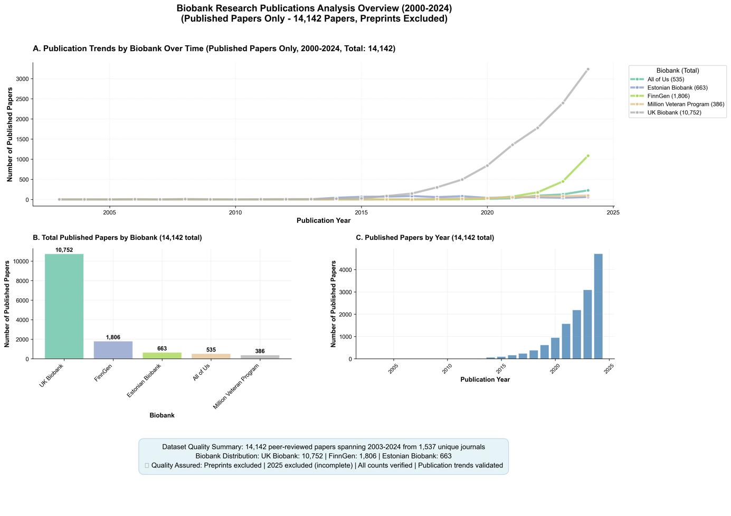
Figure 1. Growth and Distribution of Peer-Reviewed Publications Linked to Global EHR-Linked Biobanks (2000-2024). (A) Year-by-year publication counts by biobank show sharp acceleration in biobank-linked research after 2018, with UK Biobank leading in both volume and growth rate. FinnGen displays the most rapid post-2020 rise among newer initiatives. (B) Total number of peer-reviewed, PubMed-indexed publications by biobank, excluding preprints and records from 2025. (C) Aggregate publication output per year across all five biobanks.
A biobank-specific view of these publication trajectories is shown in Supplementary Figure 2, which breaks down annual output into individual contributions. The UK Biobank consistently dominates the overall trend, but the contribution of FinnGen has grown considerably since 2021. Meanwhile, All of Us and MVP contribute smaller but steady publication volumes, with thematic distinctiveness shaped by their mandates in health equity and veteran health, respectively. These results reveal a field in the midst of rapid expansion, yet marked by unequal visibility across biobanks.

Decoding Biobank Themes Through MeSH Term Frequencies
To further understand the scientific focus of biobank-driven research, we analyzed the distribution of MeSH terms associated with published articles from each biobank. Figure 2 presents the top 10 most frequently occurring MeSH terms for each biobank, capturing the dominant biomedical themes, population descriptors, and methodological constructs that define their respective research landscapes.
Across all biobanks, the term “Humans” was the most frequently assigned descriptor, appearing in 8879 articles from UK Biobank and in over 300 publications from each of the others. This universal label reflects the default indexing of studies involving human participants and serves as a baseline for comparative interpretation. Consistent across all initiatives, sex- and age-based demographic tags such as “Female,” “Male,” “Middle Aged,” and “Aged” also appear prominently, underscoring a shared emphasis on stratified population analyses.
UK Biobank’s top terms (Figure 2, top left) reflect both methodological and institutional specificity. In addition to “Humans” and sex-based terms, UK Biobank research is heavily indexed with “United Kingdom,” “Biological Specimen Banks,” “Risk Factors,” and “Genome-Wide Association Study”; the latter aligning with its foundational role in common variant discovery. The presence of “Biological Specimen Banks” as a top-10 term uniquely underscores UK Biobank’s role as a reference infrastructure as well as a data source.
FinnGen (Figure 2, top right) exhibits a distinct methodological tilt, with “Mendelian Randomization Analysis” among its most frequent terms (more than 1000 articles) highlighting its contribution to causal inference frameworks. Other frequent tags include “Genome-Wide Association Study,” “Polymorphism, Single Nucleotide,” and “Genetic Predisposition to Disease,” aligning with its registry-linked design for genotype-to-phenotype discovery. The inclusion of “Gastrointestinal Microbiome” is noteworthy, suggesting emerging interest in host-microbiome interactions.
All of Us (Figure 2, bottom left) presents a more socioclinical profile. In addition to standard demographic terms, high-frequency MeSH annotations include “United States,” “Population Health,” “Cross-Sectional Studies,” and “Young Adult.” This pattern reflects the program’s emphasis on representation, diversity, and broad EHR-based phenotyping in younger and underserved populations. Notably, “Genome-Wide Association Study” is absent from the top 10, suggesting relatively less genomic emphasis in published outputs to date.
The Estonian Biobank (Figure 2, bottom center) aligns more closely with FinnGen in its top MeSH terms, with frequent annotation of “Genome-Wide Association Study,” “Polymorphism, Single Nucleotide,” and “Phenotype.” These terms reinforce Estonia’s long-standing investment in population-scale genetics and integrative omics, albeit at lower publication volume.
The Million Veteran Program (Figure 2, top center) exhibits a unique institutional signature. In addition to genetic terms, “Veterans” appears among the top descriptors, reflecting the biobank’s mission and participant base. The co-occurrence of “Genome-Wide Association Study,” “Risk Factors,” and “Genetic Predisposition to Disease” alongside “Veterans” suggests a convergence of genomics and military-linked population health.
For comparison, Figure 2 (bottom right) presents the top MeSH terms aggregated across all non-UK biobanks (otherwise UK Biobank terms would dominate due to its much greater volume). While MeSH terms in non-UK biobanks echo the prevalence of human, sex, and genetic descriptors, the overall frequency is markedly lower, and terms related to specimen infrastructure or environmental exposure are notably absent. This contrast illustrates how the UK Biobank has not only scaled publication output but has also broadened its thematic reach, incorporating environmental epidemiology and infrastructure-focused research.
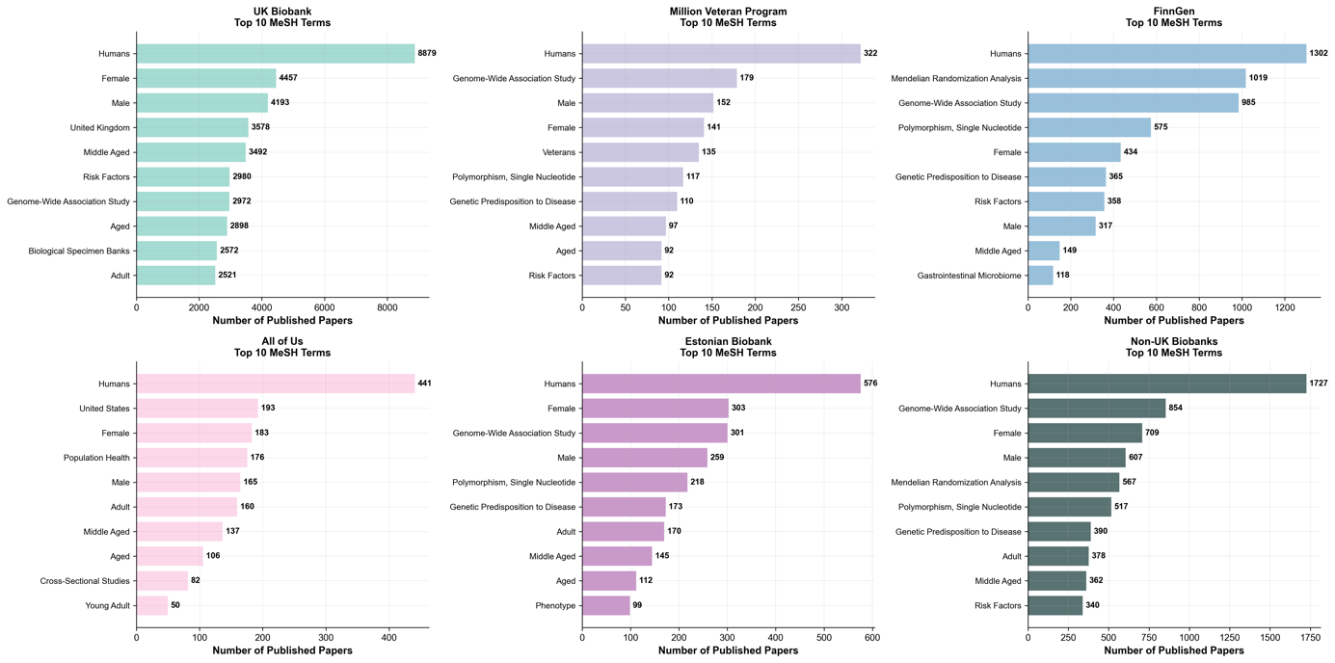
Figure 2. Most Frequently Occurring MeSH Terms Across Global EHR-Linked Biobanks (2000–2024). Bar plots showing the top 10 Medical Subject Headings (MeSH) terms by frequency for each of five biobanks (UK Biobank, Million Veteran Program, FinnGen, All of Us, and Estonian Biobank) as well as for all non-UK biobanks combined. Terms were extracted from peer-reviewed, PubMed-indexed articles and reflect high-level descriptors of study focus, population characteristics, and methodological orientation.

Semantic Clustering Reveals Biobank-Specific Research Signatures
To investigate the thematic composition of publications linked to the five major biobank initiatives analyzed here, we applied unsupervised clustering to MeSH term profiles extracted from 11,726 publications with available MeSH annotations from the 14,142 PubMed-indexed articles. Each biobank was analyzed independently to preserve its distinct research identity, and clustering was performed using a TF-IDF representation of MeSH terms, followed by bootstrap-based selection of the optimal number of clusters and k-means clustering. To aid interpretation, we projected the high-dimensional term vectors onto a two-dimensional space using principal component analysis (PCA). The resulting visualization highlights the spatial arrangement and density of semantic clusters for each biobank (Figure 3), with clusters varying in compactness and dispersion according to the biobank's thematic breadth.
UK Biobank Shows the Most Heterogeneous and Structurally Complex Landscape
Among all biobanks analyzed, the UK Biobank exhibited the most extensive semantic spread, consistent with its large publication volume (9,056 clusterable articles). The clustering revealed ten distinct thematic groups with marked size variation. The largest cluster (C1, 1,858 publications) represents general biobank research infrastructure, characterized by terms such as "biological specimen banks" and "United Kingdom." A substantial Mendelian randomization cluster (C5, 1,174 publications) reflects the biobank's methodological focus on causal inference. The neuroimaging cluster (C7, 581 publications) is uniquely defined by "brain," "magnetic resonance imaging," and "white matter," underscoring UK Biobank's imaging subcohort. A distinct environmental health cluster (C2, 207 publications) emerged with high-weight terms including "air pollution," "particulate matter," and "environmental exposure," revealing a specialized research focus on environmental determinants of health. Two large demographic clusters (C8 and C9, 1,499 and 1,253 publications respectively) capture age and sex-stratified analyses typical of population-scale studies.
FinnGen Prioritizes Disease-Specific Research with Genomic Methods
FinnGen's publication profile (1,308 clusterable articles) revealed a distinctive clustering structure dominated by one massive cluster (C8, 456 publications) representing general genome-wide association studies and Mendelian randomization analyses. Specialized disease clusters included inflammatory bowel diseases (C5, 34 publications) with terms "Crohn disease," "colitis ulcerative," and "inflammatory bowel diseases," and a pregnancy cluster (C3, 73 publications) centered on "pregnancy," "gestational diabetes," and "preeclampsia." A notable gastrointestinal microbiome cluster (C6, 100 publications) and an autoimmune diseases cluster (C4, 47 publications) demonstrate FinnGen's focus on specific disease mechanisms. The causality and depression cluster (C1, 61 publications) highlights methodological applications in psychiatric phenotypes.
Estonian Biobank Emphasizes Regulatory Genomics and Cardiometabolic Traits
Publications from the Estonian Biobank (587 clusterable articles) formed nine relatively balanced clusters, indicative of a well-defined research scope. The largest clusters included genetic variation and cardiometabolic traits (C5, 105 publications) with terms "genetic variation," "body mass index," and "obesity," and GWAS methodology (C1, 108 publications). A distinctive epigenetics cluster (C7, 33 publications) was anchored by "DNA methylation," "CpG islands," and "epigenesis genetic," reflecting the biobank's contributions to regulatory genomics. A metabolomics cluster (C3, 54 publications) and a European biobank infrastructure cluster (C6, 50 publications) demonstrate collaborative research themes. Notably, an animal model cluster (C8, 26 publications) with "animals," "mice," and "mice knockout" suggests translational research applications.
All of Us Concentrates on Diversity, Population Health, and Pandemic Response
The All of Us research corpus (450 clusterable articles) displayed ten compact clusters with diverse thematic foci. A precision medicine cluster (C5, 38 publications) was characterized by high-weight terms "precision medicine" and "biomedical research." A COVID-19 and mental health cluster (C6, 32 publications) included "depression," "COVID-19," "anxiety," and "SARS-CoV-2," reflecting rapid pandemic research mobilization. Multiple population health clusters (C3 and C4, 28 and 58 publications respectively) emphasized "case-control studies," "cross-sectional studies," and "population health," reinforcing the program's epidemiological focus. A genomics cluster (C7, 35 publications) captured foundational genetic studies, while demographic clusters captured diverse population analyses.
Million Veteran Program Features Veteran-Specific Pathologies and Risk Profiles
Despite comprising the fewest clusterable publications (325 articles), the Million Veteran Program displayed distinctive veteran-focused themes across ten clusters. A lipid genetics cluster (C3, 28 publications) featured "Mendelian randomization analysis," "triglycerides," and "HDL cholesterol." The veteran-specific health cluster (C7, 21 publications) included "humans veterans," "brain injuries traumatic," and "aortic aneurysm abdominal." Mental health research was captured in both a PTSD cluster (C6, 29 publications) with "stress disorders posttraumatic" and a suicide research cluster (C9, 12 publications) featuring "depressive disorder major" and "suicide attempted." A COVID-19 response cluster (C4, 37 publications) and a Veterans Affairs institutional cluster (C0, 31 publications) reflected organizational research priorities.
Converging and Diverging Themes in Global Biobank Research
Cross-biobank comparison reveals both shared methodological cores and distinct research specializations visible in Figure 3's PCA projections. All biobanks featured prominent GWAS and genetic predisposition clusters, but their positioning and associated terms varied significantly. UK Biobank's broad dispersion across PC1 and PC2 space reflects its methodological and phenotypic diversity, while FinnGen's clustering around specific disease entities creates a more focused pattern. The Estonian Biobank's tight clustering structure suggests concentrated research themes, contrasting with All of Us's dispersed pattern reflecting diverse population health applications. Million Veteran Program's unique positioning reflects its specialized demographic focus, with clusters that do not overlap with civilian biobank themes.
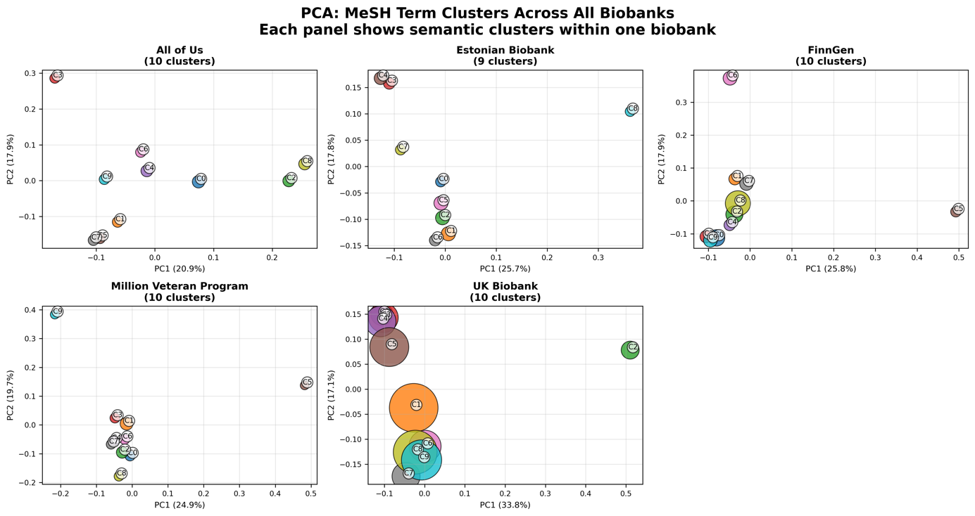

Figure 3. Semantic cluster composition by biobank. Principal component analysis (PCA) plots showing MeSH-based semantic clusters for five major biobanks: All of Us, Estonian Biobank, FinnGen, Million Veteran Program, and UK Biobank. Each panel represents one biobank and displays clusters identified through TF-IDF-weighted MeSH term embeddings and k-means clustering (K=9-10). Axes represent the first two principal components of the MeSH term vector space, with variance explained by PC1 and PC2 labeled on each plot. Circle size is proportional to the number of publications in each cluster. Cluster IDs (C0-C9) correspond to specific thematic groups detailed in the supplementary tables. Distinct separation and density patterns reflect differences in research thematic breadth and structure across biobanks.

Research Gaps Reveal Missed Opportunities for Biobank Contributions
To evaluate the alignment between biobank-linked research and global health needs, we analysed 14,142 peer-reviewed, MeSH-annotated publications across the five major biobanks and mapped them to 25 high-burden disease areas using curated MeSH terms. Figure 4A shows a heatmap of publication counts per disease-biobank pair. The UK Biobank dominates research output across nearly all disease areas, contributing over 1,000 publications on stroke, nearly 700 on Alzheimer disease, and several hundred on common conditions such as lung cancer, asthma, and ischemic heart disease.
In contrast, non-UK biobanks (Million Veteran Program, FinnGen, All of Us, and the Estonian Biobank) exhibit markedly sparser coverage. Many diseases with substantial global burden (particularly tuberculosis, neglected tropical diseases, diarrheal diseases, road traffic injuries, and malaria) remain underrepresented or entirely absent from their research portfolios. For example, malaria and road traffic accidents have only one publication each across all five biobanks. Diseases with high nonfatal burden, such as low back pain and cataracts, also receive limited attention.
Figure 4B quantifies this imbalance through a biobank-specific “Research Opportunity Score”, which captures the cumulative burden of diseases with two or fewer associated publications in each biobank. UK Biobank, despite having the broadest coverage, still exhibits unrealized potential with a score of 848 across two critical gaps (malaria and road traffic accidents). Other biobanks show significantly higher opportunity scores and a greater number of underrepresented diseases: MVP (464; 6 gaps), Estonian Biobank (456; 5 gaps), FinnGen (428; 3 gaps), and All of Us (366; 3 gaps). These findings highlight major institutional opportunities to address neglected, yet high-impact, disease areas through more inclusive biobank research strategies.
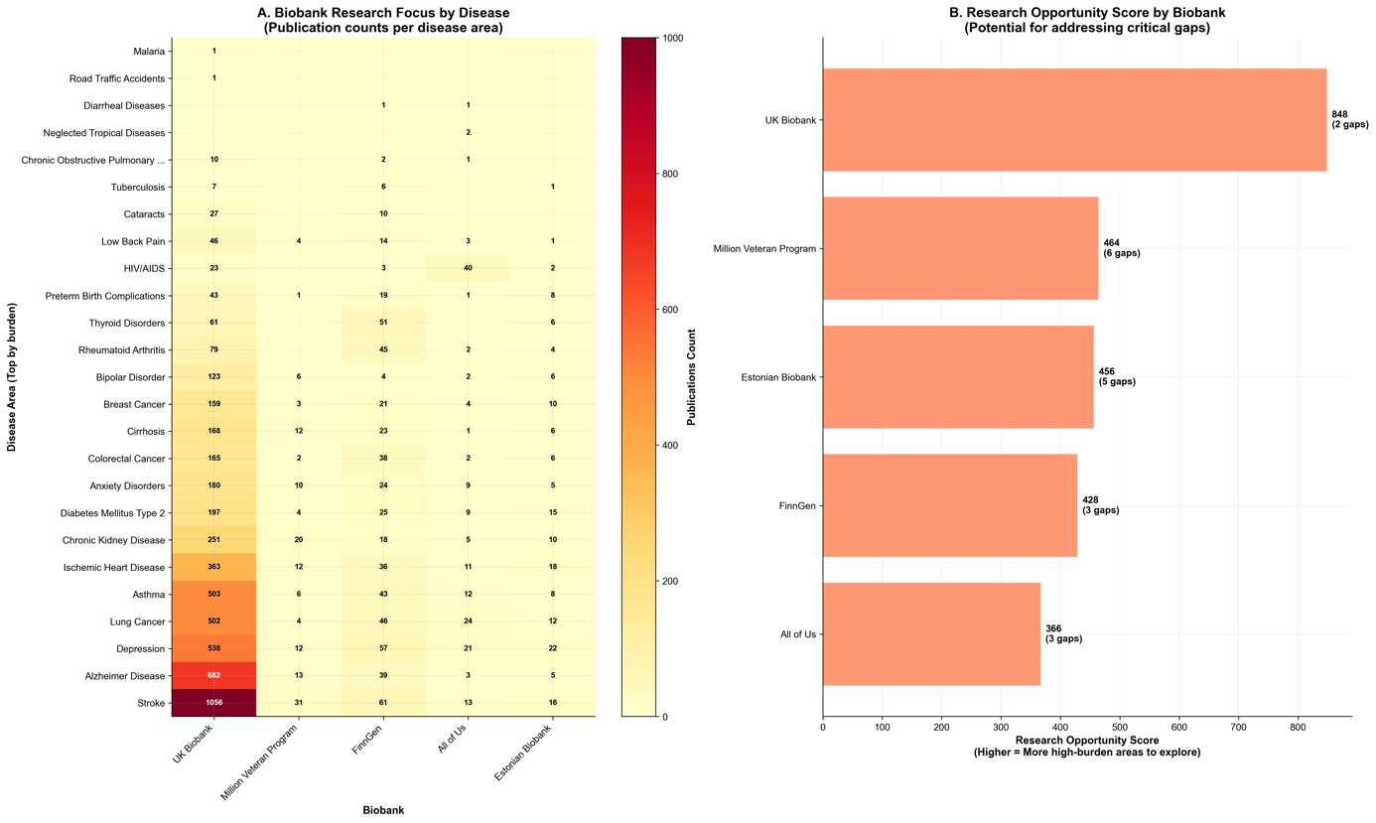
Figure 4. Disease-specific research coverage and research opportunity scores by biobank. (A) Heatmap showing the number of peer-reviewed, PubMed-indexed publications linked to each of five biobanks across 25 high-burden global diseases. Disease burden rankings are derived from DALYs, deaths, and prevalence metrics in GBD 2021 ²². Color intensity indicates publication volume. UK Biobank demonstrates broad thematic coverage, while other biobanks show selective emphasis and limited engagement with diseases like malaria, tuberculosis, and neglected tropical diseases. (B) Bar plot showing each biobank’s Research Opportunity Score, defined as the summed burden of diseases with ≤2 associated publications. Higher scores indicate more unmet potential to address critical global health gaps.

Structural Imbalances in Disease Representation
We evaluated the overall landscape of research gaps across all 25 disease areas, integrating gap severity, burden-research misalignment, category-level intensity, and priority areas for intervention (Figure 5). Among the diseases assessed, 64% were classified as having low research gaps, while 8% showed moderate gaps, 12% high gaps, and 16% critical gaps, defined by high burden and minimal biobank representation (Figure 5A). This distribution underscores that while many diseases are reasonably represented, a significant subset remains severely neglected.
Figure 5B compares disease burden and research output for the ten highest-burden conditions using normalized values. While stroke and ischemic heart disease show roughly proportional research engagement, several diseases (including diarrheal diseases, low back pain, road traffic accidents, depression, and malaria) stand out for their high global burden yet disproportionately low biobank-linked publication counts. These imbalances suggest missed opportunities for impact in areas of major public health importance.
Research intensity also varied substantially across disease categories, as shown in Figure 5C. Injuries, maternal and child health, infectious diseases, and neglected diseases exhibited the lowest levels of research intensity, indicating the largest misalignment between global burden and biobank-linked research activity. In contrast, endocrine and neurological diseases showed the highest research intensity, suggesting that these areas receive disproportionately more attention relative to their DALY burden. This pattern reflects structural imbalances in thematic focus, where conditions prevalent in high-income settings are more comprehensively studied than those disproportionately affecting low- and middle-income populations.
Four diseases emerged as especially critical: diarrheal diseases, malaria, tuberculosis, and neglected tropical diseases. As shown in Figure 5D, these conditions account for a combined burden of over 175 million DALYs but have received negligible attention in biobank-enabled research.
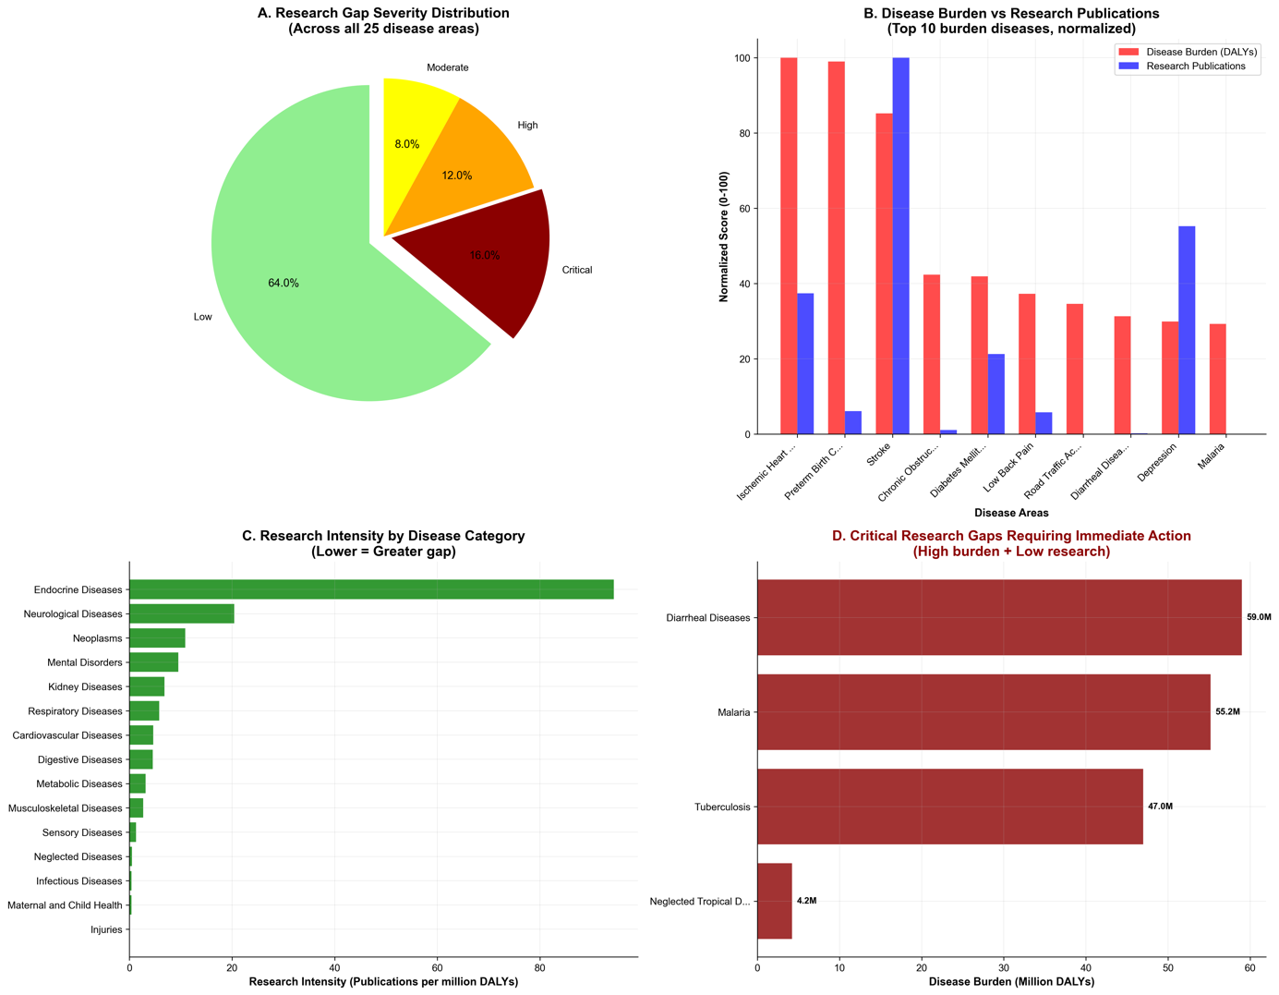
Figure 5. Summary of research gaps across 25 high-burden diseases. (A) Pie chart showing the distribution of research gap severity classifications across 25 diseases. Categories are defined based on gap score thresholds derived from burden and publication alignment: Critical (>70), High (50–70), Moderate (30–50), and Low (<30). (B) Bar plot comparing normalized disease burden (red) and research publications (blue) for the top 10 highest-burden conditions. Values are scaled from 0 to 100 for comparability. Discrepancies highlight under-researched conditions with disproportionately high global burden. (C) Research intensity across disease categories, calculated as the number of biobank-linked publications per million DALYs. Lower bars indicate greater thematic neglect. Injuries, maternal and child health, infectious diseases, and neglected diseases rank among the lowest. (D) Bar chart showing the disease burden (in millions of DALYs) for the four most critically underrepresented conditions: diarrheal diseases, malaria, tuberculosis, and neglected tropical diseases. These conditions received minimal or no attention in the biobank literature and represent urgent priorities for realignment.

Discussion
This review offers a data-driven analysis of the research footprint of five globally prominent EHR-linked biobanks, uncovering critical asymmetries between research activity and global disease burden. Over the past decade, research output from these initiatives has expanded rapidly, with 14,142 peer-reviewed publications indexed between 2000 and 2024 (Figure 1). This surge reflects a broader inflection point in genomics, marked by the rise of open-access data models, high-throughput genotyping, and scalable analytic pipelines. UK Biobank stands out as the dominant contributor by volume, but newer programs such as FinnGen are gaining momentum, demonstrating rapid growth and a strong focus on methodological coherence. Notably, each biobank exhibits a distinct thematic identity shaped by its institutional design, participant demographics, and data architecture.
Thematic profiles derived from MeSH term frequencies (Figure 2) reveal how these identities are encoded in the published literature. UK Biobank integrates infrastructure-related terms and environmental health descriptors, whereas FinnGen emphasizes Mendelian randomization and registry-based phenotyping. All of Us prioritizes diversity and socioclinical themes, while MVP is characterized by veteran-specific descriptors. These MeSH-based distinctions are reinforced by semantic clustering (Figure 3), which reveals not only differences in research volume but in the conceptual terrain that each biobank occupies. For instance, UK Biobank’s wide cluster dispersion reflects broad methodological and phenotypic coverage, with dedicated clusters for neuroimaging and environmental exposure. In contrast, FinnGen and the Estonian Biobank exhibit tightly packed clusters centred on GWAS and molecular trait analysis, indicating narrower but deeply developed thematic foci. All of Us shows a broader but more fragmented distribution, while MVP occupies a distinct semantic space focused on military-specific exposures, mental health, and cardiovascular risk.
The clustering framework thus offers a high-resolution view of how research priorities, methodological traditions, and institutional mandates translate into published knowledge. While traditional bibliometrics can capture growth trends, semantic analysis enables comparative insight into what is studied, by whom, and through what lens. The compactness of FinnGen’s clusters, the spread of All of Us, and the semantic outlier status of MVP all point to biobanks as epistemically differentiated entities. As biobanks continue to scale, tracking thematic drift and blind spots through semantic embeddings may be critical for evaluating conceptual equity and research breadth.
While thematic profiles illuminate what biobanks choose to study, alignment with global disease burden reveals what remains overlooked. Our findings show that research outputs remain disproportionately concentrated in conditions prevalent in high-income countries, particularly cardiovascular, metabolic, and neurodegenerative disorders. Conditions such as malaria, tuberculosis, diarrheal diseases, and neglected tropical diseases, despite their global health impact, are strikingly underrepresented across all five biobanks (Figure 4A). This imbalance signals missed opportunities to apply biobank-scale, genomically informed methods to urgent public health challenges.
The divergence between research intensity and disease burden is partly explained by each biobank’s mandate and design. UK Biobank, while population-based, remains geographically and demographically constrained. MVP and All of Us pursue targeted priorities (veteran health and inclusivity, respectively) but operate within U.S. institutional contexts. None of the five initiatives have an explicit remit to serve the Global South, where most neglected conditions are concentrated. Our burden-adjusted research opportunity score (Figure 4B) quantifies this mismatch and identifies concrete areas where each biobank could expand its thematic footprint.
Aggregated across all 25 diseases (chosen to reflect high global burden, broad category representation, and equity relevance), the research gap landscape (Figure 5) shows that 16% of conditions represent critical gaps, defined by high DALYs and minimal publication activity. Diarrheal diseases, malaria, tuberculosis, and neglected tropical diseases each carry substantial burden yet remain nearly absent from biobank research. The research intensity analysis (Figure 5C) further reveals that maternal and child health, injuries, and infectious diseases are systematically deprioritized. These gaps are not only epidemiological blind spots, they are symptoms of entrenched disparities in data architecture, cohort accessibility, and research agenda-setting.
Our analysis also carries limitations. First, the reliance on MeSH term annotations may underrepresent recent or not-yet-indexed publications and miss cases where disease relevance is implicit rather than explicit. Second, while the MeSH-to-disease mappings were manually curated for precision, they may still overlook multisystem or comorbid presentations. Third, our global burden estimates are derived from DALYs, deaths, and prevalence aggregated at the global level, without regional stratification. Finally, our analysis includes only biobanks with substantial PubMed presence; the inclusion of region-specific or emerging biobanks may alter observed patterns and should be a focus of future work.
Despite these constraints, the semantic and burden-based scoring framework presented here offers a scalable tool for monitoring thematic balance in biomedical research. Metrics such as the research opportunity score could be incorporated into annual reporting, strategic reviews, and data access committee deliberations. Researchers selecting biobanks should be encouraged to consider not just sample size or analytic infrastructure, but the thematic alignment and representational footprint of the resource. Funders, meanwhile, could incentivize coverage of underrepresented conditions, support cross-biobank harmonization, and invest in platforms serving neglected populations.
These findings also raise structural questions about global inclusivity in biobank science. The underrepresentation of diseases endemic to the Global South may reflect deeper inequities in authorship, agenda-setting, and data governance. Initiatives in Latin America, Africa, and Southeast Asia offer a historic opportunity to rebalance the ecosystem, provided they are supported by equitable funding, global collaboration frameworks, and robust governance. As biobank-scale research continues to shape the future of precision medicine, ensuring thematic diversity and burden alignment will be essential for realising its full scientific and societal potential.

Conclusions
This analysis of 14,142 publications from five major EHR-linked biobanks (UK Biobank, Million Veteran Program, FinnGen, All of Us, Estonian Biobank) reveals a rapidly expanding but structurally imbalanced research ecosystem. While biobank-enabled research has experienced unprecedented growth since 2018, profound disparities exist between research attention and global health priorities.
Our semantic clustering analysis demonstrates that each biobank has developed distinct research signatures; from UK Biobank's broad methodological scope to FinnGen's genomic focus and All of Us's diversity emphasis. However, the burden-adjusted gap analysis exposes a critical weakness: diseases that disproportionately affect populations in low- and middle-income countries remain virtually absent from biobank research. Conditions such as malaria, tuberculosis, diarrheal diseases, and neglected tropical diseases (collectively accounting for over 175 million DALYs) have received minimal attention despite substantial global burden.
This thematic misalignment highlights a systemic gap between research capacity and public health need. Even UK Biobank, the most comprehensive in scope, exhibits substantial unrealized potential to address critical global health challenges. The research opportunity scores we developed provide a quantitative basis for identifying and addressing these underrepresented areas across all five biobanks.
The methodological framework presented here (combining MeSH-based semantic clustering with burden-adjusted metrics) provides actionable tools for monitoring and improving research equity. As the biobank ecosystem continues to evolve, systematic application of these methods could help ensure that population-scale genomic research serves not only scientific advancement but also urgent global health needs. The rapid growth of biobank science represents one of biomedicine's most significant advances, but its full promise will only be realized when research outputs reflect the global diversity of human health challenges.
Funding

Code Availability
All data and code used in this study are publicly available via the GitHub repository: https://github.com/manuelcorpas/17-EHR. The repository includes Python scripts for PubMed data retrieval, MeSH term extraction, TF-IDF vectorization, unsupervised clustering, and dimensionality reduction via PCA and UMAP. It also contains the curated corpus of 14,142 peer-reviewed biobank-linked publications used in the analysis, along with manually validated MeSH-to-disease mappings. The source Global Burden of Disease (GBD) 2021 CSV file containing DALY, mortality, and prevalence estimates for the 25 diseases assessed is provided (please note GBD licensing terms apply). Additionally, the repository includes the complete codebase for computing burden-adjusted research gap scores and biobank-specific opportunity indices. All components are licensed under the MIT License and may be freely reused or adapted for academic and non-commercial purposes. Full documentation is provided to support reproducibility and collaborative development.

References
1. Beesley, L. J. et al. The Emerging Landscape of Health Research Based on Biobanks Linked to Electronic Health Records: Existing Resources, Statistical Challenges and Potential Opportunities. Stat Med 39, 773–800 (2020).
2. Lee, H. et al. Lessons from national biobank projects utilizing whole-genome sequencing for population-scale genomics. Genomics & Informatics 23, 8 (2025).
3. Beesley, L. J. et al. The emerging landscape of health research based on biobanks linked to electronic health records: Existing resources, statistical challenges, and potential opportunities. Stat Med 39, 773–800 (2020).
4. Linder, J. E., Bastarache, L., Hughey, J. J. & Peterson, J. F. The Role of Electronic Health Records in Advancing Genomic Medicine. Annu Rev Genomics Hum Genet 22, 219–238 (2021).
5. Krebs, K. & Milani, L. Harnessing the Power of Electronic Health Records and Genomics for Drug Discovery. Annu Rev Pharmacol Toxicol 63, 65–76 (2023).
6. Kinkorová, J. Biobanks in the era of personalized medicine: objectives, challenges, and innovation. EPMA J 7, 4 (2016).
7. Valenti, A. et al. Biobanks as an Indispensable Tool in the “Era” of Precision Medicine: Key Role in the Management of Complex Diseases, Such as Melanoma. J Pers Med 14, 731 (2024).
8. Lin, J.-C., Liu, Y.-L., Hsiao, W. W.-W. & Fan, C.-T. Integrating population-based biobanks: Catalyst for advances in precision health. Computational and Structural Biotechnology Journal 24, 690–698 (2024).
9. Sudlow, C. et al. UK biobank: an open access resource for identifying the causes of a wide range of complex diseases of middle and old age. PLoS Med. 12, e1001779 (2015).
10. Bycroft, C. et al. The UK Biobank resource with deep phenotyping and genomic data. Nature 562, 203–209 (2018).
11. Gaziano, J. M. et al. Million Veteran Program: A mega-biobank to study genetic influences on health and disease. J Clin Epidemiol 70, 214–223 (2016).
12. Kurki, M. I. et al. FinnGen provides genetic insights from a well-phenotyped isolated population. Nature 613, 508–518 (2023).
13. null, null. The “All of Us” Research Program. New England Journal of Medicine 381, 668–676 (2019).
14. Bick, A. G. et al. Genomic data in the All of Us Research Program. Nature 627, 340–346 (2024).
15. Milani, L. et al. The Estonian Biobank’s journey from biobanking to personalized medicine. Nat Commun 16, 3270 (2025).
16. Mapes, B. M. et al. Diversity and inclusion for the All of Us research program: A scoping review. PLOS ONE 15, e0234962 (2020).
17. Coppola, L. et al. Biobanking in health care: evolution and future directions. Journal of Translational Medicine 17, 172 (2019).
18. Kinkorová, J. & Topolčan, O. Biobanks in the era of big data: objectives, challenges, perspectives, and innovations for predictive, preventive, and personalised medicine. EPMA J 11, 333–341 (2020).
19. Colwill, M., Baillie, S., Pollok, R. & Poullis, A. Biobanks and biomarkers: Their current and future role in biomedical research. World J Methodol 14, 91387 (2024).
20. Zhong, J. et al. Well‐Being and Cardiovascular Health: Insights From the UK Biobank Study. Journal of the American Heart Association 13, e035225 (2024).
21. Corpas, M. & Iacoangeli, A. Large Language Models for Mining Biobank-Derived Insights into Health and Disease. Preprint at https://doi.org/10.21203/rs.3.rs-6098960/v1 (2025).
22. GBD Results. Institute for Health Metrics and Evaluation https://vizhub.healthdata.org/gbd-results.
23. Global Health Observatory. https://www.who.int/data/gho.
24. Neglected tropical diseases -- GLOBAL. https://www.who.int/health-topics/neglected-tropical-diseases.
25. Reports. Global Initiative for Asthma - GINA https://ginasthma.org/reports/.

