EHR-Linked Biobank Expansion Reveals Global Health Inequities
Manuel Corpas^{1,2,3,4,*}, Oyesola Ojewunmi⁵, Heinner Guio^{6,7}, Segun Fatumo^{5,8,*}
¹School of Life Sciences, University of Westminster, London, UK
²UNIR Health Sciences School, Universidad Internacional de La Rioja (UNIR), Madrid, Spain
³The Alan Turing Institute, London, UK
⁴Cambridge Precision Medicine, London, UK
⁵Precision Health University Research Institute, Queen Mary University of London, London, UK
⁶Universidad de Ingeniería y Tecnología (UTEC), Lima, Peru
⁷INBIOMEDIC Research and Technological Center, Lima, Peru
⁸African Computational Genomics (TACG) Research Group, MRC/UVRI and LSHTM Uganda Research Unit

*Corresponding authors: m.corpas@westminster.ac.uk, s.fatumo@qmul.ac.uk

Abstract
Electronic health record (EHR)-linked biobanks are transforming biomedical research, enabling population-scale studies that integrate genomic, clinical, and phenotypic data. Yet as these resources proliferate, it remains unclear how their research outputs reflect global health priorities. This article presents a comprehensive review of five globally established EHR-linked biobanks: the UK Biobank, Million Veteran Program (MVP), FinnGen, All of Us Research Program, and Estonian Biobank. Drawing on 14,142 peer-reviewed publications from 2000 to 2024, we show how each biobank displays a distinct thematic profile, shaped by institutional mandates, population focus, and methodological design. We further evaluate alignment with global disease burden by mapping biobank-linked publications to 25 high-priority disease areas using World Health Organisation (WHO) disability-adjusted life years (DALYs) data. Our burden-adjusted gap scores and opportunity indices reveal striking underrepresentation of conditions such as malaria, tuberculosis, and diarrheal diseases when comparing biobank research output against high-priority diseases.
Keywords: UK Biobank; Million Veteran Program (MVP); FinnGen; All of Us Research Program; Estonian Biobank; EHR-linked biobanks; global disease burden; DALYs; research gap analysis; biomedical data science.

Introduction
The convergence of large-scale population genomics, electronic health records (EHRs), and biobanking infrastructure has fundamentally transformed biomedical research over the past two decades (1, 2). EHR-linked biobanks represent a paradigm shift from traditional epidemiological studies toward comprehensive, longitudinal platforms that integrate genetic, clinical, environmental, and lifestyle data at an unprecedented scale (3–5). These initiatives have emerged as critical infrastructure for precision medicine, enabling researchers to interrogate complex disease mechanisms, validate therapeutic targets, and develop predictive models across diverse populations and phenotypes (6–8). Such developments unfold within a broader international governance landscape. UNESCO has articulated foundational norms for genomic science, including the Universal Declaration on the Human Genome and Human Rights (1997) (https://www.ohchr.org/en/instruments-mechanisms/instruments/universal-declaration-human-genome-and-human-rights), International Declaration on Human Genetic Data (2003) (https://www.unesco.org/en/ethics-science-technology/human-genetic-data), and Universal Declaration on Bioethics and Human Rights (2005) (https://www.unesco.org/en/ethics-science-technology/bioethics-and-human-rights). More recently, WHO has issued recommendations on genome data collection, access, and sharing (9) and on human genome editing (2021) (https://www.who.int/health-topics/human-genome-editing).
Major EHR-linked biobank initiatives worldwide include the UK Biobank (10, 11), the Million Veteran Program (MVP) (12), FinnGen (13), the All of Us Research Program (14, 15), and the Estonian Biobank (16). These biobanks have each adopted distinct approaches to data collection, participant recruitment, and research access policies. Despite their shared foundation in linking genomic data with longitudinal health records, they differ substantially in their demographic composition, phenotyping strategies, data-sharing frameworks, and institutional mandates (17). The UK Biobank has pioneered open-access models and deep phenotyping through imaging and environmental monitoring (11), while initiatives like All of Us prioritise diversity and health equity (18), and specialised programmes like MVP focuses on veteran populations with unique exposure profiles (19).
The scientific impact of biobanks has grown exponentially (20–22), generating thousands of publications across disciplines ranging from genomic epidemiology to environmental health. Yet this rapid expansion, both in the number of biobanks and the scale of their outputs, has introduced new challenges. As the volume and diversity of biobank-enabled research swell, it becomes increasingly difficult to map the thematic landscape, set coherent research priorities, and discern the unique contributions of each resource to biomedical knowledge. Conventional bibliometric methods are ill-suited to this complexity, as they struggle to capture the nuanced, multidimensional nature of biobank research, which spans diverse methodological approaches, disease areas, and population contexts.
Understanding the research footprint of global biobank initiatives is essential for several reasons. First, it helps researchers navigate the complex landscape of available resources and select the most appropriate biobank for their specific research questions. Second, it provides insights into how different design philosophies and access policies shape research outputs and thematic focus. Third, comprehensive mapping of biobank research can guide future development, revealing areas of scientific convergence and divergence. Finally, the dissection of the global biobank research foorpint enables funding agencies and research institutions to identify gaps and opportunities, ensuring that investments are strategically targeted to maximise impact.
Previous efforts to characterise biobank research have typically focused on single initiatives or specific disease domains (e.g., (23–25)), leaving gaps in our understanding of the broader ecosystem. Moreover, existing analyses may not capture the full semantic complexity of biobank research themes or provide a systematic basis for cross-biobank comparison. However, with the advent of advanced computational methods for semantic analysis, new opportunities arise to identify latent thematic structures, compare institutional focus areas, and quantify alignment with global health needs.
In this review, we present a comprehensive, semantics-based benchmark of the research footprint of the UK Biobank, the Million Veteran Program (MVP), FinnGen, the All of Us Research Program, and the Estonian Biobank. While we acknowledge there are many other biobanks, we chose these five EHR-linked biobanks for their recognised global biomedical research impact. We assembled a corpus of 14,142 PubMed-indexed peer-reviewed publications spanning 2000 to 2024, and employed automated MeSH term extraction, term frequency-inverse document frequency (TF-IDF) vectorisation (26), and unsupervised clustering to reveal distinct research signatures within those biobanks. Given that most EHR-linked biobanks originate in high-income countries and recruit predominantly national populations, a concentration of research on noncommunicable diseases prevalent in these regions is expected. Nonetheless, quantifying this bias remains essential to understand its scale, implications, and potential pathways toward greater global inclusion. Our approach uncovers the semantic architecture of published research, highlights key thematic divergences between biobanks, and surfaces conceptual blind spots in the ecosystem.
In addition to exploring thematic diversity, we evaluated how biobank research aligns with global health priorities. Using DALYs, mortality, and prevalence data from the Global Burden of Disease (GBD) 2021 study (https://www.healthdata.org/data-tools-practices/interactive-data-visuals) and WHO Global Health Observatory (https://www.who.int/data/gho), we constructed burden-weighted research gap scores across 25 high-burden, policy-relevant diseases. Here we also develop biobank-specific research opportunity indices to quantify unrealised potential. These findings allow us to assess not only where biobank research is focused, but also where it is absent, despite high global need.

Analytical Framework

Biobank Data Retrieval and Thematic Analysis
We performed automated PubMed retrieval of articles published between 2000 and 2024 for five major biobanks: UK Biobank, Million Veteran Program (MVP), FinnGen, All of Us, and the Estonian Biobank. Searches included the official biobank names and known aliases, with publication date constraints but no thematic filters, to maximise recall. Metadata (PMID, title, abstract, journal, publication year, and MeSH terms) was extracted for all matching records. After excluding preprints and records without MeSH annotations, the final dataset comprised 14,142 peer-reviewed publications. Full query syntax and technical implementation details are provided in the Supplementary Materials.
We analysed the curated dataset of biobank-related publications to characterise temporal trends, thematic priorities, and publication patterns across the five biobanks. We next conducted a MeSH term frequency analysis, identifying the top 10 most common MeSH terms used in publications for each biobank. These terms were analysed to highlight distinct thematic profiles. These outputs integrate publication trends, cumulative volume, year distributions, and summary statistics.

MeSH-Based Semantic Embedding and Clustering of Biobank Publications
To capture the semantic structure of biobank-linked research, we developed a pipeline that converts MeSH annotations into high-dimensional embeddings for unsupervised clustering. Unlike large language models, which operate on free-text diagnostics, our approach leverages structured metadata (MeSH terms) to reveal latent thematic groupings within and across biobanks.

TF-IDF Vectorisation of MeSH Terms
To quantify the semantic content of each publication, we employed Term Frequency-Inverse Document Frequency (TF-IDF) vectorsation of MeSH terms. TF-IDF is a numerical weighting scheme that reflects how characteristic a term is to a specific document within a larger corpus. The method assigns higher weights to terms that appear frequently in individual publications (high term frequency) but rarely across the entire dataset (high inverse document frequency), thereby identifying MeSH terms that are distinctive to specific research themes or methodological approaches.
For biobank research analysis, TF-IDF enables the identification of MeSH terms that define unique research signatures; terms like "neuroimaging" or "military personnel" that may be highly characteristic of certain biobank studies but uncommon in the broader literature. This approach transforms each PubMed publication into a high-dimensional vector where dimensions correspond to MeSH terms, and values reflect the semantic importance of each term to that specific study.
Here each publication's MeSH terms were preprocessed by converting to lowercase, removing punctuation, and replacing spaces with underscores (e.g., Genome-Wide Association Study → genomewide_association_study). Special characters were removed, and terms were split by semicolons into tokenised, deduplicated documents. Each biobank's corpus was treated separately to preserve biobank-specific vocabularies and research emphases. Terms were included in the vocabulary only if they appeared in at least 2 but no more than 80% of documents, filtering out both extremely rare terms (likely noise) and overly common terms (lacking discriminative power). The resulting TF-IDF matrices were limited to a maximum of 1000 unigram and bigram features per biobank to maintain computational tractability while preserving semantic richness.

Independent Clustering per Biobank
Given that each biobank reflects a distinct research community with unique MeSH term distributions, clustering was performed independently. We applied the following sequential steps:
- Optimal K Determination via Bootstrapped Silhouette Scoring. For each biobank, we used bootstrapped sampling to determine the optimal number of clusters (K). In each of 50 iterations, a random subset of publications was clustered for values of K ranging from 2 to 10, and silhouette scores were computed. The K that achieved the highest mean silhouette score was selected.
- K-Means Clustering. Once K was selected, we performed k-means clustering on the full TF-IDF matrix, assigning each publication to a semantic cluster. These clusters represent thematic groupings of research based on MeSH term similarity.

Cluster Interpretation via c-DF-IPF
To characterise each cluster, we computed cluster-based Document Frequency-Inverse Document Frequency (c-DF-IDF) scores, adapted from the TF-IDF framework. For each MeSH term:
- DF was defined as the proportion of publications in the cluster containing the term.
- IDF was the log ratio of total documents in the biobank to the number of documents containing that term.
- The c-DF-IDF score was calculated as the product of DF and IDF, emphasising terms that were frequent in one cluster but uncommon elsewhere within the same biobank. We selected the top five c-DF-IDF terms to summarise each cluster's vocabulary.
In parallel, we generated semantic summaries by averaging TF-IDF vectors across all publications within each cluster. The highest-weighted terms in these mean vectors were extracted as dominant semantic descriptors.

Semantic Space Analysis
For each cluster identified in the independent biobank analyses, we computed its centroid in the unified semantic space by averaging the TF-IDF vectors of all publications belonging to that cluster, using the unified vocabulary. This approach preserves the cluster structure identified within each biobank while enabling cross-biobank comparison.
We applied Principal Component Analysis (PCA) to project the high-dimensional cluster centroids into two dimensions, preserving as much variance as possible. We also employed Uniform Manifold Approximation and Projection (UMAP) with 15 nearest neighbors to better preserve local structure for non-linear projection.

Research Gap Discovery and Disease Burden Bias
To evaluate the alignment between biobank-driven research and global disease priorities, we developed a scalable analytic framework combining global burden of disease metrics, manually curated MeSH mappings, and publication-level metadata from our chosen five EHR-linked biobanks. Our goal was to identify research gaps and opportunities across 25 disease areas using real-world data and a transparent scoring methodology.
We selected 25 diseases based on three criteria: (1) global burden as measured by disability-adjusted life years (DALYs) (27), (2) representativeness across major health domains (e.g., infectious, noncommunicable, maternal/child, injury-related), and (3) relevance to global equity and neglected health priorities. Disease selection was guided by the Global Burden of Disease (GBD) 2021 study, the WHO Global Health Observatory, and strategic policy frameworks such as the WHO NTD roadmap (https://www.who.int/publications/i/item/9789240010352) and the GINA Asthma report (https://ginasthma.org/reports/).
For each disease, we extracted DALYs, annual deaths, and prevalence estimates from the Global Burden of Disease 2021 (filtered for Global, Both sexes, All ages, and "Number" as the metric). These indicators were integrated into a composite burden score using the formula:
Burden Score = (0.5 × DALYs) + (50 × Deaths) + [10 × log₁₀(Prevalence)]
This approach balances fatal and nonfatal disease components, ensuring that both mortality and quality-of-life impacts are represented without overweighting highly prevalent but low-severity conditions. Full details for this Burden Score coefficient selection, sensitivity analyses, and validation are provided in the Supplementary Materials.

MeSH Mapping and Research Coverage Estimation
Each disease was associated with 3-5 MeSH terms, manually curated from NLM MeSH hierarchies and domain-specific literature. These mappings aimed to maximise sensitivity while preserving specificity. For instance, “Tuberculosis” included “Pulmonary Tuberculosis” and “Mycobacterium tuberculosis,” while “Low Back Pain” encompassed terms like “Back Pain” and “Lumbar Pain.”
We evaluated MeSH terms for the 14,142 PubMed-indexed articles linked to one or more of the five global biobanks. Articles were matched to disease categories via case-insensitive and partial string matching. Each article could contribute to multiple disease areas.

Gap Score Calculation
We defined a research gap score (range: 0-100) to quantify the mismatch between disease burden and biobank research attention. The scoring algorithm incorporated:
- Zero-publication penalty: Diseases with no publications received a gap score of 95.
- Threshold-based adjustments: Infectious and neglected diseases received elevated scores if they fell below predefined publication thresholds (e.g., <50 for malaria or tuberculosis).
- Scaled burden-normalised intensity: Remaining diseases were scored based on publication density relative to disease burden, using decile-based thresholds for publications per million DALYs.
Gap severity was classified into four tiers: Critical (>70), High (50-70), Moderate (30-50), and Low (<30). Visualisation outputs included burden-vs-effort scatterplots and gap-severity heatmaps. Full details of weighting choices, robustness checks, and alternative formulations are provided in the Supplementary Materials.

Biobank-Specific Opportunity Metrics
We computed a biobank-specific Research Opportunity Score to assess underexplored disease space within each biobank’s publication corpus (see Supplementary Materials, Biobank-Specific Opportunity Metrics). For every disease with ≤2 linked publications in a given biobank, we added its burden score to that biobank’s opportunity index. This measure reflects the magnitude of high-burden areas left unaddressed by each biobank. We also tracked the number of critical gap diseases per biobank to highlight missed opportunities for global health impact.

Box 1. Glossary of Key Terms

Disability-adjusted life years (DALYs)
A standardised measure of overall disease burden, expressed as the sum of years of life lost due to premature mortality and years lived with disability. One DALY can be thought of as one lost year of healthy life.

EHR-linked biobank
A repository that integrates genomic and other biospecimen data with longitudinal electronic health records (EHRs). Examples include UK Biobank, FinnGen, and All of Us.

Equity dashboard
A proposed governance tool in which biobanks report annually on thematic coverage, representation of high-burden diseases, and alignment with global health priorities, analogous to financial audits.

Research footprint
The thematic and methodological profile of research outputs enabled by a biobank, characterised using bibliometrics, keyword/MeSH analysis, and clustering.

Research Gap Score
A burden-adjusted metric (0-100) quantifying misalignment between global disease burden (DALYs, deaths, prevalence) and biobank research attention. Higher scores indicate greater disparity.

Research Opportunity Score (ROS)
A composite index capturing unrealised potential of a biobank by summing burden scores of diseases with ≤2 linked publications. A higher ROS reflects larger opportunity space for equity-aligned contributions.

Insights from Comparative Analysis

Biobank Research Output Growth Reflects Rapid Expansion
To contextualise the thematic clustering results, we first examined overall publication trends across the five major global biobanks from 2000 to 2024, focusing exclusively on peer-reviewed, PubMed-indexed articles with validated MeSH annotations. A total of 14,142 published articles were retained for analysis following a multi-step curation process that excluded preprints, duplicates, and the year 2025 (due to incompleteness at the time of writing). Preprints accounted for only 3.5% of the initial dataset (513 out of 14,655 records; Supplementary Figure S2A), with the majority sourced from medRxiv and bioRxiv (Supplementary Figure S2B).
Figure 1A presents publication trajectories for each biobank over time. The UK Biobank stands out with a steep and sustained increase beginning around 2015, surpassing 3,000 peer-reviewed articles annually by 2024. This trajectory reflects the combined effect of early public data releases, widespread institutional adoption, and extensive downstream reuse. FinnGen, although more recently launched, displays the most rapid post-2020 growth, consistent with its integrative model linking genomic and registry data. In contrast, All of Us, the Estonian Biobank, and the Million Veteran Program show flatter growth curves, with lower but steady annual outputs.
Figure 1B summarises total publication volume by biobank. UK Biobank accounts for more than 75% of the analysed literature (10,752 articles), followed by FinnGen (1,806), Estonian Biobank (663), All of Us (535), and Million Veteran Program (386). These figures suggest that publication disparities stem not only from differences in cohort size or launch date but also from broader ecosystem effects; including funding models, open data practices, and global network engagement.
Figure 1C aggregates total publications across all five biobanks and reveals a dramatic acceleration in output from 2018 onward. This inflection point coincides with the wider availability of large-scale genomic data and increased use of AI and machine learning tools in biomedical research. These technologies have likely lowered analytic barriers and increased the appeal of biobank-scale data among new research constituencies.
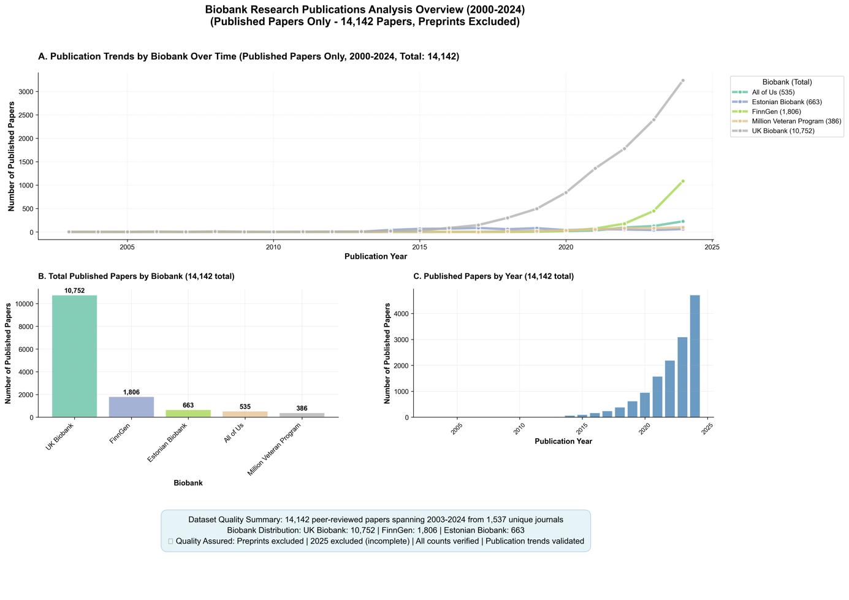
Figure 1. Growth and Distribution of Peer-Reviewed Publications Linked to Global EHR-Linked Biobanks (2000-2024). (A) Year-by-year publication counts by biobank show sharp acceleration in biobank-linked research after 2018, with the UK Biobank leading in both volume and growth rate. FinnGen displays the most rapid post-2020 rise among newer initiatives. (B) Total number of peer-reviewed, PubMed-indexed publications by biobank, excluding preprints and records from 2025. (C) Aggregate publication output per year across all five biobanks.
A biobank-specific view of these publication trajectories is shown in Supplementary Figure S3, which breaks down annual output into individual contributions. The UK Biobank consistently dominates the overall trend, but the contribution of FinnGen has grown considerably since 2021. Meanwhile, All of Us and MVP contribute smaller but steady publication volumes, with thematic distinctiveness shaped by their mandates in health equity and veteran health, respectively. These results reveal a field in the midst of rapid expansion, yet marked by unequal visibility across biobanks.

Decoding Biobank Themes Through MeSH Term Frequencies
To further understand the scientific focus of biobank-driven research, we analysed the distribution of MeSH terms associated with published articles from each biobank. Figure 2 presents the top 10 most frequently occurring MeSH terms for each biobank, capturing the dominant biomedical themes, population descriptors, and methodological constructs that define their respective research landscapes.
Across all biobanks, the term “Humans” was the most frequently assigned descriptor, appearing in 8879 articles from UK Biobank and in over 300 publications from each of the others. This universal label reflects the default indexing of studies involving human participants and serves as a baseline for comparative interpretation. Consistent across all initiatives, sex- and age-based demographic tags such as “Female,” “Male,” “Middle Aged,” and “Aged” also appear prominently, underscoring a shared emphasis on stratified population analyses.
UK Biobank’s top terms (Figure 2, top left) reflect both methodological and institutional specificity. In addition to “Humans” and sex-based terms, UK Biobank research is heavily indexed with “United Kingdom,” “Biological Specimen Banks,” “Risk Factors,” and “Genome-Wide Association Study”; the latter aligning with its foundational role in common variant discovery. The presence of “Biological Specimen Banks” as a top-10 term uniquely underscores UK Biobank’s role as a reference infrastructure as well as a data source.
FinnGen (Figure 2, top right) exhibits a distinct methodological tilt, with “Mendelian Randomization Analysis” among its most frequent terms (more than 1000 articles), highlighting its contribution to causal inference frameworks. Other frequent tags include “Genome-Wide Association Study,” “Polymorphism, Single Nucleotide,” and “Genetic Predisposition to Disease,” aligning with its registry-linked design for genotype-to-phenotype discovery. The inclusion of “Gastrointestinal Microbiome” is noteworthy, suggesting emerging interest in host-microbiome interactions.
All of Us (Figure 2, bottom left) presents a more socio-clinical profile. In addition to standard demographic terms, high-frequency MeSH annotations include “United States,” “Population Health,” “Cross-Sectional Studies,” and “Young Adult.” This pattern reflects the programme’s emphasis on representation, diversity, and broad EHR-based phenotyping in younger and underserved populations. Notably, “Genome-Wide Association Study” is absent from the top 10, suggesting relatively less genomic emphasis in published outputs to date.
The Estonian Biobank (Figure 2, bottom center) aligns more closely with FinnGen in its top MeSH terms, with frequent annotation of “Genome-Wide Association Study,” “Polymorphism, Single Nucleotide,” and “Phenotype.” These terms reinforce Estonia’s long-standing investment in population-scale genetics and integrative omics, albeit at a lower publication volume.
The Million Veteran Program (Figure 2, top center) exhibits a unique institutional signature. In addition to genetic terms, “Veterans” appears among the top descriptors, reflecting the biobank’s mission and participant base. The co-occurrence of “Genome-Wide Association Study,” “Risk Factors,” and “Genetic Predisposition to Disease” alongside “Veterans” suggests a convergence of genomics and military-linked population health.
For comparison, Figure 2 (bottom right) presents the top MeSH terms aggregated across all non-UK biobanks (otherwise, UK Biobank terms would dominate due to its much greater volume). While MeSH terms in non-UK biobanks echo the prevalence of human, sex, and genetic descriptors, the overall frequency is markedly lower, and terms related to specimen infrastructure or environmental exposure are notably absent. This contrast illustrates how the UK Biobank has not only scaled publication output but has also broadened its thematic reach, incorporating environmental epidemiology and infrastructure-focused research.
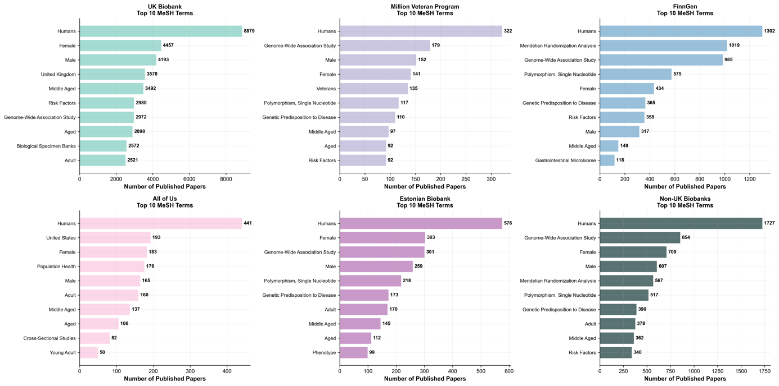
Figure 2. Most Frequently Occurring MeSH Terms Across Global EHR-Linked Biobanks (2000-2024). Bar plots showing the top 10 Medical Subject Headings (MeSH) terms by frequency for each of five biobanks (UK Biobank, Million Veteran Program, FinnGen, All of Us, and Estonian Biobank) as well as for all non-UK biobanks combined. Terms were extracted from peer-reviewed, PubMed-indexed articles and reflect high-level descriptors of study focus, population characteristics, and methodological orientation.

Semantic Clustering Reveals Biobank-Specific Research Signatures
To investigate the thematic composition of publications linked to the five major biobank initiatives analysed here, we applied unsupervised clustering to MeSH term profiles extracted from 11,726 publications with available MeSH annotations from the 14,142 PubMed-indexed articles. Each biobank was analysed independently to preserve its distinct research identity, and clustering was performed using a TF-IDF representation of MeSH terms, followed by bootstrap-based selection of the optimal number of clusters and k-means clustering. To aid interpretation, we projected the high-dimensional term vectors onto a two-dimensional space using principal component analysis (PCA). The resulting visualisation highlights the spatial arrangement and density of semantic clusters for each biobank (Figure 3), with clusters varying in compactness and dispersion according to the biobank's thematic breadth. Supplementary Table S1 provides descriptive summaries of dominant terms and inferred research themes within each biobank cluster.

UK Biobank Shows the Most Heterogeneous and Structurally Complex Landscape
Among all biobanks analysed, the UK Biobank exhibited the most extensive semantic spread, consistent with its large publication volume (9,056 clusterable articles). The clustering revealed ten distinct thematic groups with marked size variation. The largest cluster (C1, 1,858 publications) represents general biobank research infrastructure, characterised by terms such as “biological specimen banks” and “United Kingdom.” A substantial Mendelian randomisation cluster (C5, 1,174 publications) reflects the biobank’s methodological focus on causal inference. The neuroimaging cluster (C7, 581 publications) is uniquely defined by “brain,” “magnetic resonance imaging,” and “white matter,” underscoring UK Biobank’s imaging subcohort. A distinct environmental health cluster (C2, 207 publications) emerged with high-weight terms including “air pollution,” “particulate matter,” and “environmental exposure,” revealing a specialised research focus on environmental determinants of health. Two large demographic clusters (C8 and C9, 1,499 and 1,253 publications, respectively) capture age- and sex-stratified analyses typical of population-scale studies.
FinnGen Prioritises Disease-Specific Research with Genomic Methods
FinnGen’s publication profile (1,308 clusterable articles) showed a more concentrated structure, with fewer very large clusters and multiple smaller disease-focused groups. The largest cluster (C8, 456 publications) is dominated by genome-wide association studies and Mendelian randomisation, reflecting FinnGen’s methodological backbone. Smaller clusters reveal distinctive disease emphases: C5 (34 publications) centres on inflammatory bowel diseases, with terms such as “Crohn disease” and “colitis ulcerative.” Cluster C3 (73 publications) captures pregnancy-related complications, including “gestational diabetes” and “preeclampsia.” Cluster C6 (100 publications) is focused on the gastrointestinal microbiome, while C1 (61 publications) combines causal inference methods with psychiatric outcomes such as depression. This structure underscores FinnGen’s identity as a disease-specific genomic discovery engine rooted in registry-based resources.

Estonian Biobank Emphasises Regulatory Genomics and Cardiometabolic Traits
The Estonian Biobank (587 clusterable articles) formed ten balanced clusters, with relatively even distribution compared to UK Biobank or FinnGen. Cluster C1 (108 publications) is methodological, focusing on GWAS. Cluster C5 (105 publications) centres on cardiometabolic traits such as body mass index and obesity. Cluster C7 (33 publications) is anchored in regulatory genomics, with “DNA methylation” and “CpG islands” among the dominant terms, marking Estonia’s contribution to epigenetics research. Cluster C3 (54 publications) captures metabolomics, while Cluster C6 (50 publications) reflects European collaborative infrastructure. A smaller but notable cluster (C8, 26 publications) features animal models, signalling a translational orientation linking human genomic findings to mechanistic work. All these clusters indicate Estonia’s niche in regulatory layers and translational genomics, with cardiometabolic disease and multi-omics integration as key strengths.

All of Us Concentrates on Diversity, Population Health, and Pandemic Response
The All of Us research corpus (450 clusterable articles) displayed ten compact clusters, consistent with its shorter publication history but wide-ranging institutional mandate. Cluster C5 (38 publications) anchors the programme’s policy-driven identity around “precision medicine” and “biomedical research.” Cluster C6 (32 publications) captures COVID-19 and mental health, with “depression,” “COVID-19,” “anxiety,” and “SARS-CoV-2” among the dominant descriptors. Two population health clusters (C3, 28 publications; C4, 58 publications) emphasise epidemiological study designs (“case-control studies,” “cross-sectional studies”). Cluster C7 (35 publications) represents genomics, although this remains proportionally smaller than in UK Biobank or FinnGen. Additional clusters highlight demographic tags such as “United States,” “young adult,” and “population health,” consistent with the programme’s focus on diversity and representation. These clusters project a socio-clinical identity where genomics is integrated but not yet central, and responsiveness to equity and urgent health challenges is paramount.

MVP Features Veteran-Specific Pathologies and Risk Profiles
Although comprising the fewest clusterable publications (325 articles), the Million Veteran Program revealed ten well-differentiated clusters that reflect its unique participant population. Cluster C3 (28 publications) centres on lipid genetics (“triglycerides,” “HDL cholesterol”), consistent with cardiovascular research priorities. Cluster C7 (21 publications) explicitly encodes “veterans” and “traumatic brain injury,” distinguishing MVP from civilian cohorts. Mental health appears in multiple clusters: C6 (29 publications) highlights PTSD with terms such as “stress disorders, post-traumatic,” while C9 (12 publications) is focused on suicide and major depression. Cluster C4 (37 publications) represents COVID-19 mobilisation, and Cluster C0 (31 publications) corresponds to Veterans Affairs institutional research. These clusters illustrate MVP’s distinctive veteran-centred research profile, integrating cardiovascular and genomic themes with uniquely military exposures and mental health priorities.
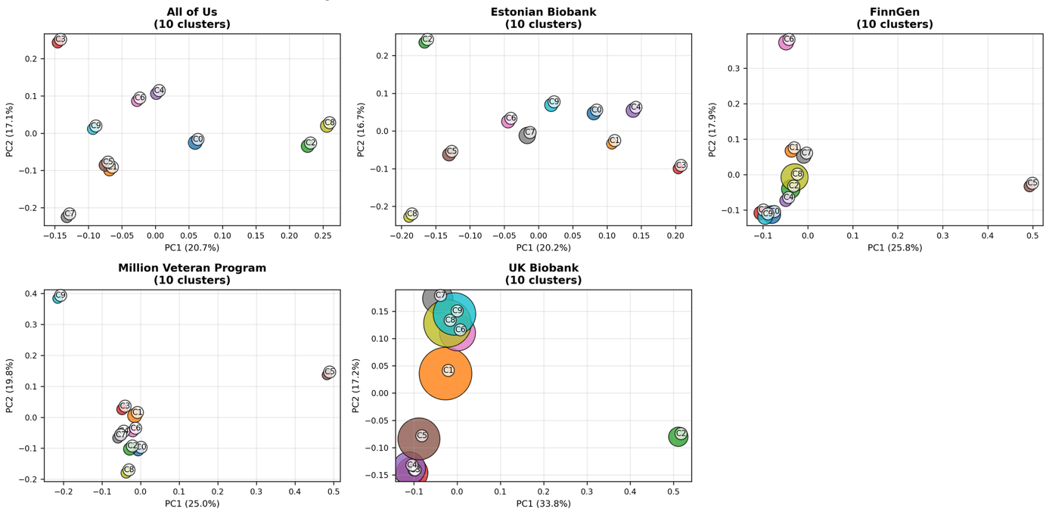
Figure 3. Semantic cluster composition by biobank. Principal component analysis (PCA) plots showing MeSH-based semantic clusters for five major biobanks: All of Us, Estonian Biobank, FinnGen, Million Veteran Program, and UK Biobank. Each panel displays 10 clusters per biobank, derived from TF-IDF-weighted MeSH term embeddings followed by k-means clustering. Axes represent the first two principal components of the MeSH vector space, with variance explained by PC1 and PC2 indicated on each plot. Circle size is proportional to the number of publications assigned to each cluster. Cluster IDs (C0–C9) correspond to the thematic groups described in Supplementary Table S1. The relative separation, dispersion, and density of clusters highlight differences in thematic breadth and research focus across the five biobanks.

Research Gaps Reveal Missed Opportunities for Biobank Contributions
To evaluate the alignment between biobank-linked research and global health needs, we analysed the 11,726 publications with available MeSH annotations and mapped them to 25 high-burden disease areas. Figure 4A shows a heatmap of publication counts per disease-biobank pair. The UK Biobank dominates research output across nearly all disease areas, contributing over 1,000 publications on stroke, nearly 700 on Alzheimer’s disease, and several hundred on common conditions such as lung cancer, asthma, and ischemic heart disease.
In contrast, non-UK biobanks (Million Veteran Program, FinnGen, All of Us, and the Estonian Biobank) exhibit markedly sparser coverage. Many diseases with substantial global burden (particularly tuberculosis, neglected tropical diseases, diarrheal diseases, road traffic injuries, and malaria) remain underrepresented or entirely absent from their research portfolios. For example, malaria and road traffic accidents have only one publication each across all five biobanks. Diseases with high nonfatal burden, such as low back pain and cataracts, also receive limited attention.
Figure 4B quantifies this imbalance through a biobank-specific “Research Opportunity Score”, which captures the cumulative burden of diseases with two or fewer associated publications in each biobank. UK Biobank, despite having the broadest coverage, still exhibits unrealised potential with a score of 848 across two critical gaps (malaria and road traffic accidents). Other biobanks show significantly higher opportunity scores and a greater number of underrepresented diseases: MVP (464; 6 gaps), Estonian Biobank (456; 5 gaps), FinnGen (428; 3 gaps), and All of Us (366; 3 gaps). These findings highlight major institutional opportunities to address neglected, yet high-impact, disease areas through more inclusive biobank research strategies.
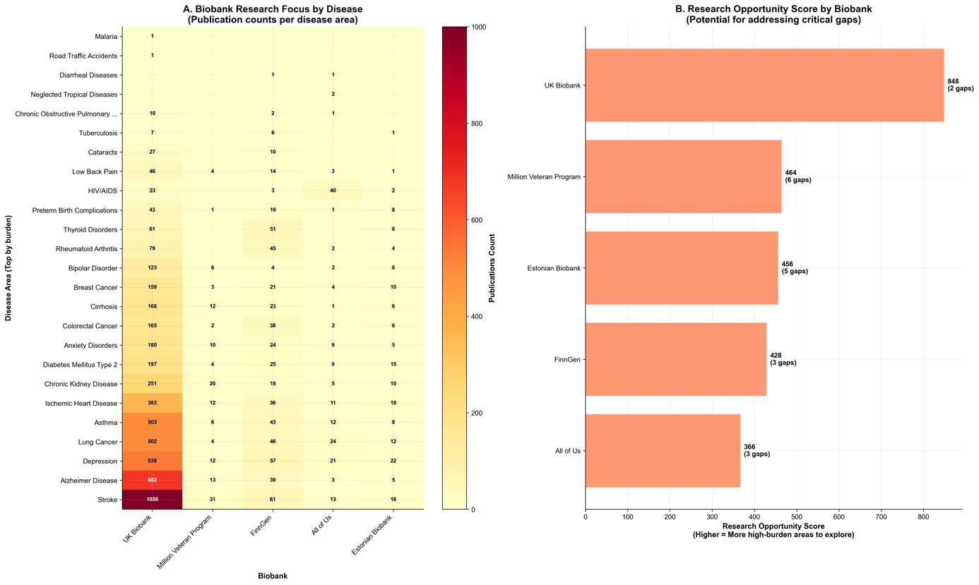
Figure 4. Disease-specific research coverage and research opportunity scores by biobank. (A) Heatmap showing the number of peer-reviewed, PubMed-indexed publications linked to each of five biobanks across 25 high-burden global diseases. Disease burden rankings are derived from DALYs, deaths, and prevalence metrics in GBD 2021 (27). Color intensity indicates publication volume. UK Biobank demonstrates broad thematic coverage, while other biobanks show selective emphasis and limited engagement with diseases like malaria, tuberculosis, and neglected tropical diseases. (B) Bar plot showing each biobank’s Research Opportunity Score, defined as the summed burden of diseases with ≤2 associated publications. Higher scores indicate more unmet potential to address critical global health gaps.

Structural Imbalances in Disease Representation
We evaluated the overall landscape of research gaps across all 25 disease areas, integrating gap severity, burden-research misalignment, category-level intensity, and priority areas for intervention (Figure 5). Among the diseases assessed, 64% were classified as having low research gaps, while 8% showed moderate gaps, 12% high gaps, and 16% critical gaps, defined by high burden and minimal biobank representation (Figure 5A). This distribution underscores that while many diseases are reasonably represented, a significant subset remains severely neglected.
Figure 5B compares disease burden and research output for the ten highest-burden conditions using normalised values. While stroke and ischemic heart disease show roughly proportional research engagement, several diseases (including diarrheal diseases, low back pain, road traffic accidents, depression, and malaria) stand out for their high global burden yet disproportionately low biobank-linked publication counts. These imbalances suggest missed opportunities for impact in areas of major public health importance.
Research intensity also varied substantially across disease categories, as shown in Figure 5C. Injuries, maternal and child health, infectious diseases, and neglected diseases exhibited the lowest levels of research intensity, indicating the largest misalignment between global burden and biobank-linked research activity. In contrast, endocrine and neurological diseases showed the highest research intensity, suggesting that these areas receive disproportionately more attention relative to their DALY burden. This pattern reflects structural imbalances in thematic focus, where conditions prevalent in high-income settings are more comprehensively studied than those disproportionately affecting low- and middle-income populations.
Four diseases emerged as especially critical: diarrheal diseases, malaria, tuberculosis, and neglected tropical diseases. As shown in Figure 5D, these conditions account for a combined burden of over 175 million DALYs but have received negligible attention in biobank-enabled research.
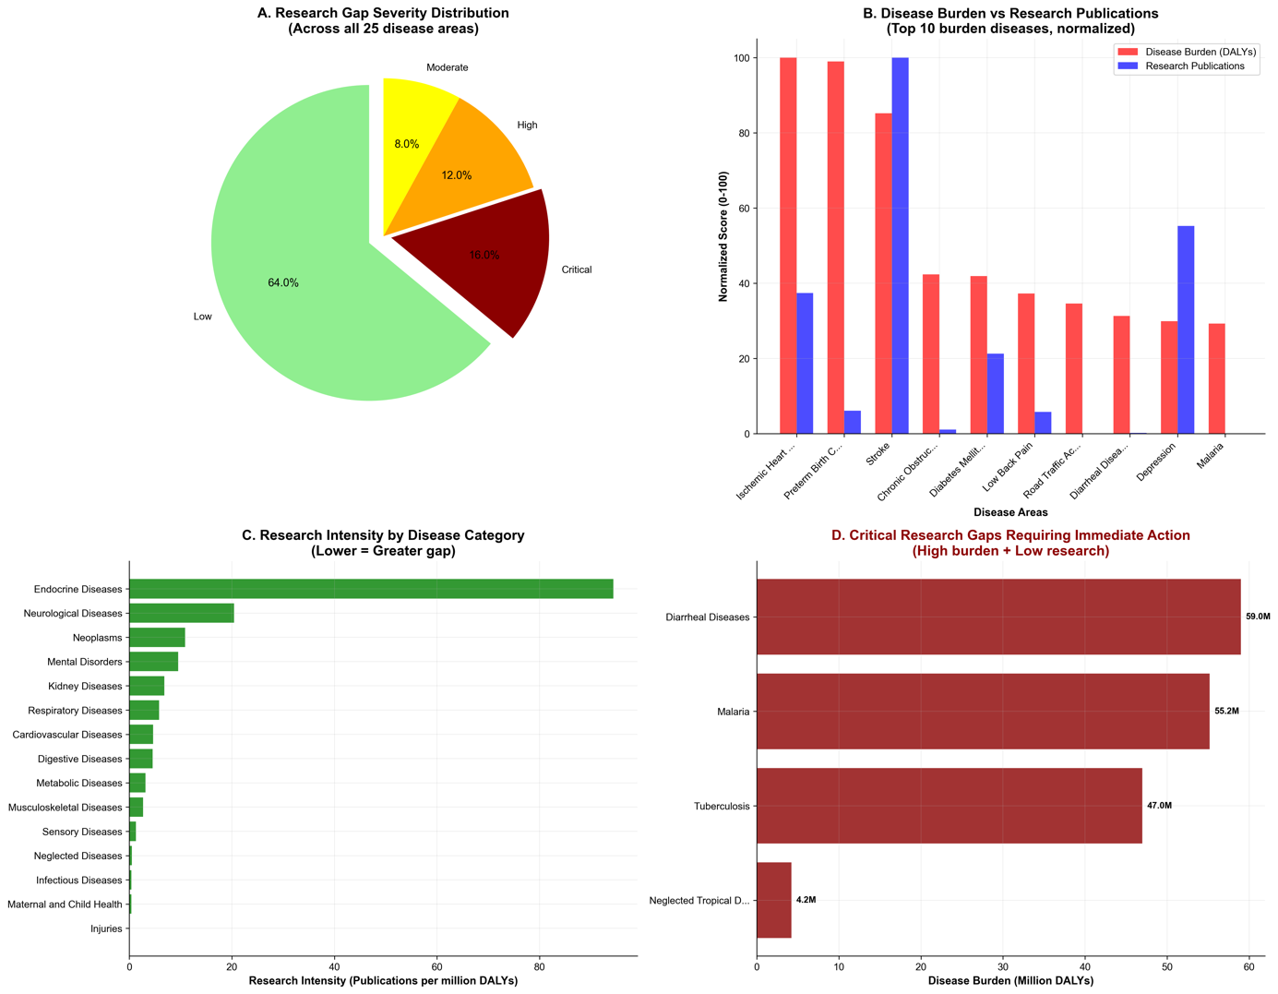
Figure 5. Summary of research gaps across 25 high-burden diseases. (A) Pie chart showing the distribution of research gap severity classifications across 25 diseases. Categories are defined based on gap score thresholds derived from burden and publication alignment: Critical (>70), High (50–70), Moderate (30–50), and Low (<30). (B) Bar plot comparing normalised disease burden (red) and research publications (blue) for the top 10 highest-burden conditions. Values are scaled from 0 to 100 for comparability. Discrepancies highlight under-researched conditions with disproportionately high global burden. (C) Research intensity across disease categories, calculated as the number of biobank-linked publications per million DALYs. Lower bars indicate greater thematic neglect. Injuries, maternal and child health, infectious diseases, and neglected diseases rank among the lowest. (D) Bar chart showing the disease burden (in millions of DALYs) for the four most critically underrepresented conditions: diarrheal diseases, malaria, tuberculosis, and neglected tropical diseases. These conditions received minimal or no attention in the biobank literature and represent urgent priorities for realignment.

Implications for the Field
This review offers a data-driven analysis of the research footprint of five globally prominent EHR-linked biobanks, uncovering critical asymmetries between research activity and global disease burden. Over the past decade, research output from these initiatives has expanded rapidly, with 14,142 peer-reviewed publications indexed between 2000 and 2024. This surge reflects a broader inflection point in genomics, marked by the rise of open-access data models, high-throughput genotyping, and scalable analytic pipelines. UK Biobank stands out as the dominant contributor by volume, but newer programmes such as FinnGen are gaining momentum, demonstrating rapid growth and a strong focus on methodological coherence. Notably, each biobank exhibits a distinct thematic identity shaped by its institutional design, participant demographics, and data architecture.
Thematic profiles derived from MeSH term frequencies reveal how these identities are encoded in the published literature. UK Biobank integrates infrastructure-related terms and environmental health descriptors, whereas FinnGen emphasises Mendelian randomisation and registry-based phenotyping. All of Us prioritises diversity and socioclinical themes, while MVP is characterised by veteran-specific descriptors. These MeSH-based distinctions are reinforced by semantic clustering, which reveals not only differences in research volume but in the conceptual terrain that each biobank occupies. For instance, UK Biobank’s wide cluster dispersion reflects broad methodological and phenotypic coverage, with dedicated clusters for neuroimaging and environmental exposure. In contrast, FinnGen and the Estonian Biobank exhibit tightly packed clusters centred on GWAS and molecular trait analysis, indicating narrower but deeply developed thematic foci. All of Us shows a broader but more fragmented distribution, while MVP occupies a distinct semantic space focused on military-specific exposures, mental health, and cardiovascular risk.
The clustering framework thus offers an overview of how research priorities, methodological traditions, and institutional mandates translate into published knowledge. While traditional bibliometrics can capture growth trends, semantic analysis enables comparative insight into what is studied, by whom, and through what lens. The compactness of FinnGen’s clusters, the spread of All of Us, and the semantic outlier status of MVP all point to biobanks as epistemically differentiated entities. As biobanks continue to scale, tracking thematic drift and blind spots through semantic embeddings may be critical for evaluating conceptual equity and research breadth.
While thematic profiles illuminate what biobanks choose to study, alignment with global disease burden reveals what remains overlooked. Our findings show that research outputs remain disproportionately concentrated in conditions prevalent in high-income countries, particularly cardiovascular, metabolic, and neurodegenerative disorders. Conditions such as malaria, tuberculosis, diarrheal diseases, and neglected tropical diseases, despite their global health impact, are strikingly underrepresented across all five biobanks. This imbalance signals missed opportunities to apply biobank-scale, genomically informed methods to urgent public health challenges.
The divergence between research intensity and disease burden is partly explained by each biobank’s mandate and design. UK Biobank, while population-based, remains geographically and demographically constrained. MVP and All of Us pursue targeted priorities (veteran health and inclusivity, respectively) but operate within U.S. institutional contexts. None of the five initiatives has an explicit remit to serve the Global South, where most neglected conditions are concentrated. Our burden-adjusted research opportunity score quantifies this mismatch and identifies concrete areas where each biobank could expand its thematic footprint.
Aggregated across all 25 diseases (chosen to reflect high global burden, broad category representation, and equity relevance), the research gap landscape shows that 16% of conditions represent critical gaps, defined by high DALYs and minimal publication activity. Diarrheal diseases, malaria, tuberculosis, and neglected tropical diseases each carry substantial burden yet remain nearly absent from biobank research. The research intensity analysis further reveals that maternal and child health, injuries, and infectious diseases are systematically deprioritised. These gaps are not only epidemiological blind spots, they are symptoms of entrenched disparities in data architecture, cohort accessibility, and research agenda-setting.
The impact of biobanks is further conditioned by accessibility, both financial and procedural. Data access fees, institutional eligibility criteria, and complex governance requirements can inadvertently disadvantage researchers in the Global South, constraining equitable participation in biobank-enabled science. Future work could integrate access feasibility as a quantitative dimension of equity assessment.
Our analysis carries some limitations. First, the reliance on MeSH term annotations may underrepresent recent or not-yet-indexed publications and miss cases where disease relevance is implicit rather than explicit. Second, while the MeSH-to-disease mappings were manually curated for precision, they may still overlook multisystem or comorbid presentations. Third, our global burden estimates are derived from DALYs, deaths, and prevalence aggregated at the global level, without regional stratification. Finally, our analysis includes only biobanks with substantial PubMed presence; the inclusion of region-specific or emerging biobanks may alter observed patterns and should be a focus of future work.
Despite these constraints, the semantic and burden-based scoring framework presented here offers a scalable tool for monitoring thematic balance in biomedical research. Metrics such as the research opportunity score could be incorporated into annual reporting, strategic reviews, and data access committee deliberations. Researchers selecting biobanks should be encouraged to consider not just sample size or analytic infrastructure, but the thematic alignment and representational footprint of the resource. Funders, meanwhile, could incentivise coverage of underrepresented conditions, support cross-biobank harmonisation, and invest in platforms serving neglected populations.
These findings also raise structural questions about global inclusivity in biobank science. The underrepresentation of diseases endemic to the Global South may reflect deeper authorship, agenda-setting, and data governance inequities. This echoes the WHO Genomics Programme’s recent call for equitable implementation of genomics worldwide (9) and aligns with ethical critiques of how genomic technologies must balance benefit and harm across diverse populations (28). Initiatives in Latin America, Africa, and Southeast Asia offer a historic opportunity to rebalance the ecosystem, provided they are supported by equitable funding, global collaboration frameworks, and robust governance. As biobank-scale research continues to shape the future of precision medicine, ensuring thematic diversity and burden alignment will be essential for realising its full scientific and societal potential.

Opportunities and Future Directions
The analyses presented here reveal deep asymmetries in how biobank-enabled research maps onto global health priorities. Yet quantifying inequities in biobank-driven research should not remain a scholarly exercise. Composite gap scores and opportunity indices can be operationalised as governance instruments. Just as funders demand reporting on diversity in clinical trials, biobanks could be required to disclose annual “equity dashboards” that track research output against the global burden of disease. Data access committees could integrate disparity metrics into their evaluation frameworks, ensuring that decisions about sample release are aligned with scientific rigour and health needs. If systematic disparity analyses are embedded into governance, biobanks can move from being passive infrastructures to active stewards of equity.
While global disease burden provides a valuable external benchmark, any equity-scoring or dashboard framework must remain adaptable to local health mandates. Most biobanks are funded through national agencies and aligned to domestic health priorities. Therefore, a balanced approach should combine global burden indicators with national relevance metrics to contextualise performance fairly.
AI-driven phenotyping and natural language processing of electronic health records can uncover latent patterns in undercoded populations, improving inclusion where structured data are sparse. Large language models (LLMs), if retrained on multilingual and non-Western corpora, could accelerate discovery in neglected disease areas by mining literature beyond English-language dominance. These tools are not inherently equitable but, deployed deliberately, they could democratise analytic power and reduce barriers for low-resource settings.
Although harmonisation has often been pursued in the name of efficiency, it must now be reoriented toward equity. The Global Alliance for Genomics and Health (GA4GH) consortia have demonstrated the feasibility of aligning data standards, access frameworks, and metadata schemas (29). The next step is to embed equity benchmarks into harmonisation charters: ensuring that multi-biobank analyses do not simply aggregate data from high-income countries, but also prioritise the integration of underrepresented cohorts. Equity-sensitive harmonisation should allow disease areas like tuberculosis, malaria, and maternal health to be studied with the same depth as cardiovascular or neurodegenerative disorders.

Regional Biobank Networks and Policy Incentives for Equity
The most promising opportunities for rebalancing the global biobank ecosystem are emerging in Latin America, Africa, and Southeast Asia. Initiatives such as H3Africa (30), Uganda’s Genome Resource (31), and the Peruvian Genome Project (32) demonstrate that regional biobanks can serve as anchors of representation, rooted in local health priorities and cultural contexts. Regional networks can provide critical counterweights to Euro-American dominance, ensuring that genomic discovery is not decoupled from the disease burdens most acutely felt outside the Global North. These networks must be supported with sustained funding, equitable governance, and reciprocal data-sharing partnerships, avoiding extractive models of collaboration.
Funders can establish protected streams for equity-driven research, insulated from shifting political climates. Journals can adopt explicit editorial policies protecting disparity research, ensuring that studies documenting underrepresentation are evaluated on scientific merit rather than political sensitivity. Regulators and ministries of health can require equity reporting as a condition for data release, in the same way that trial registries now enforce transparency. Incentives matter: without explicit policy levers, equity will remain aspirational rather than operational (See the sidebar titled Future Governance Levers for Equity in Biobanking).
Box 2. Future Governance Levers for Equity in Biobanking

Equity dashboards as regulatory instruments
Annual publication of disparity metrics (e.g., gap scores, Research Opportunity Scores) could become a requirement for continued funding or data release, much like financial audits.

Conditional data access
Biobanks could adopt policies where access to high-value datasets is contingent on demonstrable equity commitments such as inclusion of LMIC collaborators or disease areas of global relevance.

Federated ethics review
Cross-biobank projects could be governed by distributed ethics committees with representation from multiple regions, preventing dominance of high-income country perspectives in sensitive decisions.

Global equity index for funders
Funding agencies could use a standardised index (combining burden alignment, authorship parity, and data reciprocity) to evaluate whether biobank investments advance or hinder global health equity.

Sovereignty-aware governance
New models could allow countries contributing genomic data to retain partial governance rights over secondary analyses, aligning with calls for “data sovereignty” in international genomics.

A Decadal Vision for Equitable Biobanking
Looking forward to 2035, we can envisage a transformed global ecosystem. Equity metrics would be routinely reported in biobank annual statements, just as financial audits are today. Regional biobank networks across all WHO regions would ensure representation of major ancestries and health burdens, linked through harmonised standards that prioritise inclusion. AI-powered platforms would enable secure federated analyses across continents, democratising analytic capacity. Governance boards would include representatives from underrepresented populations, shifting power in agenda-setting. And critically, neglected diseases (malaria, tuberculosis, diarrhoeal conditions, maternal disorders) would feature in biobank-driven discoveries at a scale commensurate with their global impact.
Such a vision requires that we treat equity as infrastructure, not as an optional add-on. The opportunity is not merely to build larger biobanks, but to build fairer ones. In doing so, we ensure that the promise of precision medicine is not the privilege of a few populations, but a shared global good.

Concluding Remarks
This review of 14,142 peer-reviewed publications linked to five globally influential EHR-linked biobanks (UK Biobank, Million Veteran Program, FinnGen, All of Us, and the Estonian Biobank) portrays a research ecosystem that is both rapidly expanding and health equity imbalanced. Since 2018, biobank-enabled studies have grown at an unprecedented pace, fuelled by open data models, advances in sequencing, and the adoption of AI-driven analytic pipelines. Yet our comparative analysis reveals persistent misalignments: the majority of research attention continues to cluster around conditions prevalent in high-income countries, while diseases that account for a disproportionate share of global burden (including malaria, tuberculosis, diarrhoeal diseases, and neglected tropical diseases, together responsible for over 175 million DALYs) remain almost entirely absent from leading biobank portfolios.
Semantic clustering highlights the distinctive research signatures of each biobank: UK Biobank’s wide methodological scope, FinnGen’s concentration on genomic discovery, and All of Us’s socio-clinical emphasis on diversity. However, across all initiatives the burden-adjusted gap analysis underscores a critical weakness: none has yet developed a systematic remit to serve the health priorities of low- and middle-income populations. Even the UK Biobank, the most comprehensive in scale and breadth, exhibits considerable unrealised potential to address critical global health challenges.
The research opportunity scores introduced here provide a quantitative foundation for identifying neglected areas and can be adapted as equity metrics for governance, funding, and cross-biobank coordination. More broadly, the methodological framework we present (integrating MeSH-based semantic mapping with burden-adjusted scoring) illustrates how bibliometric and informatic tools can be harnessed to monitor equity in real time. Addressing these asymmetries will require not only methodological innovation but structural rebalancing of global funding and access frameworks that continue to shape who can participate in biobank-enabled discovery.
As EHR-linked biobanks continue to evolve, the challenge is no longer only scientific but ethical and geopolitical: ensuring that these infrastructures advance not just discovery but fairness. If disparity monitoring and equity incentives are systematically embedded into biobank practice, population-scale research can be redirected to address both urgent public health needs and neglected global conditions. The accelerating expansion of biobank science is one of the defining advances of modern biomedicine; its full promise will only be realised when the diversity of human health is equitably represented in its outputs.

Code Availability
All data and code used in this study are publicly available via the GitHub repository: https://github.com/manuelcorpas/17-EHR. The repository includes Python scripts for PubMed data retrieval, MeSH term extraction, TF-IDF vectorisation, unsupervised clustering, and dimensionality reduction via PCA and UMAP. It also contains the curated corpus of 14,142 peer-reviewed biobank-linked publications used in the analysis and manually validated MeSH-to-disease mappings. The source Global Burden of Disease (GBD) 2021 CSV file containing DALY, mortality, and prevalence estimates for the 25 diseases assessed is provided (please note GBD licensing terms apply). Additionally, the repository includes the complete codebase for computing burden-adjusted research gap scores and biobank-specific opportunity indices. All components are licensed under the MIT License and may be freely reused or adapted for academic and non-commercial purposes. Full documentation is provided to support reproducibility and collaborative development.

References
1. Beesley LJ, Salvatore M, Fritsche LG, Pandit A, Rao A, et al. 2020. The Emerging Landscape of Health Research Based on Biobanks Linked to Electronic Health Records: Existing Resources, Statistical Challenges and Potential Opportunities. Stat Med. 39(6):773–800
2. Lee H, Kim W, Kwon N, Kim C, Kim S, An J-Y. 2025. Lessons from national biobank projects utilizing whole-genome sequencing for population-scale genomics. Genomics & Informatics. 23(1):8
3. Beesley LJ, Salvatore M, Fritsche LG, Pandit A, Rao A, et al. 2020. The emerging landscape of health research based on biobanks linked to electronic health records: Existing resources, statistical challenges, and potential opportunities. Stat Med. 39(6):773–800
4. Linder JE, Bastarache L, Hughey JJ, Peterson JF. 2021. The Role of Electronic Health Records in Advancing Genomic Medicine. Annu Rev Genomics Hum Genet. 22:219–38
5. Krebs K, Milani L. 2023. Harnessing the Power of Electronic Health Records and Genomics for Drug Discovery. Annu Rev Pharmacol Toxicol. 63:65–76
6. Kinkorová J. 2016. Biobanks in the era of personalized medicine: objectives, challenges, and innovation. EPMA J. 7(1):4
7. Valenti A, Falcone I, Valenti F, Ricciardi E, Di Martino S, et al. 2024. Biobanks as an Indispensable Tool in the “Era” of Precision Medicine: Key Role in the Management of Complex Diseases, Such as Melanoma. J Pers Med. 14(7):731
8. Lin J-C, Liu Y-L, Hsiao WW-W, Fan C-T. 2024. Integrating population-based biobanks: Catalyst for advances in precision health. Computational and Structural Biotechnology Journal. 24:690–98
9. Ambrosino E, Abou Tayoun AN, Abramowicz M, Zilfalil BA, Boughtwood T, et al. 2024. The WHO genomics program of work for equitable implementation of human genomics for global health. Nat Med. 30(10):2711–13
10. Sudlow C, Gallacher J, Allen N, Beral V, Burton P, et al. 2015. UK biobank: an open access resource for identifying the causes of a wide range of complex diseases of middle and old age. PLoS Med. 12(3):e1001779
11. Bycroft C, Freeman C, Petkova D, Band G, Elliott LT, et al. 2018. The UK Biobank resource with deep phenotyping and genomic data. Nature. 562(7726):203–9
12. Gaziano JM, Concato J, Brophy M, Fiore L, Pyarajan S, et al. 2016. Million Veteran Program: A mega-biobank to study genetic influences on health and disease. J Clin Epidemiol. 70:214–23
13. Kurki MI, Karjalainen J, Palta P, Sipilä TP, Kristiansson K, et al. 2023. FinnGen provides genetic insights from a well-phenotyped isolated population. Nature. 613(7944):508–18
14. The All of Us Research Program Investigators. 2019. The “All of Us” Research Program. New England Journal of Medicine. 381(7):668–76
15. Bick AG, Metcalf GA, Mayo KR, Lichtenstein L, Rura S, et al. 2024. Genomic data in the All of Us Research Program. Nature. 627(8003):340–46
16. Milani L, Alver M, Laur S, Reisberg S, Haller T, et al. 2025. The Estonian Biobank’s journey from biobanking to personalized medicine. Nat Commun. 16(1):3270
17. Heeney C, Kerr SM. 2017. Balancing the local and the universal in maintaining ethical access to a genomics biobank. BMC Med Ethics. 18:80
18. Mapes BM, Foster CS, Kusnoor SV, Epelbaum MI, AuYoung M, et al. 2020. Diversity and inclusion for the All of Us research program: A scoping review. PLOS ONE. 15(7):e0234962
19. Sordillo JE, Dey A, Ho Y-L, Kosik N, Harrington K, et al. 2024. Military and occupational exposures among Veterans in the Million Veteran Program by survey self-report: a descriptive study. Occup Environ Med. 81(10):522–28
20. Coppola L, Cianflone A, Grimaldi AM, Incoronato M, Bevilacqua P, et al. 2019. Biobanking in health care: evolution and future directions. Journal of Translational Medicine. 17(1):172
21. Kinkorová J, Topolčan O. 2020. Biobanks in the era of big data: objectives, challenges, perspectives, and innovations for predictive, preventive, and personalised medicine. EPMA J. 11(3):333–41
22. Colwill M, Baillie S, Pollok R, Poullis A. 2024. Biobanks and biomarkers: Their current and future role in biomedical research. World J Methodol. 14(4):91387
23. Zhong J, Zhang P, Dong Y, Xu Y, Huang H, et al. 2024. Well‐Being and Cardiovascular Health: Insights From the UK Biobank Study. Journal of the American Heart Association. 13(19):e035225
24. Corpas M, Iacoangeli A. 2025. Large Language Models for Mining Biobank-Derived Insights into Health and Disease
25. González-Fraile E, Soriano V, Ramos JM, Gallego L, Berzosa-Grande MP, et al. 2025. Two decades of hospital admissions for adolescents with depression in Spain. Journal of Affective Disorders. 389:119672
26. TF–IDF. 2011. In Encyclopedia of Machine Learning, pp. 986–87. Springer, Boston, MA
27. Ferrari AJ, Santomauro DF, Aali A, Abate YH, Abbafati C, et al. 2024. Global incidence, prevalence, years lived with disability (YLDs), disability-adjusted life-years (DALYs), and healthy life expectancy (HALE) for 371 diseases and injuries in 204 countries and territories and 811 subnational locations, 1990–2021: a systematic analysis for the Global Burden of Disease Study 2021. The Lancet. 403(10440):2133–61
28. Gaydarska H, Takashima K, Shahrier S, Raz A, Minari J. 2024. The interplay of ethics and genetic technologies in balancing the social valuation of the human genome in UNESCO declarations. Eur J Hum Genet. 32(6):725–30
29. Rehm HL, Page AJH, Smith L, Adams JB, Alterovitz G, et al. 2021. GA4GH: International policies and standards for data sharing across genomic research and healthcare. Cell Genomics. 1(2):100029
30. Sengupta D, Choudhury A, Ramsay M. 2025. H3Africa: a model for implementing biobank-based genomic research in resource-constrained settings. Hum Mol Genet, p. ddaf113
31. Gurdasani D, Carstensen T, Fatumo S, Chen G, Franklin CS, et al. 2019. Uganda Genome Resource Enables Insights into Population History and Genomic Discovery in Africa. Cell. 179(4):984-1002.e36
32. Guio H, Sanchez C, Borda V, Jaramillo-Valverde L, Caceres O, et al. 2025. The peruvian genome project: expanding the global pool of genome diversity from South America. Front Genet. 16:1614021

