Supplementary Materials

PubMed Data Retrieval
To assemble the corpus of biobank-linked publications, we performed automated searches in PubMed covering the years 2000-2024 for five major EHR-linked biobanks: UK Biobank, Million Veteran Program (MVP), FinnGen, All of Us Research Program, and the Estonian Biobank. Searches were executed using the NCBI Entrez API (via Biopython) as implemented in our retrieval script.
For each biobank, we constructed queries consisting of the official resource name and known aliases, combined with a publication date constraint, without thematic filters. The exact search strings were:
- UK Biobank:
"UK Biobank"[All Fields] AND ("2000/01/01"[Date - Publication] : "2024/12/31"[Date - Publication])
- Million Veteran Program (MVP):
("Million Veteran Program"[All Fields] OR "MVP"[All Fields]) AND ("2000/01/01"[Date - Publication] : "2024/12/31"[Date - Publication])
- FinnGen:
"FinnGen"[All Fields] AND ("2000/01/01"[Date - Publication] : "2024/12/31"[Date - Publication])
- All of Us Research Program:
("All of Us Research Program"[All Fields] OR "All of Us"[All Fields]) AND ("2000/01/01"[Date - Publication] : "2024/12/31"[Date - Publication])
- Estonian Biobank:
("Estonian Biobank"[All Fields] OR "Estonian Genome Project"[All Fields]) AND ("2000/01/01"[Date - Publication] : "2024/12/31"[Date - Publication])
All PubMed IDs (PMIDs) retrieved by these queries were downloaded in batch mode. Metadata including PMID, title, abstract, journal, year of publication, and Medical Subject Headings (MeSH) was parsed and stored. To ensure compatibility with downstream semantic clustering, only peer-reviewed publications with valid MeSH annotations were retained; preprints (e.g., medRxiv, bioRxiv) and records lacking abstracts or MeSH terms were excluded.
This process yielded an initial set of 15,292 unique records, which after quality control and filtering resulted in a final curated dataset of 14,142 PubMed-indexed, peer-reviewed publications across the five biobanks. This dataset underpins all bibliometric, MeSH frequency, and clustering analyses presented in the manuscript.

Composite Burden Score Design and Validation
We developed a composite Burden Score to integrate multiple dimensions of disease impact using data from the Global Burden of Disease Study 2021 (1), which provides standardised estimates of mortality, morbidity, and prevalence for 369 diseases across 204 countries and territories. From this comprehensive dataset, we extracted three key metrics for our analysis:
Burden Score = (0.5 × DALYs) + (50 × Deaths) + [10 × log₁₀(Prevalence)]
This formulation balances three complementary dimensions of health loss from the GBD 2021 estimates. DALYs (disability-adjusted life years), which integrate years of life lost and years lived with disability, were weighted at 0.5 to reflect their comprehensive nature while preventing them from overshadowing other dimensions. Deaths (annual mortality counts) were weighted by 50 to scale mortality to a comparable magnitude with DALYs, ensuring that highly fatal but lower-prevalence conditions are not masked by aggregate DALY estimates. Prevalence (total disease cases) was log-transformed and scaled by 10 to represent widespread conditions without numerical dominance.
We selected coefficients through iterative calibration against established global health priorities in the GBD framework, including infectious diseases (malaria, tuberculosis), non-communicable diseases (cardiovascular disease), and maternal conditions. To assess robustness, we performed sensitivity analysis varying each coefficient by ±20%.
Composite Burden Score Validation through Sensitivity Analysis
To test the robustness of our Burden Score coefficients, we performed sensitivity analysis on a subset of diseases with complete GBD 2021 data. From our primary analysis set of 25 diseases, two conditions (cataract and thyroid disorders) lacked standalone categories in GBD 2021, leaving 23 diseases for coefficient validation. Varying each coefficient by ±20% showed stable rankings: high-burden conditions such as ischaemic heart disease, stroke, chronic obstructive pulmonary disease, neonatal disorders, and malaria consistently occupied the top positions, while lower-burden conditions such as anxiety, depression, and bipolar disorder remained toward the bottom. Only minor shifts occurred between neighbouring conditions (e.g., diabetes and lung cancer), and no disease underwent a substantial reordering. The line plot (Supplementary Figure S1, top panel) shows rank trajectories across weighting scenarios, and the heatmap (Supplementary Figure S1, bottom panel) shows that most deviations from baseline are negligible. These results suggest that the observed misalignments between biobank research and global burden are robust to parameter choice.
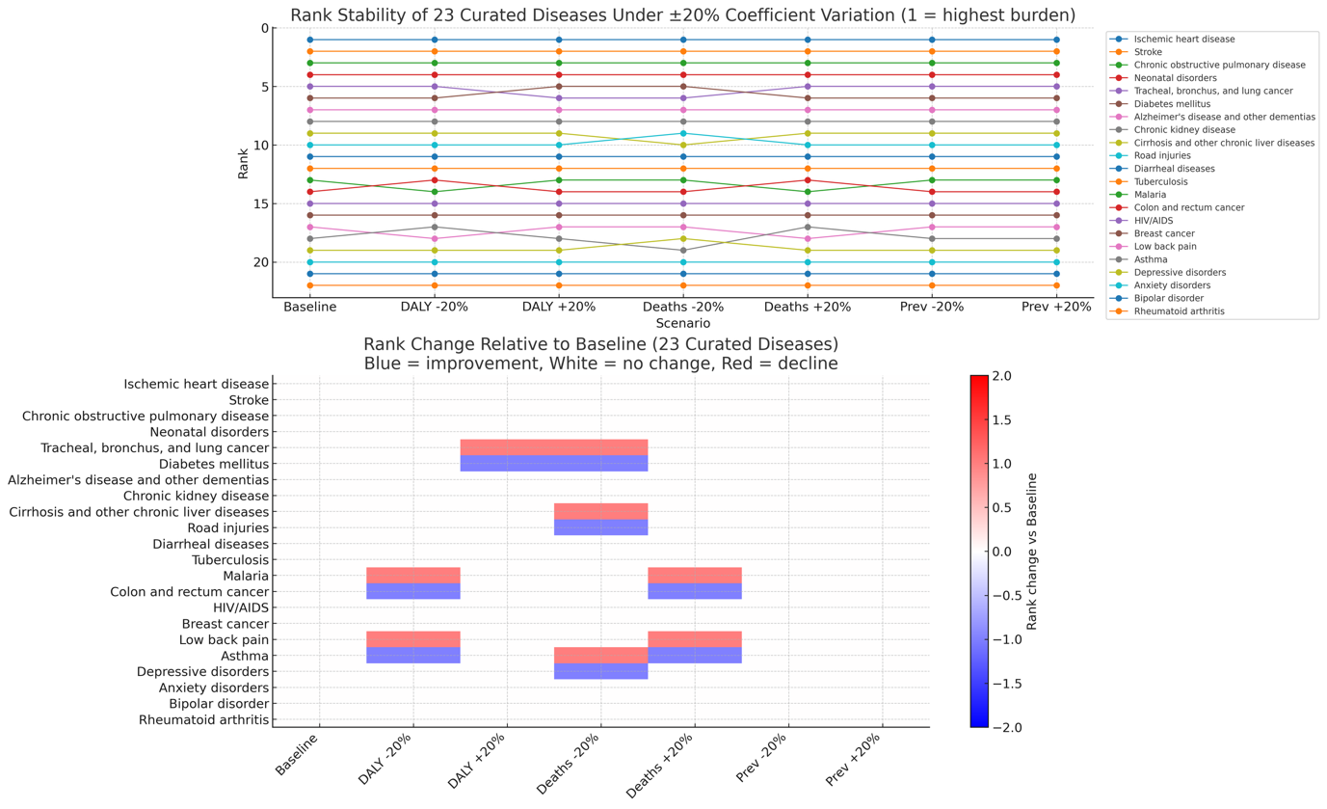
Supplementary Figure S1. Composite rank stability of 23 curated diseases under ±20% coefficient variation. The figure illustrates the robustness of the composite Burden Score when weights for DALYs, deaths, and prevalence are varied by ±20%. The top panel shows rank trajectories across scenarios (1 = highest burden). Each line represents one disease; flat lines indicate stable ranking, while deviations mark sensitivity to parameter changes. The bottom panel presents a heatmap of rank change relative to the baseline formulation. White indicates no change, blue an improvement in rank, and red a decline. These plots show that disease rankings remain highly stable across weighting schemes, with only minor shifts between neighbouring conditions.

Biobank-Specific Opportunity Metrics
To complement the global gap analysis, we developed a set of biobank-specific opportunity metrics designed to highlight where individual resources could make the greatest impact by addressing neglected disease areas. The central aim was to capture not only what each biobank has achieved, but also what remains unaddressed within its publication corpus relative to global health need.
Defining actionable gaps
For each of the 25 diseases in our curated set, we assessed whether a given biobank had published at least one study. Diseases with no publications from that biobank were classified as unaddressed. To focus attention on the most equity-relevant deficits, we restricted this definition to diseases that our global analysis had already flagged as critical or high gaps (e.g., malaria, tuberculosis, diarrhoeal diseases). The count of such conditions provides a straightforward measure of actionable gaps for each biobank.
Quantifying capacity
We also summarised each biobank’s demonstrated activity in two ways:
- Throughput: the total number of publications linked to that biobank across all disease areas.
- Breadth: the number of distinct diseases for which at least one publication exists.
These capacity measures provide context for how readily a biobank might expand into new, underexplored areas.
Research Opportunity Score (ROS)
To integrate unmet need and capacity into a single indicator, we defined a composite Research Opportunity Score (ROS) for each biobank:
ROS_b = (50 × U_b) + (10 × B_b) + (0.1 × T_b)
where:
- U_b = number of actionable gap diseases unaddressed by biobank b,
- B_b = breadth (number of distinct diseases covered by biobank b),
- T_b = throughput (total number of publications from biobank b).
This weighting scheme was designed to make the gap term (U_b) the dominant driver of the score, ensuring that the index reflects unaddressed global health need rather than sheer output. Breadth and throughput are included with smaller weights to acknowledge existing organisational capacity without allowing size alone to determine opportunity.
A higher ROS indicates that a biobank both (i) leaves more high-burden diseases unaddressed, and (ii) has sufficient breadth and throughput to expand into these neglected areas. In this way, the ROS functions as a capacity-weighted unmet need index, identifying where equity-aligned research investments could have the greatest marginal benefit.
Robustness
The coefficients were selected heuristically and tested under ±20% variation. Relative rankings of biobanks remained unchanged, confirming the robustness of the metric. As an additional sensitivity analysis, we also computed an alternative opportunity score based directly on burden weighting: for each disease with ≤2 linked publications in a given biobank, we added its global burden score to that biobank’s index. Both approaches yielded consistent conclusions about which biobanks face the largest equity-relevant opportunity space.

Preprint Filtering and Dataset Composition
To ensure that our analyses focused exclusively on peer-reviewed literature, we systematically identified and excluded preprints from the PubMed retrieval corpus. The initial dataset comprised 14,655 records spanning 2000-2024. Of these, 513 (3.5%) were identified as preprints, leaving 14,142 peer-reviewed articles in the final curated dataset used for all subsequent analyses. These results confirm that preprints represent a minor component of biobank-linked publications in PubMed and validate our decision to restrict the analysis to peer-reviewed articles with MeSH annotations.
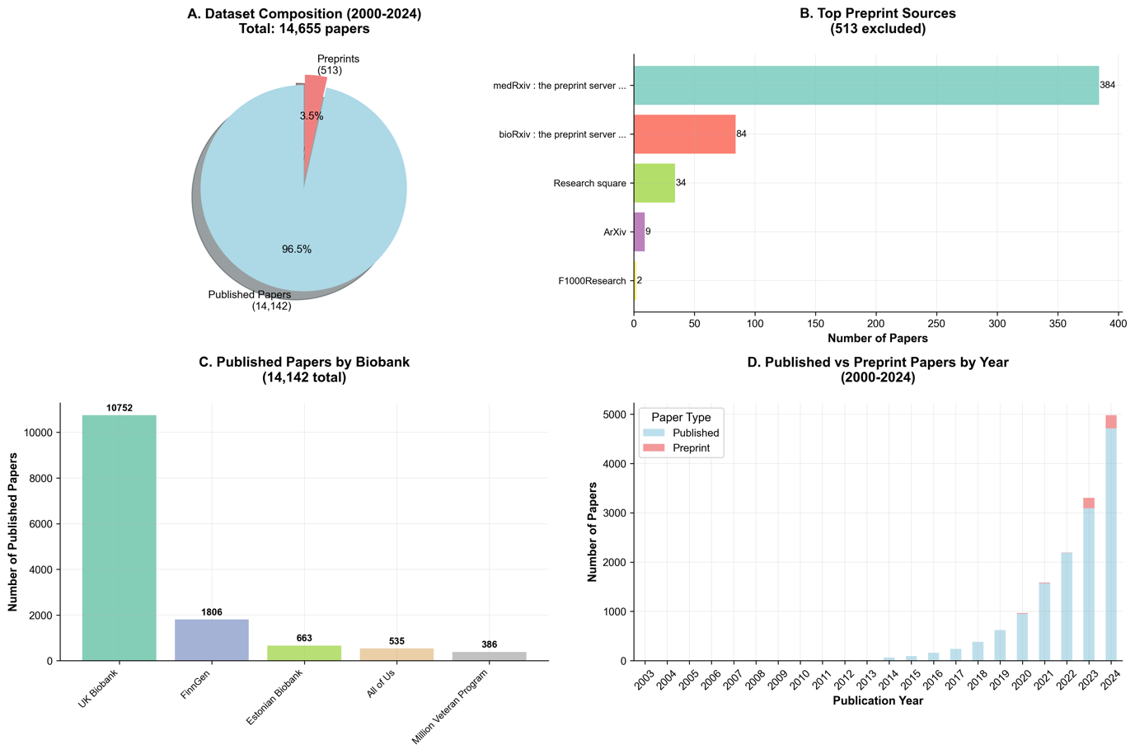
Supplementary Figure S2. Preprint filtering and dataset summary. (A) Composition of the initial dataset (2000-2024), showing peer-reviewed papers (n=14,142) versus preprints (n=513). (B) Distribution of preprints by source. Most originated from medRxiv, followed by bioRxiv, Research Square, arXiv, and F1000Research. (C) Number of peer-reviewed papers by biobank, with UK Biobank accounting for more than 75% of the total. (D) Annual trends in published versus preprint papers (2000-2024), showing the steep rise in output from 2018 onward.

Journal-Level Publication Profiles
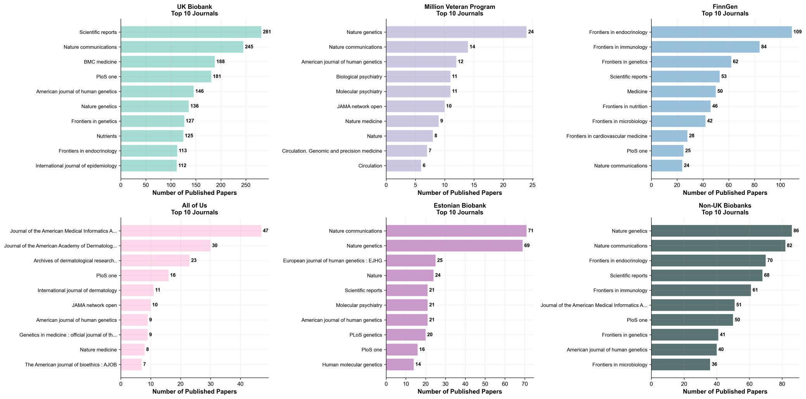
Supplementary Figure S3. Journal-level publication patterns of EHR-linked biobanks. Bar plots show the top ten journals by number of peer-reviewed publications (2000-2024) for UK Biobank, Million Veteran Program, FinnGen, All of Us, and the Estonian Biobank. A combined panel of non-UK biobanks is included for comparison. UK Biobank publications are most frequently found in Scientific Reports, Nature Communications, and BMC Medicine, while MVP outputs cluster in genetics and psychiatry journals. FinnGen favours the Frontiers series, All of Us prioritises informatics and clinical journals, and Estonian Biobank outputs are concentrated in Nature Genetics and Nature Communications. Aggregated non-UK biobank outputs show convergence on high-impact genetics and biomedical journals.

Research Gap and Equity Analysis Framework
To evaluate how biobank-enabled research aligns with global disease priorities, we analysed 25 high-burden diseases using a burden-adjusted scoring system. For each disease, DALYs, annual deaths, and prevalence estimates were obtained from the Global Burden of Disease 2021 dataset. These were integrated into a composite burden score (0.5 × DALYs + 50 × deaths + 10 × log₁₀ prevalence). Biobank-linked publications were mapped to each disease using manually curated MeSH term associations. A Research Gap Score (0–100) was then computed for each disease using three components: (i) a zero-publication penalty for conditions with no coverage, (ii) threshold-based adjustments to highlight infectious/neglected diseases with minimal representation, and (iii) burden-normalised publication density using decile thresholds. Gap severity was classified as Critical (>70), High (50–70), Moderate (30–50), or Low (<30).
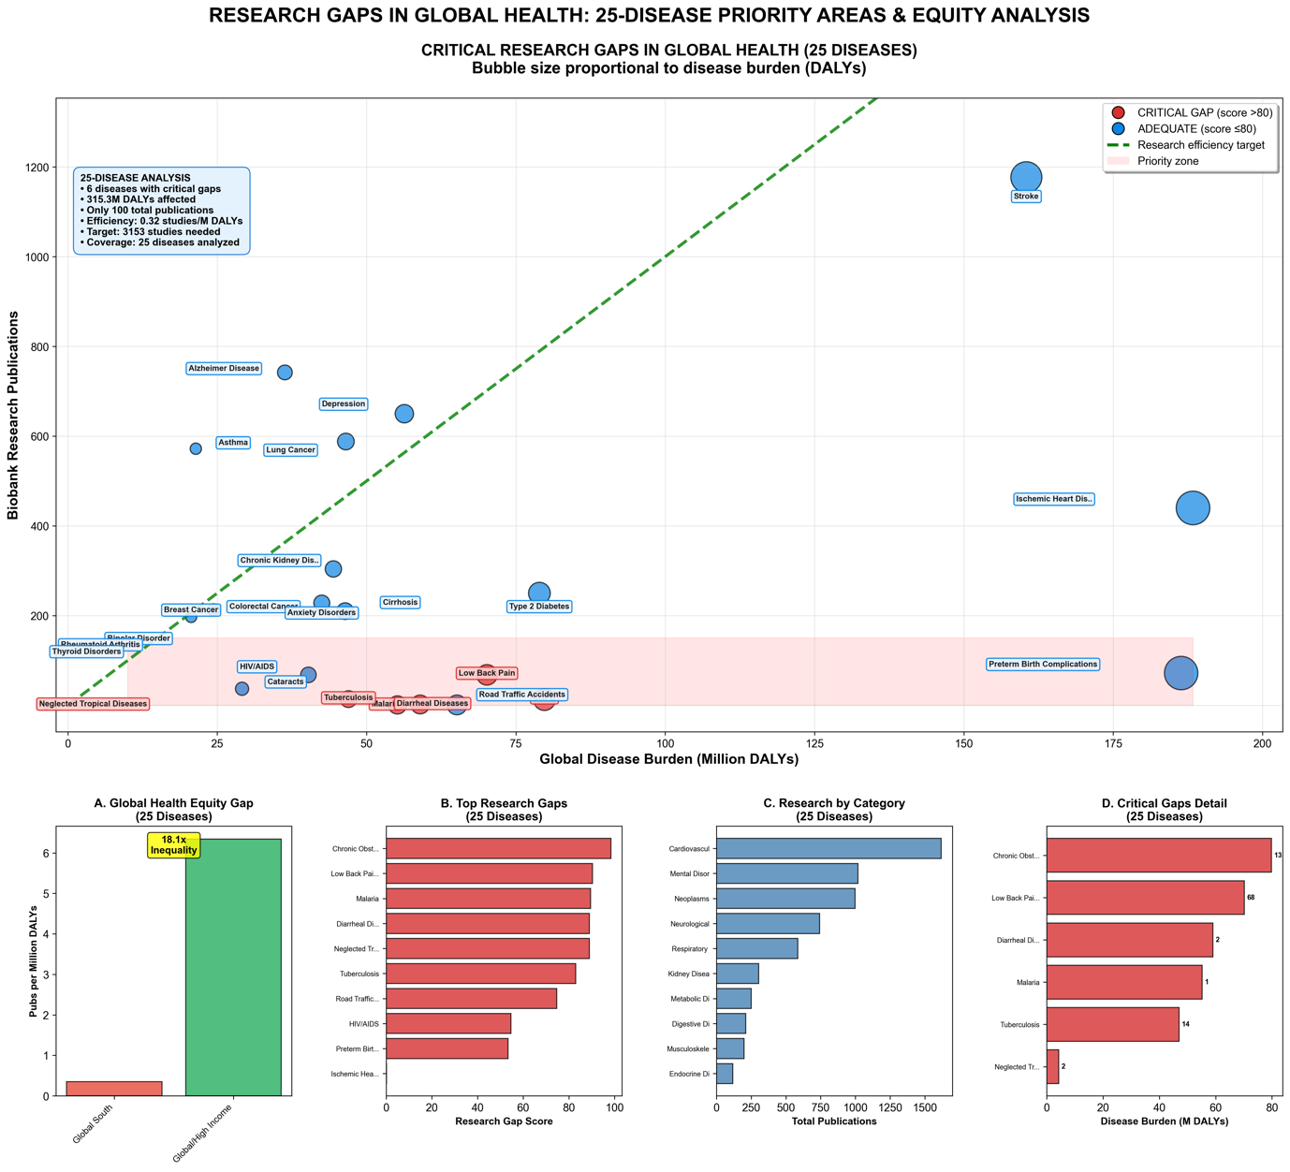
Supplementary Figure S4. Research gaps in biobank-enabled global health research (25 diseases). (A) Scatterplot of disease burden (million DALYs) versus number of biobank-linked publications. Bubble size is proportional to DALYs, colour indicates Research Gap Score severity: red = Critical (>70), blue = Adequate (<30). The green diagonal represents proportional burden–publication alignment. (B) Top 10 diseases by Research Gap Score. (C) Biobank-linked publications by disease category. (D) DALY burden of diseases classified as Critical Gaps.

References

1. Ferrari AJ, Santomauro DF, Aali A, Abate YH, Abbafati C, et al. 2024. Global incidence, prevalence, years lived with disability (YLDs), disability-adjusted life-years (DALYs), and healthy life expectancy (HALE) for 371 diseases and injuries in 204 countries and territories and 811 subnational locations, 1990–2021: a systematic analysis for the Global Burden of Disease Study 2021. The Lancet. 403(10440):2133–61

