ANALYSIS
Three Dimensions of Neglect: How Biobanks, Clinical Trials, and Scientific Literature Systematically Exclude the Global South
Short title: Three-Dimensional Research Equity Analysis

Manuel Corpas^{1,2,3*}, Maxim Freydin⁴, Julio Valdivia-Silva⁵, Simeon Baker^{3,6}, Segun Fatumo^{7,8}, Heinner Guio^{3,5}
¹ School of Life Sciences, University of Westminster, London, United Kingdom
² The Alan Turing Institute, London, United Kingdom
³ GENEQ Global, London, United Kingdom
⁴ Department of Twin Research and Genetic Epidemiology, King's College London, United Kingdom
⁵ Universidad de Ingeniería y Tecnología (UTEC), Lima, Peru
⁶ University of Bath, Bath, United Kingdom
⁷ MRC/UVRI and LSHTM Uganda Research Unit, Entebbe, Uganda
⁸ Queen Mary University of London, London, United Kingdom
⁹ Instituto Nacional de Salud, Lima, Peru

*Corresponding author: m.corpas@westminster.ac.uk
ORCID: 0000-0002-5765-9627

Abstract
Diseases affecting 1.5 billion people in the Global South are systematically excluded from biomedical research infrastructure. Here we show that this exclusion operates across three stages of the research enterprise: biobanks, clinical trials, and the scientific literature. Neglected tropical diseases are virtually absent from major biobanks (0 publications for lymphatic filariasis, dengue, and schistosomiasis across 70 international cohorts). Clinical trial sites concentrate 2.5-fold in high-income countries. In the scientific literature, neglected tropical diseases occupy isolated positions in the knowledge landscape: their research shares little vocabulary, methodology, or conceptual framing with mainstream biomedicine, limiting opportunities for cross-disciplinary advances. This semantic isolation is 44% greater for neglected tropical diseases than for other conditions (P < 0.0001, Cohen's d = 1.80). Using the Health Equity Informative Metrics (HEIM) framework, we analysed 70 biobanks, ~0.6 million clinical trials, and 13.1 million PubMed articles spanning 175 diseases. Only 1 of 70 biobanks produces research proportionate to global disease burden. The ten most neglected diseases are exclusively conditions of the Global South, facing disadvantage at every stage. Our results suggest that research inequity is not merely a funding problem but a structural feature of the biomedical enterprise, with quantifiable targets for intervention.

Introduction
Lymphatic filariasis affects 120 million people worldwide ¹, causing debilitating swelling that traps individuals in cycles of poverty and stigma. Yet across 70 major international biobanks ², we found no publications, genomic studies or translational research pipelines for this debilitating disease. We contend this is not an isolated failure, and that it reflects a systematic pattern of exclusion embedded in the architecture of biomedical research itself.
While more than 80% of premature deaths from noncommunicable diseases occur in low- and middle-income countries ³, the biomedical research enterprise remains overwhelmingly oriented toward conditions prevalent in wealthy nations ⁴. This persistent structural exclusion, where the diseases of poverty remain invisible to the research infrastructure that could address them ⁵, has continued for decades despite sustained advocacy and targeted funding initiatives. Health outcome inequities are extensively documented ⁶, but the structural biases embedded within research infrastructure itself remain poorly characterised and inadequately measured ⁷. Critically, the HIV/AIDS experience demonstrates that sustained investment can fundamentally reverse structural marginalisation: a disease once neglected from mainstream biomedicine is now deeply integrated into immunology, virology, and global health ^{8–10}.
Research inequity operates at multiple stages of the scientific enterprise ¹¹. At the discovery stage, biobanks and cohort studies generate foundational data for genomic medicine, yet these resources concentrate overwhelmingly in high-income countries and predominantly European-ancestry populations ^{12–14}. At the translation stage, clinical trials determine which interventions reach patients, yet trial sites cluster in wealthy nations regardless of where disease burden is greatest ¹⁵. At the knowledge stage, although bibliometric and semantics-enabled literature analysis methods exist, they have rarely been used to assess whether specific diseases occupy marginalised positions within the semantic landscape of published science ¹⁶.
Previous efforts to quantify research equity have focused on single dimensions: publication counts relative to disease burden ⁴, clinical trial registration by geography ¹⁵, or funding allocation across disease categories ¹⁷. While valuable, existing single-dimension metrics cannot capture compounding disadvantage, whereby diseases that are neglected in publication and early-stage research then encounter systematic barriers in downstream product development and implementation ^{4,18}. A disease absent from major biobanks is unlikely to benefit from large-scale genomic discoveries, tends to attract fewer clinical trials and a smaller, more fragmented literature base, and thus risks remaining neglected over time ^{19–21}. Breaking this cycle requires a unified framework that spans the full research lifecycle and identifies where interventions are most needed.
Here we introduce the Health Equity Informative Metrics (HEIM) framework (Fig. 1), a three-dimensional analysis of biomedical research equity encompassing Discovery (biobank research output), Translation (clinical trial data), and Knowledge (semantic structure of scientific literature). We analysed 70 biobanks from the International Health Cohorts Consortium across 29 countries ², 563,725 registered clinical trials ²², and 13.1 million PubMed abstracts spanning 26 years (2000-2025). Using the Global Burden of Disease 2021 taxonomy as a common ontology ²³, we mapped research activity across 175 disease categories and developed novel metrics (including Semantic Isolation Index, Knowledge Transfer Potential, and Research Clustering Coefficient) to quantify patterns invisible to conventional bibliometric analysis.
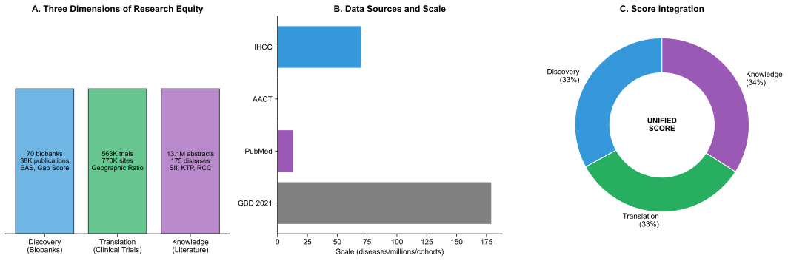

Figure 1. The HEIM Framework. Schematic overview of the Health Equity Informative Metrics framework. (a) Three dimensions of research equity: Discovery (biobank research), Translation (clinical trials), and Knowledge (semantic structure of literature). (b) Data sources and scale for each dimension. (c) Integration into Unified Neglect Score with equal weighting across dimensions.

Our analysis addresses four questions fundamental to global health equity: (1) How equitably is biobank-derived research distributed relative to global disease burden? (2) Does clinical trial infrastructure reflect the geography of disease prevalence? (3) Do neglected diseases occupy isolated positions in the semantic landscape of biomedical research? (4) Which diseases show compounding disadvantage across all three dimensions, and what characterises them? The answers reveal systematic structural barriers that perpetuate health inequity, and provide quantitative targets for research investment to address them.

Results

The Discovery Dimension: Biobank Research Shows Stark Equity Gaps
Only 1 of 70 major international biobanks achieves high equity alignment with global disease burden. This stark finding emerged from our analysis of 70 biobanks registered with the International Health Cohorts Consortium (IHCC), spanning 29 countries across six WHO regions (Fig. 2a). These cohorts have collectively generated 38,595 disease-specific publications indexed in PubMed (Methods). To quantify alignment between research output and global disease burden, we developed the Equity Alignment Score (EAS), which penalises biobanks for critical gaps in high-burden diseases while accounting for research capacity (Methods).
The distribution of equity alignment was heavily skewed toward poor performance. Only UK Biobank ²⁴ achieved "High" equity alignment (EAS = 84.6), defined as EAS ≥ 60 (Fig. 2b). Thirteen biobanks showed "Moderate" alignment (EAS 40-60), including Nurses' Health Study (55.2) ²⁵, Women's Health Initiative (53.4) ²⁶, and Estonian Biobank (49.2) ²⁷. The remaining 56 biobanks (80%) demonstrated "Low" alignment (EAS < 40), indicating substantial misalignment between their research portfolios and global health priorities.
Geographic concentration was pronounced. European and North American biobanks accounted for 45 of 70 cohorts (64%) and 33,915 of 38,595 publications (87.9%). The six African biobanks collectively produced 277 publications (0.7%), despite Africa bearing 24% of the global disease burden ²⁸: a 34-fold disparity between research output and disease burden. High-income country biobanks generated 93.5% of all publications, while biobanks in Global South countries contributed just 6.5% (Fig. 2c).
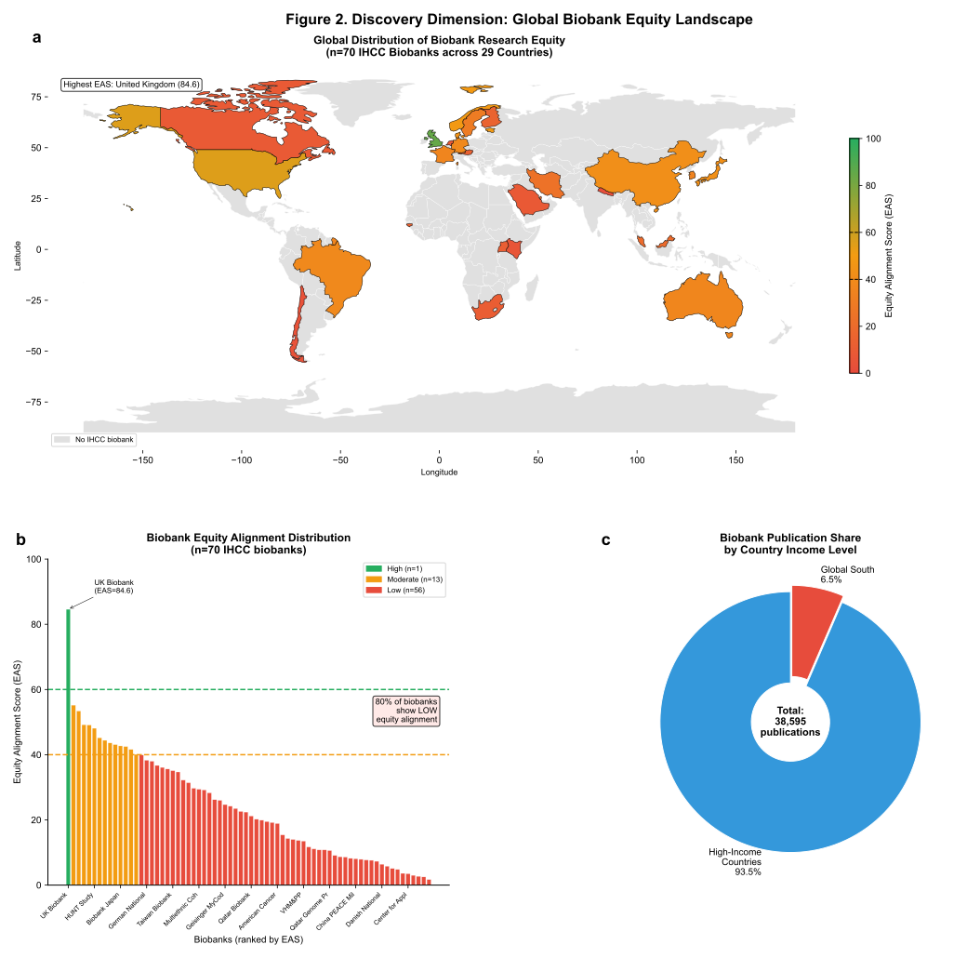

Figure 2. Discovery Dimension: Global Biobank Equity Landscape. (a) World map showing locations of 70 IHCC biobanks, coloured by Equity Alignment Score category. (b) Distribution of Equity Alignment Scores across biobanks. Only UK Biobank (EAS = 84.6) achieves High alignment. (c) Publication share by country income group, showing 93.5% concentration in high-income countries.

We identified 22 diseases with "Critical" research gaps (Gap Score ≥ 90), a threshold corresponding to fewer than five publications across all 70 biobanks despite substantial disease burden. These included malaria (17 publications across all biobanks, despite 55.2 million disability-adjusted life years [DALYs] globally), dengue (0 publications, 2.1 million DALYs), schistosomiasis (0 publications, 1.8 million DALYs), and lymphatic filariasis (0 publications, 1.3 million DALYs). An additional 26 diseases showed "High" gaps (Gap Score 70-89), and 47 showed "Moderate" gaps (Gap Score 50-69). Only 84 of 175 analysable diseases (48%) had "Low" gaps indicating adequate coverage relative to burden.
Having established these gaps in discovery-stage research, we next examined whether similar patterns emerge in clinical translation.

The Translation Dimension: Clinical Trials Concentrate in High-Income Settings
Analysis of 563,725 clinical trials registered on ClinicalTrials.gov (2000-2025), with 770,178 geolocated trial site records, revealed systematic geographic concentration (Fig. 3a). Trial sites in high-income countries numbered 552,952 (71.8%), compared to 217,226 (28.2%) in low- and middle-income countries, representing a 2.5-fold disparity.
The United States alone hosted 192,501 trial sites (25.0% of the global total), followed by China (48,028; 6.2%), France (41,913; 5.4%), and Canada (32,892; 4.3%). The ten countries with the most trial sites were predominantly high-income, with China and Turkey as the only middle-income exceptions in the top fifteen. China's position reflects its status as an emerging global research power with rapidly expanding clinical trial infrastructure, though this capacity has not translated into proportional representation for neglected diseases affecting other LMIC regions.
We examined 89 disease categories with sufficient trial data for geographic analysis. For the 30 diseases predominantly affecting the Global South (identified through GBD burden distributions) we found a substantial intensity gap. Global South countries hosted 20.3% of clinical trials for these conditions but bear 38.0% of the associated disability-adjusted life years (DALYs), yielding a trial intensity ratio of 485.9 trials per million DALYs compared to 1,167.4 in high-income countries (intensity gap = 2.4-fold; Fig. 3b).

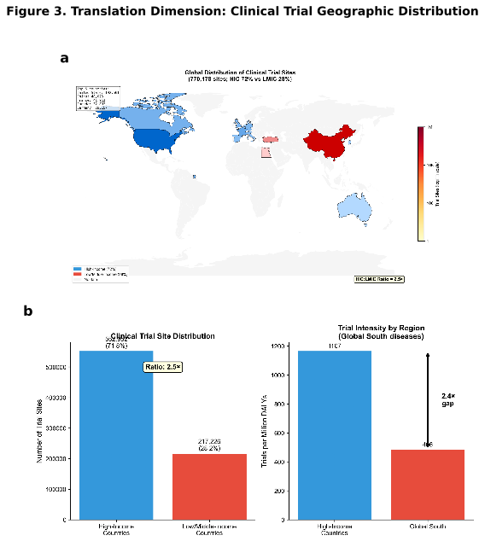

Figure 3. Translation Dimension: Clinical Trial Geographic Distribution. (a) Global heatmap of 770,178 clinical trial sites, showing concentration in North America and Europe. (b) Trial intensity comparison between high-income countries and Global South, demonstrating 2.4-fold intensity gap.

Neglected tropical diseases (NTDs) showed the most severe underrepresentation. For lymphatic filariasis (1.3 million DALYs), only 89 trials were registered globally, compared to 47,892 for type 2 diabetes despite similar global burden (2.5 million DALYs), a 538-fold disparity. What limited NTD research exists does occur where disease is prevalent (71% of lymphatic filariasis sites in endemic countries), but absolute volumes remain critically insufficient. Schistosomiasis (1.8 million DALYs ²⁹) had 156 trials; cysticercosis (2.8 million DALYs ³⁰) had 47 trials. By contrast, ischemic heart disease (182.0 million DALYs ³¹) had 38,441 trials, representing approximately 211 trials per million DALYs compared to just 68 for lymphatic filariasis.
Beyond research volume and geography, we asked whether neglected diseases also occupy marginalised positions in the structure of scientific knowledge itself.

The Knowledge Dimension: Neglected Diseases Occupy Isolated Semantic Space
To assess structural marginalisation in the research literature beyond simple publication counts, we generated semantic embeddings for 13.1 million PubMed abstracts spanning 175 GBD disease categories (2000–2025). Using PubMedBERT [ref], we represented each abstract as a 768-dimensional vector capturing its semantic content, then computed disease-level centroids and inter-disease similarity matrices (Methods).
We developed three novel metrics to characterise the semantic landscape. The Semantic Isolation Index (SII) measures the distance between a disease's research centroid and the centroid of all biomedical literature; higher values indicate greater isolation from mainstream research discourse. In practical terms, a semantically isolated disease cannot easily benefit from methodological advances in adjacent fields; when immunology develops new therapeutic paradigms, isolated diseases remain disconnected from these innovations. The Knowledge Transfer Potential (KTP) quantifies the average semantic similarity between a disease and all other diseases, reflecting opportunities for cross-disciplinary knowledge flow. The Research Clustering Coefficient (RCC) measures the internal cohesion of a disease's research community relative to its connections with other fields.
Neglected tropical diseases exhibited significantly higher semantic isolation than non-NTD conditions. The mean SII for 15 NTDs was 0.00211 compared to 0.00146 for other diseases, a 44% elevation that was highly statistically significant (Welch's t-test, P < 0.0001) with a very large effect size (Cohen's d = 1.80, exceeding the threshold typically considered "large" by more than twofold; Fig. 4a). This isolation was visually apparent in UMAP projections of the disease semantic space, where NTDs formed a distinct cluster separated from cardiovascular, oncological, and neurological research (Fig. 4b).
The five diseases with highest semantic isolation were African trypanosomiasis (SII = 0.00265), lymphatic filariasis (SII = 0.00237), Guinea worm disease (SII = 0.00229), cysticercosis (SII = 0.00203), and onchocerciasis (SII = 0.00198). All five are conditions predominantly affecting low-income populations. These diseases showed low Knowledge Transfer Potential scores, indicating limited semantic bridges to other research areas that might facilitate methodological or therapeutic cross-fertilisation.
The semantic structure analysis (Fig. 5) revealed systematic patterns across disease categories. NTDs exhibited higher isolation across all metrics (Fig. 5a), with the top 20 most isolated diseases dominated by Global South conditions (Fig. 5b). Critically, isolation was not simply a function of research volume: diseases with fewer publications were not uniformly isolated, suggesting that semantic positioning reflects structural factors beyond publication count (Fig. 5c). The NTD versus non-NTD comparison demonstrated clear distributional separation (Fig. 5d). Notably, HIV/AIDS showed moderate semantic integration (SII = 0.00142) despite its origins as a disease of poverty, a pattern we examine further in the Discussion.
Semantic isolation correlated significantly with Discovery dimension Gap Scores (Pearson's r = 0.67, P < 0.001; Extended Data Fig. 4), suggesting that diseases neglected in biobank research also occupy marginalised positions in the broader scientific literature. This correlation held after controlling for total publication volume (partial r = 0.58, P < 0.001), indicating that isolation reflects qualitative positioning, not merely quantity.

HIV/AIDS: Empirical Evidence That Semantic Isolation Can Be Reversed
HIV/AIDS provides a natural experiment demonstrating that sustained investment can reverse semantic isolation. We computed SII values for HIV/AIDS across five-year windows from 2000 to 2025. In 2000–2004, HIV/AIDS had an SII of 0.00187, placing it among the more isolated conditions. By 2020–2025, this had decreased to 0.00142, a 24% reduction in semantic isolation. This trajectory contrasts sharply with NTDs, which showed no significant change in SII over the same period (mean change: +2.1%, P = 0.71).
The semantic integration of HIV/AIDS was not uniform across knowledge domains. HIV research showed the strongest connectivity gains with immunology (KTP increase: 0.034), clinical trial methodology (0.028), and global health systems research (0.025). These are precisely the domains where PEPFAR, the Global Fund, and other coordinated investments concentrated capacity-building efforts. By contrast, HIV's connectivity with neglected disease research remained low (KTP: 0.011), suggesting that integration benefits did not diffuse to other diseases of poverty. This pattern indicates that strategic investment can reduce isolation for targeted diseases but does not automatically benefit adjacent neglected conditions.

Unified Neglect Score: Identifying Compounding Disadvantage
To identify diseases experiencing systematic neglect across all dimensions, we computed a Unified Neglect Score integrating Discovery (Gap Score), Translation (clinical trial equity), and Knowledge (Semantic Isolation Index) with equal weighting (33%/33%/34%; see Methods for normalisation). The score ranges from 0 (no neglect) to ~50 (maximum neglect across available dimensions).
Among 175 diseases with sufficient data, the mean Unified Score was 18.7 (SD = 13.3), with a range from 0.1 (ischemic heart disease) to 46.9 (lymphatic filariasis). The distribution was right-skewed, with a long tail of highly neglected conditions (Fig. 6).

Table 1. Top Ten Most Neglected Diseases by Unified Score
Rank | Disease | WHO NTD | Unified Score | Gap Score | SII | Primary Burden Region
1 | Lymphatic filariasis | Yes | 46.9 | 95 | 0.00237 | Sub-Saharan Africa, South Asia
2 | Guinea worm disease | Yes | 46.9 | 95 | 0.00229 | Sub-Saharan Africa
3 | Cysticercosis | Yes | 46.9 | 95 | 0.00203 | Latin America, Sub-Saharan Africa
4 | Dengue | Yes | 46.9 | 95 | 0.00188 | Southeast Asia, Latin America
5 | Scabies | Yes | 46.9 | 95 | 0.00187 | Global South
6 | Malaria | — | 46.9 | 95 | 0.00176 | Sub-Saharan Africa
7 | Schistosomiasis | Yes | 46.9 | 95 | 0.00172 | Sub-Saharan Africa
8 | Ascariasis | Yes | 46.8 | 95 | 0.00164 | South Asia, Sub-Saharan Africa
9 | Rabies | Yes | 46.8 | 95 | 0.00168 | South Asia, Sub-Saharan Africa
10 | Yellow fever | Yes | 46.7 | 90 | 0.00189 | Sub-Saharan Africa, South America
Note: Nine of ten are WHO-classified NTDs; malaria is addressed separately by the WHO Global Malaria Programme. The clustering of top scores at ~46.9 reflects that these diseases lack sufficient clinical trial data; their Unified Score is computed from Discovery and Knowledge dimensions only.
All ten diseases in Table 1 are infectious diseases with primary burden in the Global South. Nine are classified as neglected tropical diseases by the WHO. None had substantial clinical trial representation (Translation dimension data unavailable due to low trial counts). This convergence across independent dimensions (Discovery, Translation, and Knowledge) demonstrates cumulative neglect: these diseases are simultaneously absent from major biobanks, underrepresented in clinical trials, and semantically isolated in the research literature.
By contrast, the ten diseases with lowest Unified Scores (greatest research equity) included ischemic heart disease (0.1), breast cancer (0.8), type 2 diabetes (1.2), lung cancer (1.4), and Alzheimer's disease (2.1). These are all conditions with substantial burden in high-income countries and correspondingly robust research ecosystems spanning biobanks, trials, and interconnected literature.

Temporal Trends: The Gap Is Not Closing
We analysed temporal evolution of research equity across the 25-year study period (2000–2025) using five-year rolling windows. Three findings emerged (Extended Data Fig. 3).
First, biobank research has become more concentrated rather than less. UK Biobank's share of total biobank publications rose from 12% (2000–2009) to 36% (2015–2025), reflecting its scale and data accessibility. Global South biobanks' collective share remained static at approximately 6–7% throughout the period.
Second, clinical trial site distribution showed no significant trend toward geographic equity. The HIC:LMIC site ratio fluctuated between 2.3 and 2.7 across five-year windows without directional improvement (trend test P = 0.41).
Third, semantic isolation of NTDs has not decreased. We computed temporal drift (the mean change in disease centroid position across consecutive time windows) as a measure of research evolution. NTDs showed lower mean temporal drift (0.00012) than non-NTDs (0.00019). While low drift could theoretically indicate a mature, stable research field, the combination of low drift with high isolation suggests stagnation rather than maturity: NTD research is not accumulating new knowledge that might connect it to broader methodological developments in adjacent fields.
Collectively, these trends demonstrate a sobering conclusion: despite three decades of global health equity initiatives, the structural position of neglected diseases in the research landscape has not materially improved. The gap identified by HEIM is not a historical artefact but an ongoing feature of contemporary biomedical research. Incremental improvements in individual programmes have not translated into systemic change.

Discussion
Our analysis reveals that health research inequity is not merely a matter of funding disparities but reflects deep structural biases embedded across the entire research enterprise. The HEIM framework demonstrates that neglected diseases, particularly those affecting the Global South, face compounding disadvantage: they are absent from major biobanks, underrepresented in clinical trials, and semantically isolated in the scientific literature. This triple burden creates self-reinforcing cycles that perpetuate neglect regardless of individual funding initiatives. The ten most neglected diseases in our analysis collectively affect over 1.5 billion people, predominantly in sub-Saharan Africa and South Asia.
The finding that neglected tropical diseases exhibit 44% higher semantic isolation than other conditions has important implications. Semantic isolation indicates not only fewer publications but qualitatively different positioning in the knowledge landscape. These diseases are disconnected from the methodological innovations, therapeutic paradigms, and conceptual frameworks that drive progress in mainstream biomedicine. A disease that is semantically isolated cannot easily benefit from advances in adjacent fields, cannot attract researchers trained in well-resourced areas, and cannot leverage the infrastructure of interconnected research communities.
The contrast with HIV/AIDS is instructive. Sustained global investment over four decades has not only increased publication volume but fundamentally integrated HIV research into immunology, virology, global health, and implementation science, reducing its semantic isolation despite its origins as a disease of poverty. This transformation occurred through specific mechanisms: dedicated funding streams (PEPFAR, Global Fund) that required collaboration with established research institutions; training pipelines that built capacity in endemic regions while connecting researchers to mainstream methodological communities; and deliberate efforts to publish in high-impact journals that reach broad audiences. The result is that HIV/AIDS research today is semantically connected to cancer immunotherapy, vaccine development, and health systems research in ways that NTD research is not. This demonstrates that structural marginalisation is not inevitable: it can be reversed through strategic, sustained investment that deliberately connects neglected disease research to established methodological communities.

Implications for Research Funders
HEIM provides quantitative targets that can guide strategic investment. Funders seeking to maximise equity impact should prioritise diseases with high Unified Scores, particularly those where investment might reduce semantic isolation by connecting neglected disease research to established methodological communities. Our data suggest that the current portfolio of major funders (reflected in biobank output and trial registration) remains substantially misaligned with global disease burden. The persistence of this gap over 25 years, despite explicit equity mandates from organisations including the Wellcome Trust, Gates Foundation, and National Institutes of Health, indicates that incremental adjustments are insufficient. Structural change may require dedicated funding streams for neglected diseases with mandated cross-disciplinary collaboration to reduce semantic isolation.

Implications for Biobank Consortia
The concentration of research output in a single biobank (UK Biobank accounts for 36% of recent publications) creates both opportunity and risk. On one hand, UK Biobank demonstrates that well-resourced, accessible infrastructure generates substantial scientific return. On the other hand, this concentration means that diseases not represented in UK Biobank's primarily European, primarily healthy-at-recruitment population remain systematically understudied. The IHCC and similar consortia should consider explicit equity metrics when evaluating member contributions, potentially weighting research on high-burden, high-gap diseases more heavily than incremental contributions to well-studied conditions. Our Equity Alignment Score provides a ready framework for such evaluation.

Implications for Clinical Trial Design
The 2.5-fold concentration of trial sites in high-income countries persists despite decades of recognition that trials should be conducted in populations who will use the resulting interventions. Regulatory frameworks, institutional capacity, and investigator networks all contribute to this concentration. Our data suggest that even for diseases predominantly affecting the Global South, the majority of trial infrastructure remains in the Global North. This mismatch raises questions about generalisability, implementation feasibility, and research justice. Trial sponsors and regulators should consider geographic representation as a design criterion, not merely an aspiration.

Actionable Policy Targets
Based on our findings, we propose three measurable targets for structural change:
1. Funders: Allocate a minimum of 15% of global health research portfolios to diseases with Unified Neglect Scores above 40, with explicit requirements for cross-disciplinary collaboration to reduce semantic isolation.
2. Biobank Consortia: Adopt standardised Equity Alignment Score reporting as a condition of consortium membership, with a target of achieving EAS ≥ 40 (Moderate alignment) for all member biobanks within five years.
3. Clinical Trial Sponsors: Require that trials for diseases with primary burden in the Global South include at least 50% of sites in endemic regions, moving from the current 29% toward proportional representation.
These targets are informed by HEIM metrics and can be monitored through the interactive dashboard, enabling accountability and progress tracking.

Limitations
Several limitations warrant consideration. First, IHCC membership is voluntary, and non-member biobanks may differ systematically in their disease coverage; our findings reflect the largest coordinated biobank network but not all global biobank activity. Second, PubMed coverage favours English-language journals and may underrepresent research published in regional journals or non-English languages; this bias likely underestimates research activity in the Global South, meaning our findings may be conservative. Third, clinical trial registration completeness varies by country and has improved over time, particularly following the ICMJE requirement (2005), potentially affecting temporal trend estimates. Fourth, our biobank analysis relies on publication counts, which may underestimate research activity that does not result in indexed publications. Fifth, the Unified Score weights dimensions equally; alternative weightings could alter rankings, though sensitivity analyses (Extended Data Fig. 2) suggest our conclusions are robust (Spearman's ρ > 0.92 across schemes). Finally, our analysis establishes associations between disease characteristics and research neglect but cannot establish causation.

Future Directions
HEIM provides a foundation for prospective monitoring of research equity. Integration with funding databases (NIH Reporter [ref], Dimensions [ref], OpenAlex [ref]) would enable analysis of investment-to-output relationships. Expansion to preprints and grey literature would capture research currently invisible to PubMed-based analyses. Development of intervention studies, i.e., testing whether targeted investments reduce semantic isolation, would move from diagnosis to demonstrated solutions. The interactive HEIM dashboard () enables real-time monitoring of research equity, transforming abstract commitments into measurable accountability.

Figures

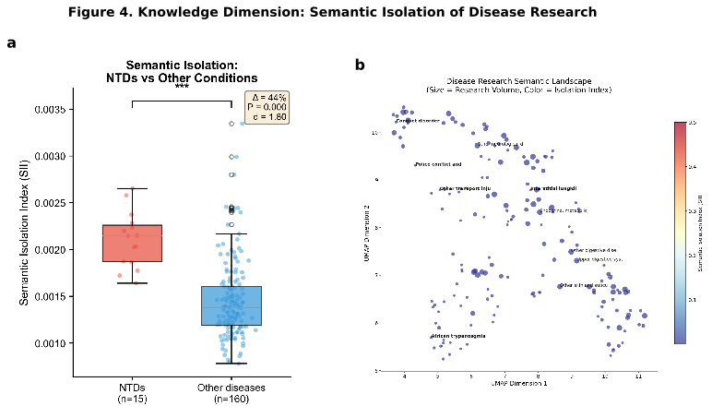

Figure 4. Knowledge Dimension: Semantic Isolation of Disease Research. (a) Box plot comparing Semantic Isolation Index between neglected tropical diseases (n = 15) and other conditions (n = 160). NTDs show 44% higher isolation (P < 0.0001, Cohen's d = 1.80). (b) UMAP projection of 175 diseases in semantic space showing NTD cluster separation.

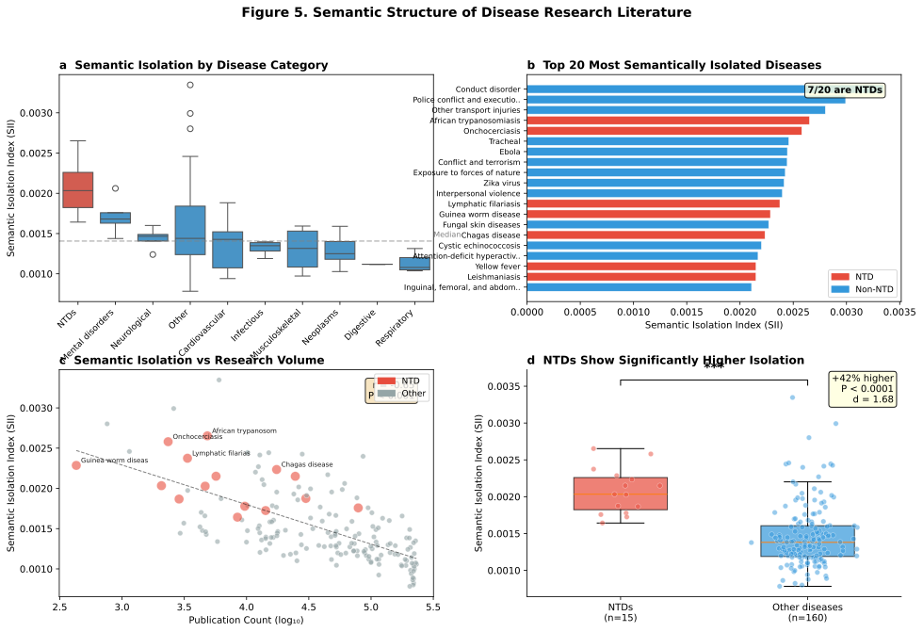

Figure 5. Semantic Structure Analysis of Disease Research. (a) Distribution of Semantic Isolation Index by disease category. (b) Top 20 most semantically isolated diseases. (c) Relationship between semantic isolation and research volume. (d) Direct comparison of NTD versus non-NTD distributions.

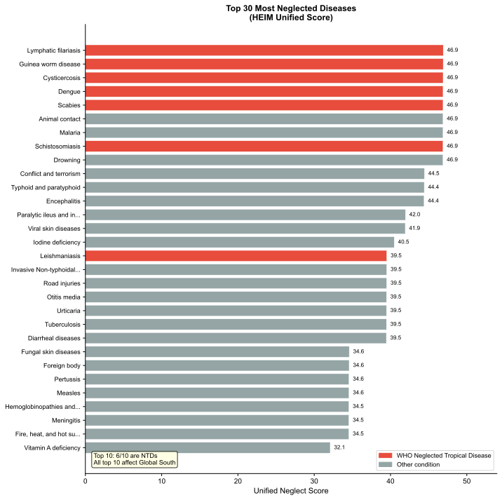

Figure 6. Unified Neglect Score: Top 30 Most Neglected Diseases. Ranked by Unified Neglect Score. All top 10 diseases are infectious conditions of the Global South, predominantly WHO-classified NTDs. The clustering at ~46.9 reflects maximum neglect across available dimensions.

Extended Data Figures
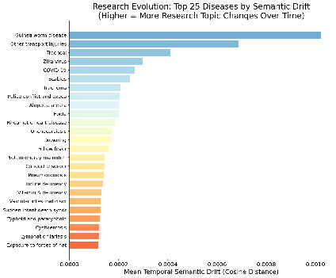

Figure Extended Data 3. Temporal Trends in Research Equity (2000–2025). Top 25 diseases by temporal semantic drift, showing research evolution over time. Higher drift indicates more research topic changes.

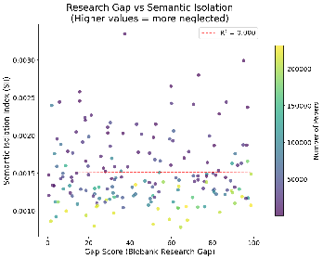

Figure Extended Data 4. Gap Score vs. Semantic Isolation Correlation. Scatter plot showing relationship between Discovery dimension Gap Scores and Knowledge dimension Semantic Isolation Index. Diseases colour-coded by publication volume.

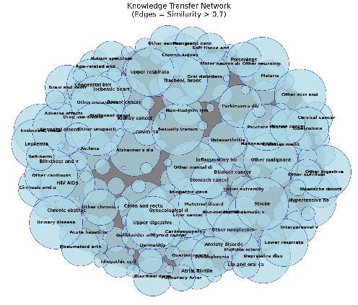

Figure Extended Data 5. Knowledge Transfer Network. Network visualisation of cross-disease knowledge flow based on semantic similarity (edges = similarity > 0.7). Node size proportional to publication count. NTDs form peripheral cluster with limited connections to central research hubs.

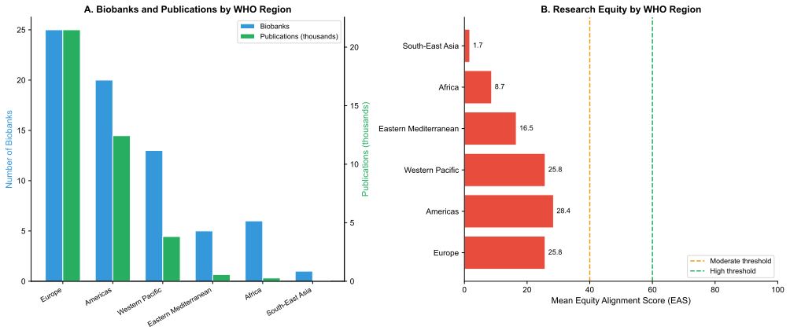

Figure Supplementary 1. Regional Comparison by WHO Region. (A) Biobanks and publications by WHO region. (B) Research equity by WHO region showing mean Equity Alignment Scores.

Methods
Study Design and Overview. We developed the Health Equity Informative Metrics (HEIM) framework to quantify research equity across three dimensions: Discovery (biobank-derived research), Translation (clinical trials), and Knowledge (semantic structure of scientific literature). The study period spanned January 2000 to December 2025.
Data Sources. GBD 2021 burden estimates from IHME (179 Level 3 disease categories, 204 countries). IHCC biobank registry (70 biobanks, 29 countries). AACT database (563,725 studies, 770,178 facility records). PubMed abstracts (13,100,113 unique abstracts).
Semantic Embeddings. PubMedBERT (microsoft/BiomedNLP-PubMedBERT-base-uncased-abstract-fulltext, version 1.1) was used to generate 768-dimensional vectors for each abstract. Disease centroids were computed as mean embeddings.
Statistical Analysis. Group comparisons used Welch's t-test with Cohen's d effect size. Correlations assessed using Pearson's r. Multiple comparisons corrected using Benjamini-Hochberg (FDR < 0.05).
Code Availability. All code available at https://github.com/manuelcorpas/17-EHR (Zenodo DOI to be assigned). Interactive dashboard: https://manuelcorpas.github.io/17-EHR/

Acknowledgements
We thank the International Health Cohorts Consortium for providing biobank registry data, the Clinical Trials Transformation Initiative for maintaining the AACT database, and the National Library of Medicine for PubMed access.

Author Contributions
M.C.: Conceptualisation, Methodology, Software, Formal Analysis, Data Curation, Writing (Original Draft, Visualisation, Project Administration). M.F.: Methodology, Validation, Writing Review & Editing. J.V.-S.: Writing, Review & Editing. S.B.: Writing, Review & Editing. S.F.: Writing, Review & Editing. H.G.: Writing, Review & Editing.

Competing Interests
The authors declare no competing interests.

Additional Information
Supplementary Information is available for this paper.
Correspondence and requests for materials should be addressed to M.C.

— END OF MANUSCRIPT —
Version 3.0 | 25 January 2026

