Health Equity Informative Metrics (HEIM):
Quantifying the Discovery-to-Translation Gap in Global Health Research
Manuel Corpas^{1,2*}, Julio Valdivia-Silva³, Segun Fatumo^{4,5}, Heinner Guio^{3,6}
¹ School of Life Sciences, University of Westminster, London, United Kingdom
² The Alan Turing Institute, London, United Kingdom
³ Universidad de Ingeniería y Tecnología (UTEC), Lima, Peru
⁴ Medical Research Council, Uganda Virus Research Institute and London School of Hygiene and Tropical Medicine (MRC/UVRI & LSHTM), Entebbe, Uganda
⁵ Precision Healthcare University Research Institute, Queen Mary University of London, London, United Kingdom
⁶ INBIOMEDIC Research and Technological Center, Lima, Peru
*Correspondence to: Dr Manuel Corpas, School of Life Sciences, University of Westminster, 115 New Cavendish Street, London W1W 6UW, United Kingdom. m.corpas@westminster.ac.uk

Summary

Background
Low- and middle-income countries (LMICs) represent 85% of the global population but contribute less than 10% of participants to large-scale health research. This disparity undermines the generalisability of findings from population cohort studies and clinical trials. Despite growing recognition of this problem, no standardised framework exists to quantify research alignment across the full discovery-to-translation pipeline. We developed the Health Equity Informative Metrics (HEIM) framework to address this gap, extending analysis from biobank research to clinical trials.

Methods
We conducted parallel analyses of biobank research and clinical trials. For biobanks, we analysed 38,595 PubMed-indexed publications (2000-2025) from 70 biobanks registered with the International Health Cohorts Consortium (IHCC) across 29 countries. For clinical trials, we analysed 2,189,930 disease-trial mappings from 563,725 ClinicalTrials.gov-registered studies (2000-2025) across 194 countries with 770,178 trial site records. Both datasets were mapped to disease categories from the Global Burden of Disease Study 2021. We calculated disease-specific Gap Scores measuring mismatch between burden (disability-adjusted life years, DALYs) and research attention, along with alignment ratios comparing high-income country (HIC) to LMIC research intensity.

Findings
In biobank research, HIC institutions produced 57.8 times more research output per DALY than LMIC biobanks. Regional concentration was stark: Europe (55.7%) and the Americas (32.2%) accounted for 87.9% of publications. In clinical trials, the geographic disparity was less extreme (HIC:LMIC ratio of 2.5:1 for trial sites) but disease focus was more skewed: neoplasms received 61.5% of all trials while representing only 8.4% of global disease burden. Global South Priority diseases (30 conditions accounting for 38% of global burden) received only 20.3% of clinical trial attention, a research intensity gap of 2.4:1. The share of trials addressing Global South Priority diseases declined from 47.7% (2000-2005) to 35.5% (2020-2025), a reduction of 12.3 percentage points despite 15.5-fold growth in overall trial volume. Nine diseases received fewer than 500 trials over 26 years, including dengue (273 trials, 2.1 million DALYs), schistosomiasis (94 trials, 1.7 million DALYs), and onchocerciasis (34 trials, 1.3 million DALYs).

Interpretation
The HEIM framework reveals a Research-to-Translation Gap: equity disparities observed in discovery research (biobanks) persist and in some cases worsen as findings move toward clinical application. These metrics quantify disease-area alignment with global burden; they do not assess research quality, participant-level diversity, governance structures, or benefit-sharing arrangements. The declining share of trials addressing Global South Priority diseases despite massive growth in research volume suggests the system is not self-correcting. Active policy intervention is required to align global research infrastructure with global health needs. An interactive dashboard (https://manuelcorpas.github.io/17-EHR/) operationalises these metrics for funders, researchers, and policymakers.

Funding
None.

Introduction
The promise of precision medicine and evidence-based public health rests on research findings that apply across human populations. Yet the infrastructure generating these findings, principally biobanks, population cohorts, and clinical trials, is highly unequal in its global distribution. Low- and middle-income countries (LMICs), home to approximately 85% of the world's population, contribute less than 10% of participants to genome-wide association studies, epidemiological cohorts, and clinical trials.
The consequences are increasingly well-documented. Risk prediction models developed in high-income populations show reduced accuracy when applied elsewhere. Clinical databases exhibit patterns consistent with systematic biases toward well-studied populations. These are not merely academic concerns; they represent barriers to equitable healthcare that may widen as data-driven medicine enters clinical practice globally.
The World Health Organization has called for measurable frameworks to track progress toward equitable health research implementation. A recent WHO report found that high-income countries account for 68% of clinical studies while low-income countries contribute less than 0.5%. However, this documentation of disparity has not translated into standardised metrics for benchmarking institutions, identifying priority gaps, or monitoring improvement across the full research pipeline.
We developed the Health Equity Informative Metrics (HEIM) framework to fill this gap. HEIM quantifies alignment between research output and global disease burden, treating alignment as an engineering problem amenable to measurement, tracking, and targeted intervention. In this paper, we extend the HEIM framework from its original focus on biobank research to encompass clinical trials, thereby capturing both discovery and translation stages of the research pipeline.
This extension is motivated by a critical question: do equity disparities observed in discovery research persist, improve, or worsen as findings move toward clinical application? If disparities attenuate during translation, the research enterprise may be self-correcting. If disparities persist or worsen, active policy intervention is required. We present parallel HEIM analyses across 70 IHCC-registered biobanks (38,595 publications) and 563,725 ClinicalTrials.gov-registered studies (2,189,930 disease-trial mappings), providing the first integrated view of equity across the discovery-to-translation pipeline.

Methods

Normative framework: global burden as benchmark
This analysis adopts the position that global research infrastructure, including both biobanks and clinical trials, constitutes a global public good, particularly given the portability of genomic discoveries and treatment protocols across populations. We therefore evaluate research alignment against global disease burden rather than institution-specific or national burden.
We acknowledge this represents one of two defensible perspectives: (a) Global alignment, where research should proportionally address diseases by global DALYs, given translational potential across populations; (b) Local responsiveness, where institutions should primarily serve their source populations' health priorities. HEIM quantifies perspective (a) and makes no claims about (b).

Scope of HEIM metrics
HEIM metrics quantify thematic alignment between research outputs and global disease burden. The framework explicitly does not assess: research quality or methodological rigour; participant-level ancestral or demographic diversity; data governance structures or access policies; benefit-sharing arrangements with source communities; or translational impact or clinical implementation.

Study design and data sources

Biobank analysis
We conducted a cross-sectional analysis of biobank research output relative to global disease burden. The study population comprised all biobanks registered with the IHCC Global Cohort Atlas as of December 2025 with at least one PubMed-indexed publication (70 of 79 registered cohorts).
Publication data were retrieved from PubMed using the NCBI Entrez API with biobank-specific queries constructed from institution names, acronyms, and known variants. Searches used [Title/Abstract] field restriction to maximise precision. The search period spanned January 2000 to December 2025. Medical Subject Headings (MeSH) terms were extracted and mapped to 179 disease categories from the Global Burden of Disease (GBD) Study 2021 using a manually curated dictionary.

Clinical trials analysis
We retrieved clinical trial data from the Aggregate Analysis of ClinicalTrials.gov (AACT) PostgreSQL database, a structured mirror of ClinicalTrials.gov maintained by the Clinical Trials Transformation Initiative. The database was accessed in January 2026 and contained all studies registered through December 2025.
Inclusion criteria comprised interventional studies with start dates between January 2000 and December 2025. We extracted study identifiers, conditions, start dates, and facility locations. Condition text was mapped to 89 GBD 2021 disease categories using a comprehensive keyword dictionary. Geographic data were obtained from facility records, with countries classified by World Bank 2024 income categories. The final dataset comprised 563,725 unique trials generating 2,189,930 disease-trial mappings across 770,178 trial site records in 194 countries.

HEIM framework metrics
The HEIM framework comprises integrated metrics applicable to both biobank research and clinical trials (Figure 1).
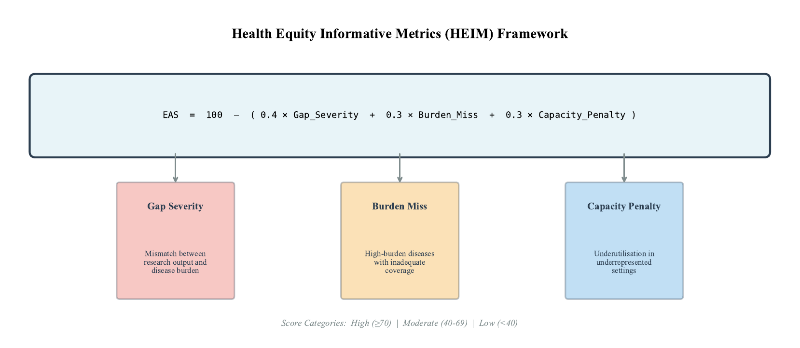
Figure 1. Health Equity Informative Metrics (HEIM) framework. Schematic representation of the Equity Alignment Score (EAS) calculation integrating Gap Severity, Burden Miss, and Capacity Penalty components.
Burden Score quantifies global health importance of each disease: Burden Score = (0.5 × DALYs) + (50 × Deaths) + [10 × log₁₀(Prevalence)]. Coefficients were iteratively calibrated against GBD priority rankings (Spearman ρ = 0.97).
Gap Score (range 0-100) measures mismatch between burden and research attention. Gap severity classification: Critical (>70), High (50-70), Moderate (30-50), Low (<30).
Research Intensity is calculated as publications (for biobanks) or trials (for clinical trials) per million DALYs, enabling comparison across diseases with different burden magnitudes.
Alignment Ratio compares research intensity between HIC and LMIC settings, providing a summary measure of structural disparity.

Results

Part I: Biobank Research Landscape

Dataset overview
We analysed 38,595 PubMed-indexed publications from 70 IHCC-registered biobanks across 29 countries. The 52 HIC biobanks contributed 36,096 publications (93.5%); the 18 LMIC biobanks contributed 2,499 (6.5%).

Geographic distribution
Research output was concentrated in two regions (Figure 2, Figure 3). Europe contributed 21,482 publications (55.7%) from 25 biobanks, with UK Biobank alone accounting for 13,785 (35.7% of total output). The Americas contributed 12,433 publications (32.2%) from 20 biobanks. Africa (277 publications, 0.7%), Eastern Mediterranean (574, 1.5%), and South-East Asia (10, <0.1%) together contributed just 2.2% of global output.
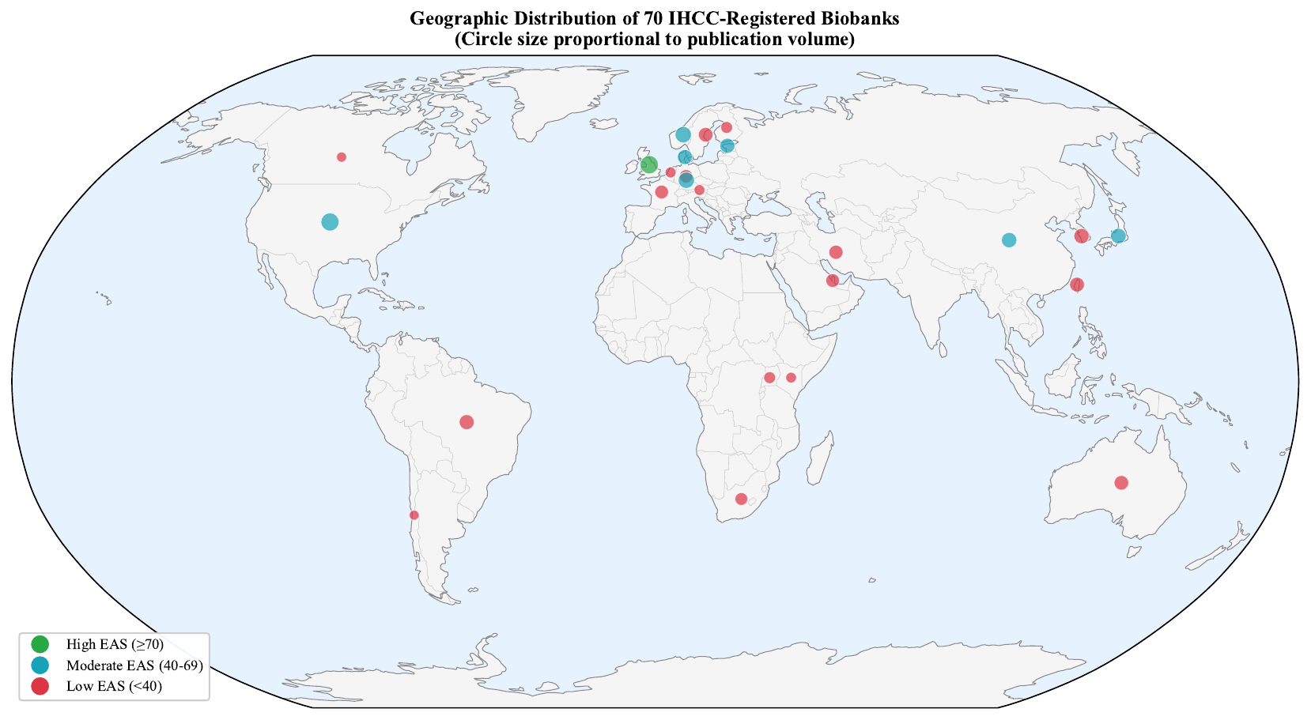
Figure 2. Geographic distribution of 70 IHCC-registered biobanks. Circle size proportional to publication volume. Colours indicate EAS category: green (High, ≥70), cyan (Moderate, 40-69), red (Low, <40).
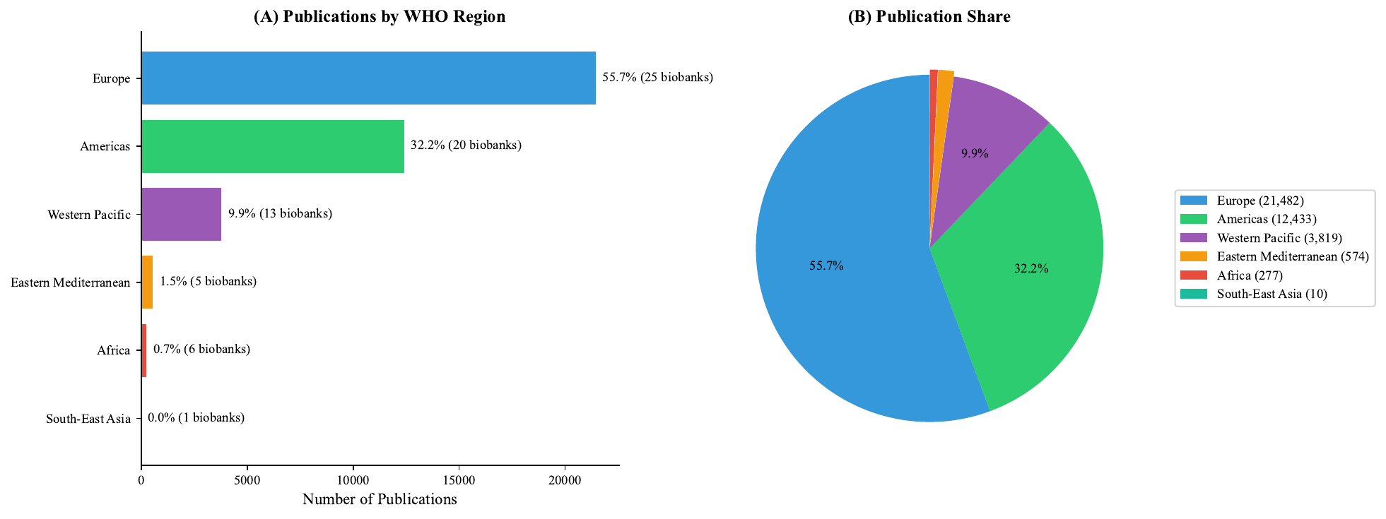
Figure 3. Regional distribution of biobank-linked publications. (A) Publications by WHO region. (B) Publication share with absolute counts.

Alignment ratio
HIC biobanks produced substantially higher research output per unit of disease burden than LMIC biobanks (Figure 4). The alignment ratio was 57.8:1, indicating that for equivalent disease burden, HIC biobanks generate nearly 58 times more research.
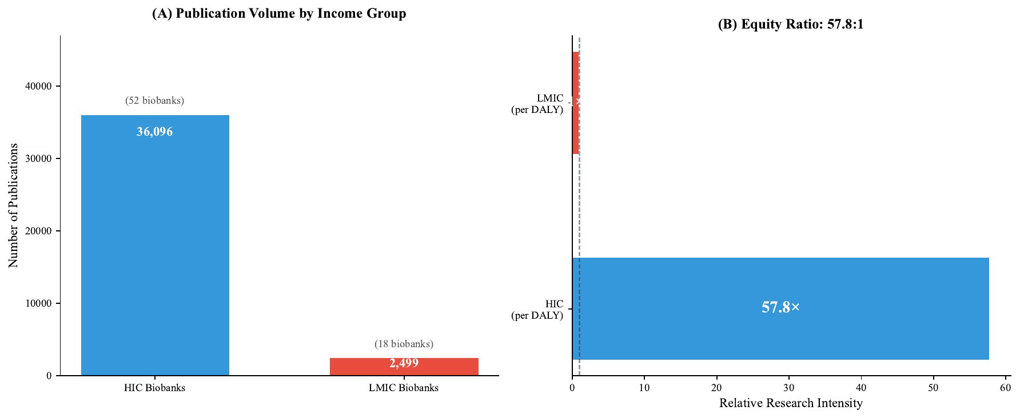
Figure 4. Research intensity by income group. (A) Publication volume: 36,096 from 52 HIC biobanks versus 2,499 from 18 LMIC biobanks. (B) Equity ratio of 57.8:1.

Disease-level gaps
Of 179 disease categories, 22 (12%) showed critical gaps (Gap Score >70), 26 (15%) high gaps, 47 (26%) moderate gaps, and 84 (47%) low gaps (Figure 5). Among infectious diseases, malaria (55.2 million DALYs) generated only 17 publications, tuberculosis (43.1 million DALYs) had 42 publications, and diarrheal diseases (46.8 million DALYs) had 46 publications.
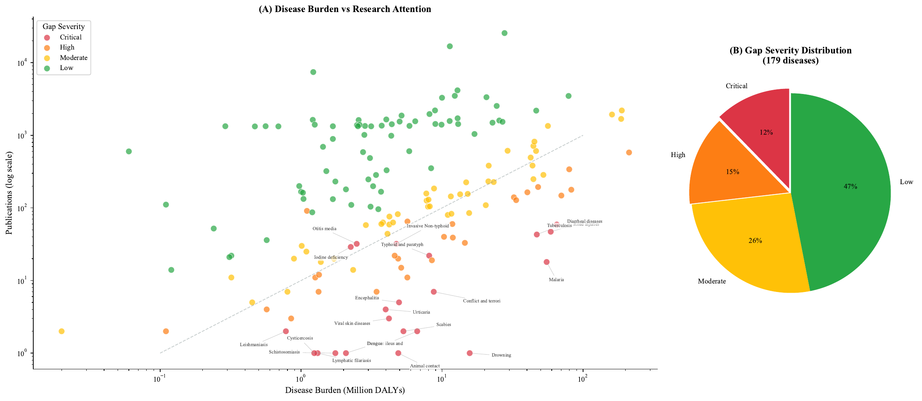
Figure 5. Disease burden versus research attention. (A) Scatterplot of 179 disease categories. Diagonal line represents proportional alignment. (B) Gap severity distribution.

Biobank-level alignment
Equity Alignment Scores ranged from 1.7 to 84.6 (Figure 6). Only one biobank (UK Biobank; 1.4%) achieved High alignment; 56 (80%) were rated Low. UK Biobank was the sole institution achieving High alignment (EAS 84.6, 95% CI 82.1-87.1), contributing 35.7% of all publications across 163 disease categories (Figure 7).
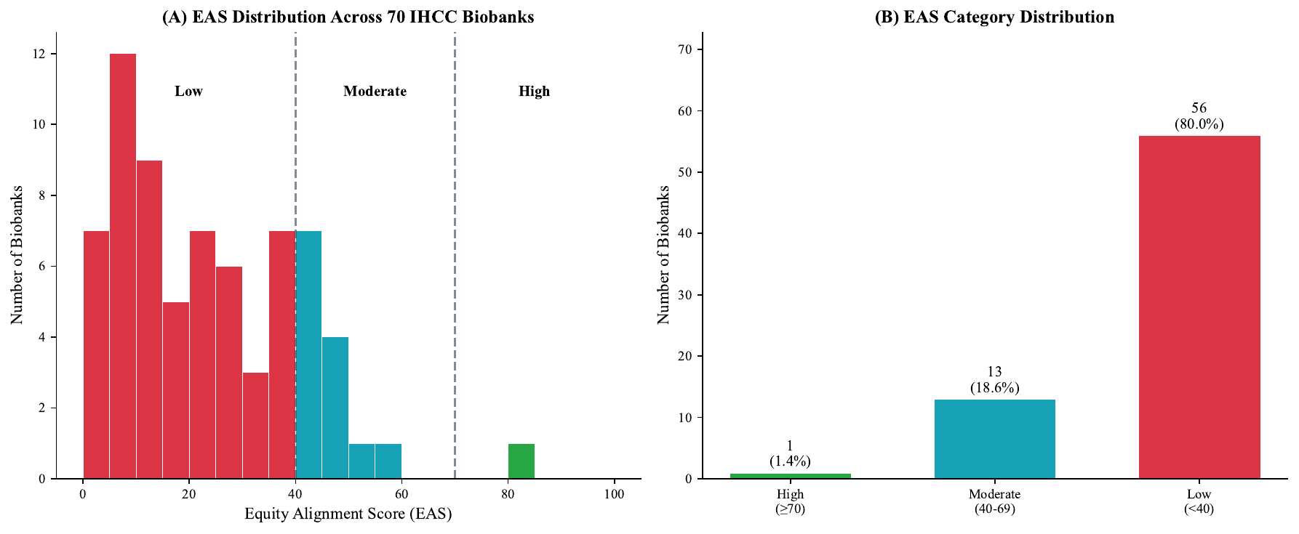
Figure 6. Equity Alignment Score distribution. (A) Histogram showing EAS distribution across 70 biobanks. (B) Category counts: 1 High (1.4%), 13 Moderate (18.6%), 56 Low (80.0%).
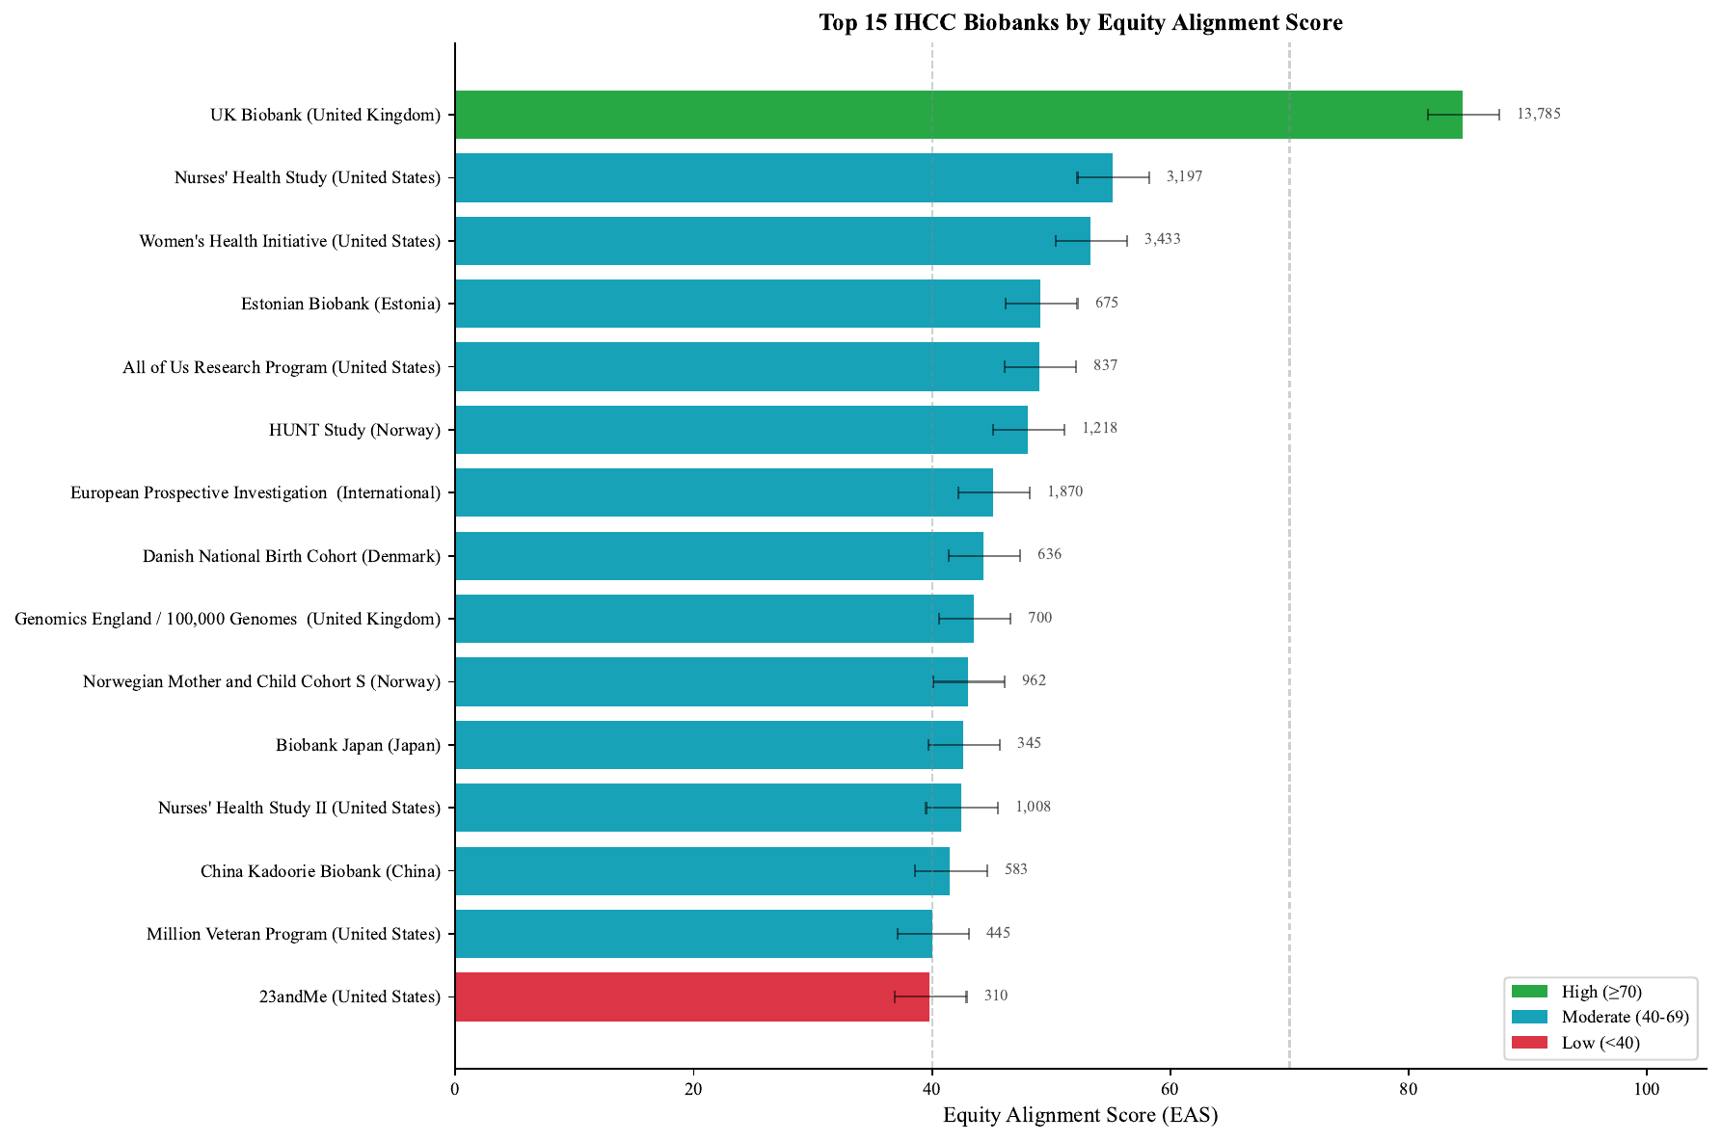
Figure 7. Top 15 IHCC biobanks by Equity Alignment Score. UK Biobank (EAS 84.6, 13,785 publications) is the sole High-rated institution.

Temporal trends
Publication output grew approximately 604% between 2015 and 2024, reaching 6,200 publications annually by 2024 (Figure 8). This acceleration reflects expanded data access and growing recognition of biobanks as essential research infrastructure.
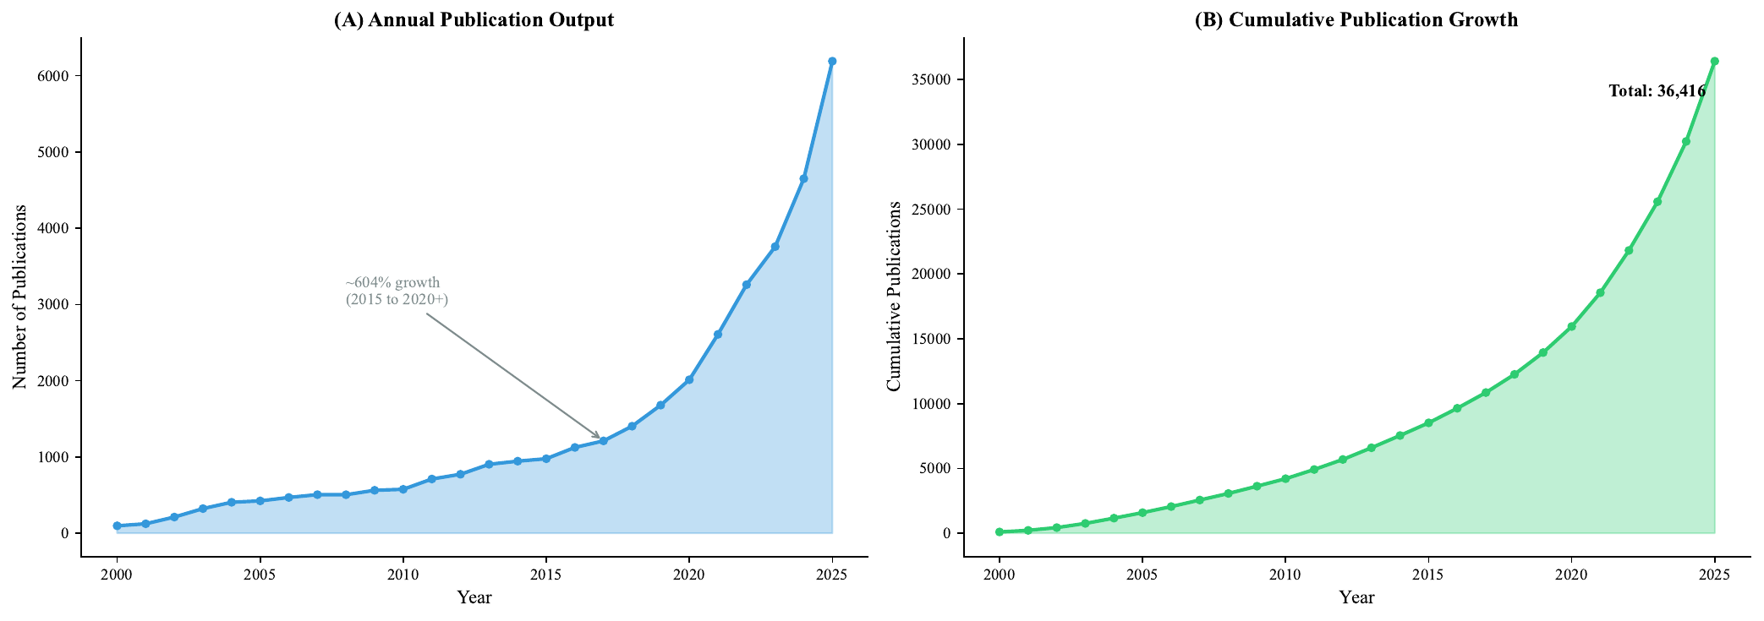
Figure 8. Temporal trends in biobank-linked publications. (A) Annual publication output showing ~604% growth. (B) Cumulative publication growth reaching 36,416 total.

Part II: Clinical Trials Landscape

Dataset overview
We analysed 563,725 clinical trials registered on ClinicalTrials.gov between 2000 and 2025, generating 2,189,930 disease-trial mappings across 89 GBD disease categories. Trial sites were distributed across 194 countries with 770,178 facility location records. Trial volume grew 15.5-fold from 2,332 trials in 2000 to 36,212 in 2025.
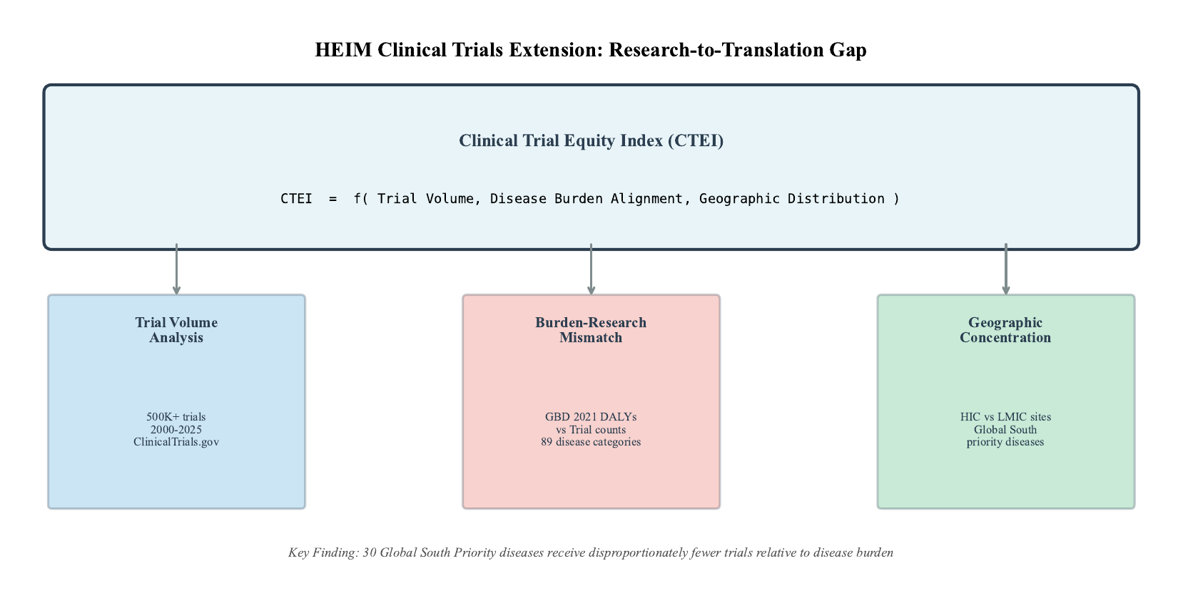
Figure 9. HEIM Clinical Trials Extension framework. The Clinical Trial Equity Index (CTEI) integrates trial volume, disease burden alignment, and geographic distribution.

Research intensity disparity
Research intensity varied by more than 1,000-fold across diseases (Figure 10). The highest intensity diseases were predominantly cancers: kidney cancer (24,964 trials per million DALYs), bladder cancer (22,824), ovarian cancer (19,428). In stark contrast, the lowest intensity diseases included malaria (25.4 trials per million DALYs), tuberculosis (32.1), and neonatal disorders (59.7).
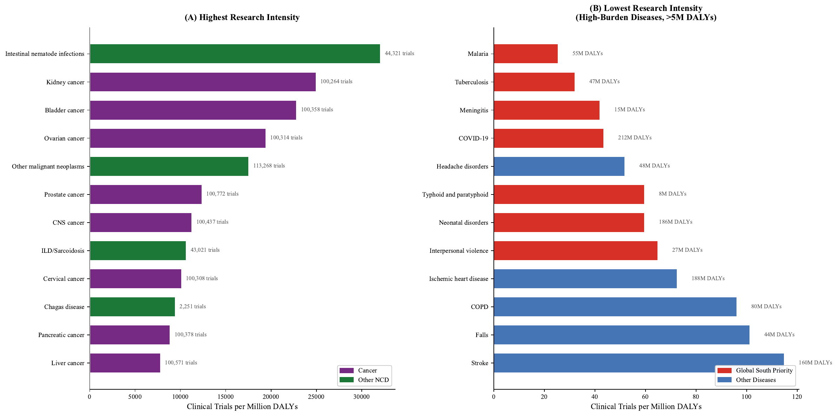
Figure 10. Research intensity disparity. (A) Diseases with highest research intensity (predominantly cancers). (B) Diseases with lowest research intensity among high-burden conditions (>5M DALYs).

Global South Priority diseases
We identified 30 Global South Priority diseases, conditions where at least 60% of burden falls in LMICs (Figure 11). These diseases collectively account for 914.8 million DALYs (38.0% of global burden) but received only 444,502 trials (20.3% of total), yielding a research intensity of 486 trials per million DALYs. Non-priority diseases received 1,167 trials per million DALYs, a 2.4-fold higher intensity.
Nine Global South Priority diseases received fewer than 500 trials over the entire 26-year period. Onchocerciasis (river blindness) received only 34 trials (1.3 million DALYs). Lymphatic filariasis received 90 trials, schistosomiasis received 94 trials, and dengue received 273 trials.
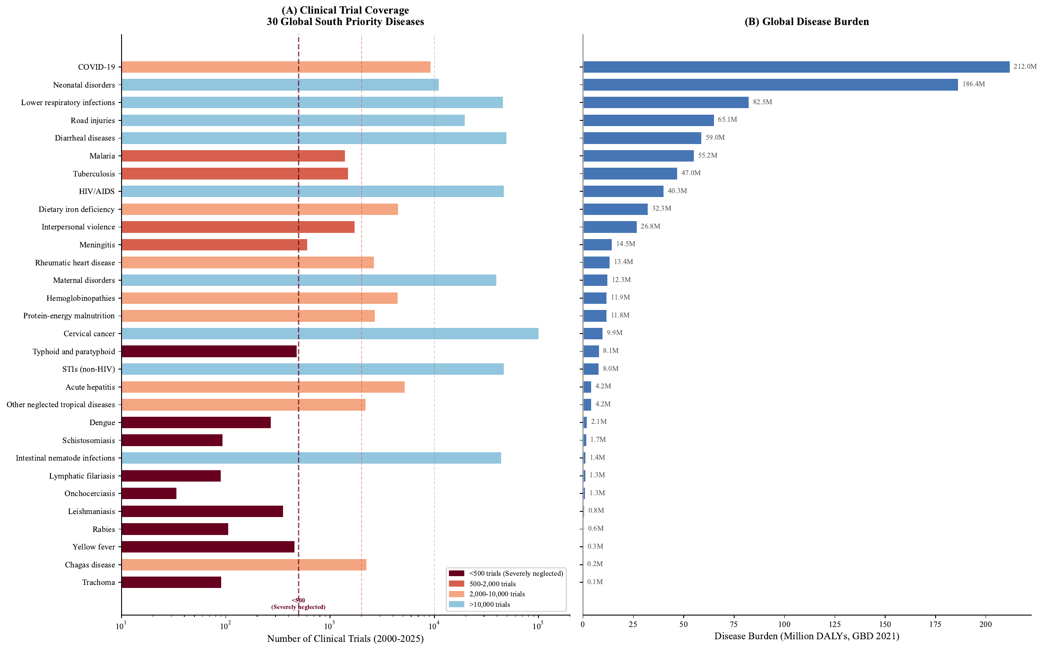
Figure 11. Global South Priority diseases: clinical trial coverage versus disease burden. (A) Trial counts for 30 diseases, with colour indicating neglect severity. (B) Corresponding burden in million DALYs.

Cancer dominance
Neoplasms received 1,345,812 trials (61.5% of all clinical trial activity) while representing only 202.0 million DALYs (8.4% of global burden), a 7.3-fold overrepresentation (Figure 12). This concentration reflects market incentives and robust clinical trial infrastructure in cancer centres.
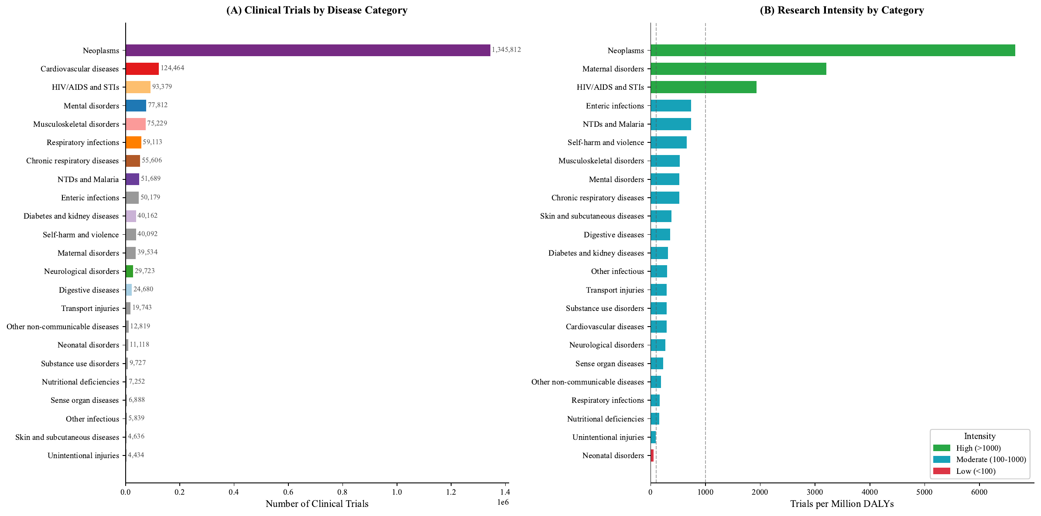
Figure 12. Disease category coverage. (A) Trial counts by GBD Level 2 category showing neoplasm dominance. (B) Research intensity by category, with neonatal disorders showing lowest intensity.

Geographic concentration
Trial sites were concentrated in high-income countries, though less extremely than biobank publications (Figure 13). HIC countries hosted 547,016 trial sites (71.0%) while LMIC countries hosted 223,162 (29.0%), an HIC:LMIC ratio of 2.5:1. The United States alone hosted 192,501 trial sites (25.0% of global total).
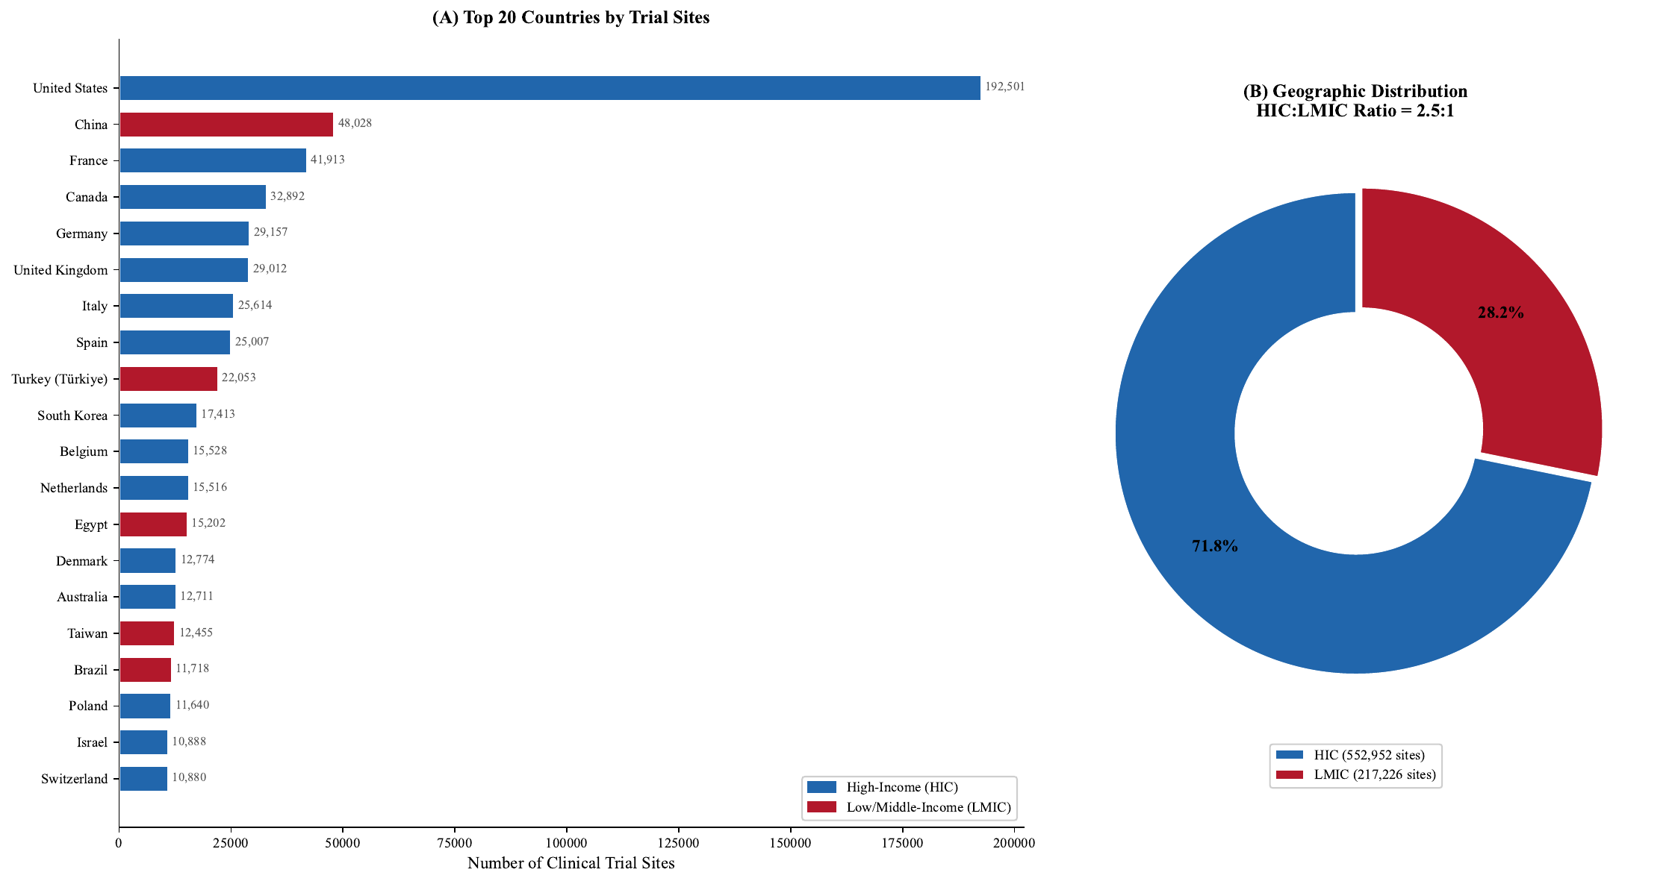
Figure 13. Geographic concentration of clinical trial sites. (A) Top 20 countries by trial site count. (B) HIC versus LMIC distribution showing 71.0% to 29.0% split (ratio 2.5:1).

Temporal trends
Despite 15.5-fold growth in clinical trial volume between 2000 and 2025, the share of trials addressing Global South Priority diseases declined (Figure 14). In 2000-2005, Global South Priority diseases received an average of 47.7% of trials. By 2020-2025, this share had fallen to 35.5%, a decline of 12.3 percentage points. This finding is critical: the clinical trial system is not self-correcting.
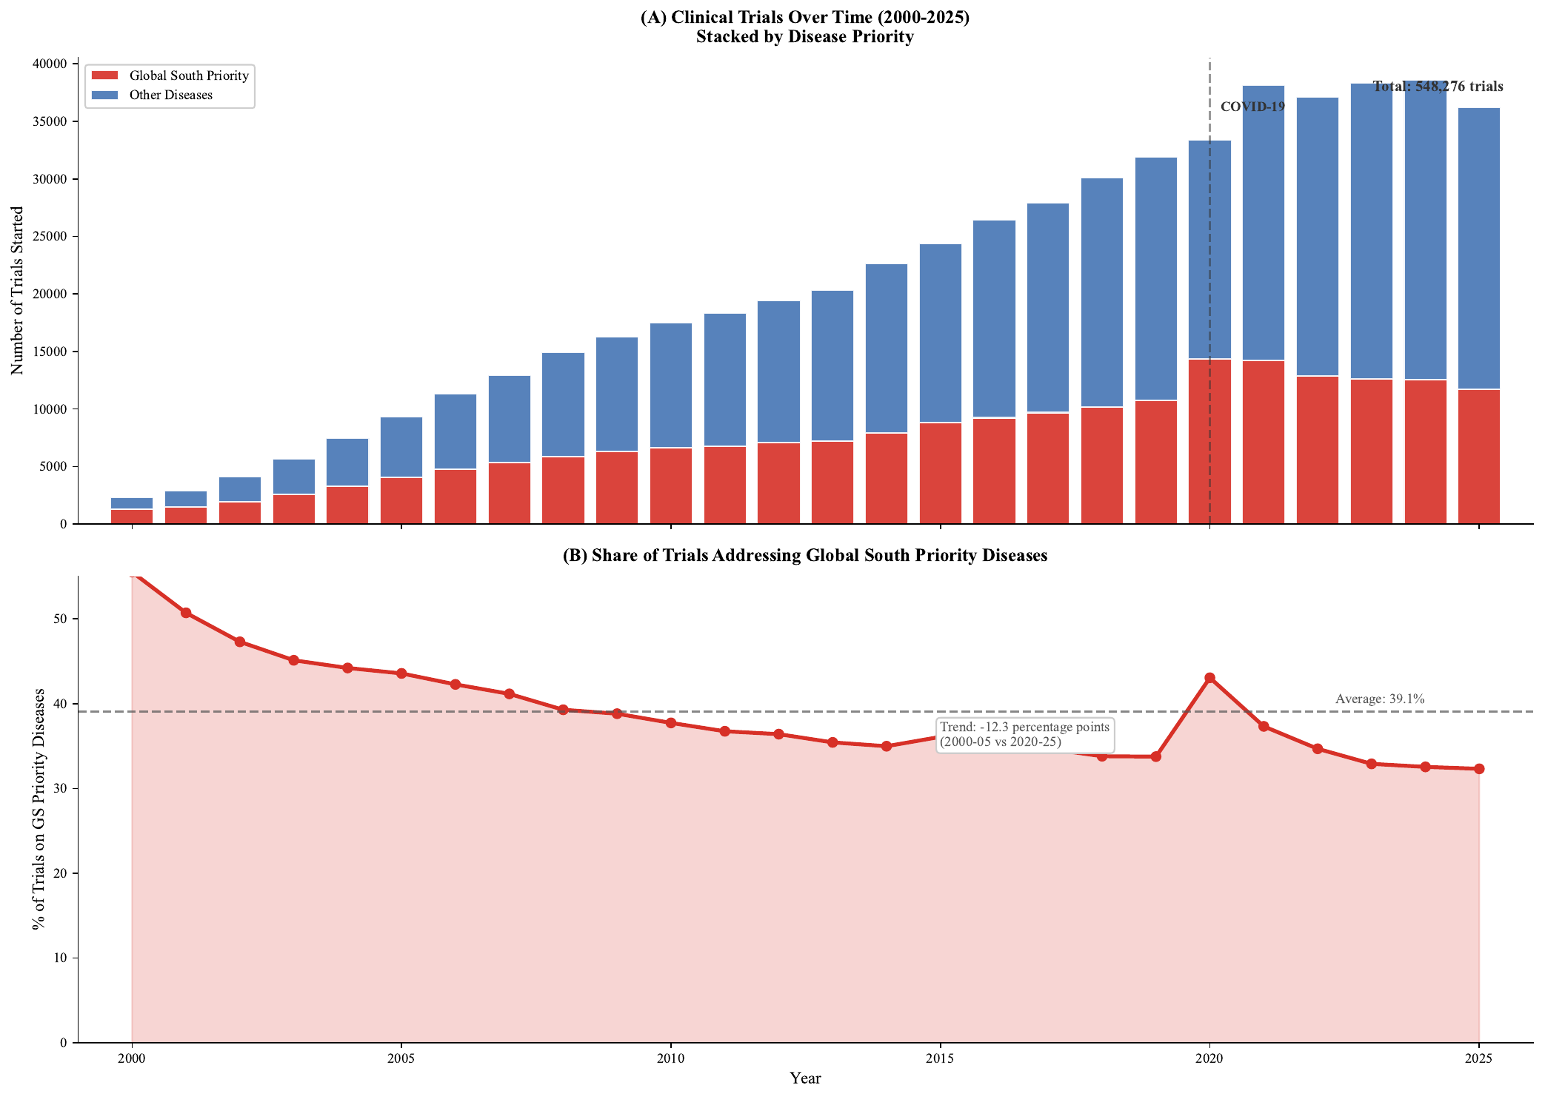
Figure 14. Temporal trends in clinical trial equity. (A) Annual trial volume showing 15.5-fold growth. (B) Declining share of trials addressing Global South Priority diseases.

Double jeopardy analysis
Diseases in the upper-left quadrant of Figure 15 face double jeopardy: high burden combined with low research attention. The most striking examples include neonatal disorders (186.4 million DALYs, 11,118 trials), malaria (55.2 million DALYs, 1,402 trials), and tuberculosis (47.0 million DALYs, 1,507 trials).
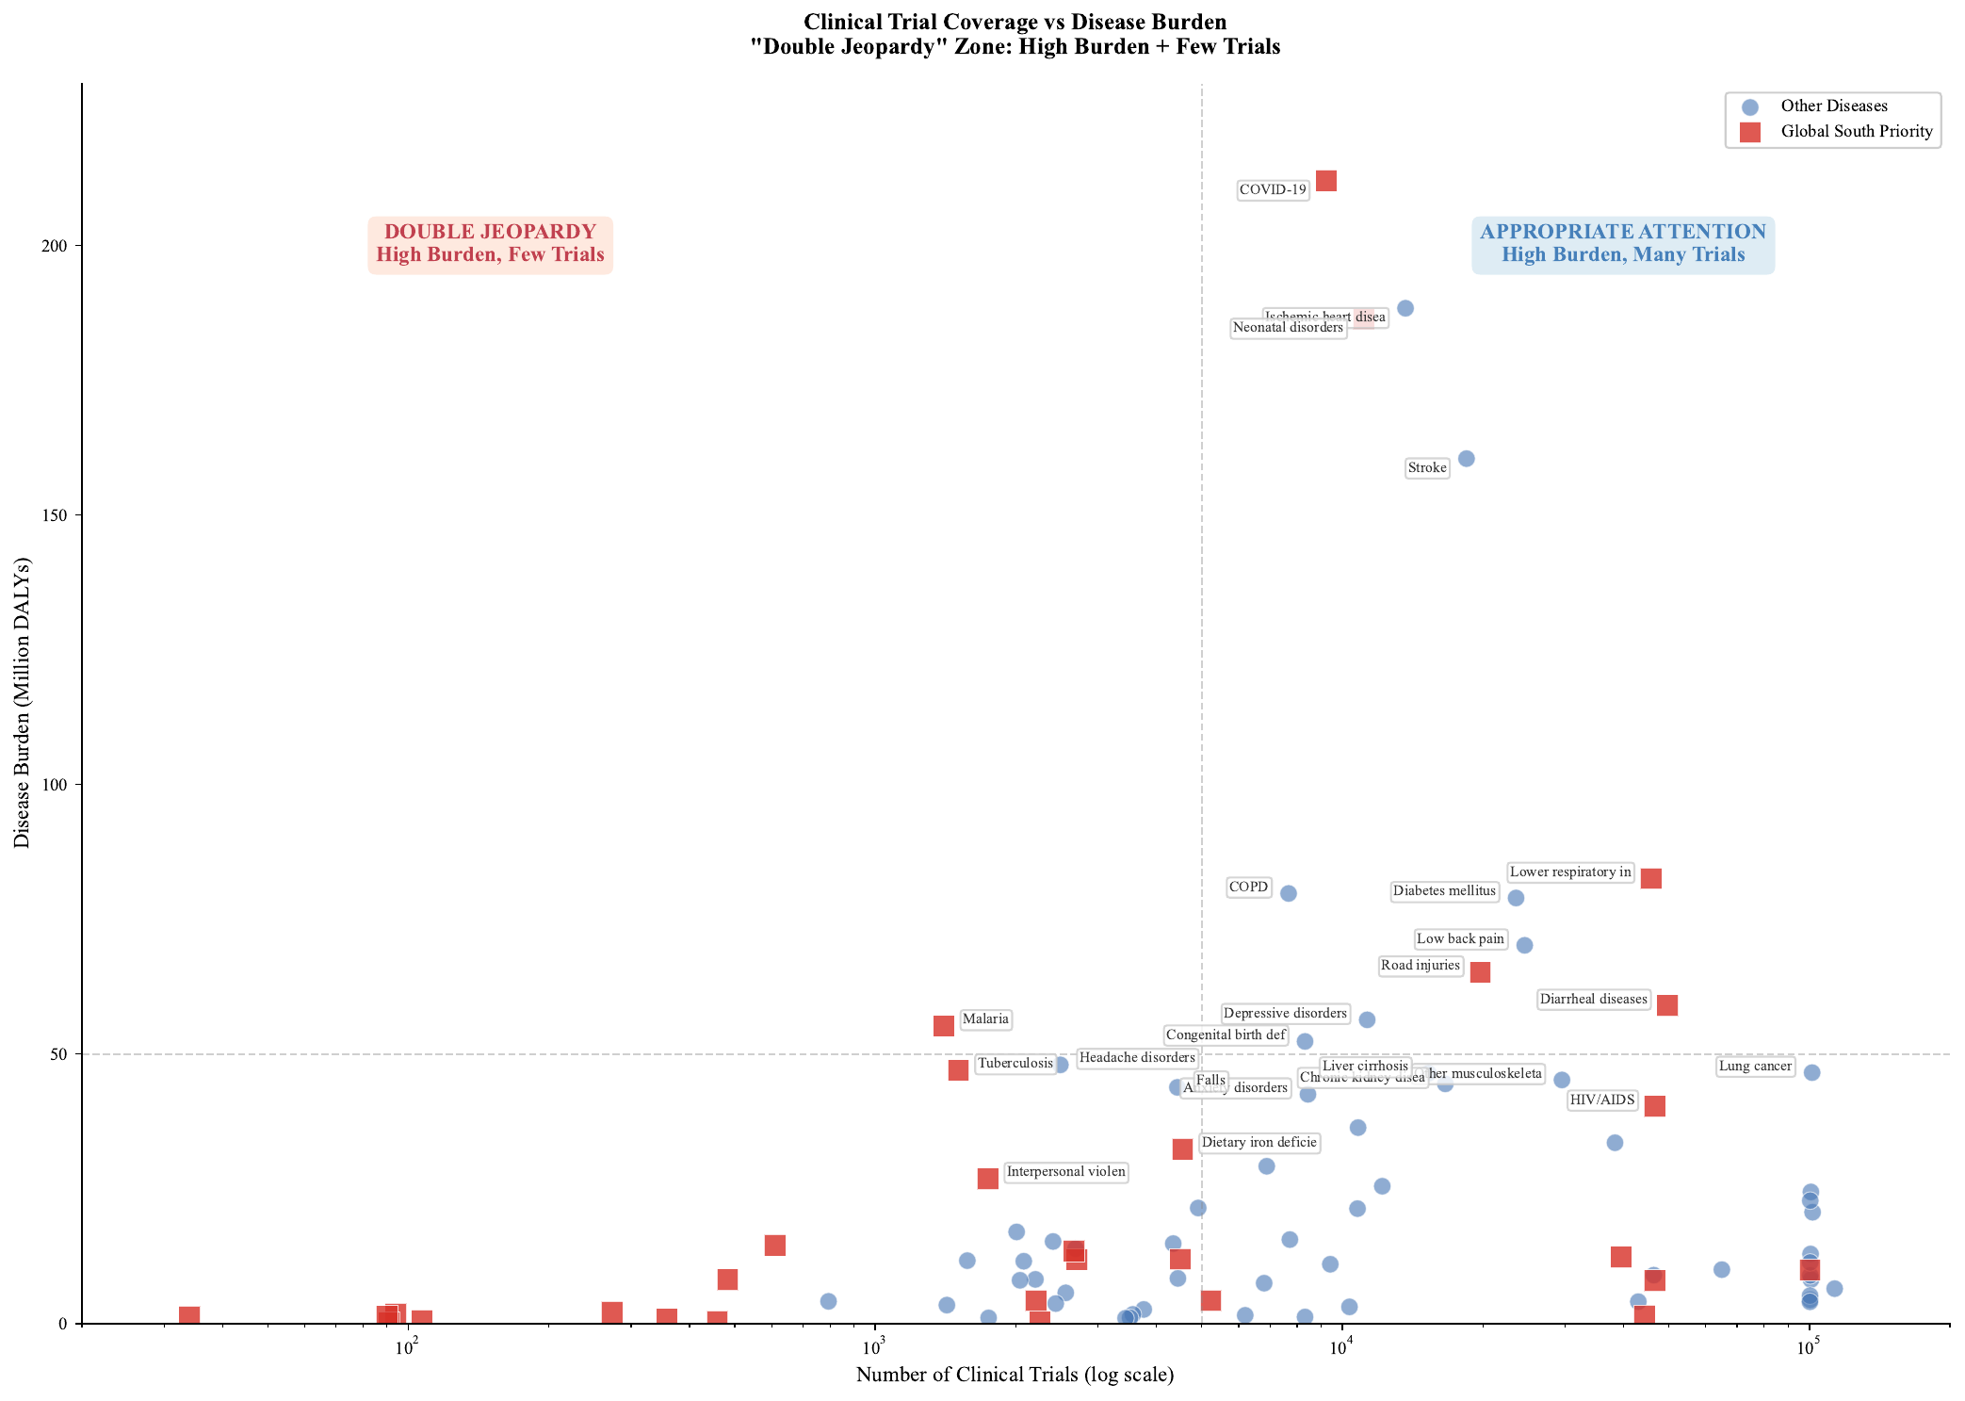
Figure 15. Double jeopardy analysis. Scatter plot showing diseases in the upper-left quadrant facing high burden combined with low research attention.
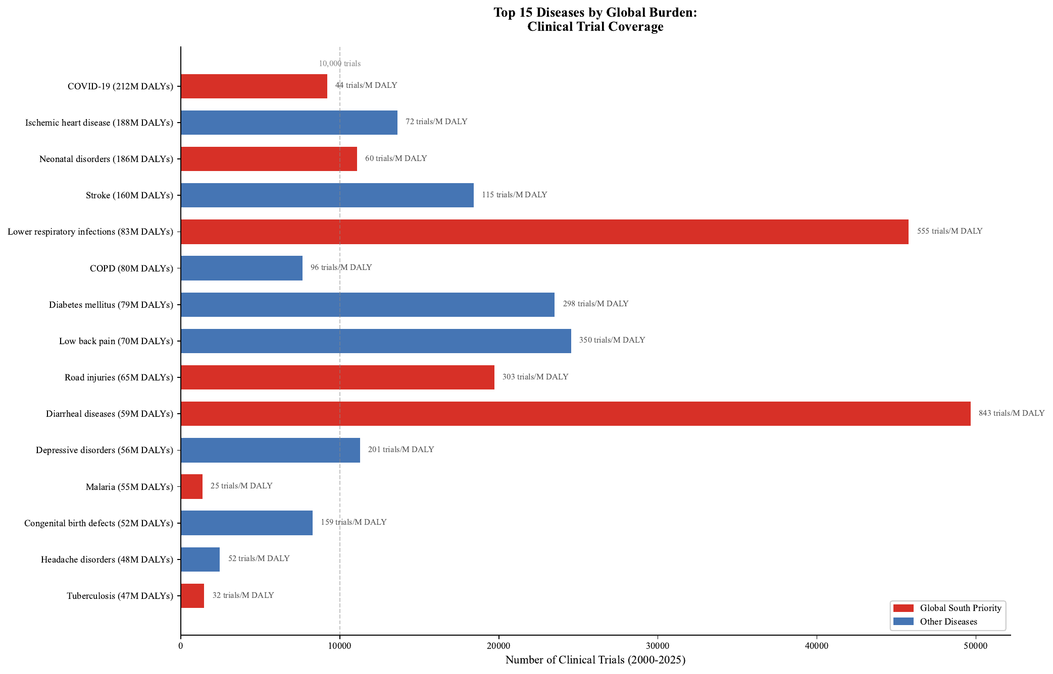
Figure 16. Top 15 diseases by global burden: clinical trial coverage. Bar chart showing trial counts with research intensity annotations.

Part III: Discovery-to-Translation Comparison

The Research-to-Translation Gap
Comparing biobank research (discovery) with clinical trials (translation) reveals a Research-to-Translation Gap where equity disparities persist across the research pipeline (Table 1).
Metric | Biobanks (Discovery) | Clinical Trials (Translation)
HIC:LMIC ratio | 57.8:1 (publications) | 2.5:1 (trial sites)
Cancer focus | ~42% of publications | 61.5% of trials
GS Priority share | ~15% | 20.3%
Temporal trend | Improving | Worsening (-12.3 pp)
Table 1. Comparison of equity patterns in biobank research and clinical trials.
Geographic concentration is better in clinical trials (2.5:1 vs 57.8:1), suggesting trials are more globally accessible than biobank research. However, disease focus is worse (61.5% cancer vs ~42%), and the temporal trend is concerning: while biobank research shows gradual improvement in coverage, clinical trial attention to Global South Priority diseases is actively declining.

Consistent neglect pattern
Several diseases show consistent neglect across both discovery and translation: malaria, tuberculosis, neonatal disorders, neglected tropical diseases, and maternal conditions. These diseases receive minimal attention from biobanks and minimal attention from clinical trials, creating a comprehensive evidence gap that spans the entire research pipeline.

Discussion
This study presents the first integrated HEIM analysis across the discovery-to-translation pipeline, examining 38,595 biobank publications and 2,189,930 clinical trial disease mappings. Our findings reveal a Research-to-Translation Gap: equity disparities observed in biobank research persist and in some cases worsen as findings move toward clinical application.

Principal findings
First, the clinical trial system exhibits structural bias toward diseases prevalent in high-income populations. Neoplasms receive 61.5% of all trial activity while representing 8.4% of global burden. Global South Priority diseases receive 2.4 times less research intensity than other conditions.
Second, the system is not self-correcting. Despite 15.5-fold growth in trial volume between 2000 and 2025, the share addressing Global South Priority diseases declined by 12.3 percentage points. Active intervention is required.
Third, several diseases face double jeopardy: high burden combined with low attention across both biobanks and clinical trials. Malaria, tuberculosis, neonatal disorders, and neglected tropical diseases are underserved at discovery and translation stages.
Fourth, geographic concentration differs between discovery and translation. While biobank research shows extreme HIC concentration (57.8:1), clinical trials are more globally distributed (2.5:1). However, this improved geographic access has not translated into improved disease coverage.

Policy recommendations
Based on our findings, we propose several policy interventions:
- Burden-proportional funding allocation: Public funders should establish minimum allocation percentages for Global South Priority diseases, tracked annually against HEIM metrics.
- Trial site infrastructure investment: Sustained investment in clinical trial infrastructure in Africa, South Asia, and Latin America.
- Regulatory harmonisation: WHO coordination of regulatory pathways for neglected diseases.
- Transparency requirements: Mandatory reporting of trial portfolio alignment with global burden for pharmaceutical companies.
- Equity dashboards: Annual publication of HEIM metrics for major research institutions, enabling benchmarking and progress tracking.

Limitations
Several limitations warrant consideration. ClinicalTrials.gov has known bias toward US-registered trials. Disease mapping achieved high but imperfect accuracy. Trial counts do not capture trial quality or completion rates. Using global DALYs as the denominator reflects a normative choice that global research should address global burden.

Conclusions
The HEIM framework reveals systematic misalignment between global research infrastructure and global disease burden across both discovery and translation stages. HIC biobanks produce 58 times more research per DALY than LMIC counterparts. Clinical trials show 2.4-fold lower intensity for Global South Priority diseases, with this gap widening over time despite massive growth in research volume.
These findings establish that the global research enterprise is not self-correcting. The diseases causing the greatest suffering receive the least attention, and this pattern is worsening. The metrics established here provide a baseline against which progress can be measured. Addressing these patterns requires sustained funding for LMIC research institutions, capacity-building, equitable collaboration frameworks, regulatory reform, and research incentives aligned with global health priorities.

Supplementary Figures
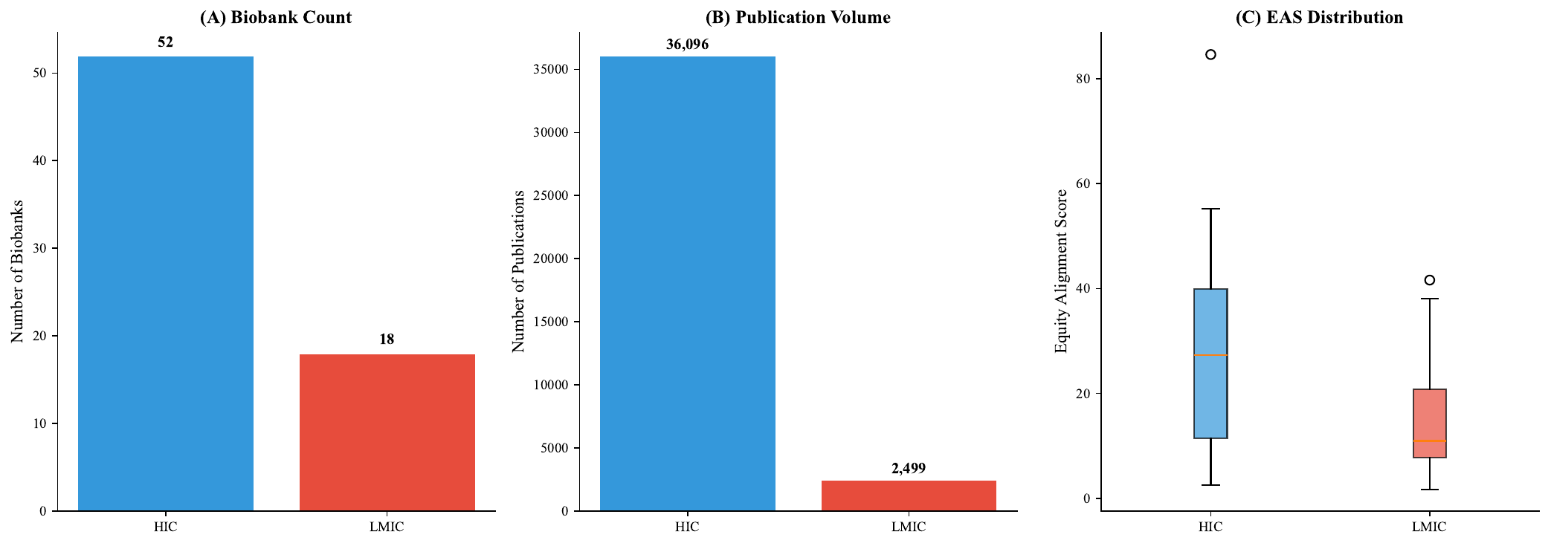
Supplementary Figure S1. HIC versus LMIC comparison. (A) Biobank count by income group. (B) Publication volume. (C) EAS distribution by income group.
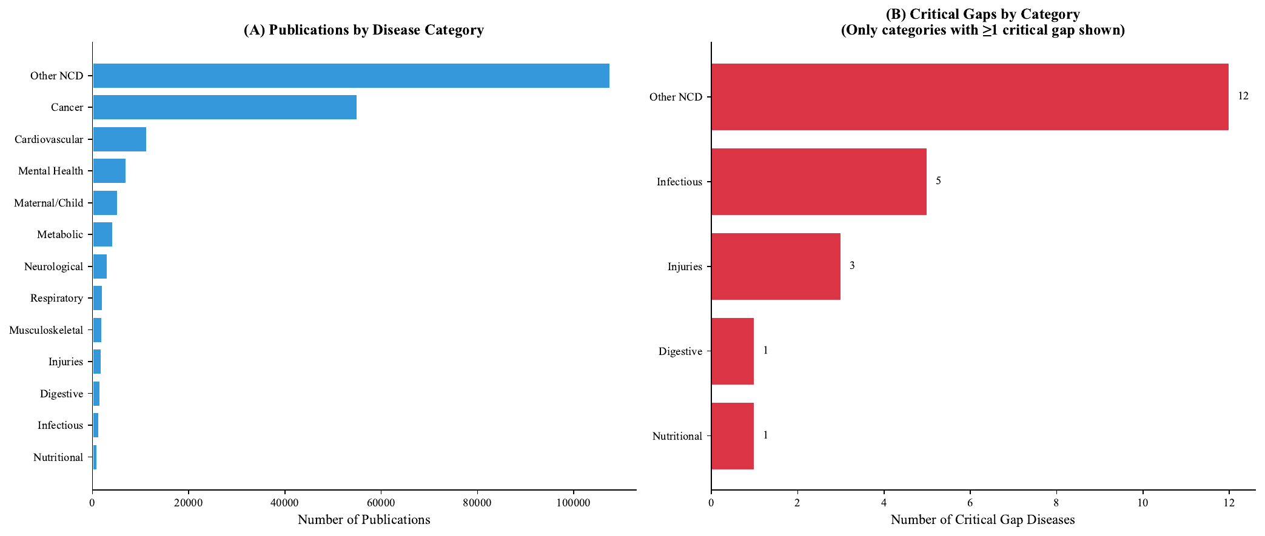
Supplementary Figure S2. Disease category coverage. (A) Publications by disease category. (B) Critical gaps by category.

Data and Code Availability
All analysis code and processed datasets are available at https://github.com/manuelcorpas/17-EHR. An interactive dashboard operationalising HEIM metrics is available at https://manuelcorpas.github.io/17-EHR/. Raw data sources include PubMed (biobank publications), ClinicalTrials.gov via AACT database (clinical trials), and IHME GBD 2021 (disease burden).

Author Contributions
MC conceptualised the study, developed the HEIM framework, conducted analyses, and wrote the manuscript. JVS contributed to biobank data collection and analysis. SF provided guidance on global health equity implications. HG contributed to disease mapping validation. All authors reviewed and approved the final manuscript.

Declaration of Interests
The authors declare no competing interests.

Acknowledgements
We thank the International Health Cohorts Consortium for maintaining the Global Cohort Atlas, the Clinical Trials Transformation Initiative for the AACT database, and the Institute for Health Metrics and Evaluation for the GBD 2021 dataset.

