Navigating between conventional phytopathometry and a multidimensional landscape phenotypic of the Phaseolus vulgaris x Boeremia spp. interaction from frozen DINOv2 representations
Manuel Alejandro Cortes-Quiceno¹, Juan David Rojas-Villafañez¹, Harold Mauricio Peña-Silgado¹, Luz Nayibe Garzón-Gutiérrez² and Edwison Alberto Rojas-Triviño¹
¹ Universidad Nacional de Colombia sede Palmira, Facultad de Ciencias Agropecuarias, Palmira Colombia
²Universidad Industrial de Santander
Corresponding author:

Abstract
Disease severity, commonly expressed as the proportion of symptomatic leaf area, remains a standard metric in plant disease assessment; however, what the affected tissue looks like, how symptoms are arranged, and how the interaction unfolds over time are difficult to measure using severity estimates alone. We asked a simple question with a broad implication: can representations taken, without any task-specific training, from a self-supervised vision foundation model describe the Phaseolus vulgaris × Boeremia spp. interaction more completely than severity alone, and does the conventional phytopathometric reading hold up under the comparison? Detached trifoliate leaves of two common-bean accessions (ASC 160 and CAL 96) were inoculated with Boeremia spp. and a non-inoculated group served as control; leaves were photographed at three post-inoculation evaluations (2,192 images from 257 biological units across the three evaluations). From a frozen DINOv2 ViT-B/14 encoder we read a global class-token embedding and a grid of patch embeddings, and treated them as a phenotypic space. The space told the three groups apart cleanly (linear-probe accuracy 0.95; Gaussian-mixture agreement with the true groups, ARI = 0.77 for global embeddings but only 0.10 for patch embeddings), placed disease intensity along a continuous gradient, and moved with the disease: accession-specific trajectories (net latent displacement 0.446 vs 0.381; permutation P = 1 × 10⁻⁴), rising within-group dispersion (PERMDISP P = 0.001), and increasing spatial aggregation of lesions (Moran’s I, P < 2 × 10⁻¹⁶). Patch embeddings, but not raw attention, tracked the visible symptom (ρ ≈ 0.35 vs −0.10). Against the conventional phytopathometric measures palette-based severity, disease-progress curves and AUDPC the embedding recovered severity under leakage-safe cross-validation (R²_CV = 0.89) while 88% of the latent variance remained unexplained by severity, and spatial organization was essentially independent of severity magnitude (RV = 0.075). Conventional severity, latent state and spatial organization are three overlapping but non-redundant descriptions of the same host–pathogen interaction.
Keywords: latent-space phenotyping; foundation models; disease progress curve; spatial phenotyping

1. Introduction
Common bean (Phaseolus vulgaris L.) is the grain legume most people on Earth eat directly (Hassan et al., 2026; Uebersax et al., 2023), and foliar disease such as ringspot is a recurring drag on its yield and grain quality (Gorny et al., 2015). Ringspot is caused by several species of Boeremia spp. (Ligarreto-Moreno et al., 2022), producing necrotic, roughly circular lesions with concentric rings and embedded pycnidia on leaves, stems, and pods. Behind every resistance-breeding decision, every epidemiological model and every field recommendation sits a phenotyping step: someone has to look at a leaf and put a number on the disease (Bock et al., 2020a; Conejo-Rodríguez et al., 2024). For decades that number has been severity the proportion of tissue showing symptoms and image analysis has made it steadily more repeatable and less subjective (Mutka & Bart, 2015).
Useful as it is, severity is a scalar, and a scalar throws information away. It says how much tissue is affected but not what kind of symptom is present, where the symptoms sit, whether they are scattered or fused, or how fast the picture is changing (Bock et al., 2021; Mutka & Bart, 2015). Two leaves that a rater would score identically can differ in the ratio of chlorosis to necrosis, in the spatial pattern of their lesions, and in their trajectory over the following week differences that matter for how we understand, and eventually manage, the interaction. The problem, put plainly, is that the standard readout may be discarding phenotype that is biologically real. If severity is too narrow, what should replace or complement it? One answer, latent-space phenotyping, treats an image-derived embedding as the phenotype in its own right rather than as a stepping-stone to a predefined trait (Chen et al., 2023; Ubbens et al., 2020). That study showed a learned latent space can order treatment responses along interpretable axes; it also depended on training a network for the task, which is not always possible or desirable. This leaves an open question: are frozen representations never tuned on a single plant image rich enough to phenotype a specific host–pathogen interaction?
There is good reason to think they might be. Self-supervised Vision Transformers learn general visual structure without labels (Vaswani et al., 2017); DINO produced attention that segments objects on its own (Caron et al., 2021), and DINOv2 scaled this into features that transfer, unmodified, to dense and image-level tasks and rival supervised backbones (Oquab et al., 2024). A Vision Transformer (Dosovitskiy et al., 2021; Elharrouss et al., 2025) hands back two things in a single forward pass: one global class-token vector that summarizes the whole image, and a grid of patch vectors that keep spatial position. The first is a natural description of what phenotype is present; the second, of where and how it is organized. For a leaf, that is exactly the distinction severity cannot make.
The P. vulgaris x Boeremia spp. pathosystem suits the question well (Ligarreto et al., 2023; Ligarreto-Moreno et al., 2022; Montero et al., 2021). Detached-leaf assays give standardized, repeatable images; two contrasting accessions let us test whether the representation resolves genotype-dependent responses; and a non-inoculated control anchors what “healthy” looks like in the same optics. What is not known for this interaction is whether a frozen DINOv2 space forms a continuous phenotypic manifold rather than a set of disconnected clusters; whether disease progression is a measurable trajectory through it; whether patch embeddings quantify a spatial organization that shifts over time; and whether any of this genuinely adds to the conventional severity reading or merely restates it.
Those unknowns define our three objectives. (i), to build and characterize a latent phenotypic space from frozen global and patch embeddings, and to test how well it discriminates the two accessions and the control. (ii), to quantify the temporal and spatial structure of that space with statistics that respect the nested, repeated-measures design. (iii), to place the representation beside the conventional phytopathometric reference palette-based severity, disease-progress curves and AUDPC and know whether the two are redundant or complementary. We are not trying to show that DINOv2 “works”; latent-space phenotyping and self-supervised features are established ideas. The contribution is their integration in a defined pathosystem and, above all, an honest test of complementarity.

2. Materials and Methods
Analytical perspective.
The workflow is deliberately linear (Figure 1). Each standardized leaf image passes once through a frozen DINOv2 ViT-B/14 encoder, yielding a global class-token embedding (phenotypic state) and a grid of patch embeddings (local phenotype and its arrangement). Global embeddings define a latent phenotypic space, which we characterize, use for group discrimination, and follow through time as trajectories; patch embeddings drive spatial statistics that keep leaf geometry. In parallel, a palette-based severity workflow with disease-progress curves and AUDPC provides the conventional reference. The two are then compared for redundancy. Nothing in the encoder is trained.
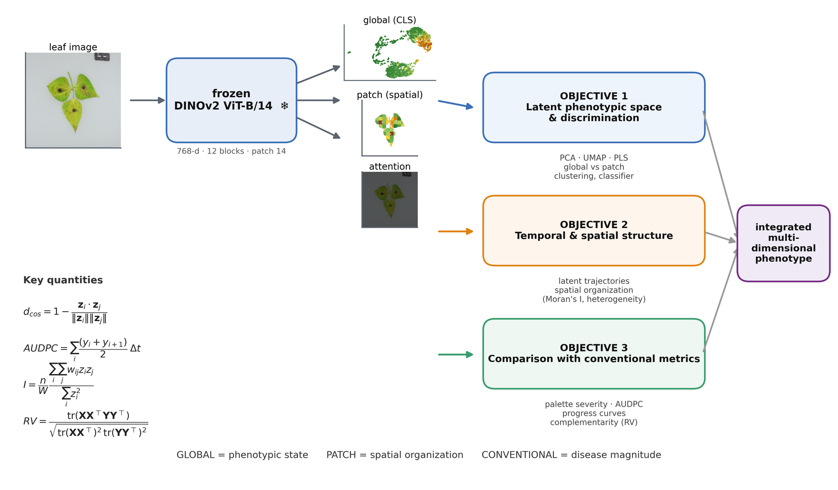
Figure 1. The Analytical perspective for multidimensional phenotyping of P. vulgaris x Boeremia spp. (1) Plant material, including the ASC 160 and CAL 96 accessions and non-inoculated controls, followed by Boeremia spp. inoculum recovery, preparation, counting, and plant inoculation. (2) Standardized image acquisition at 4, 6, and 8 days after inoculation (T1–T3). (3) Frozen DINOv2 ViT-B/14 extraction of complementary representations, including a 768-dimensional global embedding, 256 patch embeddings, and attention maps. (4) Representation of global and local phenotypes in latent space using dimensionality reduction, supervised discrimination, clustering, spatial analyses, and temporal trajectories. (5) Conventional phytopathometry based on image segmentation and R4PDE-derived disease intensity, followed by disease progress curves and AUDPC calculation. (6) Cross-representation integration to compare conventional severity with global latent state, spatial organization, and temporal dynamics, providing a multidimensional description of disease phenotype.

Plant material and inoculation.
Two P. vulgaris accessions, ASC 160 and CAL 96, belonging to the bean germplasm collection of the Alliance of Bioversity International & CIAT, were used for this study. Seeds free of chemical treatment were sown in pots containing previously sterilized subtrate (sterilized for at least two consecutive cycles) and grown inside the greenhouses at the International Center for Tropical Agriculture (CIAT) until plants reached developmental stages 13 and 14 to15 code B.B.C.H. scale (appearance of the first to third trifoliate leaf, approximately 17 days after sowing) (Meier, 2001), showing no signs or symptoms of infection or mechanical damage and appearing vigorous and well hydrated at the time of inoculation.
Inoculation with Boeremia spp. followed a four-step protocol. (i) Inoculum recovery: fungal isolates were grown on culture medium for 10 to 14 days, the time required for Boeremia spp. to reach sporulation; the sporulating culture was then flooded with sterile distilled water and gently scraped with a sterile spatula to release conidia and mycelial fragments into suspension. (ii) Filtering and collection: the resulting suspension was passed through sterile gauze to remove solid residues such as agar and mycelium, and the filtrate containing the conidial suspension was collected in a sterile beaker. (iii) Counting and inoculum preparation: a 1-µL aliquot of the filtered suspension was examined under a light microscope using a hemocytometer, counting conidia in five random squares (the four corner squares and the central square); counts exceeding 50 conidia per square were diluted before proceeding, and counts were required to fall within a homogeneous range before being averaged. The stock concentration was then adjusted to a final working concentration of 1 × 10⁶ conidia/mL using the dilution formula V1C1 = V2C2, ensuring standardized, homogeneous inoculum pressure across accessions and replicates. (iv) Inoculation: the standardized conidial suspension was applied with a "DeVilbiss"-type sprayer connected to a compressor (an atomizer served as an alternative, provided the same inoculum volume was applied to each leaf), spraying both the adaxial (upper) and abaxial (lower) leaf surfaces until fully wetted. Inoculated plants were then transferred to a humid chamber at relative humidity above 90% for approximately 10 days, after which they were moved to ambient-temperature conditions for 3 additional days to provide optimal environmental conditions for pathogen development. Non-inoculated plants, which received no spray application, served as the control group.
Each leaf was assessed at three consecutive post-inoculation timepoints: T1 was four (4) days after inoculation, T2 was six (6) days after inoculation, and T3 was eight (8) days after inoculation. This resulted in three groups for analysis: one control and two inoculated accessions. 257 biological units (118 units per accession under challenge and 21 control units per accession) made up the working set (Table 1).
Plant imaging.
Each leaf was photographed on a uniform light background using a Canon PowerShot G12 digital camera (10 megapixels; fixed 5× optical zoom lens, 8.108 mm; 2.8-inch vari-angle LCD screen; aperture f/4.0; speeds 1/250 s (0.004)), positioned at a working distance of 30 a 35 cm, under a Photobox Plus 1419 (Ortech™) lightbox as the illumination setup, at a native resolution of 3,648 × 2,736 pixels and ISO 80. Images were acquired at each of the three post-inoculation evaluations described above (T1–T3). The working set totaled 2,192 original images, with a median of three technical images per biological unit and evaluation (Table 1).
Table 1. Image dataset and experimental representation. Biological units and image counts per accession, treatment and evaluation for the original working set, plus the control-only augmentation set used to balance the discrimination analyses.
accession | treatment | biological units | images T1 | images T2 | images T3 | total images
ASC 160 | control | 10 | 11 | 11 | 11 | 33
ASC 160 | inoculated | 118 | 353 | 353 | 355 | 1061
CAL 96 | control | 11 | 12 | 12 | 12 | 36
CAL 96 | inoculated | 118 | 351 | 354 | 351 | 1056
- | augmented (controls) | - | - | - | - | 532
Data preprocessing
Images were resized to a maximum long side of 1,024 pixels for severity segmentation and to 224 × 224 pixels for encoder inference (patch 14 → 16 × 16 = 256 patch tokens); a subset was also read at 448 pixels (32 × 32 tokens) for high-resolution symptom maps.
Data augmentation
The three analysis groups were markedly unbalanced each inoculated accession contributed 118 biological units, but only 21 units were available as non-inoculated controls and a skewed training set pushes a classifier toward the majority classes while inflating its apparent accuracy on the minority one (Buda et al., 2018). To restore balance for the supervised discrimination analyses we built a control-only augmentation set of 532 images by applying, to each base control leaf, thirteen label-preserving geometric and photometric transforms (rotations, horizontal and vertical flips, mild scaling and translation, and small shifts in brightness, contrast and hue) alongside the untouched original. The transforms were deliberately conservative: they change the pose and illumination of a leaf without painting on symptoms that were never present, so the “healthy” phenotype is broadened rather than fabricated. Each synthetic image inherited the biological-unit label of its source and was locked into the same train/validation/test partition as that source through a provenance manifest, so no augmented view of a leaf could cross into a partition separate from its original and leak information into the held-out set (Ubbens et al., 2020). Augmentation was confined to balancing the supervised classes; every unsupervised analysis the latent space, trajectories, spatial statistics and the conventional severity reference used original images only.
Frozen encoder and embeddings.
We used DINOv2 ViT-B/14 (Oquab et al., 2024) with its released weights loaded locally 12 blocks, 12 heads, 768 dimensions, an exact parameter match held frozen (inference only), with ImageNet normalization. For each image the L2-normalized class-token vector was the global descriptor; the 256 patch tokens, kept with their 2-D coordinates, were the patch descriptor, and their per-image mean gave a patch-level summary for discrimination. Distances between embeddings used cosine geometry,
$$d_{cos}\left(z_{i},z_{j}\right)=1-\frac{z_{i}⋅z_{j}}{∥z_{i}∥ ∥z_{j}∥}.$$
Attention and symptom localization.
Explicit self-attention was recovered from every block (class-token attention, its across-layer mean and variance, per-head maps, and attention rollout) and rendered as smooth overlays confined to the lamina. Separately, we defined a patch symptom score as the cosine distance of each patch embedding to the mean patch embedding of control leaves, $s_{p}=1-cos\left(p,{\overset{‾}{p}}_{\text{healthy}}\right)$, and compared both attention and this score against a colour-based index of visible symptom (non-green fraction per patch). Attention is reported only as interpretability evidence; we make no causal claim from it.
Latent space, discrimination and clustering.
The global space was examined as the raw L2 space, a PCA representation, and a UMAP layout used for visualization only (McInnes et al., 2020). To ask how well and in which representation the three groups separate, we trained a small multilayer-probe (768→256→3) on global and on patch descriptors under a 70/15/15 split made at the level of biological units (so no leaf, and no augmentation of a leaf, crossed partitions), logging cross-entropy loss, accuracy and macro-recall per epoch and reporting the held-out confusion matrix. We also measured grouped 5-fold cross-validated accuracy of a logistic probe in the PCA, UMAP and PLS-DA spaces, and the silhouette of the true groups. Unsupervised recovery of the groups was assessed with k-means and Gaussian-mixture clustering, scored by the adjusted Rand index against the true labels.
Temporal trajectories and spatial phenotyping.
Technical images were first averaged to one vector per biological unit and evaluation, so trajectory statistics rest on biological, not technical, replication. Group centroids defined trajectories T1→T2→T3, from which we took stepwise and net displacement, path length and direction, inter-accession divergence, and within-group dispersion; per-unit net displacement (units seen at both T1 and T3) was summarized with unit-level bootstrap intervals and compared between accessions by permutation.
Per image, patch symptom scores were mapped back to the 16 × 16 grid. We quantified spatial heterogeneity (mean pairwise cosine distance among leaf patches), spatial autocorrelation with Moran’s I over leaf patches,
I=nW i​j​wij zizji​zi2, zi=xi-x,
lesion fraction (patches above the 95th percentile of the control score distribution) and lesion aggregation (largest connected component relative to all lesion patches).
Conventional phytopathometry: severity, progress curves and AUDPC
The conventional reference was computed in R following R4PDE package functions (Del Ponte, 2023). A colour-palette classifier assigned each pixel to healthy, lesion, background, plug or card by nearest reference colour in CIELAB; severity was the diseased fraction of leaf tissue, $\text{Sev}=100×\text{lesion}/\left(\text{healthy}+\text{lesion}\right)$. Unit × evaluation means gave disease-progress curves and the area under them,
$$\text{AUDPC}=\sum_{i=1}^{k-1}{\frac{y_{i}+y_{i+1}}{2}} \left(t_{i+1}-t_{i}\right),$$
reported as a relative index over equally spaced evaluations (Madden et al., 2007). Because AUDPC is blind to curve shape, we also compared the accession progress curves by an L² functional distance, $D=(∫{\left(f_{\text{ASC}}-f_{\text{CAL}}\right)}^{2} dt)^{1/2}$.
Integration.
Blocks were related by Partial Least Squares (Wold et al., n.d.) and the RV coefficient (Robert & Escoufier, 1976),
$$RV\left(X,Y\right)=\frac{tr\left(XX^{⊤}YY^{⊤}\right)}{\sqrt{tr\left({\left(XX^{⊤}\right)}^{2}\right) tr\left({\left(YY^{⊤}\right)}^{2}\right)}}.$$
Predictive PLS regressed severity on the global embedding under biological-unit grouped 5-fold cross-validation, with component number chosen by cross-validation and uncertainty by unit bootstrap; complementarity was the fraction of latent variance not explained by a quadratic in severity, and the Spearman correlation structure among conventional and embedding-derived metrics at the unit level.
Analytical approach.
Multivariate hypotheses were tested on unit-level vectors one point per unit × evaluation to avoid pseudoreplication, using PERMANOVA (Marti J. Anderson, 2001) and PERMDISP (Anderson, 2006) with 999 permutations using vegan R-package (Oksanen et al., 2018). Severity and spatial metrics were fitted with linear mixed models (accession × timepoint fixed, biological unit random using lme4 R-package; Bates et al., 2015) and Kenward–Roger contrasts (emmeans) (Lenth & Piaskowski, 2026). Effect sizes (R², variance components, RV), uncertainty (95% intervals) and permutation or analytic probabilities are reported with sample sizes throughout. Analyses ran as modular, seed-fixed scripts (Python 3.11: PyTorch, timm, scikit-learn, umap-learn; R 4.3.3).

3. Results

3.1 The frozen representation is grounded in the leaf and localizes the symptom in its patches, not in its attention
We first asked whether the representation is spatially anchored in the disease (Figure 2). After masking background, plug and scale card, patch symptom maps traced the chlorotic and necrotic tissue and grew as disease advanced (Figure 2, middle column), while attention rollout stayed on the lamina and its venation (right column). The distinction was clear in numbers: the patch symptom score correlated positively with the visible symptom (Spearman ρ = 0.37, 0.34 and 0.34 at T1–T3; Figure S3), whereas raw attention did not (ρ ≈ −0.10). We therefore locate the disease signal in the learned patch representation and treat attention conservatively as evidence that the model looks at the leaf, not as a lesion detector. This guards against a common over-reading of transformer attention.
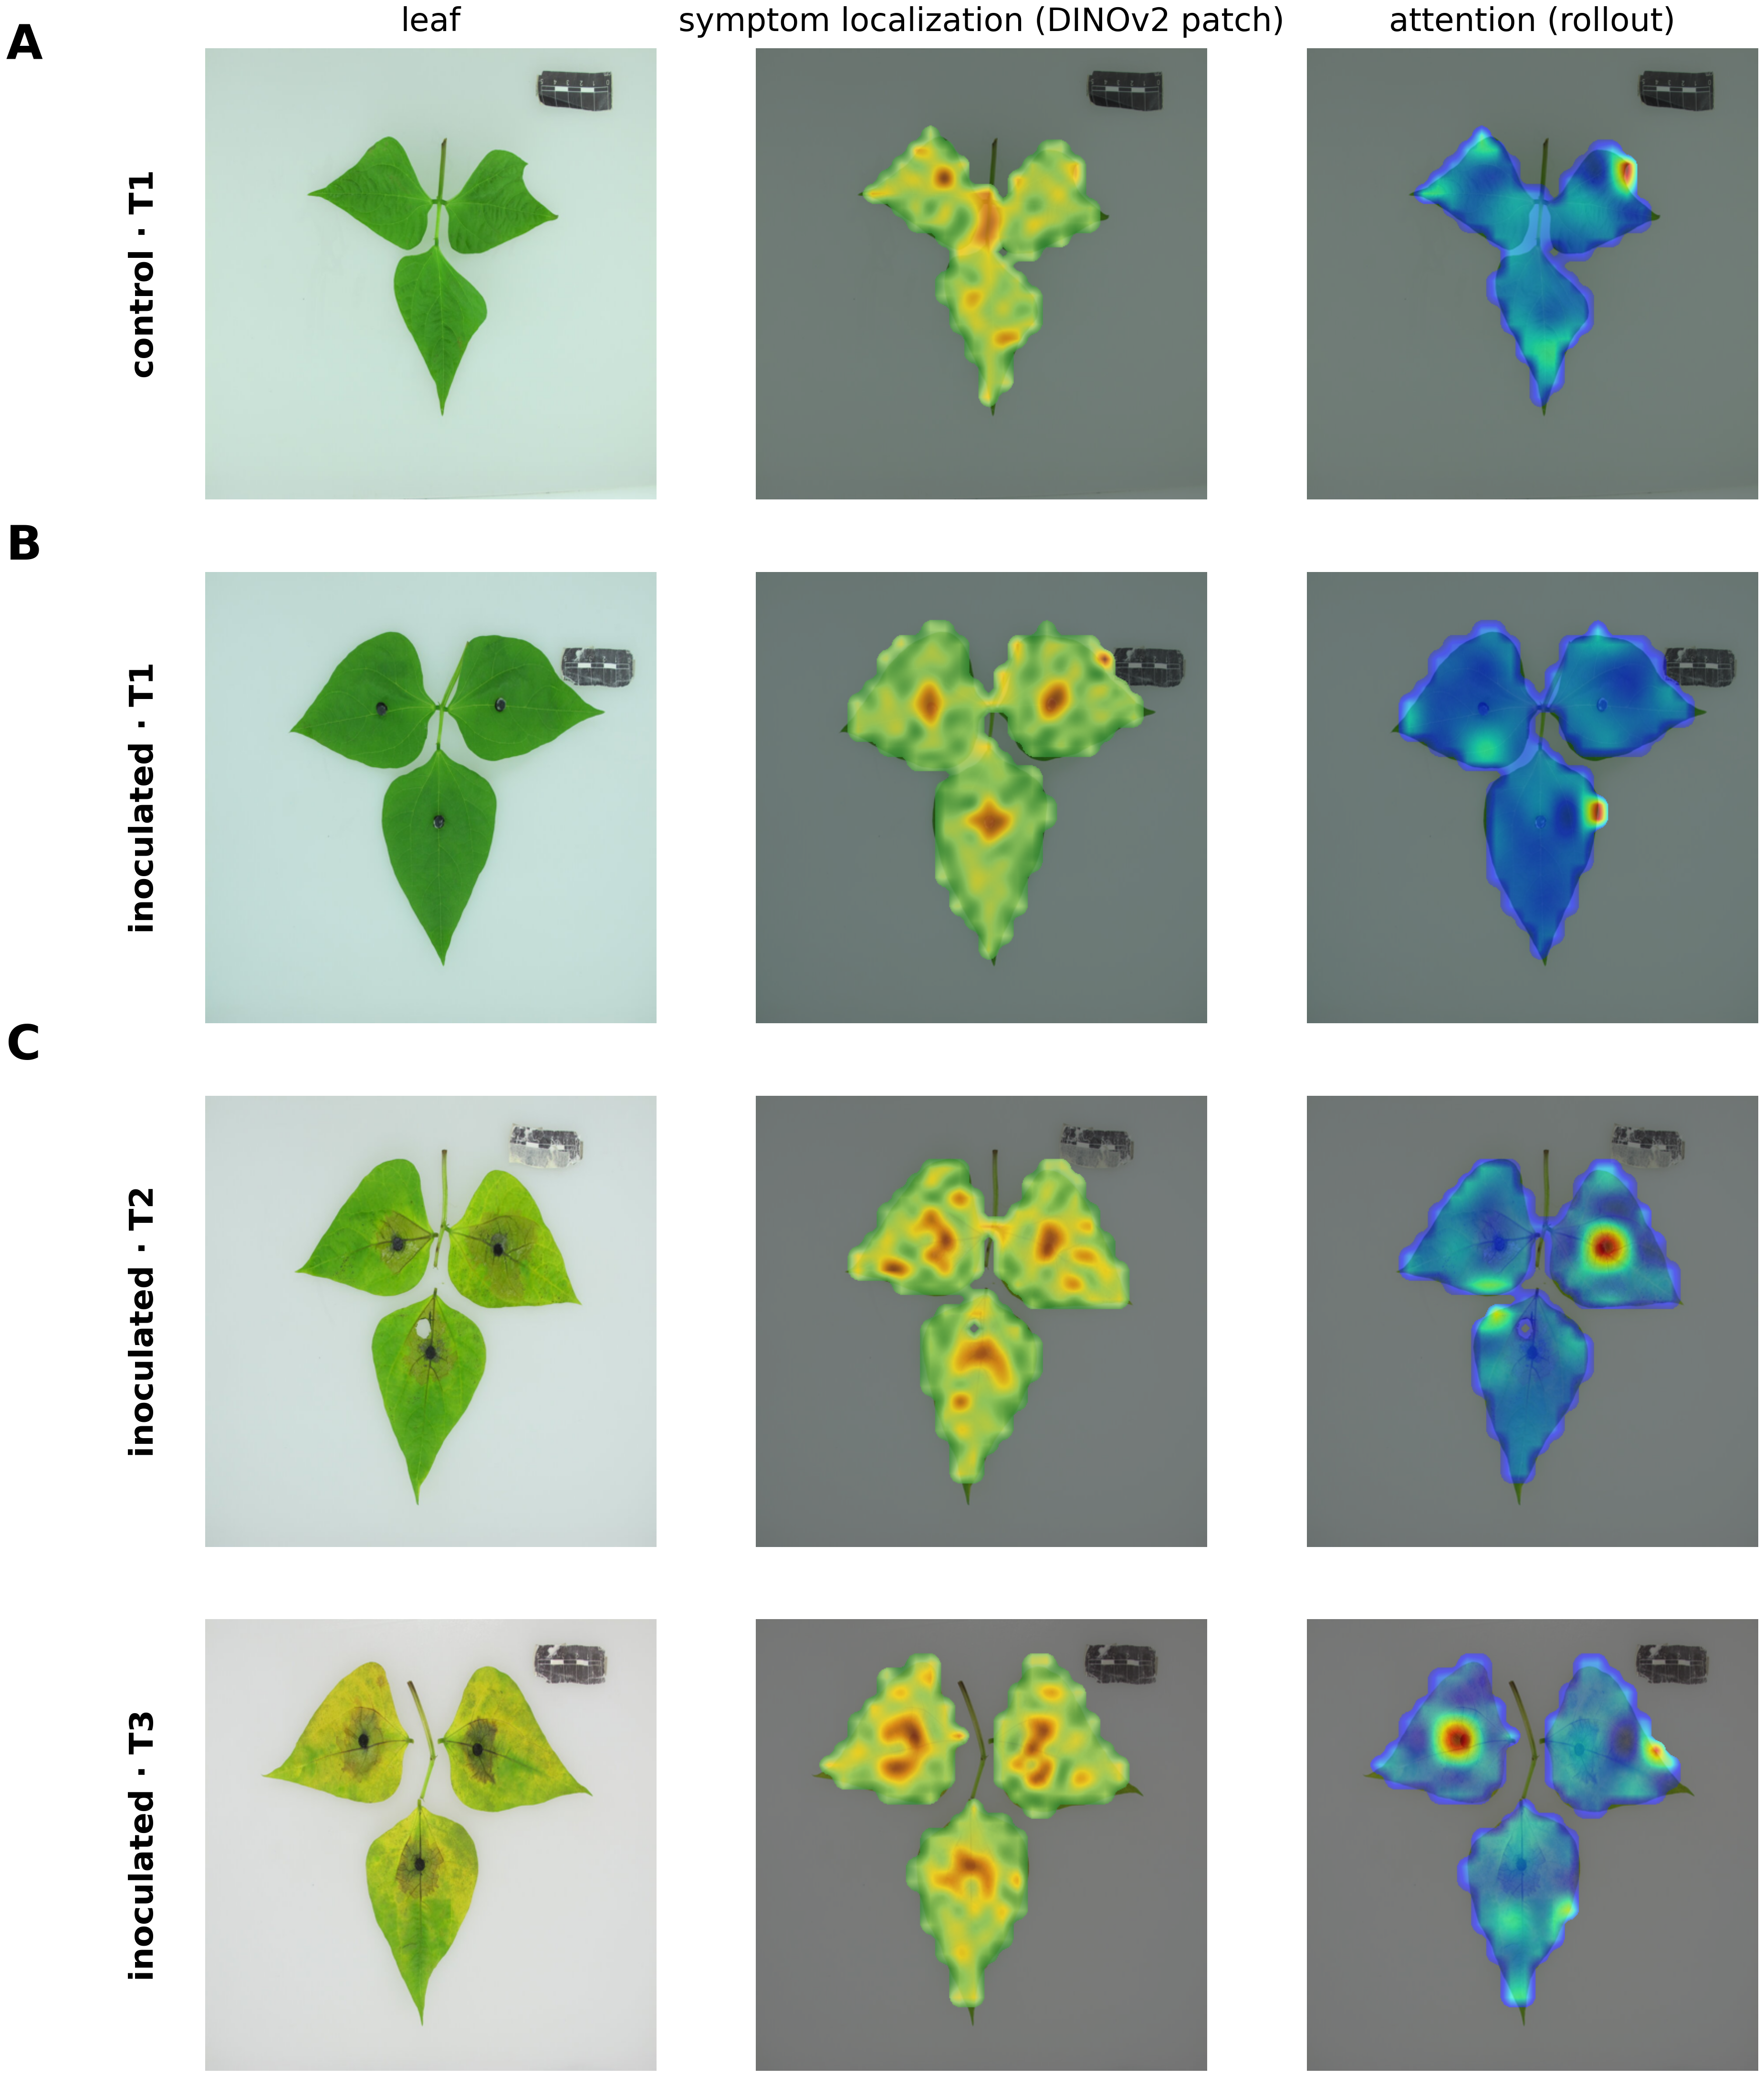
Figure 2. The representation localizes the symptom in its patches, not in its attention. (A–C) Representative leaves (control and inoculated ASC 160 at T1–T3): original image; symptom-localization map from high-resolution (32×32) DINOv2 patch embeddings (cosine distance to the healthy control-patch centroid); and attention rollout, all masked to the lamina. The patch representation concentrates on chlorotic and necrotic tissue as disease advances, whereas attention remains on the lamina and venation. Quantitative correlations with the visible symptom are in Figure S3.

3.2 A continuous latent phenotypic space separates the two accessions and the control
Principal-component analysis of the global embeddings described a smooth manifold PC1 and PC2 accounted for 15.8% and 14.6% of variance, the first ten components for 60.2%, and fifty for 85.4% (Figure 3A, 3F) on which the two accessions and the control occupied distinct but touching regions (Figure 3A–B) and the three groups formed distinct but overlapping density distributions along the main discriminant axis (Figure 3E). A supervised PLS-DA projection placed the three groups in distinct territories along a continuous severity gradient (Figure 3C), while the latent distance from the healthy centroid rose steadily across evaluations in the inoculated groups but stayed flat in the control (Figure 3D). The manifold thus carries genotype, group and disease intensity at once, and does so continuously.
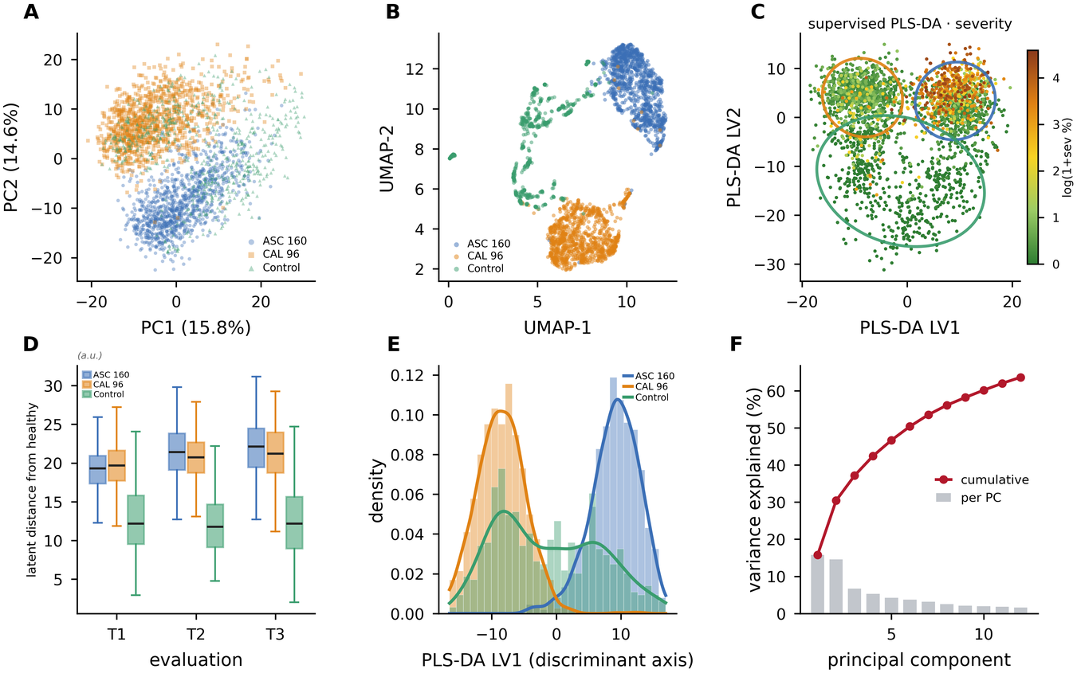
Figure 3. A continuous latent phenotypic space with three groups. (A) PCA of global embeddings. (B) UMAP by group (two accessions and control). (C) Supervised PLS-DA projection colored by conventional severity, with per-group confidence ellipses. (D) Latent distance from the healthy (control) centroid across the three evaluations, by group (boxplots). (E) Density distributions of the three groups along the supervised discriminant axis (PLS-DA LV1). (F) PCA variance explained (bars) and cumulative (line).

3.3 Disease progression is a measurable trajectory that differs between accessions
Treated as a temporal process, both inoculated accessions traced directed paths through the latent space while the control barely moved (Figure 4A). Per biological unit, the net T1→T3 displacement was larger for ASC 160 than for CAL 96 0.446 (95% CI 0.426–0.467; n = 118) versus 0.381 (0.360–0.403; n = 116) a difference confirmed by permutation (P = 1 × 10⁻⁴; Figure 4C, Table 2). Within-group dispersion rose monotonically with disease in the inoculated groups (ASC 160 0.199→0.230→0.273; CAL 96 0.228→0.253→0.307) but stayed flat in the control (PERMDISP P = 0.001; Figure 4B). PERMANOVA on unit-level vectors apportioned the structure (Table 2): accession was the largest term (R² = 0.213, F = 265.6), then timepoint (R² = 0.105) and inoculation (R² = 0.037), with a significant inoculation × timepoint interaction (R² = 0.007; all P = 0.001). That interaction matters it shows the temporal motion is disease-driven, not a developmental drift the control would share. The rising dispersion is itself a phenotype: as infection proceeds, genetically uniform groups grow phenotypically more variable, as one expects from stochastic lesion initiation and divergent local outcomes.
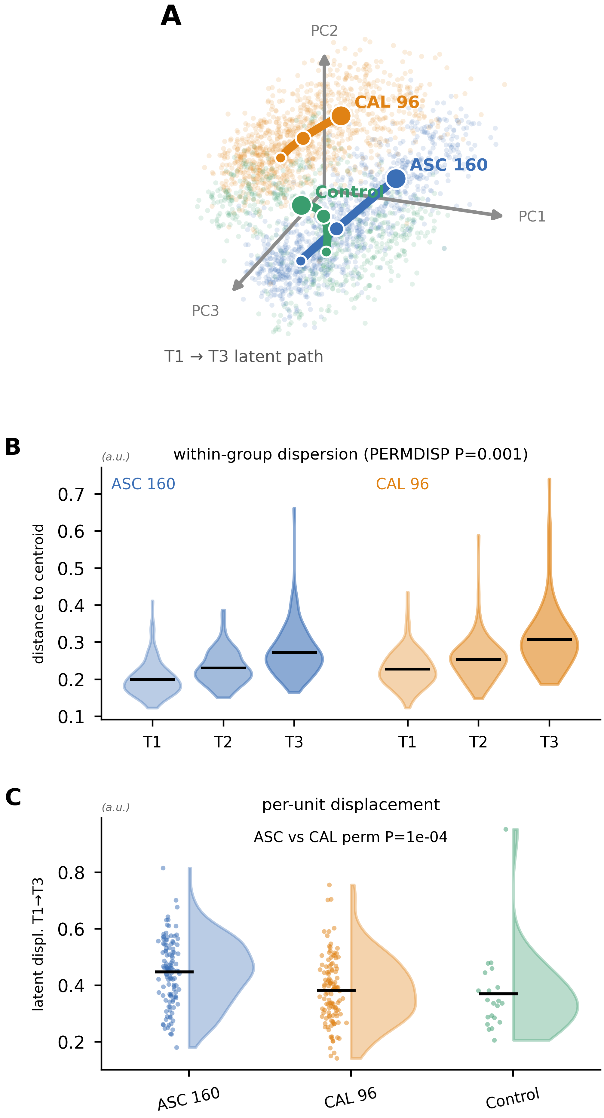
Figure 4. Disease progression as a latent trajectory. (A) Group trajectories in a two-dimensional projection of the latent space (PCA-1–3): faint points are leaves colored by group and bold curves trace each group's centroid path from T1 to T3; ASC 160 sweeps farthest and the control least. (B) Within-group dispersion (distance to centroid) per evaluation as violins with group means (PERMDISP P = 0.001). (C) Per-unit net T1→T3 displacement as half-violin rainclouds for the three groups (ASC vs CAL permutation P = 1×10⁻⁴).
Table 2. Multivariate latent-space and trajectory statistics. PERMANOVA partition of the global latent space, PERMDISP within-group dispersion across evaluations, and per-unit net latent displacement (T1→T3) with the accession permutation contrast.
analysis | term | estimate | statistic | significance
PERMANOVA | accession | R²=0.213 | F=265.6 | P=0.001
PERMANOVA | treatment | R²=0.037 | F=45.9 | P=0.001
PERMANOVA | timepoint | R²=0.105 | F=65.7 | P=0.001
PERMANOVA | accession:treatment | R²=0.010 | F=12.2 | P=0.001
PERMANOVA | accession:timepoint | R²=0.019 | F=11.8 | P=0.001
PERMANOVA | treatment:timepoint | R²=0.007 | F=4.6 | P=0.001
PERMANOVA | accession:treatment:timepoint | R²=0.002 | F=1.2 | P=0.214
PERMDISP | dispersion T1/T2/T3 (inoc) | 0.199/0.230/0.273 (ASC) | 0.228/0.253/0.307 (CAL) | P=0.001
Trajectory | net latent displ. T1→T3 (ASC, inoc) | 0.446 | 95% CI [0.426, 0.467] | n=118
Trajectory | net latent displ. T1→T3 (CAL, inoc) | 0.381 | 95% CI [0.360, 0.403] | n=116
Trajectory | ASC vs CAL displacement | permutation test | Δ=0.065 | P=1.0e-04

3.4 Patch embeddings add a spatial axis that severity cannot see
Patch embeddings described organization the global vector cannot (Figure 5). A patch-PCA colour map resolved distinct tissue regions within one leaf (Figure 5B), and lesion-score and heterogeneity maps localized deviation from the healthy phenotype (Figure 5C–D). The point is made most directly in Figure 5E–F: two inoculated leaves of nearly identical severity (17% and 20%) showed opposite spatial patterns one fragmented (Moran’s I = −0.21), the other aggregated (I = +0.28). Across the dataset the two properties are decoupled (Figure 5G): severity and Moran’s I vary almost independently, so equal severity does not imply equal spatial organization. Spatial autocorrelation also changed through time, rising from near-zero or negative at T1 to positive at T3 (mixed model: timepoint P < 2 × 10⁻¹⁶; accession × timepoint P = 2.4 × 10⁻¹²) lesions moved from scattered toward coalescent as the disease matured.
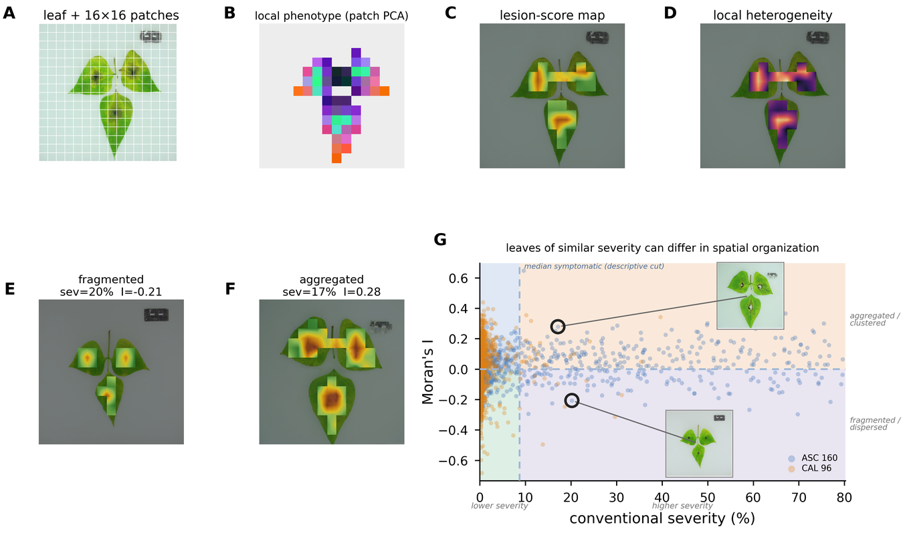
Figure 5. The spatial phenotype and its decoupling from severity. (A) Leaf with 16×16 patch grid. (B) Patch-PCA local-phenotype map. (C) Lesion-score map. (D) Local heterogeneity. (E–F) Two inoculated leaves of near-identical severity but opposite spatial organization (fragmented vs aggregated). (G) Severity–organization quadrant chart of all inoculated leaves (conventional severity vs Moran’s I), split at Moran’s I = 0 (fragmented/dispersed vs aggregated/clustered) and at a descriptive severity cut (the median of symptomatic leaves; lower vs higher severity), with a subtle density layer and the two example leaves (E, fragmented; F, aggregated) highlighted with thumbnails; leaves of similar severity can show opposite spatial organization.

3.5 Global embeddings carry group identity that patch embeddings do not
How cleanly the three groups separate, and in which representation, is quantified in Figure 6. A linear probe on the global embedding reached 0.95 test accuracy and 0.94 macro-recall, with a near-diagonal confusion matrix (Figure 6A–C); the patch summary matched it on the supervised task (0.95 accuracy; Figure 6D) but behaved differently without labels. In grouped cross-validation the global embedding separated the groups in every representation (accuracy 0.95, 0.98 and 0.96 in PCA, UMAP and PLS), while the patch summary lagged (0.87, 0.75, 0.89; Figure 6E). The gap widened in unsupervised clustering: a Gaussian mixture recovered the three groups from global embeddings (ARI = 0.77) but essentially failed on patch embeddings (ARI = 0.10; Figure 6F–H). The reading is biological, not merely numerical global embeddings encode who the leaf is (accession, healthy vs diseased state), so they cluster by group; patch embeddings encode local tissue condition, which recurs across accessions, so they do not. This is a second, independent line of evidence that the two representations are complementary rather than interchangeable.
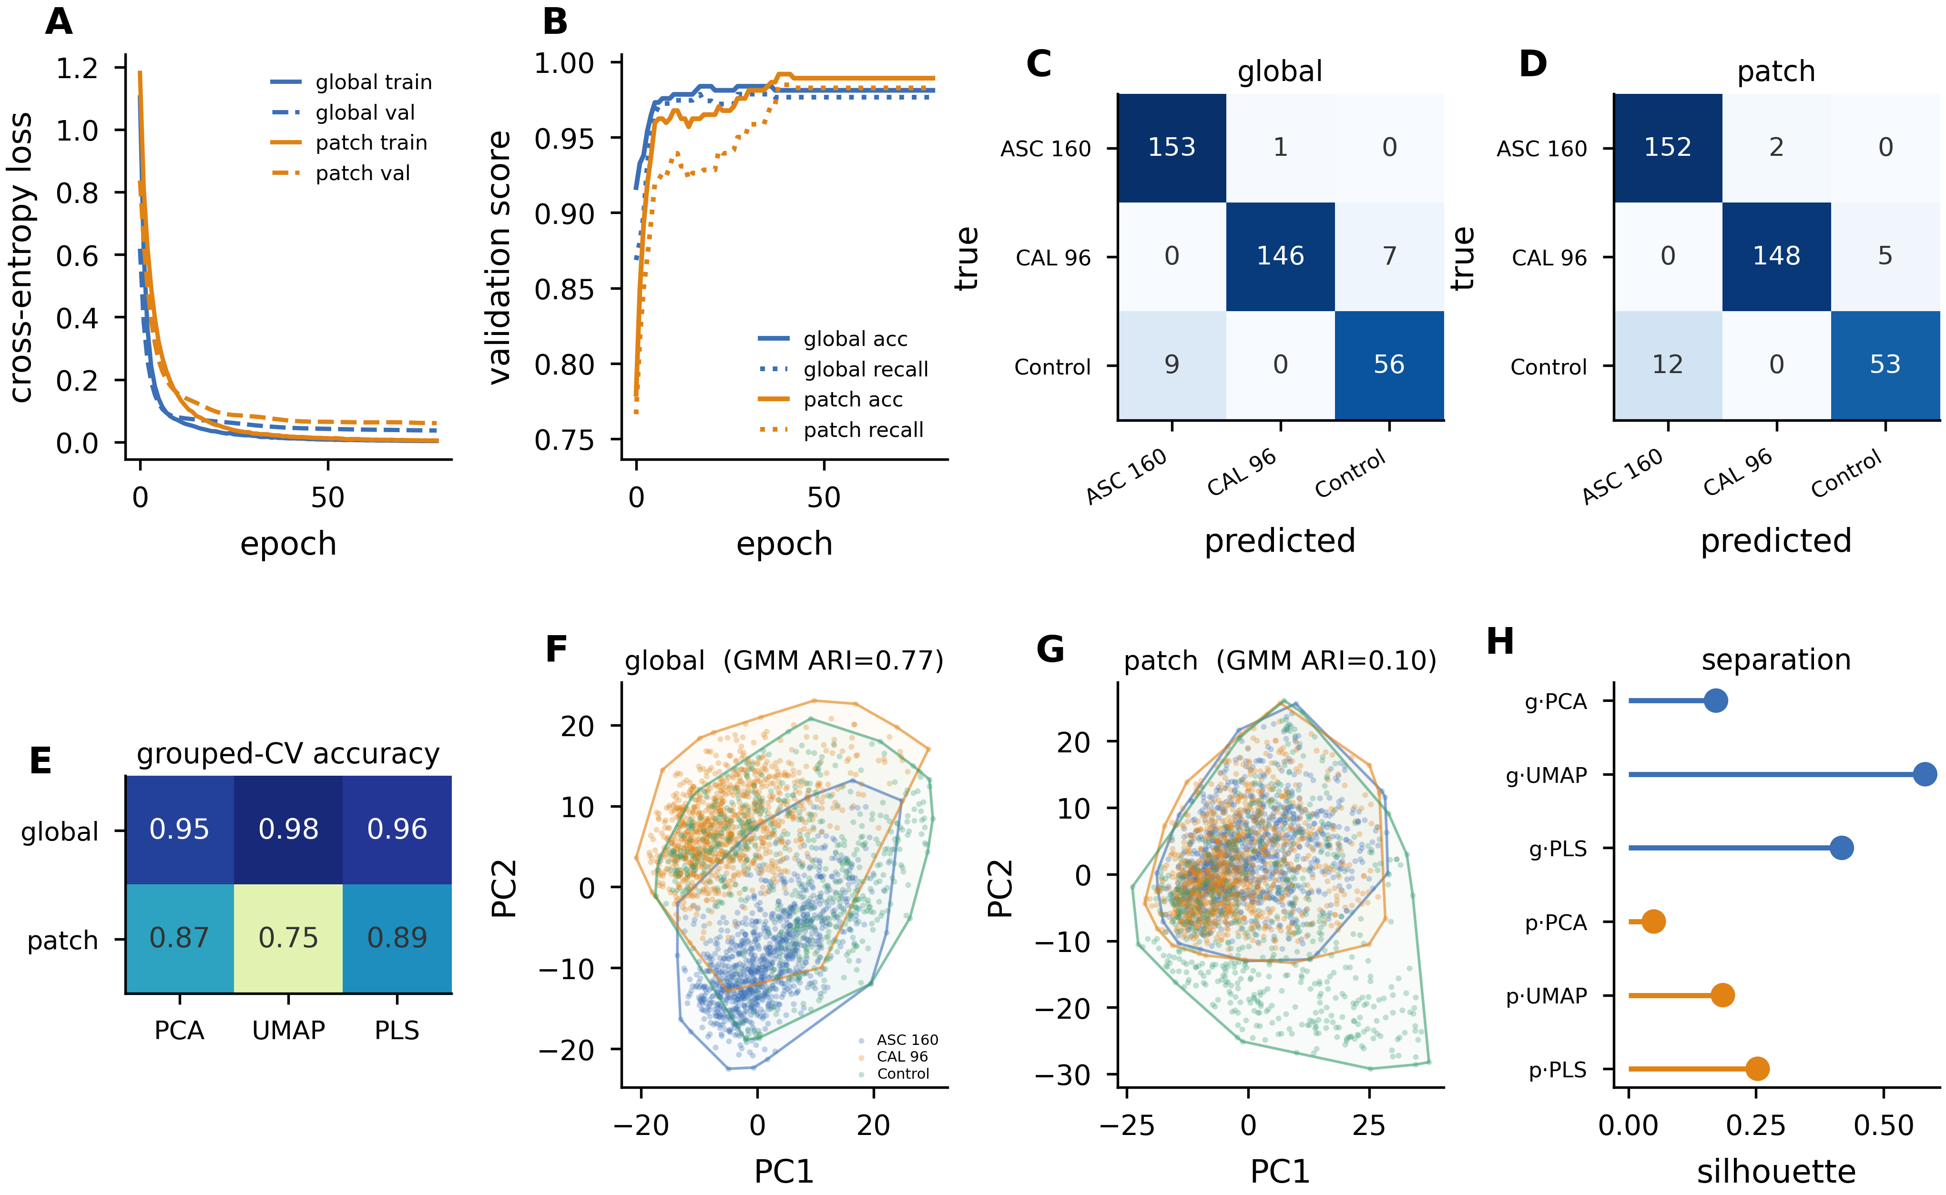
Figure 6. Discrimination and clustering: global versus patch embeddings. (A) Training cross-entropy loss and (B) validation accuracy/recall per epoch for a linear probe on global and patch descriptors (70/15/15 unit-grouped split). (C–D) Held-out confusion matrices (global, patch). (E) Grouped-CV accuracy for a probe in PCA, UMAP and PLS spaces (global vs patch). (F–G) PCA scatter with convex hulls per group and Gaussian-mixture ARI (global vs patch). (H) Silhouette of the true groups by representation. Global embeddings carry group identity (ARI = 0.77); patch embeddings do not (ARI = 0.10).

3.6 Conventional phytopathometry: severity, progress curves and AUDPC
The conventional reference behaved exactly as a plant pathologist would expect (Figure 7). The palette classifier separated healthy from diseased tissue on each leaf and returned a severity value (Figure 7A). Disease-progress curves diverged strongly by group: inoculated ASC 160 climbed 0.29% → 5.96% → 34.9%, CAL 96 only 0.25% → 0.62% → 2.95%, and the control stayed near zero (Figure 7B); the per-unit curves (Figure 7C) show how much more variable ASC 160 became. AUDPC summarized this as 23.5 for ASC 160 against 2.2 for CAL 96 (Figure 7D), and the accession × timepoint interaction in the mixed model (F = 537) confirmed that the two were indistinguishable at T1 (contrast P = 0.87) but far apart by T2 and T3 (P < 0.0001). Because AUDPC is deliberately blind to curve shape, we also compared the accessions functionally (Figure 7E–F): their progress curves sit an L² distance of 20.35 apart, with the difference accumulating late in the epidemic. ASC 160 is thus the more susceptible accession by every conventional measure, and the conventional metrics capture both the magnitude and the timing of that susceptibility.
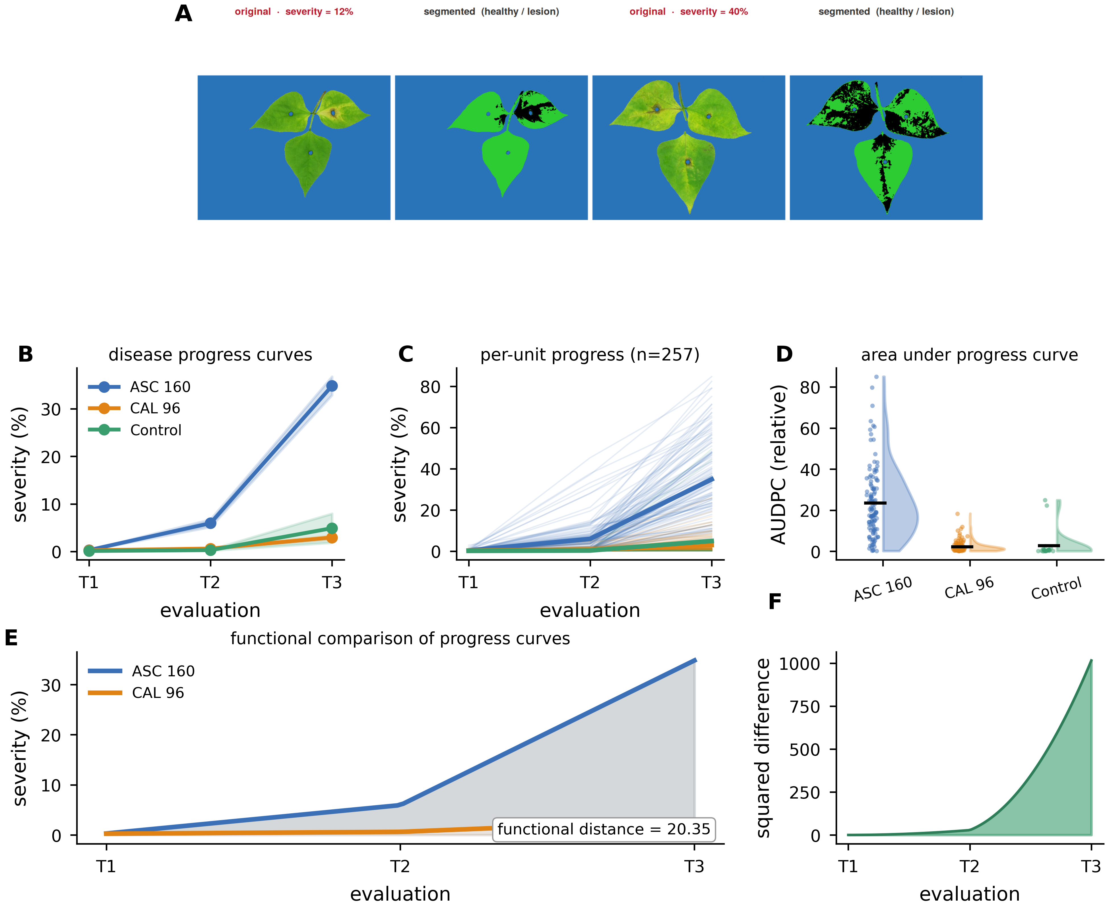
Figure 7. Conventional phytopathometry. (A) Palette-based severity on one leaf: original → palette classification (healthy/lesion) → segmented output with severity. (B) Disease-progress curves by group (mean ± SE). (C) Per-unit progress curves (n = 257). (D) AUDPC by group as half-violin rainclouds with means. (E) Functional comparison of the accession progress curves (shaded difference; L² functional distance). (F) Squared difference over time.

3.7 The embedding recovers severity but is not reducible to it
Does the latent phenotype simply re-encode severity? Part of it does. A grouped-cross-validated PLS predicted log-severity from the global embedding with R²_CV = 0.89 (95% CI 0.85–0.89; RMSE 0.42), close to the apparent R² of 0.93 and importantly barely different from a random-split R² of 0.89, so the fit is real and not a leakage artefact (Table 3). Two independent measurement principles, colour segmentation and self-supervised features, agree on which leaves are diseased.
Three results show the representation carries more. First, 88% of the latent variance is left unexplained by a quadratic function of severity. Second, the correlation structure splits into blocks (Figure 8A): the conventional metrics are almost perfectly collinear (ρ ≈ 1.0), latent displacement tracks severity only moderately (ρ = 0.58), and Moran’s I is uncorrelated with severity (ρ = −0.06), so the spatial descriptors sit apart from the conventional ones. Third, RV coefficients put modest overlap between the global embedding and severity (RV = 0.34) and near-independence between spatial organization and severity (RV = 0.075). Seen as a landscape, the three groups occupy distinct territories (Figure 8B), and their phenotypic signatures differ across four conceptual axes ASC 160 leads on magnitude and state, CAL 96 on relative organization and progression (Figure 8C). Correlation is not causation, and we do not read these associations as mechanism; what they establish is narrower and solid that magnitude, phenotypic state and spatial organization are three overlapping but non-redundant descriptions of the same interaction (Figure 8D).
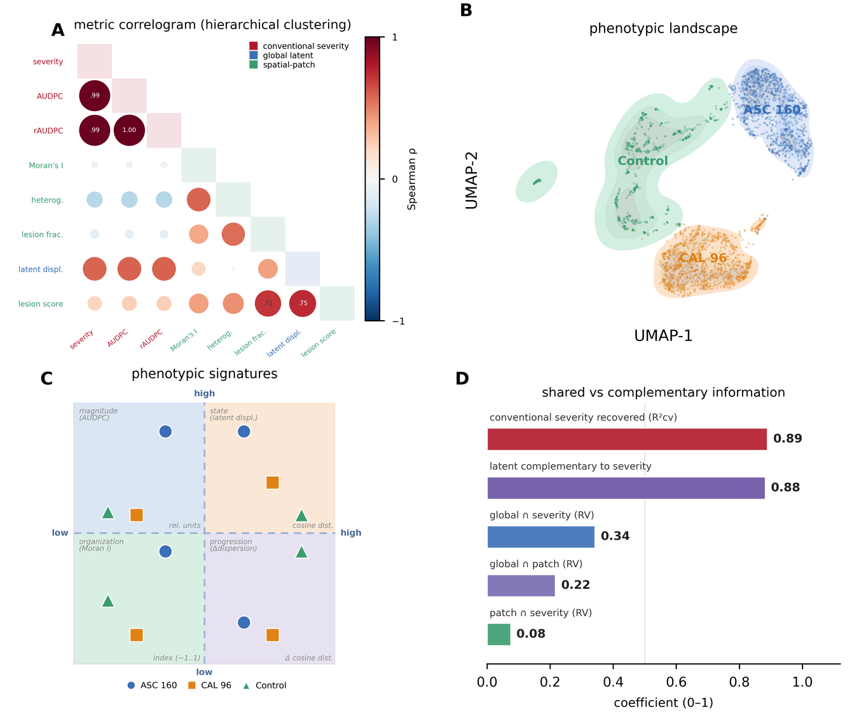
Figure 8. Integrated comparison of conventional and latent descriptors. (A) Correlogram of all block metrics (conventional severity, global-latent, spatial-patch) ordered by hierarchical clustering; each lower-triangle circle shows a Spearman correlation, its size scaling with |ρ| and its colour with the sign and magnitude of ρ, so that redundant, related and complementary metrics are immediately distinguishable. (B) Phenotype landscape: kernel-density territories of the three groups on the UMAP layout. (C) Phenotypic signatures as a four-quadrant chart, one conceptual axis per quadrant: magnitude (AUDPC), state (latent displacement), organization (Moran’s I) and progression (Δdispersion); within each quadrant the three groups are shown as markers (ASC 160 circles, CAL 96 squares, Control triangles) at their per-axis normalized level. (D) Shared versus complementary information as horizontal bars: conventional severity recovered by the global embedding (R²_CV), latent variance complementary to severity, and pairwise RV coefficients (global∩severity, global∩patch, patch∩severity).
Table 3. Integration between DINOv2 representations and conventional severity. Predictive PLS of severity from the global embedding under biological-unit grouped cross-validation, complementarity of the latent phenotype to severity, and RV block-similarity coefficients.
analysis | quantity | value | note
Predictive PLS (severity ~ global embedding) | grouped-CV R² | 0.889 | 95% CI [0.854, 0.890]
Predictive PLS | apparent R² (fit-all) | 0.928 | overfitting gap small
Predictive PLS | RMSE (log severity, CV) | 0.418 | 15 components
Complementarity | latent variance NOT explained by severity | 88.20% | -
Complementarity | latent dist. (similar-severity pairs vs overall) | 0.533 vs 0.563 | similar severity ≠ similar latent
Block similarity (RV) | global embedding vs conventional severity | 0.342 | moderate overlap
Block similarity (RV) | spatial features vs conventional severity | 0.075 | near-independent
Block similarity (RV) | global vs spatial | 0.217 | partial overlap

4. Discussion

4.1 Latent Space Phenotypic for P. vulgaris x Boeremia spp. interaction
The question that opened this study was whether representations taken, untrained, from a self-supervised vision foundation model can describe the P. vulgaris x Boeremia spp. interaction more completely than severity alone, and whether the conventional phytopathometric reading survives the comparison. The answer, on both counts, is yes. A frozen, general-purpose visual encoder yields a continuous phenotypic space for this specific host–pathogen interaction; that space is demonstrably richer than the severity readout, and yet it does not contradict it. Severity was recovered from the global embedding with high cross-validated accuracy (R²_CV = 0.89), which keeps the method anchored to a century of established phytopathology; but most of the latent variation, and very nearly all of the spatial-organization signal, sits outside severity (RV = 0.075 between spatial features and severity). The conventional reading is therefore not overturned it is relocated. Percent area diseased becomes one coordinate of a larger, measurable object rather than the object itself.
For a discipline in which “disease phenotype” is, in daily practice, synonymous with “percent leaf area affected” (Bock et al., 2010, 2020b), this is a meaningful shift of frame. The scalar severity value is repeatable and interpretable, and nothing here argues for abandoning it; the argument is that it is lossy, and that the discarded information the composition of the symptom, its arrangement across the lamina, and the direction and speed of its change is biologically real and now measurable at no extra acquisition cost. The result also settles a narrower methodological point that matters for the plant-phenotyping community, which has largely reached image-based disease description through supervised deep learning trained on large labelled sets (Ferentinos, 2018; Mohanty et al., 2016; A. Singh et al., 2016). We obtain a continuous, discriminative, spatially and temporally resolved phenotype without training a network on a single labelled leaf, extending latent-space phenotyping (Chen et al., 2023; Ubbens et al., 2020) from task-trained encoders to frozen foundation features and, in doing so, directly fulfilling the three objectives: the space was built and shown to discriminate the groups, its temporal and spatial structure was quantified with design-appropriate statistics, and it was benchmarked against the conventional reference and found complementary rather than redundant.

4.2 Why should features never tuned on a plant image behave this way?
The explanation runs through what the encoder learned and how its two outputs map onto biology. Self-supervised Vision Transformers are trained to make invariant, general-purpose descriptions of natural images, and the resulting features approximate the disentangled, reusable factors that representation learning theory predicts a good encoder should recover (Bengio et al., 2014; Elharrouss et al., 2025; Oquab et al., 2024; Vaswani et al., 2017). Natural images of leaves occupy a low-dimensional manifold within pixel space, and infection is, optically, a smooth and progressive deformation of that surface chlorosis, then necrosis, then coalescence. A smooth physical process mapped through a smooth feature extractor produces a smooth path, which is exactly why the latent space forms a continuous disease gradient (Figure 3) rather than disconnected clusters, and why progression reads as directed motion (Figure 4) rather than as categorical jumps. The manifold is not an artefact of the visualization; it is the geometric signature of a continuous biological process.
The division of labour between the two embeddings, the paper’s clearest new result, follows from the architecture (Dosovitskiy et al., 2021; Elharrouss et al., 2025). The global class token is trained to summarize the whole image into a single semantic vector, so it aggregates leaf-scale properties accession morphology and overall disease state and consequently clusters by group (ARI = 0.77): it encodes who the leaf is and how sick it is. The patch tokens, by contrast, keep their spatial coordinates and describe local tissue condition, and local tissue condition is not accession-specific a necrotic patch on ASC 160 resembles a necrotic patch on CAL 96 so the same tokens that faithfully localize the symptom (ρ ≈ 0.35) carry almost no group identity (ARI = 0.10). This is not a defect of the patch representation but a direct consequence of what “local” means biologically: the global vector answers what phenotype is present, the patch grid answers where and how it is arranged, and the two are separable because those are separate biological questions.
Read through this lens, the temporal and spatial statistics acquire mechanistic meaning rather than remaining descriptive. The monotonic rise in within-group dispersion (PERMDISP P = 0.001) is what one expects when genetically uniform material meets a stochastic infection process: lesion initiation, expansion and local host response vary from leaf to leaf, so an initially tight cloud of “healthy” phenotypes spreads as each unit follows its own path biological variance itself increasing with disease, a quantity severity cannot report. The increase in Moran’s I from near-zero at T1 to positive at T3 tracks the epidemiology of lesion growth and coalescence on a single organ (Madden et al., 2007): early infections are scattered points, late infections are merged fronts, and spatial autocorrelation rises accordingly. Crucially, that equal-severity leaves can be spatially opposite (Figure 5E–F) means the arrangement of disease is a phenotype in its own right, conceptually close to the conventional decomposition of resistance into separately inherited components infection frequency, lesion size, latent period, colonization rate rather than a single susceptibility score (Parlevliet, 1979). The latent space, the trajectories and the spatial statistics are, in effect, an image-derived, continuous re-expression of that multi-component view of the interaction.

4.3 Self-attention and embeddings-patch don't functional?
We report the weak results as plainly as the strong ones, because each clarifies what the representation is and is not. The most conspicuous is that attention did not localize the symptom (ρ ≈ −0.10) while the patch symptom score did (ρ ≈ 0.35). This is not a disappointment so much as a caution the wider field has already learned to heed: attention weights are not, in general, faithful explanations of what a model has used (Jain & Wallace, 2019), and attention rollout aggregates information flow through the network rather than isolating a task-relevant signal (Abnar & Zuidema, 2020). DINO-family encoders acquire an object-ness prior through self-distillation, so their attention settles reliably on the leaf lamina and its venation evidence that the model looks at the plant, not at the background but it was never optimized to find lesions, and so it does not. The correct instrument for symptom localization is a distance in representation space (the cosine distance of each patch to the healthy control centroid), and once we use that instrument the signal is clear. The lesson is methodological and transferable: interpret transformer attention conservatively, and measure symptoms in the feature geometry, not in the attention maps.
The second aspect, the failure of patch embeddings to recover the groups without labels (ARI = 0.10), is only unsatisfactory against a mistaken expectation; theoretically it is the expected complement of the global result, for the reason given above. It becomes informative precisely because it is a clean negative: it shows that group identity lives in the global token and local condition in the patch grid, which is the evidence that the two representations are non-redundant. The third, and the one with real biological teeth, is the developmental confound. Control leaves drifted in latent space, and the unsupervised palette scored an elevated “severity” (~9%) on senescing ASC 160 controls at T3, because age-related chlorosis is spectrally close to early disease. This is why the raw inoculated-versus-control displacement contrast was not significant (P = 0.11) even though the disease-specific inoculation × timepoint interaction was (Table 2): an unsupervised, color-driven reading cannot, on its own, separate the yellowing of senescence from the yellowing of infection, a well-known hazard of image-based severity that motivates careful controls and calibration (Bock et al., 2020a). We handled it by reading disease effects within accession and by trusting the interaction term over the raw contrast, but it bounds the strength of any claim drawn from the control drift alone. Finally, the accession axis dominates the manifold because the two accessions differ in leaf morphology as well as in susceptibility; disease effects are therefore best read within accession, as we have done throughout.

4.4 Limitations found and how they could be improved
Several constraints bound these conclusions, and each suggests a concrete remedy. First, the severity reference is automatic and unsupervised: a color-palette classifier with no expert-annotated ground truth. Calibrating the palette against rater estimates and, better, against true pixel-level lesion masks would sharpen both the severity values and the attention-versus-symptom comparison, and would let us quantify agreement rather than assume it (Bock et al., 2010; Mahlein, 2016). Second, only three evaluation points were available, so the trajectory descriptors are coarse and AUDPC is necessarily a relative index over equally spaced times; denser longitudinal sampling would support genuine functional-data and dynamical models of disease progress, in which the latent path could be fitted as a continuous curve rather than a two-segment polyline. Third, the study rests on two accessions and one pathosystem imaged under controlled detached-leaf optics, which limits generalization and, for foundation features specifically, leaves open the question of domain shift to field conditions with variable illumination and background (Fahlgren et al., 2015; Mutka & Bart, 2015). The pipeline itself is model-agnostic and transfers unchanged, so the natural improvement is breadth: more genotypes, more pathosystems, and validation on in-field imagery. Fourth, the encoder was frozen by design, which is the source of the method’s label-free simplicity but also caps its symptom specificity; parameter-efficient adaptation (a linear head or low-rank tuning on a modest annotated set) might increase the patch representation’s sensitivity to disease while keeping most of the frozen model’s generality, and the trade-off between the two is worth measuring directly rather than assuming.

4.5 Perspectives and new frontiers knowledge
Taken together, the results sketch a workable and, we think, generalizable programme for image-based disease phenotyping (Alves et al., 2021; Conejo-Rodríguez et al., 2024; A. Singh et al., 2021; A. K. Singh et al., 2018; Tanner et al., 2022). Use frozen foundation embeddings as a standardized, continuous, spatially resolved phenotype; describe disease as motion and reorganization within that space; and retain conventional severity as the interpretable, well-understood coordinate rather than as the whole account. Because the representation is cheap, needs no annotation and exposes structure that a single number cannot rising dispersion, spatial coalescence, the divergence of similar-severity leaves it lowers the cost of asking richer biological questions. Three directions seem especially promising. The first is temporal: with denser sampling, the latent trajectory could be modelled as a dynamical system, turning “how fast and in what direction the phenotype moves” into estimable rate parameters that map naturally onto the conventional components of resistance (Parlevliet, 1979). The second is genetic: latent displacement, within-group dispersion and Moran’s I are continuous, image-derived traits that could serve as phenotypes in QTL mapping or genome-wide association, letting breeders select on the organization and dynamics of disease and not only on its magnitude. The third is representational: comparing embeddings across foundation models, imaging modalities (RGB, multispectral, hyperspectral) and pathosystems would test how much of this structure is a property of the biology and how much of the encoder, and would clarify which latent axes are portable. In every direction the through-line is the same one that answered the original question a frozen representation gives a fuller, still-interpretable, and complementary account of the host–pathogen interaction, and the conventional severity reading remains a coordinate within it rather than a casualty of it.

5. Conclusions
Frozen DINOv2 embeddings build a continuous, spatially organized and temporally dynamic phenotypic space for the P. vulgaris–Boeremia spp. interaction. The space separates the two accessions and the control (probe accuracy 0.95; global-embedding clustering ARI 0.77), localizes the symptom in its patch tokens (ρ ≈ 0.35), and moves with the disease along accession-specific trajectories with rising dispersion and increasing spatial aggregation. Benchmarked against conventional phytopathometry, it recovers severity (R²_CV = 0.89) yet is not reducible to it: 88% of its variance is unexplained by severity, spatial organization is independent of severity magnitude (RV = 0.075), and equal-severity leaves occupy distinct latent positions. Global embeddings capture phenotypic state, patch embeddings capture spatial organization, latent trajectories capture progression, and conventional severity captures magnitude four complementary readings that, together, give a fuller account of the interaction than any one alone.

Data and code availability Data and code availability

Conflict of interest

All the authors declare that there is no potential conflict of interest.

Ethics statement

The authors confirm that the research meets any required ethical guidelines, including adherence to the legal requirements of the study country.

Acknowledgments

We thank the CIAT for images...

Author contributions

All authors contributed equally to the manuscript's development, conceptualization, methods, data analysis, visualization, and writing.

Funding statement

This research received no specific grant from any funding agency in the public, commercial, or not-for-profit sectors.

Authors’ declarations

The author declares that the manuscript has not been submitted to any publisher.

References
Abnar, S., & Zuidema, W. (2020). Quantifying Attention Flow in Transformers. http://arxiv.org/abs/2005.00928
Alves, K. S., Guimarães, M., Paulo, J., Marcia, A., Rafael, Q., Eduardo, F. A., & Emerson, S. G. M. (2021). RGB-based phenotyping of foliar disease severity under controlled conditions (pp. 1–29). https://doi.org/https://doi.org/10.31219/osf.io/fs4vm
Anderson, M. J. (2006). Distance-based tests for homogeneity of multivariate dispersions. Biometrics, 62(1), 245–253. https://doi.org/10.1111/j.1541-0420.2005.00440.x
Bates, D., Mächler, M., Bolker, B. M., & Walker, S. C. (2015). Fitting linear mixed-effects models using lme4. Journal of Statistical Software, 67(1). https://doi.org/10.18637/jss.v067.i01
Bengio, Y., Courville, A., & Vincent, P. (2014). Representation Learning: A Review and New Perspectives. http://arxiv.org/abs/1206.5538
Bock, C. H., Barbedo, J. G. A., Del Ponte, E. M., Bohnenkamp, D., & Mahlein, A. K. (2020a). From visual estimates to fully automated sensor-based measurements of plant disease severity: status and challenges for improving accuracy. In Phytopathology Research (Vol. 2, Number 1). BioMed Central Ltd. https://doi.org/10.1186/s42483-020-00049-8
Bock, C. H., Barbedo, J. G. A., Del Ponte, E. M., Bohnenkamp, D., & Mahlein, A. K. (2020b). From visual estimates to fully automated sensor-based measurements of plant disease severity: status and challenges for improving accuracy. In Phytopathology Research (Vol. 2, Number 1). BioMed Central Ltd. https://doi.org/10.1186/s42483-020-00049-8
Bock, C. H., Chiang, K.-S., & Ponte, E. M. Del. (2021). Plant disease severity estimated visually: a century of research, best practices, and opportunities for improving methods and practices to maximize accuracy. https://doi.org/10.1007/s40858-021-00439-z/Published
Bock, C. H., Poole, G. H., Parker, P. E., & Gottwald, T. R. (2010). Plant disease severity estimated visually, by digital photography and image analysis, and by hyperspectral imaging. Critical Reviews in Plant Sciences, 29(2), 59–107. https://doi.org/10.1080/07352681003617285
Buda, M., Maki, A., & Mazurowski, M. A. (2018). A systematic study of the class imbalance problem in convolutional neural networks. https://doi.org/10.1016/j.neunet.2018.07.011
Caron, M., Touvron, H., Misra, I., Jégou, H., Mairal, J., Bojanowski, P., & Joulin, A. (2021). Emerging Properties in Self-Supervised Vision Transformers. http://arxiv.org/abs/2104.14294
Chen, F., Valerio Giuffrida, M., & Tsaftaris, S. A. (2023). Adapting Vision Foundation Models for Plant Phenotyping. IEEE/CVF International Conference on Computer Vision Workshops, 604–613.
Conejo-Rodríguez, D. F., Gonzalez-Guzman, J. J., Ramirez-Gil, J. G., Wenzl, P., & Urban, M. O. (2024). Digital descriptors sharpen conventional descriptors, for improving genebank accession management: A case study on Arachis spp. and Phaseolus spp. PLoS ONE, 19(5 May). https://doi.org/10.1371/journal.pone.0302158
Del Ponte, E. M. (2023). R for Plant Disease Epidemiology (R4PDE). In The Study of Plant Disease Epidemics. https://r4pde.net
Dosovitskiy, A., Beyer, L., Kolesnikov, A., Weissenborn, D., Zhai, X., Unterthiner, T., Dehghani, M., Minderer, M., Heigold, G., Gelly, S., Uszkoreit, J., & Houlsby, N. (2021). An Image is Worth 16x16 Words: Transformers for Image Recognition at Scale. http://arxiv.org/abs/2010.11929
Elharrouss, O., Himeur, Y., Mahmood, Y., Alrabaee, S., Ouamane, A., Bensaali, F., Bechqito, Y., & Chouchane, A. (2025). ViTs as backbones: Leveraging vision transformers for feature extraction. Information Fusion, 118. https://doi.org/10.1016/j.inffus.2025.102951
Fahlgren, N., Gehan, M. A., & Baxter, I. (2015). Lights, camera, action: High-throughput plant phenotyping is ready for a close-up. In Current Opinion in Plant Biology (Vol. 24, pp. 93–99). Elsevier Ltd. https://doi.org/10.1016/j.pbi.2015.02.006
Ferentinos, K. P. (2018). Deep learning models for plant disease detection and diagnosis. Computers and Electronics in Agriculture, 145, 311–318. https://doi.org/10.1016/j.compag.2018.01.009
Gorny, A. M., Kikkert, J. R., Dunn, A. R., Dillard, H. R., Smart, C. D., & Pethybridge, S. J. (2015). Tan spot of lima bean caused by Boeremia exigua var. exigua in New York State, USA. Canadian Journal of Plant Pathology, 37(4), 523–528. https://doi.org/10.1080/07060661.2015.1105873
Hassan, N., Khan, A. A., Iqbal, B., & Hemat, M. (2026). Beyond the Plate: The Multifaceted Role of Common Bean (Phaseolus vulgaris L.) in Nutrition Security, Sustainable Agriculture, and Food System Resilience. In Advances in Agriculture (Vol. 2026, Number 1). John Wiley and Sons Ltd. https://doi.org/10.1155/aia/5860340
Jain, S., & Wallace, B. C. (2019). Attention is not Explanation. http://arxiv.org/abs/1902.10186
Lenth, R. V., & Piaskowski, J. (2026). emmeans: Estimated Marginal Means, aka Least-Squares Means. In American Statistician (Vol. 34, Number 4, pp. 216–221). R package. https://doi.org/10.1080/00031305.1980.10483031
Ligarreto, G., Garzón Gutiérrez, L. N., & Pimentel Ladino, C. C. (2023). Differential responses of Phaseolus spp. against Black node disease (Boeremia noackiana). Bragantia, 82. https://doi.org/10.1590/1678-4499.20220225
Ligarreto-Moreno, G. A., Garzón-Gutiérrez, L. N., & Pimentel-Ladino, C. C. (2022). Seeking long-lasting resistance to black node disease in common beans: Development of interspecific populations. Revista Colombiana de Ciencias Horticolas, 16(2). https://doi.org/10.17584/rcch.2022v16i2.14402
Madden, L. V., Hughes, G., & van den Bosch, F. (2007). The study of plant disease epidemics. American Phytopathological Society. https://doi.org/10.1094/9780890545058
Mahlein, A. K. (2016). Plant disease detection by imaging sensors – Parallels and specific demands for precision agriculture and plant phenotyping. In Plant Disease (Vol. 100, Number 2, pp. 241–254). American Phytopathological Society. https://doi.org/10.1094/PDIS-03-15-0340-FE
Marti J. Anderson. (2001). A new method for non-parametric multivariate analysis of variance. Austral Ecology , 26, 32–46.
McInnes, L., Healy, J., & Melville, J. (2020). UMAP: Uniform Manifold Approximation and Projection for Dimension Reduction. http://arxiv.org/abs/1802.03426
Meier, U. (2001). Growth stages of mono-and dicotyledonous plants BBCH Monograph Federal Biological Research Centre for Agriculture and Forestry.
Mohanty, S. P., Hughes, D. P., & Salathé, M. (2016). Using deep learning for image-based plant disease detection. Frontiers in Plant Science, 7(September). https://doi.org/10.3389/fpls.2016.01419
Montero, Y. M., Rivera, L. R., & Gutiérrez, L. N. G. (2021). Diagrammatic scales for the estimation of black node disease severity in common bean. Ciencia Rural, 51(3), 1–5. https://doi.org/10.1590/0103-8478cr20200347
Mutka, A. M., & Bart, R. S. (2015). Image-based phenotyping of plant disease symptoms. In Frontiers in Plant Science (Vol. 5, Number JAN). Frontiers Media S.A. https://doi.org/10.3389/fpls.2014.00734
Oksanen, J., Blanchet, F. G., Friendly, M., Kindt, R., Legendre, P., Mcglinn, D., Minchin, P. R., O’hara, R. B., Simpson, G. L., Solymos, P., Henry, M., Stevens, H., Szoecs, E., & Maintainer, H. W. (2018). Title Community Ecology Package.
Oquab, M., Darcet, T., Moutakanni, T., Vo, H., Szafraniec, M., Khalidov, V., Fernandez, P., Haziza, D., Massa, F., El-Nouby, A., Assran, M., Ballas, N., Galuba, W., Howes, R., Huang, P.-Y., Li, S.-W., Misra, I., Rabbat, M., Sharma, V., … Bojanowski, P. (2024). DINOv2: Learning Robust Visual Features without Supervision. http://arxiv.org/abs/2304.07193
Parlevliet, J. E. (1979). COMPONENTS OF RESISTANCE THAT REDUCE THE RATE OF EPIDEMIC DEVELOPMENT. Ann. Rev. Phytopathol, 17, 203–225. www.annualreviews.org
Robert, P., & Escoufier, Y. (1976). A Unifying Tool for Linear Multivariate Statistical Methods: The RV-Coefficient. In Appl. Statist (Vol. 25, Number 3).
Singh, A., Ganapathysubramanian, B., Singh, A. K., & Sarkar, S. (2016). Machine Learning for High-Throughput Stress Phenotyping in Plants. In Trends in Plant Science (Vol. 21, Number 2, pp. 110–124). Elsevier Ltd. https://doi.org/10.1016/j.tplants.2015.10.015
Singh, A., Jones, S., Ganapathysubramanian, B., Sarkar, S., Mueller, D., Sandhu, K., & Nagasubramanian, K. (2021). Challenges and Opportunities in Machine-Augmented Plant Stress Phenotyping. In Trends in Plant Science (Vol. 26, Number 1, pp. 53–69). Elsevier Ltd. https://doi.org/10.1016/j.tplants.2020.07.010
Singh, A. K., Ganapathysubramanian, B., Sarkar, S., & Singh, A. (2018). Deep Learning for Plant Stress Phenotyping: Trends and Future Perspectives. In Trends in Plant Science (Vol. 23, Number 10, pp. 883–898). Elsevier Ltd. https://doi.org/10.1016/j.tplants.2018.07.004
Tanner, F., Tonn, S., de Wit, J., Van den Ackerveken, G., Berger, B., & Plett, D. (2022). Sensor-based phenotyping of above-ground plant-pathogen interactions. In Plant Methods (Vol. 18, Number 1). BioMed Central Ltd. https://doi.org/10.1186/s13007-022-00853-7
Ubbens, J., Cieslak, M., Prusinkiewicz, P., Parkin, I., Ebersbach, J., & Stavness, I. (2020). Latent space phenotyping: Automatic image-based phenotyping for treatment studies. Plant Phenomics, 2020. https://doi.org/10.34133/2020/5801869
Uebersax, M. A., Cichy, K. A., Gomez, F. E., Porch, T. G., Heitholt, J., Osorno, J. M., Kamfwa, K., Snapp, S. S., & Bales, S. (2023). Dry beans (Phaseolus vulgaris L.) as a vital component of sustainable agriculture and food security—A review. In Legume Science (Vol. 5, Number 1). John Wiley and Sons Inc. https://doi.org/10.1002/leg3.155
Vaswani, A., Brain, G., Shazeer, N., Parmar, N., Uszkoreit, J., Jones, L., Gomez, A. N., Kaiser, Ł., & Polosukhin, I. (2017). Attention Is All You Need. Advances in Neural Information Processing Systems.
Wold, S., Sjostrom, M., Eriksson, L., & Sweden˚˚, S. (n.d.). PLS-regression: a basic tool of chemometrics. In Chemometrics and Intelligent Laboratory Systems (Vol. 58). Retrieved www.elsevier.comrlocaterchemometrics

