Supplementary Information

Navigating between conventional phytopathometry and a multidimensional landscape phenotypic of the Phaseolus vulgaris x Boeremia sp. interaction from frozen DINOv2 representations
Detailed methods, quality control, complete statistical outputs, sensitivity analyses and supplementary figures for the main text. Main-text figures are cited as Figure 1–8 and main tables as Table 1–3; supplementary items are Figure S1–S2 and Table S1–S12.

S1. Dataset and image quality control
The archive held 2724 files: 2192 original leaf images and 532 augmented control images (Table 1, main text). Original images were 3648x2736 (resized to <=1024 long side for compute); 257 biological units. Quality control removed 3 exact duplicates and 3 images with an unresolved evaluation label; 0 files were missing. Technical replication was a median of 3 images per unit and evaluation.
Augmentation audit.
The manifest listed 966 entries; 532 were present (434 not materialized). Augmentation was control-only and used only to balance the three groups for the discrimination analyses (Figure 6, main text); ancestry was preserved and every transform stayed with its source unit and data partition. Unsupervised analyses used originals only (n = 2186); the balanced discrimination set comprised n = 2680.

S2. DINOv2 configuration and embeddings
Frozen DINOv2 ViT-B/14: 12 blocks, 12 heads, 768 dimensions, exact parameter match. Inference at 224 px (16×16 = 256 patch tokens) and, for high-resolution symptom maps (Figure 2, main text), 448 px (32×32 tokens). Global = L2-normalized class token; patch = 256 tokens with coordinates; patch summary = per-image mean. PCA variance: PC1 15.8%, PC2 14.6%, PC3 6.7%; cumulative 60.2% (10 PCs), 85.4% (50 PCs).

S3. Sensitivity and robustness
Predictive PLS for severity (Figure 8, Table 3, main text): grouped-CV R² = 0.8893 vs random-split R² = 0.8933 (leakage inflation 0.004); apparent R² = 0.928. The negligible grouped-vs-random gap shows the severity signal is genuine and not a technical-replicate leakage artefact. The inoculated-vs-control latent displacement contrast was not significant (permutation P = 0.11) because control leaves also drift (senescence); the disease-specific signal is the inoculation × timepoint PERMANOVA term (P = 0.001, Table S1).

S4. Complete statistical outputs
Table S1. PERMANOVA (unit-level, 999 permutations, by terms). Referenced from Results 3.3 and Table 2 (main text).

Unnamed: 0 | Df | Sum Of Sqs | R2 | F | Pr(>F)
accession | 1 | 19.0807873 | 0.212920848 | 265.5595075 | 0.001
treatment | 1 | 3.30078867 | 0.036833214 | 45.9391848 | 0.001
timepoint | 2 | 9.437445474 | 0.105311634 | 65.67347912 | 0.001
accession:treatment | 1 | 0.873979712 | 0.009752664 | 12.16373404 | 0.001
accession:timepoint | 2 | 1.692793529 | 0.018889736 | 11.77984453 | 0.001
treatment:timepoint | 2 | 0.661708777 | 0.007383951 | 4.604711907 | 0.001
accession:treatment:timepoint | 2 | 0.175548971 | 0.001958936 | 1.221613591 | 0.214
Residual | 757 | 54.39140974 | 0.606949017
Total | 768 | 89.61446217 | 1
Table S2. PERMDISP mean distance-to-centroid by evaluation (inoculated). Supports Figure 4B.
timepoint | mean_dist
T1 | 0.27482649
T2 | 0.294524293
T3 | 0.333858912
Table S3. Severity linear mixed model: estimated marginal means (accession within evaluation). Supports Figure 7B.
Unnamed: 0 | accession | timepoint | emmean | SE | df | lower.CL | upper.CL
1 | ASC 160 | T1 | 0.22120969 | 0.051698838 | 437.3992276 | 0.119600672 | 0.322818708
2 | CAL 96 | T1 | 0.20925236 | 0.051789712 | 439.8554137 | 0.107466315 | 0.311038404
3 | ASC 160 | T2 | 1.253542814 | 0.051698838 | 437.3992276 | 1.151933796 | 1.355151831
4 | CAL 96 | T2 | 0.393548662 | 0.05166497 | 436.3794347 | 0.29200555 | 0.495091775
5 | ASC 160 | T3 | 3.112709972 | 0.051643651 | 435.6060695 | 3.01120826 | 3.214211684
6 | CAL 96 | T3 | 0.93588389 | 0.051789712 | 439.8554137 | 0.834097846 | 1.037669934

Table S4. Severity accession contrasts within evaluation.
Unnamed: 0 | contrast | timepoint | estimate | SE | df | t.ratio | p.value
1 | ASC 160 - CAL 96 | T1 | 0.01195733 | 0.073177483 | 438.6271201 | 0.16340177 | 0.870277369
2 | ASC 160 - CAL 96 | T2 | 0.859994151 | 0.073089254 | 436.8892576 | 11.76635564 | 5.92E-28
3 | ASC 160 - CAL 96 | T3 | 2.176826082 | 0.073138505 | 437.729676 | 29.76306506 | 3.12E-107

Table S5. Spatial-metric mixed-model ANOVA (accession × timepoint). Supports Figure 5, Figure 6.
Sum Sq | Mean Sq | NumDF | DenDF | F value | Pr(>F) | term | metric
0.000392806 | 0.000392806 | 1 | 233.9299009 | 0.034316432 | 0.853195859 | accession | morans_I
2.515475052 | 1.257737526 | 2 | 1877.343077 | 109.8788602 | 7.46E-46 | timepoint | morans_I
0.62126917 | 0.310634585 | 2 | 1877.343077 | 27.13775606 | 2.41E-12 | accession:timepoint | morans_I
0.034576588 | 0.034576588 | 1 | 234.3757437 | 21.73686269 | 5.25E-06 | accession | lesion_fraction
0.297506788 | 0.148753394 | 2 | 1878.269449 | 93.51507178 | 1.92E-39 | timepoint | lesion_fraction
0.043941148 | 0.021970574 | 2 | 1878.269449 | 13.81198591 | 1.11E-06 | accession:timepoint | lesion_fraction
0.001935004 | 0.001935004 | 1 | 234.1727589 | 3.517273481 | 0.061976643 | accession | heterogeneity
0.024121813 | 0.012060907 | 2 | 1877.691485 | 21.92321837 | 3.88E-10 | timepoint | heterogeneity
0.044021518 | 0.022010759 | 2 | 1877.691485 | 40.00915463 | 9.64E-18 | accession:timepoint | heterogeneity
0.000918545 | 0.000918545 | 1 | 233.9867917 | 1.740656033 | 0.188345274 | accession | mean_lesion_score
0.430883113 | 0.215441556 | 2 | 1877.205046 | 408.2647588 | 6.12E-148 | timepoint | mean_lesion_score
0.011582635 | 0.005791317 | 2 | 1877.205046 | 10.97462723 | 1.83E-05 | accession:timepoint | mean_lesion_score

Table S6. Discrimination of the three groups by representation (grouped-CV accuracy, silhouette). Supports Figure 6E–H.
embedding | representation | CV accuracy | silhouette
global | PCA | 0.95 | 0.172
global | UMAP | 0.979 | 0.581
global | PLS | 0.96 | 0.418
patch | PCA | 0.87 | 0.05
patch | UMAP | 0.749 | 0.185
patch | PLS | 0.889 | 0.253

Table S7. Unsupervised clustering agreement with the true groups (adjusted Rand index). Supports Figure 6F–G.
embedding | KMeans ARI | GMM ARI
global | 0.63 | 0.768
patch | 0.11 | 0.097
Table S8. Held-out classifier performance (linear probe). Supports Figure 6A–D.
representation | test_accuracy | test_macro_recall | test_macro_precision | test_macro_f1 | n_train | n_val | n_test
global | 0.954 | 0.936 | 0.942 | 0.939 | 1977 | 372 | 372
patch | 0.949 | 0.923 | 0.942 | 0.932 | 1977 | 372 | 372
Table S9. Symptom localization: correlation of patch embedding and of raw attention with the visible symptom. Supports Figure 2D–E.
comparison | ρ overall | ρ T1 | ρ T2 | ρ T3
patch embedding vs symptom | 0.348 | 0.366 | 0.341 | 0.336
raw attention vs symptom | -0.096 | -0.157 | -0.057 | -0.074
Table S10. PLS component-number cross-validation scan.
components | grouped_CV_R2 | RMSE
2 | 0.7582 | 0.6176
4 | 0.838 | 0.5056
6 | 0.8654 | 0.4608
8 | 0.8792 | 0.4366
10 | 0.8853 | 0.4254
15 | 0.8893 | 0.4178
Table S11. Correlation of leading principal components with severity. Supports Figure 8A.
PC | Spearman(sev)
PC1 | 0.05
PC2 | -0.722
PC3 | 0.281
PC4 | 0.234
PC5 | -0.024
PC6 | 0.016
PC7 | 0.038
PC8 | 0.209
PC9 | -0.078
PC10 | -0.059

Table S12. Conventional severity, AUDPC and spatial metrics by group. Source data for Figures 5–8.
Severity by group:
accession | treatment | timepoint | mean | std | median | count
ASC 160 | control | T1 | 0.164 | 0.142 | 0.099 | 11
ASC 160 | control | T2 | 0.477 | 0.55 | 0.318 | 11
ASC 160 | control | T3 | 9.125 | 18.726 | 0.746 | 11
ASC 160 | inoculated | T1 | 0.289 | 0.524 | 0.187 | 353
ASC 160 | inoculated | T2 | 5.963 | 10.925 | 1.683 | 353
ASC 160 | inoculated | T3 | 34.899 | 25.525 | 30.877 | 355
CAL 96 | control | T1 | 0.078 | 0.135 | 0.014 | 12
CAL 96 | control | T2 | 0.136 | 0.117 | 0.081 | 12
CAL 96 | control | T3 | 0.289 | 0.3 | 0.161 | 12
CAL 96 | inoculated | T1 | 0.249 | 0.239 | 0.18 | 351
CAL 96 | inoculated | T2 | 0.62 | 0.975 | 0.314 | 354
CAL 96 | inoculated | T3 | 2.952 | 5.855 | 0.946 | 351
AUDPC by group (functional distance ASC vs CAL = 20.35):
accession | treatment | AUDPC_mean | AUDPC_sd | rAUDPC_mean | n
ASC 160 | control | 5.512 | 9.596 | 0.028 | 10
ASC 160 | inoculated | 23.501 | 17.256 | 0.118 | 118
CAL 96 | control | 0.322 | 0.236 | 0.002 | 11
CAL 96 | inoculated | 2.203 | 2.719 | 0.011 | 118
Spatial metrics by group:
accession | treatment | timepoint | heterogeneity | morans_I | lesion_fraction | aggregation | mean_lesion_score
ASC 160 | control | T1 | 0.4262 | 0.0343 | 0.0282 | 0.8333 | 0.2914
ASC 160 | control | T2 | 0.4362 | -0.016 | 0.0535 | 0.4792 | 0.2896
ASC 160 | control | T3 | 0.4298 | 0.0653 | 0.0553 | 0.5458 | 0.2982
ASC 160 | inoculated | T1 | 0.4679 | -0.0096 | 0.0672 | 0.4099 | 0.3006
ASC 160 | inoculated | T2 | 0.4737 | 0.0094 | 0.0801 | 0.4228 | 0.3108
ASC 160 | inoculated | T3 | 0.4635 | 0.0338 | 0.086 | 0.445 | 0.3295
CAL 96 | control | T1 | 0.4402 | -0.0681 | 0.049 | 0.3611 | 0.2936
CAL 96 | control | T2 | 0.4341 | -0.0143 | 0.05 | 0.4333 | 0.2738
CAL 96 | control | T3 | 0.4386 | 0.0424 | 0.0544 | 0.3593 | 0.2767
CAL 96 | inoculated | T1 | 0.4638 | -0.0573 | 0.075 | 0.4182 | 0.2985
CAL 96 | inoculated | T2 | 0.4736 | 0.0178 | 0.0908 | 0.4688 | 0.3133
CAL 96 | inoculated | T3 | 0.4803 | 0.0681 | 0.115 | 0.4481 | 0.3395

S5. Supplementary figures
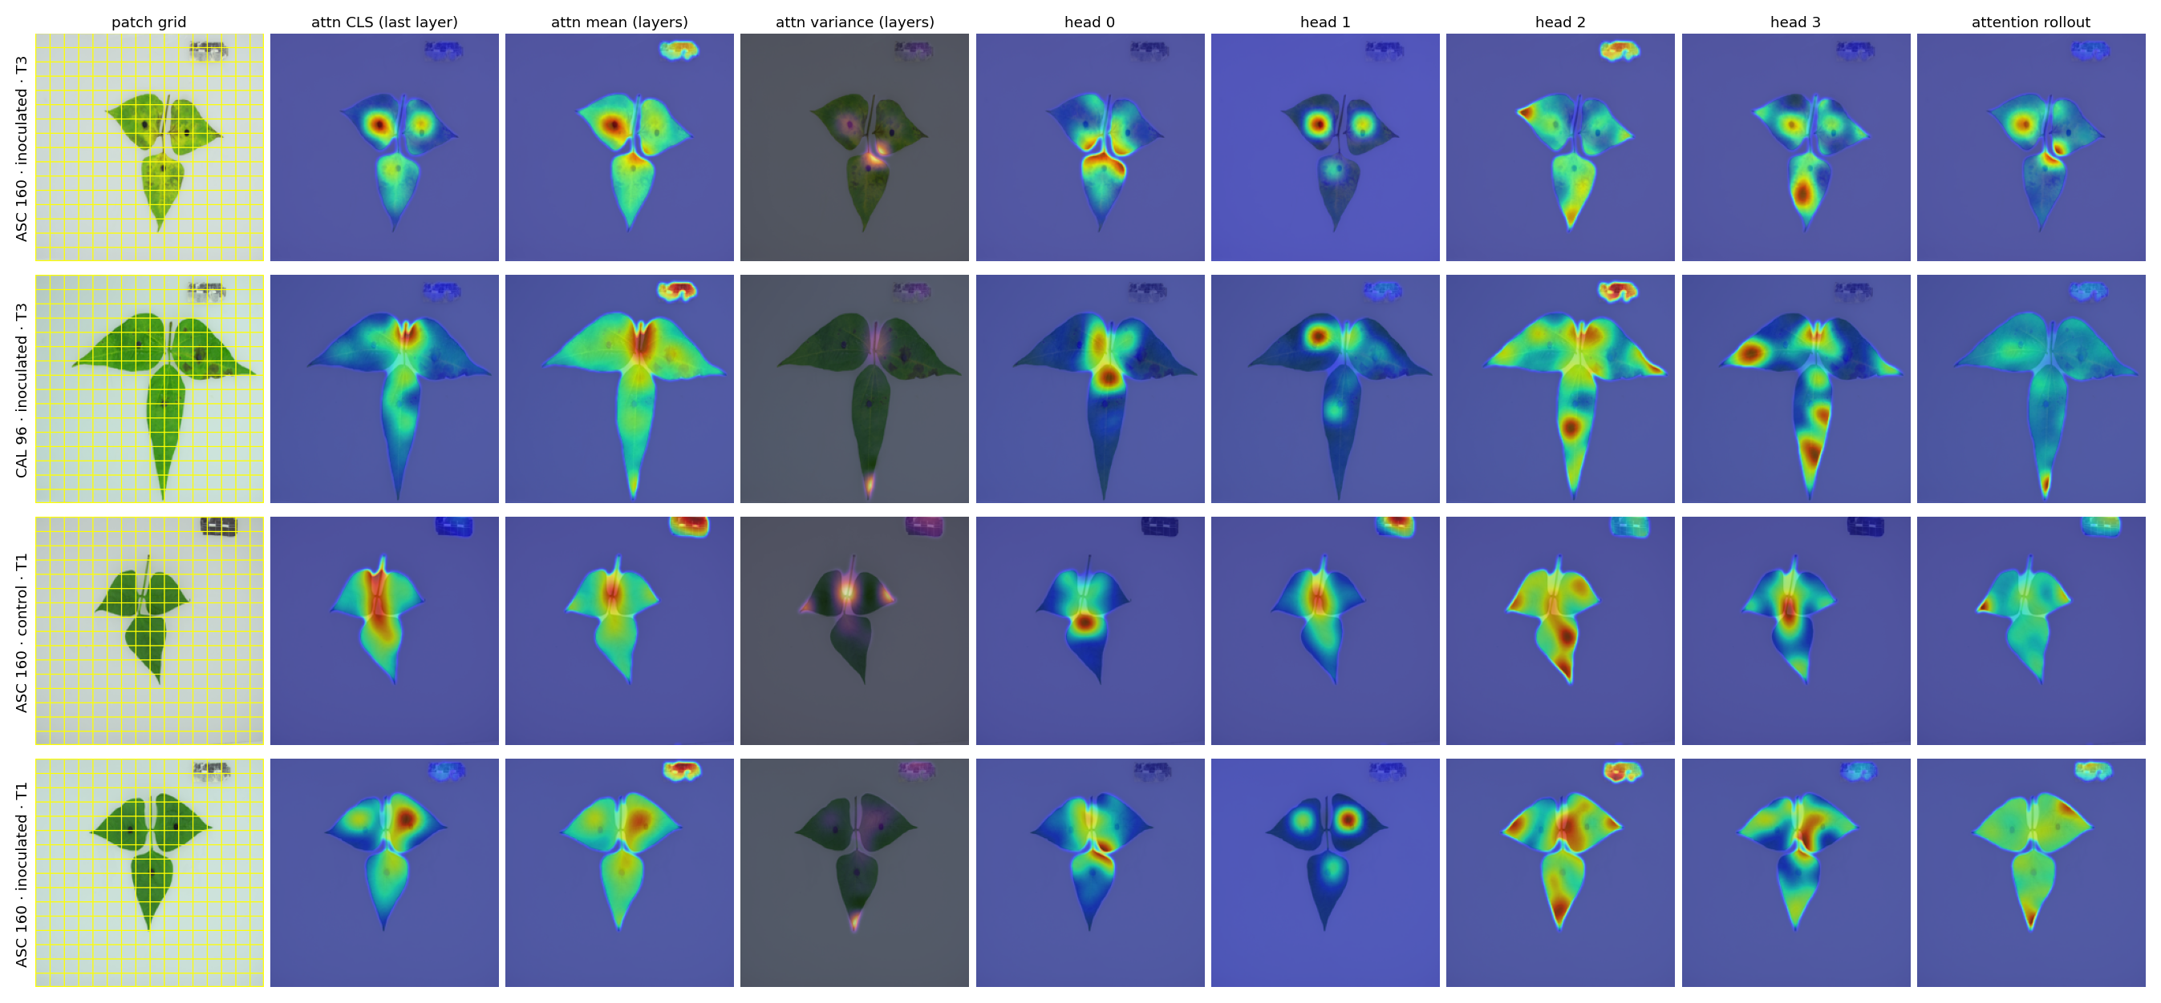
Figure S1. Per-head attention analysis. For representative inoculated and control leaves: the 16×16 patch grid, class-token attention (last layer), layer-averaged attention, inter-layer variance, four individual heads, and attention rollout, as smooth lamina-masked overlays. Heads capture partially distinct patterns; none is specifically lesion-tuned (cf. Figure 2, main text).
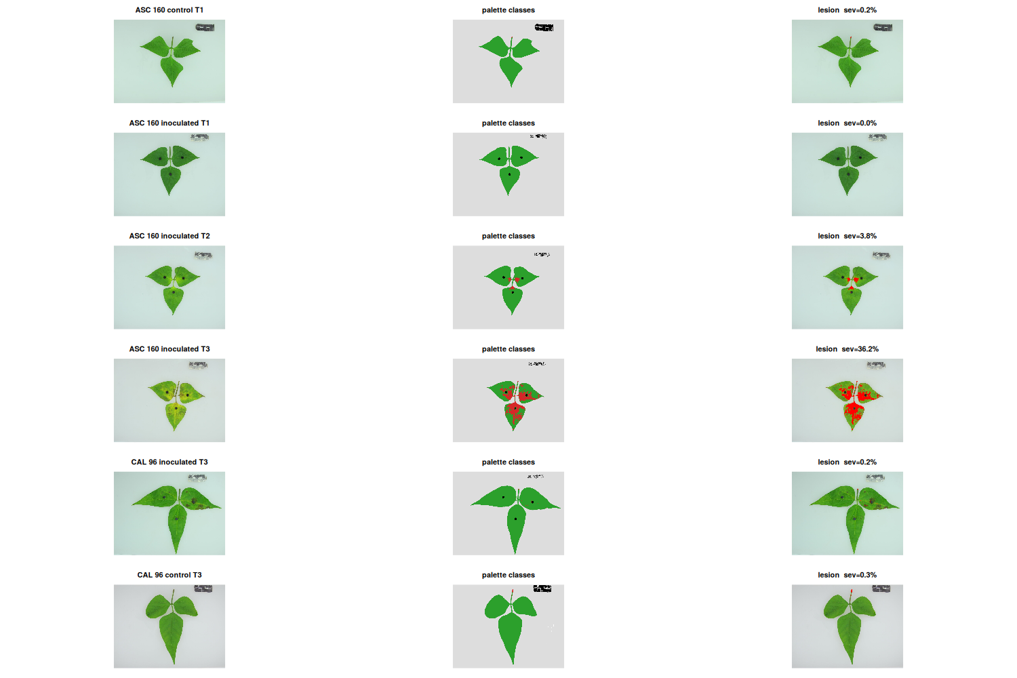
Figure S2. Palette-based severity validation. For representative leaves across group and evaluation: original image, palette-class map, and highlighted lesion tissue with the resulting severity, showing exclusion of the inoculation plug and scale card and capture of chlorotic + necrotic area (cf. Figure 7A, main text).
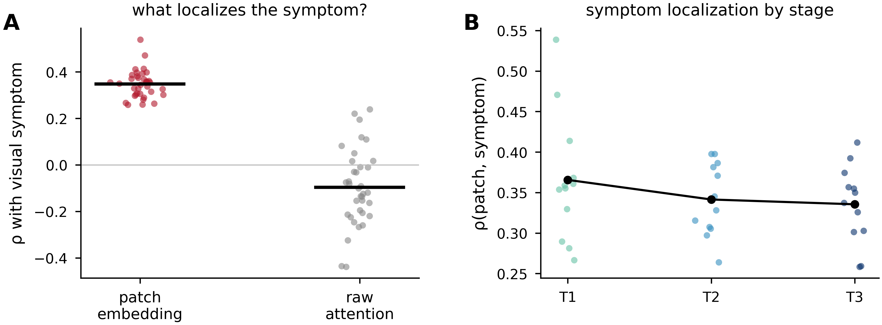
Figure S3. Quantitative symptom localization (supports Figure 2, main text). (A) Per-patch Spearman correlation with the visible symptom for the DINOv2 patch embedding versus raw attention (points = leaves; bars = means): the patch representation tracks the symptom (ρ ≈ 0.35) while raw attention does not (ρ ≈ −0.10). (B) Patch–symptom correlation by evaluation.

References
Del Ponte, E. M. (2023). R for plant disease epidemiology (R4PDE). Author. https://r4pde.net

